Bidirectional associations between mental health problems and language ability across 8 years of childhood

Supplementary material
Supplementary Table 1. Summary of assessments
 | Child’s age years | Mental health reported by | Language ability assessment
Wave 2 | 3 | Mother | BAS Naming Vocabulary
Wave 3 | 5 | Mother | BAS Naming Vocabulary
Wave 4 | 7 | Mother and teacher | BAS Word Reading
Wave 5 | 11 | Teacher | BAS Verbal Similarities
All mental health assessments correspond to the SDQ. BAS= British Ability Scales. All language ability were assessed by a trained interviewer.

Supplementary Table 2. Correlation coefficients.
 | Int3 | Ext3 | L3 | Int5 | Ext5 | L5 | Int7 | Ext7 | L7 | Int11 | Ext11 | L11
Int3 | 1 | 0.39 | -0.19 | 0.49 | 0.29 | -0.16 | 0.43 | 0.27 | -0.16 | 0.16 | 0.13 | -0.18
Ext3 |  | 1 | -0.24 | 0.32 | 0.61 | -0.21 | 0.32 | 0.56 | -0.25 | 0.2 | 0.29 | -0.21
L3 |  |  | 1 | -0.18 | -0.24 | 0.51 | -0.17 | -0.23 | 0.33 | -0.15 | -0.22 | 0.31
Int5 |  |  |  | 1 | 0.41 | -0.18 | 0.60 | 0.34 | -0.17 | 0.23 | 0.19 | -0.18
Ext5 |  |  |  |  | 1 | -0.23 | 0.37 | 0.72 | -0.29 | 0.24 | 0.41 | -0.23
L5 |  |  |  |  |  | 1 | -0.16 | -0.21 | 0.40 | -0.17 | -0.22 | 0.41
Int7 |  |  |  |  |  |  | 1 | 0.46 | -0.2 | 0.29 | 0.23 | -0.18
Ext7 |  |  |  |  |  |  |  | 1 | -0.32 | 0.28 | 0.47 | -0.23
L7 |  |  |  |  |  |  |  |  | 1 | -0.22 | -0.32 | 0.35
Int11 |  |  |  |  |  |  |  |  |  | 1 | 0.44 | -0.19
Ext11 |  |  |  |  |  |  |  |  |  |  | 1 | -0.23
L5 |  |  |  |  |  |  |  |  |  |  |  | 1

Prefixes: Int, Ext and L: Internalizing and externalizing problems and language assessments. Suffixes 3, 5, 7 and 11: represent age at assessment. Pearson’s correlation coefficients are presented.

Supplementary Table 3. Conjunct development of internalizing and externalizing problems and language ability.
 |  | Model 1 RI-CLPM |  |  |  | Model 2 CLPM
 |  | β | 95% CI | p | β | 95% CI | p
Child age 3 years | Child age 5 years
Internalizing | Internalizing | 0.31 | (0.27, 0.35) | <.001 | 0.42 | (0.40, 0.45) | <.001
Externalizing | Internalizing | 0.13 | (0.12, 0.17) | <.001 | 0.07 | (0.06, 0.09) | <.001
Language | Internalizing | 0.002 | (-0.04, 0.03) | 0.88 | -0.06 | (-0.08, -0.03) | <.001
Internalizing | Externalizing | 0.03 | (0.004, 0.08) | 0.03 | 0.05 | (0.03, 0.08) | <.001
Externalizing | Externalizing | 0.50 | (0.47, 0.53) | <.001 | 0.50 | (0.48, 0.51) | <.001
Language | Externalizing | -0.02 | (-0.06, 0.03) | 0.45 | -0.11 | (-0.14, -0.08) | <.001
Internalizing | Language | 0.05 | (0.02, 0.07) | 0.001 | -0.02 | (-0.03, -0.001) | 0.04
Externalizing | Language | -0.03 | (-0.04, -0.01) | 0.01 | -0.03 | (-0.04, -0.02) | <.001
Language | Language | 0.25 | (0.23, 0.29) | <.001 | 0.46 | (0.44, 0.48) | <.001
Child age 5 years | Child age 7 years
Internalizing | Internalizing | 0.45 | (0.41, 0.49) | <.001 | 0.60 | (0.57, 0.63) | <.001
Externalizing | Internalizing | 0.16 | (0.14, 0.20) | <.001 | 0.11 | (0.10, 0.13) | <.001
Language | Internalizing | 0.01 | (-0.02, 0.05) | 0.52 | -0.03 | (-0.05, 0.001) | 0.06
Internalizing | Externalizing | 0.06 | (0.03, 0.10) | <.001 | 0.07 | (0.05, 0.10) | <.001
Externalizing | Externalizing | 0.61 | (0.58, 0.64) | <.001 | 0.69 | (0.68, 0.72) | <.001
Language | Externalizing | -0.005 | (-0.03, 0.05) | 0.72 | -0.04 | (-0.06, -0.004) | 0.02
Internalizing | Language | 0.004 | (-0.03, 0.04) | 0.74 | -0.03 | (-0.05, 0.003) | 0.08
Externalizing | Language | -0.16 | (-0.19, -0.13) | <.001 | -0.18 | (-0.20, -0.16) | <.001
Language | Language | 0.19 | (0.16, 0.25) | <.001 | 0.53 | (0.51, 0.57) | <.001
Child age 7 years | Child age 11 years
Internalizing | Internalizing | 0.08 | (0.05, 0.14) | <.001 | 0.20 | (0.19, 0.25) | <.001
Externalizing | Internalizing | 0.16 | (0.10, 0.17) | <.001 | 0.13 | (0.07, 0.13) | <.001
Language | Internalizing | -0.09 | (-0.12, -0.06) | <.001 | -0.11 | (-0.14, -0.09) | <.001
Internalizing | Externalizing | 0.01 | (-0.01, 0.08) | 0.11 | -0.01 | (-0.03, 0.04) | 0.66
Externalizing | Externalizing | 0.23 | (0.17, 0.28) | <.001 | 0.35 | (0.32, 0.38) | <.001
Language | Externalizing | -0.16 | (-0.19, -0.13) | <.001 | -0.18 | (-0.21, -0.16) | <.001
Internalizing | Language | 0.00 | (-0.04, 0.02) | 0.45 | -0.04 | (-0.06, -0.03) | <.001
Externalizing | Language | -0.04 | (-0.05, 0.01) | 0.19 | -0.03 | (-0.04, -0.02) | <.001
Language | Language | 0.12 | (0.12, 0.16) | <.001 | 0.15 | (0.14, 0.16) | <.001
CFIr |  | 0.96 |  |  | 0.93
RMSEAr |  | 0.05 |  |  | 0.07
SRMR |  | 0.03 |  |  | 0.05
Model 1 output corresponds to the RI-CLPM’s auto-regressive and cross-lagged paths depicted in Figure 1. Model 2 output corresponds to the CLPM’s auto-regressive paths depicted in Figure 1. CFIr: Robust comparative fit index. RMSEAr: Robust root mean square error of approximation. SRMR: Robust standardized root mean square residual.

Supplementary Table 4. Conjunct development of internalizing and externalizing problems and language ability for boys and girls.
 |  |  | Model 1 |  |  | Model 3 |  |  | Model 4
 |  | β | 95% CI | p | β | 95% CI | p | β | 95% CI | p
Child age 3 years | Child age 5 years
Internalizing | Internalizing | 0.31 | (0.27, 0.35) | <.001 | 0.30 | (0.24, 0.36) | <.001 | 0.31 | (0.27, 0.38) | <.001
Externalizing | Internalizing | 0.13 | (0.12, 0.17) | <.001 | 0.14 | (0.12, 0.19) | <.001 | 0.11 | (0.10, 0.16) | <.001
Language | Internalizing | 0.002 | (-0.04, 0.03) | 0.88 | 0.001 | (-0.07, 0.04) | 0.66 | -0.003 | (-0.04, 0.05) | 0.91
Internalizing | Externalizing | 0.03 | (0.004, 0.08) | 0.03 | 0.02 | (-0.02, 0.10) | 0.21 | 0.05 | (0.005, 0.11) | 0.03
Externalizing | Externalizing | 0.50 | (0.47, 0.53) | <.001 | 0.48 | (0.42, 0.51) | <.001 | 0.51 | (0.47, 0.54) | <.001
Language | Externalizing | -0.02 | (-0.06, 0.03) | 0.45 | -0.02 | (-0.09, 0.04) | 0.4 | -0.03 | (-0.08, 0.03) | 0.40
Internalizing | Language | 0.05 | (0.02, 0.07) | 0.001 | 0.06 | (0.01, 0.08) | 0.02 | 0.04 | (0.003, 0.07) | 0.03
Externalizing | Language | -0.03 | (-0.04, -0.01) | 0.01 | -0.001 | (-0.04, 0.02) | 0.41 | -0.06 | (-0.07, -0.02) | 0.001
Language | Language | 0.25 | (0.23, 0.29) | <.001 | 0.23 | (0.20, 0.29) | <.001 | 0.28 | (0.24, 0.32) | <.001
Child age 5 years | Child age 7 years
Internalizing | Internalizing | 0.45 | (0.41, 0.49) | <.001 | 0.46 | (0.41, 0.52) | <.001 | 0.43 | (0.38, 0.49) | <.001
Externalizing | Internalizing | 0.16 | (0.14, 0.20) | <.001 | 0.15 | (0.11, 0.20) | <.001 | 0.17 | (0.14, 0.21) | <.001
Language | Internalizing | 0.01 | (-0.02, 0.05) | 0.52 | 0.01 | (-0.04, 0.06) | 0.68 | 0.02 | (-0.04, 0.07) | 0.6
Internalizing | Externalizing | 0.06 | (0.03, 0.10) | <.001 | 0.07 | (0.04, 0.13) | 0.001 | 0.04 | (0.003, 0.09) | 0.04
Externalizing | Externalizing | 0.61 | (0.58, 0.64) | <.001 | 0.59 | (0.53, 0.63) | <.001 | 0.63 | (0.59, 0.67) | <.001
Language | Externalizing | -0.005 | (-0.03, 0.05) | 0.72 | -0.01 | (-0.05, 0.07) | 0.73 | -0.01 | (-0.06, 0.05) | 0.92
Internalizing | Language | 0.004 | (-0.03, 0.04) | 0.74 | 0.01 | (-0.04, 0.06) | 0.76 | -0.001 | (-0.04, 0.05) | 0.88
Externalizing | Language | -0.16 | (-0.19, -0.13) | <.001 | -0.17 | (-0.22, -0.14) | <.001 | -0.17 | (-0.20, -0.13) | <.001
Language | Language | 0.19 | (0.16, 0.25) | <.001 | 0.18 | (0.13, 0.26) | <.001 | 0.21 | (0.15, 0.27) | <.001
Child age 7 years | Child age 11 years
Internalizing | Internalizing | 0.08 | (0.05, 0.14) | <.001 | 0.11 | (0.06, 0.17) | <.001 | 0.04 | (0.01, 0.13) | 0.03
Externalizing | Internalizing | 0.16 | (0.10, 0.17) | <.001 | 0.16 | (0.09, 0.18) | <.001 | 0.15 | (0.08, 0.17) | <.001
Language | Internalizing | -0.09 | (-0.12, -0.06) | <.001 | -0.07 | (-0.13, -0.05) | <.001 | -0.10 | (-0.15, -0.06) | <.001
Internalizing | Externalizing | 0.01 | (-0.01, 0.08) | 0.11 | 0.01 | (-0.02, 0.11) | 0.18 | 0.02 | (-0.02, 0.09) | 0.24
Externalizing | Externalizing | 0.23 | (0.17, 0.28) | <.001 | 0.23 | (0.14, 0.28) | <.001 | 0.21 | (0.15, 0.29) | <.001
Language | Externalizing | -0.16 | (-0.19, -0.13) | <.001 | -0.17 | (-0.22, -0.13) | <.001 | -0.14 | (-0.19, -0.10) | <.001
Internalizing | Language | 0.00 | (-0.04, 0.02) | 0.45 | 0.04 | (-0.03, 0.05) | 0.51 | -0.03 | (-0.07, 0.002) | 0.07
Externalizing | Language | -0.04 | (-0.05, 0.01) | 0.19 | -0.06 | (-0.08, 0.004) | 0.08 | -0.03 | (-0.05, 0.02) | 0.36
Language | Language | 0.12 | (0.12, 0.16) | <.001 | 0.13 | (0.12, 0.18) | <.001 | 0.13 | (0.11, 0.17) | <.001
CFIr |  | 0.96 |  |  | 0.97 |  |  | 0.97
RMSEAr |  | 0.05 |  |  | 0.05 |  |  | 0.05
SRMR |  | 0.03 |  |  | 0.03 |  |  | 0.03
The models output correspond to the RI-CLPM’s auto-regressive and cross-lagged paths. Model 1 output corresponds to the RI-CLPM’s auto-regressive and cross-lagged paths depicted in Figure 1. Model 3 and 5 represent a similar analysis to model 1 depicted in Figure 1 further stratified for boys and girls respectively. CFIr: Robust comparative fit index. RMSEAr: Robust root mean square error of approximation. SRMR: Robust standardized root mean square residual.

Supplementary Table 5. Conjunct development of internalizing and externalizing problems and language ability, sensitivity analysis models.
 |  |  | Model 5 |  |  | Model 6
 |  | β | 95% CI | p | β | 95% CI | p
Child age 3 years | Child age 5 years
Internalizing | Internalizing | 0.31 | (0.27, 0.36) | <.001 | 0.33 | (0.30, 0.36) | <.001
Externalizing | Internalizing | 0.12 | (0.11, 0.16) | <.001 | 0.11 | (0.10, 0.14) | <.001
Language | Internalizing | 0.01 | (-0.03, 0.04) | 0.72 | 0.003 | (-0.04, 0.03) | 0.97
Internalizing | Externalizing | 0.03 | (0.003, 0.08) | 0.03 | 0.02 | (-0.01, 0.06) | 0.18
Externalizing | Externalizing | 0.50 | (0.46, 0.52) | <.001 | 0.51 | (0.47, 0.52) | <.001
Language | Externalizing | -0.001 | (-0.04, 0.04) | 0.93 | -0.01 | (-0.05, 0.03) | 0.75
Internalizing | Language | 0.06 | (0.03, 0.08) | <.001 | 0.04 | (0.01, 0.06) | 0.001
Externalizing | Language | 0.003 | (-0.01, 0.03) | 0.45 | -0.02 | (-0.03, -0.003) | 0.02
Language | Language | 0.31 | (0.27, 0.36) | <.001 | 0.26 | (0.23, 0.29) | <.001
Child age 5 years | Child age 7 years
Internalizing | Internalizing | 0.21 | (0.19, 0.24) | <.001 | 0.08 | (0.03, 0.12) | 0.001
Externalizing | Internalizing | 0.45 | (0.41, 0.49) | <.001 | 0.09 | (0.05, 0.13) | <.001
Language | Internalizing | 0.15 | (0.13, 0.19) | <.001 | -0.01 | (-0.06, 0.03) | 0.58
Internalizing | Externalizing | 0.02 | (-0.02, 0.06) | 0.26 | -0.001 | (-0.05, 0.05) | 0.88
Externalizing | Externalizing | 0.05 | (0.03, 0.10) | <.001 | 0.25 | (0.17, 0.27) | <.001
Language | Externalizing | 0.61 | (0.57, 0.63) | <.001 | -0.04 | (-0.10, 0.02) | 0.21
Internalizing | Language | 0.02 | (-0.01, 0.07) | 0.21 | -0.002 | (-0.03, 0.03) | 1.00
Externalizing | Language | 0.01 | (-0.02, 0.05) | 0.31 | -0.15 | (-0.18, -0.13) | <.001
Language | Language | -0.14 | (-0.17, -0.12) | <.001 | 0.19 | (0.16, 0.25) | <.001
Child age 7 years | Child age 11 years
Internalizing | Internalizing | 0.08 | (0.06, 0.14) | <.001 | 0.25 | (0.19, 0.28) | <.001
Externalizing | Internalizing | 0.15 | (0.09, 0.16) | <.001 | 0.18 | (0.13, 0.19) | <.001
Language | Internalizing | -0.08 | (-0.11, -0.05) | <.001 | -0.06 | (-0.10, -0.04) | <.001
Internalizing | Externalizing | 0.01 | (-0.01, 0.08) | 0.11 | 0.03 | (-0.01, 0.05) | 0.24
Externalizing | Externalizing | 0.22 | (0.17, 0.27) | <.001 | 0.51 | (0.47, 0.54) | <.001
Language | Externalizing | -0.14 | (-0.17, -0.11) | <.001 | -0.07 | (-0.11, -0.06) | <.001
Internalizing | Language | -0.003 | (-0.04, 0.01) | 0.33 | 0.02 | (-0.02, 0.04) | 0.66
Externalizing | Language | -0.02 | (-0.03, 0.01) | 0.41 | -0.02 | (-0.04, 0.04) | 0.99
Language | Language | 0.08 | (0.07, 0.11) | <.001 | 0.13 | (0.12, 0.17) | <.001
CFIr |  | 0.95 |  |  | 0.96
RMSEAr |  | 0.06 |  |  | 0.05
SRMR |  | 0.04 |  |  | 0.03
The models output correspond to the RI-CLPM’s auto-regressive and cross-lagged paths. Model 5 assessed the bidirectional association of internalizing problems, externalizing problems and language ability as model 1 further adjusting for child IQ. Model 6 assessed the bidirectional association of internalizing problems, externalizing problems and language ability as model 1 with the SDQ teacher assessment at age 7. Significant paths are presented in Supplementary Figure 2. CFIr: Robust comparative fit index. RMSEAr: Robust root mean square error of approximation. SRMR: Robust standardized root mean square residual .

Supplementary Figure 1. Conjunct development of internalizing and externalizing problems and language ability.
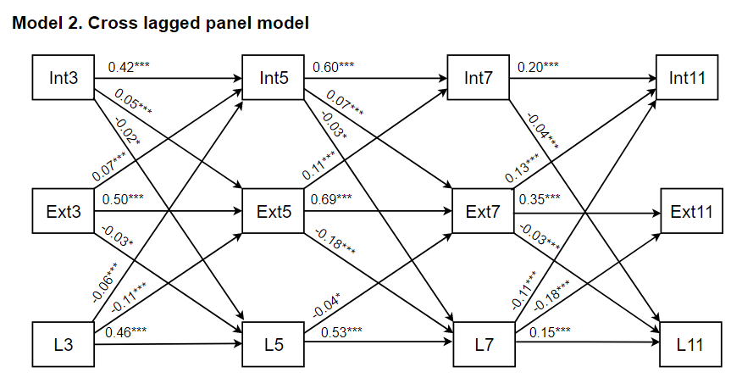
The output corresponds to the CLPM’s auto-regressive and cross-lagged paths depicted as Model 2 in Supplementary figure 1. Prefixes L, Ext and Int: Language assessments, externalizing and internalizing problems. Suffixes 3, 5, 7 and 11: represent age at assessment. The complete output of all these paths is presented in Supplementary Table 1.

Supplementary Figure 2. Conjunct development of internalizing and externalizing problems and language ability, sensitivity analysis models.
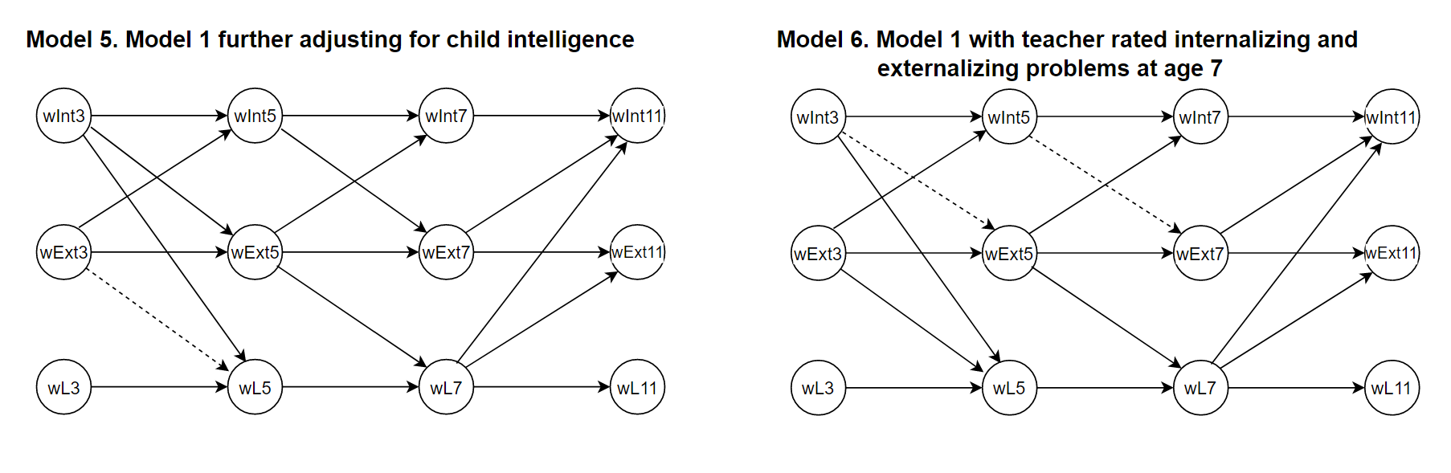
The models output correspond to the RI-CLPM’s auto-regressive and cross-lagged paths. Model 5 assessed the bidirectional association of internalizing problems, externalizing problems and language ability as model 1 further adjusting for child IQ. Model 6 assessed the bidirectional association of internalizing problems, externalizing problems and language ability as model 1 with the SDQ teacher assessment at age 7. Complete output of these paths is presented in Supplementary Table 4.

