The detailed population genetic structure of the rare endangered latid fish akame Lates japonicus with extremely low genetic diversity revealed from single-nucleotide polymorphisms

Conservation Genetics

Takuya Naito, Kouji Nakayama, Hirohiko Takeshima, Yasuyuki Hashiguchi, Tetsuya Akita, Yo Y. Yamasaki, Tappei Mishina, Naohiko Takeshita, Atsushi J. Nagano, Hiroshi Takahashi

Corresponding author: Takuya Naito, Division of Applied Biosciences, Graduate School of Agriculture, Kyoto University, Kitashirakawa Oiwake-cho, Sakyo, Kyoto 606-8502, Japan
Email:naito.takuya.22w@st.kyoto-u.ac.jp

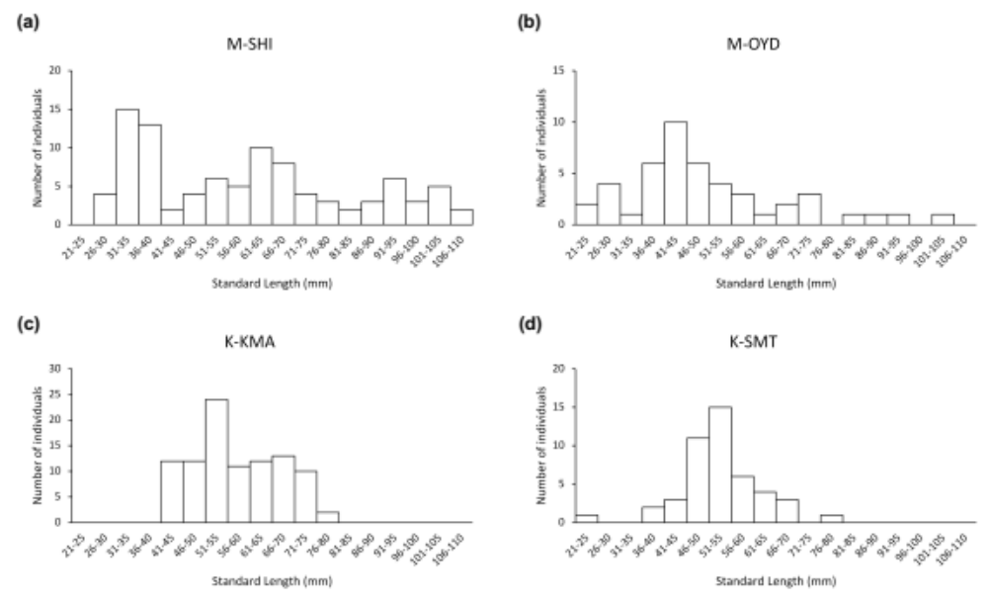
Supplementary Figure 1 Histograms of standard length of individuals from a M-SHI, b M-OYD, c K-KMA, d K-SMT. One individual from M-SHI is excluded because of the lack of SL data

Supplementary Figure 2 ΔK values based on the method of Evanno et al. (2005) and calculated by using Structure Harvester

Supplementary Figure 3 Results of a Structure analysis for K = 4 (the number of sampling sites). Each bar shows a different individual, each sampling site is separated by a black line, and colors represent the probability membership coefficient of each individual for each genetic cluster. ↓ above the bar shows that the individual has admixed ancestry, and ↑ below the bar shows that the individual is a migrant, as estimated from the Structure analysis

Supplementary Figure 4 Bayesian information criterion (BIC) values of discriminant analysis of principal components, obtained by using the find.clusters function to estimate the optimal number of clusters. We selected K = 2 (the number of clusters with the lowest BIC value)

Supplementary Figure 5 Cross-validation of the optimal number of principal components to retain in the discriminant analysis of principal components, performed by using the xvaldapc function. PCA, principal component analysis

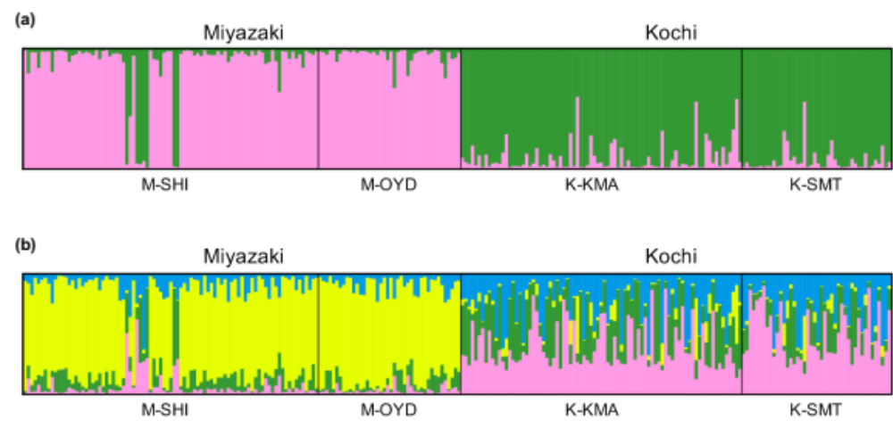
Supplementary Figure 6 Results of a Structure analysis for a K = 2 and b K = 4, without 26 individuals assigned as full siblings by the Colony software

Supplementary Figure 7 Results of a principal component (PC) analysis without 26 individuals assigned as full siblings by the Colony software. Plots represent samples and are colored according to sampling sites The x-axis represents PC1 (explains 2.8% of the total genetic variance) and the y-axis represents PC2 (explains 1.1%)

Supplementary Figure 8 Results of discriminant analysis of principal components without 26 individuals assigned as full siblings by the Colony software. The x-axis represents the first discriminant function and the y-axis represents the density of individuals

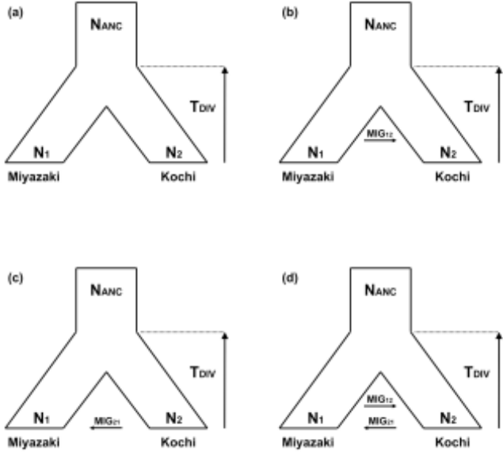

Supplementary Figure 9 Four forward-in-time models tested in the fastsimcoal2 analysis. Parameters include ancestral (N_{ANC}) and (N₁, Miyazaki; N₂, Kochi) effective population size, timing of population split (T_{DIV}), and migration rate (MIG₁₂ and MIG₂₁): (a) absence of gene flow; (b) gene flow only in the direction from Miyazaki to Kochi; (c) gene flow only the direction from Kochi to Miyazaki; and (d) bidirectional gene flow between the two populations

