Supplemental information

Tyrosine phosphorylation of CARM1 promotes its enzymatic activity and alters its target specificity

Hidehiro Itonaga, Adnan K. Mookhtiar, Sarah M. Greenblatt, Fan Liu, Concepcion Martinez, Renata Grozovsky, Daniel Bilbao, Masai Rains, Pierre-Jacques Hamard, Jun Sun, Afoma C. Umeano, Stephanie Duffort, Chuan Chen, Na Man, Gloria Mas, Stephan Schürer, and Stephen D. Nimer

1. Supplemental Figure

2. Supplemental experimental procedures

3. Supplemental Tables (Key resource table)

4. Supplemental reference

1. Supplemental Figure
Figure S1.
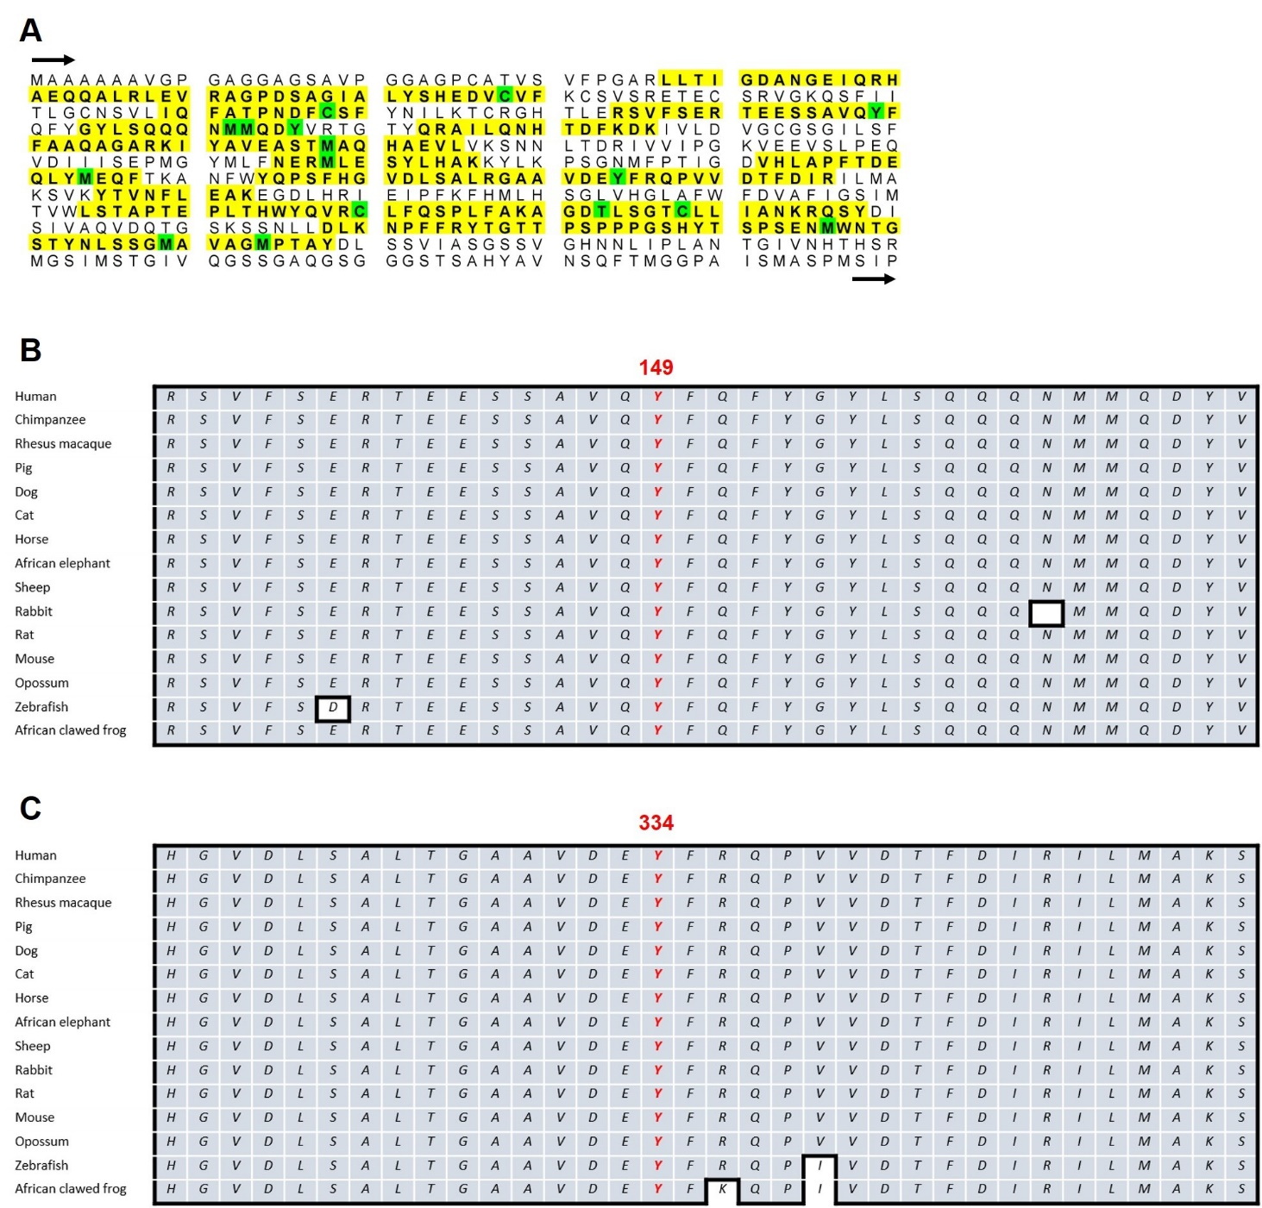

Figure S1. Primary sequence alignment of CARM1 protein.
(A) The coverage rate of mass spectrometry analysis is 48% of full-length human CARM1 protein (indicating yellow or green marked residues), in which we checked 16 out of 20 tyrosine residues.
Sequence alignment around tyrosine-149 (Y149) (B) and tyrosine-334 (Y334) (C) in CARM1. These alignments shown are evolutionally conserved, from African clawed frog to human.

Figure S2.
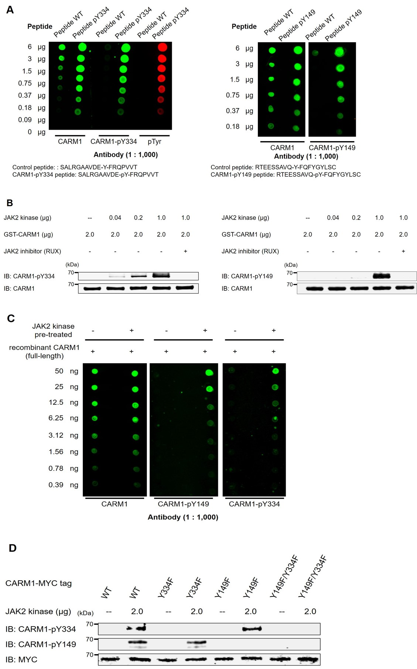
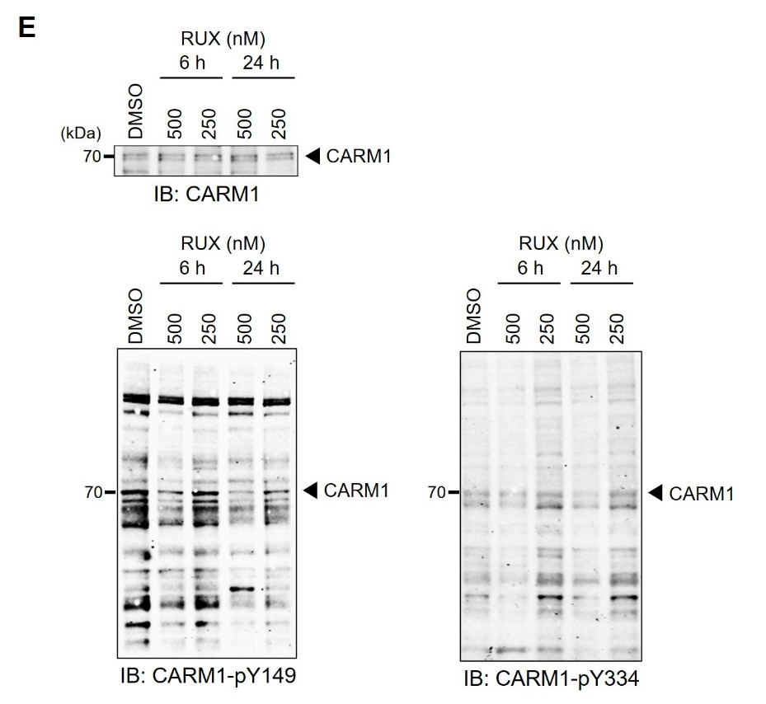

Figure S2. Anti-CARM1phosphospecific antibodies recognize phosphorylated CARM1
(A) Dot-blot analysis showed that anti-CARM1-Y334 (left) and -Y149 (right) phosphospecific antibodies recognized phosphorylated peptides in a dose-dependent manner.
(B) Anti-CARM1-Y334 phosphospecific antibody recognized CARM1 in the presence of active JAK2 kinase in a dose dependent manner (left). Anti-CARM1-Y149 phosphospecific antibody recognized CARM1 in the presence of active JAK2 kinase in a dose dependent manner (right). In both assays, the complete abolishment of CARM1 phosphorylation by JAK2 inhibitor (ruxolitinib, RUX) was observed.
(C) Dot-blot analysis showed that anti-CARM1-Y149 (middle) and -Y334 (right) phosphospecific antibodies recognized phosphorylated CARM1 proteins (full-length), generated by incubation with active JAK2 kinase.
(D) MYC-tagged CARM1 wild-type (WT), Y149F or Y334F single mutations, or Y149F/Y334F double mutations were expressed in K562 cells. Proteins were precipitated by anti-MYC immunoprecipitation, and immunoblotted using anti-CARM1-phosphospecific antibodies following the incubation with or without recombinant active JAK2 kinase.
(E) Endogenous phosphorylated CARM1 was immunoblotted from total cell lysates of HEL cells treated with DMSO or RUX, using anti-CARM1-Y149 (left) and -Y334 (right) phosphospecific antibodies. The reduction of CARM1 phosphorylation was observed at the higher RUX concentration (500 nM).

Figure S3.
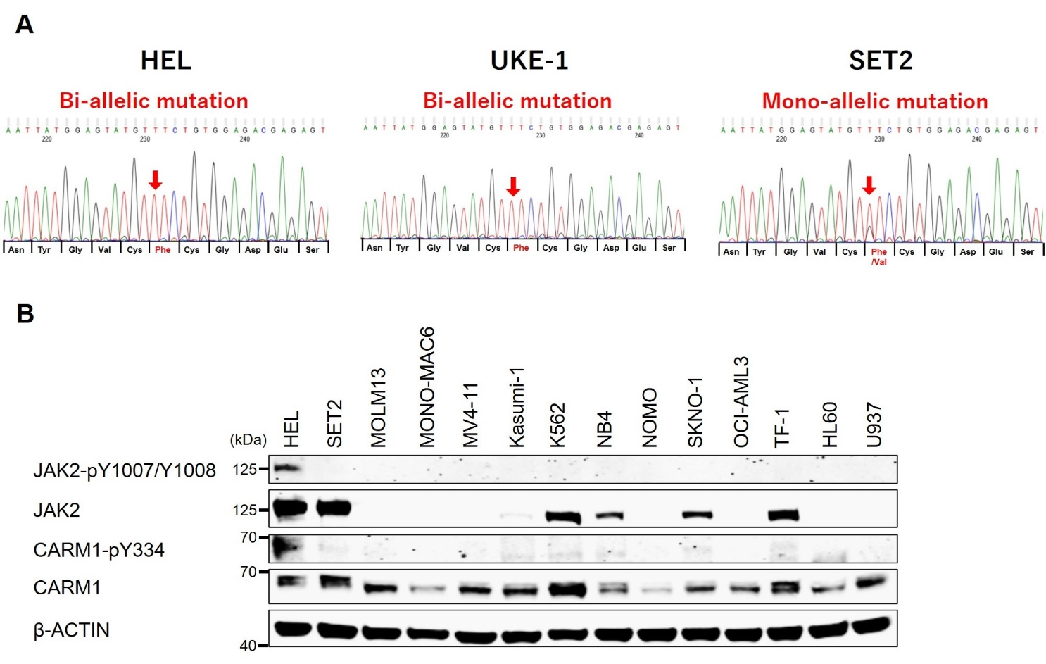

Figure S3. Mutational status of JAK2-V617F and JAK2 auto-phosphorylation
(A) JAK2-V617F mutation was detected by direct sequencing after the amplification of genomic DNA by PCR as described previously [1]. Positions of the JAK2-V617F mutation are indicated by arrows. HEL and UKE-1 cells have bi-allelic mutations (homozygous), while SET2 cells has a mono-allelic mutation (heterozygous) at the genomic DNA level.
(B) The phosphorylation status of JAK2 and CARM1 is shown in 14 myeloid leukemia cell lines. HEL cells showed the highest level of JAK2 auto-phosphorylation.

Figure S4.
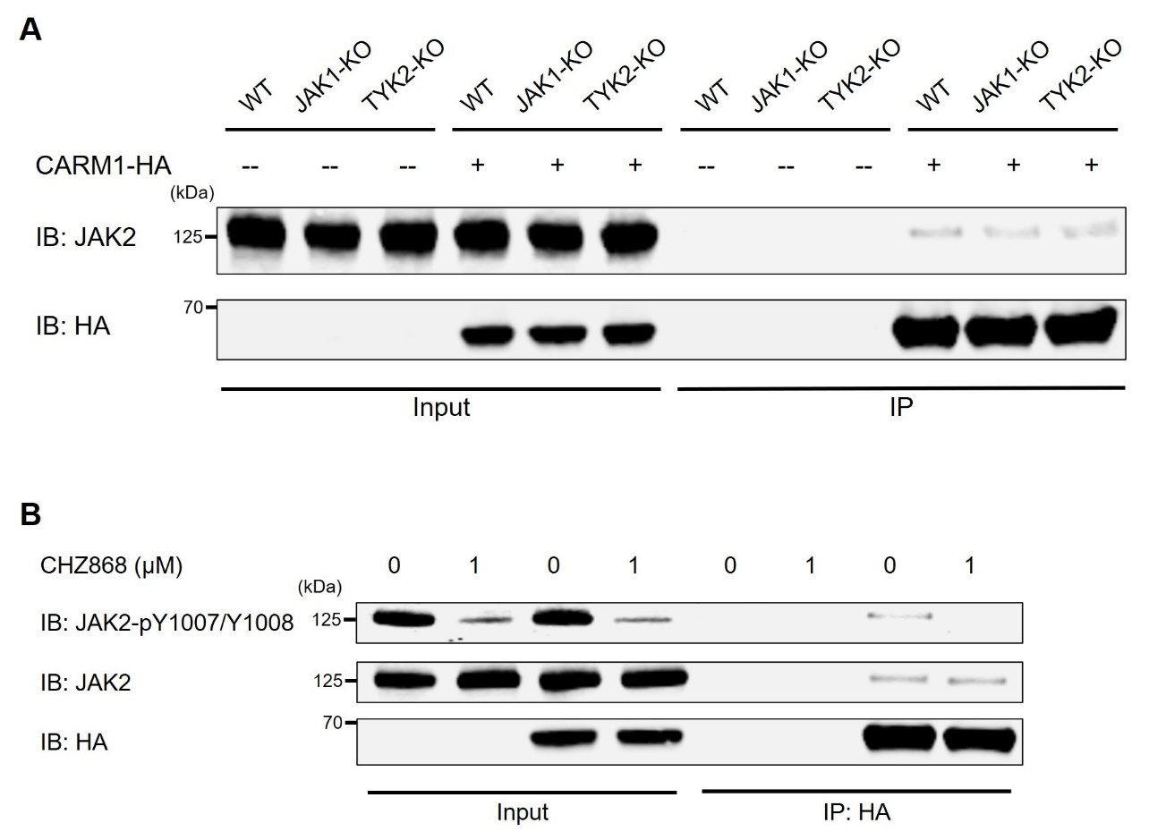

Figure S4. The effect of transphosphorylation of JAK2 by JAK1 or TYK2 on the binding between JAK2 and CARM1
(A) Immunoprecipitation was performed using clustered regularly interspaced short palindromic repeat (CRISPR)/CRISPR-associated protein-9 (Cas9) mediated JAK1 or TYK2 knockout HEL cells that express HA-tagged CARM1, with an anti-HA antibody. Immunoblotting with anti-HA and anti-JAK2 antibodies revealed the interaction between JAK2 and CARM1. Knockout of JAK1 or TYK2 did not alter the binding between CARM1 and JAK2.
(B) Immunoprecipitation was performed with an anti-HA antibody using HEL cells expressing HA-tagged CARM1 which were treated with type II JAK2 inhibitor (CHZ868) for 24 hours. Immunoblotting with anti-HA and anti-JAK2 antibodies revealed the interaction between JAK2 and CARM1. The binding between CARM1 and JAK2 was observed after reduction of JAK2 auto-phosphorylation.

Figure S5.
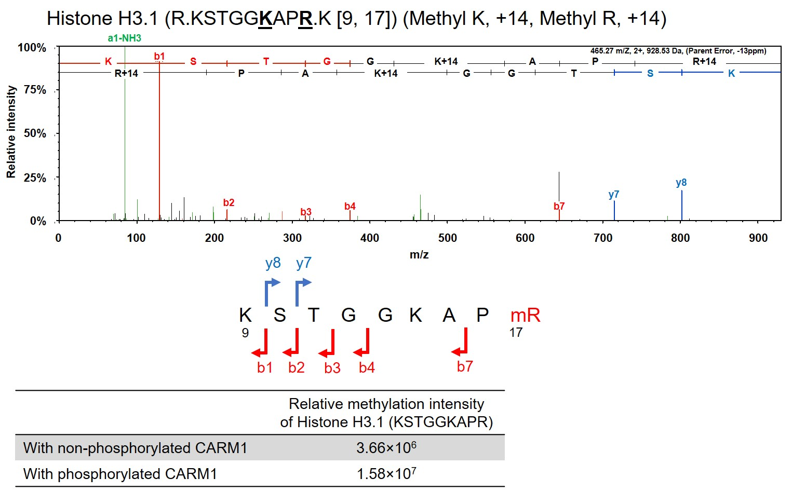

Figure S5. Mass spectrometry for the substrates of CARM1 after in vitro methylation assay
Recombinant CARM1 was incubated with or without active JAK2 kinase in an in vitro assay, then phosphorylated CARM1 or non-phosphorylated CARM1 were subsequently incubated with histone 3.1. These substrates were subjected to LC-MS/MS analysis. Histone 3.1 peptides containing methylated R17 were identified in the incubation with phosphorylated CARM1 and non-phosphorylated CARM1.

Figure S6.
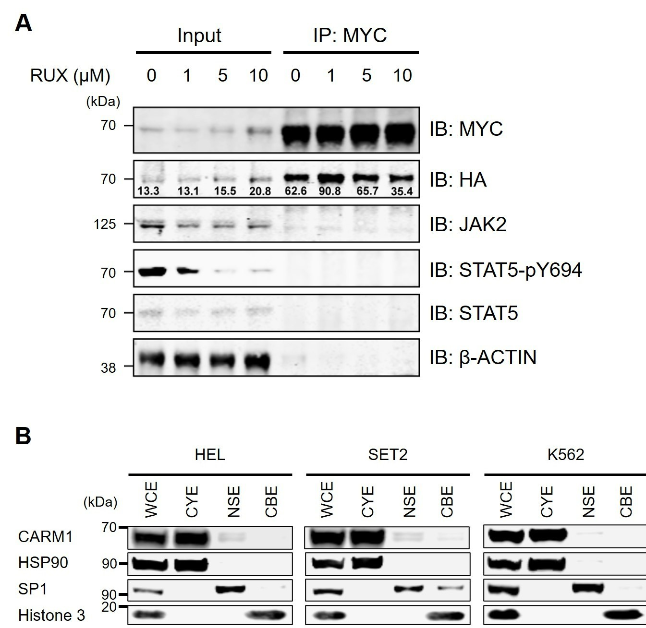

Figure S6. Dimerization and subcellular localization of CARM1
(A) HA-tagged WT-CARM1 and MYC-tagged WT-CARM1 constructs were co-transfected into 293T cells. Following immunoprecipitation with anti-MYC antibody, the detectable HA-tagged WT-CARM1 was decreased in the 293T cells treated with RUX 10 μM vs. those treated with DMSO (RUX 0 μM).
(B) The immunoblotting assay of subcellular localizations in HEL, SET2, and K562 cells revealed that total CARM1 is localized mainly in the cytoplasm. Purity of the subcellular fractions was assessed by detecting HSP90 (cytoplasmic extraction, CYE), SP1 (nuclear soluble extraction, NSE), and histone H3 (chromatin-bound extraction, CBE).

Figure S7.
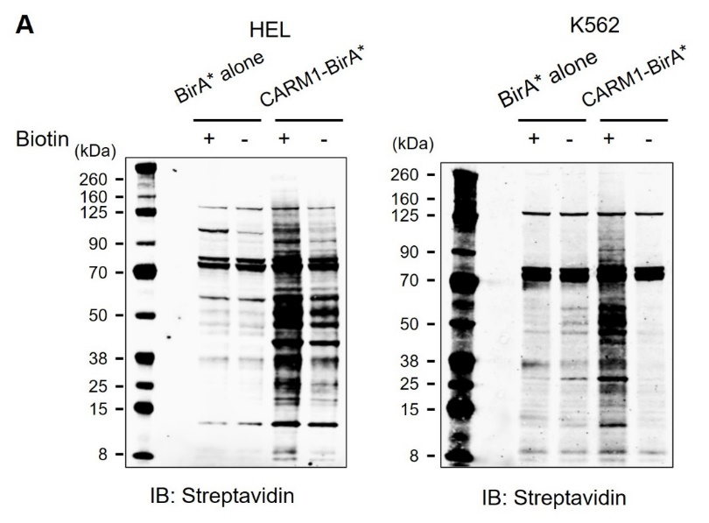

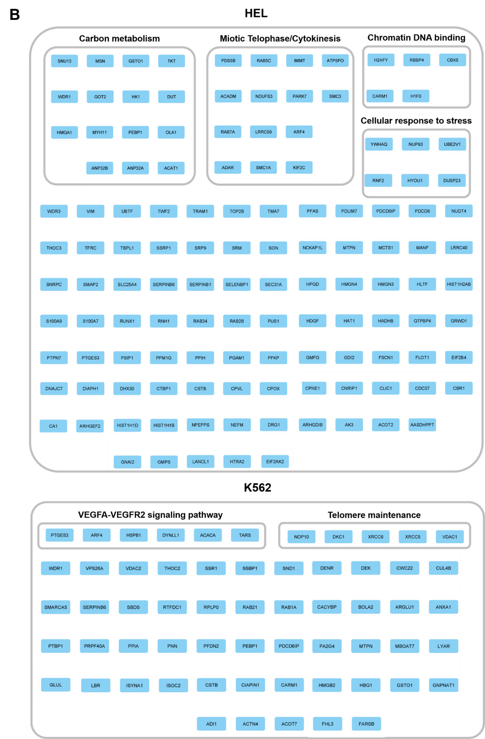

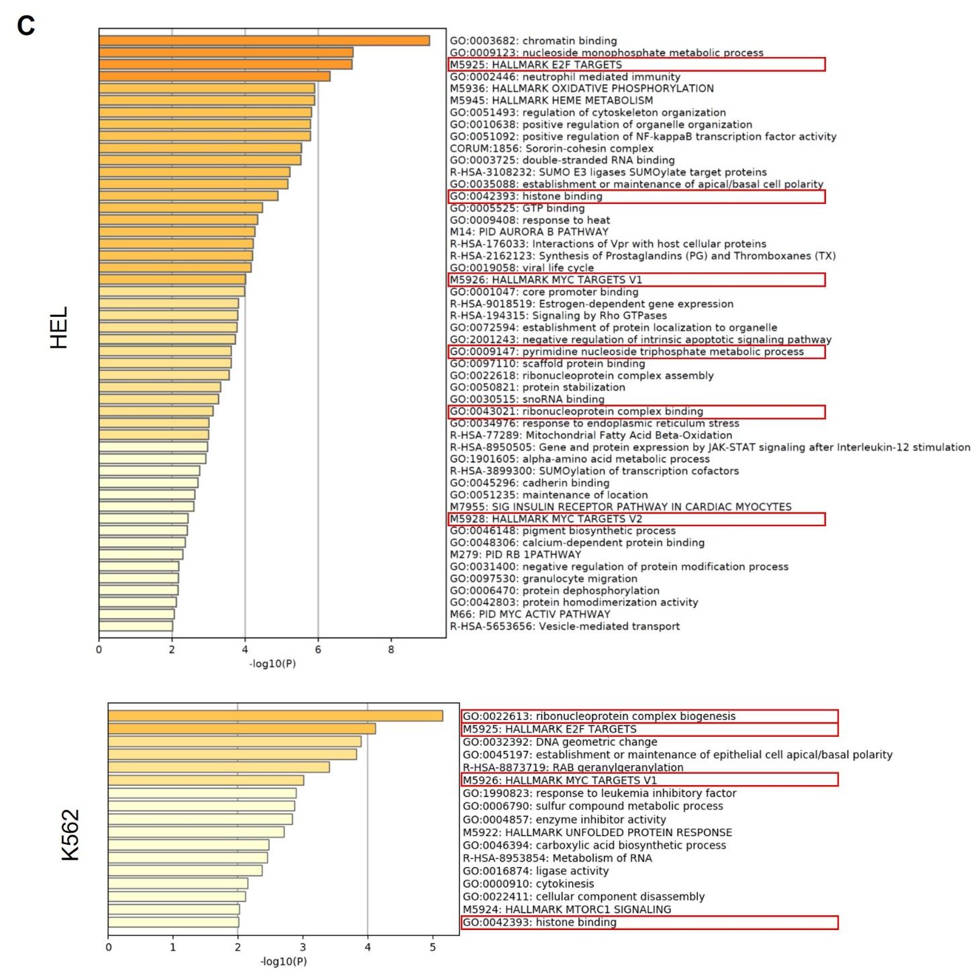
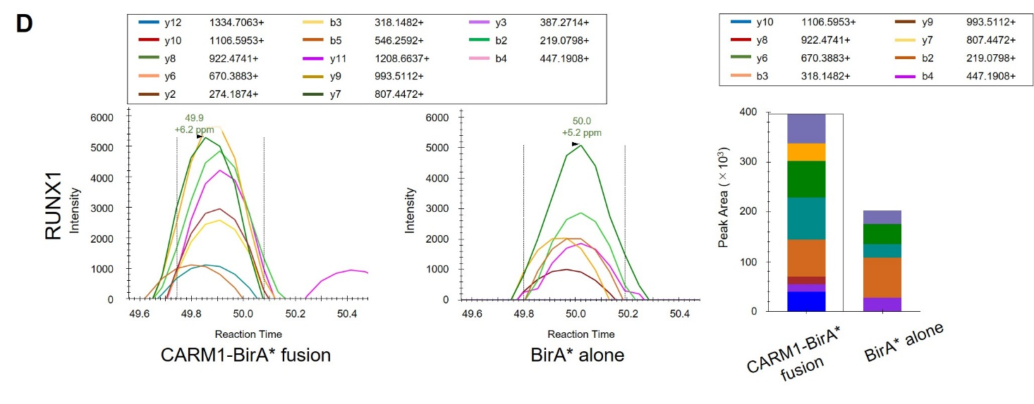

Figure S7. The interactome of CARM1 by BioID system
(A) Western blots confirming biotinylated proteins of lysate from HEL cells with CARM1-BirA* fusion proteins overexpression in culture medium with or without biotin.
(B) Proteins binding to CARM1 and enrichment network visualization for the results in HEL and K562 cells. See also supplemental data.
(C) Metascape bar graph for viewing top non-redundant enrichment clusters in HEL and K562 cells, one per cluster, using a discrete color scale to represent statistical significance. Red squares indicate the clusters which associates with purine nucleotide metabolism, E2F targets, MYC targets, histone binding proteins, and ribonucleoprotein complex biogenesis.
(D) Targeted mass spectrometry analysis revealed the interaction of CARM1 with RUNX1 in HEL cells. Skyline chromatogram visualizations showed the intensity at each resampled retention time point for all fragment ions, which were presented as different colored lines identified in the legends. Peak areas by each fragment were displayed as the bar graphs (left) to compare the intensity of samples from HEL cells with CARM1-BirA* fusion (total AUC value, 395,628) to those with BirA* alone (total AUC value, 215,928).

Figure S8.
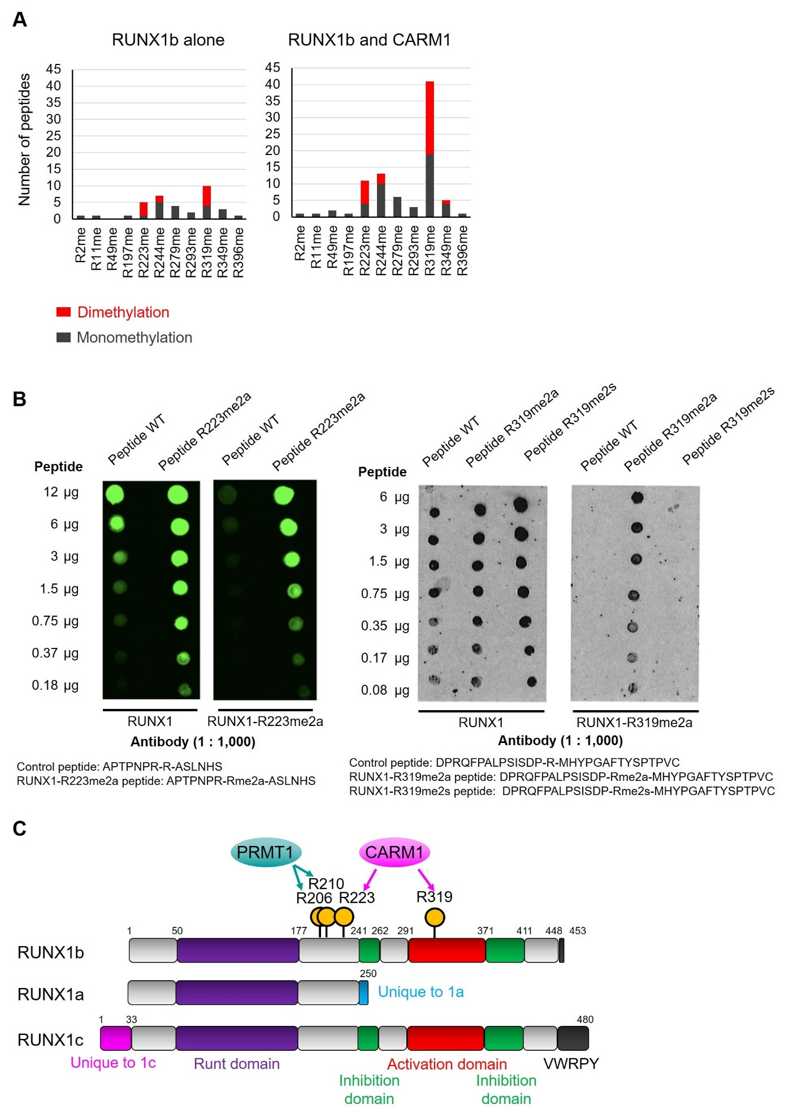
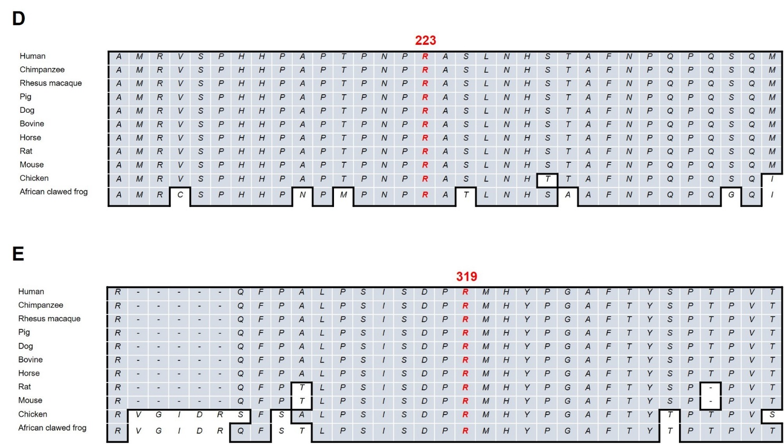

Figure S8. Asymmetric dimethylation of R223 and R319 in RUNX1b
(A) Recombinant RUNX1b (full-length) was generated from baculovirus-infected Sf9 cells. Recombinant RUNX1b was incubated with CARM1 in an in vitro methylation assay, and RUNX1b peptides were subjected to LC-MS/MS analysis. The RUNX1b peptides containing methylated arginine-223 (R223) and arginine-319 (R319) were twice as represented in the incubation of RUNX1b and CARM1 than the RUNX1b alone (baseline).
(B) The dot-plot analysis showed that anti-RUNX1-R223 (left) or -R319 (right) methylation specific antibodies recognized methylated peptides in a dose-dependent manner.
(C) Schematic diagram of RUNX1b, showing the positions of R223 and R319; the numbers correspond to the amino acid positions.
(D) Sequence alignment around R223 of RUNX1b.
(E) Sequence alignment around R319 of RUNX1b. The alignments of R223 and R319 in RUNX1b showed are evolutionally conserved in mammals.

Figure S9.
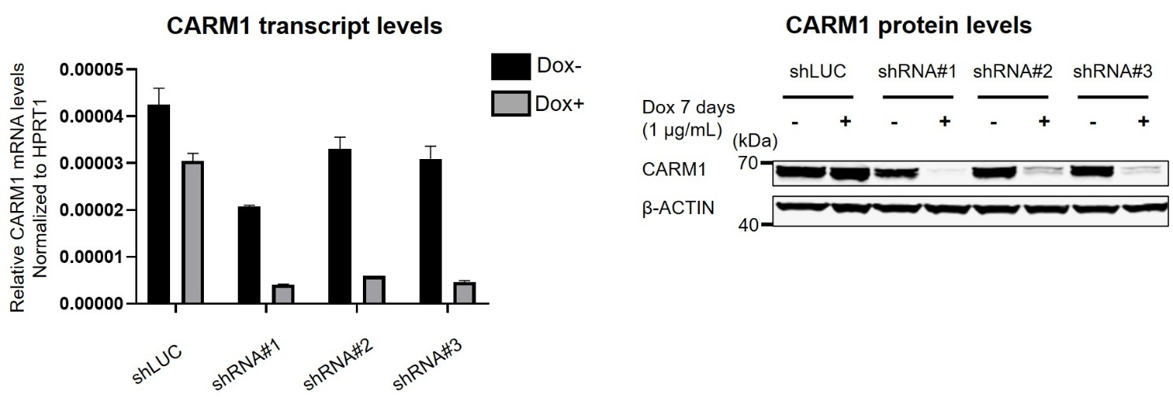

Figure S9. Doxycycline-inducible shRNAs knockdown CARM1 in HEL cells
Doxycycline-inducible short hairpin RNAs (shRNAs) against CARM1 were stably expressed in HEL cells. CARM1 transcripts (left) and protein (right) were significantly reduced following 7 days of doxycycline exposure.

Figure S10.
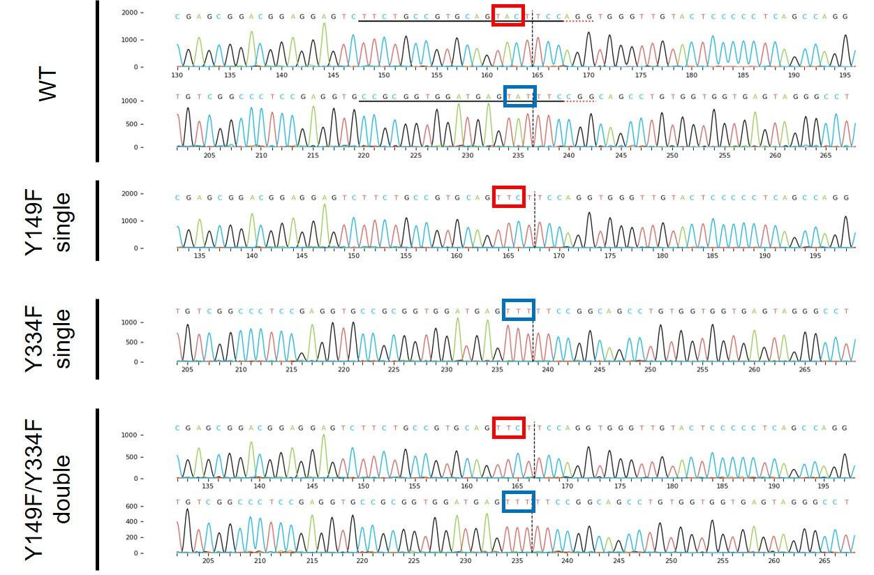

Figure S10. Confirmation of non-phosphorylatable CARM1 mutation knock-in HEL cells
Monoclonal populations of CRISPR/Cas9 mediated CARM1-Y149F or -Y334F single, or -Y149F/Y334F double mutant knock-in cells were generated after single cell expansion. Homozygous single mutations (Y149F or Y334F) or double mutations (Y149F/Y334F) were confirmed by direct sequencing after the amplification of genomic DNA.

Figure S11.

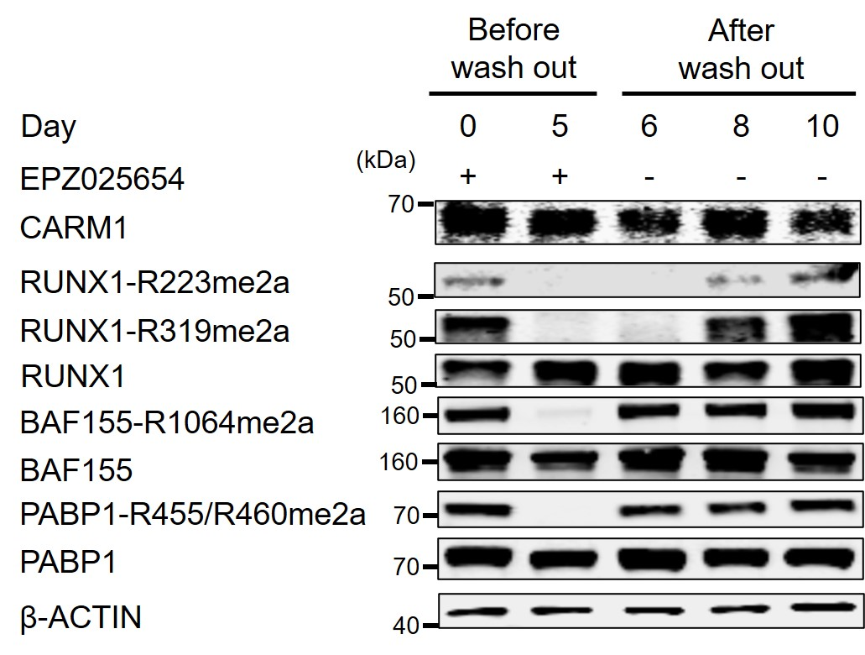

Figure S11. The reversibility of ADMA in multiple CARM1 substrates
The asymmetrically dimethylated arginine levels of RUNX1, BAF155, and PABP1, were defined following EPZ025654 treatment for 5 days and a variable period of wash-out.

Figure S12.
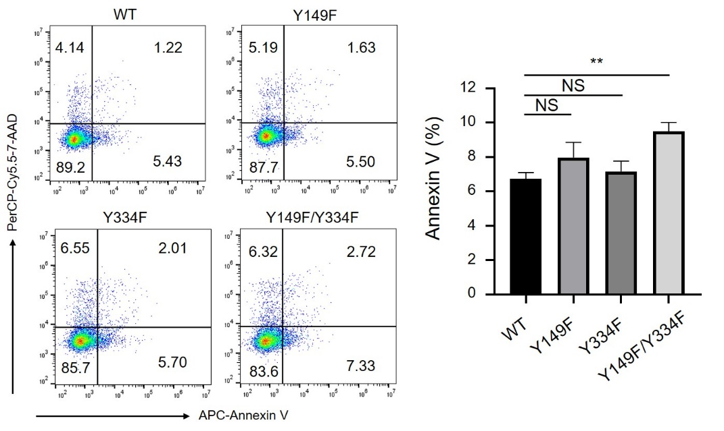

Figure S12. Comparison of the effects of non-phosphorylatable CARM1 mutation on Annexin V/7-ADD positivity in HEL cells
Flow cytometric analysis of various CARM1 mutant HEL cells to detect annexin V positive cells (left panel). Fractions of the annexin V-positive populations are plotted (right panel) as mean ± s.d. n=3, **p<0.01.

Figure S13.
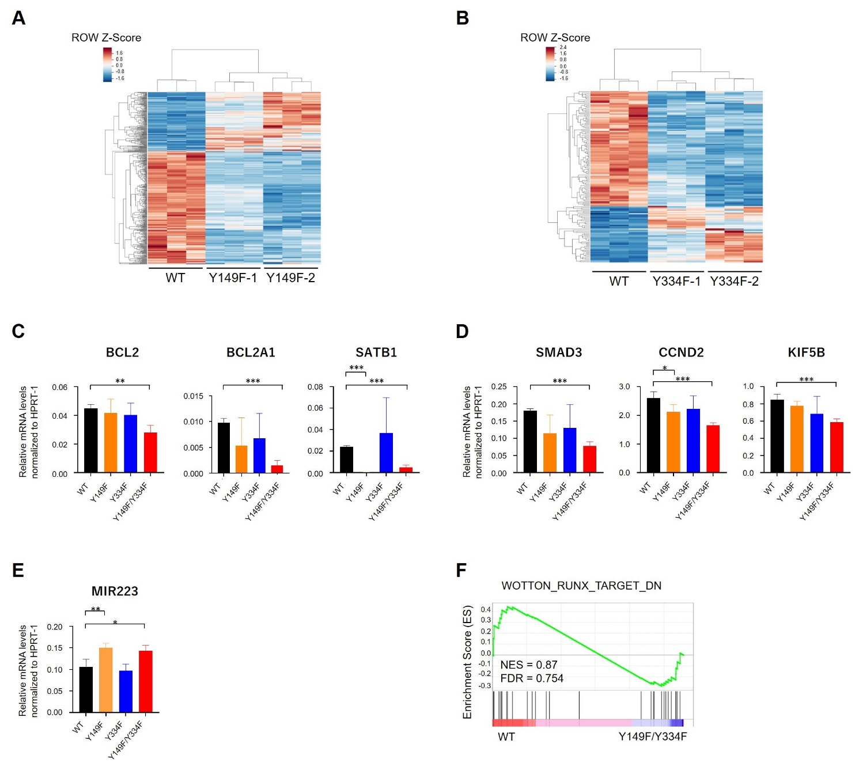

Figure S13. Gene expression in non-phosphorylatable CARM1 mutation knock-in HEL cells
(A) Heatmap of the expression of 401 differentially expressed genes, representing replicates of cells expressing CARM1-WT or two independent cells expressing CARM1-Y149F single mutation (Y149F-1 and Y149F-2).
(B) Heatmap of the expression of 144 differentially expressed genes, representing replicates of cells expressing CARM1-WT or two independent cells expressing CARM1-Y334F single mutation (Y334F-1 and Y334F-2).
(C) qRT-PCR analysis showing expression genes associated with anti-apoptosis (BCL2, BCL2A1, and SATB1). Mean and SD are expressed as a percentage of HPRT-1 expression.
(D) qRT-PCR analysis showing expression genes associated with G2/M checkpoint (SMAD3, CCND2, and KIF5B). Mean and SD are expressed as a percentage of HPRT-1 expression.
(E) qRT-PCR analysis showing the higher expression of MIR223 in CARM1-Y149F/Y334F double mutation than CARM1-WT. Mean and SD are expressed as a percentage of HPRT-1 expression.
(F) Representative GSEA plot depicting the regulation of “RUNX1-target” signature.

Figure S14.
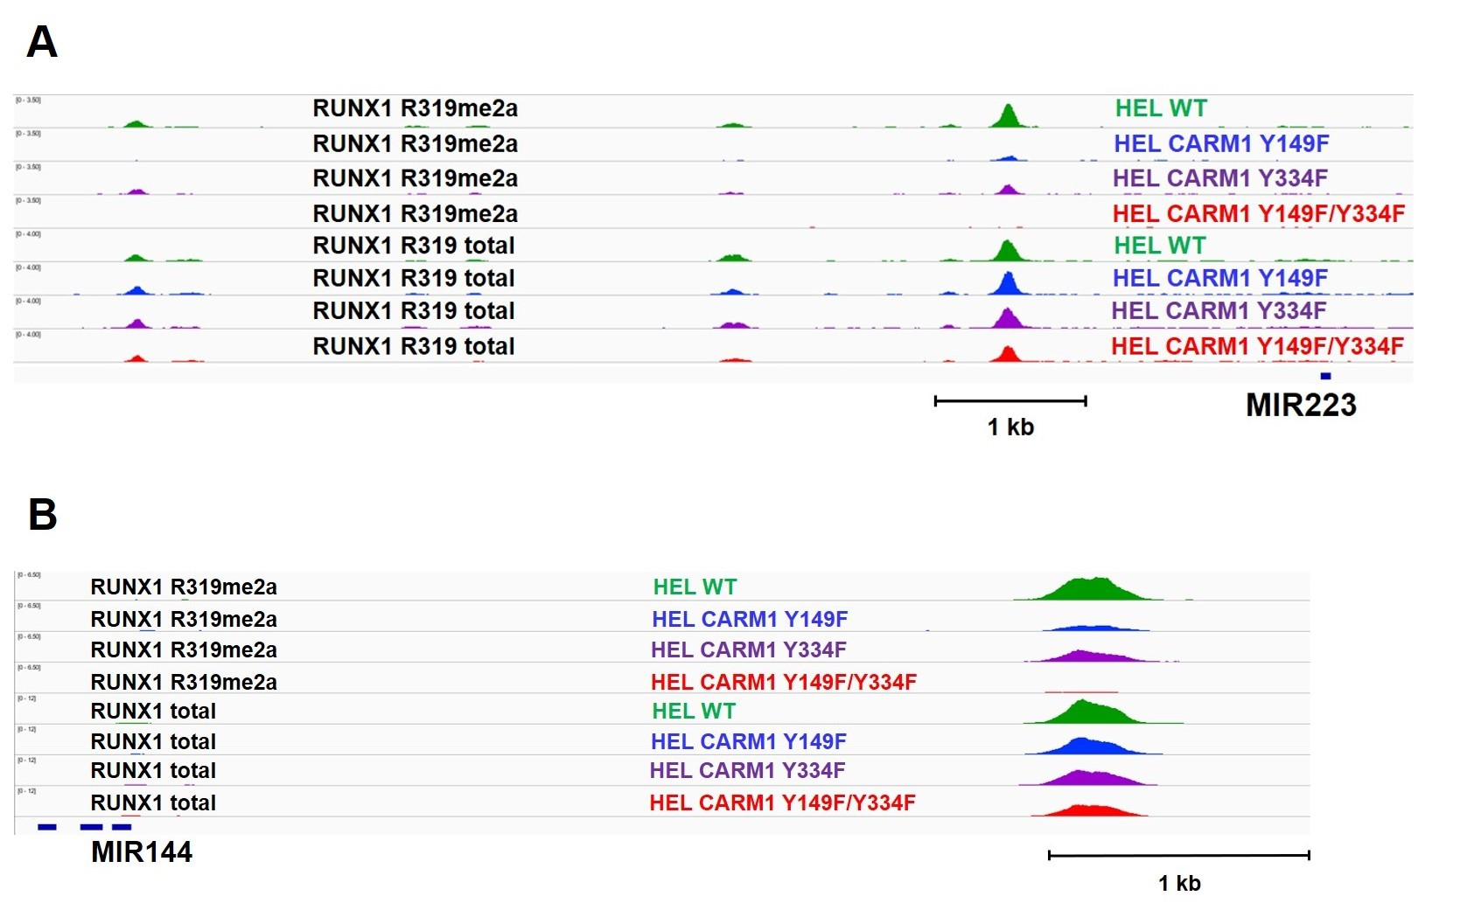

Figure S14. ChIP-seq analysis demonstrating changes in asymmetrically dimethylated R319-RUNX1 occupancies on RUNX1 targeted genes
Target occupancies of RUNX1 and asymmetrically dimethylated R319-RUNX1 at MIR144 (A) and MIR223 genes (B) determined using antibody against total R319-RUNX1 and asymmetrically dimethylated R319-RUNX1, as shown in IGV genome browser tracks.

Figure S15.
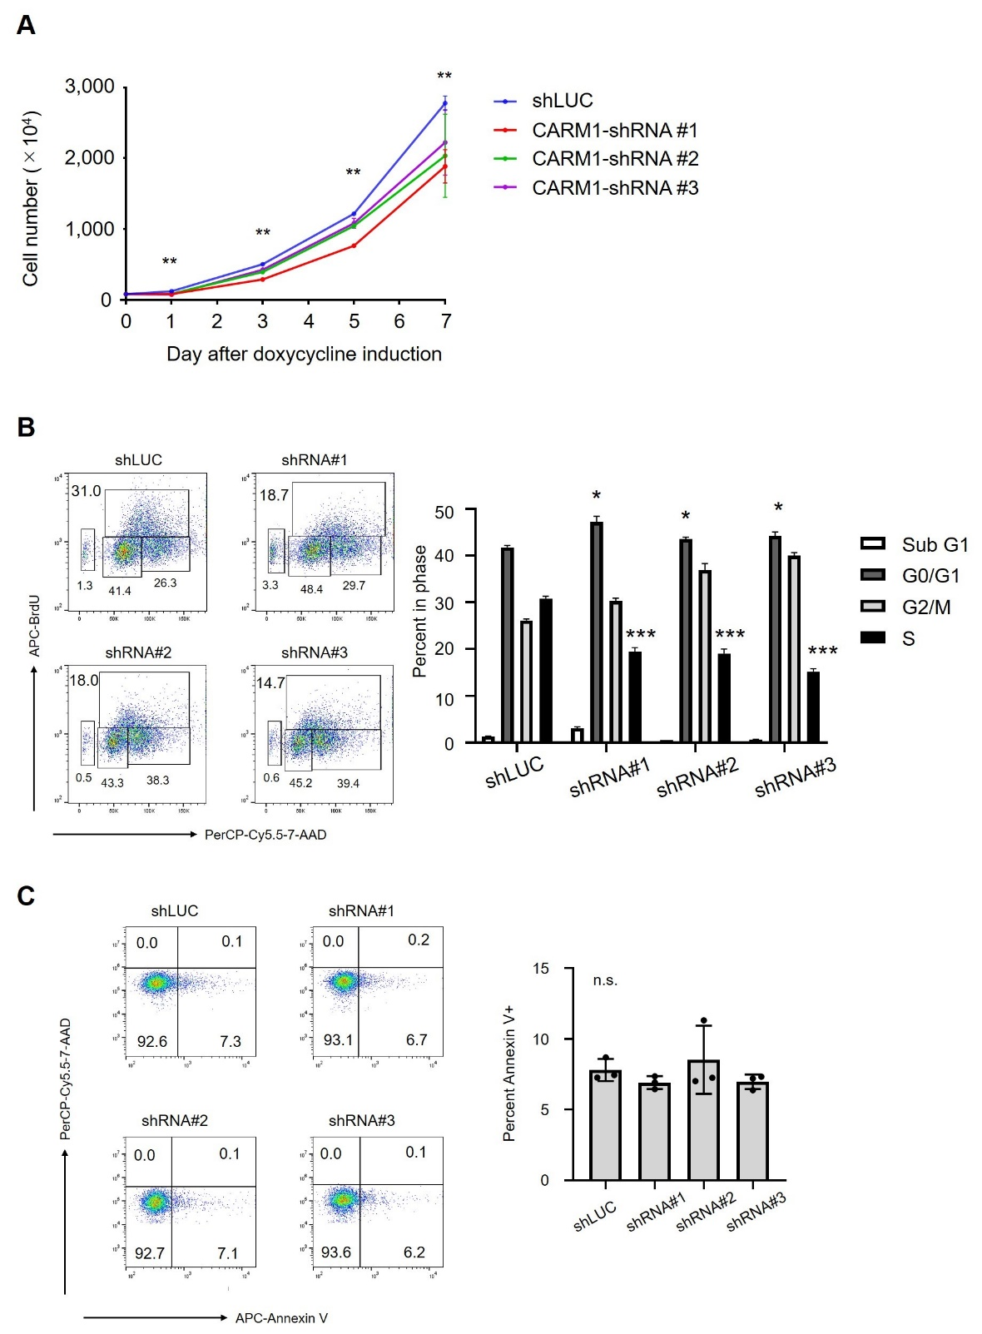

Figure S15. The biological impact of CARM1 knockdown in HEL cells
(A) Cell counts from shRNA-mediated CARM1 knockdown (KD) HEL cells using three different shRNAs plus a control shRNA (shLUC). n=3, **p<0.01.
(B) Percentage of cells in sub-G1, G1, S or G2/M phase in HEL cells infected with a CARM1 KD lentivirus. All experiments were repeated three independent times.
(C) KD of CARM1 has minimal effect on apoptosis in HEL cells. The percentage of apoptotic cells in HEL cells stably expressing doxycycline-inducible shRNA against CARM1 are shown in bar graphs. All experiments were repeated three independent times.

Figure S16.
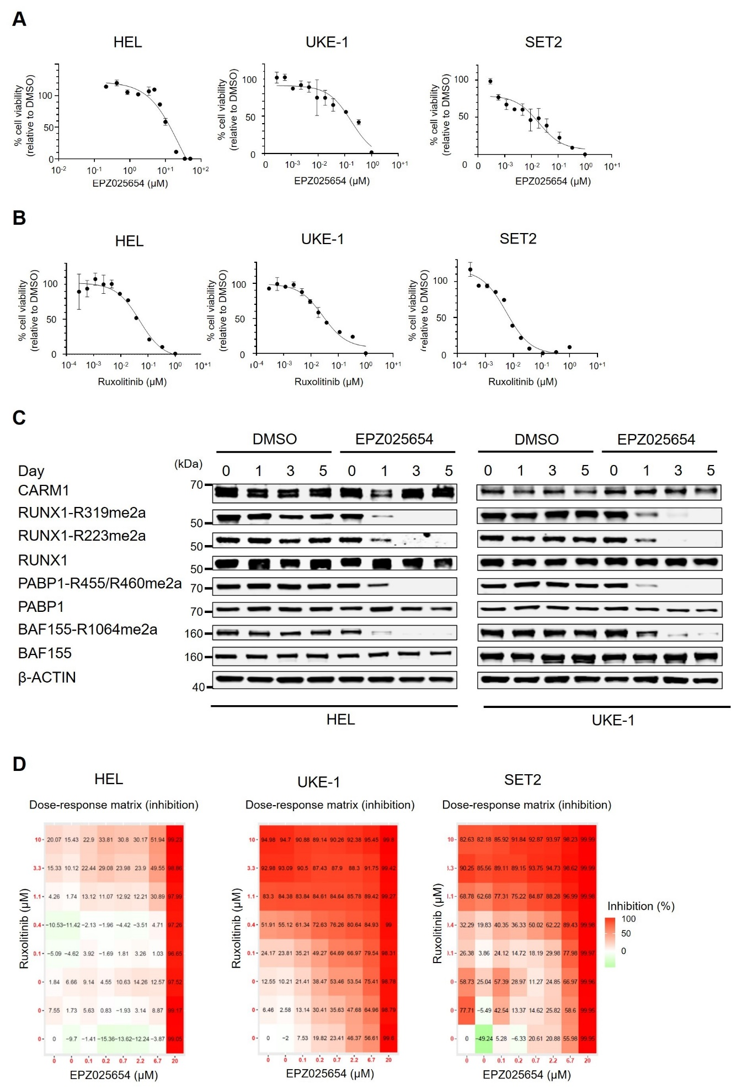

Figure S16. Pharmacological inhibition of CARM1 and JAK2
(A) Proliferation of HEL, UKE-1, and SET2 cells (harboring JAK2-V617F mutations) with increasing concentration of EPZ025654 (μM) relative to DMSO. The half maximal inhibitory concentration (IC50) values for EPZ025654 are 23.7 μM, 1.8 μM, and 186.5 nM in HEL, UKE-1, and SET2 cells, respectively.
(B) Proliferation with increasing concentration of RUX (μM) relative to DMSO is depicted for HEL, UKE-1, and SET2 cells. IC50 values for RUX are 492 nM, 269 nM, and 56 nM in HEL, UKE-1, and SET2 cells, respectively.
(C) HEL cells were treated with a CARM1 inhibitor (5 μM EPZ025654) for 1, 3, and 5 days. The level of ADMA RUNX1, BAF155, and PABP1 was significantly decreased at day 1, and completely abolished at day 5.
(D) Visualization of the dose-response matrix and the plots of phenotypic cellular responses to EPZ025654, ruxolitinib, or the combination in HEL (left), UKE-1 (middle), and SET2 cells (right).

2. Supplemental experimental procedures
Cell lines and cell culture
Leukemia cell lines were purchased from the ATCC, DSMZ, or Coriell, and cultured according to the provider’s instructions (Supplemental Table 1). All cell lines were grown at 37°C in 5% CO₂: HEL cells were grown in RPMI 1640 media with 10% fetal bovine serum (FBS) (Invitrogen). SKNO-1 cells were supplemented with 10 ng/mL GM-CSF (Peprotech); TF-1 cells were supplemented with 10 ng/mL IL-3 (Peprotech); and UKE-1 cells were supplemented with 10% fetal calf serum, 10% horse serum, and 1 μM hydrocortisone (Sigma). 293T cells were grown in 10cm dishes with 10% FBS and DMEM media. HEL, SET2, and UKE-1 cells were treated with a selective JAK1/JAK2 inhibitor (ruxolitinib, RUX) at the indicated concentration, in order to inhibit JAK2 activity (DMSO was used as the control).

Plasmid construction
The full-length sequence of CARM1 was verified by Sanger sequencing [2] and reconstructed into the pCDH-MSCV-EF1 vector, purchased from SBI Biotech. Non-phosphorylatable CARM1 tyrosine to phenylalanine mutant cDNAs (Y149F, Y334F, and Y149F/Y334F) were generated using PCR-based site-directed mutagenesis and confirmed by sequencing analysis. To generate vectors for the BioID system, pCDH-MSCV-EF1 lentiviral vector containing a green fluorescent protein (GFP) reporter gene, a puromycin selection cassette, a fusion with Multiple Approaches Combined (MAC)-tagged versions (N-terminal: BirA* (Arg118Gly)/HA/StrepIII) and the bait protein (CARM1) were synthesized by In-Fusion® HD Cloning Plus Kit (Takara, #638910).
The pCDH plasmids, expressing one of three human CARM1 shRNAs, were purchased from Sigma: sequences of shRNAs are shown in Supplemental Table 2 [3]. Stable knockdown cells were selected with 1 μg/mL puromycin.

Lentivirus and retrovirus production, concentration, and infection
Lentiviruses were produced in 293T cells using lipofectamine 2000, psPAX2, and pMD2.G as transfection reagent, packaging plasmid, and envelope plasmid, respectively, according to standard protocols. Lentiviruses were collected 48 hours after transfection and concentrated using the lenti-X concentrator (Clontech). Transient transfection of cell lines was conducted using polybrene (Millipore, TR-1003-G), according to the manufacturer’s instructions. To generate stable cell lines, HEL cells were transduced with scrambled shRNA and CARM1 shRNAs expressing vectors, using polybrene. Stable knock down cells were selected with 1 μg/mL puromycin. Cells were cultured with or without doxycycline induction for 7 days, to induce expression of the shRNA.

CRISPR/Cas9 base editing in HEL cells
HEL cells expressing clustered regularly interspaced short palindromic repeat (CRISPR)/CRISPR-associated protein-9 (Cas9) mediated knockout (KO) (#4143204-4 and -5) of JAK1 or TYK2, and non-phosphorylatable Y149F, Y334F, and Y149F/Y334F CARM1 mutants-knock-in (#4143204-1, -2, and -3) were generated by Synthego Corporation (Redwood City, CA, USA). To generate these cells, ribonucleoproteins containing the Cas9 protein and synthetic chemically modified sgRNA were electroporated into the cells using Synthego’s optimized protocol. Editing efficacy is assessed upon recovery, 48 hours post electroporation. Genomic DNA is extracted from a portion of the cells, PCR amplified, and sequenced Sanger sequencing. The resulting chtomatograms are processed using Synthego Inference of CRISPR edits software (ice.synthego.com). All sgRNA sequences are given in Supplemental Table 3.
To create monoclonal cell populations, edited cell pools are seeded at <1 cell/well via limiting dilution into 96 well plates. All wells are imaged every 3 days to ensure single cell clone expansion. Clonal populations are screened and identified using the PCR-Sanger-ICE genotyping strategy described above.

In vitro kinase assay
In vitro kinase assays were performed using commercially available JAK2 kinase (Abcam, ab42619), which contains only the kinase domain (from amino acids 808 to 1132), and bacterially-purified GST-CARM1 (Reaction Biology, HMT-11-120) (Supplemental Table 4). Bacterially-purified GST-PAK1 (Abcam, ab177574) was used as control substrate. For each reaction, 0.2 or 1.0 μg of JAK2, 2.0 μg of GST-CARM1 or GST-PAK1, and ATP (Cell Signaling Technology, #9804) were added to the kinase buffer (Cell Signaling Technology, #9802). Reactions were incubated at 30°C for 20 min, and the proteins resolved by gel electrophoresis.

In vitro methylation assay
Wild-type (WT) and non-phosphorylatable GST-CARM1 were incubated with JAK2 kinase, as described in the in in vitro kinase assay, and used for in vitro assays. We also used MYC-tagged WT CARM1 and non-phosphorylatable mutant CARM1, which were purified from transfected 293T cells by an anti-MYC immunoprecipitation. Two known CARM1 substrates, histone H3.1 (New England Biolabs, M2503S) and RUNX1b (MyBioSource, MBS1471613), were used in the methylation assay (Supplemental Table 4). The MYC-CARM1 protein or recombinant CARM1 protein was then incubated with substrates in the presence of 5 mM Tris [pH 8.5], 2 mM KCl, 1 mM MgCl2, 0.1 mM β-mercaptoethanol, 10 mM sucrose) and S-adenosyl-L-[methyl-3H] methionine (SAM)(15 Ci/mmol, 66 µM; Amersham Bioscience) at 30°C for 4 h. The reactions were stopped by adding SDS loading buffer, and the proteins were separated in 4-12% NuPAGE Bis-Tris Protein Gels (Invitrogen, NP0336BOX). After fixation in 45% methanol and 10% acetic acid for 30 min, the gels were treated with Gel Dry Drying Solution (Thermo Fisher Scientific, LC4025) for 15 min, and exposed to x-ray films.

Subcellular fractionation assay
Subcellular fractionation of HEL, UKE-1, SET2, and K562 cells was performed using the Subcellular Protein Fractionation Kit for cultured cells (Thermo Scientific, #78840) according to the manufacturer’s instructions. Briefly, cellular proteins from equal number of cultured cells were fractionated into cytoplasmic, nuclear soluble, and chromatin bound fractions. Purity of the subcellular fractions was assessed by blotting with HSP90 (cytoplasmic extraction, CYE), SP1 (nuclear soluble extraction, NSE), and histone H3 (chromatin-bound extraction, CBE).

Immunoprecipitation studies
Cultured cells were washed (or scraped off plates for 293 T cells) in cold PBS. Cells pellets were resuspended in lysis buffer containing 50 mM Tris-HCl, 150 mM NaCl, 1% Triton X-100, 1 mM EDTA, 1 mM DTT, 1mM PMSF, and both protease inhibitors and phosphatase inhibitors (Roche). Proteins were precipitated using anti-phosphotyrosine antibody (Millipore Sigma, 05-321X) plus protein A/G agarose beads (Thermo Fisher Scientific, #88802), anti-HA magnetic beads (Thermo Fisher Scientific, #88837), or anti-MYC beads (Thermo Fisher Scientific, #88842) with sonication. Insoluble debris was removed by centrifugation, and then an equal amount of cell lysate was subjected to incubation with magnetic beads at 30°C for overnight. Following four washes and protein separation using SDS-PAGE gels, the membranes were probed using specific antibodies, as described in the western blotting paragraph.

Western blotting
Protein samples were separated by electrophoresis on denaturing 4-12% NuPAGE Bis-Tris Protein Gels and blotted to nitrocellulose membranes (Bio-Rad, 1620112). Membranes were blocked in TBS blocking buffer (LI-COR Biosciences, 927-50003). Antibodies were added to directly to the TBS blocking buffer and incubated overnight at 4°C with gentle shaking. Antibodies used for immunoblotting are shown in Supplemental Table 5.

Flow cytometry
The BrdU assay was performed using the BD Pharmingen BrdU Flow Kit (BD Pharmingen, #552598). Cell surface Annexin V and intracellular 7-AAD staining were performed using an PE Annexin V Apoptosis Detection Kit I (BD Pharmingen, #559763). These assays were performed according to the manufacturer’s instructions. Flow cytometry was performed using a FACSCAN running CellQuest software (BD), with data analysis performed using FlowJo (Tree Star, Inc.).

RNA isolation and quantitative RT-PCR
RNA was extracted using Direct-zol RNA Microprep (ZYMO RESEARCH, R2061) and cDNA synthesized by qScript cDNA Super-Mix (Quanta bio, #95048-100), according to the manufacturer’s instructions. Quantitative RT-PCR was performed using the TaqMan Universal PCR Master Mix (Thermo Fisher Scientific, #4364340). The thermal cycle conditions to amplify cDNA were 48°C for 15 min; 95°C for 10 min, followed by 45 cycles of 95°C for 15 s; 60°C for 1min. HPRT-1 was used as an internal control. The catalog numbers of TaqMan primers are shown in Supplemental Table 6. Relative quantification of the genes was calculated using the method (2^^{-Ct}) as described by the manufacturer.

RNA-seq assays
RNA-seq library prep was carried out using the Illumina TruSeq Total Total Stranded kit (RS-122-2201) with Ribo-Zero rRNA reduction following the manufacturer’s protocol without modification. Paired-end sequencing (75 base pairs) was performed on a NovaSeq 6000. FASTQ data were processed with cutadapt v1.15 (--nextseq-trim=20 -m 18) to remove low quality reads. Gene level counts were estimated using RSEM v1.3.0 and STAR v2.6.0c alignment to the human hg19 transcriptome (GENCODE V19 annotation). RUVseq v1.12.0 was sed adjusted gene counts by removing unwanted variance using exogenous ERCC spike-in RNA. DESeq2 version 1.18.1 and R (version 3.4.1) were used for sample normalization and differential expression analysis with a q value < 0.25 and an FC > 2.0 (Wald test). Heatmaps were generated using variance stabilized gene counts from DESeq2. For GSEAs, the Wald statistic of each time point compared to hormone-deprived conditions was used as input for the pre-ranked list of GSEA v3.0 on gene sets (-scoring_scheme weighted -nrom meandiv).

ChIP-seq assays
CARM1 wild type or non-phosphorylatable mutant-knock-in HEL cells from two independent experiments were collected and subjected to ChIP-sequencing using antibody against RUNX1 or asymmetrically dimethylated R319-RUNX1. ChIP and ChIP-seq were performed as previously described [4]. In brief, cells were fixed and lysed with sonication buffer (16.7 mM Tris pH8, 167 mM NaCl, 0.1% SDS, 1% Triton X-100, 1 mM EDTA). After sonication with Bioruptor Pico (Diagenode), insoluble debris was removed by centrifuge. Remaining supernatant was incubated with antibody overnight at 4ºC, and then the antibody-chromatin complex was pulled down with 20 μl of magnetic Protein A beads (NEB S1425s). The beads were washed twice with high salt buffer (20 mM Tris pH8, 500 mM NaCl, 0.1% SDS, 1% Triton X-100 and 2mM EDTA) and Li buffer (10 mM Tris pH8, 0.25M LiCl, 1% NP40, 1% sodium deoxycholate and 1 mM EDTA), and then suspended in 30 μl buffer (100 mM Tris pH8, 250 mM NaCl, 1 mM EDTA, and 0.1% SDS) with 1 μl of Proteinase K (Invitrogen, AM2546), and incubated at 65 ºC for 4h. The DNA in the supernatant was purified with Agencourt AM-Pure beads (Beckman Coulter A63880), and used for ThruPLEX DNA-Seq Kit (Takara, #112219) as DNA library construction and sequenced on Novo-seq platform.
The sequencing reads were aligned to the human genome (hg19) using bowtie2 (2.2.6) [5] with the default parameter. The peaks were called with MACS2 (2.1.1.20160309) [6]. Heatmaps and average binding profiles were generated using DeepTools (3.1.3) [7] and NGS plot (2.61) [8].

Identification of phosphorylated or methylated residues by mass spectrometry analysis
The in vitro kinase and in vitro methylation assays were performed using recombinant proteins, as described above. A band corresponding to phosphorylated CARM1, methylated H3.1, and methylated RUNX1 were excised from the gel and subjected to further separation on a 4-12% NuPAGE Bis-Tris Protein Gels followed by staining with Coomassie Blue Protein Stain. The CARM1, H3.1, and RUNX1 bands were identified by size, and was excised from the gels. Excised gels were sent to the Proteomics and Metabolomics Core Facility at Moffitt Cancer Center for further sample preparation and analysis. Briefly in-gel digestion (Insert different enzymes here, such as trypsin/chymotrypsin etc.) was performed after protein reduction and alkylation. The digested peptides were purified using ZiptipC18 (Millipore), followed by LC-MS/MS analysis. Peptide identifications were performed using the Mascot and Sequest algorithm for searching against the Swiss-Prot human database and summarized in Scaffold software. Dynamic modifications included carbamidomethylation (Cys), oxidation (Met), methylation (Lys/Arg), and phosphorylation (Ser/Thr/Tyr).

BioID system set up and pull-down experiments
To generate stable cell lines, that inducibly express MAC (multiple approaches combined)-tagged versions of CARM1, HEL and K562 cells were transfected with the pCDH-MSCV-EF1-CARM1-MAC tag lentiviral vector using polybrene. MAC-tag contains HA-tag, StrepIII-tag, and a bacterial biotin ligase (Arg188Gly mutant, BirA*). Five days after transfection, GFP-positive cells were selected by flow cytometric cell sorting, then the GFP-positive clones were pooled and amplified in 1 μg/mL puromycin for 2 weeks. Stable cells expressing MAC-tag fused to GFP were used as negative controls and processed in parallel to the MAC-tagged CARM1 protein. Cells were cultured in biotin-free media for 24 or 48 h to allow for cell synchronization. The in vivo biotinylation was activated by supplement with 50 μM biotin as a final concentration, for 16 h. Samples were snap frozen and stored at -80°C.
The affinity purification of samples was performed as described previously. In brief, cell pellets were thawed in ice-cold lysis buffer #1 (0.5% IGEPAL, 50mM Hepes, pH 8.0, 150 mM NaCl, 50 mM NaF, 1.5 mM NaVO₃, 5 mM EDTA, 0.1% SDS, supplemented with 0.5 mM PMSF, phosphatase inhibitors, and protease inhibitors). For BioID pull-downs, cleared lysate was obtained by centrifuge and incubated with MagStrep “type3” XT beads 5% suspension (IBA, 2-4090-002) with overnight rotation at 4°C to pull down all biotinylated proteins. The beads were washed twice with lysis buffer #2 (0.5% IGEPAL, 50 mM Hepes, pH 8.0, 150 mM NaCl, 50 mM NaF, 1.5 mM NaVO₃, 5mM EDTA, supplemented with 0.5 mM PMSF, phosphatase inhibitors, and protease inhibitors) and 4 times with wash buffer (50 mM Tris-HCl, pH 8.0, 150 mM NaCl, 50 mM NaF, 5 mM EDTA). The beads were then resuspended in 2 × 300 μL elution buffer (50 mM Tris-HCl, pH 8.0, 150 mM NaCl, 50 mM NaF, 5mM EDTA, 0.5 mM Biotin) for 5 min and the eluates collected into Eppendorf tubes, followed by reduction of the cysteine bonds using 5 mM Tris(2-carboxyethyl)phosphine (TECP) for 30 min at 37°C and alkylation with 10 mM iodoacetamide. The proteins were then digested to peptides with sequencing grade modified trypsin (Promega, V5113) at 37°C for overnight. After quenching with 10% TFA, the samples were desalted by C18 reversed-phase spin columns according to the manufacturer’s instructions. The eluted peptide sample was dried in vacuum centrifuge and reconstituted to a final volume of 2 μL in 0.1% Formic Acid and 2% CH₃CN. Liquid Chromatography coupled Parallel reaction monitoring (LC-PRM) method was applied to target proteins, including CARM1 and RUNX1.

Liquid chromatography-mass spectrometry and data analysis
A nanoflow ultra-high performance liquid chromatograph (RSLC, Dionex, Sunnyvale, CA) coupled to an electrospray bench top orbitrap mass spectrometer (Q-Exactive, Thermo, San Jose, CA) was used for tandem mass spectrometry peptide sequencing experiments. The sample was first loaded onto a pre-column (2 cm x 100 μm ID packed with C18 reversed-phase resin, 5 μm, 100Å) and washed for 8 min with aqueous 2% acetonitrile and 0,04% trifluoroacetic acid. The trapped peptides were eluted onto the analytical column, (C18, 75 μm ID x 25 cm, 2 μm, 100Å, Dionex, Sunnyvale, CA). The gradient for 120 min was programmed as: 95% solvent A (2% acetonitrile + 0.1% formic acid) for 8 min, solvent B (90% acetonitrile ~ 0.1% formic acid) from 5% to 15% in 5 min; 15% to 40% in 85 min; then solvent B from 50% to 90% in 2min; and re-equilibrate for 10 min. The flow rate on the analytic column was 300 nL/min. Sixteen tandem mass spectra were collected in a data-dependent manner following each survey scan. Both MA and MS/MS scans were performed in Orbitrap to obtain accurate mass measurement using 15 s exclusion for previously sampled peptide peaks.
Contaminant Repository for Affinity Purification (CRAPome, https://www.crapome.org/)[9] were used as statistical tools to determine a comprehensive characterization of background contamination and identify specific high-confidence interactions from the data of our mass spectrometry. A cutoff frequency of ≥80% was applied in CRAPome database except that the average spectral count fold change ≥3.0 was assigned to high-confidence interactions. Furthermore, we used Metascape (https://metascape.org/gp/index.html#/main/step1)[10] to perform functional enrichment and interactome analyses for Annotation and Visualization.

Molecular dynamics simulation
The CARM1 co-crystal structure of sinefungin and the PABP1-R455 peptides were downloaded from the Protein Data Bank (PDB: 5dx1) and processed using “Protein Preparation Wizard” in Maestro v11.4. In the crystal structures of CARM1, peptides sequences included known or hypothesized substrates, such as PABP1-R455, H3-R17, H3-R26, EP300-R2142, EP300-R580, EP300-R604, and BAF155-R1064. Bond orders were assigned using the CCD database. Sinefungin was manually edited to S-adenylmethionine using “3-D Builder” in Maestro Suite at minimized state. H-bond assignments were refined by sampled water orientations in Epik using PROPKA pH. Waters with less than 3 hydrogen bonds to non-waters were removed. The model underwent restrained minimization, converging heavy atoms to RMSD 0.30 angstroms. Docking grids suitable for peptide docking were generated using GLIDE “Receptor Grid Generation” and defining PABP1 peptide as excluded substrate. A scaling factor 1.0 and a partial charge cutoff of 0.25 for van der waals radius scaling was used. Peptide fragments were built and minimized locally using “3-D Builder” and all substrate arginine were aligned to co-crystal in catalytic site using “Flexible Ligand Alignment”. OPLS3e force field was used to generate substrates for docking and substrates were generated for all possible states at target pH 7.0 using Epik. Stereoisomers were computed retaining specified chirality (for amino acids) and allowing for up to 10 conformers.

In vitro proliferation assay
For proliferation assays, 10,000 cells / 200 μl medium were plated in triplicate and supplemented with increasing doses of inhibitor using 11 points with EPZ025654 or RUX (Supplemental Table 7). Cells were treated with RUX and incubated for 48 hours. In the proliferation assay with EPZ025654, cells were split 1:1 and supplemented with fresh medium and inhibitor after 2 and 4 days. Viability was measured by cellular ATP determination using the CellTiter-Glo luminescent cell viability assay (Promega) and normalized proliferation in media with an equivalent volume of DMSO. IC50 values were determined by Graph Pad Prism 8.0.

Drug combinations and synergy analysis
Cells were seeded on 96-well plates at 40,000 cells per well and treated for 6 days with the indicated doses of EPZ025654. Fresh media and drug were added on day 2 and 4. To evaluate synergy with RUX, cells were treated with EPZ025654 for 4 days followed by the addition of RUX for 48 hrs. Viability assay was assessed with the CellTiter Glo method at day 6. To interpret the value of synergy scores, Bills synergy was calculated using the Bioconductor package SynergyFinder v2.0 [11]. All experiments were repeated independently at two times.

Colony formation assays in methylcellulose
Clonogenic potential of HEL and SET2 cells were plated in methylcellulose semi-solid media supplemented with DMSO (control), RUX (JAK2-inhibitor), EPZ025654 (CARM1-inhibitor), or a combination of both (MethoCultTM H4435 Enriched, STEMCell Technologinies). The concentration of RUX was used according to the IC50 values for each cell line: 500, 250, and 50 nM in HEL, UKE-1, and SET2 cells, respectively. Scoring of colonies was performed after 14 days using the automated and standardized colony counting machine STEMvisionTM (STEMCell Technologies).

Statistical analysis
The data shown were performed with at least three independent biological replicates. The results are shown as mean ± SD of three independent experiments. Data were analyzed and statistics were performed using unpaired two-tailed Student’s t-test or one-way ANOVA (Graph Pad Prism 8.0). Significant differences between two groups were noted by asterisks (*P<0.05, **P<0.01, ***P<0.001).

3. Supplemental Tables (Key resource table)
Table S1. Leukemia cell lines
Cell line | Source | Identifier
Human: HEL | ATCC | TIB-180, RRID:CVCL_2481
Human: SET2 | DSMZ | ACC-608, RRID:CVCL_2187
Human: MOLM-13 | DSMZ | ACC-554, RRID:CVCL_RS50
Human: MONO-MAC6 | DSMZ | ACC-124, RRID:CVCL 1426
Human: MV4-11 | ATCC | CRL-9591, RRID:CVCL_0064
Human: Kasumi-1 | ATCC | CRL-2724, RRID:CVCL_0589
Human: K562 | ATCC | CCL-243, RRID:CVCL 0004
Human: NB-4 | DSMZ | ACC-207, RRID:CVCL_0005
Human: NOMO-1 | DSMZ | ACC-542, RRID:CVCL_1609
Human: SKNO-1 | DSMZ | ACC-690, RRID:CVCL_2196
Human: OCI-AML3 | DSMZ | ACC-582, RRID:CVCL_1844
Human: TF-1 | ATCC | CRL-2003, RRID:CVCL_0559
Human: HL-60 | ATCC | CCL-240, RRID:CVCL_A794
Human: U937 | ATCC | CRL-1593.2, RRID:CVCL_0007
Human: UKE-1 | Coriell | RRID:CVCL 0104
Human: CMK | DSMZ | ACC-392, RRID:CVCL 0216
Human: M-07e | DSMZ | ACC-104, RRID:CVCL 2106

Table S2. Human CARM1 shRNAs
shRNA for CARM1 | Source | Identifier
Human CARM1-KD #1: TTTGTGTAAAATATGGCAGCGA | RNAi Core MSKCC | N/A
Human CARM1-KD #2: TTCAGGTACTTCTTGGCGTGGA | RNAi Core MSKCC | N/A
Human CARM1-KD #3: TAAAGGAATCAGGTTGTTGTGG | RNAi Core MSKCC | N/A

Table S3. Human sgRNAs
sgRNA | Source | Identifier
Human CARM1-Y334F knock-in: TTCTGCCGTGCAGTACTTCC | Synthego | N/A
Human CARM1-Y149F knock-in: CCGCGGTGGATGAGTATTTC | Synthego | N/A
Human JAK1 knockout: CATCTTGTCATCAACGGTGA | Synthego | N/A
Human TYK2 knockout: TTGGGCCTGAGCATCGAAGA | Synthego | N/A

Table S4. Recombinant peptides and proteins
Proteins | Source | Identifier
JAK2 | Abcam | ab42619
Histone H3.1 | New England Biolabs | M2503S
PAK1 | Abcam | ab177574
CARM1 | Reaction Biology | HMT-11-120
RUNX1b | MyBioSource | MBS1471613

Table S5. Antibodies for immunoblotting
Antibodies | Source | Identifier
Phosphotyrosine (clone 4G10) | Millipore Sigma | 05-321X
Glutathione-S-Transferase (GST) | Sigma-Aldrich | G7781
CARM1 | Bethyl Laboratories | A300-420A
BAF155 | Santa Cruz Biotechnology | sc-365543
Asymmetric-dimethyl BAF155 Arg1064 | Millipore | ABE1339
PABP1 (clone 10E10) | Abcam | ab6125
Asymmetric-dimethyl PABP1 Arg455/Arg460 | Cell Signaling Technology | 3505S
β-ACTIN (clone N-21) | Santa Cruz Biotechnology | sc-130656
JAK2 (mouse monoclonal) (clone 8E10.2) | EMD Millipore | 04-001
JAK2 (rabbit polyclonal) | Cell Signaling Technology | 3230S
Phosphorylated JAK2 Tyr1007/Tyr1008 | Cell Signaling Technology | 3771S
STAT5 | Cell Signaling Technology | 4807S
Phosphorylated STAT5 Tyr694 | Cell Signaling Technology | 9359S
ERK1/2 | Cell Signaling Technology | 4695S
Phosphorylated ERK1/2 Thr202/Tyr204 | Cell Signaling Technology | 9101S
AKT | Santa Cruz Biotechnology | sc-81434
Phosphorylated AKT Ser473 | Cell Signaling Technology | 4058S
JAK1 | EMD Millipore | 06-272
JAK3 | Cell Signaling Technology | 3775S
TYK2 | Cell Signaling Technology | 9312S
Histone 3 | Abcam | ab24834
HSP90 | ORIGENE | TA500494
SP1 | Cell Signaling Technology | 5931S
RUNX1 (mouse monoclonal) | Santa Cruz Biotechnology | sc-365644
RUNX1 (rabbit polyclonal) | Cell Signaling Technology | 8229S
HA Epitope Tag Antibody | Rockland | 600-445-384
MYC Epitope Tag Antibody | Rockland | 600-445-381
Streptavidin | LI-COR | 926-32230

Table S6. TaqMan primers in quantitative RT-PCR
Primer | Source | Identifier
CARM1 | Thermo Fisher Scientific | Hs00406354_m1
HPRT1 | Thermo Fisher Scientific | Hs01003267_m1
BMI-1 | Thermo Fisher Scientific | Hs00995536_m1
CD34 | Thermo Fisher Scientific | Hs00990732_m1
ID2 | Thermo Fisher Scientific | Hs0074379_m1
MIR144 | Thermo Fisher Scientific | Hs04231506_s1
SATB1 | Thermo Fisher Scientific | Hs00962580_m1
BCL2 | Thermo Fisher Scientific | Hs01048932_g1
BCL2A1 | Thermo Fisher Scientific | Hs06637395_s1
SMAD3 | Thermo Fisher Scientific | Hs00969210_m1
CCND2 | Thermo Fisher Scientific | Hs00153380_m1
KIF5B | Thermo Fisher Scientific | Hs01037194_m1
MIR223 | Thermo Fisher Scientific | Hs04333910_s1

Table S7. Chemicals
Proteins | Source | Identifier
Ruxolitinib | Cayman Chemical Company | 11609
EPZ025654 | Epizyme | N/A
CPZ868 | MedChemExpress | HY-18960

4. Supplemental reference
1. Matsumoto N, Mori S, Hasegawa H, Sasaki D, Mori H, Tsuruda K, et al. Simultaneous screening for JAK2 and calreticulin gene mutations in myeloproliferative neoplasms with high resolution melting. Clinica Chimica Acta. 2016;462:166-173.
2. Greenblatt SM, Man N, Hamard PJ, Asai T, Karl D, Martinez C, et al. CARM1 Is Essential for Myeloid Leukemogenesis but Dispensable for Normal Hematopoiesis. Cancer Cell. 2018;34(5):868.
3. Moffat J, Grueneberg DA, Yang X, Kim SY, Kloepfer AM, Hinkle G, et al. A lentiviral RNAi library for human and mouse genes applied to an arrayed viral high-content screen. Cell. 2006;124(6):1283-1298.
4. Liu F, Xu Y, Lu X, Hamard PJ, Karl D, Man N, et al. PRMT5-mediated histone arginine methylation antagonizes transcriptional repression by polycomb complex PRC2. Nucleic Acids Res. 20202;48(6):2956-2968.
5. Langmead B, Salzberg SL. Fast gapped-read alignment with Bowtie 2. Nat Methods. 2012;9:357-359.
6. Zhang Y, Liu T, Meyer CA, Eeckhoute J, Johnson DS, Bernstein BE, et al. Model-based analysis of ChIP-Seq (MACS). Genome Biol. 2008;9:R137.
7. Ramírez F, Ryan DP, Grüning B, Bhardwaj V, Kilpert F, Richter AS, et al. deep-Tools2: a next generation web server for deep-sequencing data analysis. Nucleic Acids Res. 2016;44:W160–5.
8. Shen L, Shao N, Liu X, Nestler E. ngs.plot: Quick mining and visualization of next-generation sequencing data by integrating genomic databases. BMC Genomics. 2014;15:284.
9. Mellacheruvu D, Wright Z, Couzens AL, Lambert JP, St-Denis NA, Li T, et al. The CRAPome: a contaminant repository for affinity purification-mass spectrometry data. Nat Methods. 2013;10(8):730-736.
10. Zhou Y, Zhou B, Pache L, Chang M, Khodabakhshi AH, Tanaseichuk O, et al. Metascape provides a biologist-oriented resource for the analysis of systems-level datasets. Nat Commun. 2019;10(1):1523.
11. Ianevski A, Giri AK, Aittokallio T. SynergyFinder 2.0: visual analytics of multi-drug combination synergies. Nucleic Acids Res. 2020;48(W1):W488-W493.

