Supporting Information

Impact of sample preparation methods on single cell X-ray microscopy and light elemental analysis evaluated by combined Low Energy X-ray Fluorescence, STXM and AFM

Lucia Merolle1, Lorella Pascolo2, Luisa Zupin2, Pietro Parisse3,4, Valentina Bonanni4, Gianluca Gariani4, Sasa Kenig5, Diana E. Bedolla4,6, Sergio Crovella7, Giuseppe Ricci2,8, Stefano Iotti9, Emil Malucelli9, George Kourousias4and Alessandra Gianoncelli4*
1 AUSL-IRCCS di Reggio Emilia, Transfusion Medicine Unit, Reggio Emilia, 42123, Italy
2 IRCCS Burlo Garofolo, Institute for Maternal and Child Health, Trieste, 34137, Italy
3 Consiglio Nazionale delle Ricerche, Istituto Officina dei Materiali, Trieste, 34149, Italy
4 Elettra - Sincrotrone Trieste S.C.p.A., 34149 Basovizza, Trieste, Italy
5 University of Primorska - Faculty of health sciences, Polje 42, 6310 Izola, Slovenia
6 Area Science Park, 34149 Padriciano TS, Italy.
7 Biological Science Program, Department of Biological and Environmental Science, College of Arts and Sciences, Qatar University, Doha Qatar
8 Department of Medical, Surgical, and Health Sciences, University of Trieste, 34149 Trieste, Italy
9 Department of Pharmacy and Biotechnology, University of Bologna, Italy

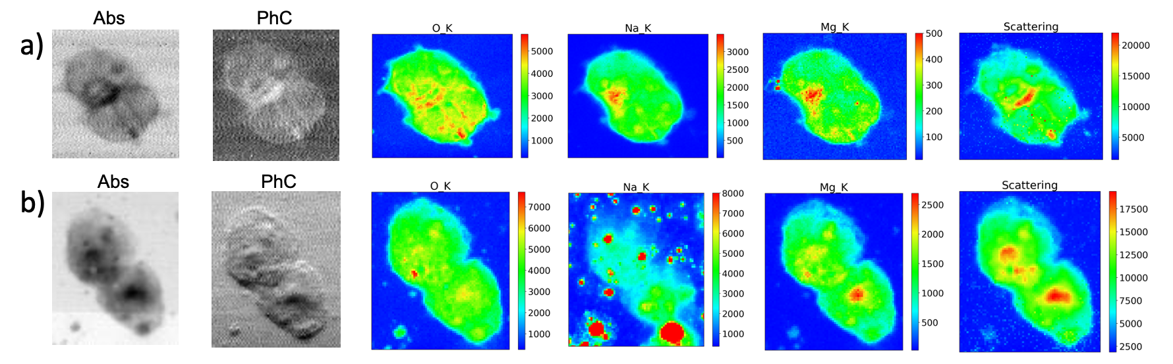
Fig S1. Absorption (Abs) and differential phase contrast (PhC) images, together with O, Na, Mg and scattering maps of HEK-293 cells fixed with different methods, a) 1:1 MeOH/C₃H₆O washed; b) and 70% Ethanol washed. Cells were fixed with the organic solvents for 3 min at -20°C, excess fixative was removed and samples were left to dry. In the washed conditions, excess fixative was removed, sample were quickly rinsed in DI water and then left to dry.

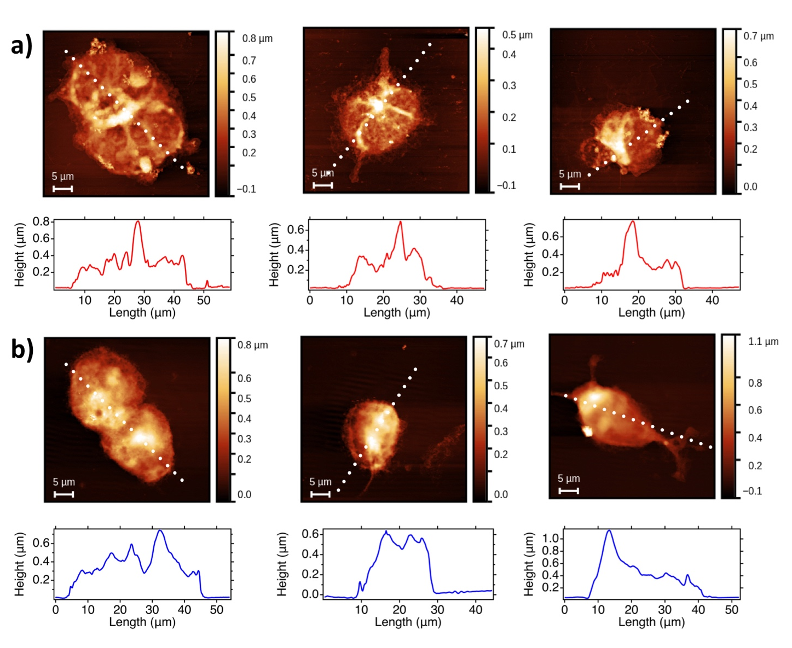
Fig. S2. AFM images with corresponding surface profiles collected on a selection of a) 1:1 MeOH/C₃H₆O washed cells and of b) 70% Ethanol washed cells.

Descriptive statistics
Oxygen fluorescence counts were used to asses precision of X-ray measurements related to different fixation methods. One-way ANOVA with Tukey's multiple comparisons test was performed to determine statistical significance statistical analysis was performed using GraphPad Prism 8.4.2 (GraphPad Software Inc., CA, USA).
HEC-1-A
 | EtOH | PFA 2% | PFA 3.7%
Number of values | 3 | 3 | 3
Minimum | 3670 | 2840 | 3550
Maximum | 4130 | 4020 | 4260
Range | 460,0 | 1180 | 710,0
Mean | 3887 | 3253 | 3883
Std. Deviation | 231,2 | 664,6 | 357,0
Std. Error of Mean | 133,5 | 383,7 | 206,1
Coefficient of variation | 5,947% | 20,43% | 9,193%

Spermatozoa
 | EtOH | PFA 2% | PFA 3.7%
Number of values | 8 | 6 | 7
Minimum | 3500 | 3880 | 3800
Maximum | 4740 | 4790 | 5890
Range | 1240 | 910,0 | 2090
Mean | 3975 | 4470 | 4583
Std. Deviation | 417,9 | 317,8 | 785,6
Std. Error of Mean | 147,8 | 129,7 | 296,9
Coefficient of variation | 10,51% | 7,110% | 17,14%

 | EtOH | PFA 2% | PFA 3.7% | MeOH/Ac. | Cryo-fixed
Number of values | 3 | 2 | 3 | 2 | 3
Minimum | 8152 | 9697 | 8981 | 17118 | 18582
Maximum | 11738 | 9697 | 11149 | 19564 | 33182
Range | 3586 | 0,000 | 2168 | 2446 | 14600
Mean | 9630 | 9697 | 10117 | 18341 | 23891
Std. Deviation | 1874 | 0,000 | 1088 | 1730 | 8074
Std. Error of Mean | 1082 | 0,000 | 628,0 | 1223 | 4661
Coefficient of variation | 19,46% | 0,000% | 10,75% | 9,430% | 33,79%
HEK-293

.

EtOH vs. Cryo-fixed | -14261 | -26176 to -2346 | Yes | * | 0,0202
PFA 2% vs. Cryo-fixed | -14194 | -27516 to -872,1 | Yes | * | 0,0368
PFA 3.7% vs. Cryo-fixed | -13774 | -25690 to -1859 | Yes | * | 0,0243

*P<0.05

