Description, identification, and growth on different lime contents of mycorrhizal Tuber borchii Vitt. and Pinus sylvestris L.
Tanja Mrak¹, Tine Grebenc¹, Silke Friedrich² and Babette Münzenberger³

¹Department of Forest Physiology and Genetics, Slovenian Forestry Institute, Večna pot 2, 1000 Ljubljana, Slovenia
²Truffle nursery, Jägerhäusleweg 19, 79104 Freiburg, Germany
³Department of Fungal Interactions, Research Area 1 ‚Landscape Functioning‘, Leibniz Centre for Agricultural Landscape Research (ZALF), Eberswalder Strasse 84, 15374 Müncheberg, Germany

Supplementary file

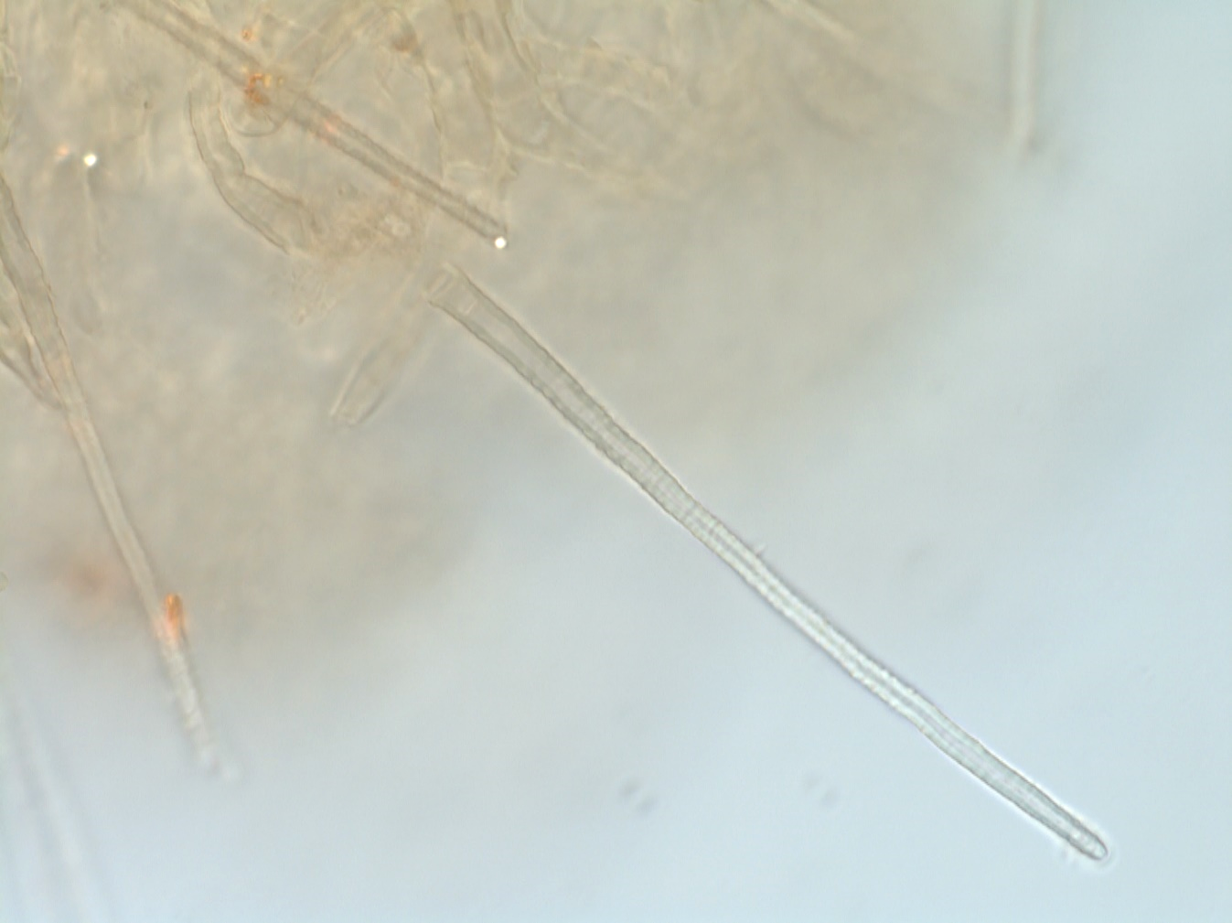
Figure S1: Warts covering cystidia of Tuber borchii ectomycorrhizae.

