16.1) Supplemental information
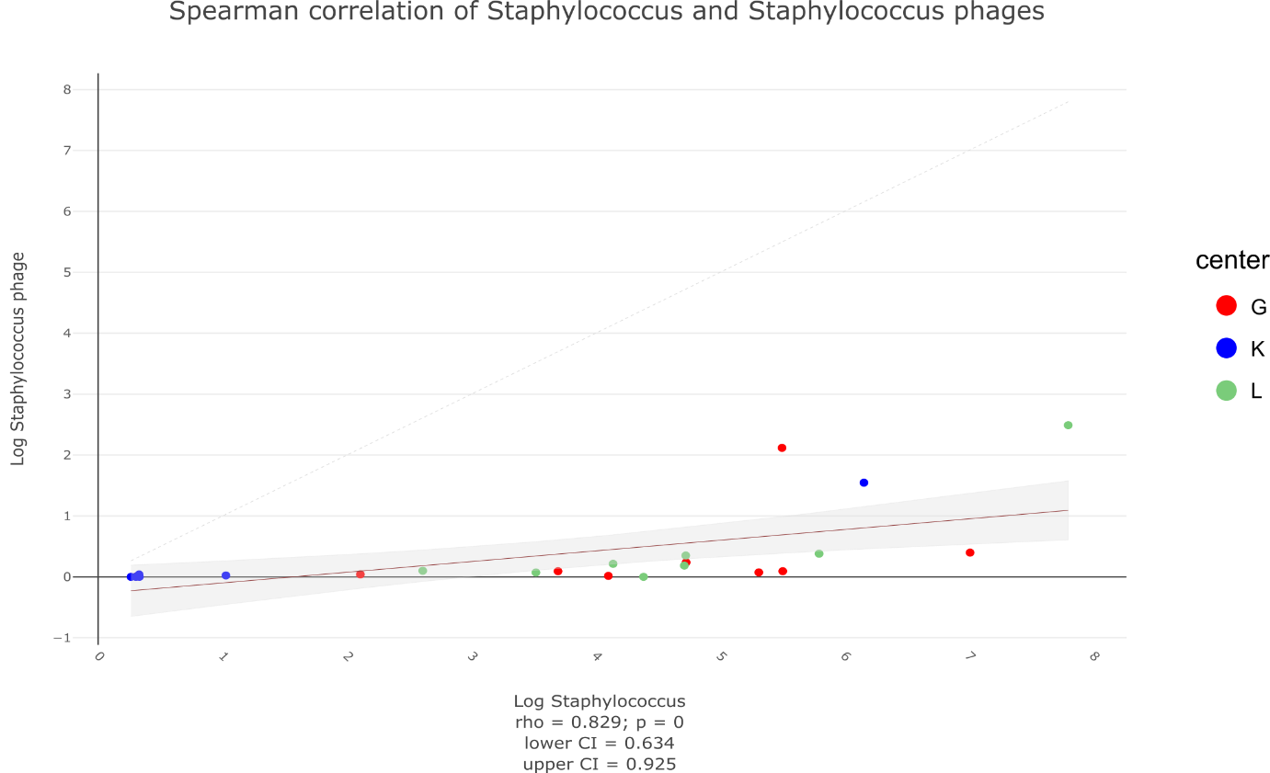
Suppl. Fig. 1: Spearman Correlation of Staphylococcus with Staphylococcus phages

Suppl. Table 1: timepoint of stool sample collections
Time Points | Minimum | Maximum | Mean
tp1 | 1 | 3 | 1.56
tp2 | 3 | 6 | 3.75
tp3 | 5 | 8 | 5.82
tp4 | 7 | 15 | 8.04
tp5 | 9 | 13 | 10.06
tp6 | 11 | 15 | 12.15
tp7 | 13 | 21 | 14.50

Suppl. Table 2: Bifidobacterium reference genomes
sample | Bifidobacterium longum subsp. longum JCM1217^{T} | Bifidobacterium longum subsp. infantis JCM1222^{T} | Bifidobacterium catenulatum subsp. Kashiwanohense JCM15439^{T} | Bifidobacterium longum subsp. suillum JCM19995^{T} | Bifidobacterium longum subsp.suis JCM1269^{T} | Bifidobacterium breve JCM1192^{T} | Bifidobacterium bifidum JCM1255^{T}
K08-7 | 46.59% | 86.80% | 3.99% | 49.90% | 48.67% | 17.49% | 3.70%
K11-7 | 50.14% | 97.98% | 4.31% | 53.85% | 52.17% | 18.70% | 3.81%
K13-7 | 52.26% | 95.56% | 4.22% | 55.66% | 54.27% | 19.55% | 4.20%
K14-7 | 53.31% | 00.07% | 4.28% | 56.91% | 55.43% | 19.80% | 4.15%
K15-7 | 51.31% | 97.60% | 4.30% | 54.76% | 53.22% | 19.36% | 4.09%
K16-7 | 3.07 % | 6.01% | 0.26% | 3.30% | 3.66% | 1.14% | 0.23%
K17-7 | 48.87% | 97.38% | 4.31% | 52.49% | 50.76% | 18.34% | 3.74%
K18-7 | 22.63% | 43.34% | 1.94% | 24.29% | 23.55% | 8.48% | 1.76%

Suppl. Table 3: Distribution of overall reads (56,660,357) into Archaea, Ascomycetes-Basidiomycetes, Viruses and Bacteria as well as in their highest abundant subgroups. Distribution is given in overall reads and percentages and each for the three centers.
 | Archaea | Fungi:  Asco-Basidio |  | Viruses | Bacteria
all | 24,081 (0.04%) | 53,192  (0.09%) |  | 83,670 (0.15%) | 56,446,924 (99.62%)
G | 8,906 (36.98%) | 11,522  (21.66%) |  | 20,860 (24.93%) | 15,677,124 (27.77%)
K | 6,937 (28.81%) | 14,918  (28.05%) |  | 30,894 (36.92%) | 20,204,643 (35.79%)
L | 8,238 (34.21%) | 26,752  (50.29%) |  | 31,916 (38.15%) | 20,565,157 (36.43%)
 | Methano-gens | Asco-mycota | Basidio-mycota | Phages
all | 15,040 (62.46%) | 13,662 (25.68%) | 3,9530 (74.32%) | 83,670  (100%)
G | 5,482 (36.45%) | 5,632 (41.22%) | 5,890 (14.90%) | 20,860 (24.93%)
K | 4,813 (32.00%) | 1,298 (9.50%) | 13,620 (34.45%) | 30,894 (36.92%)
L | 4,745 (31.55%) | 6,732 (49.28%) | 20,020 (50.65%) | 31,916 (38.15%)
 | Methano-brevibacter |  |  |  | Enterococcus | Bifidobacterium | Geobacillus | Lactobacillus | Escherichia | Staphylococcus
all | 2,193 (14.58%) |  |  |  | 28,334,208 (50.20%) | 16,144,186 (28.60%) | 289,736  (0.51%) | 1,501,052 (2.66%) | 1,187,293 (2.10%) | 2,414,309  (4.28%)
G | 943  (43.00%) |  |  |  | 11,089,852 (39.14%) | 11,506  (0.07%) | 38,973  (13.45%) | 853,834  (56.88%) | 36,431 (3.07%) | 827,634  (34.28%)
K | 99  (4.51%) |  |  |  | 1,506,496 (5.32%) | 16,115,145 (99.82%) | 202,224 (69.80%) | 74,547  (4.97%) | 1,145,599 (96.49%) | 258,229  (10.70%)
L | 1,151 (52.49%) |  |  |  | 15,737,860 (55.54%) | 17,535  (0.11%) | 48,539  (16.75%) | 572,671  (38.15%) | 5,263 (0.44%) | 1,328,446 (55.02%)

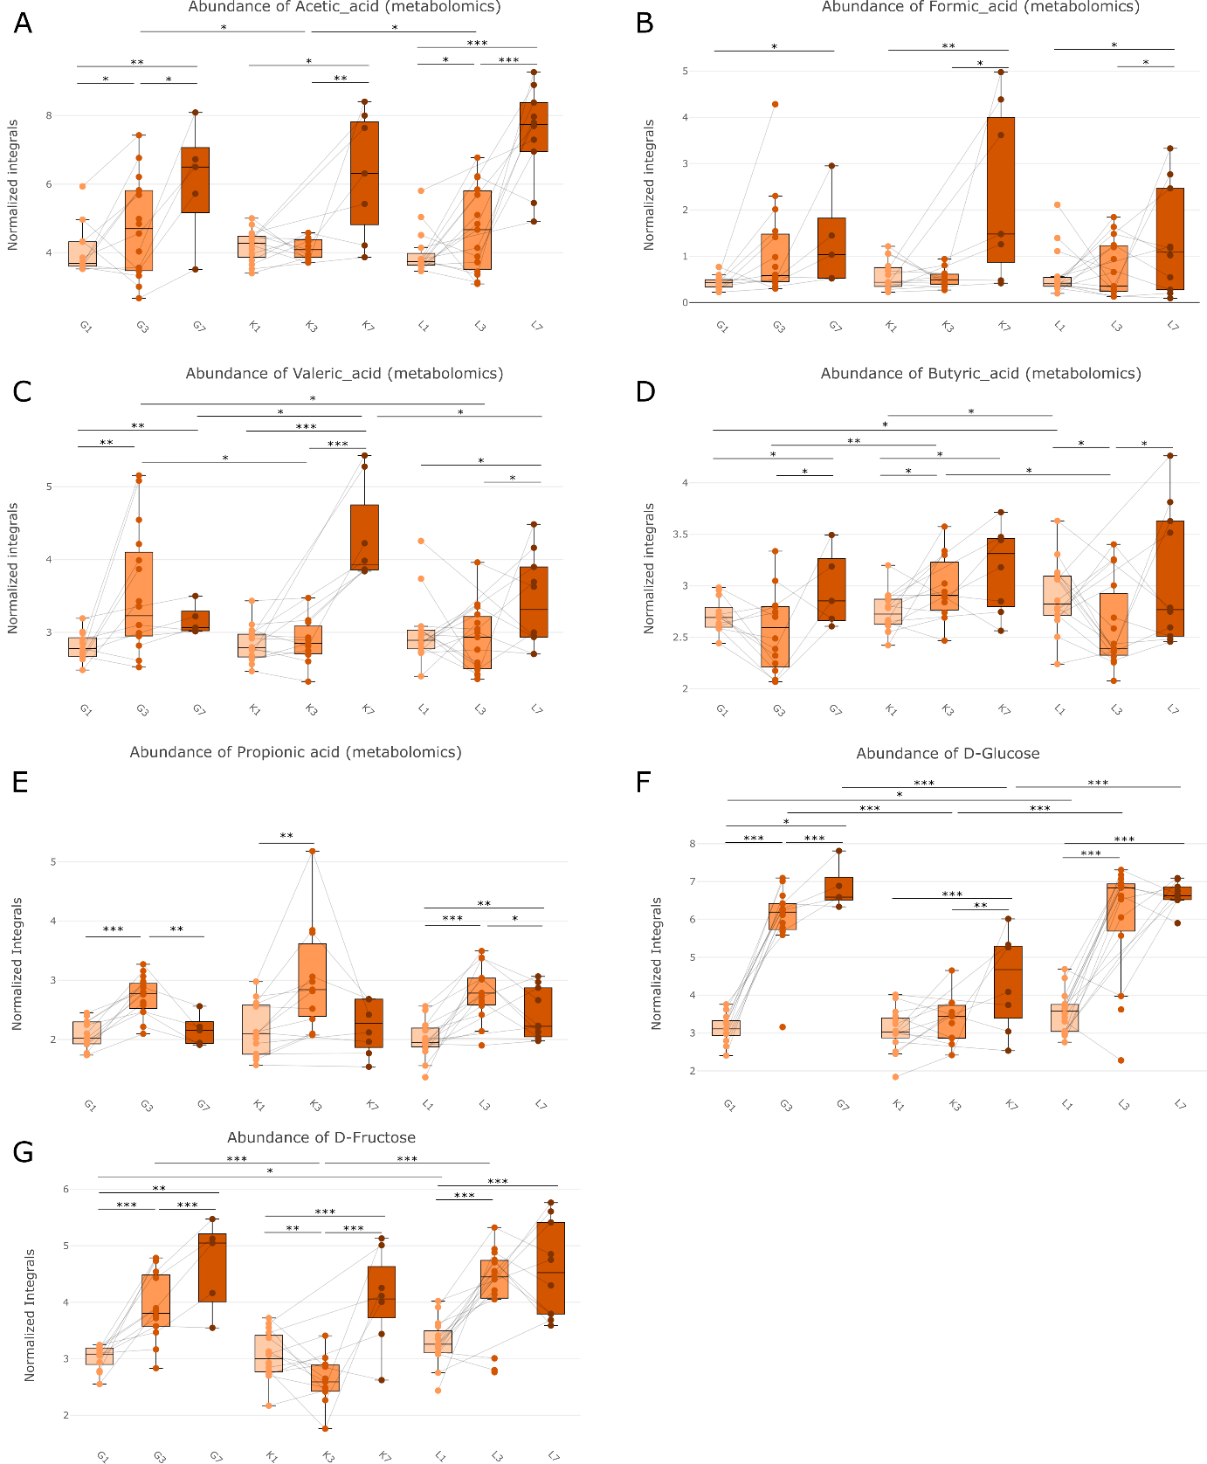

Suppl. Fig 2: Normalized integrals of several metabolites over time (tp1, tp3, tp7) and centers (G, K, L); A) acetic acid, B) formic Acid, C) valeric acid, D) butyric acid, E) propionic acid, F) D-glucose, and G) D-fructose

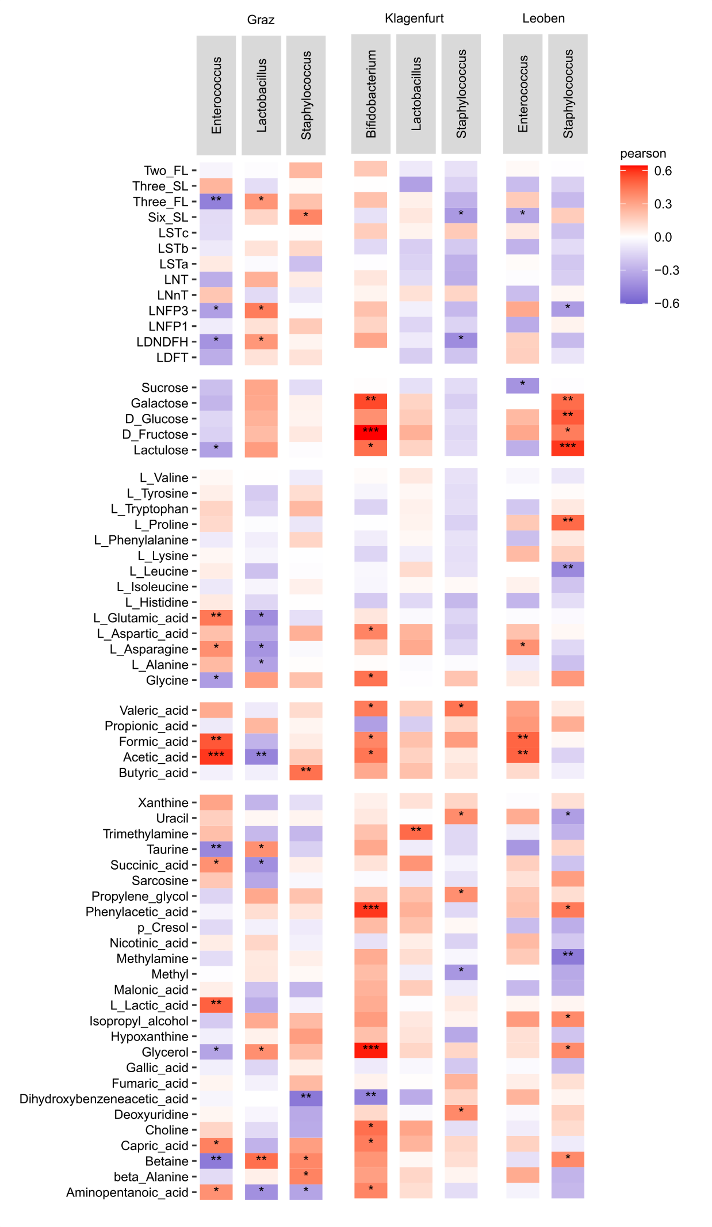
Suppl. Fig. 3: Complete heat map of correlation of metabolites and key-taxa of the three centers.

