Presentation of the Simple and Accurate Models for Estimating the Individual
Hydrogen Bonds Energies of Watson-Crick Base Pairs
Asyeh Barkhodaª, Alireza Nowroozi^{a*}, Mohammad Reza Housaindokht ^{b}

a. Department of Chemistry, Faculty of Science, University of Sistan and Bluchestan, P.O.Box 98135-674, Zahedan, Iran
b. Department of Chemistry, Faculty of Science, Ferdowsi University of Mashhad, Mashhad, Iran
*e-mail: Correspondent: anowroozi@chem.usb.ac.ir
^{Tell: +989153140218}
^{Fax: +985433446565}

Fig s1. Plot of the RDG versus sign(λ2)ρ of the NH…N Complexes by the proposed model at M06-2X/6-311++G(d,p).
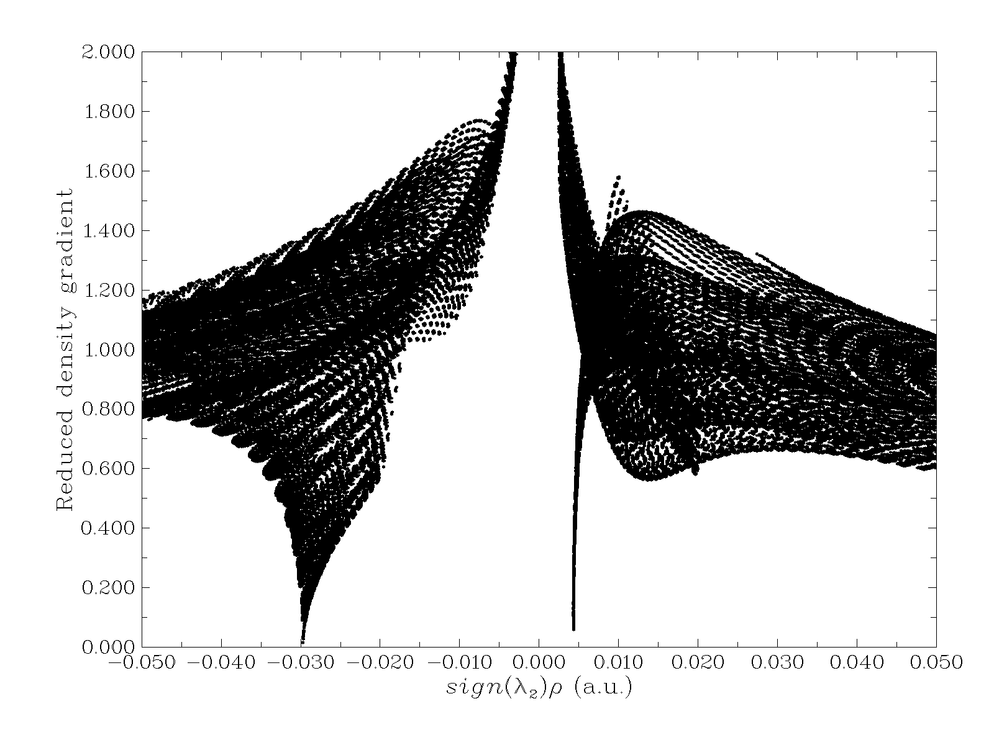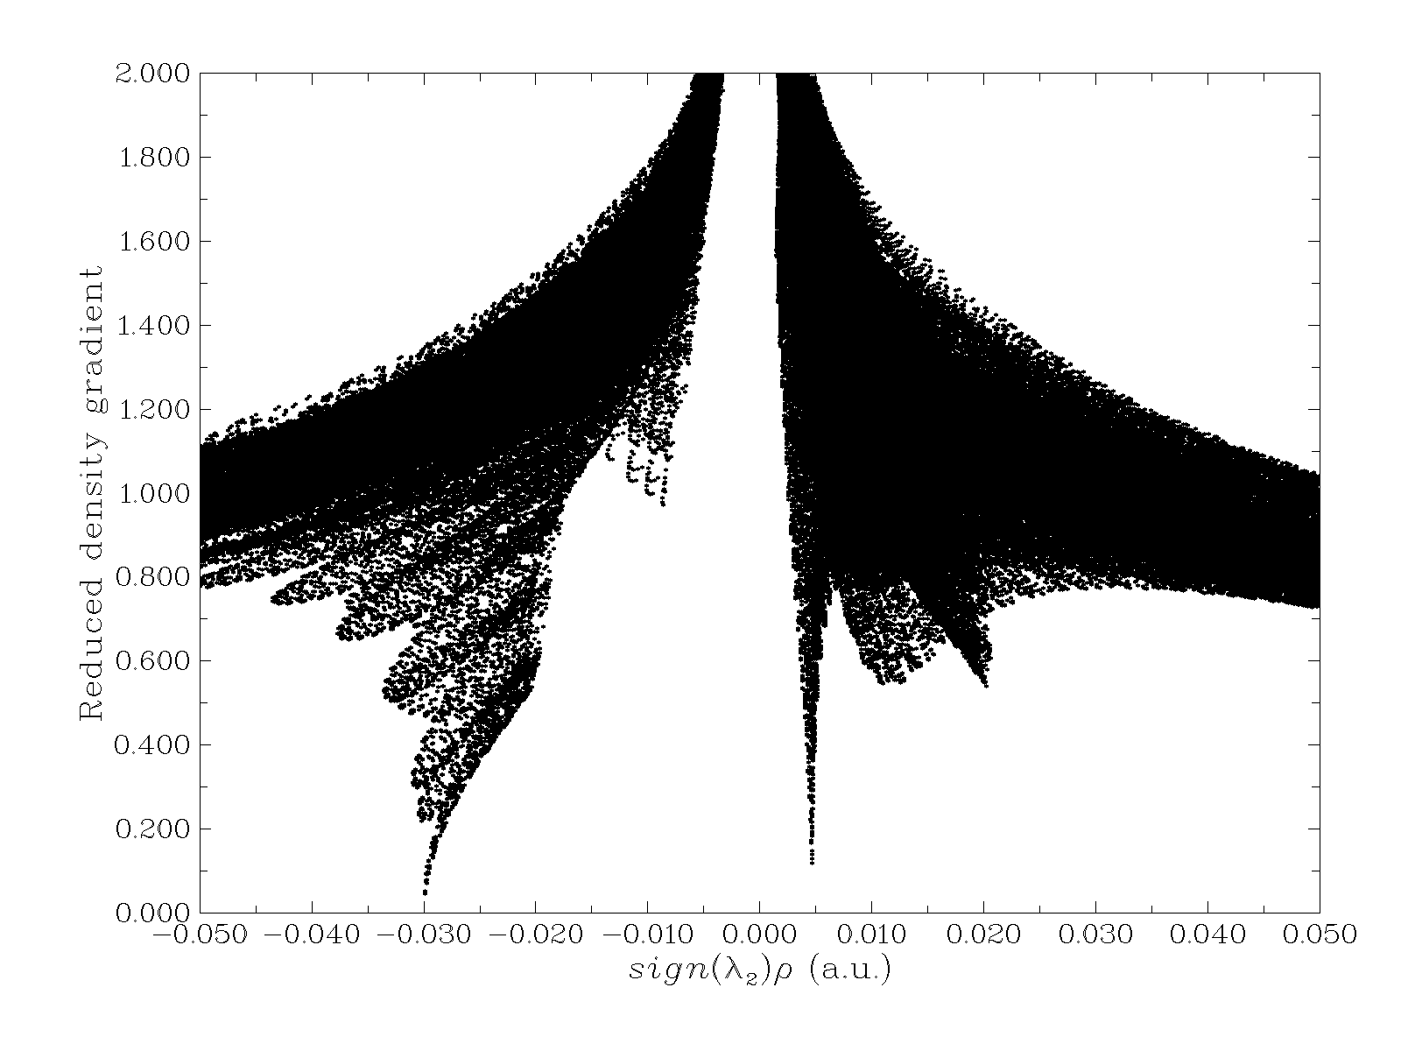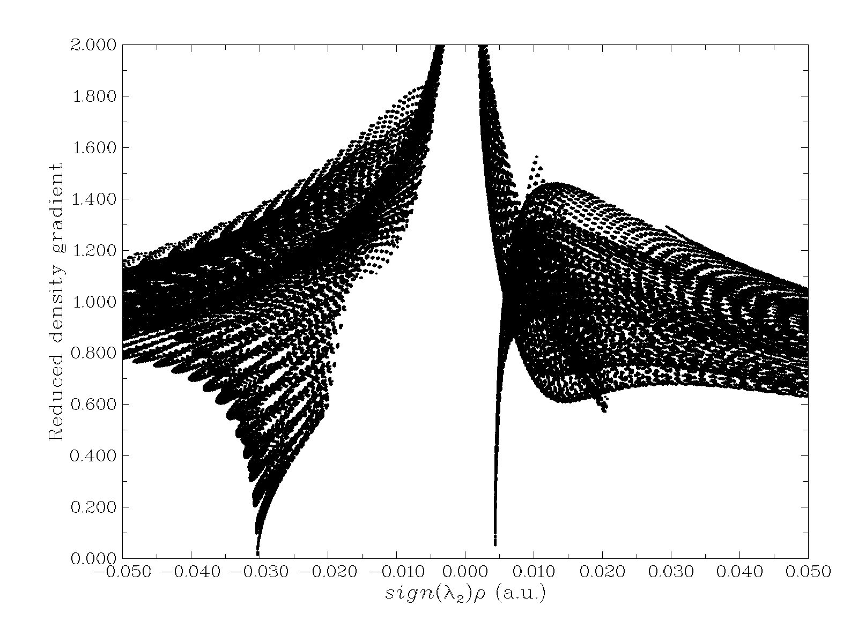
a.Br b.CH3 c.Cl

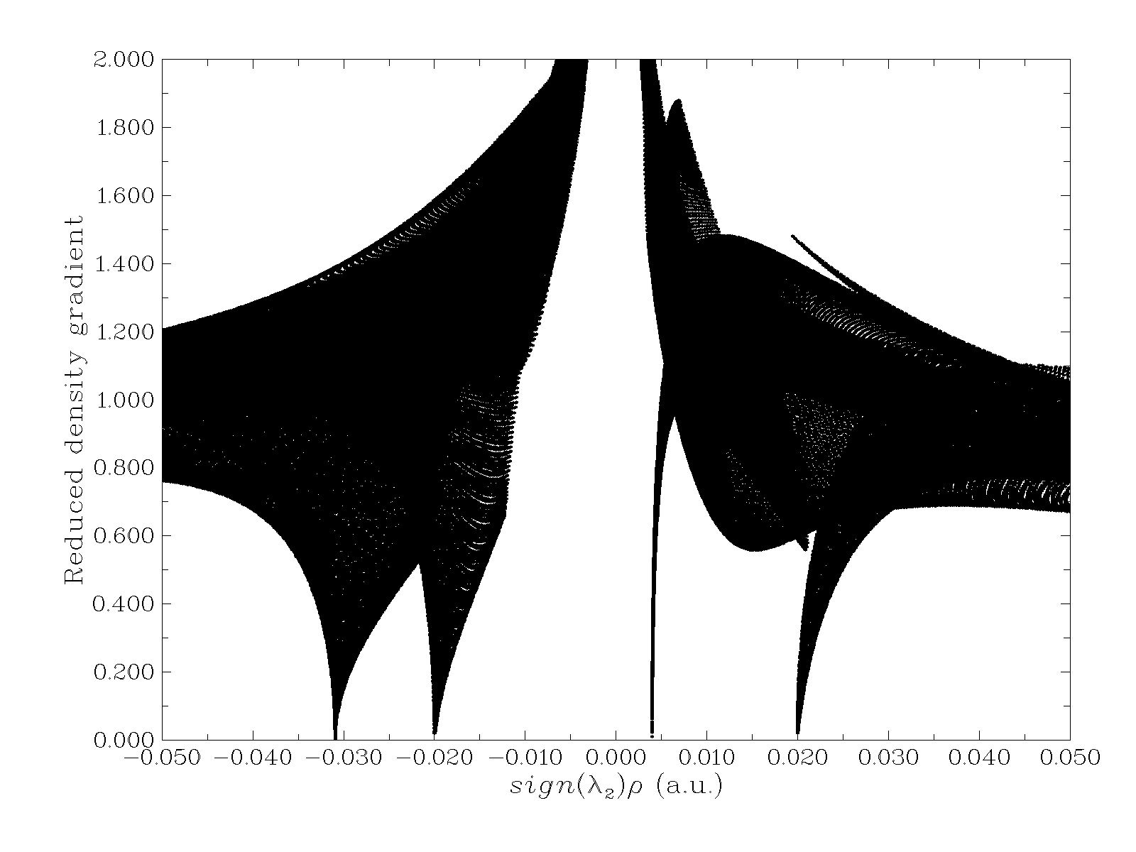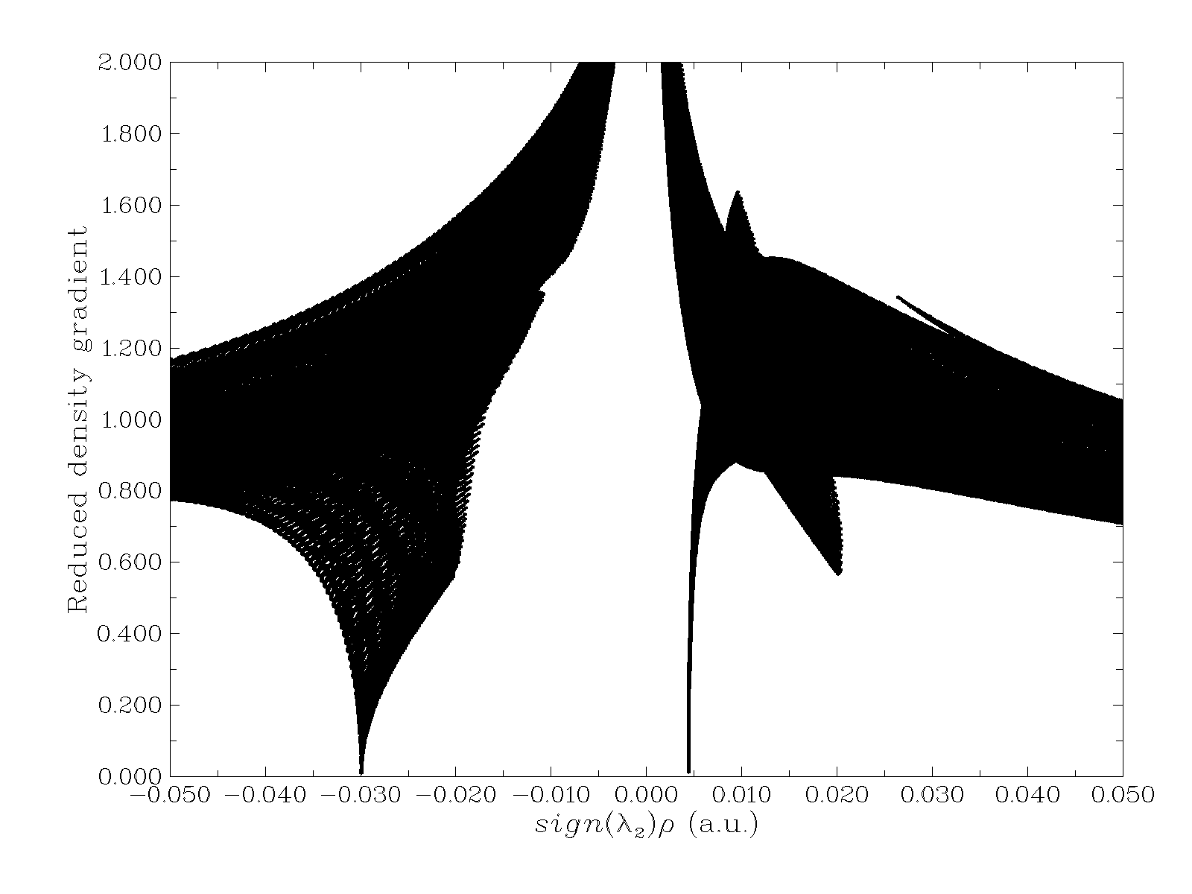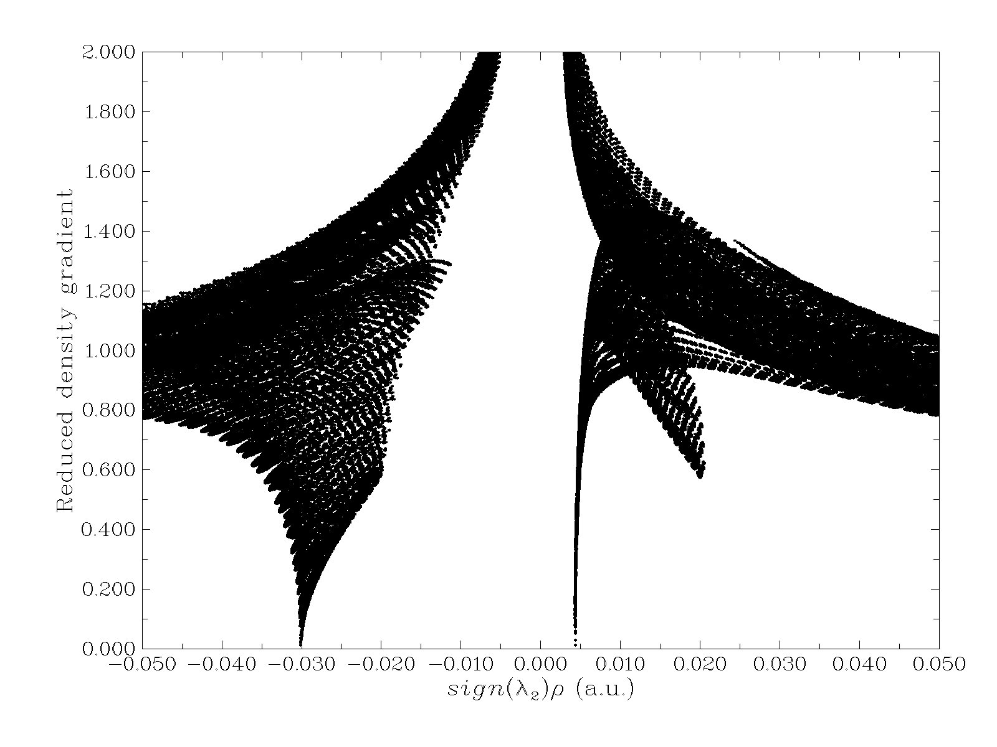

d. Cyano e. Ethynyl f. F

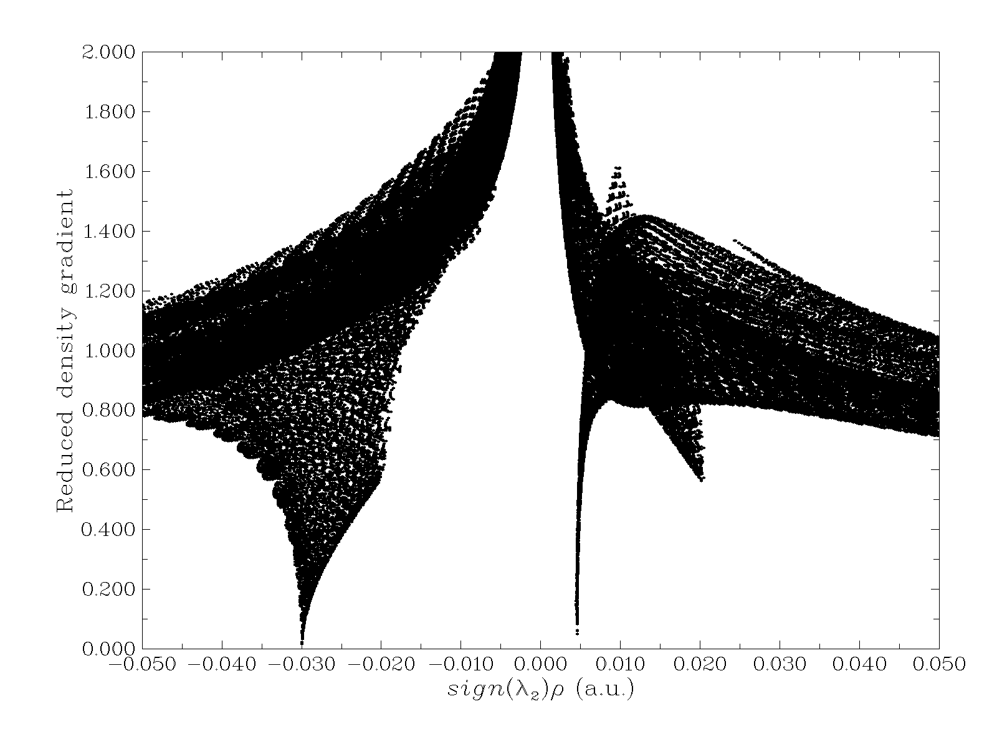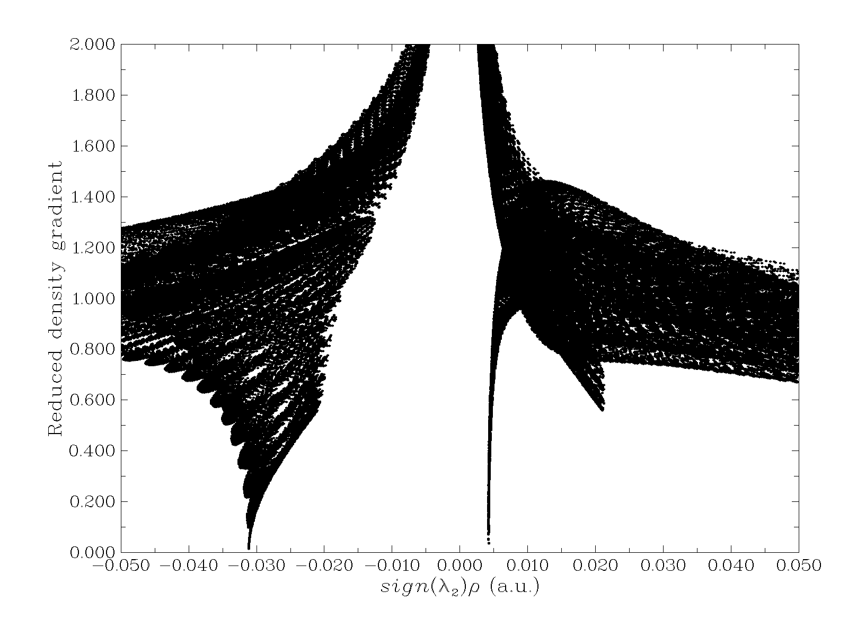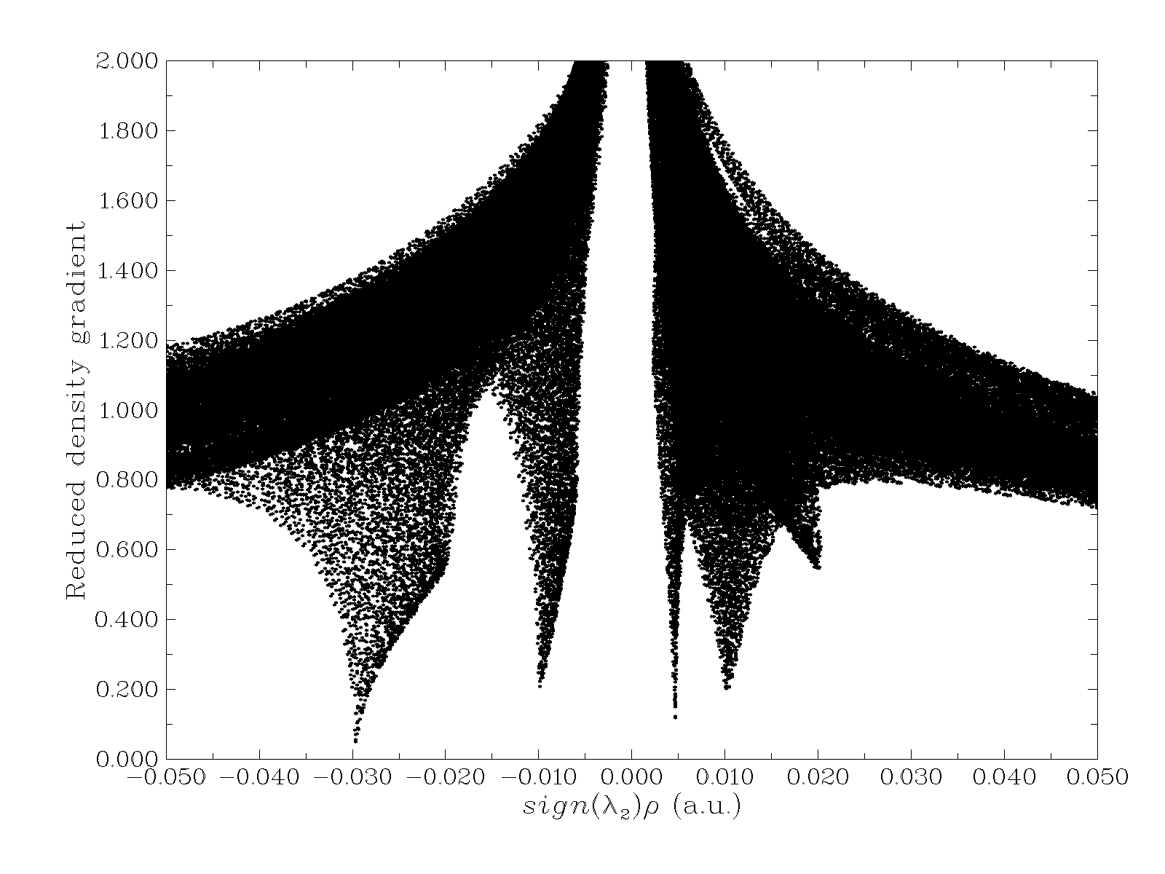
g. H h. Nitroso i. Vynyl

Fig s2. Plot of the RDG versus sign(λ2)ρ of the NH…O Complexes’ by the proposed model at M06-2X/6-311++G(d,p).

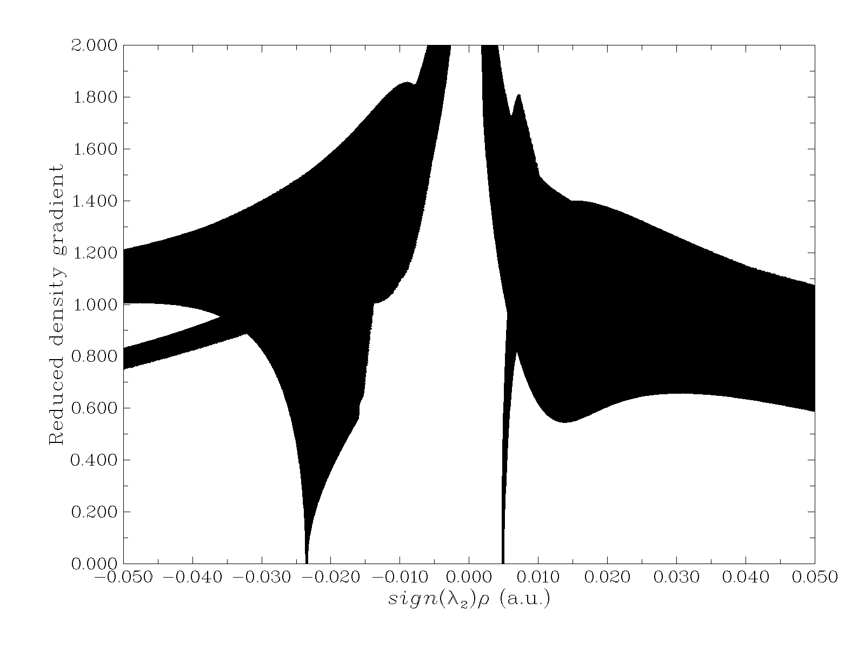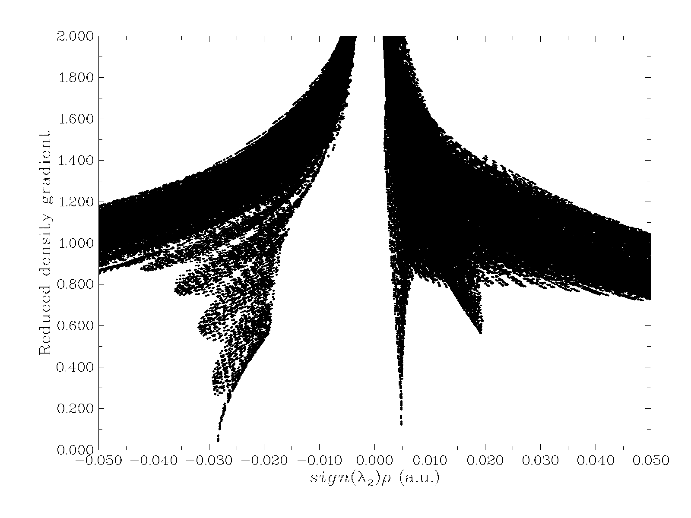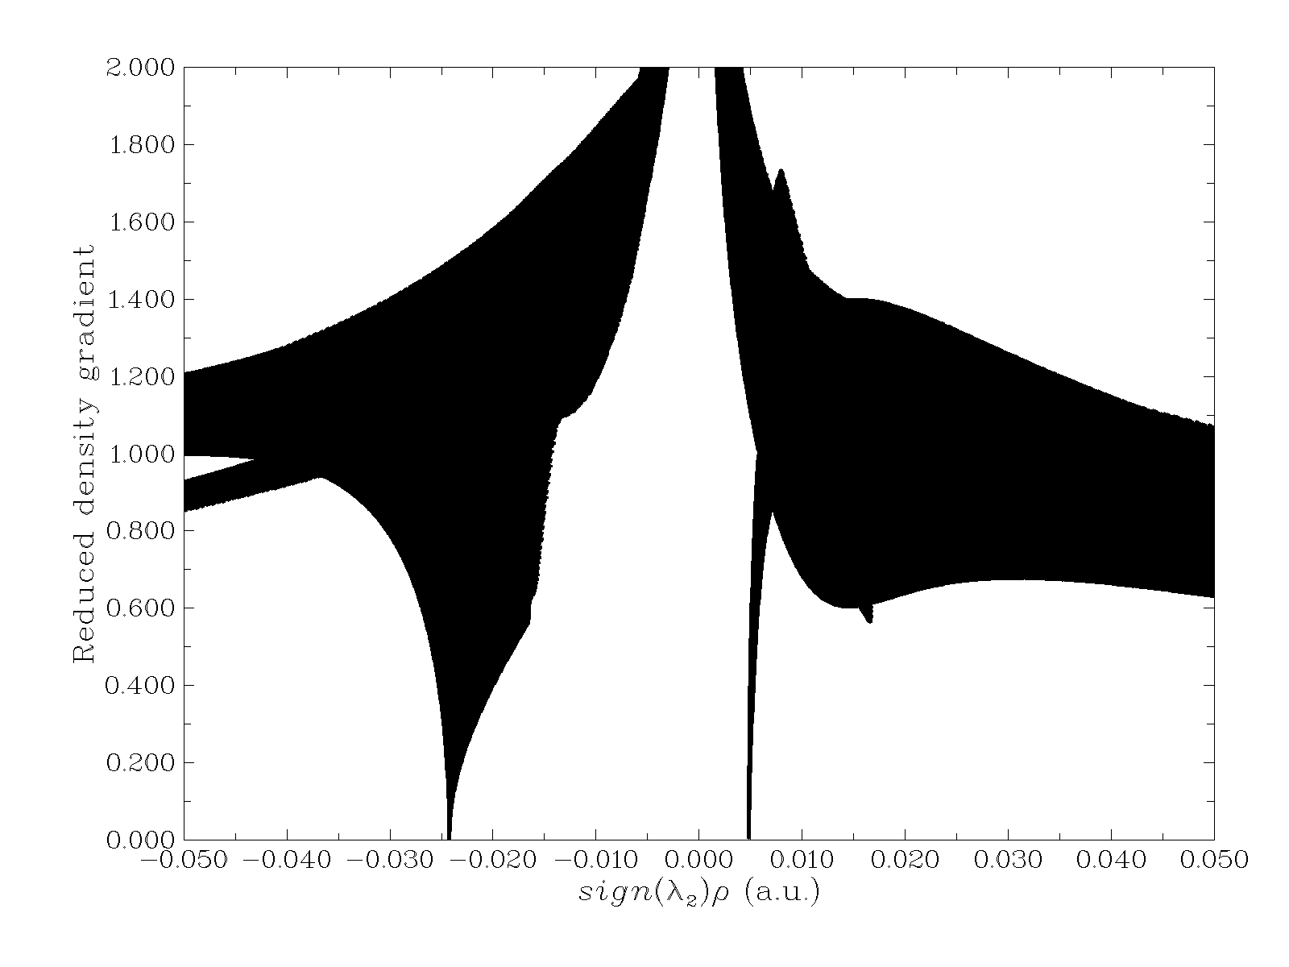
a.Br b.CH3 c. Cl

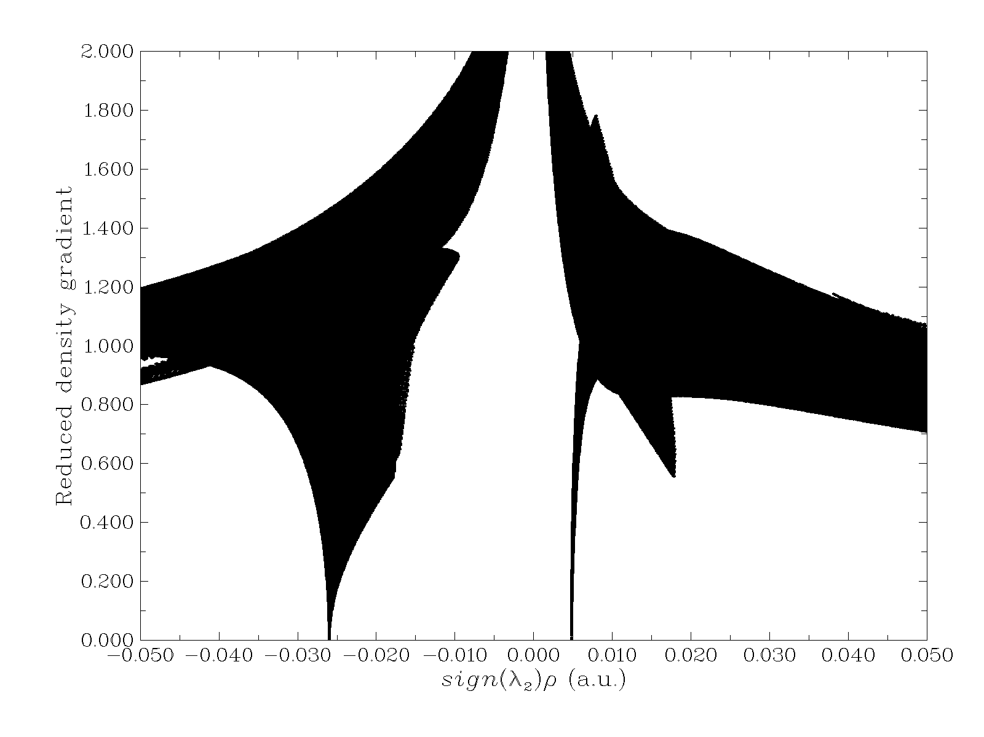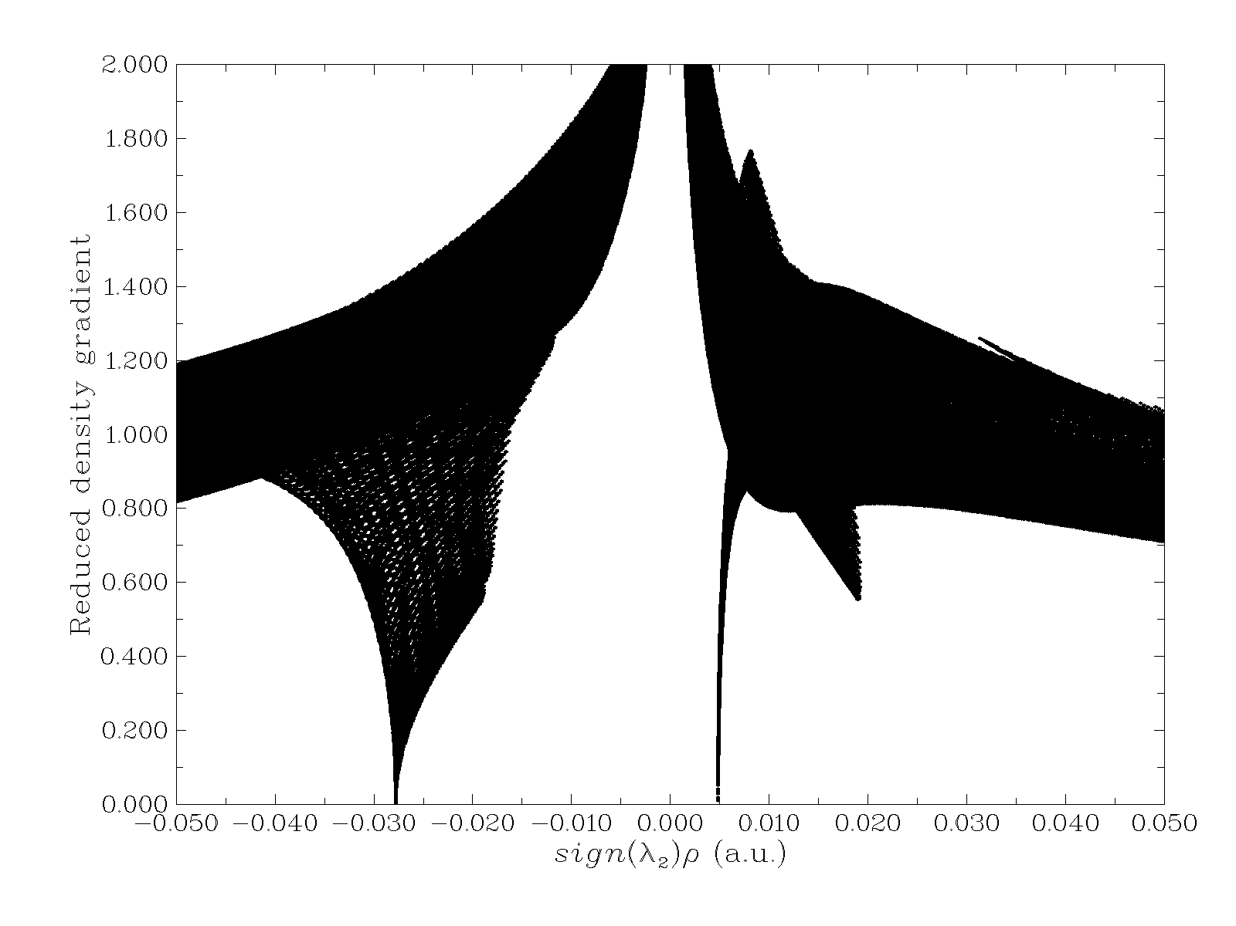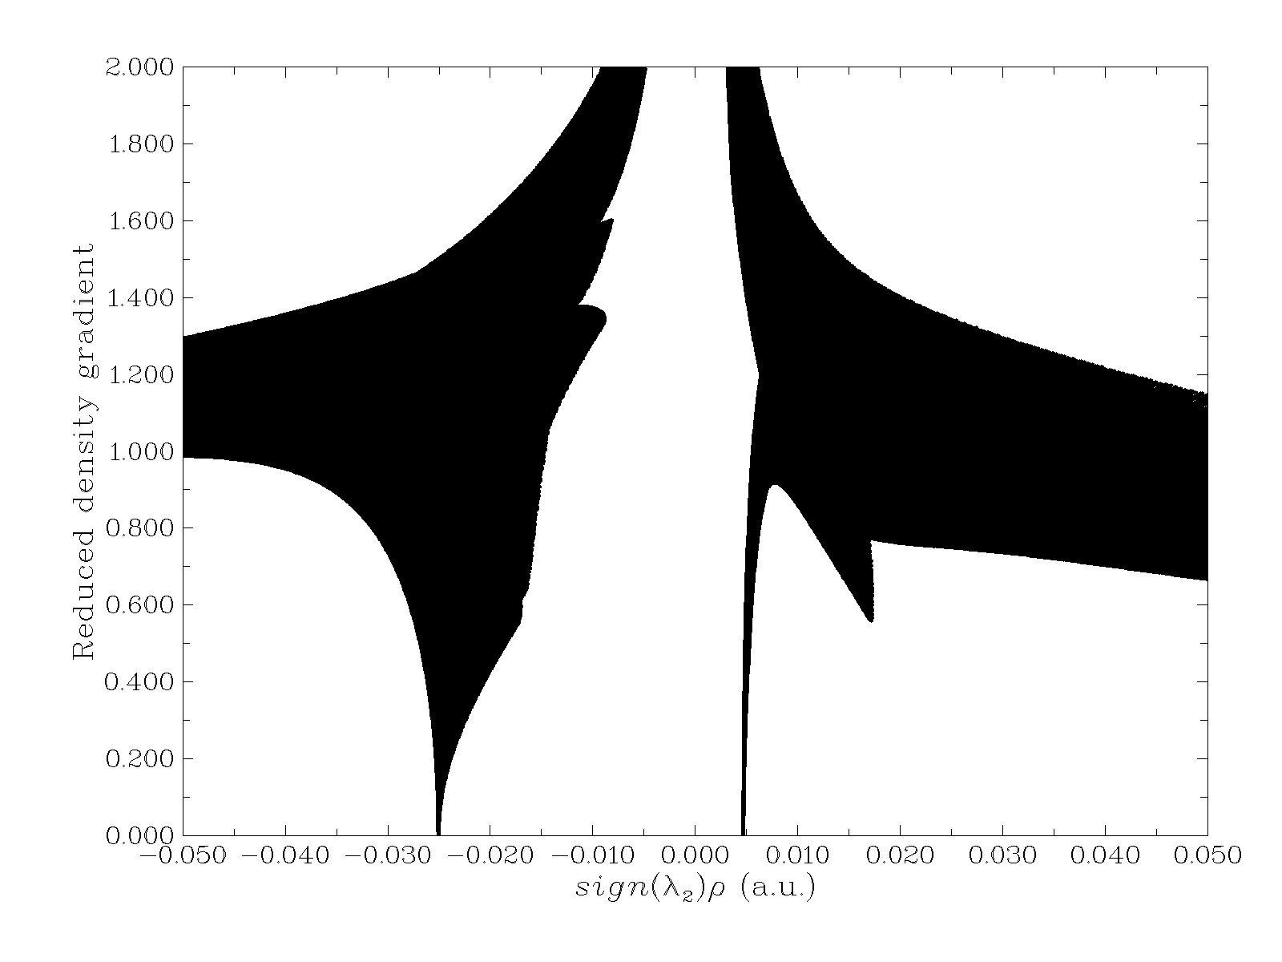
d. Cyano e. Ethynyl f. F

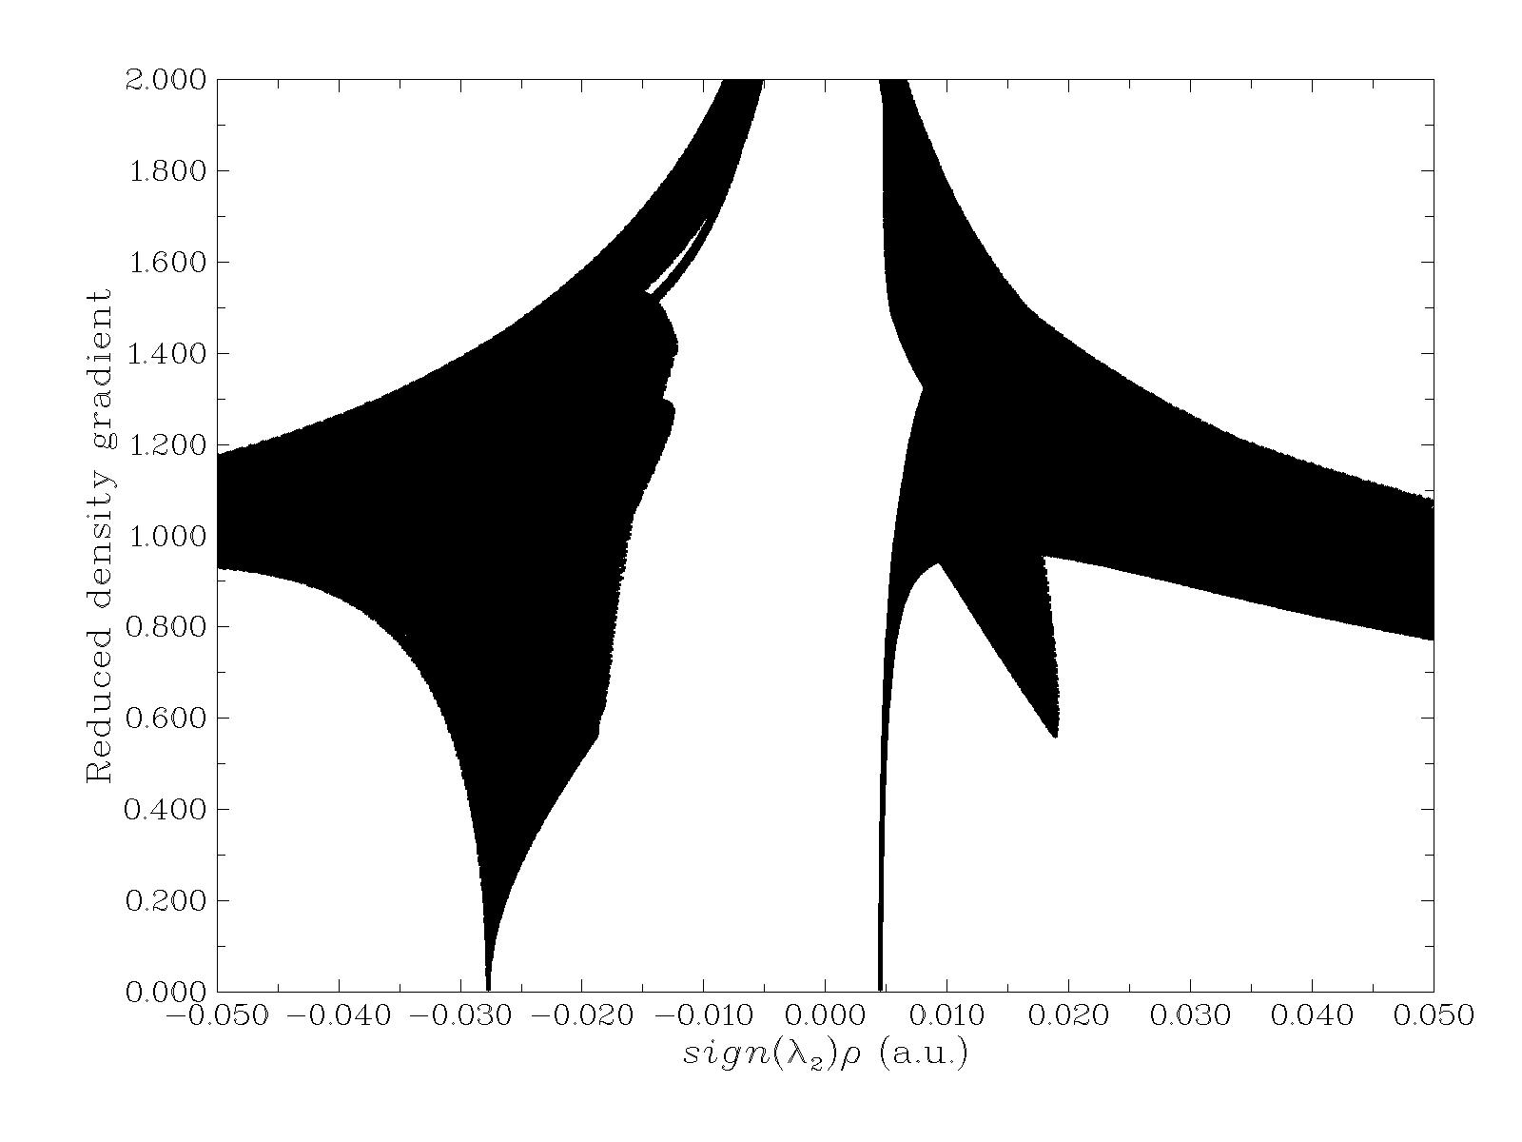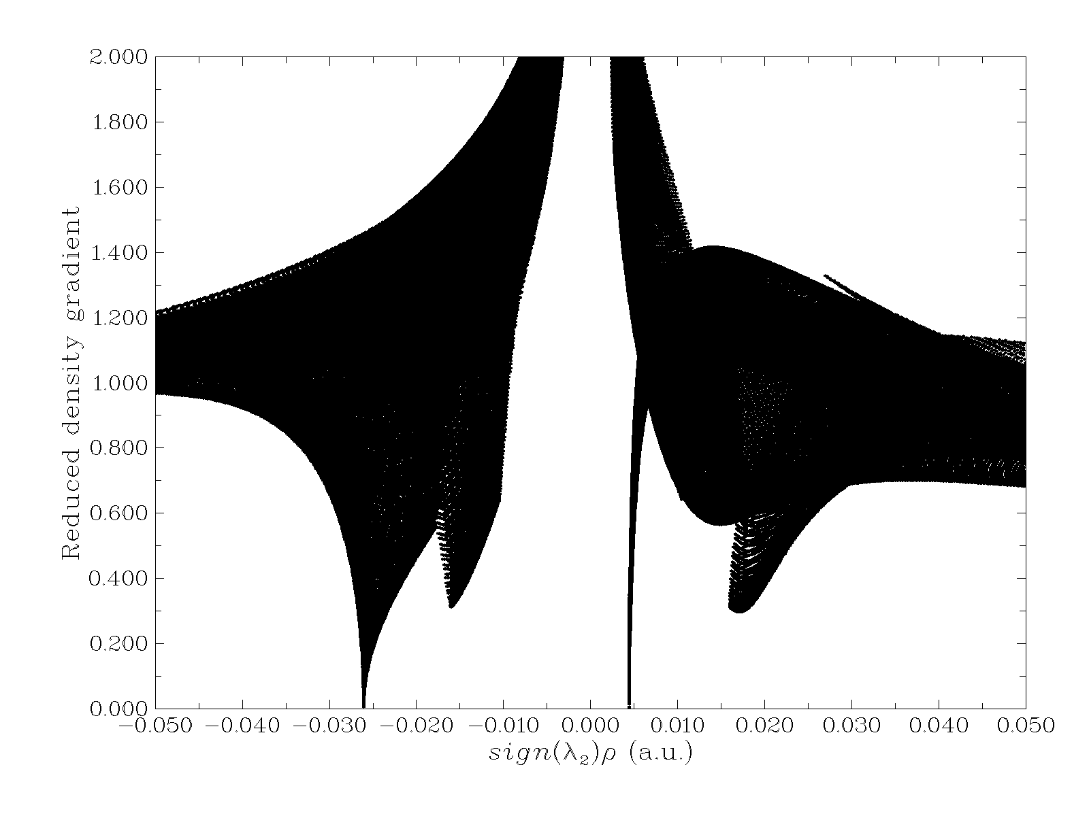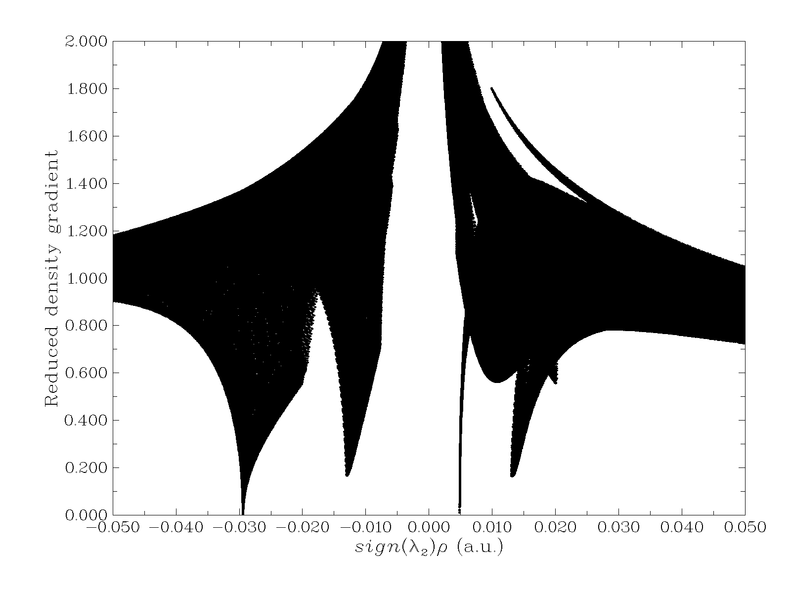
g. H h. Nitroso i. Vynyl

