Appendix
In this Appendix, the maps showing the change in annual maximum flows based on the observed data, without any assumptions on the shape of the distribution are presented. These values are consistent with values calculated with fitted Gumbel distribution and described in section 5.1.

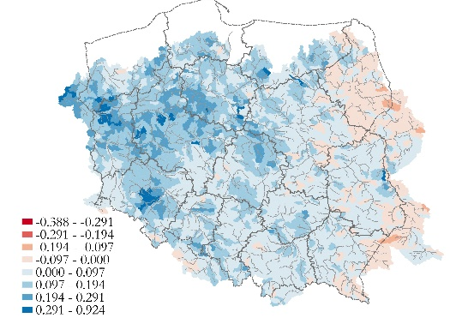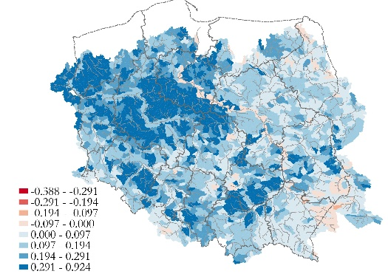
(a) RCP4.5, 2024 - 2050 (b) RCP8.5, 2024 - 2050
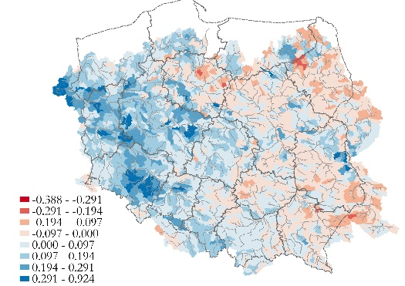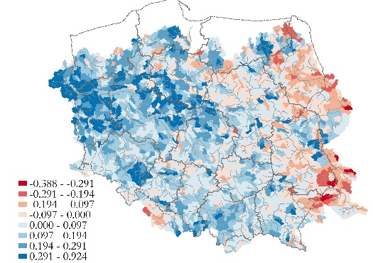
(c) RCP4.5, 2074 - 2100 (d) RCP8.5, 2074 - 2100
Figure 12: The multimodel ensemble mean change in the mean of the annual daily flow maximum (data based)
Source: Own calculations on the basis of data by Piniewski et al. (2017)
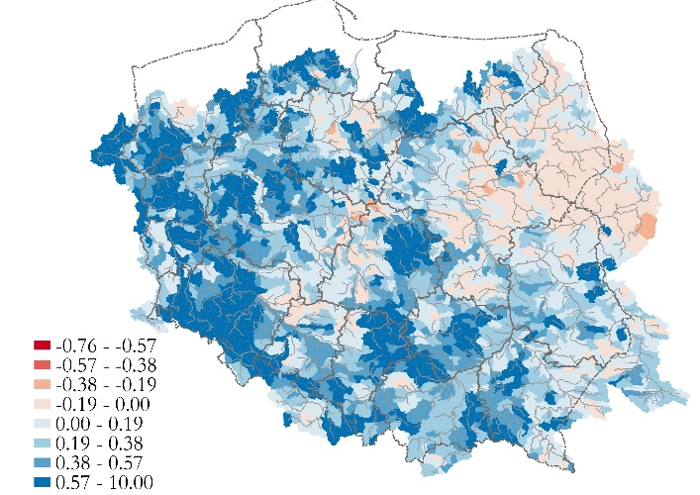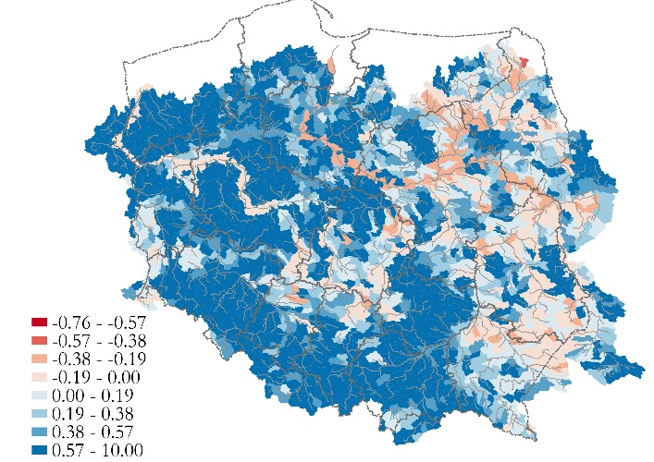
(a) RCP4.5, 2024 - 2050 (b) RCP8.5, 2024 - 2050
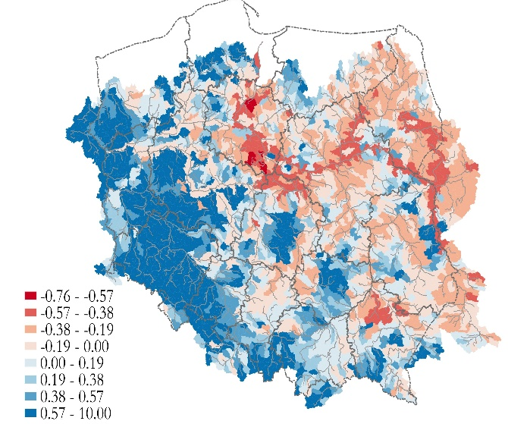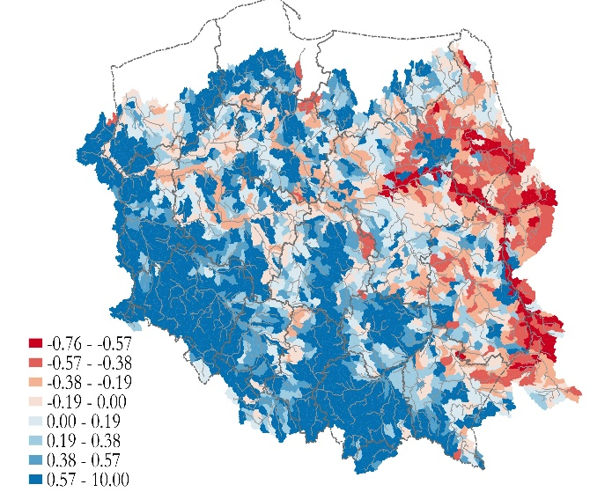
(c) RCP4.5, 2074 - 2100 (d) RCP8.5, 2074 - 2100
Figure 13: The multimodel ensemble mean change in the variance of the annual daily flow maximum (data based)
Source: Own calculations on the basis of data by Piniewski et al. (2017)
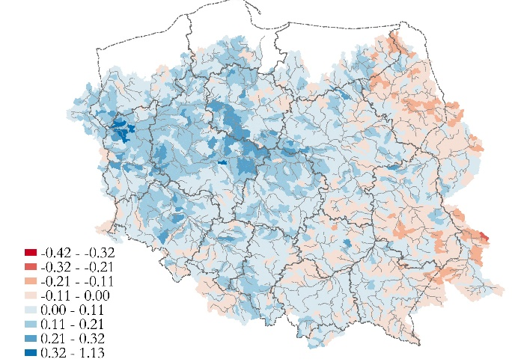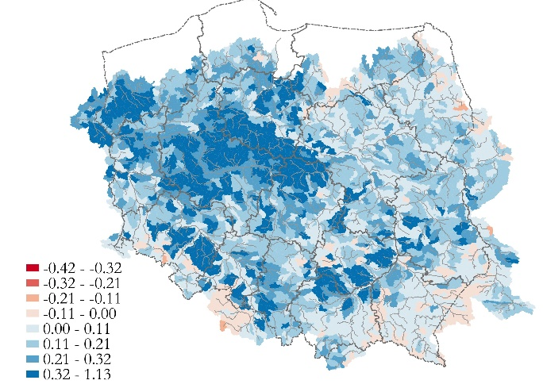
(a) RCP4.5, 2024 - 2050 (b) RCP8.5, 2024 - 2050
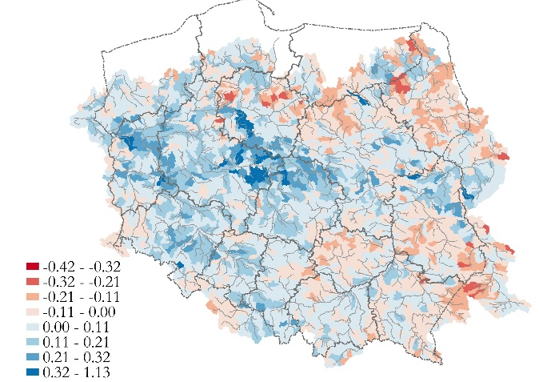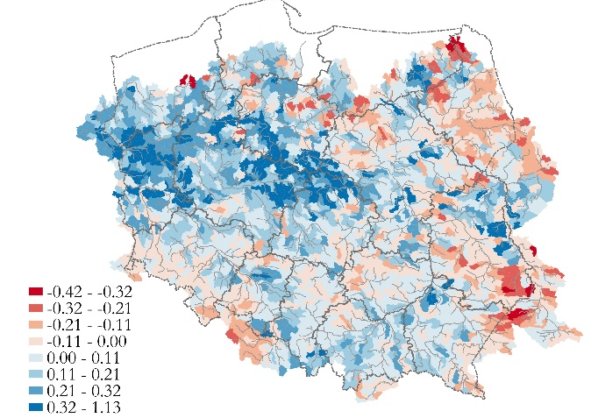
(c) RCP4.5, 2074 - 2100 (d) RCP8.5, 2074 - 2100

Figure 14: The multimodel ensemble mean change in the median of the annual daily flow maximum (data based)
Source: Own calculations on the basis of data by Piniewski et al. (2017)

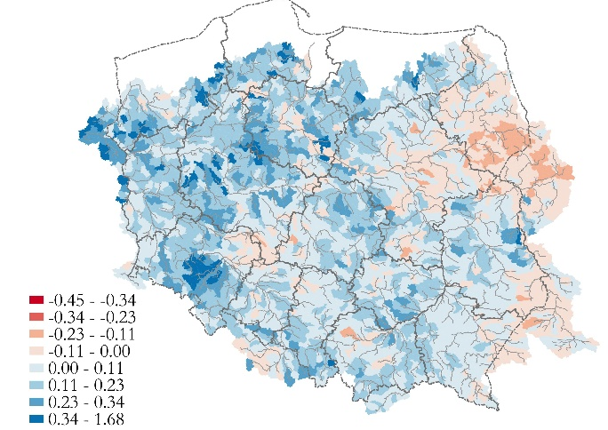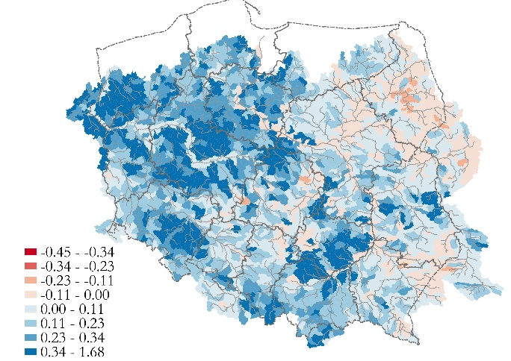
(a) RCP4.5, 2024 - 2050 (b) RCP8.5, 2024 - 2050
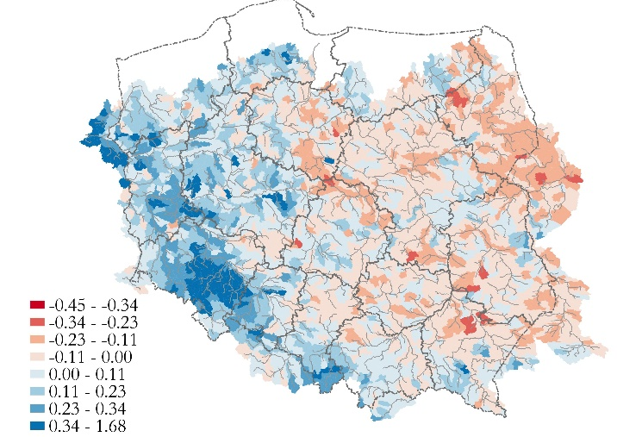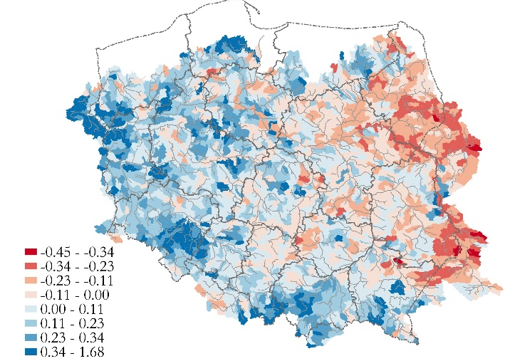
(c) RCP4.5, 2074 - 2100 (d) RCP8.5, 2074 - 2100
Figure 15: The multimodel ensemble mean change in the 90th percentile of the annual daily flow maximum (data based)
Source: Own calculations on the basis of data by Piniewski et al. (2017)

