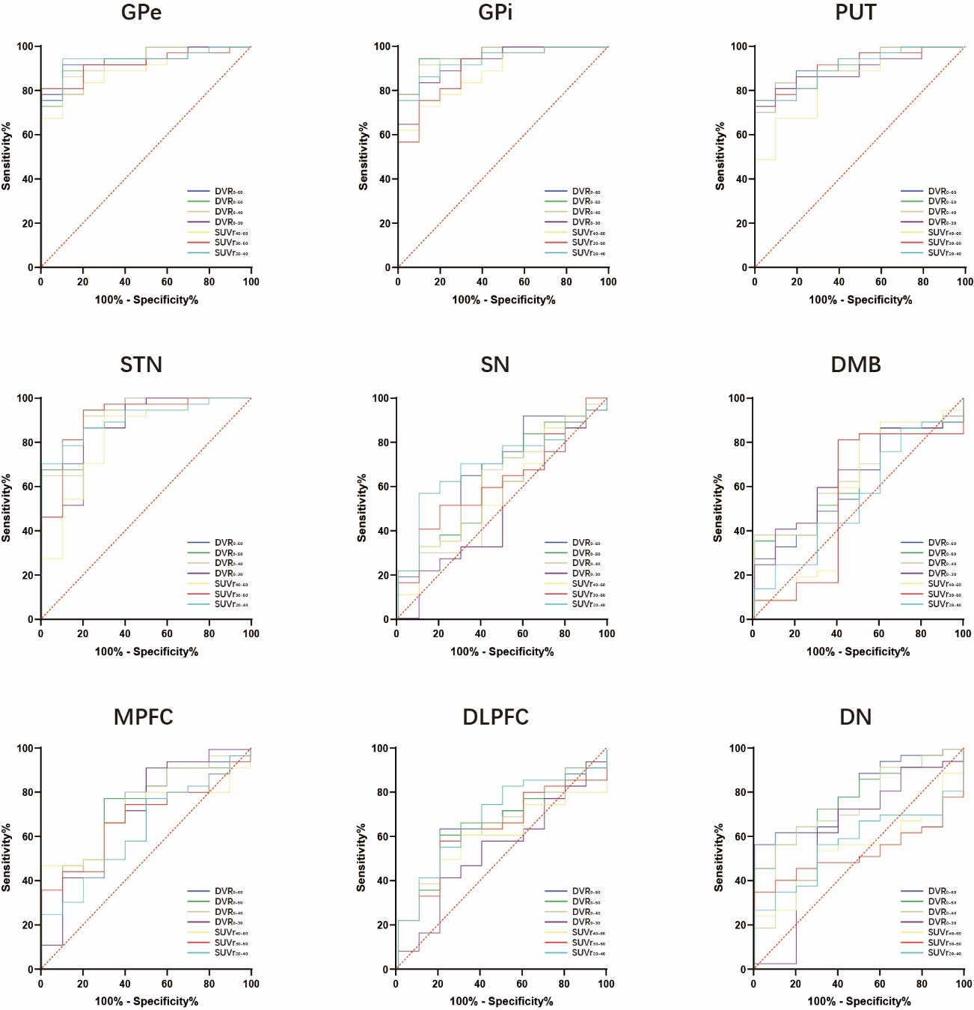
Supplemental Figure 1: Illustration of receiver operating curves (ROC) in all brain regions for different dynamic and static [¹⁸F]PI-2620 imaging windows. DVR = distribution volume ratio; SUVr = standardized uptake value ratio; GPe = globus pallidus externus; GPi = globus pallidus internus; PUT = putamen; STN = subthalamic nucleus; SN = substantia nigra; DMB = dorsal midbrain; MPFC = medial prefrontal cortex; DLPFC = dorsolateral prefrontal cortex; DN = dentate nucleus

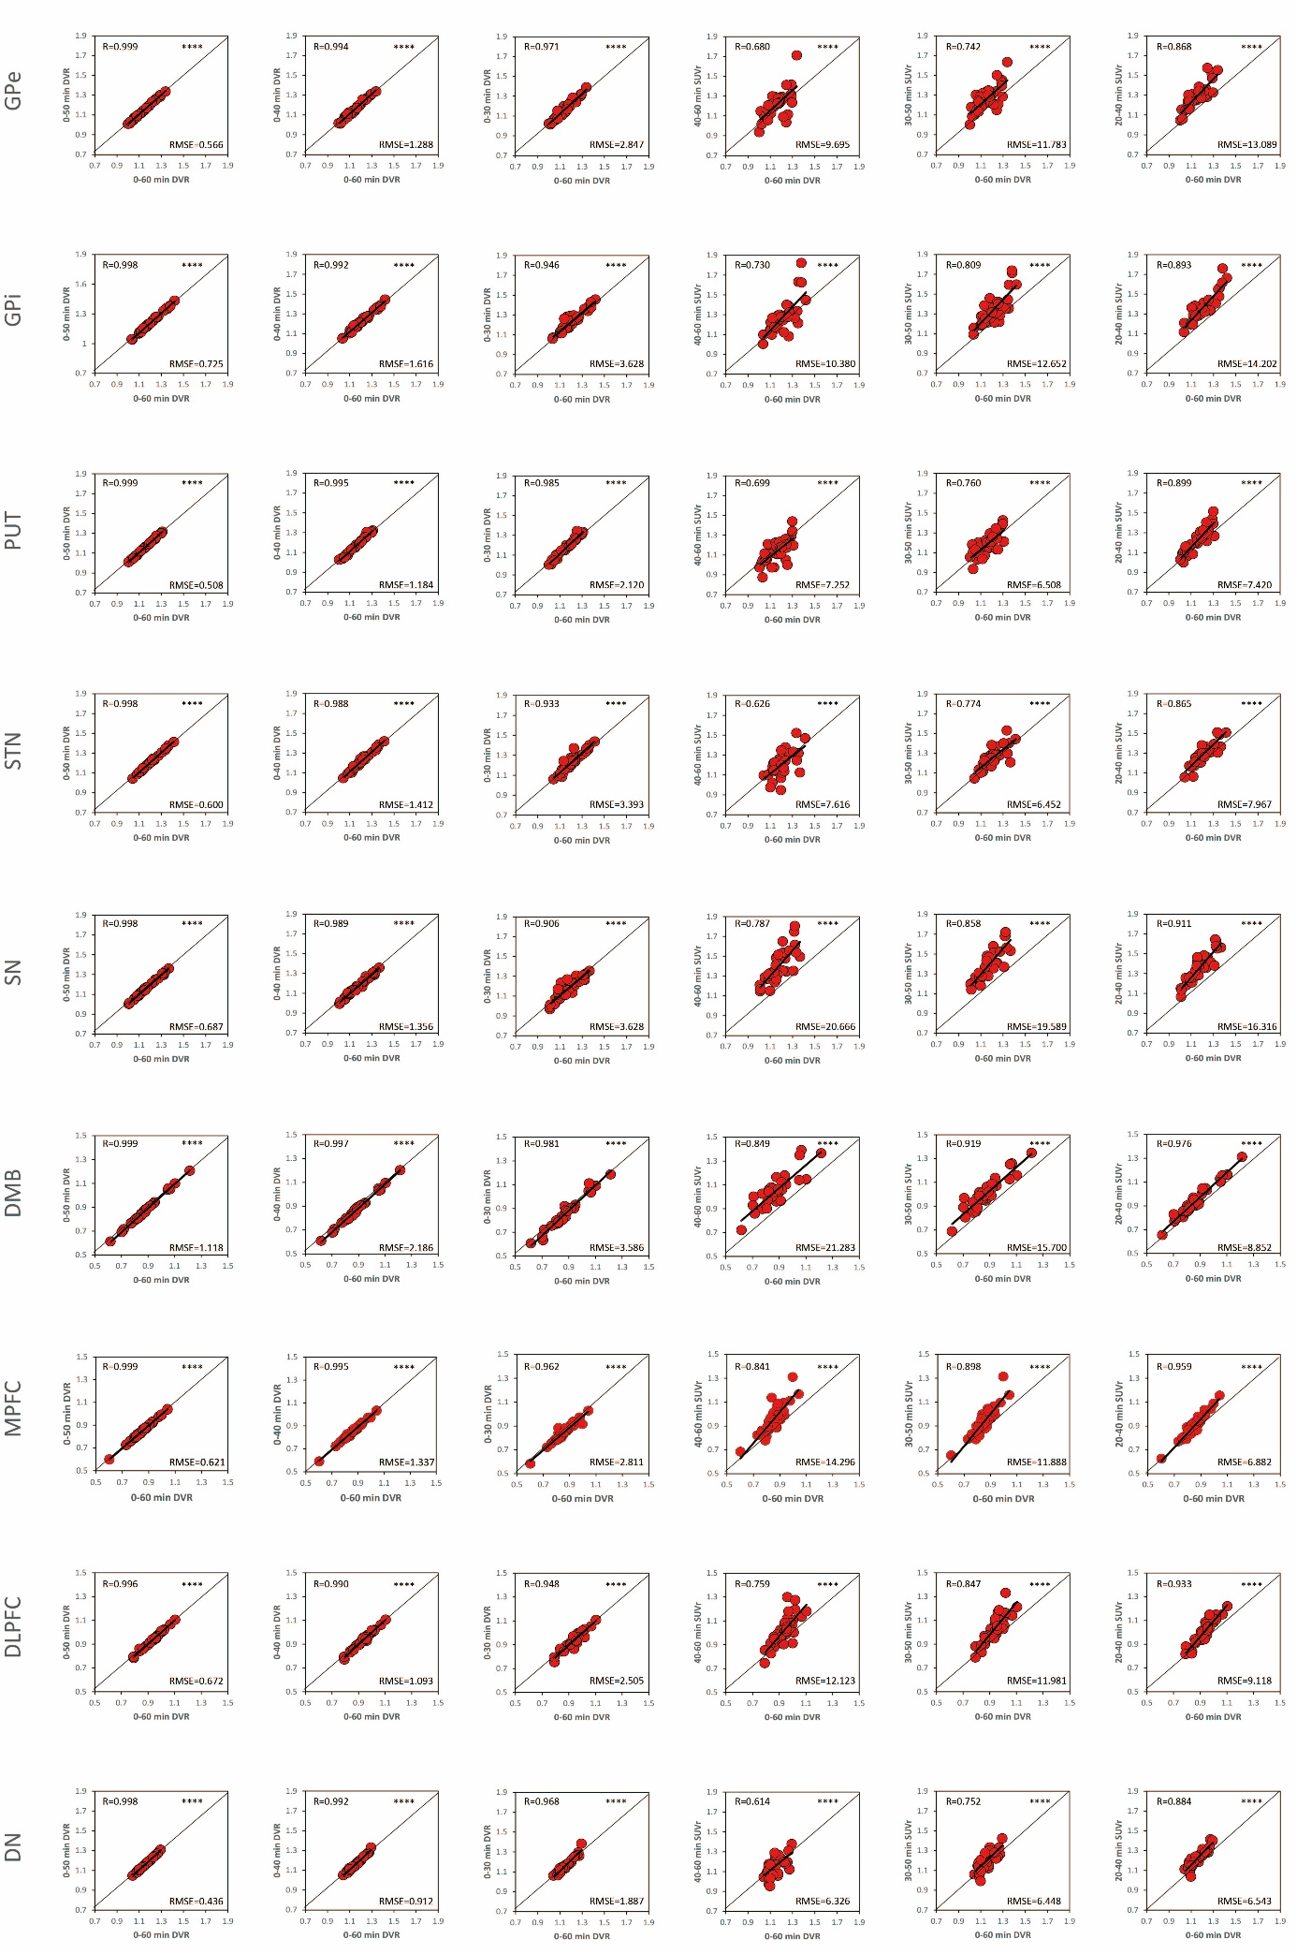
Supplemental Figure 2: Agreement between different truncated dynamic and static [¹⁸F]PI-2620 imaging windows with 0-60 distribution volume ratios (DVR) for all brain regions. SUVr = standardized uptake value ratio; GPe = globus pallidus externus; GPi = globus pallidus internus; PUT = putamen; STN = subthalamic nucleus; SN = substantia nigra; DMB = dorsal midbrain; MPFC = medial prefrontal cortex; DLPFC = dorsolateral prefrontal cortex; DN = dentate nucleus; RMSE = root-mean-square-error; R = Pearson’s correlation coefficient

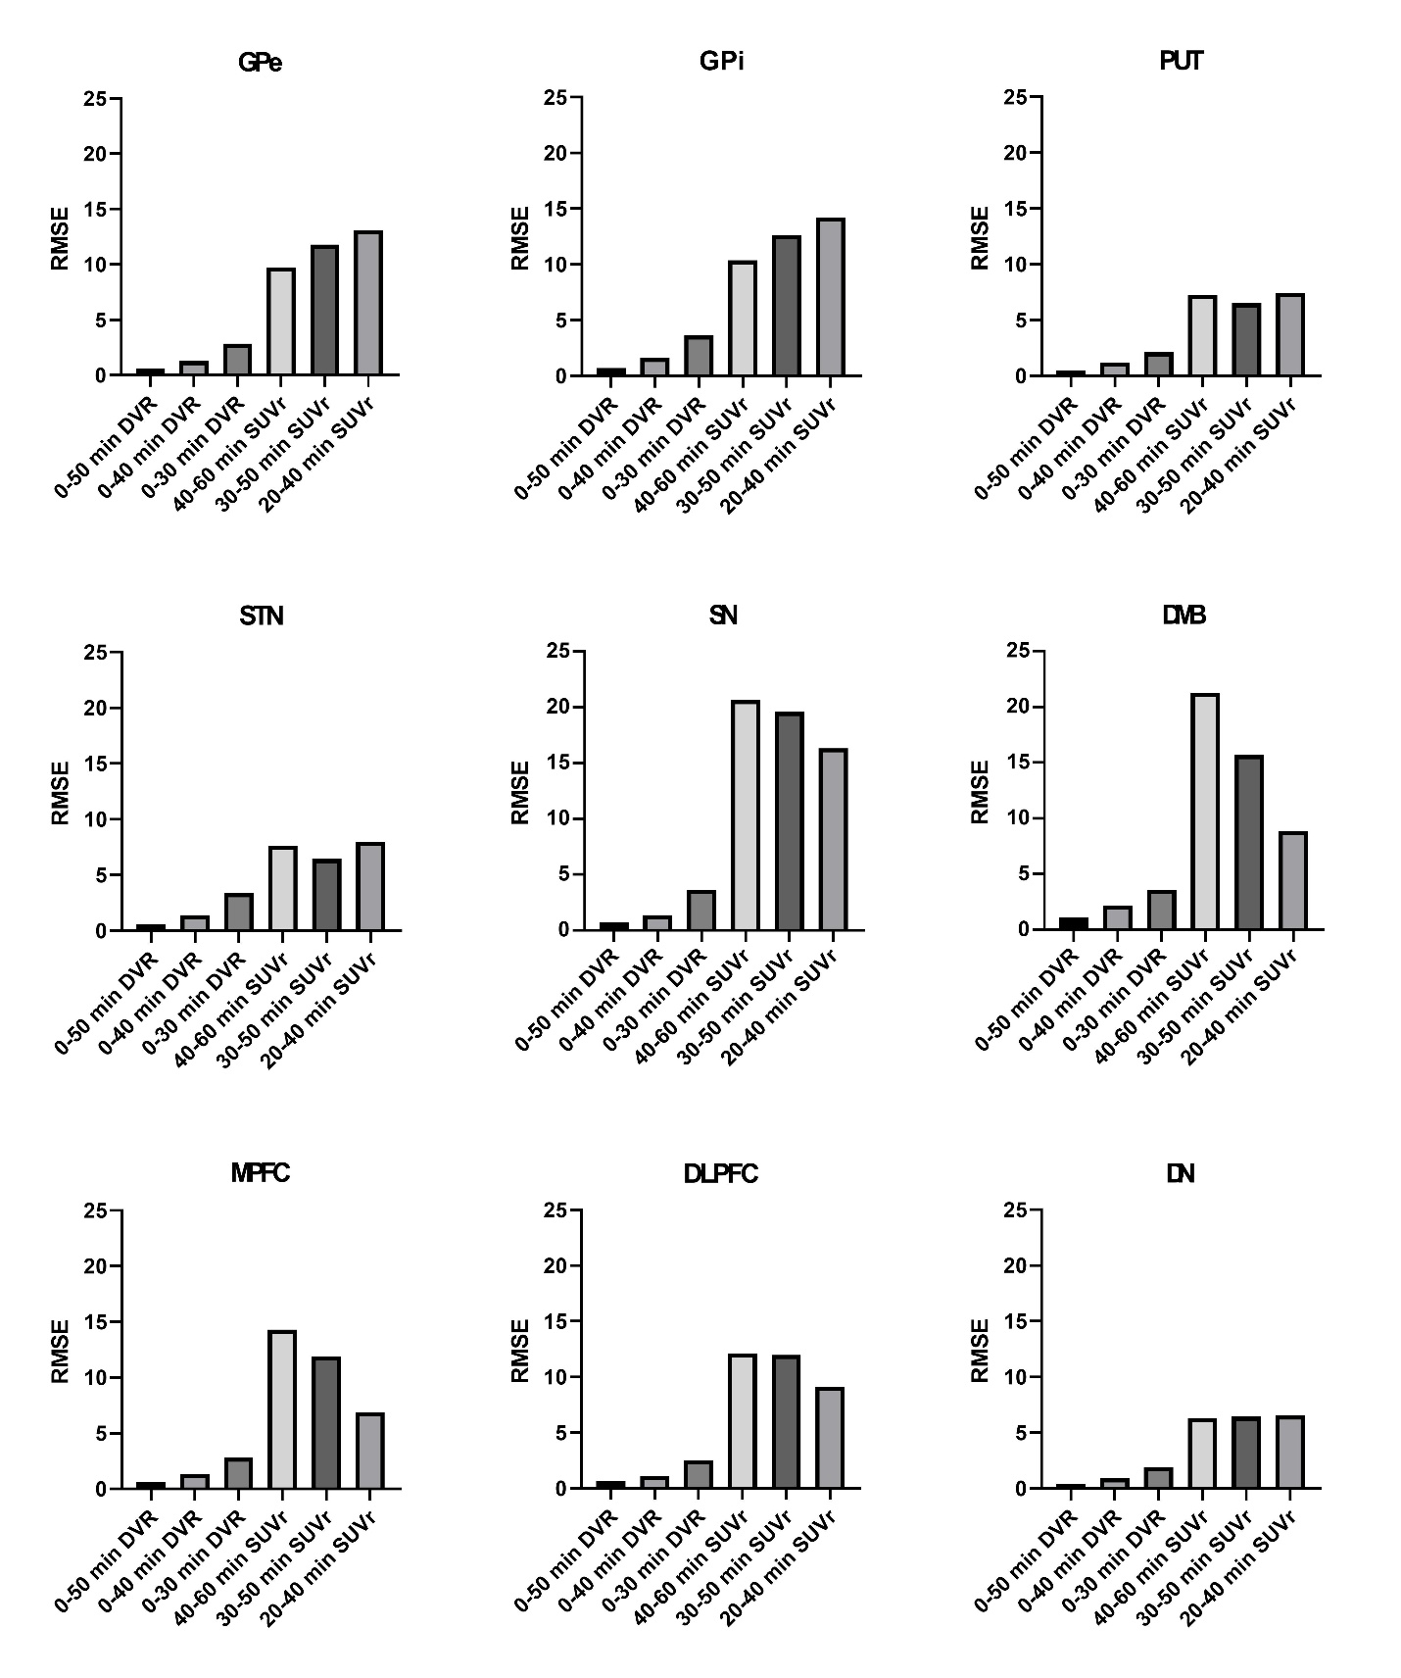
Supplemental Figure 3: Illustration of root-mean-square-errors (RMSE) in all brain regions for different dynamic and static [¹⁸F]PI-2620 imaging windows. DVR = distribution volume ratio; SUVr = standardized uptake value ratio; GPe = globus pallidus externus; GPi = globus pallidus internus; PUT = putamen; STN = subthalamic nucleus; SN = substantia nigra; DMB = dorsal midbrain; MPFC = medial prefrontal cortex; DLPFC = dorsolateral prefrontal cortex; DN = dentate nucleus; RMSE = root-mean-square-error

