Supplementary figures

The Alzheimer risk factor CD2AP causes dysfunction of the brain vascular network

Table S1: Characteristics of participants from the Religious Order Study

Soluble and insoluble Aβ levels were quantified by ELISA in parietal cortex samples and are presented as a log. ¶ p < 0.0001 vs NCI et vs MCI. * p < 0.001 vs NCI et vs MCI. & p < 0.05 vs NCI et vs MCI. A = ANOVA. C = contingency. NCI: no cognitive impairment. MCI: mild cognitive impairment. MMSE: mini mental state examination. APOE4: apolipoprotein E epsilon 4. CERAD: consortium for Consortium to Establish a Registry for Alzheimer's Disease.

Table S2: Correlations between CD2AP levels and AD hallmarks in the parietal cortex and isolated brain vessels extracts
Soluble and insoluble Aβ levels were quantified by ELISA in parietal cortex samples. The correlations were evaluated using a linear regression analysis. Significant correlations (P<0.05) are highlighted in blue. Correlations that are close to be significant (P = 0.05) are highlighted in grey. *Correlation still significant after adjustment for age of death and education. MMSE: mini mental state examination.

Table S3: List of primary antibodies

Table S4: DNA sequences of the shRNAs targeting mouse CD2ap (accession NM_009847) in each AAV construct

Construct | 97-mer shRNA sequence
pAAV-U6-Dh09shRNA-CMV-GFP-WPRE-hgHpA or pAAV-U6-Dh09shRNA-tdTomato-GFP-WPRE-hgHpA | TGCTGTTGACAGTGAGCGACCATCAAACGGGAAAGGCAAGTAGTGAAGCCACAGATGTACTTGCCTTTCCCGTTTGATGGGTGCCTACTGCCTCGGA
pAAV-U6-Dh10shRNA-CMV-GFP-WPRE-hgHpA or pAAV-U6-Dh10shRNA-tdTomato-GFP-WPRE-hgHpA | TGCTGTTGACAGTGAGCGCAGGGTGAACTGAACGGTAAAGTAGTGAAGCCACAGATGTACTTTACCGTTCAGTTCACCCTTTGCCTACTGCCTCGGA
pAAV-U6-Dh11shRNA-CMV-GFP-WPRE-hgHpA or pAAV-U6-Dh11shRNA-CMV-tdTomato-WPRE-hgHpA | TGCTGTTGACAGTGAGCGAGCGGTATGGCTACAGACCAAGTAGTGAAGCCACAGATGTACTTGGTCTGTAGCCATACCGCCTGCCTACTGCCTCGGA
pAAV-U6-Dh12shRNA-CMV-GFP-WPRE-hgHpA or pAAV-U6-Dh12shRNA-CMV-tdTomato-WPRE-hgHpA | TGCTGTTGACAGTGAGCGCAAGTCAGATTTCTTGTGTTATTAGTGAAGCCACAGATGTAATAACACAAGAAATCTGACTTTTGCCTACTGCCTCGGA
pAAV-U6-scAshRNA-CMV-GFP-WPRE-hgHpA or pAAV-U6-scAshRNA-tdTomato-GFP-WPRE-hgHpA | TGCTGTTGACAGTGAGCGCGCCAGTATTTGCCCTTGATATTAGTGAAGCCACAGATGTAATATCAAGGGCAAATACTGGCATGCCTACTGCCTCGGA
pAAV-U6-scBshRNA-CMV-GFP-WPRE-hgHpA or pAAV-U6-scBshRNA-CMV-tdTomato-WPRE-hgHpA | TGCTGTTGACAGTGAGCGAACCACTAAGCTTGCTTCTTACTAGTGAAGCCACAGATGTAGTAAGAAGCAAGCTTAGTGGTCTGCCTACTGCCTCGGA
pAAV-U6-scCshRNA-CMV-GFP-WPRE-hgHpA or pAAV-U6-scCshRNA-CMV-tdTomato-WPRE-hgHpA | TGCTGTTGACAGTGAGCGATGTACAGGACTTCACAGAAAATAGTGAAGCCACAGATGTATTTTCTGTGAAGTCCTGTACAGTGCCTACTGCCTCGGA
pAAV-U6-scramb-CMV-GFP-WPRE-hgHpA or pAAV-U6-scramb-CMV-tdTomato-WPRE-hgHpA | TGCTGTTGACAGTGAGCGAAACAGCAAGTAACGCAGACGCTAGTGAAGCCACAGATGTAGCGTCTGCGTTACTTGCTGTTCTGCCTACTGCCTCGGA

Antisense sequences are underlined

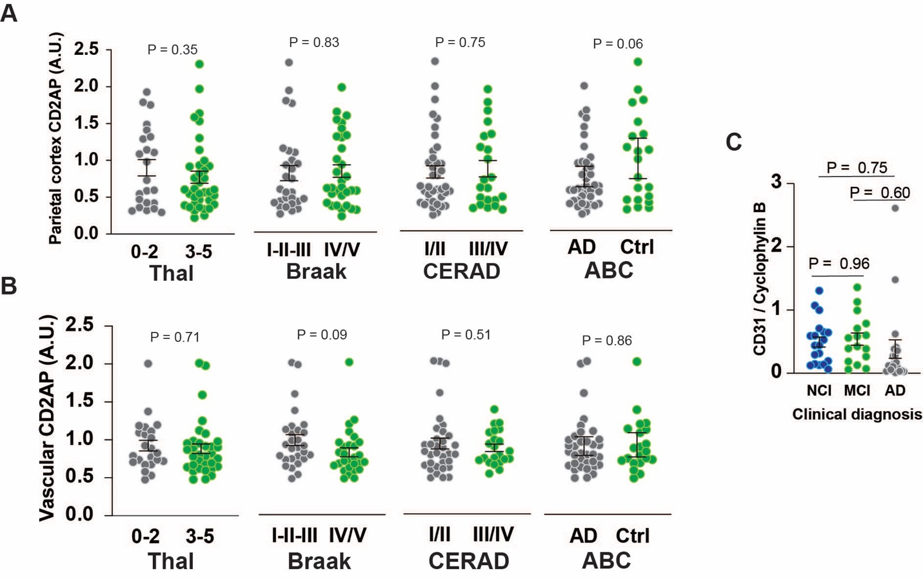

Figure S1: CD2AP levels in the cortex and isolated brain vessels of AD volunteers.
A) CD2AP levels in parietal cortex samples from volunteers classified according to Thal (0-2: n = 23, 3-5: n = 37, Unpaired Student t-test, t = 0.9499, df = 58), Braak (I-II-III: n = 32, IV/V: n = 28, Unpaired Student t-test, t = 0.2106, df = 68), CERAD (I/II: n = 38, III/IV: n = 22, Unpaired Student t-test, t = 0.3199, df = 58) or ABC (Control: n = 21, AD: n = 39, Unpaired Student t-test, t = 1.900, df = 58) scores. B) CD2AP levels in isolated brain microvessels of volunteers classified according to Thal (0-2: n = 23, 3-5: n = 33, Unpaired Student t-test, t = 0.3795, df = 54), Braak (I-II-III: n = 28, IV/V: n = 28, Unpaired Student t-test, t = 1.746, df = 54), CERAD (I/II: n = 34, III/IV: n = 22, Unpaired Student t-test with Welch’s correction, t = 0.6583, df = 52.77) or ABC (Control: n = 21, AD: n = 35, Unpaired Student t-test, t = 0.1717, df = 54) scores. D) Levels of the endothelial cells marker CD31 in the isolated brain vessels from volunteers classified according to the clinical diagnosis (NCI, n=19, MCI, n=16, AD, n=19, One-way ANOVA, P = 0.6043, F(2,51) = 0.5087).
Brain samples were obtained from participants in the Religious Orders Study, a longitudinal study of aging and dementia with an extensive amount of clinical and neuropathological data ¹.
Values for CD31 levels can also be found in ².
CD2AP: CD2-associated protein.

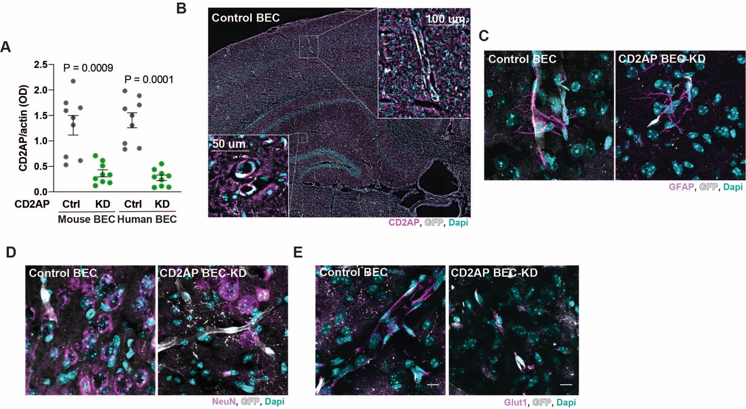

Figure S2: AAVBR1 targets brain endothelial cells in mice
A) Level of CD2AP in mouse (m) primary brain endothelial cells and hCMEC/D3 immortalized cell line (h) after transfection with CD2AP siRNA. N = 9 wells per group. mControl and mCD2AP KD and hControl and hCD2AP KD were compared using an Unpaired Student t-test with a Welch’s correction. mControl vs mCD2AP KD: t = 4.647, df = 9.994. hControl vs hCD2AP KD : t = 7.222, df = 10.10. Immunofluorescent image of brain slice from Control BEC and CD2AP BEC-KD mice stained for B) CD2AP (magenta), GFP (white) and Dapi (cyan), C) GFAP (magenta), GFP (white) and Dapi (cyan), D) NeuN (magenta), GFP (white) and Dapi (cyan), E) Glut1 (magenta), GFP (white) and Dapi (cyan),

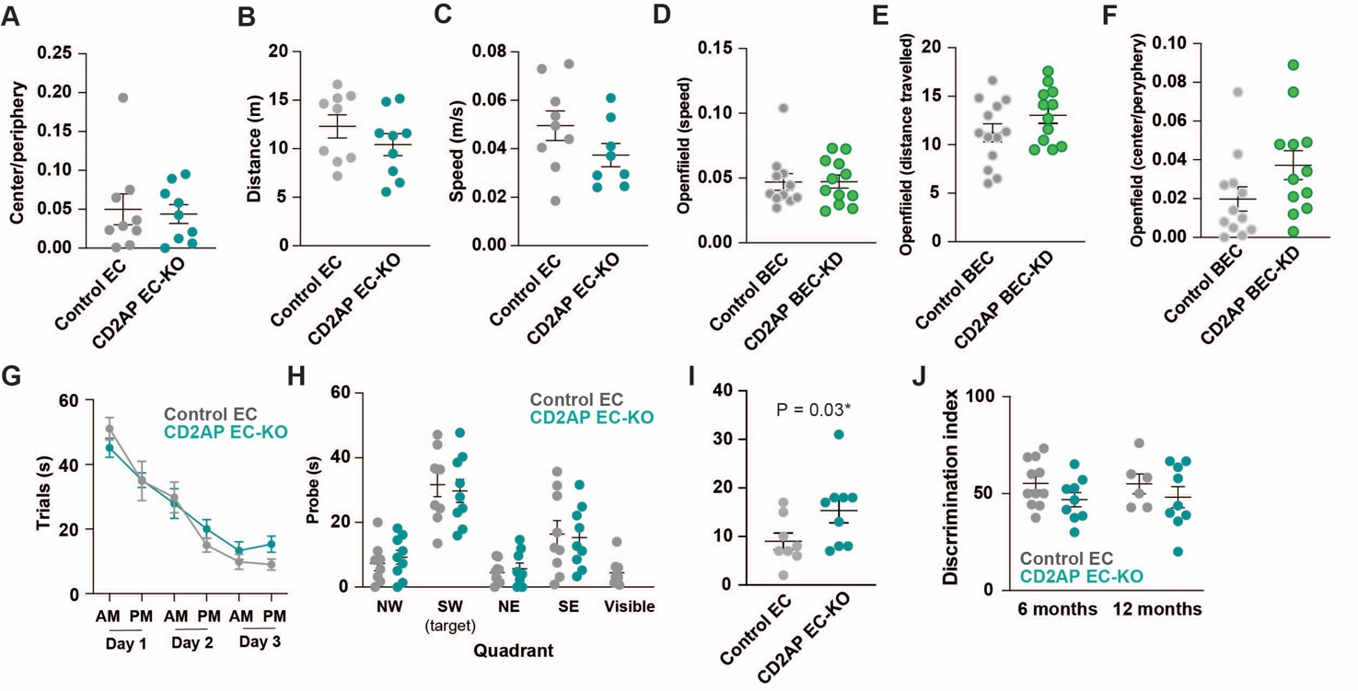

Figure S3: Behavioral consequences of endothelial-CD2AP downregulation in mice
Control EC and CD2AP EC-KO A) Center/periphery ratio, B) Distance travelled and C) Speed during the openfield.
Control BEC and CD2AP BEC-KD D) Center/periphery ratio, E) Distance travelled and F) Speed during the openfield.
Time to reach the reach the target during the G) trials and the H) probe test and time to target in at I) Day3 PM during the Morris Water Maze in Control EC and CD2AP EC-KO mice.
J) Discrimination index during the novel object recognition test in Control EC and CD2AP EC-KO mice.
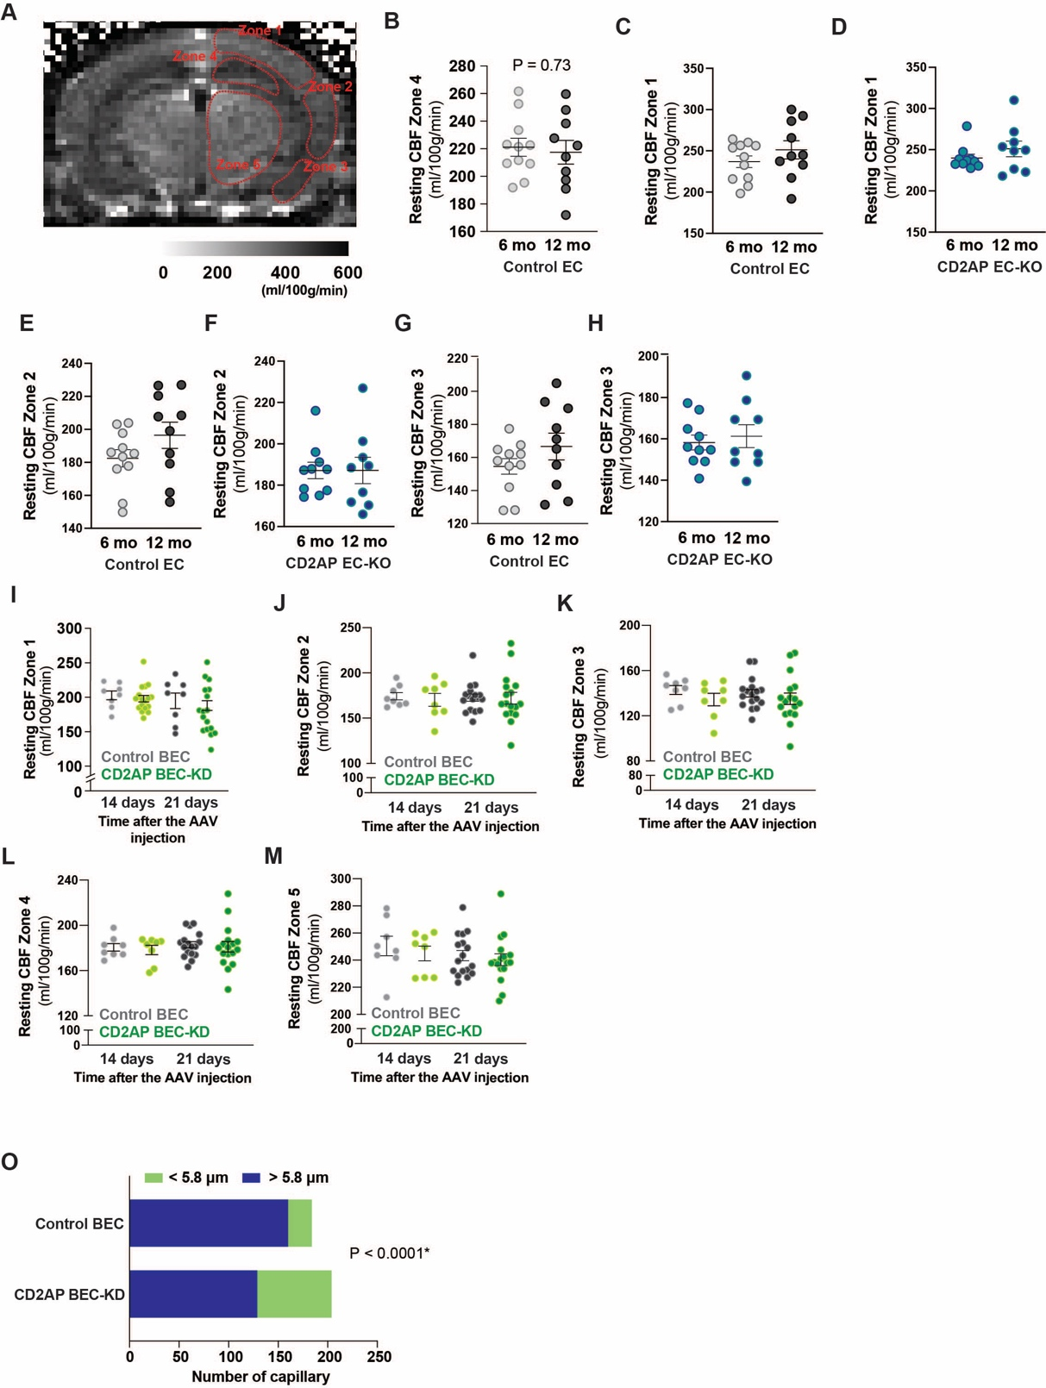
Figure S4: Resting cerebral blood flow in mice with endothelial CD2AP downregulation.
A) Identification of the zones where the measurement of cerebral blood flow were done. B to H) Measurements for Control EC and CD2AP EC-KO mice.
I to M) Measurements for Control BEC and CD2AP BEC-KO mice.
N) Number of vessels with a diameter under 5.8 μm and over 5.8 μm in Control-BEC (n = 6 mice) and CD2AP BEC-KD mice (n = 6 mice). Qui-square, P<0.0001, df = 28, 64,1, z = 5.352.
Data are presented as mean and SEM.
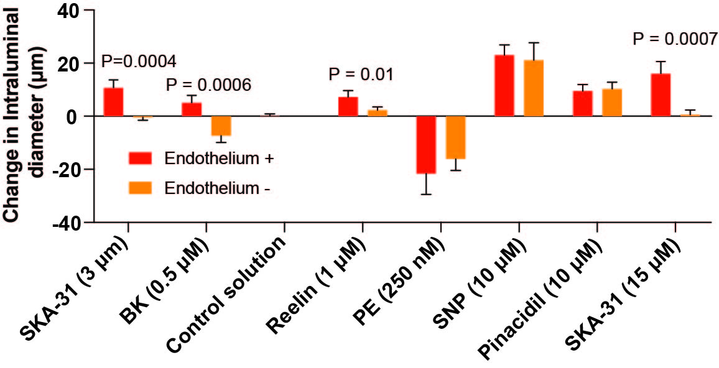

Figure S5: Endothelium- and nitric oxide-dependent effects of Reelin on brain vessels dilation
A) Intraluminal diameter changes in single cannulated cerebral arteries from 5-6 weeks old mice (n = 4-8) with endothelium and without endothelium. Following generation of myogenic tone at 70 mmHg, arteries were bath exposed to SKA-31 (3 and 15 µM), bradykinin (BK, 0.5 µM), MOCK media (volume matched with Reelin), Reelin (1 µM), and the endothelium-independent agent phenylephrine (PE, 250 nM), sodium nitroprusside (SNP, 10 µM) and pinacidil (10 µM) in the presence and absence of endothelium. Maximal passive vessel diameter at the end of the protocol was obtained in the presence of Krebs’ buffer containing 2 mM EGTA and zero added CaCl₂. * indicates a statistical difference (P<0.05) between intact vs. endothelium denuded vessel within a given strain evaluated using an unpaired student t-test.

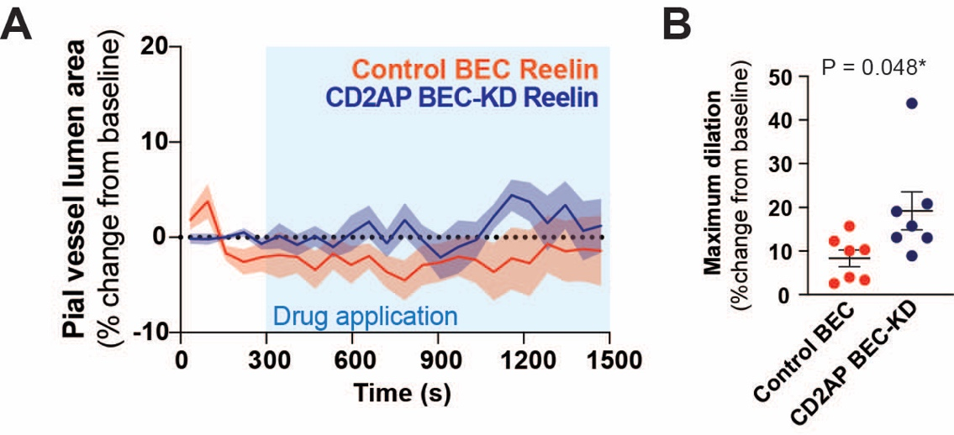

Figure S6: Control BEC and CD2AP BEC-KD mice pial vessels response to Reelin superfusion.
A) Effects of Control BEC and CD2AP BEC-KD on pial vessel luminal area in response to Reelin (1 μM) superfusion. B) Maximal dilation of pial vessels in response to Reelin (Unpaired Student t-test, t = 2.551, df = 8, each dot represents one animal).
Data are presented as mean ± SEM.

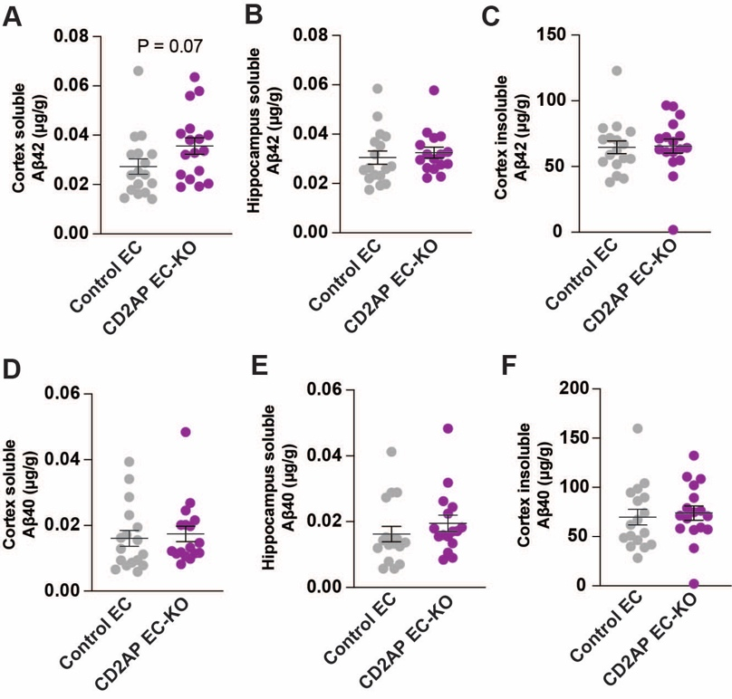
Figure S7: Endothelial CD2AP loss impact on Aβ accumulation in the PS2APP mouse model of AD.
Levels of soluble Aβ42 in the A) cortex and B) hippocampus.
C) Levels of insoluble Aβ42 in the hippocampus.
Levels of soluble Aβ40 in the D) cortex and E) hippocampus.
F) Levels of insoluble Aβ40 in the hippocampus.
Data were compared using unpaired Student t-test. No difference were found between groups.

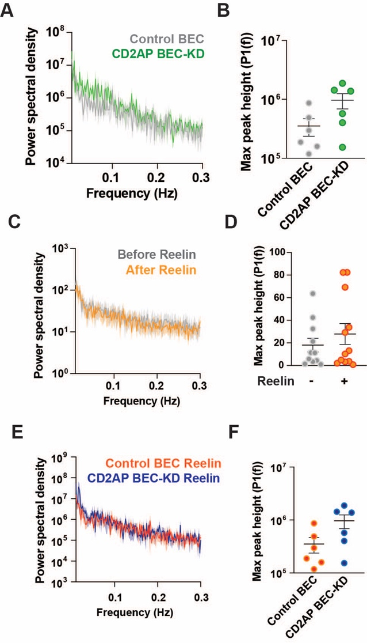
Figure S8: Vasomotion of Control and CD2AP BEC-KD mice
A and B) Control BEC (gray) vs CD2AP BEC-KD (green)
C and D) C57/BL6 mice before and after Reelin superfusion
E anf F) After Reelin superfusion in Control BEC and CD2AP BEC-KD mice.
Data are presented as mean and SEM.
Data were compared using an Unpaired Student t-test. No difference was found.

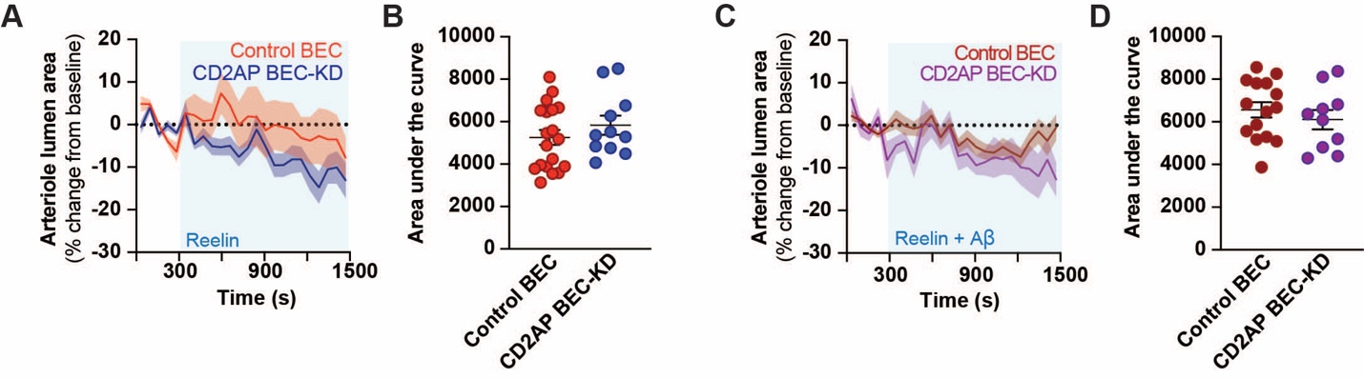
Figure S9: Drug application in Control and CD2AP BEC-KD mice
A and B) Control BEC (orange) and CD2AP BEC-KD (blue) arteriole lumen area change with Reelin (1 μM) application.
C and D) Control BEC (brown) and CD2AP BEC-KD (purple) arteriole lumen area change with Reelin (1 μM) + Aβ42 (100 nM) application.
Data are presented as mean and SEM.
Data were compared using an Unpaired Student t-test. No difference was found.

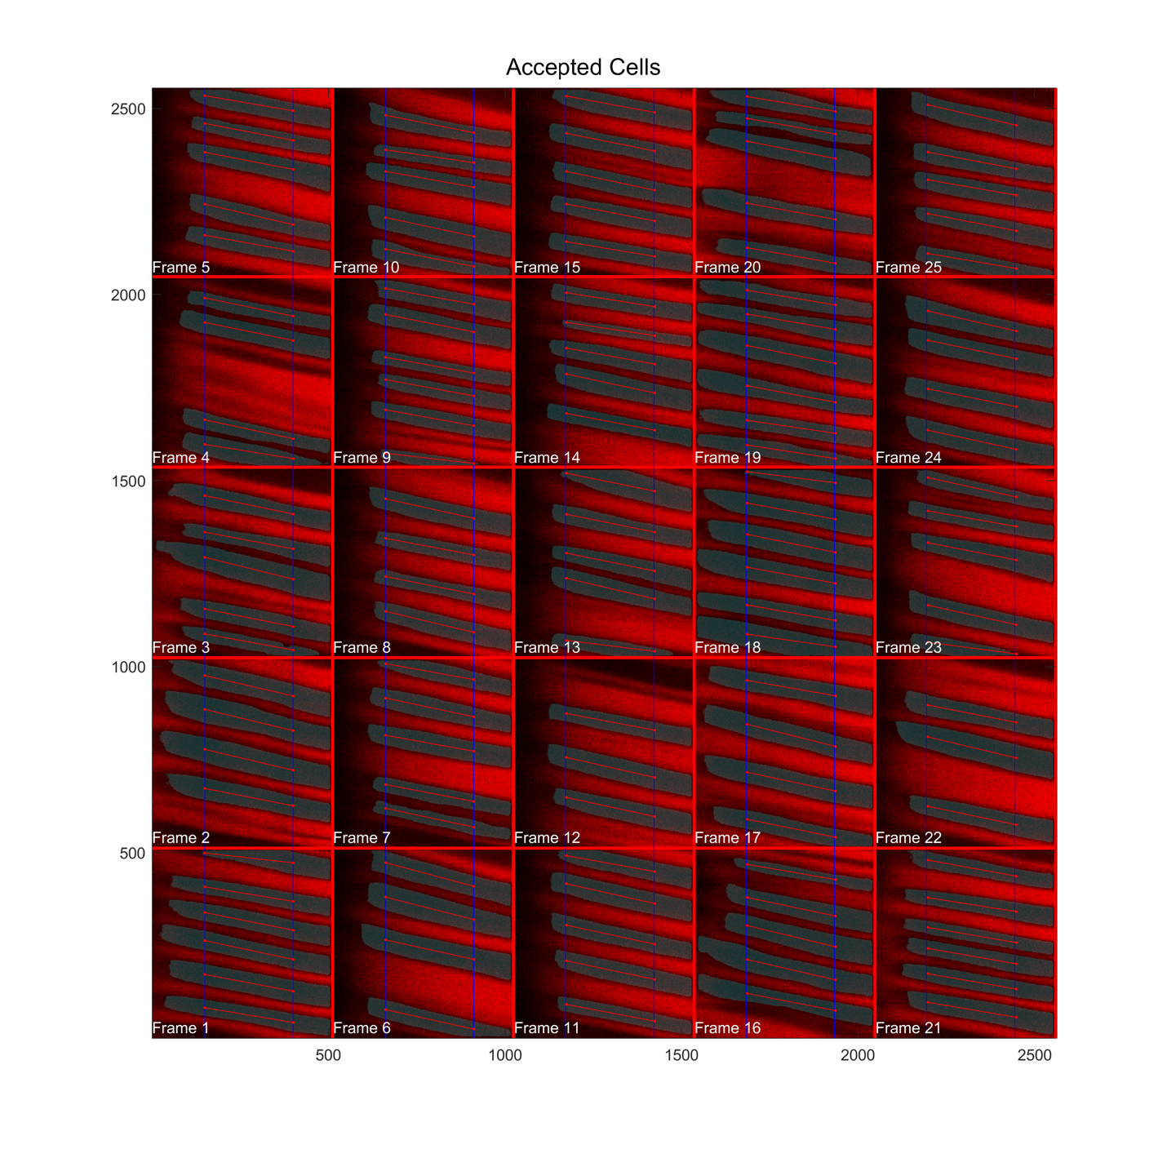

Figure S10: Ouput example from the capillary red blood cells analysis for U-Net slow.
Gray: Red blood cells picked up by U-Net slow.

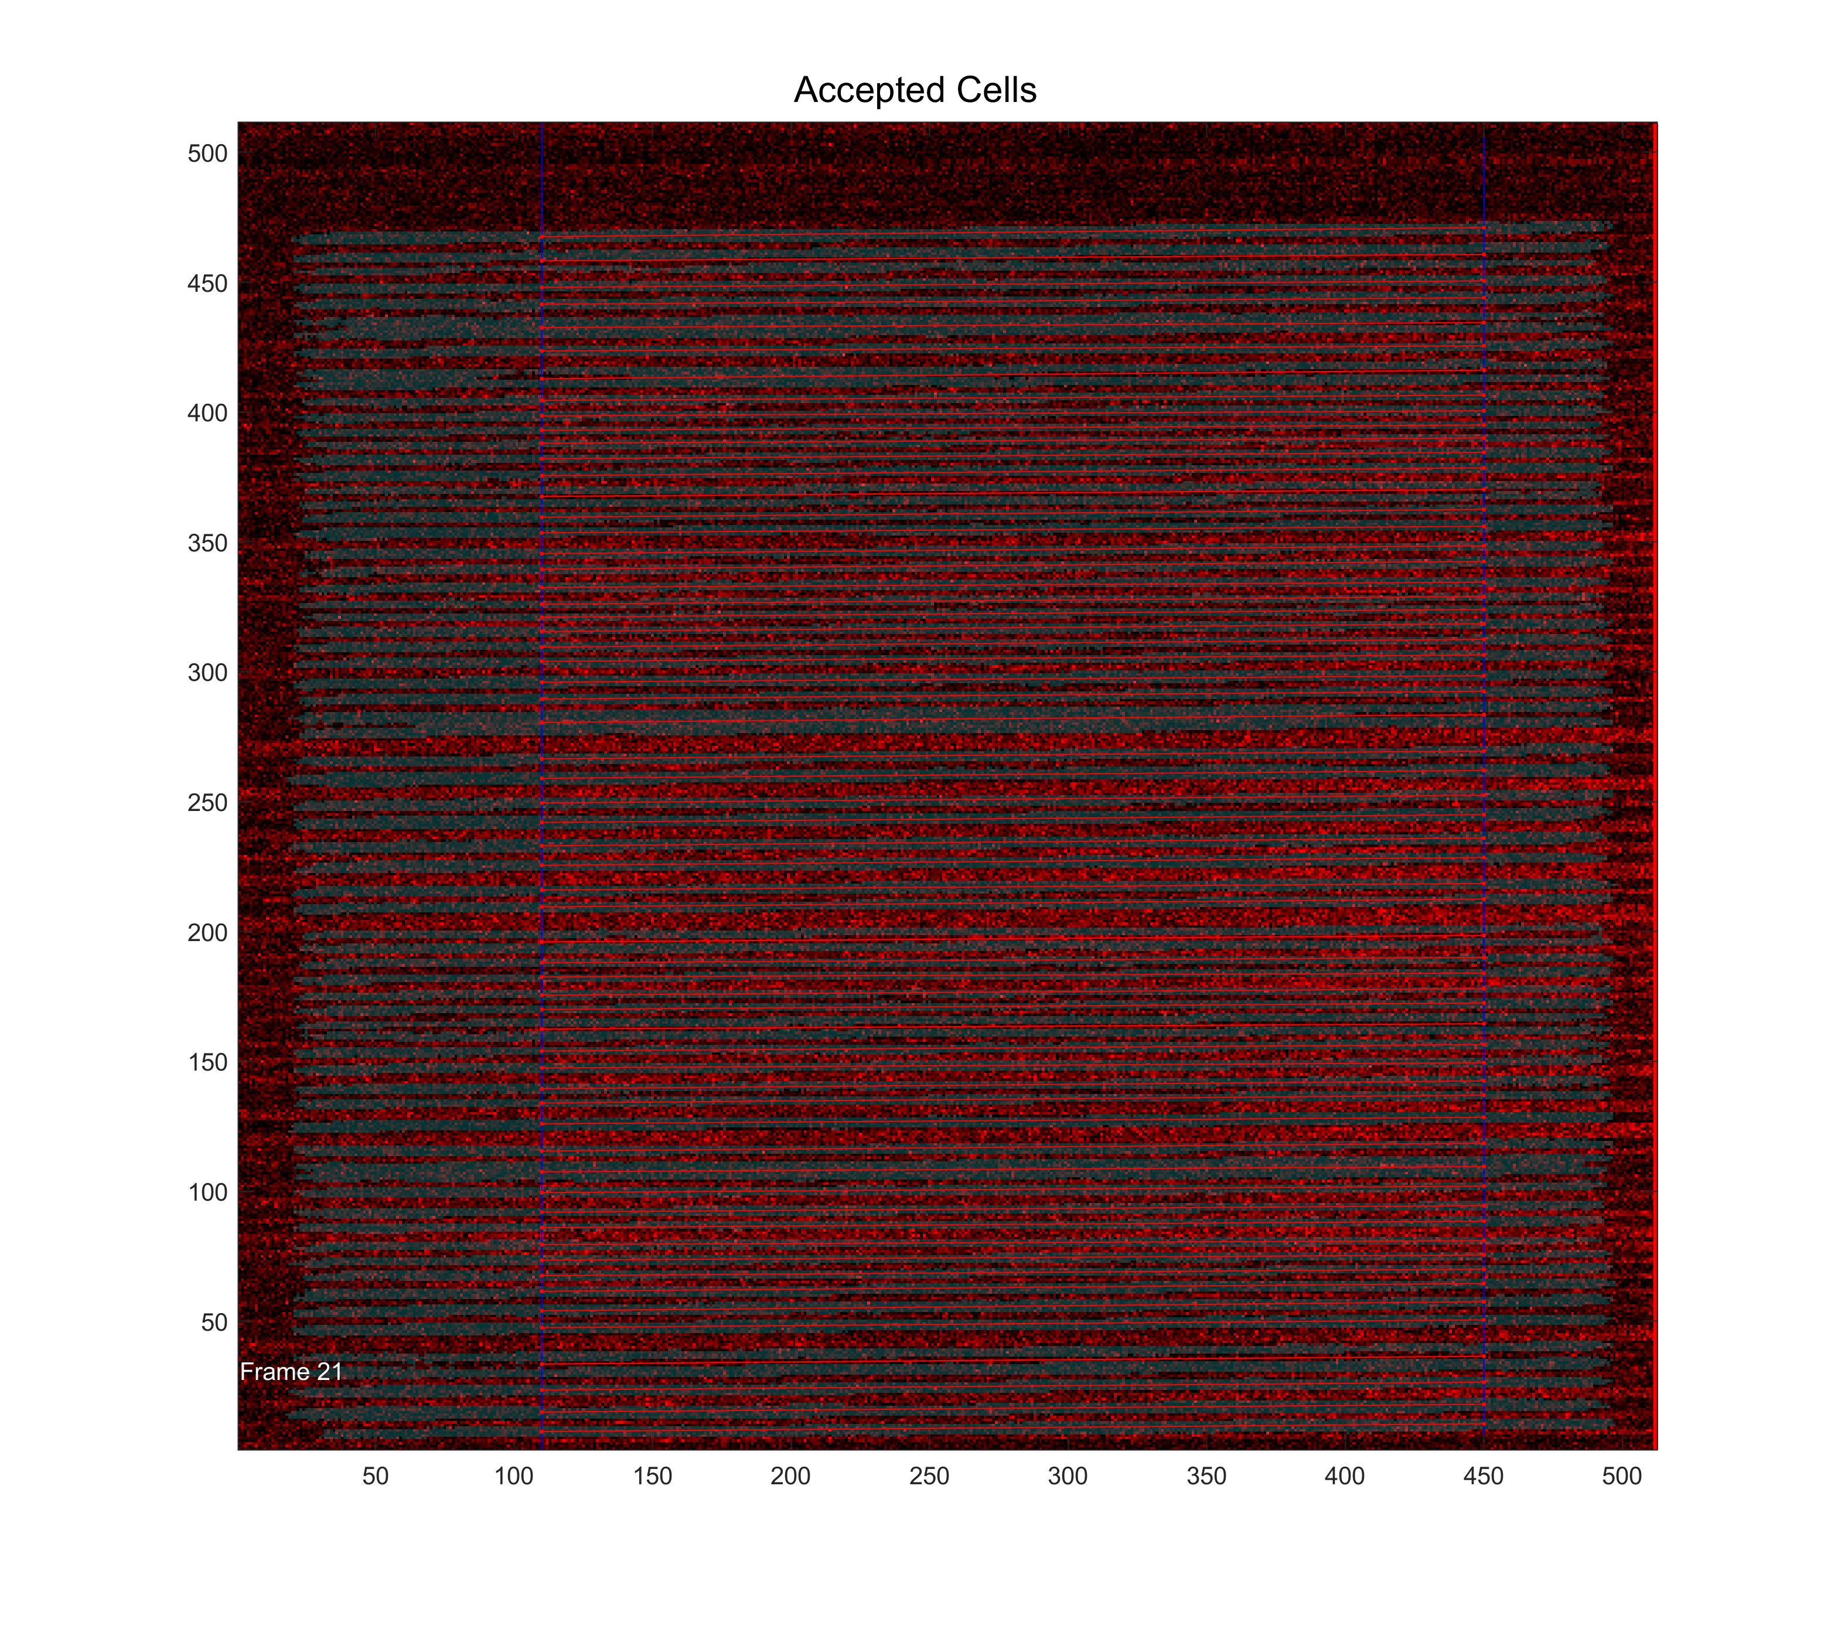
Figure S11: Ouput example from the capillary red blood cells analysis for U-Net fast.
Gray: Red blood cells picked up by U-Net fast.

References

1. Tremblay, C. et al. Biochemical characterization of Abeta and tau pathologies in mild cognitive impairment and Alzheimer’s disease. J Alzheimers Dis 12, 377-390 (2007).
2. Bourassa, P., Tremblay, C., Schneider, J. A., Bennett, D. A. & Calon, F. Brain mural cell loss in the parietal cortex in Alzheimer’s disease correlates with cognitive decline and TDP-43 pathology. Neuropathol Appl Neurobiol (2020).

