Target gene | Primer set | Sequence (5'-3') | Reference
Bacterial 16S | Eub338 (F) | ACTCCTACGGGAGGCAGCAG | (Lane 1991)
 | Eub518 (R) | ATTACCGCGGCTGCTGG | (Muyzer et al. 1993)
Fungal ITS | ITS1F | CTTGGTCATTTAGAGGAAGTAA | (Gardes and Bruns 1993)
 | ITS2R | GCTGCGTTCTTCATCGATGC | (Vilgalys and Hester 1990)
AOB amoA | amoA1F | GGGGHTTYTACTGGTGGT | (Stephen et al. 1999)
 | amoA2R | CCCCTCKGSAAAGCCTTCTTC | (Stephen et al. 1999)
AOA amoA | Arch-amoAF | STAATGGTCTGGCTTAGACG | (Francis et al. 2005)
 | Arch-amoAR | GCGGCCATCCATCTGTATGT | (Francis et al. 2005)
nirK | nirK-F | GGMATGGTKCCSTGGCA | (Braker et al. 1998)
 | nirK-R | GCCTCGATCAGRTTRTGG | (Braker et al. 1998)
nirS | Cd3aF | GTSAACGTSAAGGARACSGG | (Throbäck et al. 2004)
 | R3cd | GASTTCGGRTGSGTCTTGA | (Throbäck et al. 2004)
nosZ | nosZF | AACGCCTAYACSACSCTGTTC | (Rösch and Bothe 2005)
 | nosZR | TCCATGTGCAGNGCRTGGCAGAA | (Rösch and Bothe 2005)
F.oxysporum | ITS1F | CTTGGTCATTTAGAGGAAGTAA | (Lievens et al. 2005)
 | AFP308 | CGAATTAACGCGAGTCCCAAC | (Lievens et al. 2005)
F.solani | ITS1F | CTTGGTCATTTAGAGGAAGTAA | (Lievens et al. 2006)
 | AFP346 | GGTATGTTCACAGGGTTGATG | (Lievens et al. 2006)
Ralstonia solanacearum | Flic-F | GAACGCCAACGGTGCGAACT | (Schonfeld et al. 2003)
 | Flic-R | GGCGGCCTTCAGGGAGGTC | (Schonfeld et al. 2003)
Table S1. Primers used for real-time PCR in this study

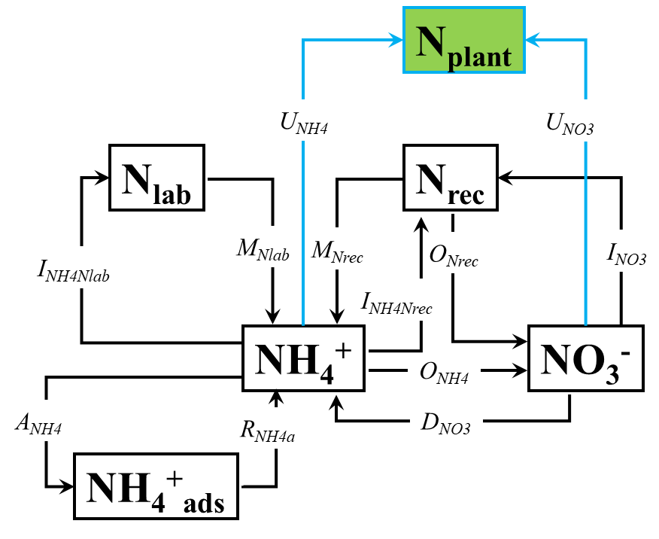

Fig. S1. The Ntrace_{plant} tool used in this study. N_{plant}, plant N pool; N_{lab}, labile soil organic N; N_{rec}, recalcitrant soil organic N; NH₄⁺, ammonium; NO₃⁻, nitrate; NH₄⁺_{ads}, adsorbed NH₄⁺; M_{Nlab}, mineralization of labile organic N (Nlab) to NH₄⁺; M_{Nrec}, mineralization of recalcitrant organic N (Nrec) to NH₄⁺; I_{NH4Nlab}, immobilization of NH₄⁺ to Nlab; I_{NH4Nrec}, immobilization of NH₄⁺ to Nrec; R_{NH4a}, release of adsorbed NH₄⁺; A_{NH4}, adsorption of NH₄⁺ on cation exchange sites; O_{NH4}, oxidation of NH₄⁺ to NO₃–; O_{Nrec}, oxidation of recalcitrant organic N to NO₃– (heterotrophic nitrification); I_{NO3}, immobilization of NO₃– to organic N pool; D_{NO3}, dissimilatory NO₃– reduction to NH₄⁺ (DNRA); U_{NH4}, plant NH₄⁺ uptake; U_{NO3}, plant NO₃– uptake.
Fig. S2. In the DST (degraded soil under continuous tomato cultivation), observed (points) and modeled (lines) concentrations of soil NH₄⁺ (a), soil NO₃⁻ (c), and plant N pools (e), and ¹⁵N enrichments of soil NH₄⁺ (a), soil NO₃⁻ (c), and plant N pools (e). CC, control (without reductive soil disinfestation) without plants; RC, reductive soil disinfestation without plants; CP, control (without reductive soil disinfestation) with plants; RP, reductive soil disinfestation with plants. Vertical bars indicate standard deviations.
Fig. S3. In the DSC (degraded soil under continuous cucumber cultivation), observed (points) and modeled (lines) concentrations of soil NH₄⁺ (a), soil NO₃⁻ (c), and plant N pools (e), and ¹⁵N enrichments of soil NH₄⁺ (a), soil NO₃⁻ (c), and plant N pools (e). CC, control (without reductive soil disinfestation) without plants; RC, reductive soil disinfestation without plants; CP, control (without reductive soil disinfestation) with plants; RP, reductive soil disinfestation with plants. Vertical bars indicate standard deviations.

References:
Braker G, Fesefeldt A, Witzel K-P (1998) Development of PCR primer systems for amplification of nitrite reductase genes (nirK and nirS) to detect denitrifying bacteria in environmental samples. Applied and environmental microbiology 64: 3769-3775.
Francis CA, Santoro A, Oakley BB, Beman JM, Roberts KJ (2005) Ubiquity and diversity of ammonia-oxidizing archaea in water columns and sediments of the ocean. Proceedings of the National Academy of Sciences of the United States of America 102.
Gardes M, Bruns TD (1993) ITS primers with enhanced specificity for basidiomycetes‐application to the identification of mycorrhizae and rusts. Molecular ecology 2: 113-118.
Lane DJ (1991) 16S/23S rRNA Sequencing. Nucleic Acid Techniques in Bacterial Systematics.
Lievens B, Brouwer M, Vanachter AC, Cammue BP, Thomma BP (2006) Real-time PCR for detection and quantification of fungal and oomycete tomato pathogens in plant and soil samples. Plant science 171: 155-165.
Lievens B, Brouwer M, Vanachter AC, Lévesque CA, Cammue BP, Thomma BP (2005) Quantitative assessment of phytopathogenic fungi in various substrates using a DNA macroarray. Environmental Microbiology 7: 1698-1710.
Muyzer G, De Waal EC, Uitterlinden AG (1993) Profiling of complex microbial populations by denaturing gradient gel electrophoresis analysis of polymerase chain reaction-amplified genes coding for 16S rRNA. Applied and environmental microbiology 59: 695-700.
Rösch C, Bothe H (2005) Improved assessment of denitrifying, N2-fixing, and total-community bacteria by terminal restriction fragment length polymorphism analysis using multiple restriction enzymes. Applied and Environmental Microbiology 71: 2026-2035.
Schonfeld J, Heuer H, Van Elsas J, Smalla K (2003) Specific and sensitive detection of Ralstonia solanacearum in soil on the basis of PCR amplification of fliC fragments. Applied and Environmental Microbiology 69: 7248-7256.
Stephen JR, Chang YJ, Macnaughton SJ, Kowalchuk GA, White DC (1999) Effect of Toxic Metals on Indigenous Soil ??-Subgroup Proteobacterium Ammonia Oxidizer Community Structure and Protection against Toxicity by Inoculated Metal-Resistant Bacteria. Applied and Environmental Microbiology 65: 95-101.
Throbäck IN, Enwall K, Jarvis Å, Hallin S (2004) Reassessing PCR primers targeting nirS, nirK and nosZ genes for community surveys of denitrifying bacteria with DGGE. FEMS microbiology ecology 49: 401-417.
Vilgalys R, Hester M (1990) Rapid genetic identification and mapping of enzymatically amplified ribosomal DNA from several Cryptococcus species. Journal of Bacteriology 172: 4238-4246.

