Supporting Information
Biotransformation pathway and side reaction engineering for the whole-cell production of glycolic acid from formaldehyde
Hye-Jin Jo¹, Hanna Yu¹, Jun-Hong Kim², Huijin Cheon¹, Jeong-Sun Kim²* and Jin-Byung Park ¹*
¹ Department of Food Science and Engineering, Ewha Womans University, Seoul 03760, Republic of Korea.
² Department of Chemistry, Chonnam National University, Gwangju 61186, Republic of Korea.

* Corresponding author:
Prof. Jeong-Sun Kim
Tel) +82-62-530-3384 E-mail) jsunkim@chonnam.ac.kr
Prof. Jin-Byung Park
Tel) +82-2-3277-4509 E-mail) jbpark06@ewha.ac.kr

8 Pages, 1 Scheme, 2 Tables and 3 Figures are presented.

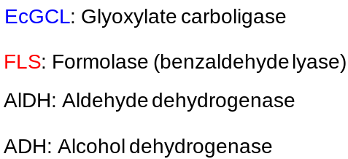
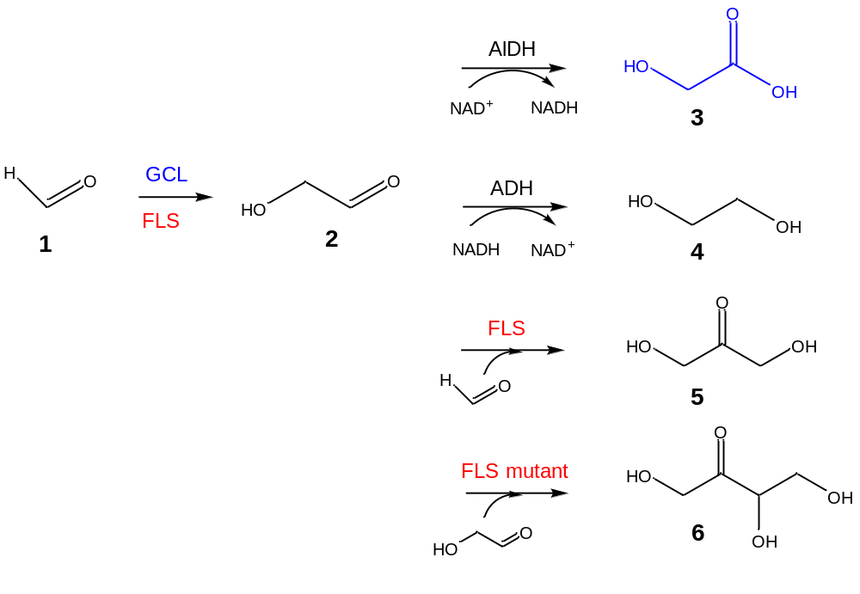
Scheme S1. C1 biotransformation pathways. Formaldehyde (1) is condensed into glycolaldehyde (2) by EcGCL and FLS. Glycolaldehyde can be transformed into glycolic acid (3) by aldehyde dehydrogenase, ethylene glycol (4) by alcohol dehydrogenase, dihydroxyacetone (5) and erythrulose (6) by FLS and FLS mutant, respectively.
Table S1. Plasmids used in this study.
Plasmids | Description | Reference
General plasmids
p.LIC B3-EcGCL | pBR322 origin, P_{T7}, Amp^{R} | ¹
pACYC-EcAldA | p15A origin, P_{T7}, Chl^{R} | This study
pRSFduet-KGSADH | RSF origin, P_{T7}, Kan^{R} | ²
CRISPR-Cas9 system plasmid
pCas | Kan^{R}, Cas9, araC, Gam, Bet, Exo, repA101 | ³
pTargetF | sgRNA, aadA, pMB1 | ³
pTargetF-frmA | aadA, pMB1, sgRNA-frmA (1.1kbp) | This study
pTargetF-glcD | aadA, pMB1, sgRNA-glcD (1.5kbp) | This study
* EcGCL: glyoxylate carboligase from E. coli, KGSADH: α-ketoglutaric semialdehyde dehydrogenase from Azospirillum brasilense, EcAldA: lactaldehyde dehydrogenase from E. coli

Table S2. Oligonucleotide primers used for PCR
Name | Primer sequence (5’ – 3’)
EcGCL_R484MN283QL478M | (F)-AACAACGCTTATCTGGGGATGATTCGTCAGTCACAACGC  (R)-GCGTTGTGACTGACGAATCATCCCCAGATAAGCGTTGTT
EcAldA | (F)- ACCACAGCCAGGATCCGATGTCAGTACCCGTTCAAC  (R)-TGCGGCCGCAAGCTTTTAAGACTGTAAATAAACCACCTGG
frmA | (sgRNA frmA F)-TCACCCATACGTTTTAGAGCTAGAAATAGC  (sgRNA frmA R)-CTTTAATTAGACTAGTATTATACCTAGGAC
glcD | (sgRNA glcD F)- TCGGTACTGAGTTTTAGAGCTAGAAATAGC  (sgRNA glcD R)- TGTGCGGTCGACTAGTATTATACCTAGGAC

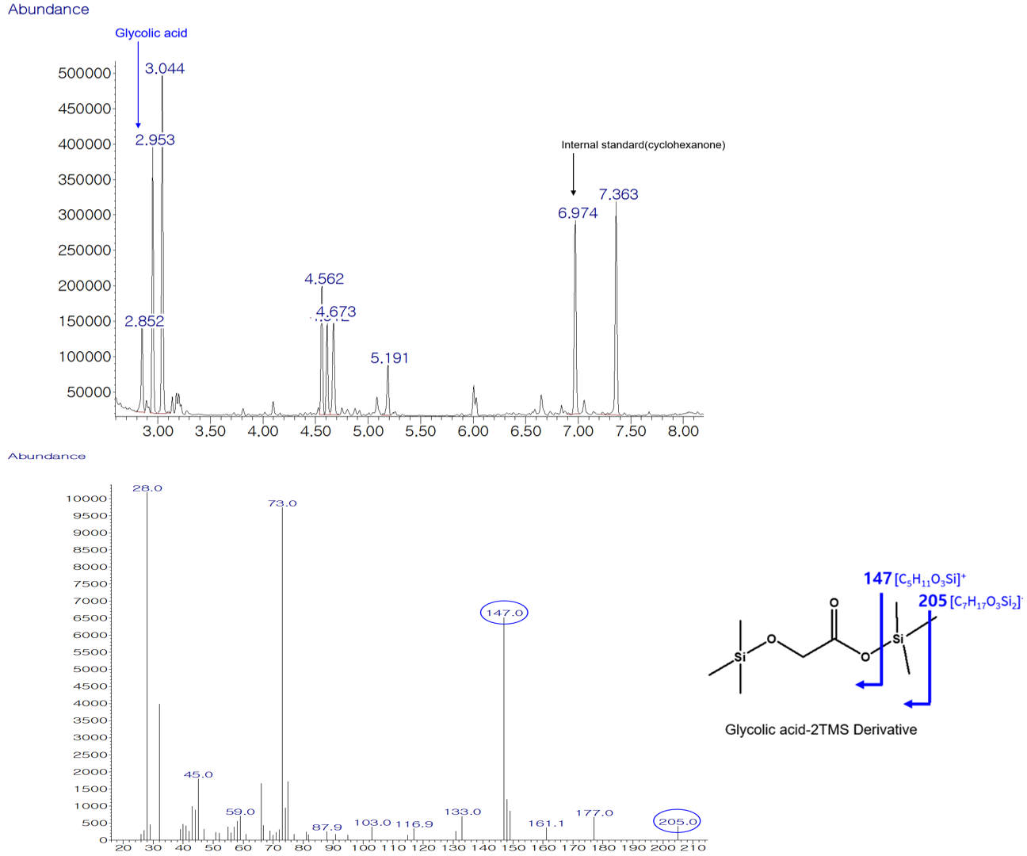
Figure S1. GC/MS analysis of the reaction products including glycolic acid (3).

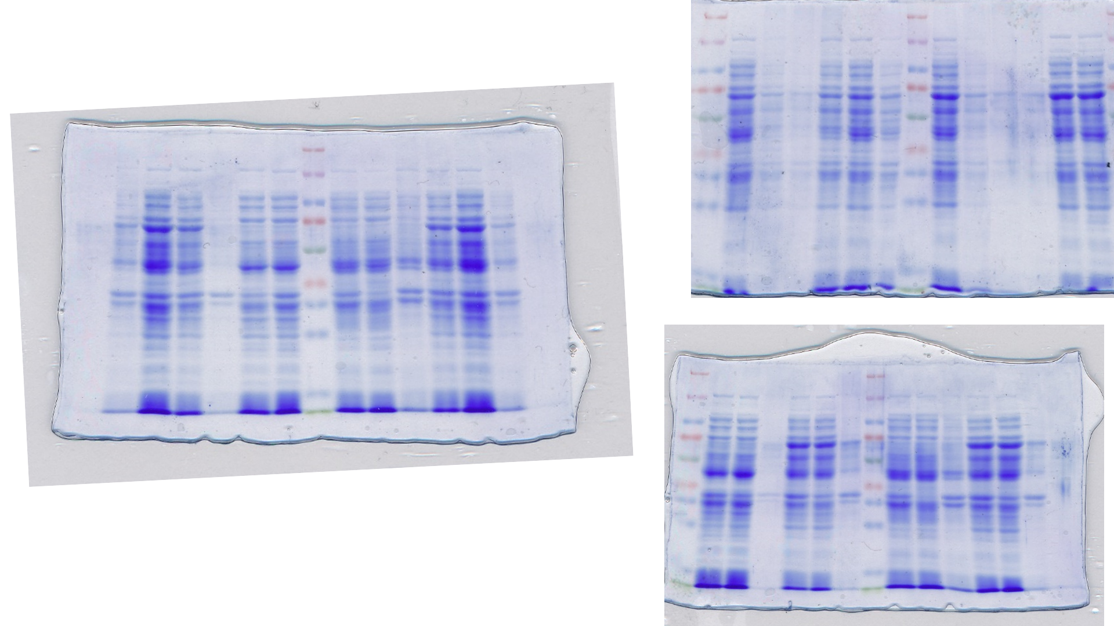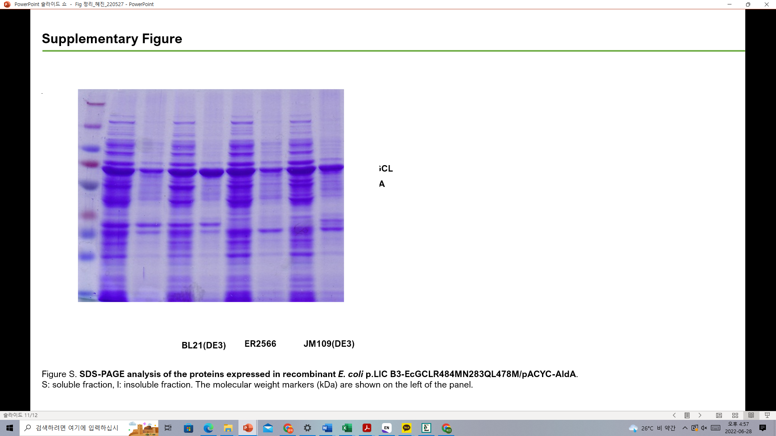
260
140
100
70
50
40
35
25
kDa
M
T
S
I
S
T
I
Before IPTG
After IPTG
15
EcGCL
EcAldA
M
S I
S I
S I
EcGCL
EcAldA
BL21(DE3)
ER2566
JM109(DE3)
kDa
260
140
100
70
50
40
35
25
15
B
A
Figure S2. SDS-PAGE analysis of the proteins expressed in recombinant E. coli p.LIC B3-EcGCL_R484MN283QL478M/pACYC-AldA. SDS-PAGE gel overexpression of EcGCL and EcAldA protein with induction with IPTG. S: soluble fraction, I: insoluble fraction. The molecular weight markers (kDa) are shown on the left of the panel.
B
A
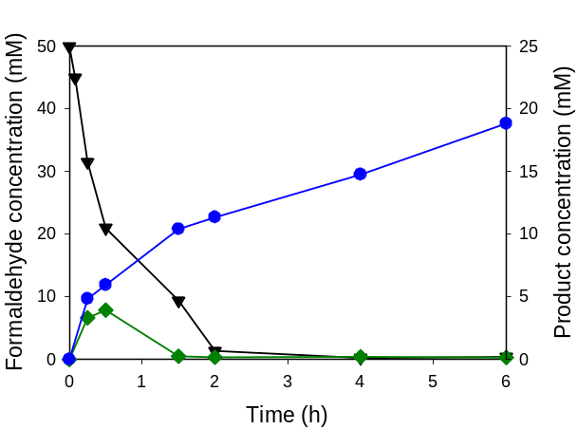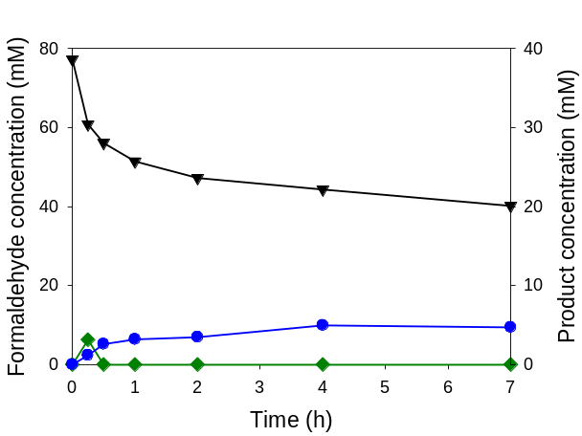
Figure S3. Whole-cell biotransformation of formaldehyde (1) by E. coli ER2566 co-expressing EcGCL_R484MN283QL478M and AldA with formaldehyde 50mM (A) and 75mM (B). The symbols indicate the concentrations of formaldehyde (▼), glycolaldehyde (◆), and glycolic acid (●).

References
1. Kaplun, A. et al. Glyoxylate carboligase lacks the canonical active site glutamate of thiamine-dependent enzymes. Nat. Chem. Biol. 4, 113 (2008).
2. Son, H.F., Park, S., Yoo, T.H., Jung, G.Y. & Kim, K.-J. Structural insights into the production of 3-hydroxypropionic acid by aldehyde dehydrogenase from Azospirillum brasilense. Sci. Rep. 7, 1-10 (2017).
3. Jiang, Y. et al. Multigene editing in the Escherichia coli genome via the CRISPR-Cas9 system. Appl. Environ. Microbiol. 81, 2506-2514 (2015).

