[Supplementary material]

Highly bright silica-coated InP/ZnS quantum dot-embedded silica nanoparticles as biocompatible nanoprobes

Kyeong-Min Ham^{a,†}, Minhee Kim^{a,†}, Sungje Bockª, Jaehi Kimª, Wooyeon Kimª, Heung Su Jung^{b}, Jaehyun An^{a,c}, Hobeom Song^{c}, Jung-Won Kim^{c}, Hyung-Mo Kim^{a,d}, Won-Yeop Rho^{e}, Sang-Hun Lee^{f}, Seung-min Park^{g}, Dong-Eun Kim^{a,}* and Bong-Hyun Jun^{a,}*

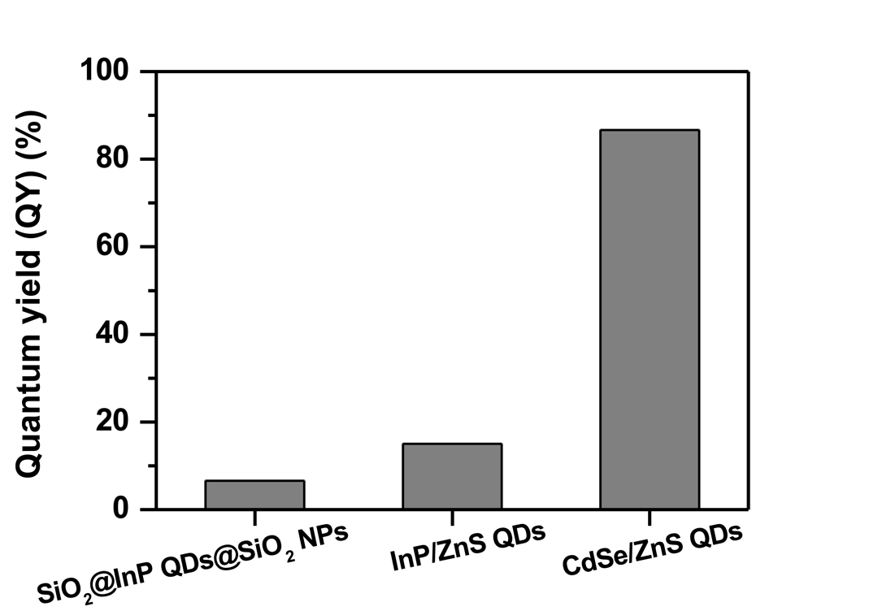
Fig. S1. Comparison of QY of SiO₂@InP QDs@SiO₂ NPs, CdSe/ZnS QDs, and InP/ZnS QDs. The QY of SiO₂@InP QDs@SiO₂ NPs, InP/ZnS QDs, and CdSe/ZnS QDs were 6.61%, 15.03%, and 86.65%, respectively.

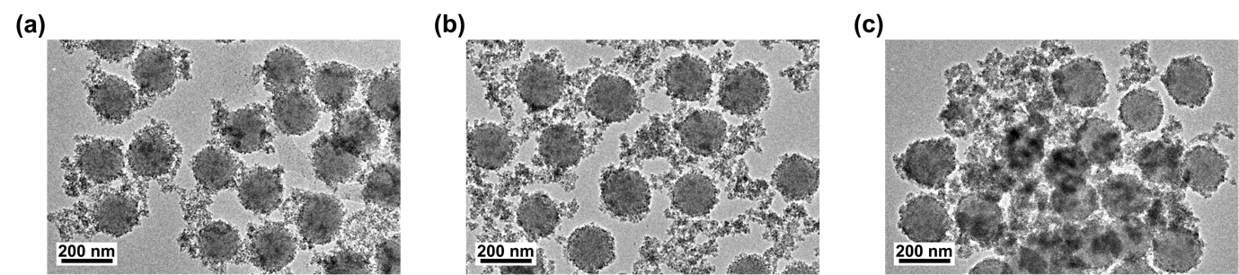
Fig. S2. TEM images of SiO₂@InP QDs@SiO₂ NPs by amount of added QDs. The amount of added QDs were (a) 1.4 mg, (b) 2.8 mg and (c) 5.6 mg per 1mg of SiO₂ NPs

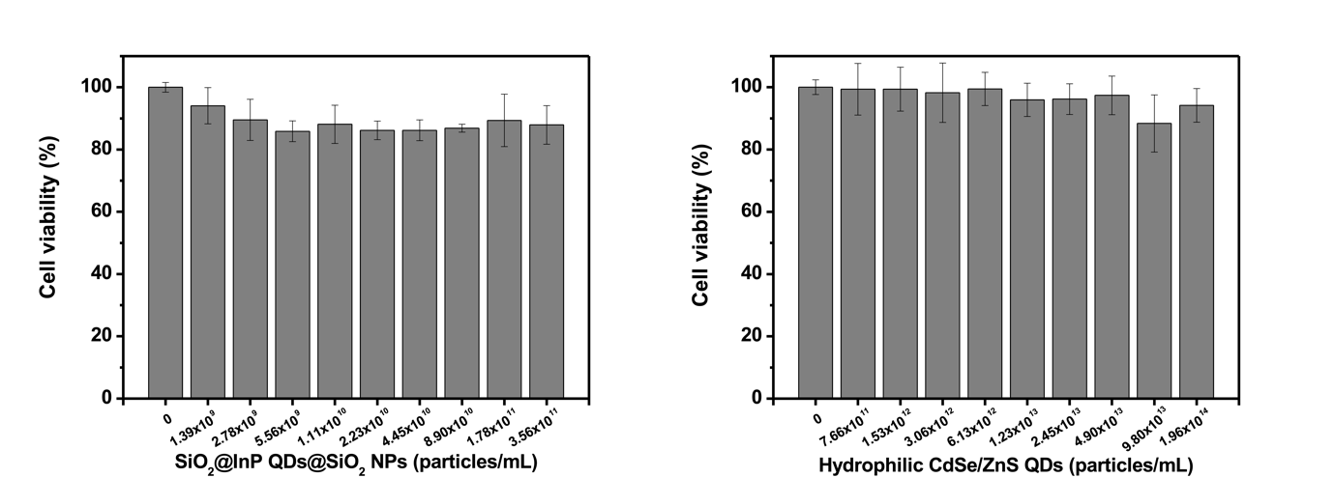
Fig. S3. Cytotoxicity investigation of SiO₂@InP QDs@SiO₂ NPs and hydrophilic CdSe/ZnS QDs. Cell viability of A549 cells in DMEM after 24 hours incubation with SiO₂@InP QDs@SiO₂ NPs and hydrophilic CdSe/ZnS QDs

