Supplementary Material: Biochar as a carbon dioxide removal strategy in integrated long-run climate scenarios
Candelaria Bergero^{1,2}, Marshall Wise¹*, Patrick Lamers³, Yong Wang³, Maridee Weber¹
¹ Joint Global Change Research Institute (Pacific Northwest National Laboratory and University of Maryland), 5825 University Research Court, College Park, MD, USA
² Department of Earth System Science, University of California, Irvine, CA, USA
³ National Renewable Energy Laboratory, 15013 Denver W Pkwy, Golden, CO, USA
*Corresponding author: marshall.wise@pnnl.gov

Supplementary Material 1 (SM1) – Carbon Prices
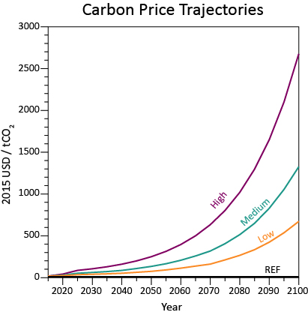
Figure SM1 | The four carbon price trajectories in this study: High, Medium, Low and Reference. High carbon price trajectories are those required to meet a radiative forcing of 2.6 W/m² by 2100 in default GCAM v5.3 (without biochar or any further changes from this study). The Medium carbon price trajectory is half of the High price, and the Low carbon price trajectory is half of the Low price. The Reference carbon price trajectory equals one cent in each model period to allow carbon sequestration to operate in the model (which includes biochar). The one cent value is understood as zero.
Supplementary Material 2 (SM2) – Scenario Matrix
Table SM1 | Scenario Matrix. Each column represents a scenario component, and each row represents one of the 36 scenarios run. Colors show carbon price trajectories from Reference (no carbon price), to Low, Medium, and High. We run 4 scenarios without biochar, and 32 with biochar. Scenarios can have an application rate of 0 tons per hectare (t/ha, for those scenarios without biochar), 10 t/ha or 20 t/ha. We also modeled yield improvements based on biochar application to compare to default yields. Finally, we either allow BECCS or not.
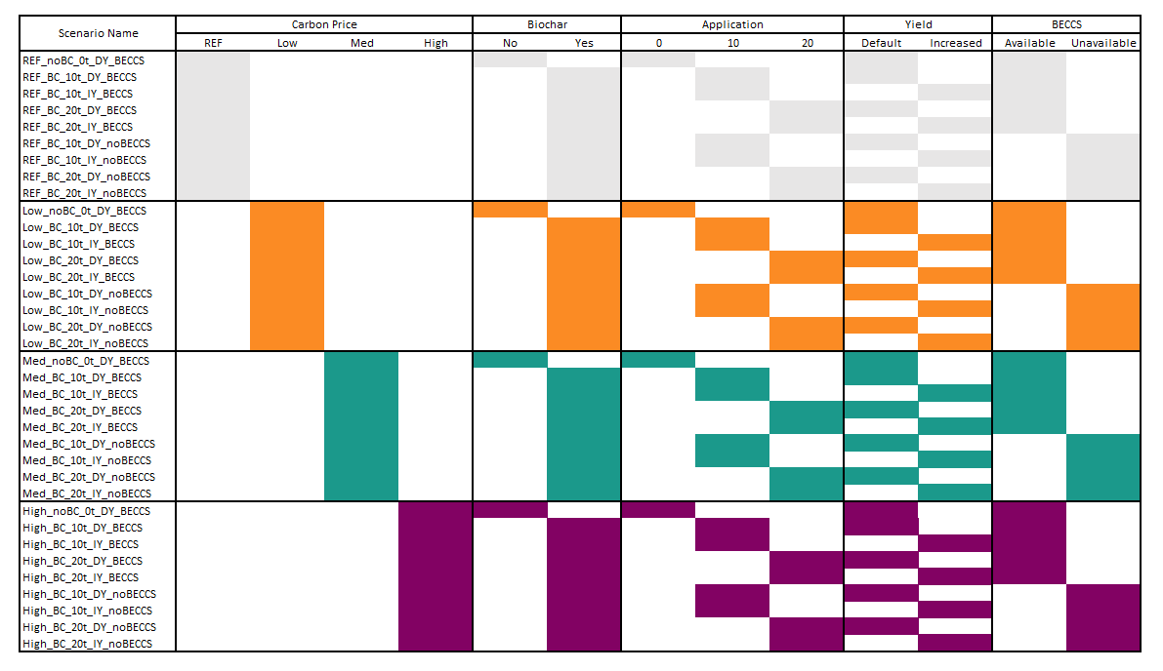

Supplementary Material 3 (SM3) – Negative Emissions Constraint in GCAM
Note that GCAM has an embedded assumption related to how much money can be spent on negative emissions. This limit represents 1% of GDP and is meant to cap how much can a region spend relative to its GDP to subsidize negative emissions. Because of this assumption, carbon prices affect the slope of emissions reductions, but not necessarily the long-term reduction. Similar to this, carbon sequestration follows a bell curve with higher carbon prices deriving in more rapid and larger sequestration in the mid-term, with a decrease after the cap that derives in convergence between different carbon prices in the long-term.

Supplementary Material 4 (SM4) – Climate Results
Biochar as a CDR option in global, long-term scenarios
Biochar can lower climate forcing and temperature increases compared to pre-industrial levels, product of reduced global CO₂ emissions and increased CO₂ sequestration (Fig. SM2). The total climate forcing in a Reference case without biochar grows from 2.6 watts per meter squared (W/m²) in 2015 to about 6.6 W/m² in 2100, which relates to a temperature increase from 1.19 to 3.71°C in the same period compared to pre-industrial times (Fig. SM2 a-b). Carbon prices reduce global climate forcing and projected temperature: the higher the carbon price, the lower the global radiative forcing and temperature compared to the Reference case. More importantly, biochar allows for a slightly lower forcing and temperature via increased yields, offering an additional reduction. By 2100, global radiative forcing is 0.7, 1.7, 1.9 and 2% lower in the Reference, Low, Medium, and High carbon price trajectories, respectively, in scenarios with biochar compared to the no biochar scenario. By the same year, biochar application allows for a decrease in temperature of 0.5, 1.1, 1.8 and 1.7% for the Reference, Low, Medium, and High carbon price trajectories, respectively. However, eliminating BECCS deployment in refining, electricity generation and hydrogen production increases both climate forcing and temperature, given that BECCS is a competitive CDR option, when carbon prices are present. By the end of the century, the lowest global warming potential and temperature increase compared to the Reference case is seen in the scenarios with the highest carbon price, where biochar and BECCS are available and where yield increases are incorporated. In these two scenarios, by 2100, the climate forcing reaches less than 2.46 W/m², and the temperature increase is less than 1.70°C.
Global CO₂ emissions grow from about 35.4 gigatons of CO₂ per year (GtCO₂/yr) in 2015 to about 66.4 GtCO₂/yr by 2100 in a Reference case without biochar. Introducing carbon prices into the model penalizes carbon emissions and thus emissions decrease in all scenarios compared to a Reference case. In the short- and medium-term, the higher the carbon price the lower the carbon emissions, although in the long-term emissions seem to converge given model assumptions on negative emissions feasibility (see SM3). The higher the carbon price trajectory the sooner the emission reductions appear. Biochar deployment allows for a further reduction in CO₂ emissions (between 0.11 and 0.3 GtCO₂ by 2100), and modeling crop yield improvements and increasing application rates decreases emissions even further (between 0.5 to 2.6 GtCO₂ by 2100), given that there is an additional economic incentive that drives a higher biochar deployment. If BECCS were not available to deploy, then emissions increase overall, since this represents a limitation of CDR options in the model.
Carbon sequestration results are the flip side to carbon emissions, with higher sequestration under higher carbon prices. Since biochar is a CDR technology, allowing the deployment of biochar increases overall carbon sequestration, with application rates and yield impacts playing a role in this increase. Limiting BECCS deployment reduces total carbon sequestration. In the longer-term, the plateau and subsequent decrease observed in most scenarios for carbon sequestration, particularly the most ambitious carbon price trajectory, is a result of a modeling assumption regarding the amount of global net negative emissions that is economically feasible (see SM3).

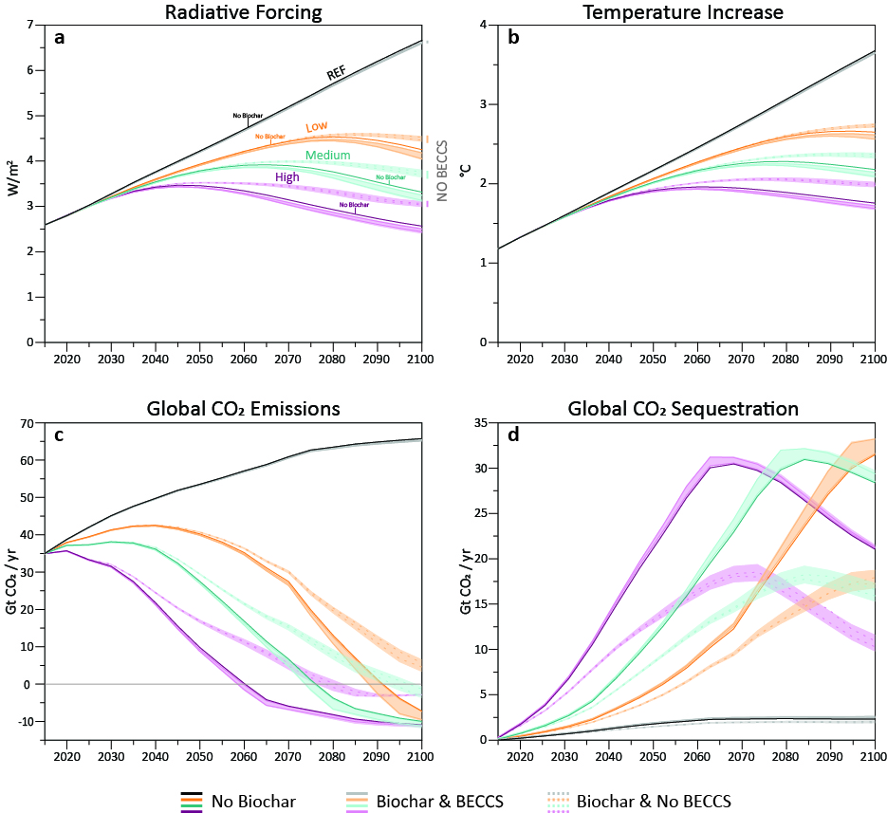

Figure SM2| The four panels represent (a) total climate forcing, (b) temperature increase, (c) global CO₂ emissions and (d) global total CO₂ sequestration. Each panel shows the 36 scenarios modeled here, with each color representing a carbon price trajectory. A darker shade of the color represents the 4 scenarios without biochar, whereas the lighter shade of the color represents scenarios where we include biochar. Solid lines represent scenarios where BECCS is available whereas dotted and shaded lines represent scenarios where BECCS is unavailable.

Supplementary Material 5 (SM5) – Biochar Carbon Sequestration
In a Reference case, global biochar carbon sequestration never exceeds 0.4 GtCO₂/yr (Fig. SM3a). In the Low carbon price trajectories, by the peak-year of 2095 global carbon sequestration from biochar ranges between 0.2 and 2.4 GtCO₂/yr. By 2095, in this carbon price trajectory increasing application rates from 10 t/ha to 20 t/ha increases sequestration by 35% with default yields, and by 89% with increased yields. Modeling yield improvements increases carbon sequestration by 465% and 693% with application rates of 10 and 20 t/ha, respectively, compared to modeling default yields. When BECCS are unavailable, biochar increasingly sequesters carbon, peaking at 2.6 GtCO₂/yr in 2100 in the scenario with increased yields and an application rate of 20 t/ha (Fig. SM3b).
In the Medium carbon price trajectories, global biochar carbon sequestration by the peak-year of 2080 ranges between 0.2 and 1.8 GtCO₂/yr when BECCS are available. By the peak-year, doubling application rates from 10 to 20 t/ha increases carbon sequestration by 38% and 84% in scenarios with default and increased yields, respectively. Modeling yield improvements increases carbon sequestration by 376% and 534% in scenarios with application rates of 10 and 20 t/ha respectively. Not allowing BECCS in the model leads to a maximum global biochar carbon sequestration of 2.8 GtCO₂/yr by 2100 in the scenario with increased yields and an application rate of 20 t/ha (Fig. SM3c).
In the High carbon price scenarios, by the peak-year of 2065 biochar sequesters between 0.2 and 1.4 GtCO₂/yr where BECCS are available. By 2065, doubling application rates increases global biochar carbon sequestration by 55% and 76% in scenarios with default and increased yields, respectively. By the same year, modeling increased yields leads to 264% and 318% higher sequestration in scenarios with 10 and 20 t/ha, respectively, compared to not modeling these yield improvements. The maximum biochar carbon sequestration is achieved by 2100 in scenarios without BECCS, with a maximum of 2.8 GtCO₂/yr by 2100 in the scenario with increased yields and an application rate of 20 t/ha (Fig. SM3d).

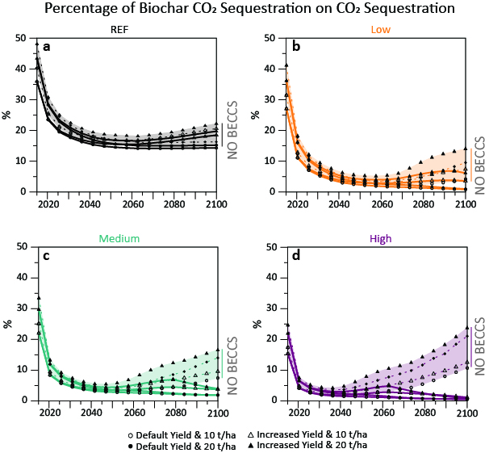
Figure SM3 | Percentage of biochar carbon dioxide sequestration on total carbon dioxide sequestration based on different carbon price trajectories: (a) Reference, (b) Low, (c) Medium, and (d) High. Solid lines represent scenarios where BECCS is available, whereas dotted and shaded lines represent scenarios where BECCS is unavailable. Circle geoms represent scenarios with default yields and application rates of either 10 t/ha (white circle) or 20 t/ha (black circle). Increased yields are represented by triangle geoms, with 10 t/ha (white triangle) and 20 t/ha (black triangle).

Supplementary Material 6 (SM6) – Biochar Demand and the Effects of Varying Assumptions
In the Reference carbon price trajectories, global biochar demand ranges between 34 and 104 Mt by 2100. There is almost no difference in these scenarios when BECCS is available or unavailable given that there are no incentives to sequester carbon. Increasing application rates from 10 to 20 t/ha increases demand by almost 30% with default yields, and by 19% with increased yields by 2100. Modeling yield improvements increases biochar demand by 147% and 133% in scenarios with application rates of 10 and 20 t/ha, respectively, also by 2100 (manuscript Fig. 2a, top left).
In the Low carbon price trajectories, global biochar demand ranges between 66 and 776 Mt by the peak-year of 2095. This range goes from a scenario with an application rate of 10 t/ha, default yields and BECCS availability, to one with 20 t/ha, increased yields and BECCS unavailability. When BECCS are available, doubling application rates increases biochar demand by 36 and 89% for scenarios with default and increased yields, respectively, by 2095. Modeling yield improvements increases biochar demand by 462 and 679% in scenarios with 10 and 20 t/ha, respectively, and with BECCS availability by the same year. Eliminating BECCS from the model allows for biochar demand to grow throughout the century, and by 2100 demand for this organic matter reaches a maximum of 839 Mt in the scenario with increased yields and an application rate of 20 t/ha. Interestingly, when BECCS are unavailable the change in application rate has a larger impact than modeling increased yields: doubling application rates increases biochar demand by 161 (default yields) and 110% (increased yields), whereas modeling yield improvements increases demand by 114 (10 t/ha) and 72% (20 t/ha) by 2095 (manuscript Fig. 2a, top right).
By its peak-year of 2080, in the Medium carbon price scenarios biochar demand ranges between 68 and 699 Mt. In scenarios with BECCS availability, doubling application rates increases demand by 38 and 84% in pathways with default and increased yields, respectively. In the scenario with an application rate of 10 t/ha, modeling increased yields leads to a 388% higher biochar demand, whereas in the scenario with 20 t/ha the increase is 541%. In scenarios where BECCS are unavailable, increasing application rates from 10 to 20 t/ha increases biochar demand by 162 and 106%, respectively, whereas modeling yield improvements leads to an increase in biochar demand of 98% (10 t/ha) and 56% (20 t/ha) (manuscript Fig. 2a, bottom left).
In the High carbon price scenarios with BECCS global biochar demand ranges from 74 to 465 Mt by 2065, the peak-year. In scenarios with BECCS availability, doubling application rates increases biochar demand by 52 and 78% in scenarios with default and increased yields, respectively, by 2065. By the same year, modeling yield improvements leads to a biochar increase of 253 (10 t/ha) and 319% (20 t/ha). By 2100, when BECCS are unavailable, doubling application rates increases biochar demand by 127 (default yields) and 115% (increased yields), whereas the increase caused by modeling yield improvements is 24 (10 t/ha) and 20% (20 t/ha) (manuscript Fig. 2a, bottom right).
Supplementary Material 7 (SM7) – Putting Biochar in the Biomass Context
Even though biochar deployment allows for a decrease in CO₂ emissions and in climate variables, such as temperature and global warming potential (SM4), biochar demand for biomass is within the boundaries of other sectors (Fig. SM4 and SM5). Total global biomass consumption and production increases in all scenarios compared to Reference, with higher carbon prices resulting in higher biomass values in the medium term (Fig. SM6). Global biomass consumption and production in 2015 is around 26 EJ (this consists of purpose-grown lignocellulosic biomass, crop residues and municipal solid waste, Fig. SM7). In the long-term biomass demand peaks on different periods depending on the carbon price trajectory, and then slowly decreases, product of the assumption on how much can be spent on negative emissions on GCAM (as explained in SM3). By 2100, in the scenarios with a Reference carbon price trajectory, global biomass consumption never increases 112 EJ, compared to between 263-349 EJ, 278-371 EJ, and 133-236 EJ in a Low, Medium, and High carbon price trajectory, respectively.

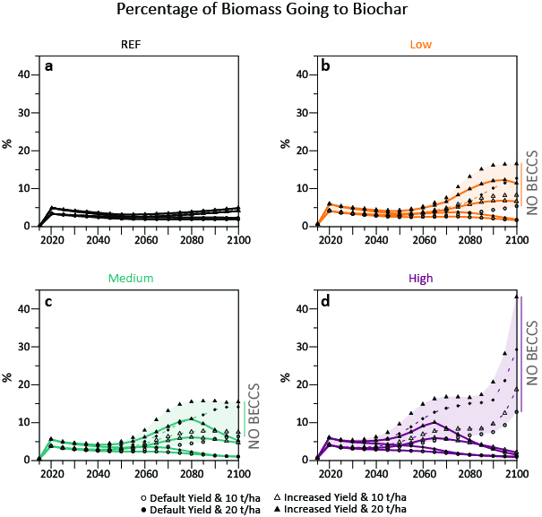
Figure SM4 | Percentage of biomass going into biochar production based on different carbon price trajectories: (a) Reference, (b) Low, (c) Medium, and (d) High. Solid lines represent scenarios where BECCS is available, whereas dotted and shaded lines represent scenarios where BECCS is unavailable. Circle geoms represent scenarios with default yields and application rates of either 10 t/ha (white circle) or 20 t/ha (black circle). Increased yields are represented by triangle geoms, with 10 t/ha (white triangle) and 20 t/ha (black triangle).
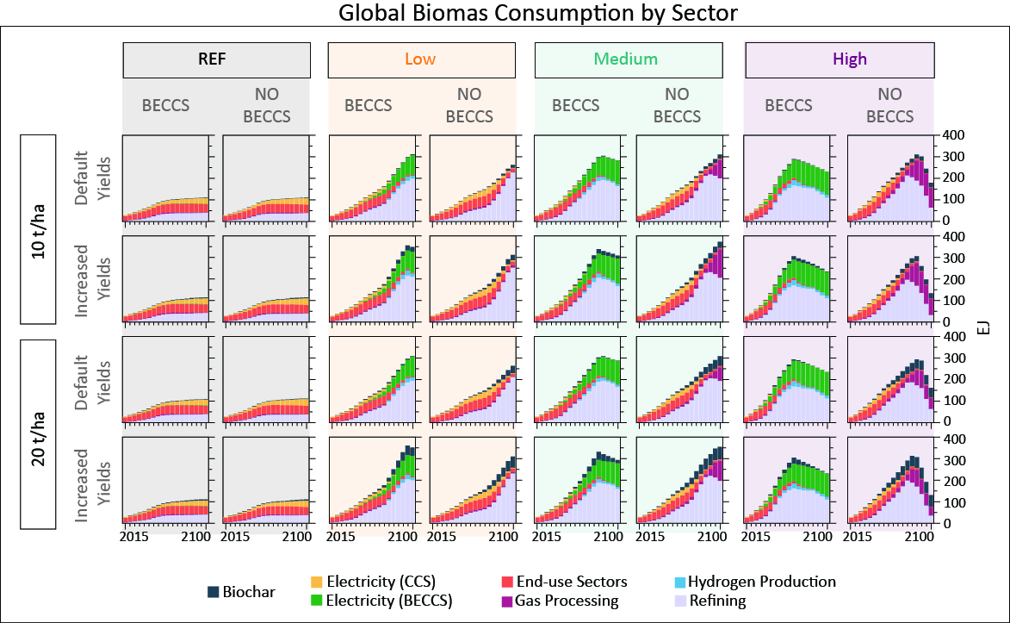
Figure SM5 |Global biomass consumption by sector in each scenario. Each facet represents one scenario, each column represents a combination of carbon price and BECCS availability (e.g., “REF & BECCS”), and each row represents a combination of the application rate and yield improvements (e.g., “10 t/ha & Default Yields”). Note that there are 32 scenarios out of 36, since the remaining 4 scenarios do not have biochar deployment.

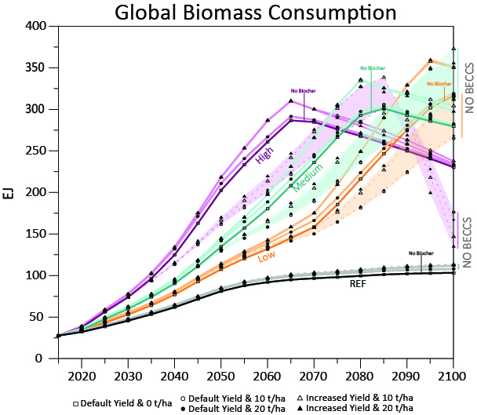

Figure SM6 | Total global biomass consumption by scenario. Each color represents a carbon price trajectory. A darker shade represents the 4 scenarios without biochar, whereas a lighter shade represents the 32 scenarios with biochar. Solid lines represent scenarios where BECCS is available, whereas dotted and shaded lines represent scenarios where BECCS is unavailable. Square geoms represent scenarios without biochar, thus default yields and 0 t/ha application rates. Circle geoms represent scenarios with default yields and application rates of either 10 t/ha (white circle) or 20 t/ha (black circle). Increased yields are represented by triangle geoms, with 10 t/ha (white triangle) and 20 t/ha (black triangle).

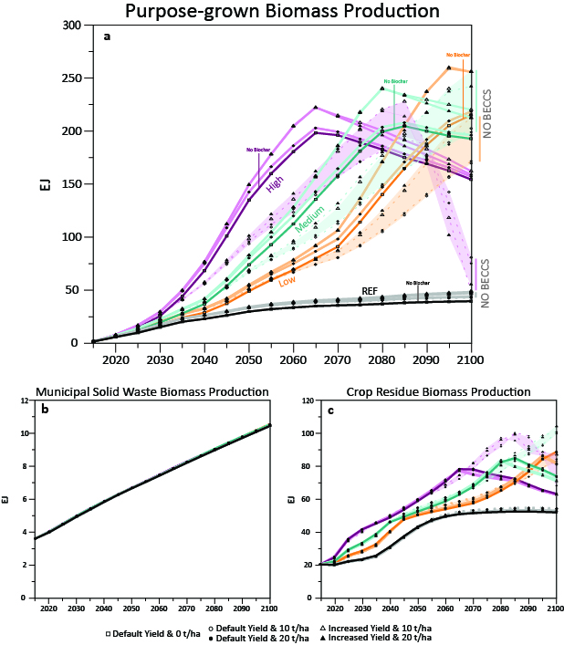
Figure SM7 | Total global biomass production from (a) purpose-grown biomass, (b) municipal solid waste, and (c) crop residue. Each color represents a carbon price trajectory. A darker shade represents the 4 scenarios without biochar, whereas a lighter shade represents the 32 scenarios with biochar. Solid lines represent scenarios where BECCS is available, whereas dotted and shaded lines represent scenarios where BECCS is unavailable. Square geoms represent scenarios without biochar, thus default yields and 0 t/ha application rates. Circle geoms represent scenarios with default yields and application rates of either 10 t/ha (white circle) or 20 t/ha (black circle). Increased yields are represented by triangle geoms, with 10 t/ha (white triangle) and 20 t/ha (black triangle).
Supplementary Material 8 (SM8) – Regional Biochar Demand
By midcentury, regional biochar demand does not vary much by scenario except when there is a High carbon price trajectory (Fig. SM8a). Within each carbon price trajectory, increasing yields, increasing application rate, and not having BECCS available leads to a greater demand for biochar. By 2100 (Fig. SM8b), the regional variation is more apparent, but the same behavior is observed. In a Reference carbon price trajectory with increased yields, Western Africa has the highest biochar demand of any region. Increasing yields and application rate to 20 t/ha results in a noticeable increase in biochar demand in Canada and the Middle East. In the scenarios with a carbon price, not having BECCS available results in an increase in biochar demand in almost all regions due to its greater appeal as a carbon removal technology. This is especially evident in the High carbon price trajectory, where biochar is less competitive and therefore less demanded when BECCS is available versus unavailable. Across all carbon price scenarios, increased yields also result in an increase in biochar demand due to the additional appeal of increased crop production. In the scenarios that results in the highest demand for biochar (20 t/ha, increased yields, no BECCS, carbon price), the regions that demand the most are consistently Western Africa and India.
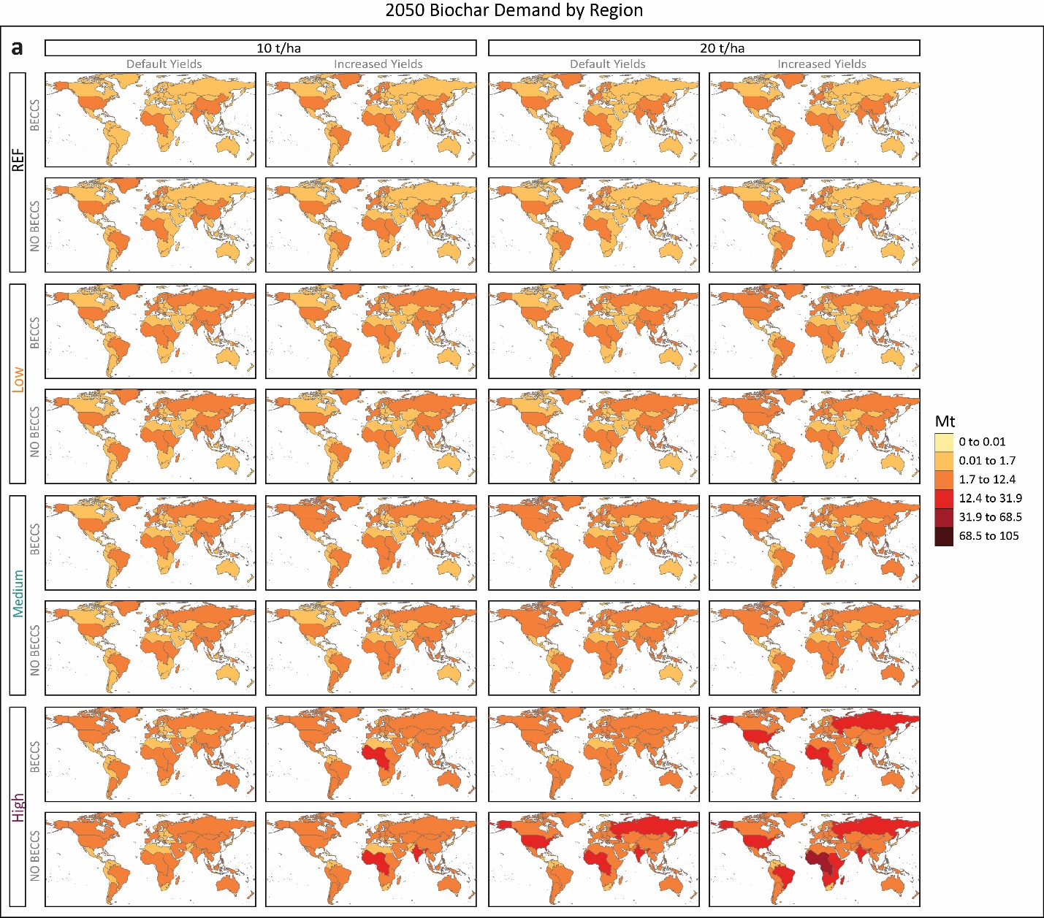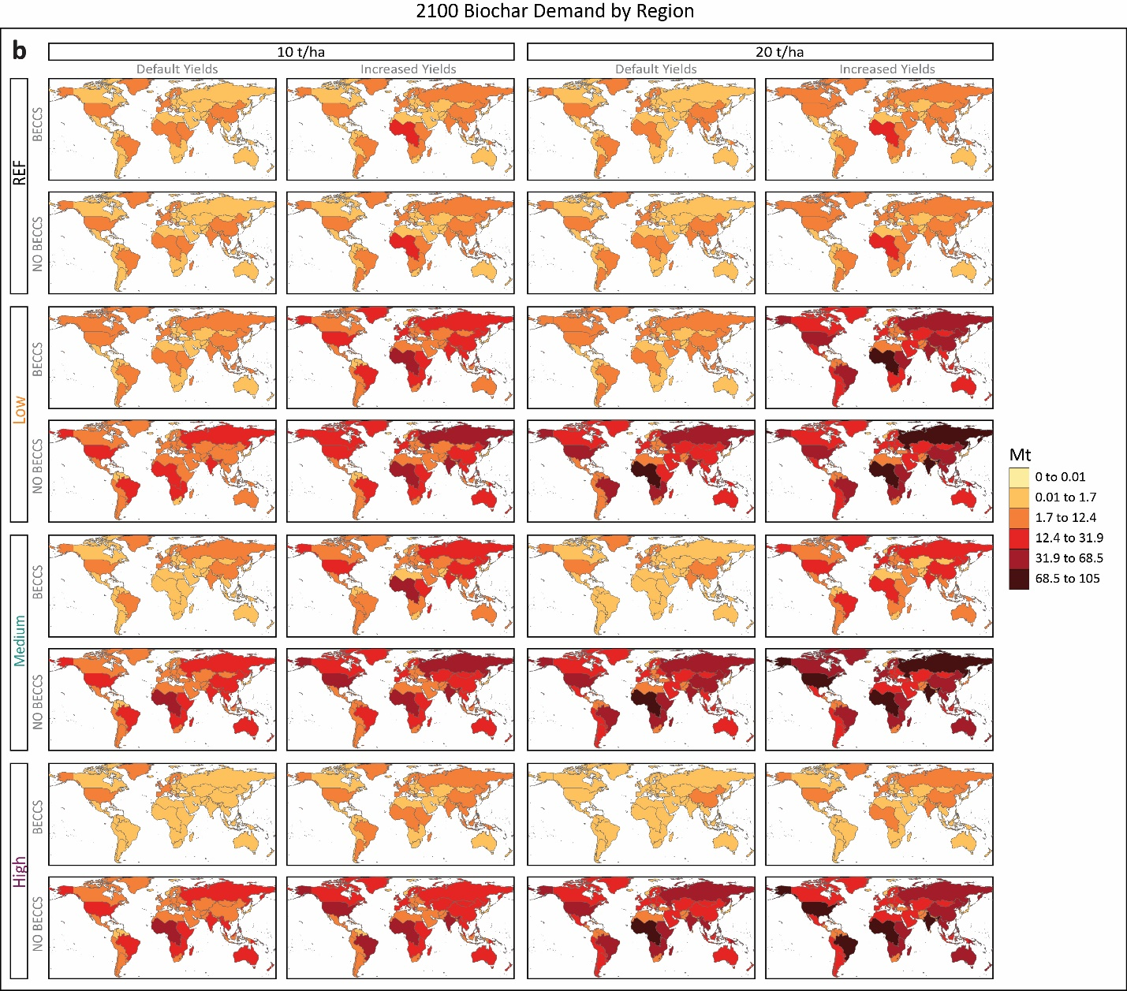
Figure SM8 | Regional biochar demand in (a) 2050 and (b) 2100. Each facet represents one scenario, each column represents a combination of the application rate and yield improvements (e.g., “10 t/ha & Default Yields”), and each row represents a combination of carbon price and BECCS availability (e.g., “REF & BECCS”). Note that there are 32 scenarios out of 36, since the remaining 4 scenarios do not have biochar deployment.

Supplementary Material 9 (SM9) – Cropland Allocation in Detail
We assume that biochar application occurs once on each plot of land during the study horizon to 2100. That application is not applied immediately to the share of land that is determined by GCAM to be economic for biochar in the long-term but applied in smaller increments equally over the model horizon. Specifically, our assumption of yield increases on biochar land assume that $\sim$¹/₁₆th of the land determined by GCAM in a period to be economic for biochar receives a biochar application each period. This value comes from biochar application beginning in 2020 and continuing through 2100 (81 years, inclusive) and GCAM modelling in 5-year intervals (81/5 = 16.2). The total amount of land in biochar in each period is an accumulation of the current and all previous periods’ application amounts.

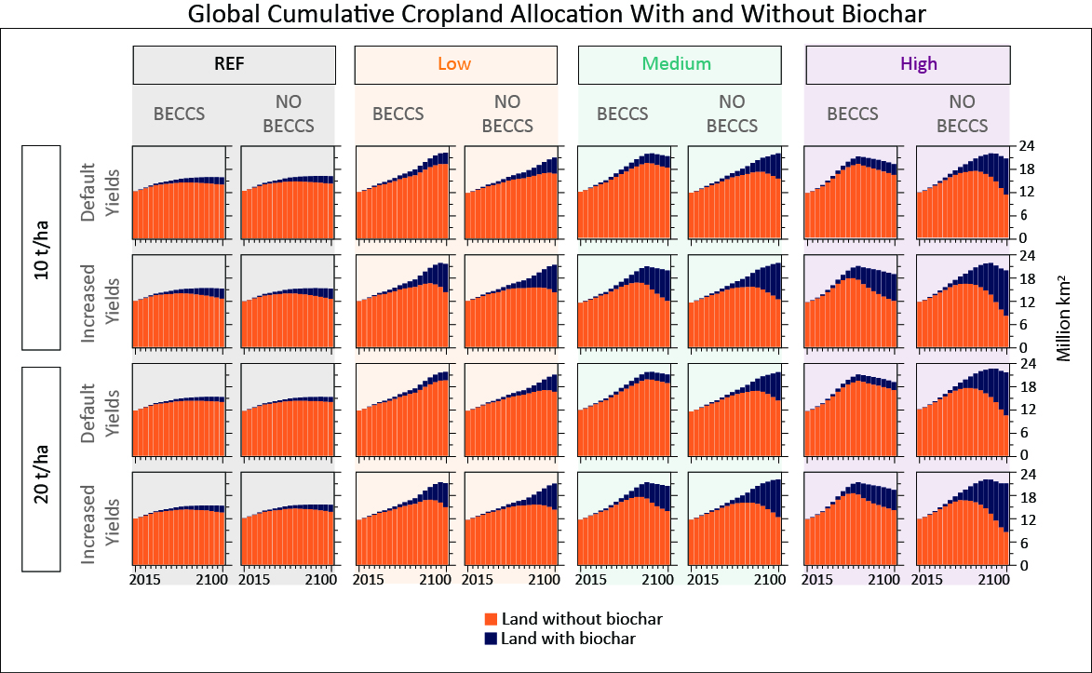
Figure SM9 | Cumulative cropland allocation with and without biochar in each scenario. Each facet represents one scenario, each column represents a combination of carbon price and BECCS availability (e.g., “REF & BECCS”), and each row represents a combination of the application rate and yield improvements (e.g., “10 t/ha & Default Yields”). Note that there are 32 scenarios out of 36, since the remaining 4 scenarios do not have biochar deployment.

Supplementary Material 10 (SM10) – Land Impacts
The largest relative changes in land allocation happens in land used to grow biomass, in other arable land, followed by grazed pasture and by cropland. The other arable land in GCAM refers to land that could be productive but is not currently cultivated (such as fallow land). The larger the carbon price, the higher the incentives to deploy biomass (particularly in the form of BECCS), the more land gets allocated to biomass production, the more the other arable land diminishes. Forest land allocation decreases in all scenarios compared to Reference (both managed and unmanaged), mostly explained by biomass cropland expansion. Total global land allocation to crops increases in all scenarios compared to the Reference case, with yield improvements diminishing this slightly, since less land is required per unit of carbon sequestered.
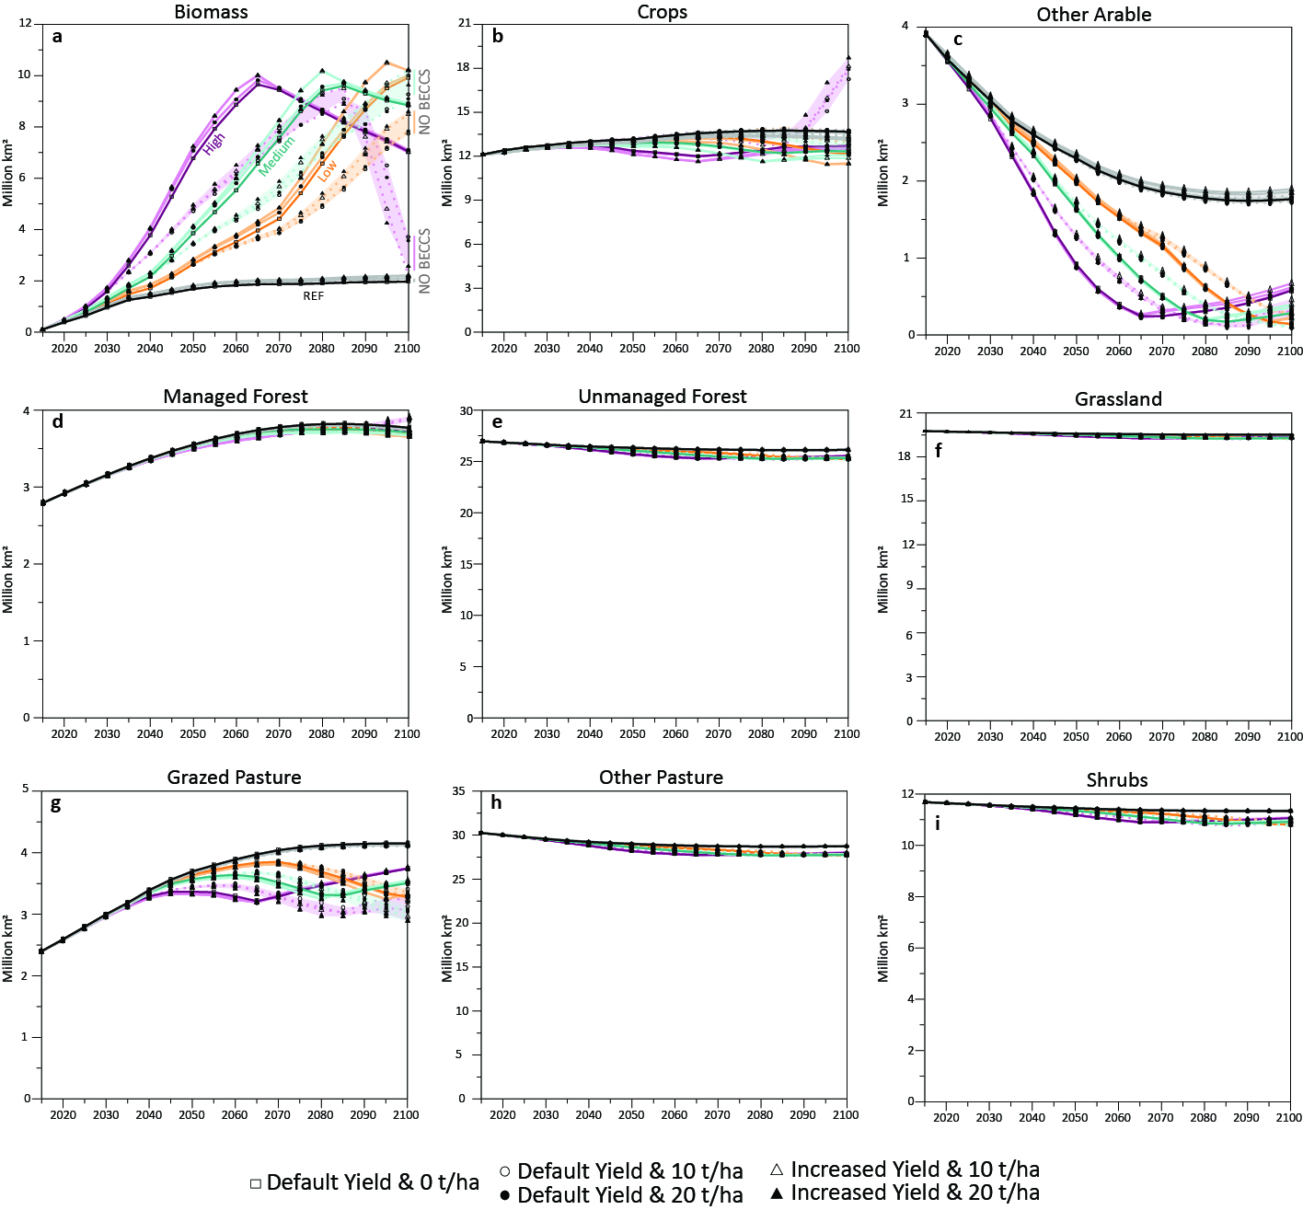
Figure SM10 | Global land allocation by land type: (a) biomass, (b) crops, (c) other arable land, (d) managed forest, (e) unmanaged forest, (f) grassland, (g), grazed pasture, (h) other pasture, and (i) shrubs. Each line represents one scenario, and each color represents one carbon price trajectory. A darker color represents a no-biochar case, and a lighter shade of the color represents scenarios with biochar. Solid lines represent scenarios where BECCS are available and dotted and shaded lines those where BECCS is unavailable. A square geom represents default yields and 0 application rates, a circle represents default yields, and a triangle represents increased yields. The white circular and triangular geoms represent application rates of 10 t/ha, whereas a black geom represents application rates of 20 t/ha. Note different scales on y-axes.

Supplementary Material 11 (SM11) – Refined Liquid Fuel Production
Higher carbon prices lead to lower refined liquid fuel production, given that there is an electrification of end-use sectors (SM14), especially transportation. In 2015 total global refined liquid fuel production is about 177 EJ, which increases to almost 366 EJ by 2100 in a Reference case, with little impact when including biochar (Fig. SM11).
The different carbon prices derive in lower total global refined liquid fuel production, with higher prices causing larger reductions compared to the Reference case. By 2100, refined liquid fuel production in scenarios without biochar range from 239 EJ, to 180, to 137 EJ, in the Low, Medium and High carbon price scenarios, respectively.
Eliminating BECCS deployment in the model increases global refined liquid fuel production by 6-13%, 20-28% and 25-34% in the Low, Medium, and High carbon price trajectories by 2100, respectively, with the range representing the different scenario variations. This increase is largely driven by a growth in bioliquids production (without CCS) since this conversion pathway offers, at least, carbon-neutral fuels for transportation (Fig. SM12). Eliminating BECCS deployment increases bioliquids in the refining sector, since there are fewer low-carbon technology options in this sector, as opposed to the electricity generation sector, for example, where eliminating BECCS mostly increases renewable energies (SM14).

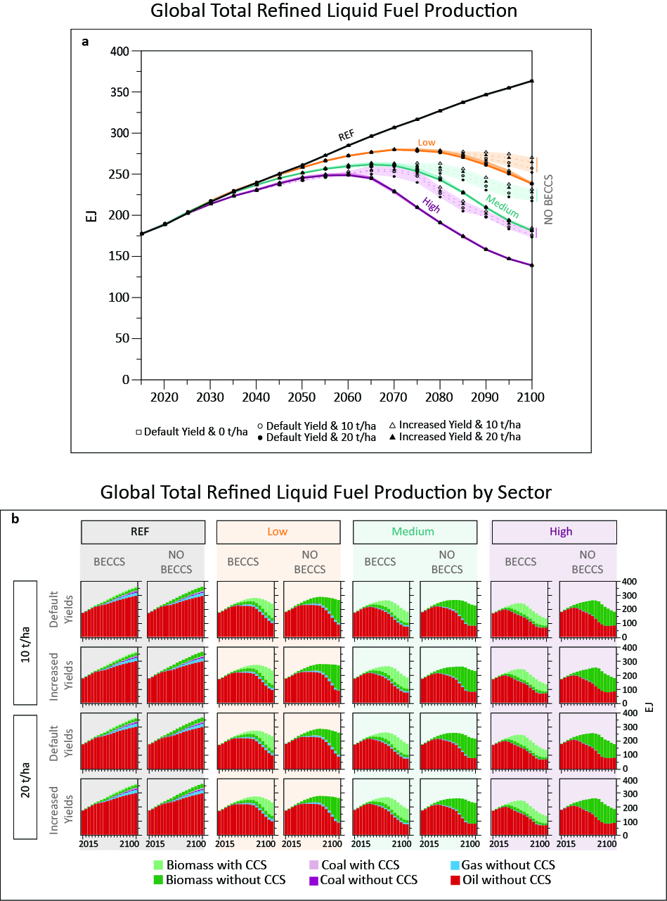
Figure SM11 | Total global refined liquid fuel production (a) and refined liquid fuel production by technology (b). In panels (a) each line represents one scenario, and each color represents one carbon price trajectory. A darker color represents a no-biochar case, and a lighter shade of the color represents scenarios with biochar. Solid lines represent scenarios where BECCS are available and dotted and shaded lines those where BECCS is unavailable. A square geom represents default yields and 0 application rates, a circle represents default yields, and a triangle represents increased yields. The white circular and triangular geoms represent application rates of 10 t/ha, whereas a black geom represents application rates of 20 t/ha. In (b) each facet represents one scenario, each column represents a combination of carbon price and BECCS availability (e.g., “REF & BECCS”), and each row represents a combination of the application rate and yield consideration (e.g., “10 t/ha & Default Yields”).
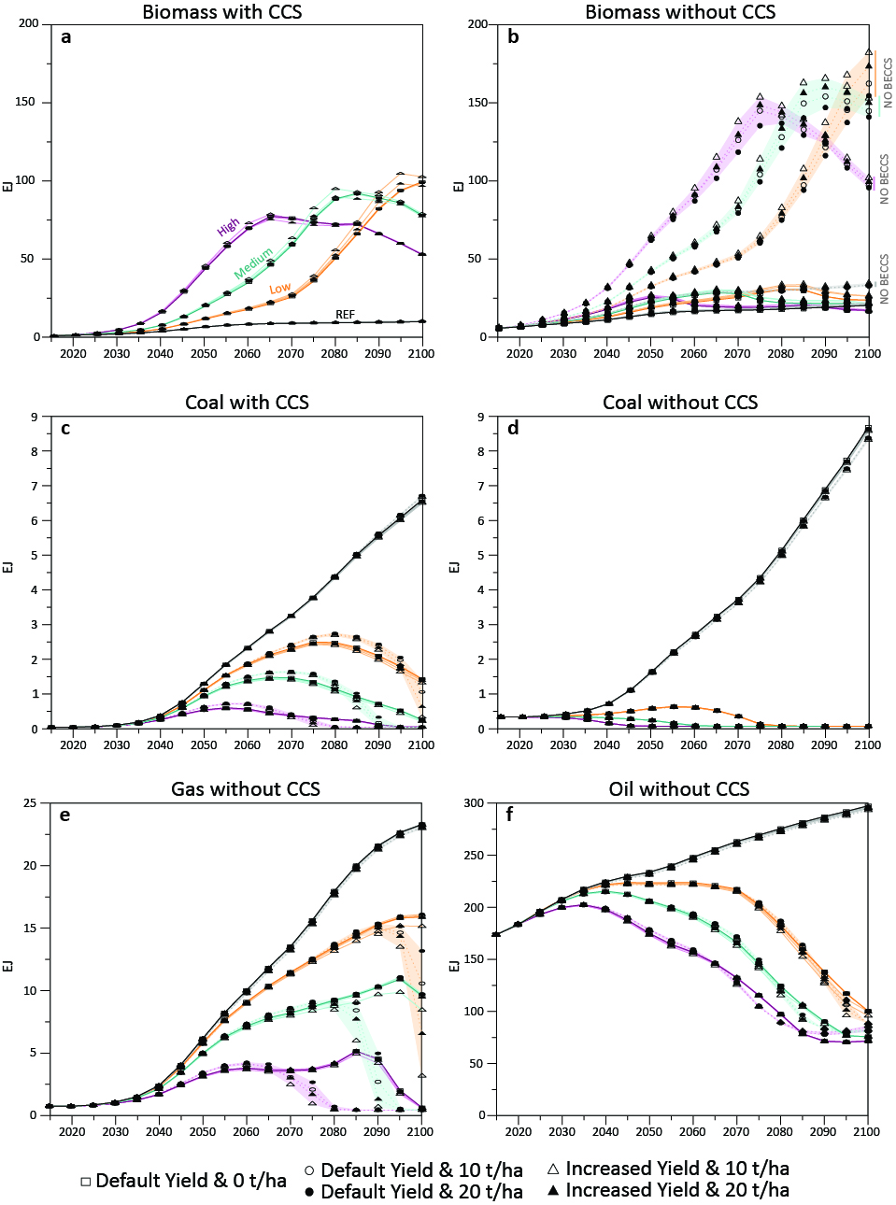
Figure SM12 | Total global refined liquid fuel production by technology: (a) biomass with CCS, (b) biomass without CCS, (c) coal with CCS, (d) coal without CCS, (e) gas without CCS, and (f) oil without CCS. Each line represents one scenario, and each color represents one carbon price trajectory. A darker color represents a no-biochar case, and a lighter shade of the color represents scenarios with biochar. Solid lines represent scenarios where BECCS are available and dotted and shaded lines those where BECCS is unavailable. A square geom represents default yields and 0 application rates, a circle represents default yields, and a triangle represents increased yields. The white circular and triangular geoms represent application rates of 10 t/ha, whereas a black geom represents application rates of 20 t/ha. Note the different y-scales.
Supplementary Material 12 (SM12) – Water Withdrawals by Sector
Water withdrawals vary by sector, with reductions compared to the Reference case in water used for cattle and meat animal production, resource production and municipal water, and increases in water for crops and for electricity generation. Recall that biomass production grows significantly, product of high carbon prices (Fig. SM13). Restricting BECCS deployment reduces global water withdrawals even further, since there is less overall electricity generation, particularly from BECCS, which demands water for cooling (Fig. SM13c).

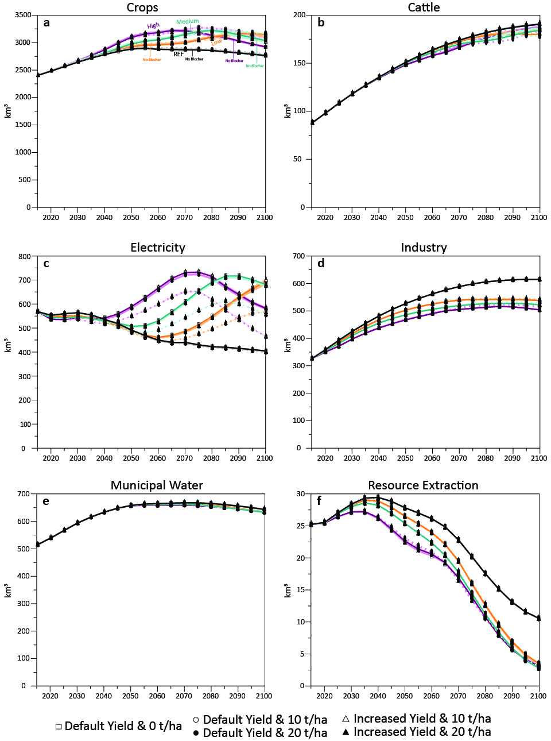
Figure SM13 |Global water withdrawals by sector: (a) crops, (b) cattle, (c) electricity, (d) industry, (e) municipal water, and (f) resource extraction. Each line represents one scenario, and each color represents one carbon price trajectory. A darker color represents a no-biochar case, and a lighter shade of the color represents scenarios with biochar. Solid lines represent scenarios where BECCS are available and dotted and shaded lines those where BECCS is unavailable. A square geom represents default yields and 0 application rates, a circle represents default yields, and a triangle represents increased yields. The white circular and triangular geoms represent application rates of 10 t/ha, whereas a black geom represents application rates of 20 t/ha. Note different scales on y-axes.
Supplementary Material 13 (SM13) – Regional Water Withdrawals for Crops
By midcentury, regional water withdrawals for crops varies by region, but is overall consistent by scenario (Fig. SM14a). By 2100, (Fig. SM14b) water withdrawal is still largely consistent between scenarios, but the regional withdrawals have changed with some regions using more water than they were in 2050, while others are using less. This is particularly obvious in India and the Middle East, with both regions’ water withdrawals for crops decreasing from 2050 to 2100. Most other regions that show a visual change exhibit the opposite trend, with water withdrawal for crops increasing from 2050 to 2100. Still, the regions withdrawing the most water for crops remain India and the Middle East across both periods, and in all scenarios.

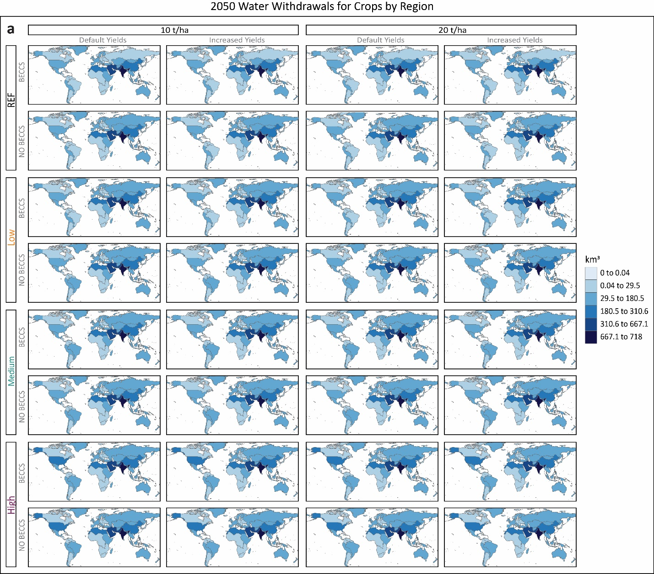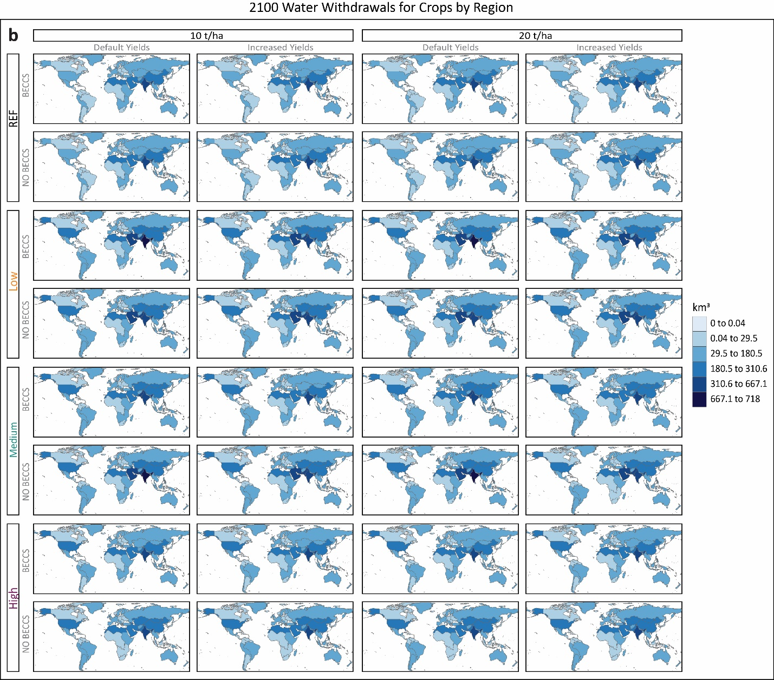
Figure SM14 | Regional water withdrawal for crops in (a) 2050 and (b) 2100. Each facet represents one scenario, each column represents a combination of the application rate and yield improvements (e.g. “10 t/ha & Default Yields”), and each row represents a combination of carbon price and BECCS availability (e.g. “REF & BECCS”). Note that there are 32 scenarios out of 36, since the remaining 4 scenarios do not have biochar deployment.

Supplementary Material 14 (SM14) – Electricity Generation
Whereas refined liquid fuel production decreases with carbon prices, (SM11) electricity generation increases. Global electricity generation in 2015 is about 87 EJ, which increases to about 311 EJ at the end of the century in a Reference case, product of growing GDP and population. By 2100, total global electricity generation increases in all scenarios compared to Reference, with higher carbon prices deriving in higher electricity generation (Fig. SM15a). Higher carbon prices also drive a decarbonization of the electricity matrix, with decreases of fossil fuels without CCS (coal, oil, and natural gas), and increases on renewable energies (biomass, nuclear, solar and wind) and fossil fuels with CCS (Fig. SM15b).
Including biochar into GCAM has no effect on total electricity generation nor its composition. As a corollary to this, nor do application rates and yield improvements. Eliminating BECCS deployment, however, does play a role in terms of both total electricity generation and its composition. Electricity generation decreases in all scenarios by 2100 when BECCS are unavailable compared to scenarios where BECCS is available, although the decrease is rather small; the larger impact of eliminating BECCS is fuel-switching. Since there is no BECCS for electricity generation, there is an increase in biomass, nuclear, solar and wind technologies, as well as some fossil fuel electricity generation with CCS (coal, gas, and oil) (Fig. SM16).

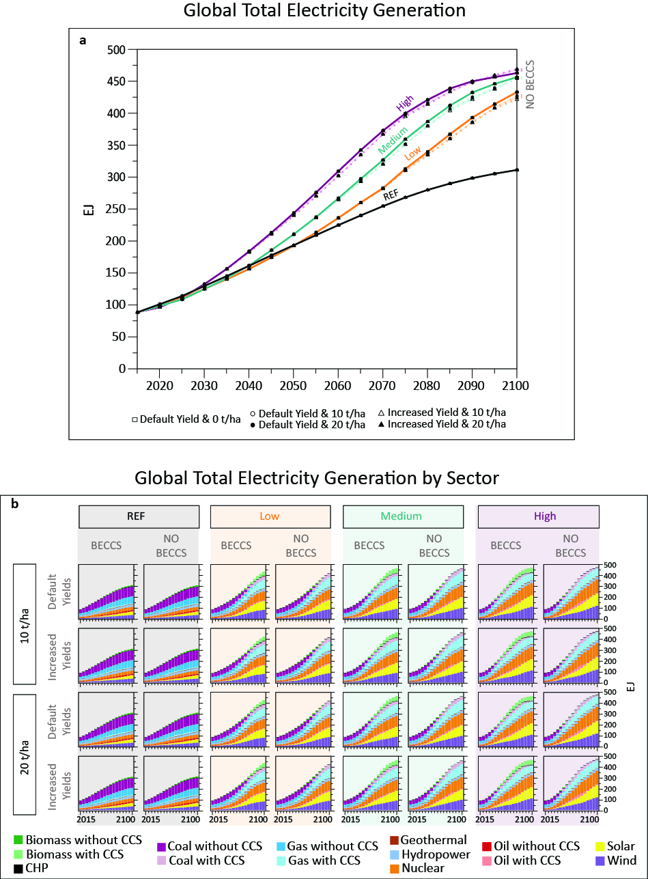
Figure SM15 | Total global electricity generation (a) and electricity generation by technology (b). In (a) each line represents one scenario, and each color represents one carbon price trajectory. A darker color represents a no-biochar case, and a lighter shade of the color represents scenarios with biochar. Solid lines represent scenarios where BECCS are available and dotted and shaded lines those where BECCS is unavailable. A square geom represents default yields and 0 application rates, a circle represents default yields, and a triangle represents increased yields. The white circular and triangular geoms represent application rates of 10 t/ha, whereas a black geom represents application rates of 20 t/ha. In (b) each facet represents one scenario, each column represents a combination of carbon price and BECCS availability (e.g., “REF & BECCS”), and each row represents a combination of the application rate and yield consideration (e.g., “10 t/ha & Default Yields”).
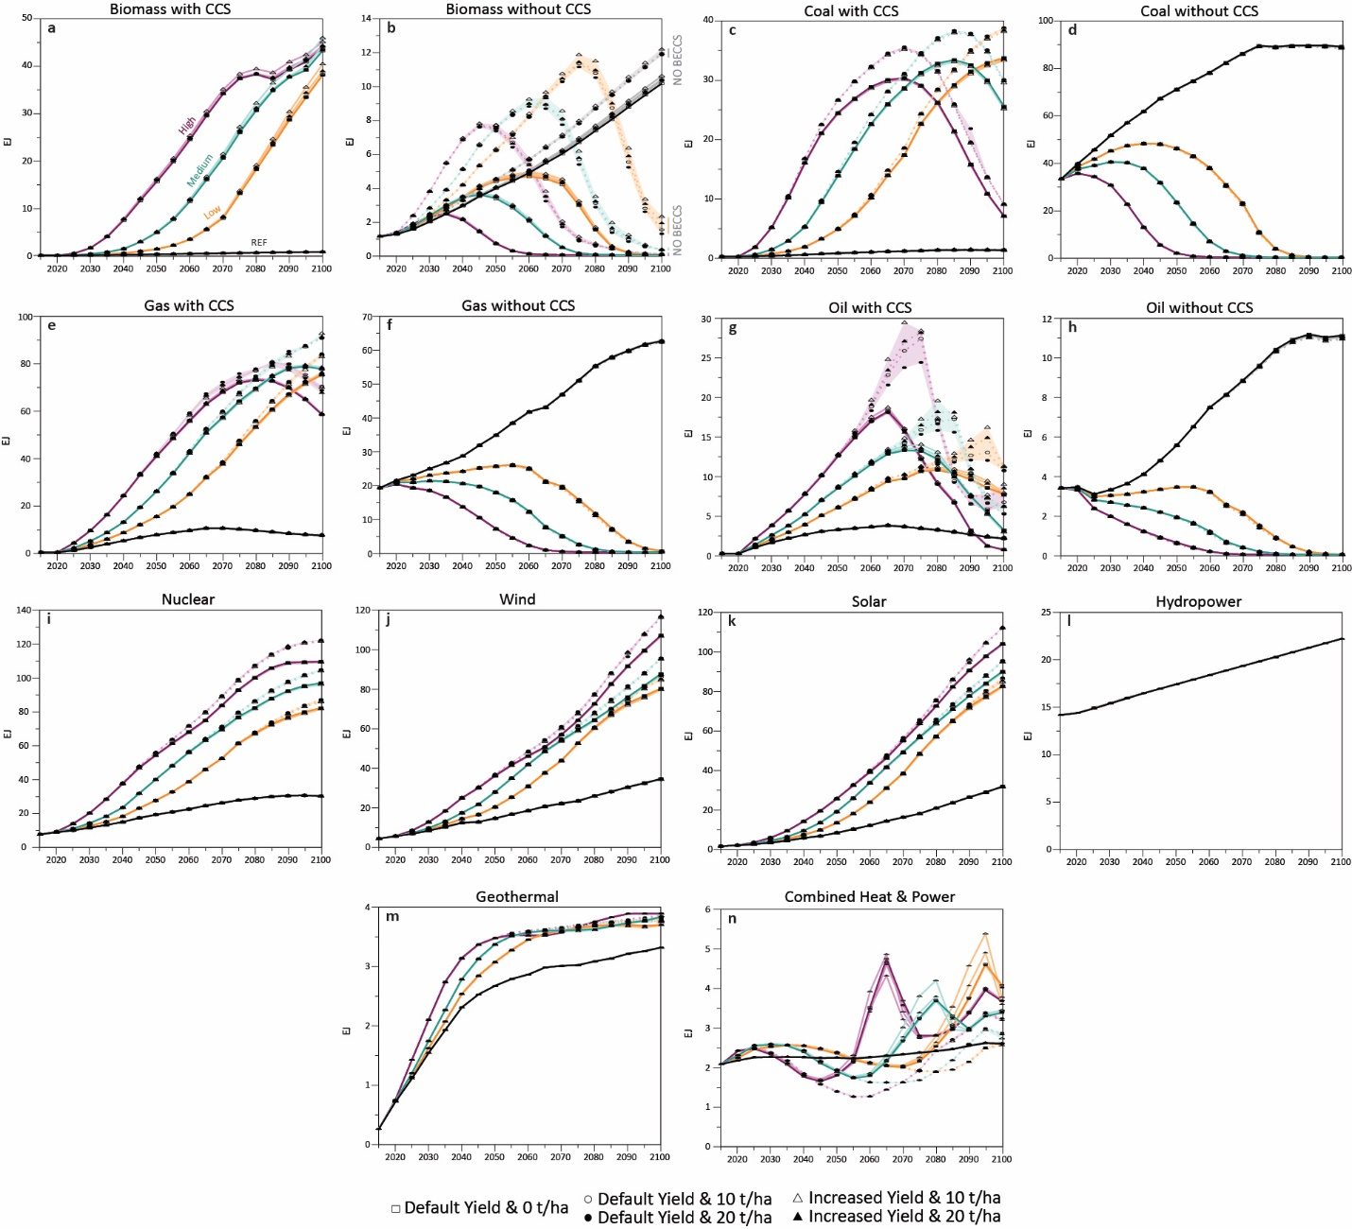
Figure SM16 | Total global electricity generation by sector. Each line represents one scenario, and each color represents one carbon price trajectory. A darker color represents a no-biochar case, and a lighter shade of the color represents scenarios with biochar. Solid lines represent scenarios where BECCS are available and dotted and shaded lines those where BECCS is unavailable. A square geom represents default yields and 0 application rates, a circle represents default yields, and a triangle represents increased yields. The white circular and triangular geoms represent application rates of 10 t/ha, whereas a black geom represents application rates of 20 t/ha. Note that GCAM v5.3 has endogenous hydropower. Note the different y-axis scales.

Supplementary Material 15 (SM15) – Yield Improvement Research
Scopus database was used to do the literature search of biochar effects on yield for different cropping systems. Key words “biochar”, “yield”, and crop name in the GCAM crop library were used during the search, for example: biochar-corn-yield. There are 15 different crop types in GCAM, with some specific crop names such as corn, wheat, and rice, while the remaining indicating certain crop types such as sugar crops, root tuber, and others. For the crop types without specifying crop names, representative crops in those types were selected (Table SM2). After literature search and screening, 145 publications were used to calculate the biochar effects on yield. An average yield change was calculated for each publication, regardless of the numbers of cropping systems, biochar application rates, field trial sites and durations involved in the publication. The yield changes were then categorized into one of the four climatic zone (temperate or tropical) and irrigation strategy scenarios (irrigated or rainfed). The yield changes were averaged in each scenario to indicate the biochar effects on yield in that climatic zone and irrigation strategy scenario.

Table SM2 | Crop library in GCAM and representative crops for crop types without specifying crop names in GCAM crop library
Crop name or type in GCAM | Representative crops for crop types | Source
Corn
Wheat
Rice
Fodder herb | alfalfa, clover | http://www.fao.org/es/faodef/fdef11e.htm
Fodder grass | rye grass | http://www.fao.org/es/faodef/fdef11e.htm
Oil crop | soybeans, sunflower, canola, rape, peanuts | https://www.ers.usda.gov/topics/crops/soybeans-oil-crops/oil-crops-sector-at-a-glance/
Sugar crop | sugar cane, sugar beet | https://www.ers.usda.gov/topics/crops/sugar-sweeteners/background/
Root tuber | potatoes, sweet potatoes, cassava | http://www.fao.org/es/faodef/fdef02e.htm
Other grains | oats, millet, sorghum, barley, rye | https://www.nationalgeographic.org/encyclopedia/grain/
Fiber crops | cotton, hemp, jute | HYDE
Palm fruit | oil palm, coconut | HYDE
Biomass | switchgrass, miscanthus | https://www.ers.usda.gov/webdocs/publications/81903/err-223.pdf?v=0
Pasture | N/A
Forest | N/A
Miscellaneous crops | N/A

