Supplementary Information for
A Feedforward Network with a Few Million Neurons Learns from Images to Covertly Attend to Contextual Cues like Human and Bayesian Ideal Observers

Authors

Sudhanshu Srivastava*, William Y. Wang, Miguel P. Eckstein

Corresponding Author: Sudhanshu Srivastava
Email: sudhanshu@ucsb.edu

This PDF file includes:

Supplementary text
Figures S.1 to S.5
SI References

Supplementary Text

S.1. Bayesian Ideal Observer Models
We describe the ideal observer models applied to the three tasks and their corresponding images. General developments of the Bayesian ideal observers can be found in many publications (1–3). The current treatment differs from previous Bayesian ideal observer treatments for the Posner cueing task and visual search (4–7) in incorporating the process of the detection of the cue. Previous model treatments incorporate a prior reflecting the conditional probability of the presence of the target given the cue but implicitly assume the perfect detection of the cue. Here, we develop a theoretically more general model that explicitly calculates the likelihoods of the data given the joint presence of the cue and target, target alone, and cue alone. When the cue visibility is high, the model makes identical performance predictions to the BIO model that only uses the priors and assumes perfect detection of the cues. Novel to this paper is the approximation to a Bayesian ideal observer for the contextual cueing task.
In the BIO framework, a decision across hypotheses $s_{i}$is arrived at by calculating a posterior probability of each hypothesis given the sensory data, $P\left(s_{i} | g\right)$. Bayes’ theorem relates the posterior probability of a hypothesis to the likelihood of the observed sensory data given the hypothesis, $P\left(g | s_{i}\right)$ and the prior probability of the hypothesis, $P\left(s_{i}\right):$
$$P\left(s_{i} | g\right)=\frac{P(s_{i})P\left(g | s_{i}\right)}{P(g)}$$ | (S.1)

Typically, the denominator, $P\left(g\right),$ which is the probability of the data over all possible hypotheses, is a constant across the various hypotheses. Thus, the BIO chooses the hypothesis with the highest product of likelihood and prior.

S.2. Calculating Likelihoods
Throughout the following sections, we will make references to the likelihood terms defined here. Suppose we have an n by m image ($g$) which contains either a luminance-defined element, a tilted line with orientation 1 ($s_{1}$), or a tilted line with orientation 0 ($s_{0}$) or a box with additive Gaussian independent noise (with mean µ and standard deviation σ). Thus, each pixel luminance, $g_{p}$ of $g$ is a corresponding luminance pixel of $s_{i,p}$ (where the first subscript refers to the hypothesis and the second subscript the location in the image) and some additive noise.

Because the noise added is Gaussian, the likelihood of observing a pixel value $g_{p}$ given that the i^{th} signal is present is given by the normal probability density function:
 | $${P(g_{p}|s}_{i,p})=\frac{1}{\sqrt{2πσ^{2}}}exp⁡\left(-\frac{{\left(g_{p}-s_{i,p}\right)}^{2}}{2σ^{2}}\right)$$ | (S.2)

where σ is the pixel standard deviation of the luminance noise. We note that the likelihoods are defined with respect to pixel luminance values rather than hypothetical internal responses, feature values, or neural responses.
Because the noise added to each pixel is independent and identical, the joint likelihood of all pixels given the presence of the i^{th} signal, ${P(g|s}_{i})$, reduces to the product of individual pixel likelihoods:

 | $${P(g|s}_{i})=\prod_{p}{{P(g_{p}|s}_{i,p})}=\prod_{p}{\frac{1}{\sqrt{2πσ^{2}}}exp⁡\left(-\frac{{\left(g_{p}-s_{i,p}\right)}^{2}}{2σ^{2}}\right)}∝\prod_{p}{\exp\left(\frac{-g_{p}^{2}+2g_{p}s_{i,p}-s_{i,p}^{2}}{2σ^{2}}\right)∝}\exp\left(\frac{-g^{T}g+2 s_{i}^{T}g-s_{i}^{T}s_{i}}{2σ^{2}} \right)$$ | (S.3)
where $g$ is a 1-D vectorized version of the image and $s_{i}$ is a vectorized version of the i^{th} signal. Eq (S.3) is a basic likelihood calculation and contains a template matching term $\left( {s_{i}}^{T}g\right).$ Variants of Eq. S.3 are used throughout the development of the BIO for each specific task.
S.3. Combining likelihoods across within hypothesis sub-events
Another important property that we will repeatedly in our development of the BIO for the various tasks is that of summing likelihoods. In basic probability, the probability of an event A involves summing probabilities across all mutually exclusive events that qualify as A: P(A) = P(A₁)+ P(A₂)+…+P(A_{n}). Similarly, in many tasks calculating the likelihood of the data given the presence of the target involves considering different locations, orientations, etc., for the target and distractors. The likelihood is calculated for each of the possible events and then summed to obtain a sum of likelihoods of the data given the presence of the target.
$${P(g|s}_{i})=\sum_{k=1}^{K}{{P(g|s}_{i,k})}.\frac{P(s_{i,k})}{P(s_{i})}$$ | (S.4)

where $\frac{P(s_{i,k})}{P(s_{i})}$ is the prior probability of the k^{th} event or target parameter value. Evaluating Equation S.4 requires the BIO to know apriori all possible values or locations attained by the target and distractors.
In the next, sections we formulate the BIO for each of the specific tasks: Posner cueing, visual search, and contextual cueing.

S.4. Posner Paradigm
In the Posner cueing task, the hypothesis $s^{+}$ is that the target is present (target line with orientation 1 is at one location and a line with a smaller tilt, orientation 0, is at a second location), and the hypothesis $s^{-}$ is that the target is absent (both elements have lines with orientation 0). The box cue is present at either location with equal probability. The target appears with the cue with a probability of 80%. The likelihood of the sensory data, $g,$ given the presence of the target has to be summed across the mutually exclusive locations of the target.

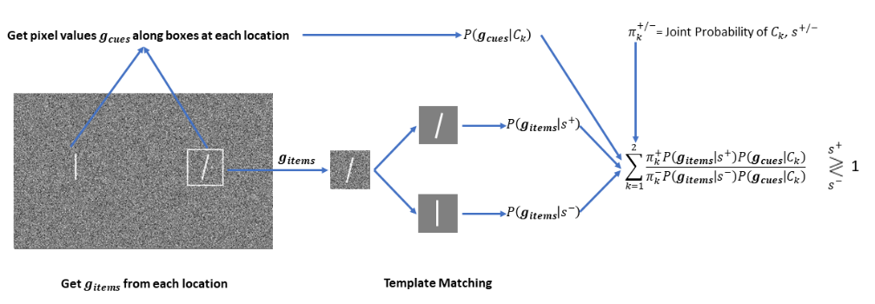

Supplementary Figure S.1 | Flow Chart for the Ideal Observer for Posner Paradigm.

 | $$P\left(s^{+} | g\right)=\sum_{i=1}^{2}{P(s_{i}^{+'}}\left|g\right)$$ | (S.5)

Where $s_{i}^{+'}$ stands for the target being present at location i, and the target being absent at the other location.

 | $$P(s_{1}^{+'}\left|g\right)=P(s_{1}^{+}\left|g_{1}\right).P(s_{2}^{-}\left|g_{2}\right)$$  And  $P(s_{2}^{+'}\left|g\right)=P(s_{1}^{-}\left|g_{1}\right).P(s_{2}^{+}\left|g_{2}\right)$ | (S.6)
where $g_{1}$ and $g_{2}$ are pixel values from the first and second locations, respectively.
Marginalizing over the two configurations corresponding to the box cue appearing at the right or left location, we have
 | $$P(s_{i}^{+'} \left|g\right)=\sum_{k=1}^{2}{P(s_{i}^{+'} ,C_{K} \left|g\right)}$$ | (S.7)
Where $C_{1}$ refers to box on the Left Location, no box on the right location and $C_{2}$ refers to the box on the right location, no box on the left location.

Now,

 | $$P(s_{i}^{+'} ,C_{K} \left|g\right)∝P\left(g | s_{i}^{+'} ,C_{K} \right).P\left(C_{K} ,s_{i}^{+'} \right)$$ | (S.8)
The likelihood can be separated into the independent contributions of the items (target/distractor) and the cues:
 | $$P\left(g | s_{i}^{+'},C_{K}\right)=P\left(g_{items},g_{cues} | s_{i}^{+'},C_{K}\right)=P\left(g_{items} | s_{i}^{+'}\right).P(g_{cues}|C_{K})$$ | (S.9)

And
 | $$P\left(C_{K} ,s_{i}^{+'}\right)=P\left(s_{i}^{+'} | C_{K}\right).P(C_{K})$$ | (S.10)
Thus, (S.9) reduces to:
 | $$P(s_{i}^{+'},C_{K}\left|g\right)∝P\left(g_{items} | s_{i}^{+'}\right).P\left(g_{cues} | C_{K}\right). P\left(s_{i}^{+'} | C_{K} \right).P\left(C_{K}\right)∝P\left(g_{i} | s_{i}^{+}\right).P\left(g_{!i} | s_{!i}^{-}\right).P\left(g_{cues} | C_{K}\right). P\left(s_{i}^{+'} | C_{K}\right).P\left(C_{K}\right)$$ | (S.11)
Where $g_{i}$ indicates pixels from location i, and $g_{!i}$ indicates pixels from the location other than i. $s_{i}^{+}$indicates target presence at location i, while $s_{!i}^{-}$ indicates distractor presence at the location other than i.
Now, in our implementation of the Posner Paradigm, the target angle is sampled from a Gaussian distribution with a mean of 15 degrees and standard deviation of 3.5 degrees, while the distractor angle is sampled from a Gaussian distribution with a mean of 7 degrees and a standard deviation of 3.5 degrees. However, since the number of pixels is finite, only a finite number of angles can be drawn on the actual images of the target and distractors. While calculating the likelihood of a target being present, we marginalize across all possible angles along with their prior probabilities.
Thus, using equation (S.4), it follows that:

$$P\left(g_{i} | s_{i}^{+}\right)=\sum_{θ ∈\left[0,2π\right)}{P\left(g_{i} | s_{iθ}^{+}\right)}.\frac{π_{θ}^{+}}{P\left(s_{i}^{+}\right)}$$  And  $$P\left(g_{!i} | s_{!i}^{-}\right)=\sum_{θ ∈\left[0,2π\right)}{P\left(g_{!i} | s_{!iθ}^{-}\right)}.\frac{π_{θ}^{-}}{P\left(s_{!i}^{-}\right)}$$ | (S.12)

Where $s_{iθ}^{+}$ denotes the presence of the target with an angle $θ$ at location i, $s_{!iθ}^{-}$ denotes the presence of the distractor with an angle $θ$ at the location other than i, $π_{θ}^{+}$ is the prior probability of sampling a template with angle $θ$ from the target angle distribution and $π_{θ}^{-}$ is the prior probability of sampling a template with angle $θ$ from the distractor angle distribution.
Thus, combining equations (S.5), (S.7), (S.9), and (S.12), we get:
 | $$P\left(s^{+} | g\right)∝\sum_{i=1}^{2}{\sum_{k=1}^{2}{\sum_{θ_{b}∈[0,2π]}{\sum_{θ_{a} ∈\left[0,2π\right)}{P\left(g_{i} | s_{iθ_{a}}^{+}\right)}}P\left(g_{!i} | s_{!iθ_{b}}^{-}\right).P\left(g_{cues} | C_{K}\right). P\left(s_{i}^{+'} | C_{K}\right).P\left(C_{K}\right)}}.\frac{π_{θ_{a}}^{+}}{P\left(s_{i}^{+}\right)} .\frac{π_{θ_{b}}^{-}}{P\left(s_{!i}^{-}\right)}$$ | (S.13)
The first three likelihood terms in the summand here are obtained using (eq (S.3)), and the last four terms are known. The four summations are across target location (i), cue location (k), target angle ($θ$, and distractor angle ($θ).$
Likewise, to calculate the posterior probability for the target absence
 | $$P(s^{-}\left|g\right)=P\left(s_{1}^{-},s_{2}^{-} | g\right)=P\left(g | s_{1}^{-},s_{2}^{-}\right).\frac{P\left(s_{1}^{-},s_{2}^{-}\right)}{P\left(g\right)}∝0.5 P\left(g | s_{1}^{-},s_{2}^{-}\right)∝0.5 P\left(g_{1},g_{2} | s_{1}^{-},s_{2}^{-}\right)∝0.5 P\left(g_{1} | s_{1}^{-}\right).P\left(g_{2} | s_{2}^{-}\right)$$ | (S.14)

where $s_{i}^{-}$ denotes the distractor being present at location i. $P\left(g_{1} | s_{1}^{-}\right)$ and $P\left(g_{2} | s_{2}^{-}\right)$ are again marginalized over all possible distractor angles similar to (S.12).
Finally, the BIO makes the decision: target absent, $s^{-}$ , if $P\left(s^{-} | g\right)>P\left(s^{+} | g\right)$ and target present, $s^{+}$, if $P\left(s^{-} | g\right)<P\left(s^{+} | g\right)$.

S.5. Visual Search
In the visual search task, the hypothesis $s^{+}$ is that the target (tilted line) is present, and the hypothesis $s^{-}$ is that the target is absent (all vertical lines). The target could appear at one of the eight locations. There were one, two, four, or eight box cues that could appear in M different configurations. The likelihood of the sensory data, $g,$ given the presence of the target has to be summed across the mutually exclusive locations of the target.
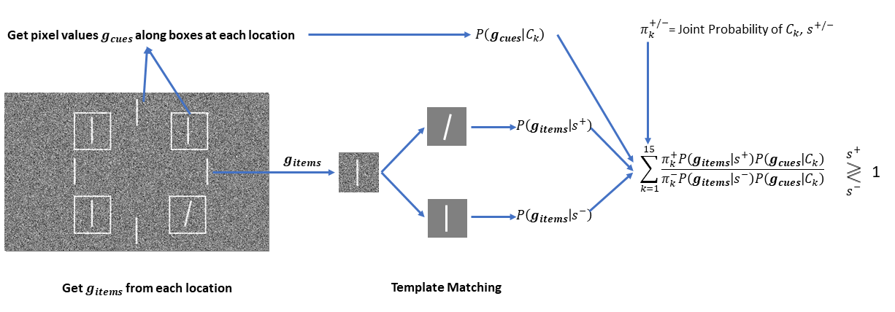

Supplementary Figure S.2 | Flow Chart for the Ideal Observer for Visual Search.

 | $$P\left(s^{+} | g\right)=\sum_{i=1}^{8}{P(s_{i}^{+'}}\left|g\right)$$ | (S.15)
Where $s_{i}^{+'}$ stands for the target being present at location i, and the target being absent at all locations except location i.
In other words,
$$P(s_{i}^{+'}\left|g\right)=P(s_{i}^{+}\left|g_{i}\right).\prod_{j!=i}{P(s_{j}^{-}\left|g_{j}\right)}$$ | (S.16)
Where $s_{i}^{+}$ stands for the target being present at location i, $s_{j}^{-}$ stands for the distractor being present at location j and $g_{i}$ refers to pixel values from the location j.
Because the box cue locations are randomized across trials, there are various mutually exclusive configurations that the likelihood needs to marginalize across;

 | $$P(s_{i}^{+'}\left|g\right)=\sum_{k=1}^{15}{P(s_{i}^{+'},C_{K}\left|g\right)}$$ | (S.17)

Where $C_{K}$ refers to Configuration k. Note that there were constraints on the box cue locations. There were evenly distributed across locations reducing the number of possible configurations (8 configurations for set-size one, 4 for set size two, 2 for set-size four, 1 for set size eight).
Now,
 | $$P(s_{i}^{+'},C_{K}\left|g\right)∝P\left(g | s_{i}^{+'},C_{k}\right).P\left(C_{K} ,s_{i}^{+'}\right)$$ | (S.18)

We now separate the sensory data corresponding to the line items in the displays and the box cue.

$$\begin{aligned}P\left(g | s_{i}^{+'},C_{K}\right)=P\left(g_{items},g_{cues} | s_{i}^{+'},C_{K}\right)=P\left(g_{items} | s_{i}^{+'}\right).P\left(g_{cues} | C_{K}\right)\#\end{aligned}$$ | (S.19)
And

 | $$P\left(C_{K} ,s_{i}^{+'}\right)=P\left(s_{i}^{+'} | C_{K}\right).P\left(C_{K}\right)$$ | (S.20)

Thus, (S.18) reduces to:

 | $$P(s_{i}^{+'},C_{K}\left|g\right)∝P\left(g_{items} | s_{i}^{+'}\right).P\left(g_{cues} | C_{K}\right).P\left(s_{i}^{+'} | C_{K}\right).P\left(C_{K}\right)$$ | (S.21)
The first two terms here are obtained using the likelihood calculated in Eq (S.3), and the last two terms are known.
Likewise, we calculate $P\left(s^{-} | g\right)$ as follows:

$$P(s^{-}\left|g\right)=P\left(s_{1}^{-},s_{2}^{-},…,s_{8}^{-} | g\right)=\sum_{k=1}^{15}{P(s_{1}^{-},s_{2}^{-},…,s_{8}^{-},C_{K}\left|g\right)}∝\sum_{k=1}^{15}{P(g_{items}\left|s_{1}^{-},s_{2}^{-},…,s_{8}^{-}\right).P(g_{cues}|C_{k})}.P\left(s_{1}^{-},s_{2}^{-},…,s_{8}^{-} | C_{k}\right).P(C_{k})$$ | (S.22)

Where $s_{i}^{-}$ denotes the distractor being present at location i.
Finally, we decide $s^{-}$ if $P\left(s^{-} | g\right)>P\left(s^{+} | g\right)$ and $s^{+}$ if $P\left(s^{-} | g\right)<P\left(s^{+} | g\right)$.

S.6. Contextual Cueing
For contextual cueing, there are two hypotheses. The hypothesis s_{R} is that the rightward tilted T is present, and the hypothesis s_{L} is that the leftward tilted T is present. Calculating the likelihood of the sensory data given the presence of either of the targets involves marginalizing across all possible target locations and background configurations.
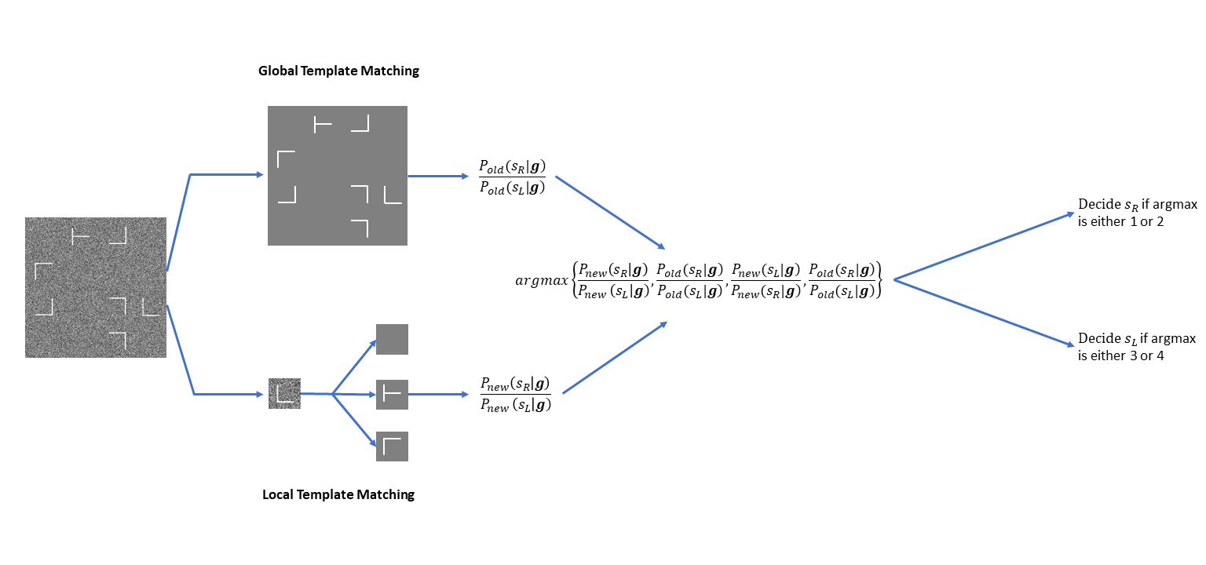

Supplementary Figure S.3 | Flow Chart for approximation to the Bayesian Ideal Observer for Contextual Cueing

Ideally, for the likelihood, the observer should go through all possible configurations and assign a higher prior to old configurations (0.5/number of old configurations) and a lower prior to new configurations (0.5/number of new configurations).
The BIO thus calculates
$$P\left(s_{R} | g\right)=\sum_{i=1}^{N_{old}}{P\left(C_{O,R,i}\right|g)}+\sum_{i=1}^{N_{new}}{P\left(C_{N,R,i}\right|g)}$$ | (S.23)
And
$$P\left(s_{L} | g\right)=\sum_{i=1}^{N_{old}}{P\left(C_{O,L,i}\right|g)}+\sum_{i=1}^{N_{new}}{P\left(C_{N,L,i}\right|g)}$$ | (S.24)
Where $C_{O,R,i}$ denotes the $i^{th}$ old configuration with the rightward tilted target, $C_{N,R,i}$ denotes the $i^{th}$ new configuration with the rightward tilted target, $C_{O,L,i}$ denotes the $i^{th}$ old configuration with the leftward tilted target, $C_{N,L,i}$ denotes the $i^{th}$ old configuration with the leftward tilted target and $N_{new}$ and $N_{old}$ denote the total number of new and old configurations with a given target orientation, respectively.
Now, using Bayes Theorem,
$$P\left(C_{O,R,i}\right|g)=P\left(g\right|C_{O,R,i}).\frac{0.5}{N_{old}};$$  $$P\left(C_{O,L,i}\right|g)=P\left(g\right|C_{O,L,i}).\frac{0.5}{N_{old}};$$  $$P\left(C_{N,R,i}\right|g)=P\left(g\right|C_{N,R,i}).\frac{0.5}{N_{new}};$$  $$P\left(C_{N,L,i}\right|g)=P\left(g\right|C_{N,L,i}).\frac{0.5}{N_{new}}$$ | (S.25) | $$P\left(C_{O,R,i}\right|g)=P\left(g\right|C_{O,R,i}).\frac{0.5}{16}$$ | (25)
Now, each of $P\left(g\right|C_{O,R,i})$, $P\left(g\right|C_{O,L,i})$, $P\left(g\right|C_{N,R,i})$, and $P\left(g\right|C_{N,L,i})$ can be calculated using equation (S.3).

For our display with six Ls elements with four possible orientations, one T, nine blank locations in a 4 x 4 element array, and 16 possible target locations, however, the BIO requires calculating a summation across over 650 million configurations (656,015,360). Such calculation is computationally intractable. Thus, we developed a model that approximates the BIO (~ BIO) but is computationally more tractable. We first present the ~BIO model and then validate it using a display with fewer elements for which the BIO and ~BIO model performance can be calculated.
The ~BIO consists of an optimal model that uses target and background information for the old configurations and a model that uses only local image patches. Thus, this suboptimal model differs from the BIO in that it does not use background information about all possible new configurations that could appear. In a sense, the ~BIO might be a better model for humans. It is unlikely that human observers consider all possible new configurations that might appear.
The local IO has templates of both target types and all distractor types (4 orientations of Ls and one template for blank (no T or L).
The local IO gets the data $g_{j}$ from each location j and returns $P\left(s_{R} | g\right)$ and $P\left(s_{L} | g\right)$ where $s_{R}$and $s_{L}$ refer to the target being oriented to the right and to the left, respectively.
We have:

 | $$P\left(s_{R} | g\right)=\sum_{j=1}^{16}{P\left(s_{Rj} | g_{j}\right).\prod_{i!=j}{P(s_{Di}|g_{i})}}$$ | (S.26)

Where ${P(s}_{Di}|G_{i})$ denotes the presence of a distractor at location i.
Clearly,

 | $$\prod_{i!=j}{P\left(s_{Di} | g_{i}\right)}=\frac{\prod_{i=1}^{16}{P\left(s_{Di} | g_{i}\right)}}{P\left(s_{Dj} | g_{j}\right)}$$ | (S.27)

Notice that $\prod_{i=1}^{16}{P\left(s_{Di} | g_{i}\right)}$ does not change on changing i, so let $k≔\prod_{i=1}^{16}{P\left(s_{Di} | g_{i}\right)}$.
Thus,
 | $$P\left(s_{R} | g\right)=k.\sum_{j=1}^{16}{\frac{P\left(s_{Rj} | g_{j}\right)}{P\left(s_{Dj} | g_{j}\right)}}$$ | (S.28)

Likewise,

 | $$P\left(s_{L} | g\right)=k.\sum_{j=1}^{16}{\frac{P\left(s_{Lj} | g_{j}\right)}{P\left(s_{Dj} | g_{j}\right)}}$$ | (S.29)

Therefore, k cancels out while calculating the likelihood ratio, and thus we need not calculate k.

 | $$P\left(s_{Rj} | g_{j}\right)=P\left(g_{j} | s_{Rj}\right) .P\left(s_{Rj}\right)/P\left(g_{j}\right)$$ | (S.30)

 | $$P\left(s_{Dj} | g_{j}\right)= P\left(g_{j} | s_{Dj}\right) .P\left(s_{Dj}\right)/P\left(g_{j}\right)$$ | (S.31)

$P\left(g_{j} | s_{Rj}\right)$and $P\left(g_{j} | s_{Dj}\right)$can be calculated via template matching (eq (S.3)), $P\left(s_{Rj}\right)$ and $P\left(s_{Dj}\right)$ is known and $P\left(g_{j}\right)$ cancels out.
Global IO: The global IO has 32 templates; 16 of them have the target pointing to the left and another 16 pointing to the right. There are 16 backgrounds, each background appearing twice, with one containing the target oriented to the left, the other to the right. For a given background, the target appears at the same location for both orientations.
 | $$P\left(s_{R} | g\right)=\sum_{i=1}^{16}{P\left(s_{TRi}\right|g)}$$ | (S.32)

 | $$P\left(s_{L} | g\right)=\sum_{i=1}^{16}{P\left(s_{TLi}\right|g)}$$ | (S.33)

Where $P\left(s_{TRi}\right|I)$ denotes the probability that the $i^{th}$ template with target pointing right is present in the image and $P\left(s_{TLi}\right|I)$ denotes the probability that the $i^{th}$ template with target pointing left is present in the image.

 | $$P\left(s_{TRi}\right|g)=P\left(g | s_{TRi}\right).P(s_{TRi})/P(g)$$ | (S.34)

$P\left(g | s_{TRi}\right)$is calculated via template matching (eq(S.3)) and $P\left(s_{TRi}\right)=1/32$ and $P\left(g\right)$ cancels out while taking the likelihood ratio.

Integrating the two models:
Let $P_{new}$ denote the likelihood returned by the local IO, and $P_{old}$ denote the likelihood returned by the global IO. We calculate:
$$argmax\left\{\frac{P_{new}\left(s_{R} | g\right)}{P_{new }\left(s_{L}\right|g)},\frac{P_{old}(s_{R}|g)}{P_{old}(s_{L}|g)},\frac{P_{new}(s_{L}|g)}{P_{new}(s_{R}|g)},\frac{P_{old}(s_{R}|g)}{P_{old}(s_{L}|g)}\right\}$$
If the argmax returns 1 or 2, the integrated model decides that the target is oriented to the right; else, if the argmax returns 3 or 4, the integrated model decides that the target is oriented to the left.

Validation of approximation to the Bayesian ideal observer with a smaller contextual cueing image set
We have used an approximate version of the ideal observer for contextual cueing because it is not feasible to run the ideal observer because of the large number of possible configurations. To validate that the ~ BIO is a good approximation of the actual BIO, we created a scenario that included fewer configurations and for which both model performances could be calculated and compared. We made smaller images with only 4 locations, containing one target, two Ls, and one blank. Further, we reduced the number of possible orientations of L from 4 to 2. This results in a total of 96 possible configurations, 8 out of which are old configurations and 88 are new.
We ran the ideal observer on this set of images as well as our approximate ideal observer (~BIO). The ~BIO obtained an efficiency of 93% relative to the ideal observer and a contextual cueing (proportion correct for old configurations – proportion correct for new configurations) of 3.2, as compared to a contextual cueing of 2.9 for BIO.

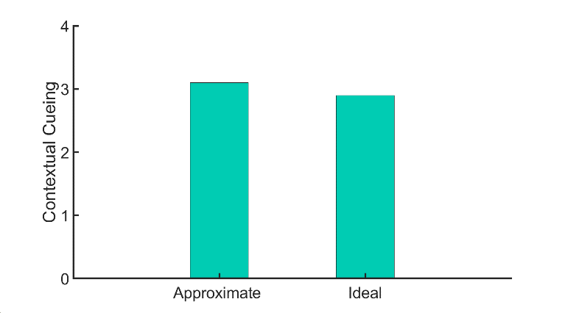
Supplementary Figure S.4 | Performance for the approximation to the ideal observer (~BIO) vs. the actual Bayesian ideal observer. Contextual Cueing is defined as (Proportion correct for old configurations – Proportion correct for new configurations).

Results for a larger pre-trained model retrained on the three tasks
We used a VGG-16 model pre-trained on ImageNet. We kept the first three blocks of the network, consisting of 7 convolution layers and three max-pooling layers, and discarded the remaining part. The weights of these three blocks were frozen and were thus not learned again. Two dense layers, with 1000 and 500 neurons, respectively, were added to this network, and only these layers were trained on the three tasks. The input images were resized to 224 by 224, which is the input size of the standard VGG-16 architecture. Since VGG-16 also needs a three-channel input, the same image was repeated in all three channels because the images used in all the experiments are in grayscale. Supplementary Figure S.5 shows the performance of the network on the three tasks.

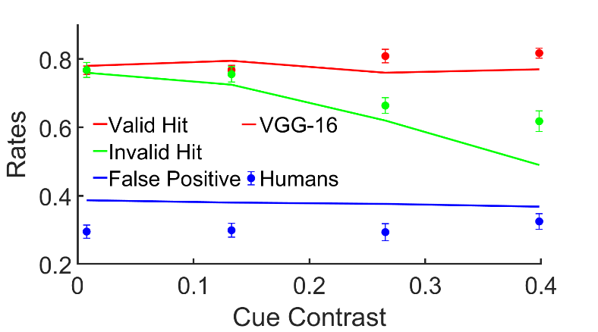 | 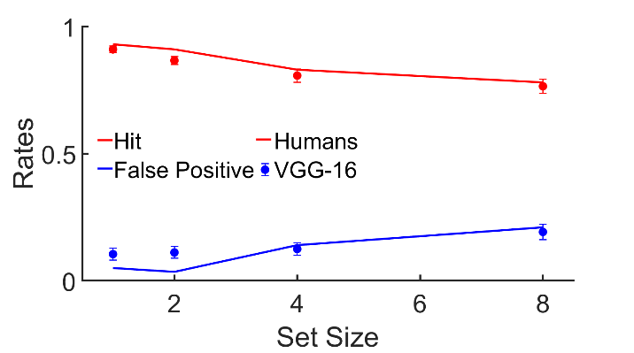
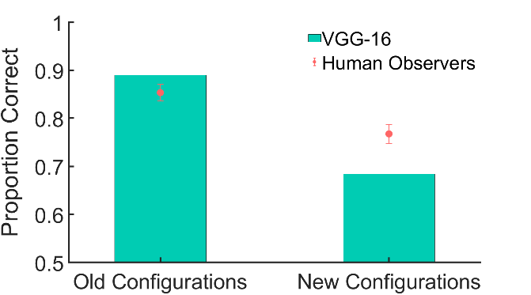

Supplementary Figure S.5 | Performance for the retrained VGG-16 Network on the Three tasks (Top Left: Posner Cueing, Top Right: Visual Search, Bottom: Contextual Cueing).

Supplementary Figures

Supplementary Figure S.1 | Flow Chart for the Ideal Observer for Posner Paradigm.

Supplementary Figure S.2 | Flow Chart for the Ideal Observer for Visual Search.

Supplementary Figure S.3 | Flow Chart for approximation to the Bayesian Ideal Observer for Contextual Cueing

Supplementary Figure S.4 | Performance for the approximation to the ideal observer (~BIO) vs. the actual Bayesian ideal observer. Contextual Cueing is defined as (Proportion correct for old configurations – Proportion correct for new configurations).

Supplementary Figure S.5 | Performance for the retrained VGG-16 Network on the Three tasks (Top Left: Posner Cueing, Top Right: Visual Search, Bottom: Contextual Cueing).

SI References
1. A. E. Burgess, R. F. Wagner, R. J. Jennings, H. B. Barlow, Efficiency of human visual signal discrimination. Science. 214, 93–94 (1981).
2. A. E. Burgess, H. Ghandeharian, Visual signal detection. II. Signal-location identification. J Opt Soc Am A. 1, 906–910 (1984).
3. W. S. Geisler, Contributions of ideal observer theory to vision research. Vision Research. 51, 771–781 (2011).
4. M. P. Eckstein, S. S. Shimozaki, C. K. Abbey, The footprints of visual attention in the Posner cueing paradigm revealed by classification images. J Vis. 2, 25–45 (2002).
5. M. P. Eckstein, M. F. Peterson, B. T. Pham, J. A. Droll, Statistical decision theory to relate neurons to behavior in the study of covert visual attention. Vision Res. 49, 1097–1128 (2009).
6. B. T. Vincent, Bayesian accounts of covert selective attention: A tutorial review. Atten Percept Psychophys. 77, 1013–1032 (2015).
7. W. J. Ma, V. Navalpakkam, J. M. Beck, R. van den Berg, A. Pouget, Behavior and neural basis of near-optimal visual search. Nat. Neurosci. 14, 783–790 (2011).

