List of Appendices
Appendix A: Comparisons of satellite imagery across different days
Appendix B: Creating the impervious cover layer
Appendix C: Model Validation
Appendix D: Supplementary figures

Appendix A: Comparisons of satellite imagery across different days
To ensure that results were not simply an artefact of the day chosen for analysis, we repeated our analyses for both LST and NO₂ concentrations using data from multiple days during different times of the year. We selected the least cloudy image for each of May, July and October (8th, 27th, 15th, respectively). Results for the relationship between building cover and LST (Fig. 6), and building cover and NO₂ (Fig. 7) are robust to differences in day of the year.
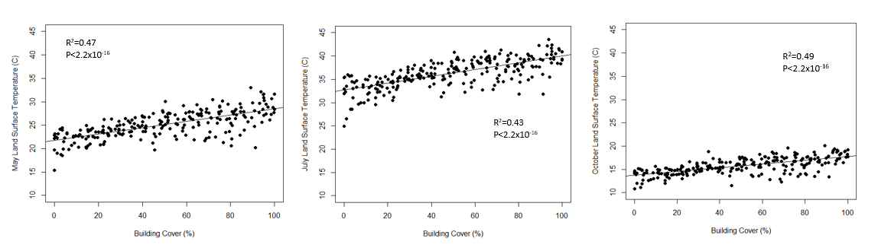
c.
b.
a.

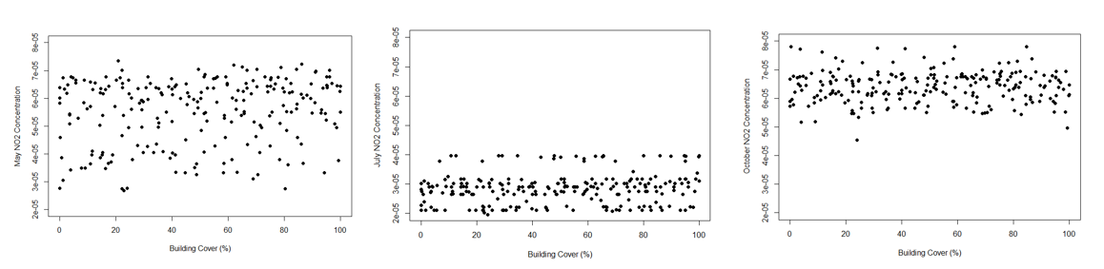
Fig. 6: The relationship between LST and percent building cover is consistent across multiple times of year that have leaves on trees. From left to right, these plots represent this relationship on the least cloudy day in May (a), July (b), and October (c).
c.
b.
a.

Fig. 7: The relationship between percent building cover and NO₂ concentrations (mol/m²) is consistently uniform across multiple times of the year that have leaves on trees. From left to right, these plots represent this relationship on the least cloudy day in May (a), July (b), and October (c).

Details for images used in study results
Image LANDSAT/LC08/C01/T1_SR/LC08_015028_20190727 (12 bands)
type:
Image
id:
LANDSAT/LC08/C01/T1_SR/LC08_015028_20190727
version:
1565081213023531
Band:
“B10”
properties:
Object (24 properties)
CLOUD_COVER:
3.03
CLOUD_COVER_LAND:
3.08
EARTH_SUN_DISTANCE:
1.015599
ESPA_VERSION:
2_23_0_1b
GEOMETRIC_RMSE_MODEL:
6.652
GEOMETRIC_RMSE_MODEL_X:
4.94
GEOMETRIC_RMSE_MODEL_Y:
4.454
IMAGE_QUALITY_OLI:
9
IMAGE_QUALITY_TIRS:
9
LANDSAT_ID:
LC08_L1TP_015028_20190727_20190801_01_T1
LEVEL1_PRODUCTION_DATE:
1564679951000
PIXEL_QA_VERSION:
generate_pixel_qa_1.6.0
SATELLITE:
LANDSAT_8
SENSING_TIME:
2019-07-27T15:44:28.8481450Z
SOLAR_AZIMUTH_ANGLE:
141.884476
SOLAR_ZENITH_ANGLE:
31.488647
SR_APP_VERSION:
LaSRC_1.3.0
WRS_PATH:
15
WRS_ROW:
28
system:asset_size:
617880495
system:footprint:
LinearRing, 21 vertices
system:index:
LC08_015028_20190727
system:time_end:
1564242268848
system:time_start:
1564242268848

Image COPERNICUS/S5P/OFFL/L3_NO2/20190727T135830_20190802T154506 (1 band)
type:
Image
id:
COPERNICUS/S5P/OFFL/L3_NO2/20190727T135830_20190802T154506
version:
1585815639729277
bands:
List (1 element)
0:
"tropospheric_NO2_column_number_density", double, EPSG:4326, 36000x16000 px
ALGORITHM_VERSION:
1.3.0
BUILD_DATE:
1554465840000
HARP_VERSION:
harp-1.5
INSTITUTION:
KNMI
L3_PROCESSING_TIME:
1585733194750
L3_PROCESSING_VERSION:
20200331
LAT_MAX:
89.97127532958984
LAT_MIN:
-81.56941223144531
LON_MAX:
179.99954223632812
LON_MIN:
-179.9989776611328
ORBIT:
9253
PLATFORM:
S5P
PROCESSING_STATUS:
OFFL-processing nominal product
PROCESSOR_VERSION:
1.3.2
PRODUCT_ID:
S5P_OFFL_L2__NO2____20190727T135830_20190727T154000_09253_01_010302_20190802T154506
PRODUCT_QUALITY:
NOMINAL
SENSOR:
TROPOMI
SPATIAL_RESOLUTION:
7x3.5km2
STATUS_CTMFCT:
Nominal
STATUS_MET_2D:
Nominal
TIME_REFERENCE_DAYS_SINCE_1950:
25409
TIME_REFERENCE_JULIAN_DAY:
2458691.5
TRACKING_ID:
52deaa33-e9e2-4ee9-afdf-546c59b96e22
system:asset_size:
3480252693
system:footprint:
LinearRing, 5 vertices
system:index:
20190727T135830_20190802T154506
system:time_end:
1564240341000
system:time_start:
1564237204000

Appendix B: Creating the impervious cover layer
There is no existing layer of all impervious surfaces for Montreal at ground-level (i.e., existing LIDAR data does not differentiate the surface underneath canopy). The layer of impervious cover was created using a two-step process. The first step was to combine multiple existing GIS layers mapping specific portions of impervious cover. This included a layer of building footprints, the road network, sidewalks, bicycle paths, and intersections. The sources of these layers are listed and linked in the table below.
Resource | Description | Link
CMM Util-Sol | A layer classifying every land parcel in Montreal into land use types. We used classifications: 700, 710, 720, 725, 750, 760. | http://observatoire.cmm.qc.ca/observatoire-grand-montreal/produits-cartographiques/donnees-georeferencees/
Montreal Open Data Portal Voirie-actif | A layer of all roadways, sidewalks and intersections | http://donnees.ville.montreal.qc.ca/dataset/voirie-actif
Montreal Open Data Portal Pistes-cyclables | A layer of all bicycle paths in Montreal | http://donnees.ville.montreal.qc.ca/dataset/pistes-cyclables
Microsoft Building Footprints | A layer rendering the building footprints of every building in Quebec | https://github.com/Microsoft/CanadianBuildingFootprints

Once these layers were combined, all remaining impervious surfaces (including buildings, parking areas, recreational areas, roads, and misc. impervious) were hand digitized onto the map. The final layer produced included all impervious surfaces in Montreal with the exception of minor impervious features such as driveways at private homes, which we were unable to digitize due to time constraints. A unique feature of this layer is that due to the hand digitizing process involved, impervious features that are under vegetation are included, even though they are often missed in remote sensing based impervious datasets.

Appendix C: Model Validation
As a form of validation, all collected data was initially split into a training data set (90% of data) and a test, or validation, data set (10% of the data). To ensure our models were representative and to avoid overfitting, all models were initially run using the training dataset that excluded 10% of the collected data, with the 10% test data set visually inspected for fit to the training model (Fig 8). The training data was also used to predict the values of the test data. The pearson correlation coefficients for predicted vs. observed vales of test data are 0.69 for LST, 0.43 for NO₂, 0.52 for distance to public green space, and 0.82 for amount of private green space. Residuals (observed – predicted values) were also inspected visually to assess model fit (Fig 9). The models presented in the final analysis are complete models using all collected data. For all analyses, the p-value threshold used for statistical significance was alpha = 0.05, with alpha = 0.1 considered as marginally significant.

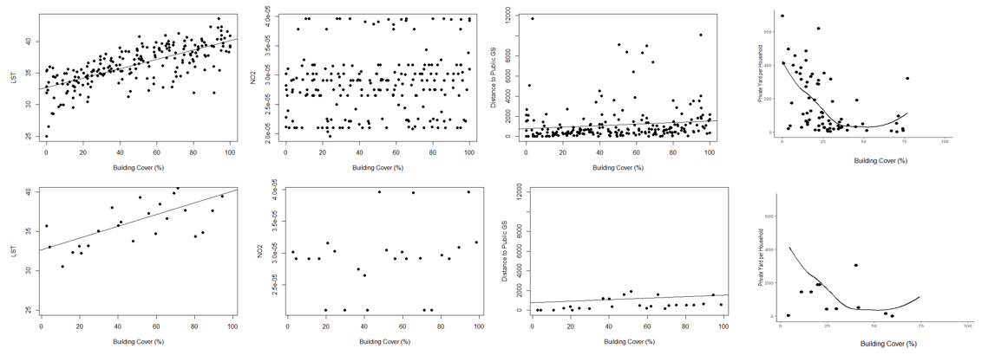
d.
c.
b.
a.

Fig. 8: Test vs. Training data for building cover percentage models for a) LST, b) NO₂, c) distance to public green space, and d) amount of private green space. For each model, the data was split into a “training” dataset of 90% of the data (top row), and a “test” dataset of 10% of the data (bottom row). Each model was first run using the training data, then again using the test data, and finally as a complete model which was used in analysis. The regression lines represent the regression line for the training model.

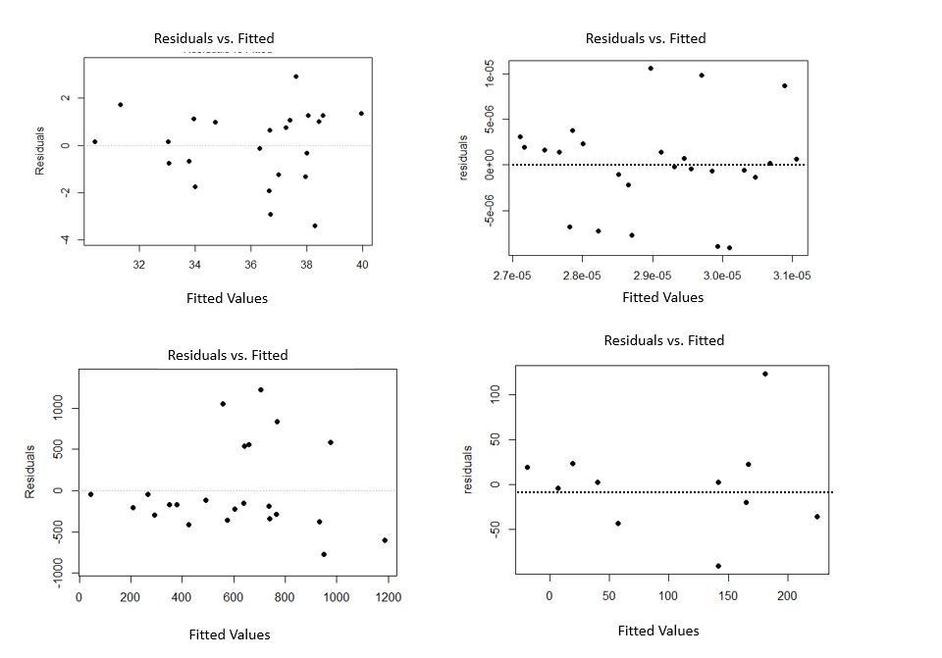
d.
c.
b.
a.

Fig. 9: Plots of residuals (observed – predicted values) vs. fitted values for models for the 10% test data set of a) LST, b) NO2, c) distance to public green space and, d) amount of private green space. The correlation coefficients for predicted vs. observed vales of test data are as follows: a) 0.69, b) 0.43, c) 0.52, and d) 0.82.

Appendix D: Supplementary figures

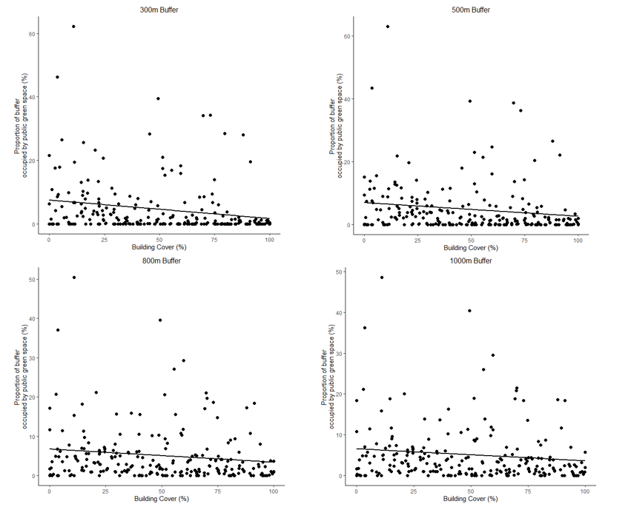
d.
c.
b.
a.
Fig. 10: Proportion (%) of publicly accessible green space within a buffer of (a) 300 m, (b) 500 m, (c) 800 m, and (d) 1000 m plotted against building cover percentage for 250 study sites. Trend lines indicate statistical significance. For all buffer sizes, there was a weakly negative relationship between building cover percentage and the amount of green space within the buffer.
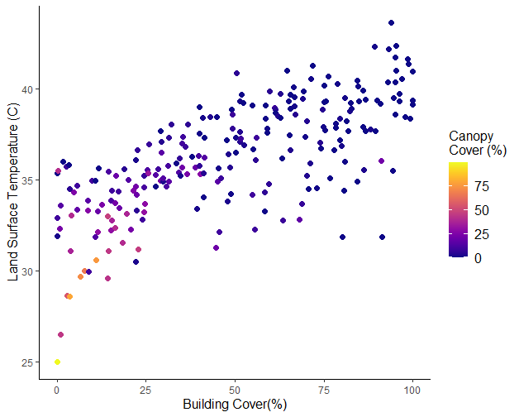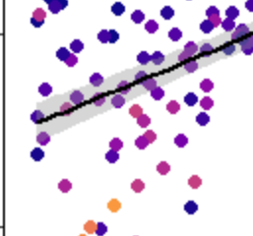
R² = 0.69
P<2.2x10⁻⁶
Fig. 11: Daytime land surface temperature (LST) as a function of building cover percentage for 250 sites across the Island of Montreal. Shaded area represents +/-2 SE. Colour represents percent canopy cover within each site. Some of the spread of the points in the building cover percentage – LST relationship can be explained by differences in canopy cover. When we zoom into the low building cover percentage section of the plot (inset figure) we can see that sites with lower LST tend to have higher canopy cover, even at the same level of building cover.

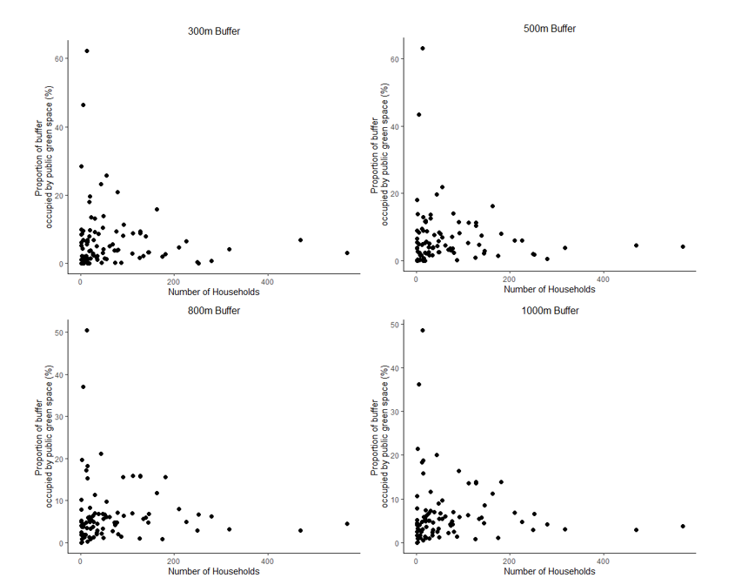
a.
d.
c.
b.
Fig. 12: Surface area of publicly accessible green space within a buffer of (a) 300 m, (b) 500 m, (c) 800 m, and (d) 1000 m plotted against the number of households at a study site. For all buffer sizes, there was a non-statistically significant negative relationship between the number of households at a site and the amount of green space within the buffer. All p-values >0.1.

