Supplemental Materials

Mini review of spatial normalization in patients with glioma
Accurate spatial normalization is important in basic science studies of functional localization as well as clinical decision making. We identified 40 studies that use rs-fMRI and FC analysis in patients with glioma (Table S1). As discussed in previous systemic reviews [1, 2], a variety of methods has been used, which makes generalization across studies challenging. Of the 40 presently identified studies, 12 used affine registration, 10 used either SPM8, SPM12, or DARTEL [3] without cost-function masking, 7 used non-linear registration (e.g., SPM12, DRAMMS [4], ANTs [5]) with either cost function masking or intrinsic weighting options, and 11 did not specify which registration option was used (Table S1).

A. Affine registration | B. Non-linear registration  (* with CFM or weighting) | C. Not specified
Huang et al., 2014 [6] | Liu et al., 2019 [7] | Zhang et al., 2016 [8]
Harris et al., 2014 [9] | van Dokkum et al., 2019 [10] | Yahyavi-Firouz-Abadi et al., 2017 [11]
Maesawa et al., 2015 [12] | Gohel et al., 2019 [13] | Vassal et al., 2017 [14]
Tuovinen et al., 2016 [15] | Liu et al., 2019 [16] | Metwali et al., 2019 [17]
Park et al., 2016 [18] | Liu et al., 2020 [19] | Sparacia et al., 2020 [20]
Ghumman et al., 2016 [21] | Yuan et al., 2020 [22] | Metwali et al., 2020 [17]
Hart et al., 2016 [23] | Yuan et al., 2020 [24] | Stoecklein et al., 2020 [25]
De Baene et al., 2017 [26] | Yang et al., 2021 [27] | Fang et al., 2021 [28]
Hart et al., 2017 [29] | Noll et al., 2021 [30] | Wang et al., 2021 [31]
De Baene et al., 2019 [32] | Cai et al., 2021 [33] | Jin et al., 2021 [34]
Daniel et al., 2021 [35] | Zhang et al., 2018 [36]* | Almairac et al., 2021 [37]
Tordjman et al., 2021 [38] | Coget et al., 2018 [39]*
 | Yuan et al., 2019 [40]*
 | Jütten et al., 2020 [41]*
 | Nenning et al., 2020 [42]*
 | Kocher et al., 2020 [43]*
 | Silvestri et al., 2022 [44]*

Table S1. Registration options used in prior studies assessing changes in the functional organization in brain tumor patients using rs-fMRI and parcel-based FC.

3D Convolutional Neural Network automated tumor segmentation
We trained a 3D convolutional neural network (CNN) architecture [45] using post-contrast T1-weighted, T2-weighted, and Fluid Attenuated Inversion Recovery (Flair) scans to produce multi-class tumor segmentation maps of glioma. Tissue classes were (i) vasogenic edema, (ii) necrotic/non-enhancing tumor core, and (iii) enhancing tumor core. For training and cross-validation purposes, we used the BraTS 2021 training dataset (n = 1251). For hyperparameter tuning, we performed a random search [46] using five-fold cross-validation on this data by using 80% of the data for training (n =1000) and 20% for validation (n = 251). The hyperparameters that yielded the best cross-validation results were selected as the “best” hyperparameters. Next, the model was trained on 100% of the training data (n = 1251) using the “best” set of hyperparameters and subsequently used for prediction on the hold-out BraTS 2021 validation data (n = 219) which was used as a surrogate for test data.

Scans from the BraTS 2021 dataset were already registered to the SRI24 anatomical atlas [47], resampled to 1mm³ isotropic resolution, and skull stripped. Additionally, for every scan, image intensities within the brain were normalized to zero mean and unit variance after excluding intensities below the 5th and above the 95th percentile. Subsequently, the image volumes were resized to a dimension of 128x128x128 before being fed into the network. We used an Adam [48] optimizer with a multi-class dice loss function. The training batch size was set to 5. The network was trained for 300 epochs with an early-stopping callback, which stopped the training after 50 epochs if the validation loss was not improving. The training was started with an initial learning rate of 5 x 10⁻⁴, which was reduced by a factor of 2 every time the validation loss became stagnant for 10 epochs. To prevent the network from overfitting, the data were augmented using mirroring along each axis with a probability of 0.5. Two example cases are illustrated in Figure S1.

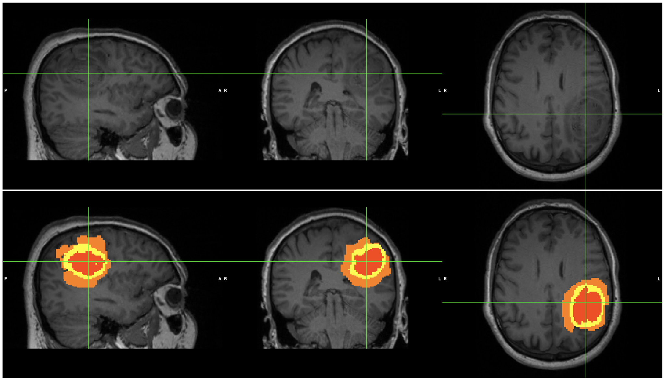

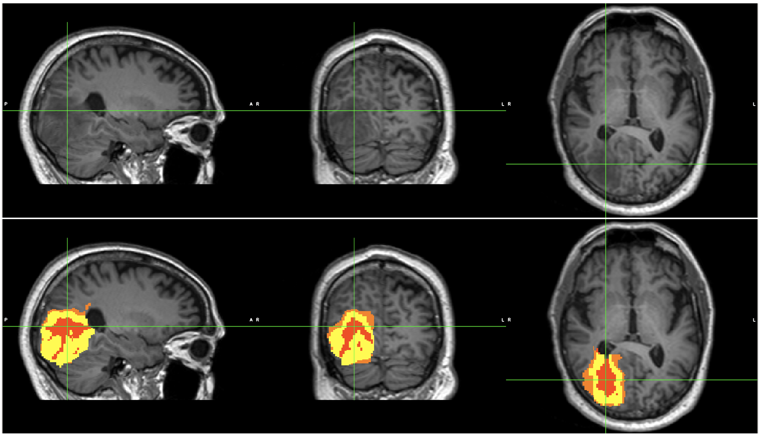
Figure S1. Examples of segmentations of two patients. Vasogenic edema, necrotic/non-enhancing tumor core, and enhancing tumor core are visualized in orange, red, and yellow, respectively.

Computation of the DVARS frame censoring threshold in individuals
DVARS provides a global measure of BOLD signal intensity change from one frame to the next [49]. DVARS is evaluated as root-mean-square signal change over the whole brain computed by backward differences over successive frames. Thus, DVARS,

$\sqrt{(1/{n)}\sum_{i}{{\left({ΔI}_{i}\right)}^{2}}}$, Eq. A1

is a time series, where $n$ is voxel count and ${ΔI}_{i}$ is change in signal intensity at voxel $i$, ${ΔI}_{i}= I_{it}-I_{i(t-1)}$, and $t$ indexes frame.

DVARS fluctuations largely reflect head motion directly measured by frame-to-frame image registration, i.e., the frame displacement measure (FD) [49]. However, unlike FD, DVARS is sensitive to any transient change in fMRI signal, e.g., fluctuations in arterial pCO₂ linked to respiratory rate variation [50]. The DVARS "baseline", i.e., values in the absence of head motion, varies across individuals, most likely in relation to arousal-related differences in respiratory rate [51]. Thus, a fixed censoring threshold would exclude too many frames in some subjects and too few in others. A rational approach to DVARS-based frame censoring is necessary to optimize the signal-to-noise ratio (SNR) as suppression of artifact must be balanced against minimization of sampling error consequent to loss of data [52].

To accommodate DVARS baseline variability across subjects, we determine the frame-censoring threshold accounting for the distribution of DVARS values compiled over whole resting state fMRI sessions. We previously published an algorithm for determining the frame censoring threshold using an algorithm based on identifying the mode the DVARS histogram [53]. However, that algorithm proved to be unstable and has been superseded by the following. Stable frame censoring is based on the observation that the distribution of observed DVARS values conforms to a gamma distribution in almost all cases, provided that outliers have been eliminated. Thus, the distribution of DVARS values is modeled as

$f\left(x\right)=(1/Γ(k))x^{k-1}exp⁡(-x/{θ)},$ Eq. A2

where $k$ and $θ$ are shape and scale parameters, respectively [54] and $Γ(k)$ is the gamma function. We determine $k$ and $θ$ by estimation of moments. Thus,

$k={μ_{1}^{2}}/{μ_{2}}$, $θ={μ_{2}}/{μ_{1}}$, Eq. A3

where $μ_{1}$ is the mean and $μ_{2}$ is the variance (second moment about the mean), relative to an offset, $q$, taken to be the least observed value of DVARS. An important property of any gamma function is that the third and second moments about the mean satisfy $μ_{3}=2μ_{2}$. Hence, any set of values for which $μ_{3}>2μ_{2}$ is incompatible with a gamma function. This rule provides a rational basis for “peeling off” outlier values. Thus, in pseudo-code:

Evaluate DVARS over all data in a session (i.e., over concatenated fMRI runs)
Sort DVARS values in increasing order
$q←$ least value
do $\{$
Evaluate $μ_{1}, μ_{2},μ_{3}, k, θ$ taking $q$ as the origin of $x$
Eliminate greatest value
$\}$ while ($μ_{3}>2μ_{2}$)

This algorithm defines $f(x)$. The censoring threshold may be taken as any $x$ corresponding to a chosen percentile, e.g., 100% (all values compatible with a gamma distribution), 95% (eliminate the upper 5%), etc. Two example cases are illustrated below Figures. S2 and S3.

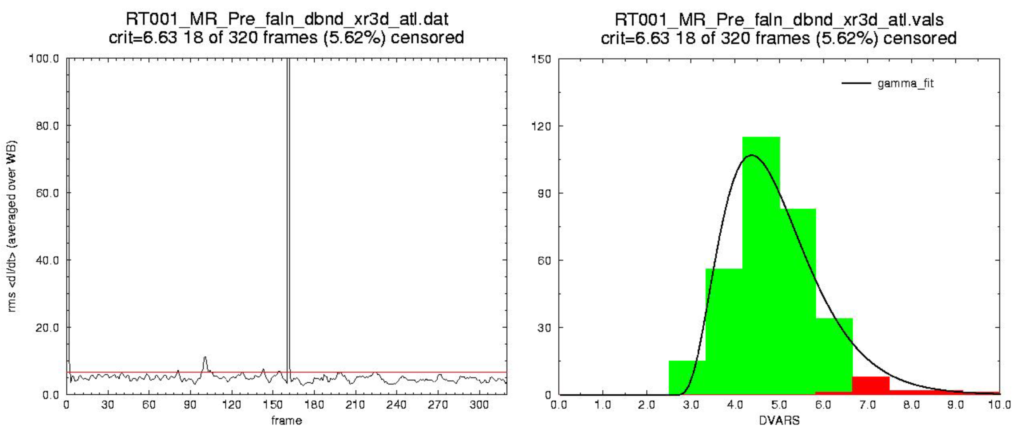Figure S2. frame censoring using gamma_fit in an exemplar low-motion participant. The DVARS time series concatenated over 2 fMRI runs is shown on the left. The corresponding histogram is shown in the right. The “spike” in the time series represents ignored data at the boundary between runs. The frame censoring criterion (red line on time series plot) was set at the 95%-tile of the analytically determined gamma distribution model. Censored frames are red in the histogram. Note different histogram scales in the two examples.

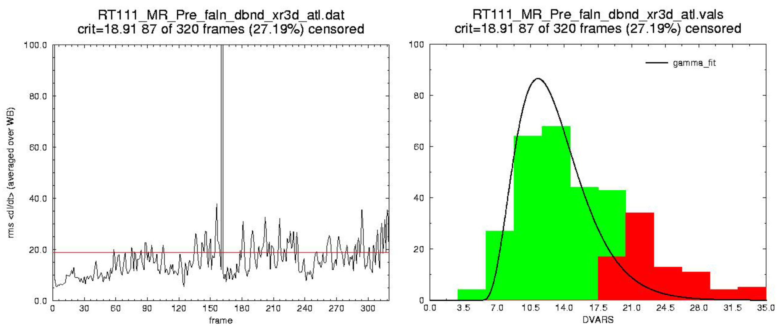 Figure S3. frame censoring using gamma_fit in an exemplar high-motion participant. The DVARS time series concatenated over 2 fMRI runs is shown on the left. The corresponding histogram is shown in the right. The frame censoring criterion (red line on time series plot) was set at the 95%-tile of the analytically determined gamma distribution model. Note different histogram scales in the two examples.

Aberrant Parcel Mapping (APM) analysis strategy in relation to prior work
Nenning and colleagues evaluated the change in connectivity patterns using a cosine similarity measure in patients with tumors [42]; Siegel and colleagues used a student t-test to study a patient with abulia [55]. Both studies evaluated the change in FC at a voxel-level resolution. We used APM analysis to assess FC abnormalities in GBM patients at the microscopic level. Our approach differs from prior studies in that we evaluated a spatial pattern of FC at a parcel-level instead of voxel-level. Moreover, we used the non-parametric Kolmogorov-Smirnov test to compare the FC profile of each parcel. The reason for our parcel-based analysis is the following. Using a finer brain parcellation (i.e., closer to a voxel-level resolution) increases the specificity in obtaining neuroanatomical information. Conversely, using a coarser brain parcellation improves the signal-to-noise ratio (SNR) of the BOLD signal compared to using a voxel-level resolution. In our work, we addressed both issues by using the most granular version of the Schaefer atlas (i.e., L = 1000 parcellation).

1. Ghinda, D.C., et al., How much is enough-Can resting state fMRI provide a demarcation for neurosurgical resection in glioma? Neurosci Biobehav Rev, 2018. 84: p. 245-261.
2. Fox, M.E. and T.Z. King, Functional Connectivity in Adult Brain Tumor Patients: A Systematic Review. Brain Connect, 2018. 8(7): p. 381-397.
3. Ashburner, J., A fast diffeomorphic image registration algorithm. NeuroImage, 2007. 38(1): p. 95-113.
4. Ou, Y., et al., DRAMMS: Deformable Registration via Attribute Matching and Mutual-Saliency Weighting. Medical image analysis, 2011. 15(4): p. 622-639.
5. Avants, B.B., et al., A reproducible evaluation of ANTs similarity metric performance in brain image registration. Neuroimage, 2011. 54(3): p. 2033-44.
6. Huang, Q., et al., Disturbed Small-World Networks and Neurocognitive Function in Frontal Lobe Low-Grade Glioma Patients. PLOS ONE, 2014. 9(4): p. e94095-e94095.
7. Liu, L., et al., Overall survival time prediction for high-grade glioma patients based on large-scale brain functional networks. Brain imaging and behavior, 2019. 13(5): p. 1333-1351.
8. Zhang, H., et al., Alteration of the Intra- and Cross- Hemisphere Posterior Default Mode Network in Frontal Lobe Glioma Patients. Sci Rep, 2016. 6: p. 26972.
9. Harris, R.J., et al., Altered functional connectivity of the default mode network in diffuse gliomas measured with pseudo-resting state fMRI. J Neurooncol, 2014. 116(2): p. 373-9.
10. van Dokkum, L.E.H., et al., Resting state network plasticity related to picture naming in low-grade glioma patients before and after resection. NeuroImage: Clinical, 2019. 24: p. 102010-102010.
11. Yahyavi-Firouz-Abadi, N., et al., Presurgical Brain Mapping of the Ventral Somatomotor Network in Patients with Brain Tumors Using Resting-State fMRI. American Journal of Neuroradiology, 2017. 38(5): p. 1006-1012.
12. Maesawa, S., et al., Evaluation of resting state networks in patients with gliomas: connectivity changes in the unaffected side and its relation to cognitive function. PLoS One, 2015. 10(2): p. e0118072.
13. Gohel, S., et al., Resting-State Functional Connectivity of the Middle Frontal Gyrus Can Predict Language Lateralization in Patients with Brain Tumors. American Journal of Neuroradiology, 2019. 40(2): p. 319-325.
14. Vassal, M., et al., Recovery of functional connectivity of the sensorimotor network after surgery for diffuse low-grade gliomas involving the supplementary motor area. Journal of Neurosurgery, 2017. 126(4): p. 1181-1190.
15. Tuovinen, N., et al., Transient effects of tumor location on the functional architecture at rest in glioblastoma patients: Three longitudinal case studies. Radiation Oncology, 2016. 11(1): p. 1-18.
16. Liu, D., et al., Potential Intra- or Cross-Network Functional Reorganization of the Triple Unifying Networks in Patients with Frontal Glioma. World Neurosurg, 2019. 128: p. e732-e743.
17. Metwali, H., et al., Inter-Network Functional Connectivity Changes in Patients With Brain Tumors: A Resting-State Functional Magnetic Resonance Imaging Study. World Neurosurgery, 2020. 138: p. e66-e71.
18. Park, J.E., et al., Alteration of long-distance functional connectivity and network topology in patients with supratentorial gliomas. Neuroradiology, 2016. 58(3): p. 311-320.
19. Liu, D., et al., Contralesional homotopic functional plasticity in patients with temporal glioma. Journal of Neurosurgery, 2020. 134(2): p. 417-425.
20. Sparacia, G., et al., Resting-State Functional Connectome in Patients with Brain Tumors Before and After Surgical Resection. World Neurosurgery, 2020. 141: p. e182-e194.
21. Ghumman, S., et al., Exploratory study of the effect of brain tumors on the default mode network. J Neurooncol, 2016. 128(3): p. 437-44.
22. Yuan, B., et al., Tumor grade-related language and control network reorganization in patients with left cerebral glioma. Cortex, 2020. 129: p. 141-157.
23. Hart, M.G., S.J. Price, and J. Suckling, Connectome analysis for pre-operative brain mapping in neurosurgery. British journal of neurosurgery, 2016. 30(5): p. 506-517.
24. Yuan, T., et al., Structural and Functional Alterations in the Contralesional Medial Temporal Lobe in Glioma Patients. Frontiers in Neuroscience, 2020. 14: p. 10-10.
25. Stoecklein, V.M., et al., Resting-state fMRI detects alterations in whole brain connectivity related to tumor biology in glioma patients. Neuro-Oncology, 2020. 22(9): p. 1388-1398.
26. De Baene, W., G.J.M. Rutten, and M.M. Sitskoorn, The Temporal Pattern of a Lesion Modulates the Functional Network Topology of Remote Brain Regions. Neural Plasticity, 2017. 2017.
27. Yang, J., et al., Glioma-Induced Disruption of Resting-State Functional Connectivity and Amplitude of Low-Frequency Fluctuations in the Salience Network. American Journal of Neuroradiology, 2021. 42(3): p. 551-558.
28. Fang, S., et al., Contralesional functional network reorganization of the insular cortex in diffuse low-grade glioma patients. Sci Rep, 2021. 11(1): p. 623.
29. Hart, M.G., S.J. Price, and J. Suckling, Functional connectivity networks for preoperative brain mapping in neurosurgery. J Neurosurg, 2017. 126(6): p. 1941-1950.
30. Noll, K.R., et al., Alterations in Functional Connectomics Associated With Neurocognitive Changes Following Glioma Resection. Neurosurgery, 2021. 88(3): p. 544-551.
31. Wang, C., et al., Characterization of cognitive function in survivors of diffuse gliomas using resting-state functional MRI (rs-fMRI). Brain Imaging and Behavior, 2022. 16(1): p. 239-251.
32. De Baene, W., G.J.M. Rutten, and M.M. Sitskoorn, Cognitive functioning in glioma patients is related to functional connectivity measures of the non-tumoural hemisphere. European Journal of Neuroscience, 2019. 50(12): p. 3921-3933.
33. Cai, S., et al., Hemisphere-Specific Functional Remodeling and Its Relevance to Tumor Malignancy of Cerebral Glioma Based on Resting-State Functional Network Analysis. Frontiers in Neuroscience, 2021. 14.
34. Jin, L., et al., The Functional Reorganization of Language Network Modules in Glioma Patients: New Insights From Resting State fMRI Study. Frontiers in Oncology, 2021. 11: p. 159-159.
35. Daniel, A.G.S., Park, K.Y., Roland, J.L., Dierker, D., Gross, J., Humphries, J.B., Hacker, C.D., Snyder, A.Z., Shimony, J.S., Leuthardt, E.C. , Functional connectivity within glioblastoma impacts overall survival. Neuro-Oncology, 2021. 23: p. 412–421.
36. Zhang, N., et al., Reorganization of cerebro-cerebellar circuit in patients with left hemispheric gliomas involving language network: A combined structural and resting-state functional MRI study. Human Brain Mapping, 2018. 39(12): p. 4802-4819.
37. Almairac, F., et al., Homotopic redistribution of functional connectivity in insula-centered diffuse low-grade glioma. Neuroimage Clin, 2021. 29: p. 102571.
38. Tordjman, M., et al., Functional connectivity of the default mode, dorsal attention and fronto-parietal executive control networks in glial tumor patients. Journal of neuro-oncology, 2021. 152(2): p. 347-355.
39. Coget, A., et al., Transient immediate postoperative homotopic functional disconnectivity in low-grade glioma patients. NeuroImage : Clinical, 2018. 18: p. 656-656.
40. Yuan, B., et al., Resting-state functional connectivity predicts individual language impairment of patients with left hemispheric gliomas involving language network. NeuroImage: Clinical, 2019. 24: p. 102023-102023.
41. Jütten, K., et al., Asymmetric tumor-related alterations of network-specific intrinsic functional connectivity in glioma patients. Human Brain Mapping, 2020. 41(16): p. 4549-4561.
42. Nenning, K.H., et al., Distributed changes of the functional connectome in patients with glioblastoma. Sci Rep, 2020. 10(1): p. 18312.
43. Kocher, M., et al., Role of the default mode resting-state network for cognitive functioning in malignant glioma patients following multimodal treatment. NeuroImage: Clinical, 2020. 27: p. 102287-102287.
44. Silvestri, E., et al., Widespread cortical functional disconnection in gliomas: an individual network mapping approach. Brain Commun, 2022. 4(2): p. fcac082.
45. Isensee, F., et al., Brain tumor segmentation and radiomics survival prediction: Contribution to the brats 2017 challenge. International MICCAI Brainlesion Workshop, 2017: p. 287–297.
46. Bergstra, J. and Y. Bengio, Random search for hyper-parameter optimization. Journal of Machine Learning Research, 2012. 13.
47. Rohlfing, T., et al., The SRI24 multichannel atlas of normal adult human brain structure. Hum Brain Mapp, 2010. 31(5): p. 798-819.
48. Kingma, D.P. and J.L. Ba, ADAM: A METHOD FOR STOCHASTIC OPTIMIZATION. arXiv Prepr. ArXiv1412.6980, 2014.
49. Power, J.D., et al., Methods to detect, characterize, and remove motion artifact in resting state fMRI. Neuroimage, 2014. 84: p. 320-41.
50. Chang, C. and G.H. Glover, Relationship between respiration, end-tidal CO2, and BOLD signals in resting-state fMRI. Neuroimage, 2009. 47(4): p. 1381-93.
51. Power, J.D., et al., Ridding fMRI data of motion-related influences: Removal of signals with distinct spatial and physical bases in multiecho data. Proc Natl Acad Sci U S A, 2018. 115(9): p. E2105-E2114.
52. Raut, R.V., et al., On time delay estimation and sampling error in resting-state fMRI. Neuroimage, 2019. 194: p. 211-227.
53. White, R.L., 3rd, et al., Little Change in Functional Brain Networks Following Acute Levodopa in Drug-Naive Parkinson's Disease. Mov Disord, 2020. 35(3): p. 499-503.
54. Wikipedia. Gamma distribution. Wikipedia; Available from: https://en.wikipedia.org/wiki/Gamma_distribution.
55. Siegel, J.S., et al., The circuitry of abulia: insights from functional connectivity MRI. Neuroimage Clin, 2014. 6: p. 320-6.

