Additional file 1

Title: Microbiome variation during culture growth of the European house dust mite, Dermatophagoides pteronyssinus

Authors: M. Nesvorna, V. Molva, S. Pekar, E. Shcherbachenko, T. Erban, S. J. Green, P. B. Klimov and J Hubert

Table S1
Figures S1–S5

Table S1 Oligonucleotide primers for PCR and qPCR quantification of 16S rRNA and 18S rRNA in Dermatophagoides pteronyssinus samples.
Group | Name | Primer/probe (5′-3′) | AT (ºC) | Tm | Size (bp) | Reference | Note
Universal 18SrRNA, qPCR | FR1 | ACACTGACGACATGGTTCTACA CGWTAACGAACGAGACCT | 50 | 87.5 | 390 | Vainio and Hantula [52] | 1
Universal 18SrRNA, qPCR | FF390 | CGATAACGAACGAGACCT
Illumina | CS1_FF390 | ACACTGACGACATGGTTCTACA CGWTAACGAACGAGACCT | 50 |  | 390 | Chemidlin Prevost-Boure et al. [50]
 | CS2_FR1 | TACGGTAGCAGAGACTTGGTCT A/I/C CAT TCA ATC GGT A/I/T
Universal, 16S rRNA -V4, Illumina | F27 | AGAGTTTGATCMTGGCTCAG | 57 |  |  | Sakai et al. [54]
Universal, 16S rRNA -V4, Illumina | 783r-a | GGACTACCAGGGTATCTAATCCTG
Universal, 16S rRNA -V4, Illumina | 783r-bL | GGACTACCGGGGTATCTAATCCCG
Universal, 16S rRNA -V4, Illumina | 783r-cL | GGACTACCCGGGTATCTAATCCGG
Universal, 16S rRNA -V4, Illumina | CS1_515F | ACACTGACGACATGGTTCTACAGTGCCAGCMGCCGCGGTAA | 55 |  | 275 | Caporaso et al. [51]
Universal, 16S rRNA -V4, Illumina | CS2_806R | TACGGTAGCAGAGACTTGGTCTGGACTACHVGGGTWTCTAAT
Universal, 16S rRNA, PCR | F27 | AGAGTTTGATCCTGGCTCAG | 50 |  | 1500 | Lane [71]
Universal, 16S rRNA, PCR | R1492 | TACGGYTACCTTGTTACGACTT
Universal, 16S rRNA, qPCR | Com1 | CAGCAGCCGCGGTAATAC | 59 | 82.49 | 270 | Dorn‐In et al. [72] | 2
Universal, 16S rRNA, qPCR | 769R | ATCCTGTTTGMTMCCCVCRC
Cardinium, 16S rRNA, qPCR | Card_6QF | TGCAAATCTCAAAAGCATGT | 56 | 83.76 | 160 | Hubert et al. [73] | 3
Cardinium, 16S rRNA, qPCR | Card_6QR | TCAAGCTCTACCAACTCCCA
Wolbachia | WoQf | GAAGAAGGCCTTTGGGTTGT | 62 |  | 118 | Jeong and Stouthamer [74]
Wolbachia | WoQr | AACGCTAGCCCTCTCCGTA
Firmicutes, qPCR | Firm934F | GGAGYATGTGGTTTAATTCGAAGCA | 60 | 82.13 | 126 | Guo et al. [75] | 4
Firmicutes, qPCR | Firm1060R | AGCTGACGACAACCATGCAC
Actinobacteria, qPCR | Actino235F | CGCGGCCTATCAGCTTGTTG | 60 | 89.04 | 283 | Stach et al. [76] | 5
Actinobacteria, qPCR | Eub518R | ATTACCGCGGCTGCTGG
Sacharomycces cerevisiae | SCF1 | GGACTCTGGACATGCAAGAT | 62 |  | 104 | Salinas et al. [77] | 6
Sacharomycces cerevisiae | SCR1 | ATACCCTTCTTAACACCTGGC3
Notes – standard preparation: 1 – source: Fusarium fungal culture, amplification: FR1/FF390; 2 – source: Tyrophagus putrescentiae DNA, amplification: WpF/WpR [78]; 3 – source: Dermatophagoides farinae DNA; amplification Card4/Card6 [79] ; 4 – source: Melissococcus plutonius bacterial culture; amplification: Firm934F/Firm1060R; 5 – source: Kocuria isolate; amplification F27/R14ů 6 – source: Saccharomyces cerevisiae isolate

Figure S1 Comparison of the amount of guanine in the bodies of mites in the initial and declining phase of experiments. The columns are medians and bars represent interquartile range.
0
0.2
0.4
0.6
0.8
1
1.2
1.4
1.6
1.8
mite_14 days
mite_84 days
Amount of guanine mg/g

Figure S2 Histological observations of the gut of Dermatophagoides pteronyssinus. A – ingestion of unidentified diet pieces (arrows) in the ventriculus; B – fragmented mycelium without contents in the ventriculus (arrows), C – undigested spores in the ventriculus (arrows); D – detail of spores (arrows) in the ventriculus, E – detail of fragmented diet (arrows) in the colon. ACE – 28 days, D – 56 days, B – 70 days old culture; Scale bars 50µ ABC, 25µ D; Legend: ca – caecum, co – colon, eo – eosophagus, sg – synganglion, v – ventriculus.
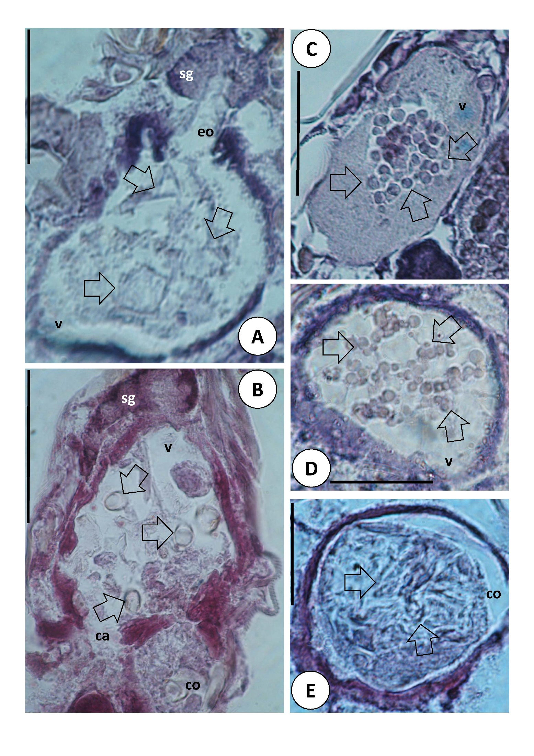

Figure S3 Heatmap of microbiomes of the D. pteronyssinus samples during the mite culture growth, A – bacterial and B – fungal community. Samples of ingested microbial community are indicated by black color, while red color indicates samples from the mite culture environment. Note: The x axes show time of experiment, D – diet without mites

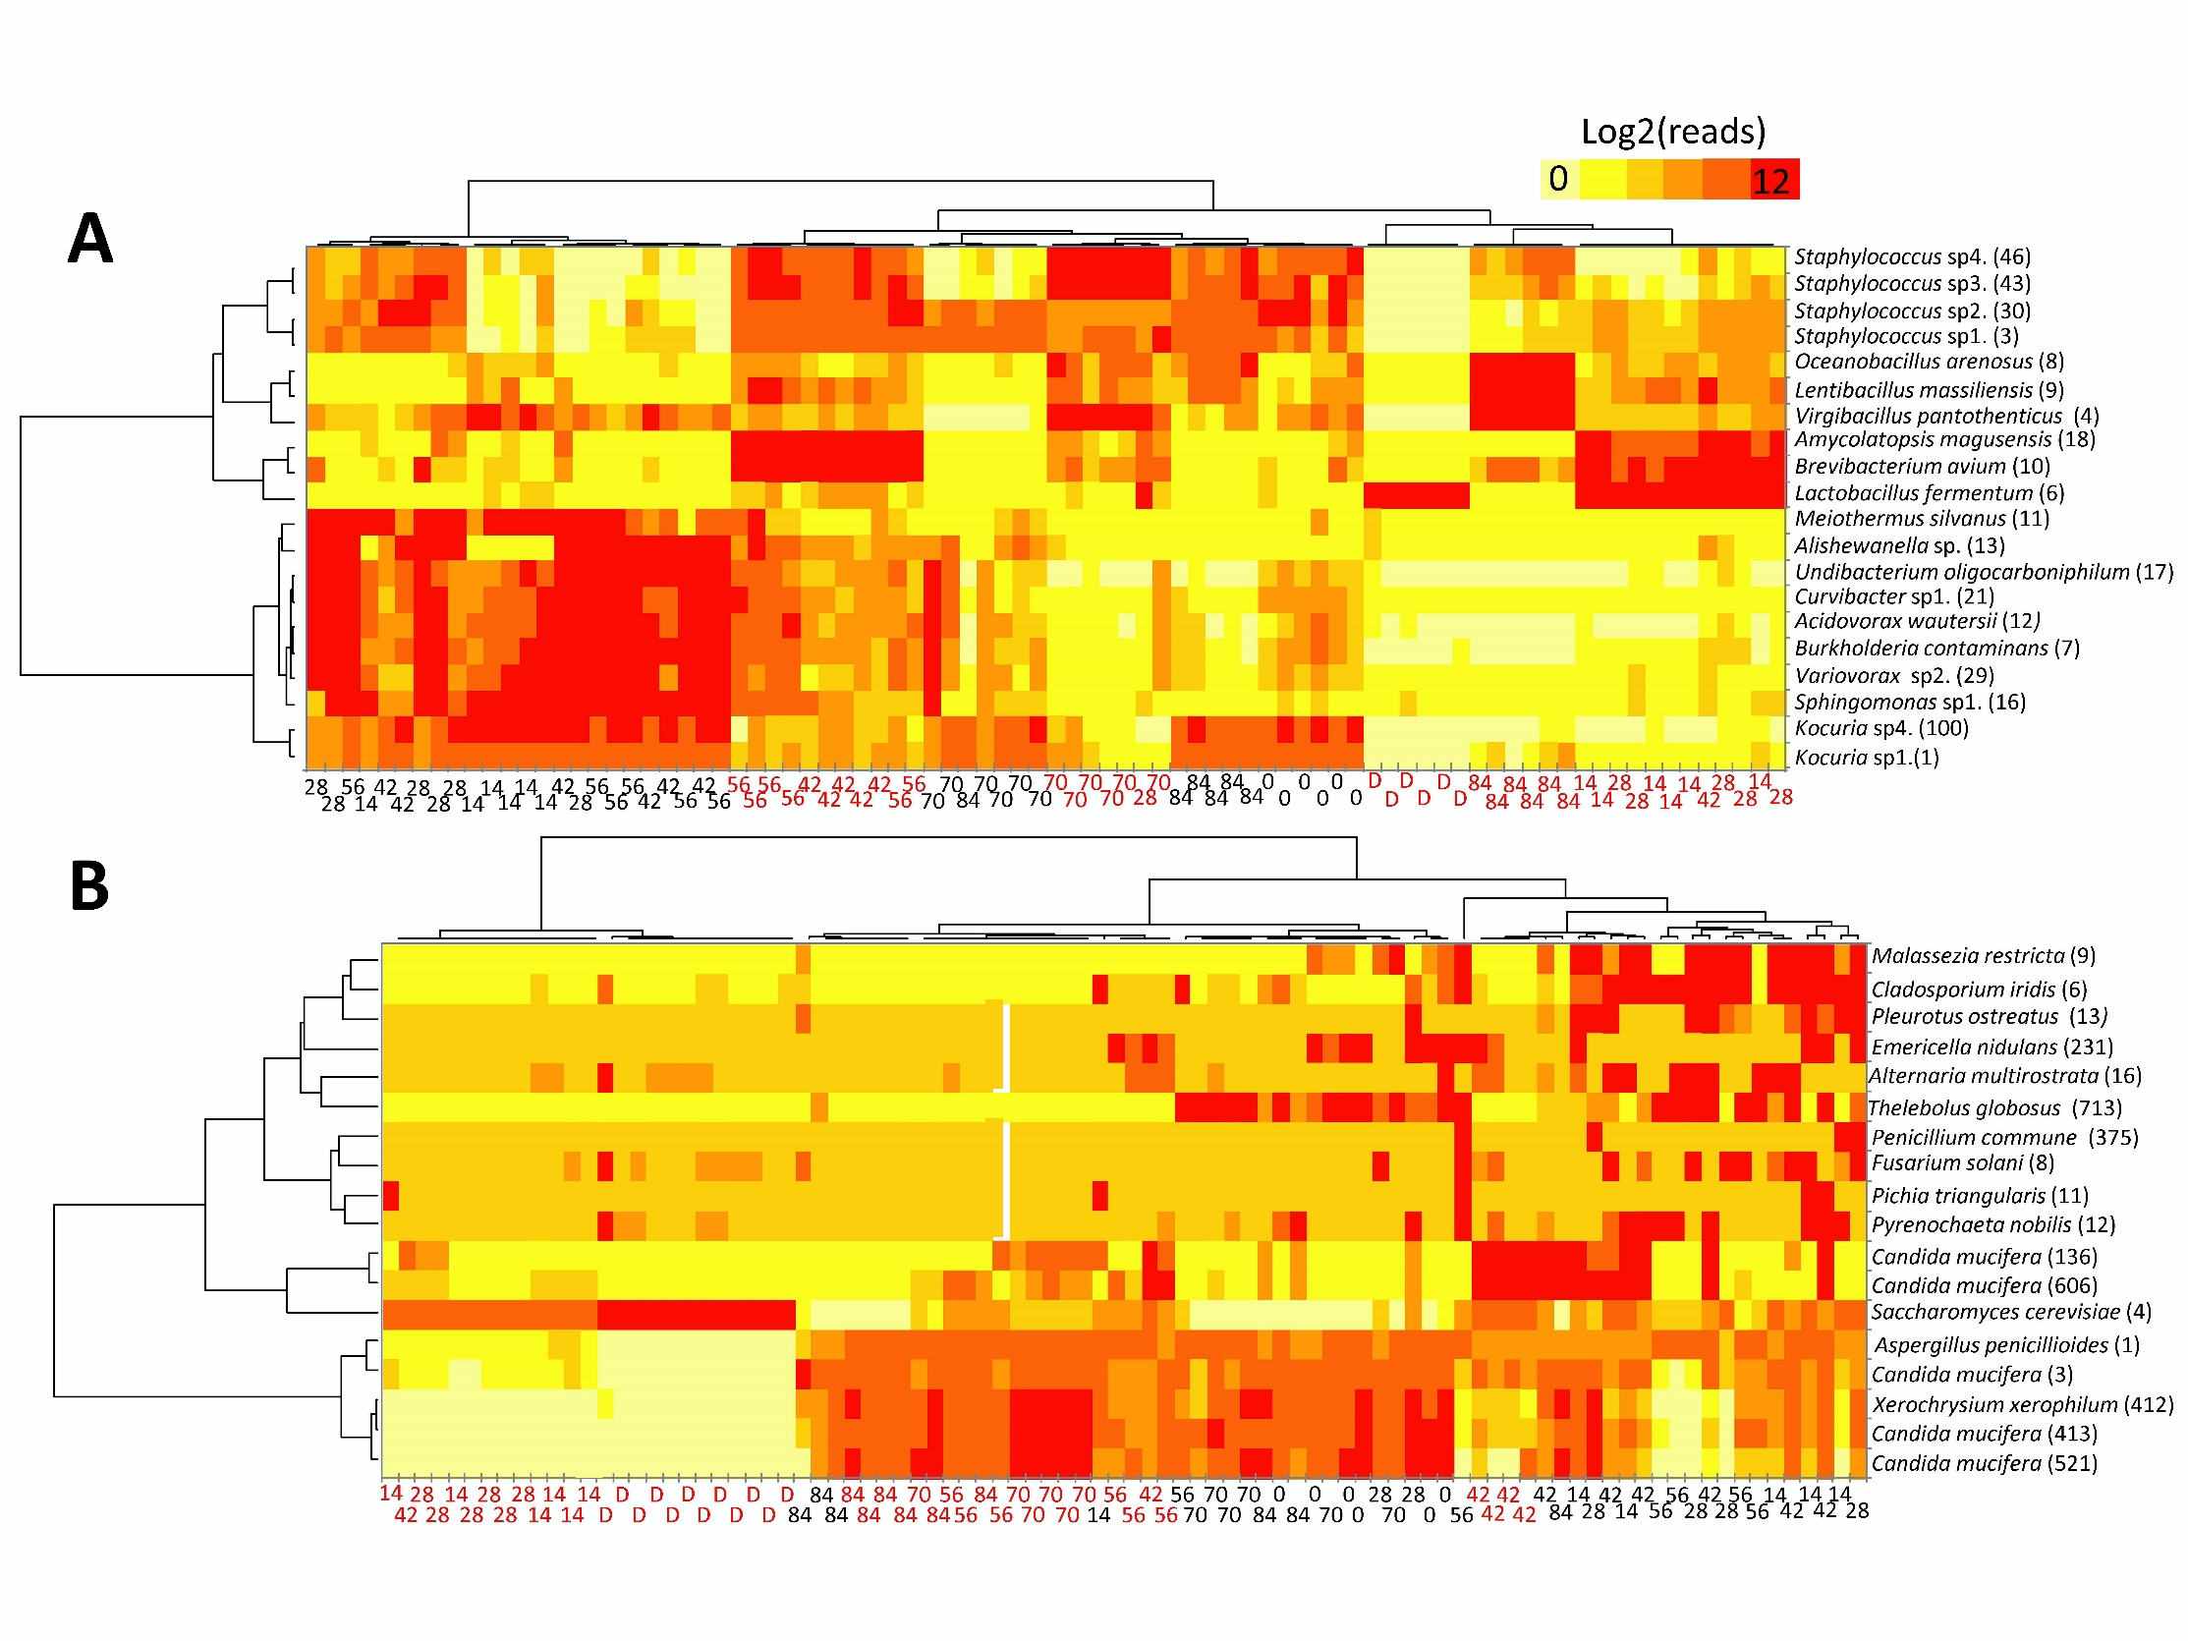
Figure S4 Quantification of the microbial composition in the ingested and environmental communities of D. pteronyssinus culture during the mite culture growth using qPCR. Copy number was estimated by amplification using universal and taxon-specific primers (Table S1), and data were recalculated on a per mite (ingested microbial community) or per gram of diet (environmental community) basis.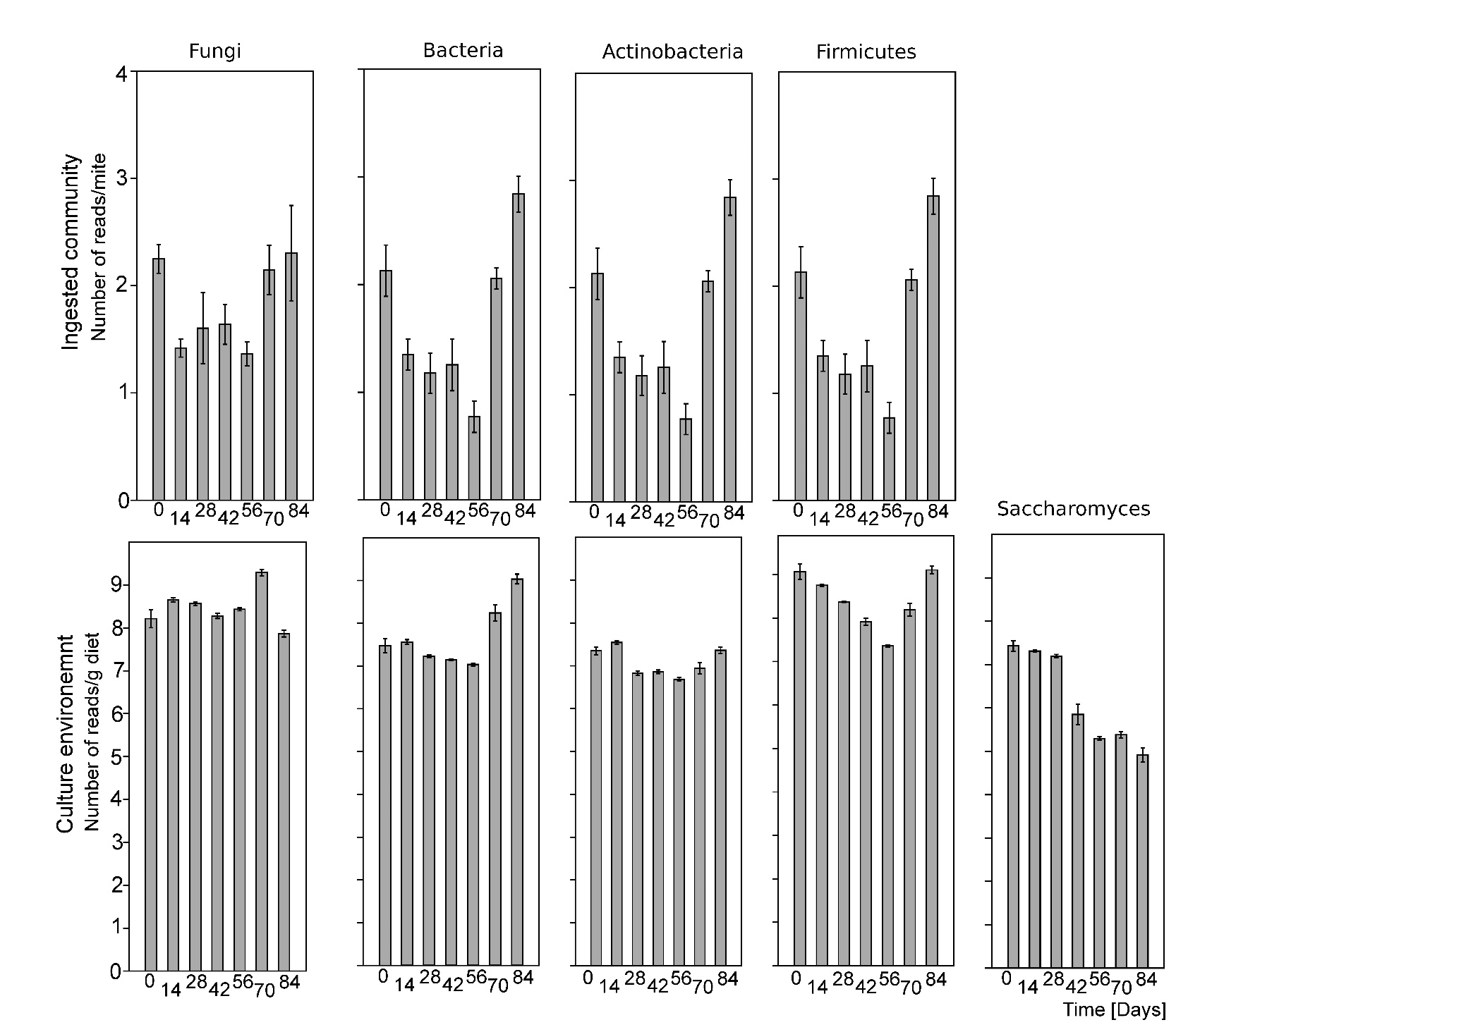
Figure S5 Experimental design of the study.
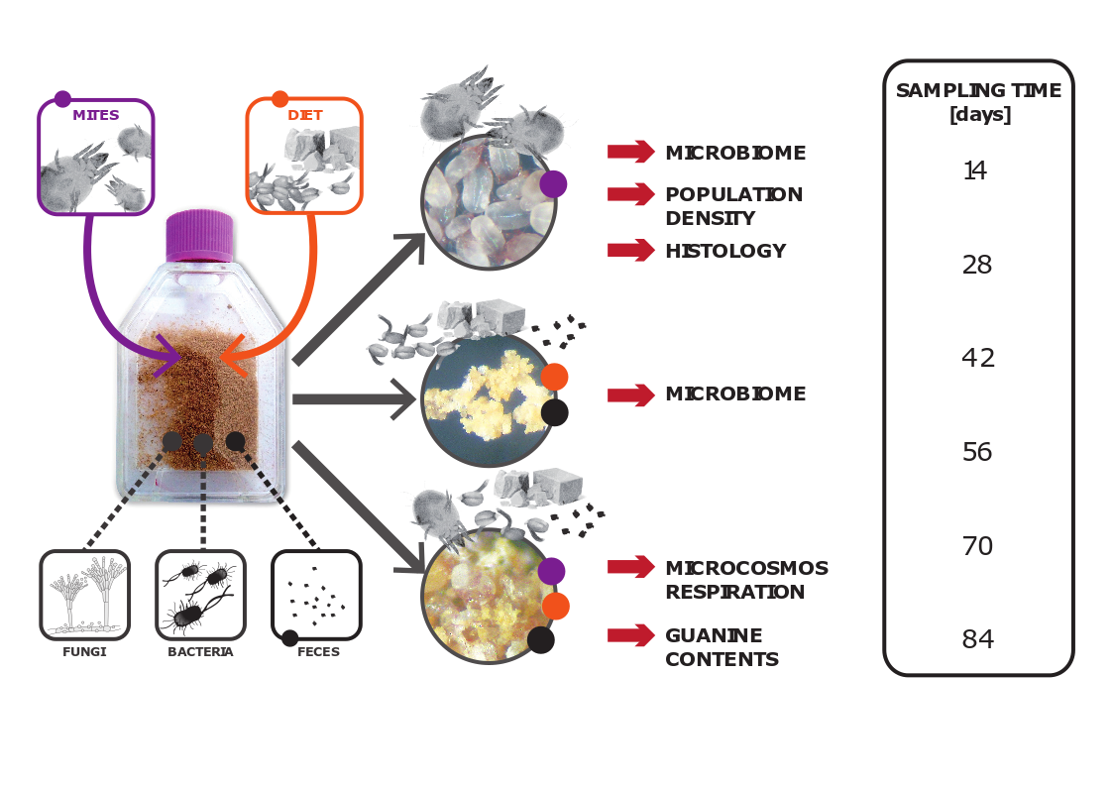

Supplementary references
50. Chemidlin Prevost-Boure N, Christen R, Dequiedt S, Mougel C, Lelievre M, Jolivet C, et al. Validation and application of a PCR primer set to quantify fungal communities in the soil environment by real-time quantitative PCR. PLoS One 2011;6:e24166.
51. Caporaso JG, Lauber CL, Walters WA, Berg-Lyons D, Huntley J, Fierer N, et al. Ultra-high-throughput microbial community analysis on the Illumina HiSeq and MiSeq platforms. ISME J. 2012;6:1621–4.
52. Vainio EJ, Hantula J. Direct analysis of wood-inhabiting fungi using denaturing gradient gel electrophoresis of amplified ribosomal DNA. Mycol Res. 2000;104:927–36.
54. Sakai M, Matsuka A, Komura T, Kanazawa S. Application of a new PCR primer for terminal restriction fragment length polymorphism analysis of the bacterial communities in plant roots. J Microbiol Methods 2004;59:81–9.
71. Lane DJ. 16s/23s rRNA sequencing. In: Stackebrandt E, Goodfellow M, editors. Nucleic acid techniques in bacterial systematics. Chichester & New York, NY: John Wiley and Sons; 1991. p. 115–75.
72. Dorn‐In S, Bassitta R, Schwaiger K, Bauer J, Holzel CS. Specific amplification of bacterial DNA by optimized so-called universal bacterial primers in samples rich of plant DNA. J Microbiol Methods 2015;113:50–56.
73. Hubert J, Erban T, Kopecky J, Sopko B, Nesvorna M, Lichovnikova M, et al. Comparison of microbiomes between red poultry mite populations (Dermanyssus gallinae): predominance of Bartonella-like bacteria. Microb Ecol. 2017;74:947–60.
74. Jeong G, Stouthamer R. Quantification of Wolbachia copy number in Trichogramma eggs (Hymenoptera: Trichogrammatidae): lysozyme treatment significantly improves total gene yield from the Gram‐negative bacterium. Entomol Res. 2009;39:66–9.
75. Guo X, Xia X, Tang R, Zhou J, Zhao H, Wang K. Development of a real-time PCR method for Firmicutes and Bacteroidetes in faeces and its application to quantify intestinal population of obese and lean pigs. Lett Appl Microbiol. 2008;47:367–73.
76. Stach JEM, Maldonado LA, Ward AC, Goodfellow M, Bull AT. New primers for the class Actinobacteria: application to marine and terrestrial environments. Environ Microbiol. 2003;5:828–41.
77. Salinas F, Garrido D, Ganga A, Veliz G, Martinez C. Taqman real-time PCR for the detection and enumeration of Saccharomyces cerevisiae in wine. Food Microbiol. 2009;26:328–32.
78. Calvitti M, Marini F, Desiderio A, Puggioli A, Moretti R. Wolbachia density and cytoplasmic incompatibility in Aedes albopictus: concerns with using artificial Wolbachia infection as a vector suppression tool. PLoS One 2015;10:e0121813.
79. Kopecky J, Perotti MA, Nesvorna M, Erban T, Hubert J. Cardinium endosymbionts are widespread in synanthropic mite species (Acari: Astigmata). J Invertebr Pathol. 2013;112:20–3.

