Characterisation of Patients Referred to a Tertiary Level Inherited Cardiac Condition Clinic with Suspected Arrhythmogenic Right Ventricular Cardiomyopathy (ARVC)

Supplementary

eTable 1. Overview of patients with minor ARVC criteria only and family members of ARVC patients with ARVC excluded

Demographic | ARVC excluded based on genetic testing (n=14) | Patients with Minor ARVC criteria (n=27)
Age | 41± 18 | 39±16
Male/ Female | 7/7 | 17/10
weight(kg) | 79 ± 13.8 | 79.3± 19.4
Height(cm) | 168 ± 8.7 | 172.5 ± 8.6
Body Surface Area BSA(m²) | 1.9 ± 0.2 | 1.9±0.3
Body Mass Index BMI (kg/m²) | 27.8±4.1 | 26.8 ±6
Echo
2D RA Area (cm2) | 16.4±3.9 | 14.7 ±3.5
RVOT PLAX (cm) | 3.4 ± 0.7 | 2.7±0.4
Proximal RVOT(RVOT1)PSAX(cm) | 2.9 ± 0.4 | 2.9 ±0.4
4C base RV1(cm) | 3.3 ± 0.5 | 3.4 ± 0.6
4C mid RV2 (cm) | 2.9 ±0.5 | 2.9±0.4
4C length RV3 (cm) | 6.2 ± 0.8 | 7±0.8
RVEDA (cm2) | 19.8 ±3.2 | 20.9±6.1
RVESA(cm2) | 10.4 ±2.2 | 9.5±3.3
FAC(%) | 47 ± 8 | 54±11
TAPSE(cm) | 2.5 ± 0.3 | 2.5±0.5
EDV(ml) | 81.8 ±16.5 | 101.3±23.2
ESV(ml) | 25.5±5.8 | 39.1±12.7
EF (%) | 68 ± 6 | 63±5
LA Area(cm²) | 16.1±5 | 16.4 ±3
LA Volume(ml) | 44 ±19.8 | 40.6 ±11.6
ECG
HR | 67.7 ±13.6 | 71.3±15.1
PR interval(ms) | 157.2 ±31 | 144.9±20.5
QRS duration(ms) | 101.4± 38.6 | 93.6±11
QT(ms) | 388 ±32.3 | 384±36.8
QTC(ms) | 406.3±28 | 403.5±25.5
P axes | 39.9±33.1 | 44.8±24
QRS axes | 40.6±35.9 | 38.4±39.3
T axes | 34±15.1 | 39.7±20.3
SAECG
Std.QRS durarion (unfiltered)(ms) | 90.0 ±11.8 | 94.4±10.1
Total.QRS durartion(filtered)(ms) | 116 ± 27.3 | 103.5±11
Duration of HFLA signals<40mv(ms) | 42.5 ±24.9 | 29.5±9.8
RMS voltage in terminal 40 ms(mv) | 31.8 ± 22.3 | 44.1±27.2
Mean voltage in terminal 40 ms(mv) | 23.6 ±12.5 | 28.6±16.8
Bio markers
Na(mmol/L) | 140.3±1.7 | 140.4±1.9
K(mmol/L) | 3.8 ±0.3 | 4±0.2
Creatinine (umol/L) | 75.7 ±10 | 69.8±13.7
NT-pro BNP (ng/L) | - | 78.5±43.5
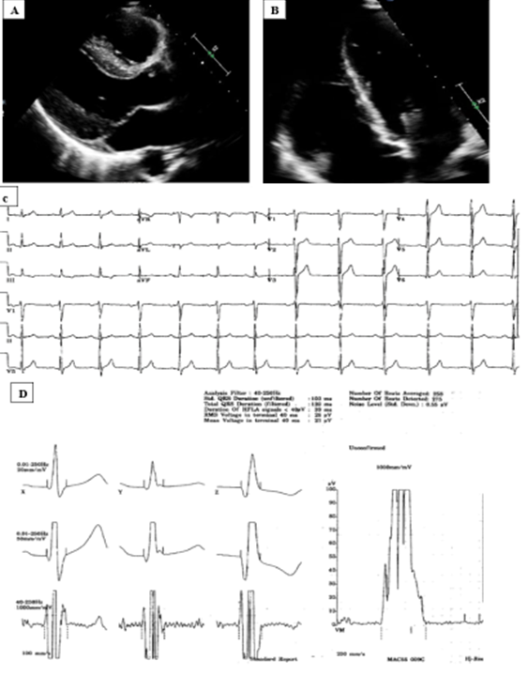
Abbreviations: Body surface area BSA, Body Mass Index BMI, N-terminal pro-B-type natriuretic peptide NT-proBNP, Sodium Na, Potassium K, right atrial area RA area,, Right ventricular outflow tract Parasternal long axis RVOT PLAX, Right ventricular outflow tract Parasternal short axis RVOT PSAX, 4 chamber Right ventricular basal diameter 4C base RV1, 4 chamber Right ventricular mid diameter 4C mid RV2, 4 chamber Right ventricular length 4C length RV3, Right ventricular end diastolic area RVEDA, Right ventricular end systolic area RVESA, Right ventricular fractional area change RVFAC, Tricuspid Annular Plane Systolic Excursion TAPSE, Left Ventricular End-Diastolic Volume LVEDD, Left Ventricular End-Systolic Volume LVESV, ejection fraction EF, Left atrial area LA area, Left atrial volume LA volume
eFigure 1. 18 year old male with early stage ARVC and hence mild phenotype. Echocardiography shows normal RV and LV size and function (A and B). 12 lead ECG shows normal T wave with no epsilon wave (C). Signal-averaged ECG is positive for two of the three criteria. QRS duration filtered is 120 ms and duration of high low frequency signal is less than 40 μV at 39 ms.

