Protecting those who protect nature by supporting conservationists’ mental health

Supplementary information (SI)
Thomas Pienkowski; Aidan Keane; Sofia Castelló y Tickel; Emiel de Lange; Mirjam Hazenbosch; Munib Khanyari; William N. S. Arlidge; Gergő Baranyi; Stephanie Brittain; Vena Kapoor; Vik Mohan; Sarah Papworth; Roshni Ravi; Izak P.J. Smit; E.J. Milner-Gulland

Contents
SI 1: Survey information and questions 3
SI 2: Hypothesis table 15
SI 3: Distribution of Kessler-10 and Kessler-6 scores 19
SI 4: Model fit 20
SI 5: More conservative definition of conservationists 21
SI 6: Removing dispositional optimism 22
SI 7: Replace situational optimism with collective goal progress satisfaction 23
SI 8: Exploring the role of age 25
SI 9: Gender-disaggregated analysis 28
SI 10: Using the original effort-reward imbalance instrument 30
SI 11: Impacts of the COVID-19 pandemic 31
SI 12: Work country, nationalism, and psychological distress 33
SI 13: Recruitment email 37
SI 14: Ideas table 38
SI 15: Ethical protocol 42
SI 16: Life Orientation Test - Revised 43
SI 17: Situational optimism instrument 44
SI 18: Effort-reward imbalance model 45
SI 19: Patterns of missing data 46
SI 20: Multivariate imputation through chained equations 48
References 49

SI 1: Survey information and questions
The following illustrates the survey form used in the study. This survey is available at https://livedataoxford.shinyapps.io/lifeinconservation/. The survey form uses conditional logic in multiple places.
- Those under 18 are re-directed out of the survey.
- When asked the goal progress questions (page 1), respondents are first asked if the goal is important to them. If they answer yes, they are their degree of satisfaction or dissatisfaction.
- Three of the Kessler-10 items are paired. The exact statements are provided below the survey form.
We show the survey through screenshots to illustrate what participants saw. Respondents were provided with the option to leave the survey (at the end of each page); the data for those who chose to do so was deleted.
Page 0 – Information and consent page
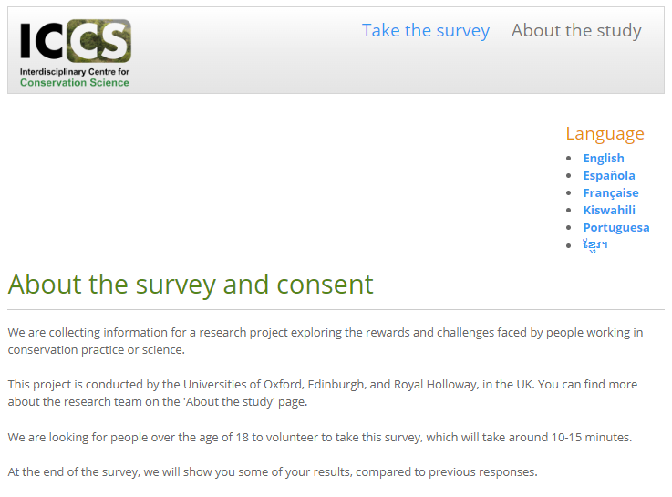
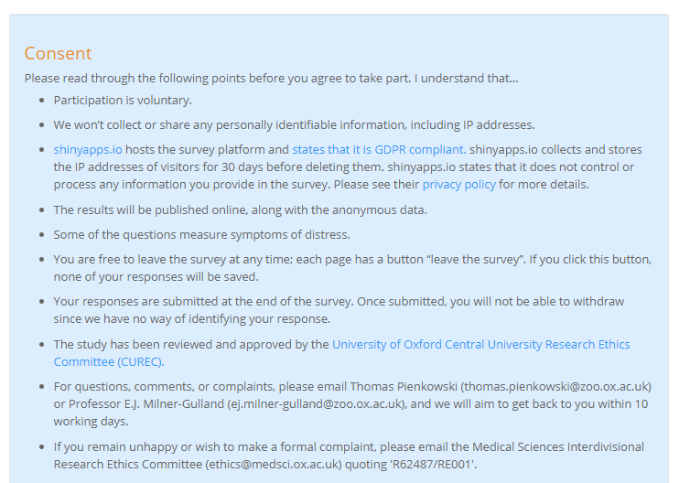
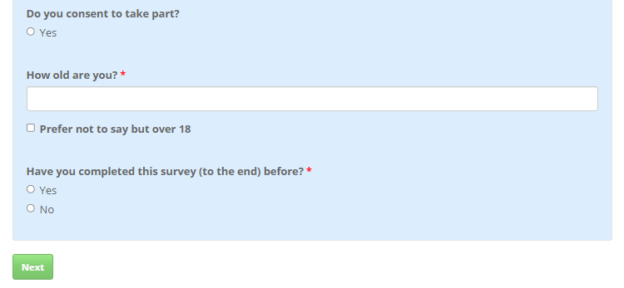

Page 1 – Personal and conservation goals
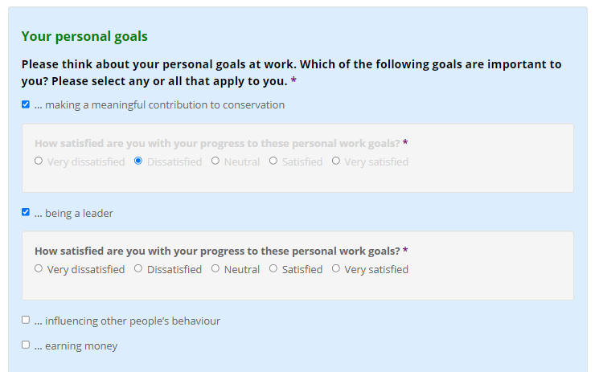
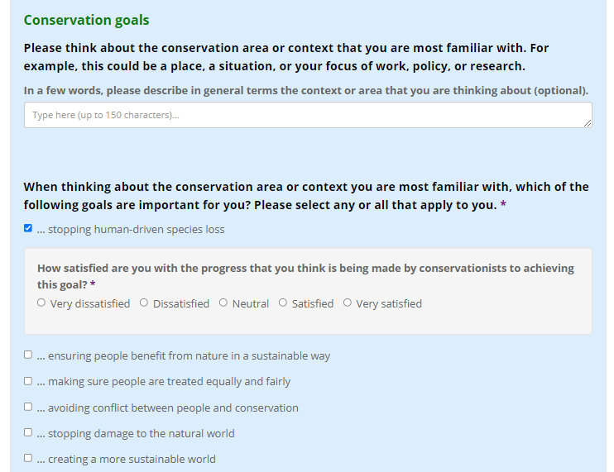
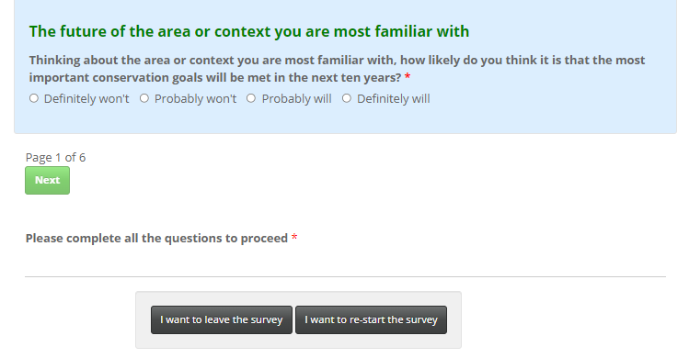

Page 2 – Effort-reward imbalance items
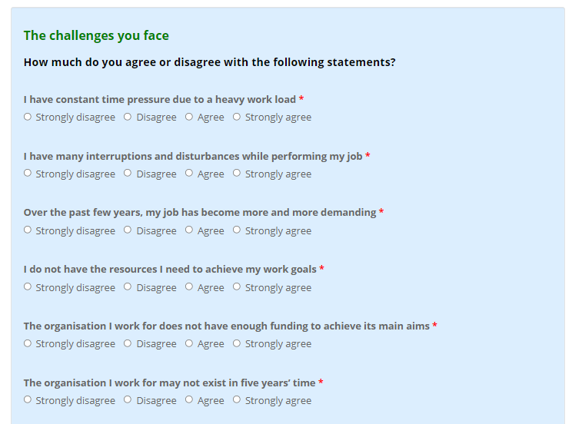
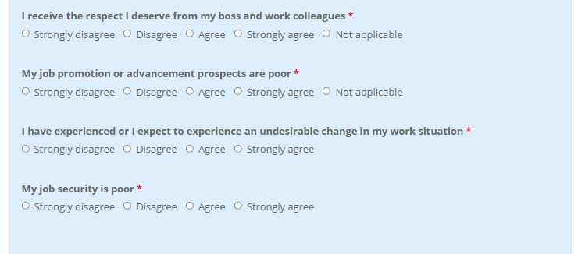
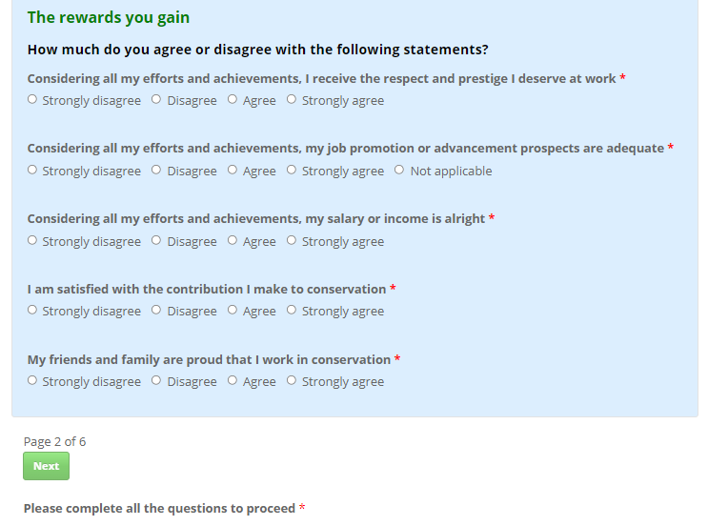

Page 3 – Situational and dispositional optimism
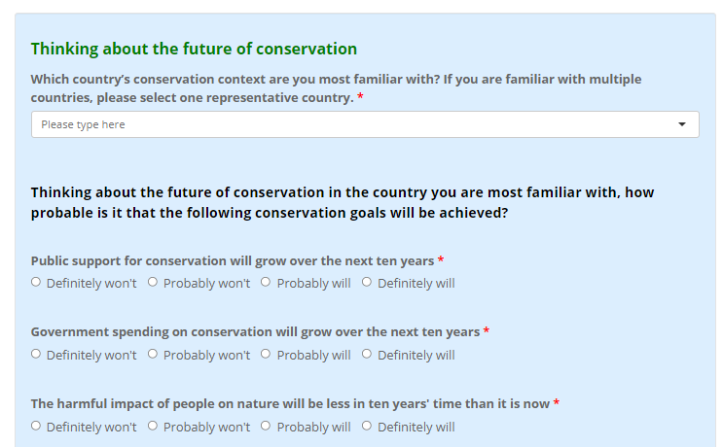
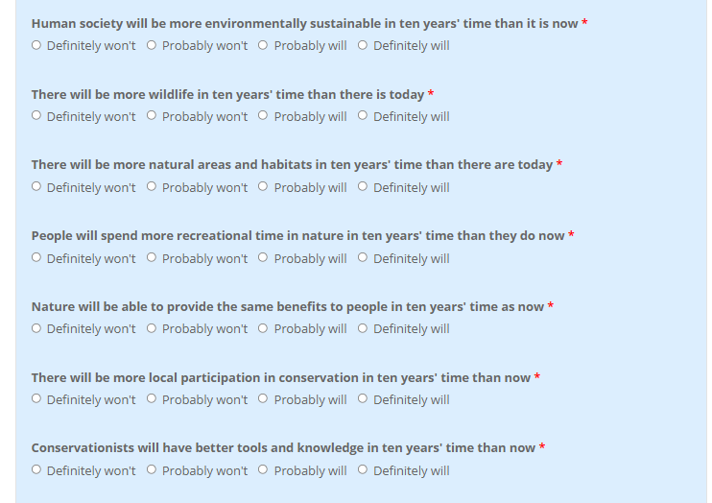
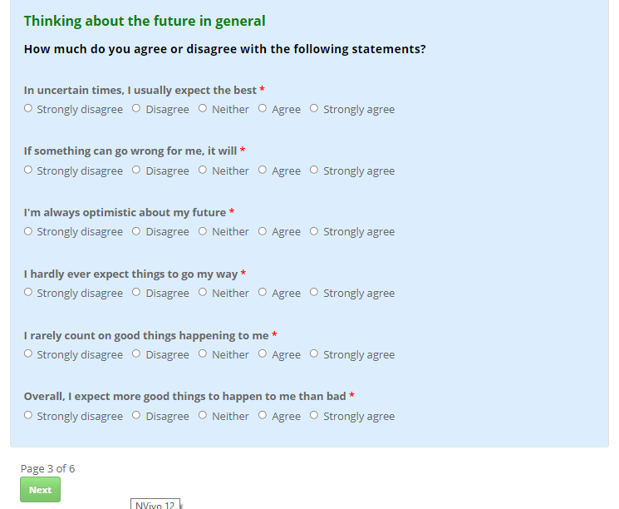

Page 4 – Kessler-10 questions
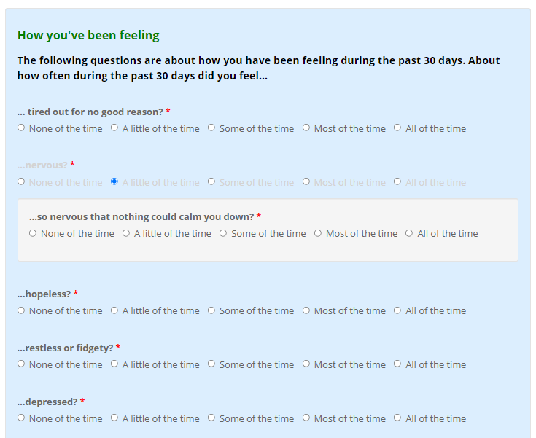
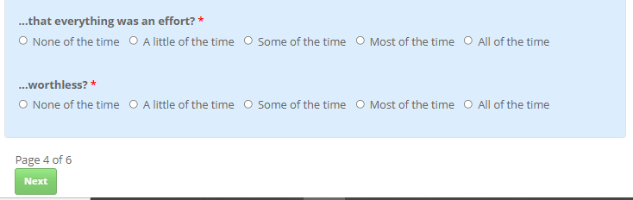

Page 5 – Physical health, social support, and personal security
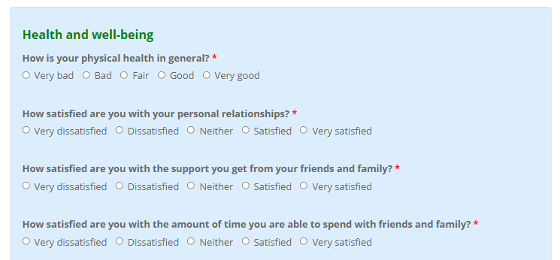
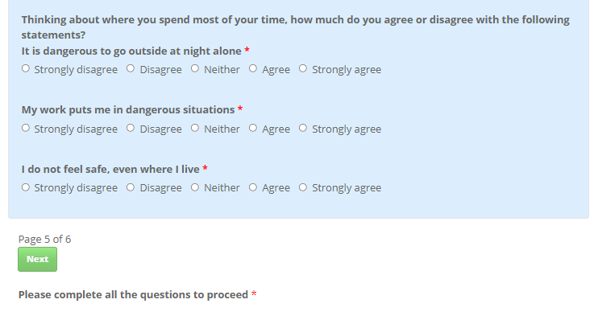

Page 6 – Additional occupational and personal questions
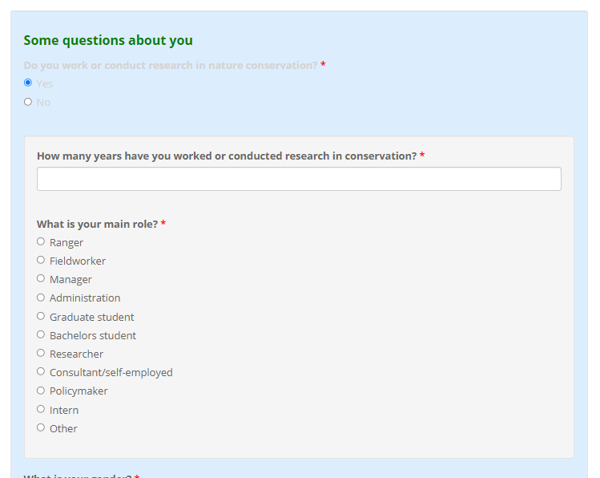
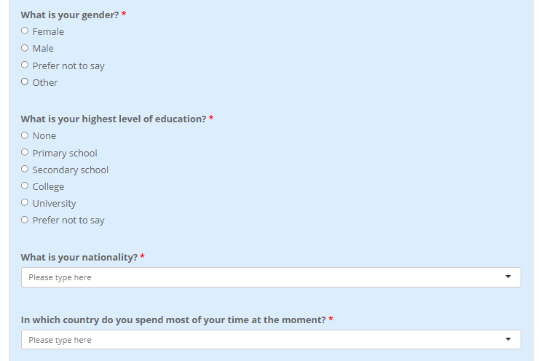
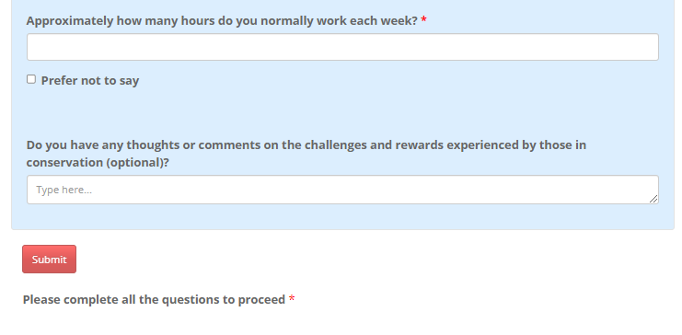

Information and consent page
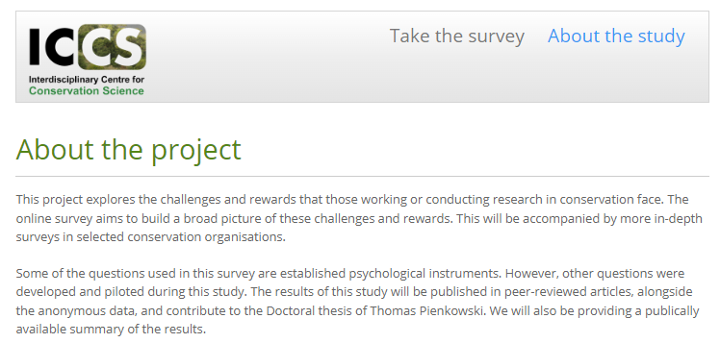
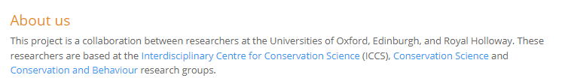
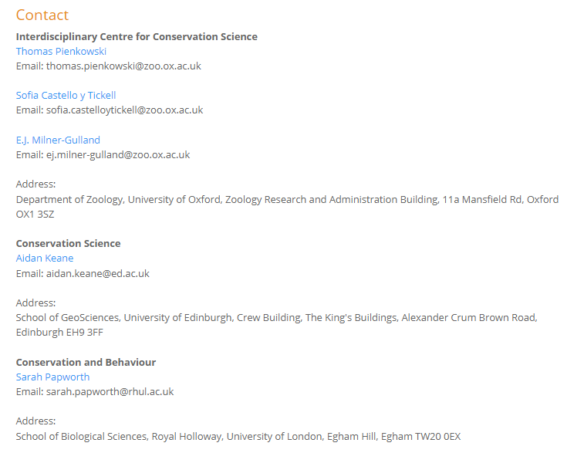

Kessler-10 questions
The phrasing of the Kessler-10 instrument is as follows: “The following questions are about how you have been feeling during the past 30 days. About how often during the past 30 days did you feel…
1. … tired out for no good reason?
2. …nervous?
3. …so nervous that nothing could calm you down?
4. …hopeless?
5. …restless or fidgety?
6. …so restless that you could not sit still?
7. …depressed?
8. …so depressed that nothing could cheer you up?
9. …that everything was an effort?
10. …worthless?”
The response levels are “None of the time”, “A little of the time”, “Some of the time”, “Most of the time”, and “All of the time”. Items 3, 6, and 8 are not asked if the response to the prior question (2, 5, or 7) is “None of the time”.

SI 2: Hypothesis table
Table S1. Personal characteristics and occupational risk factors expected to be associated with psychological distress in two models. The ‘ERI-score model’ includes the effort-reward imbalance score but excludes each item of the effort-reward imbalance instrument. The ‘ERI-item model’ includes each item of the instrument but excludes the effort-reward imbalance score. * Variables moderately correlated with other explanatory variables (rho >0.6) were removed from the statistical analysis post-hoc. †Ordinal exogenous variables were treated as numeric. ‡ Conservation-specific items added to the original effort-reward imbalance instrument. Key: RL = reference level; + = expected positive association; - = expected negative association; and ? = ambiguous or unclear expected association.
Variable type | Name | Statement | Description | Expected association with psychological distress
Personal characteristics | Dispositional optimism |  | A latent variable derived from the Life Orientation Test – Revised | (-) Those optimistic in life are expected to report lower psychological distress¹.
Personal characteristics | Situational optimism |  | Latent situational optimism about conservation outcomes. | (-) Those more optimistic about outcomes for nature are expected to report lower psychological distress². A correlation between situational and dispositional optimism was included in the analysis.
Personal characteristics | Gender |  | Female or male (RL = female) | (-) Gender-differentiated stressors are expected to affect men and women, with evidence that women can face barriers in conservation work³. Outside work, there can be greater social and cultural risk factors for psychological distress among women^{4,5}.
Personal characteristics | Age* |  | Age in years | (?) Changes in biological and behavioural characteristics and how individuals are treated over their life course are expected to influence their risk of psychological distress, although exactly how is uncertain in this case⁴.
Personal characteristics | Years in conservation |  | Years working in conservation | (?) Those in conservation for longer are expected to be more established in their careers, with more secure roles and better compensation than early-career conservationists⁶. Alternatively, those in the sector for longer may have witnessed repeated failure to meet conservation goals, which may be distressing.
Personal characteristics | National / non-national |  | National or non-national (RL = national) | (?) Employees that are nationals of the country they work in may face differing pressures compared to non-nationals^{7,8}, although relationships with reported psychological distress are unclear.
Personal characteristics | Education |  | University or non-university education (RL = non-University) | (?) Education level is both a consequence and determinant of socioeconomic status and social mobility, which are associated with poor mental health^{9,10}. Equally, those with higher education may be more aware of the scale of nature loss, which may be distressing⁶.
Personal characteristics | Physical health† | “How is your physical health in general?” | A single item ordinal variable measuring general health. | (-) There is often co-morbidity between physical and mental health, which may be bi-directional, so we expect good health to be negatively associated with psychological distress¹¹.
Personal characteristics | Personal relationships† | Satisfied with:  “…your personal relationships?” | Each of the three social support items | (-) Social support appears consistently associated with better mental and physical health, although the relationship may be bi-directional¹².
Personal characteristics | Friends and family support† | “…the support you get from your friends and family?” | Each of the three social support items
Personal characteristics | Friends and family time† | “…the amount of time you are able to spend with friends and family”† | Each of the three social support items
Workplace conditions | Effort-reward score |  | The adapted effort-reward imbalance score (‘ERI-score model’). | (+) A high ratio of effort relative to reward is expected to be associated with psychological distress (e.g.,¹³⁻¹⁸).
Workplace conditions | Heavy workload† | “I have constant time pressure due to a heavy work load” | The effort items from the adapted effort-rewards imbalance instrument (‘ERI-item model’). | (+) Each effort item from the adapted effort-rewards imbalance instrument is expected to be positively associated with psychological distress.
Workplace conditions | Many disturbances*,† | “I have many interruptions and disturbances while performing my job”
Workplace conditions | Increasingly demanding job† | “Over the past few years, my job has become more and more demanding”
Workplace conditions | Not enough resources† | “I do not have the resources I need to archive my work goals”
Workplace conditions | Not enough funding*, † | “The organisation I work for does not have enough funding to achieve its main aims” ‡
Workplace conditions | Organisational instability† | “The organisation I work for may not exist in five years time” ‡
Workplace conditions | Respect I deserve*,† | “I receive the respect I deserve from my boss and work colleagues” | The reward items from the adapted effort-rewards imbalance instrument (‘ERI-item model’). | (-) Each reward item from the adapted effort rewards imbalance instrument is expected to be negatively associated with psychological distress.
Workplace conditions | Job advancement prospects*,† | “My job promotion or advancement prospects are poor (reverse coding)”
Workplace conditions | Do not expect undesirable job change† | “I have experienced or I expect to experience an undesirable change in my work situation (reverse coding)”
Workplace conditions | Good job security† | “My job security is poor (reverse coding)”
Workplace conditions | Respect and prestige† | “Considering all my efforts and achievements, I receive the respect and prestige I deserve at work”
Workplace conditions | Job advancement† | “Considering all my efforts and achievements, my job promotion or advancement prospects are adequate”
Workplace conditions | Income is alright† | “Considering all my efforts and achievements, my salary or income is alright”
Workplace conditions | Contribution to conservation† | “I am satisfied with the contribution I make to conservation” ‡
Workplace conditions | Social pride† | “My friends and family are proud that I work in conservation” ‡
Workplace conditions | Position |  | Academia and research or practice and policy (RL = academia and research) | (?) Academics and practitioners or policymakers face different challenges and rewards, although the relationship with reported psychological distress is unclear.
Workplace conditions | Dangerous at night*,† | “It is dangerous to go outside at night alone” | Each of the three items describing personal security at work and home | (+) Threats to personal security at work and home are expected to be positively associated with psychological distress^{19,20}.
Workplace conditions | Dangerous situations† | “My work puts me in dangerous situations”
Workplace conditions | Not feeling safe† | “I do not feel safe, even where I live”
Workplace conditions | Working hours |  | Work hours per week | (+) Some evidence suggests that high working hours is expected to contribute to burnout and psychological distress²¹.

SI 3: Distribution of Kessler-10 and Kessler-6 scores
The following illustrates the distribution of Kessler-10 and Kessler-6 (a brief standardised version of the instrument, which uses six items, Figure S1 and S2). The Kessler-6 is reported to aid comparison between studies. Respondents had a mean Kessler-6 score of 12.8 (standard deviation = 4.4) and median score of 12.0 (inter-quartile range = 6.0).
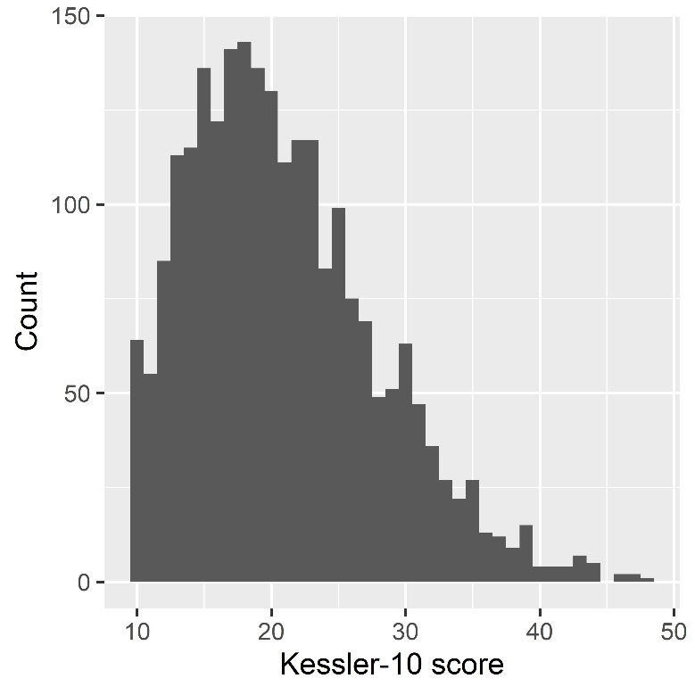
Figure S1. The distribution of Kessler-10 scores.

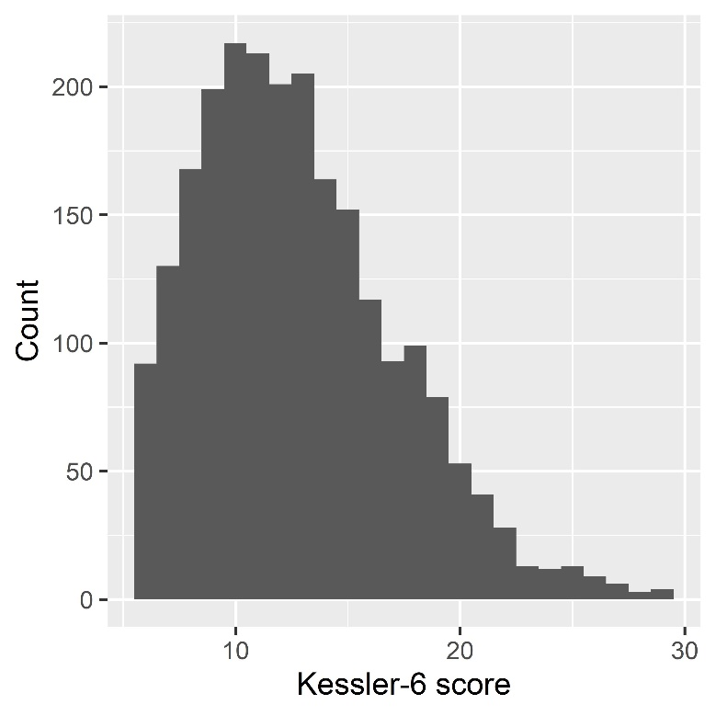
Figure S2. The distribution of Kessler-6 scores.

SI 4: Model fit
The ‘ERI-score’ model had a mean root mean square error of approximation of 0.05 (95% confidence interval 0.05 - 0.05), Tucker–Lewis index of 0.98, and standardized root mean square residual of 0.06 across the ten imputed datasets. The ‘ERI-item model’ had a mean root mean square error of approximation of 0.04 (95% confidence interval 0.04 - 0.04), Tucker–Lewis index of 0.98, and standardized root mean square residual of 0.05 across the imputed datasets. These measures suggested that both models fitted the data well.

SI 5: More conservative definition of conservationists
We used a broad definition of conservationists, which may include those not currently formally employed in conservation or those who did not disclose their current employment status. A stricter definition of conservationists may include only those who currently work or conduct research within conservation. To explore the sensitivity of our primary analysis to how we define conservationists, we repeated the analysis with 2017 responses from those who said they worked or conducted research in conservation. The results of this analysis were consistent with the primary analysis (Figure S3).

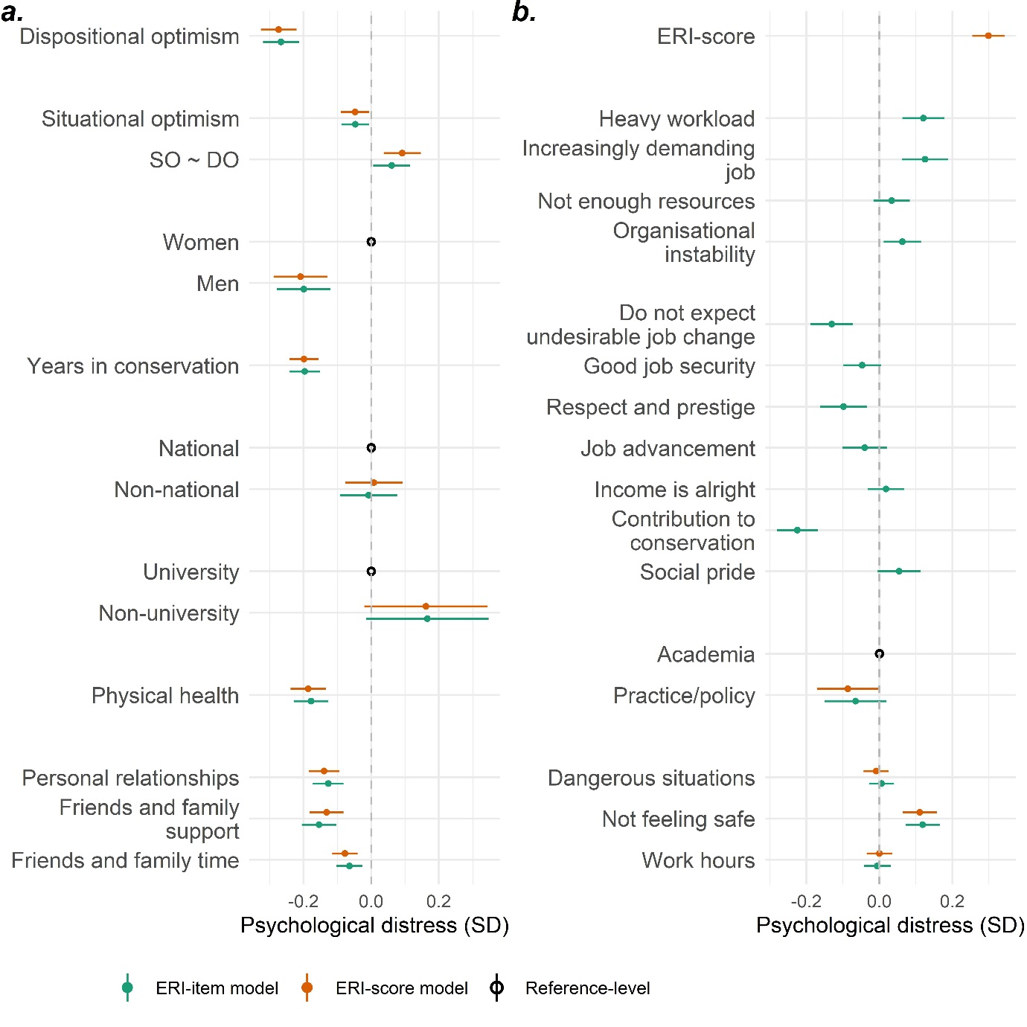

Figure S3. The estimated association in standard deviations (SD) between latent psychological distress and (a) personal characteristics and (b) occupational risk factors among 2017 respondents. This analysis was implemented with those who said they currently worked in conservation. ‘ERI-score model’ included the effort-reward imbalance score but excluded the individual instrument items, while the ‘ERI-item model’ included these items but excluded the score. Continuous variables were scaled and centred. ‘Unknown’ response levels are not shown.

SI 6: Removing dispositional optimism
Dispositional optimism may be a confounding variable between psychological distress and other explanatory variables. To evaluate this, we repeated the analysis after the dispositional optimism variable and compared the results to those of the original model. However, the results were consistent with the primary analysis, suggesting dispositional optimism did not have a confounding effect (Figure S4).

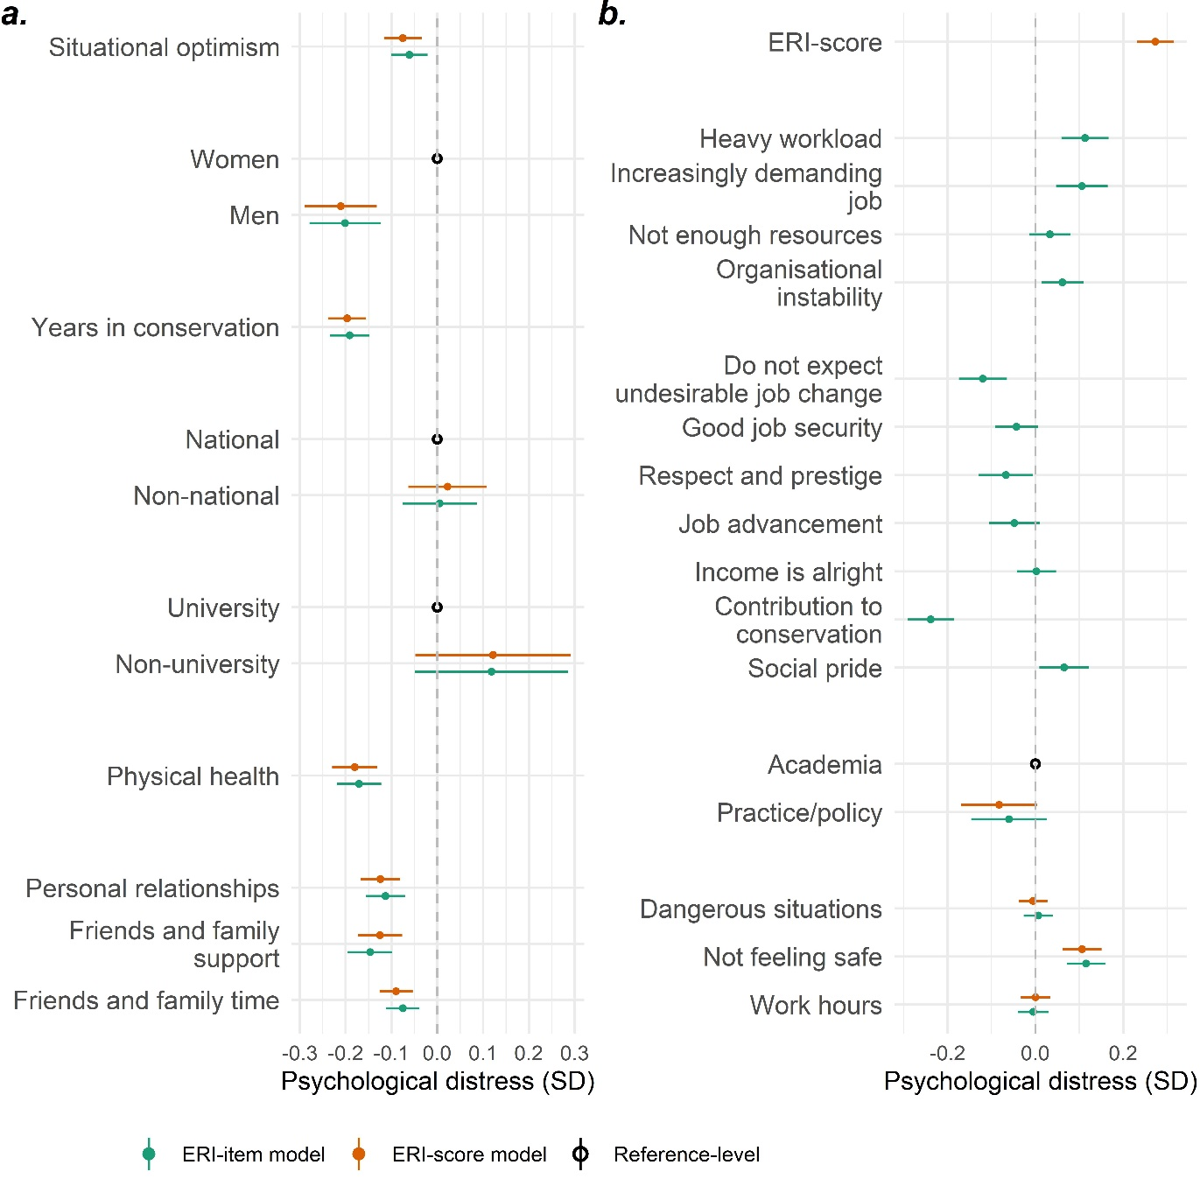
Figure S4. The estimated association in standard deviations (SD) between latent psychological distress and (a) personal characteristics and (b) occupational risk factors among 2306 respondents. Dispositional optimism was removed from the analysis. ‘ERI-score model’ included the effort-reward imbalance score but excluded the individual instrument items, while the ‘ERI-item model’ included these items but excluded the score. Continuous variables were scaled and centred. ‘Unknown’ response levels are not shown.

SI 7: Replace situational optimism with collective goal progress satisfaction
Goal progress increases feelings of control, autonomy, and competence and alleviates distress caused by unmet needs and undesirable situations²². Consequently, satisfaction with goal progress may contribute to wellbeing, but inadequate progress may be a source of distress²³⁻²⁵. For instance, a meta-analysis of 85 studies found consistent positive associations between subjective wellbeing and perceived goal progress²⁶. We, therefore, replaced situational optimism with a measure of satisfaction with collective conservation goal progress. This measure was developed in Pienkowski, et al. ⁶.
In summary, six statements were developed based on sub-dimensions of the value-belief-norm theory and other literature^{27,28} (Table S2). These were developed during a series of workshops attended by six authors. Not all conservationists were expected to endorse the same goals. So, respondents were first asked which goals were important. Second, for those considered important, respondents were to indicate their satisfaction or dissatisfaction according to five response levels ranging from “very dissatisfied” (1) to “very satisfied” (5). Respondents were asked to think about the conservation area or context they were most familiar with when responding to questions about collective goals. The satisfaction scores for each endorsed goal were added and then scaled and centred for each respondent. This variable was used to indicate satisfaction with collective conservation goal progress.
Table S2. Six statements describing collective conservation goal progress satisfaction developed based on sub-dimensions of the value-belief-norm theory^{27,28}.
Dimension | Sub-dimension | Corresponding goals
Altruistic | Equality: equal opportunity for all | “Making sure people are treated equally and fairly”
Altruistic | Social justice: correcting injustice, caring for the weak | “Making sure people are treated equally and fairly”
Altruistic | A world at peace: free of war and conflict | “Avoiding conflict between people and conservation”
Altruistic | Helpful: working for the welfare of others | “Ensuring people benefit from nature in a sustainable way”
Biospheric | Preventing pollution: protecting natural resources | “Stopping human-driven species loss”
Biospheric | Respecting the earth: harmony with other species | “Creating a more sustainable world”
Biospheric | Unity with nature: fitting into nature | “Creating a more sustainable world”
Biospheric | Protecting the environment: preserving nature | “Stopping damage to the natural world”

In this supplementary analysis, collective goal progress satisfaction had a small negative association with psychological distress (Figure S5). This small association corroborates our suggestion that respondents may be less concerned about the “bigger picture” of ongoing biodiversity loss in contrast to their own role (indicated by their reported satisfaction with their contributions to conservation”).
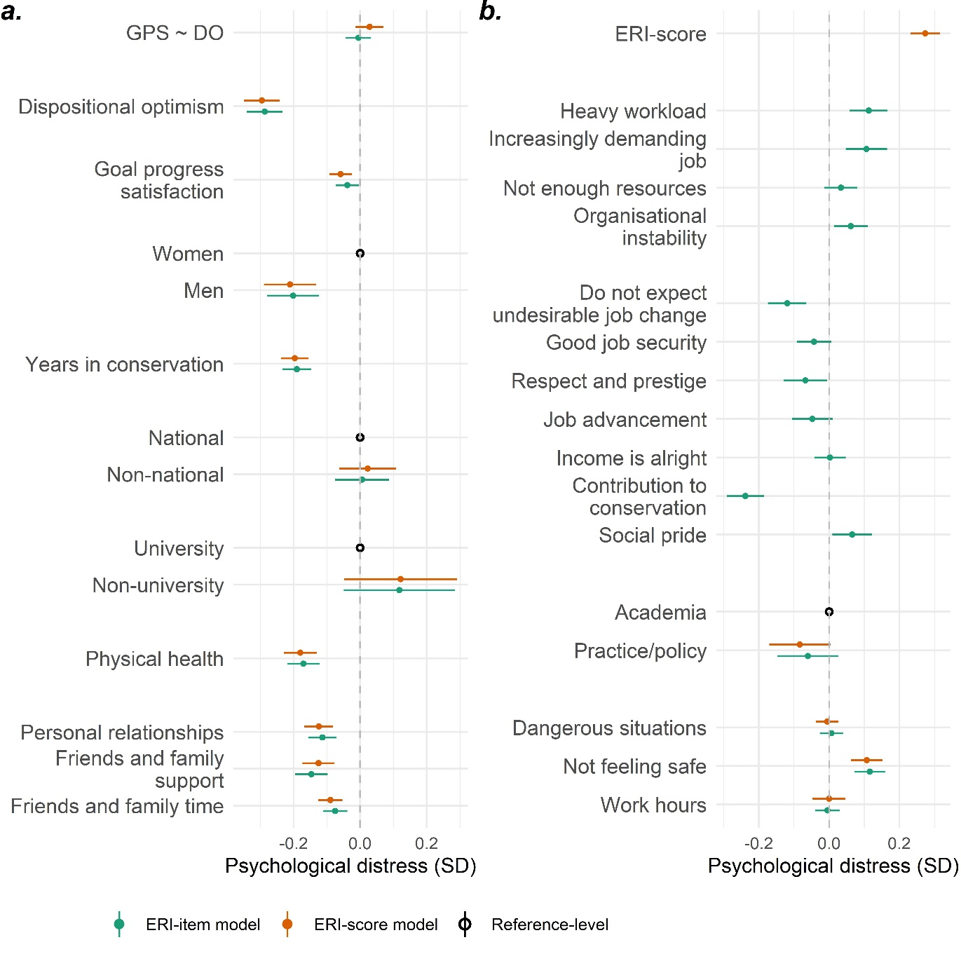
Figure S5. The estimated association in standard deviations (SD) between latent psychological distress and (a) personal characteristics and (b) occupational risk factors among 2306 respondents. Situational optimism was replaced with a measure of respondents’ satisfaction with collective conservation goal progress. ‘ERI-score model’ included the effort-reward imbalance score but excluded the individual instrument items, while the ‘ERI-item model’ included these items but excluded the score. Continuous variables were scaled and centred. ‘Unknown’ response levels are not shown.

SI 8: Exploring the role of age
Age was excluded from the primary analysis because of its strong association with years’ experience in conservation (Figure S6). To explore the sensitivity of our primary result, we substituted the years in conservation variable with age. The results of this analysis were consistent with the primary analysis (Figure S7). Furthermore, the primary analysis interprets years in conservation as a proxy for many social, professional, and biological changes that occur throughout the life course. However, we conducted a supplementary analysis that included both years in conservation and age. Both had similar associations with psychological distress, which were approximately half as large as the association observed for years in conservation in the original analysis (Figure S8).

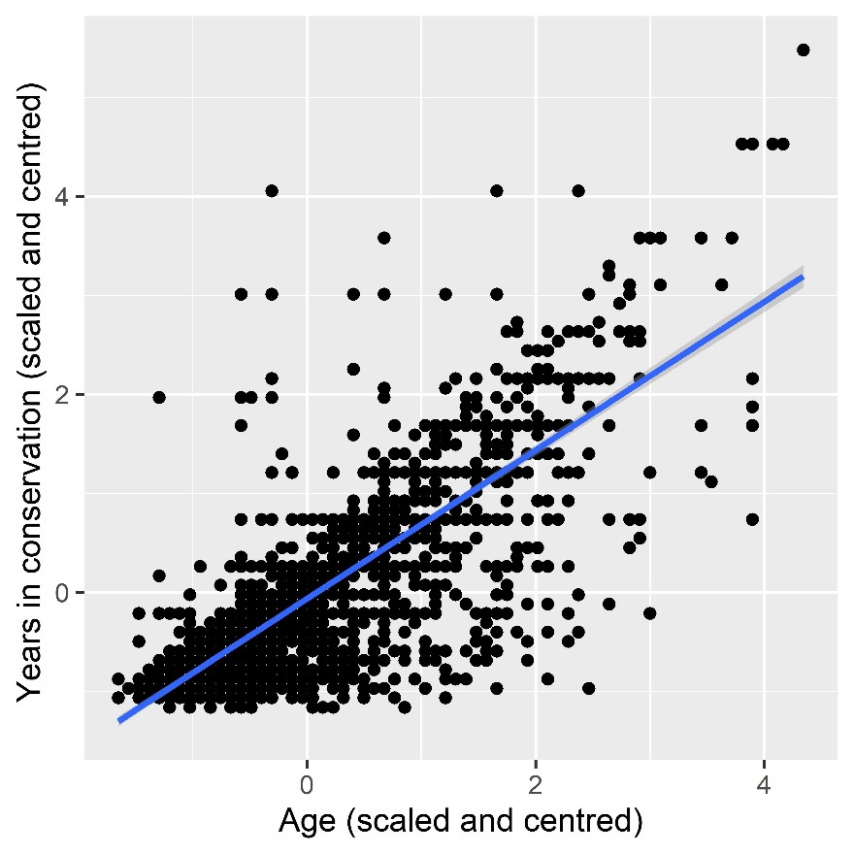
Figure S6. The association between age and years in conservation (both scaled and centred).
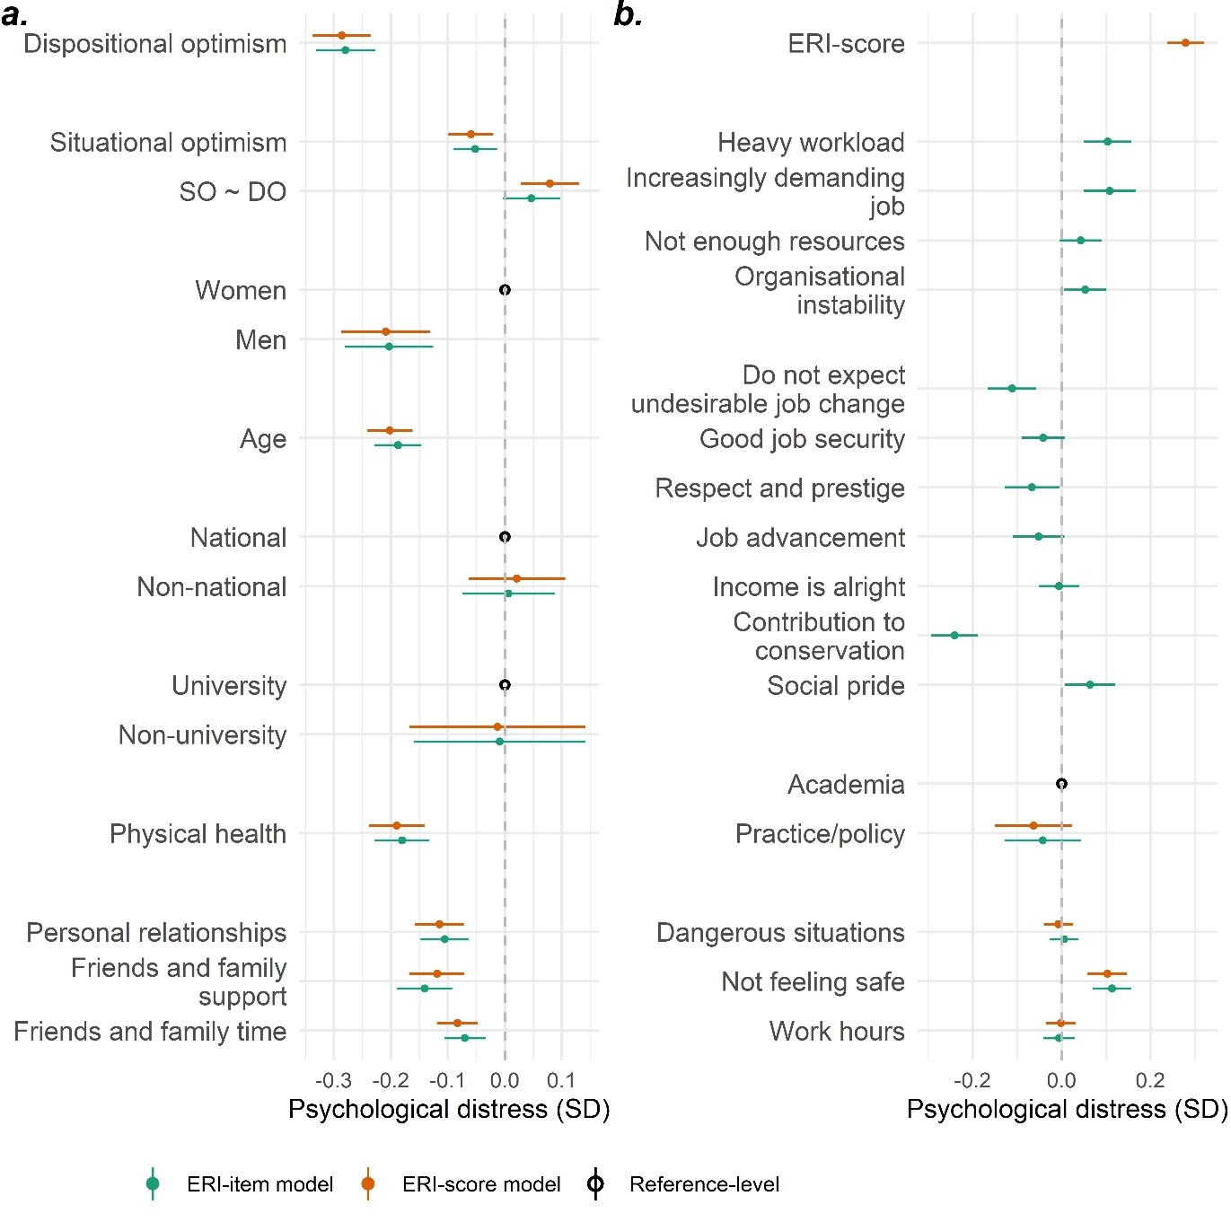
Figure S7. The estimated association in standard deviations (SD) between latent psychological distress and (a) personal characteristics and (b) occupational risk factors among 2306 respondents. Years in conservation were replaced with age. ‘ERI-score model’ included the effort-reward imbalance score but excluded the individual instrument items, while the ‘ERI-item model’ included these items but excluded the score. Continuous variables were scaled and centred. ‘Unknown’ response levels are not shown.

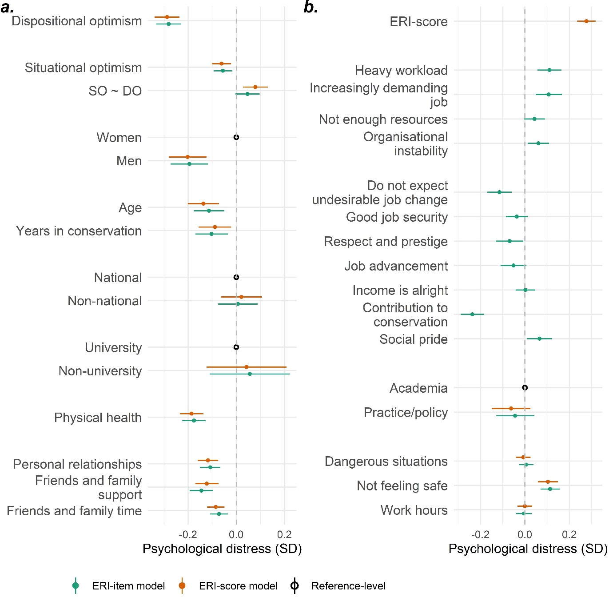
Figure S8. The estimated association in standard deviations (SD) between latent psychological distress and (a) personal characteristics and (b) occupational risk factors among 2306 respondents. Both age and years in conservation were included in this analysis. ‘ERI-score model’ included the effort-reward imbalance score but excluded the individual instrument items, while the ‘ERI-item model’ included these items but excluded the score. Continuous variables were scaled and centred. ‘Unknown’ response levels are not shown.

SI 9: Gender-disaggregated analysis
To explore how risk factors for psychological distress varied between men and women, the analysis was repeated disaggregated by gender. The results were broadly consistent between the two analyses (Figures S9 and S10). However, one notable difference was that women in academia reported higher rates of distress than those in practice. In contrast, there was no significant difference in distress between male academics and practitioners.

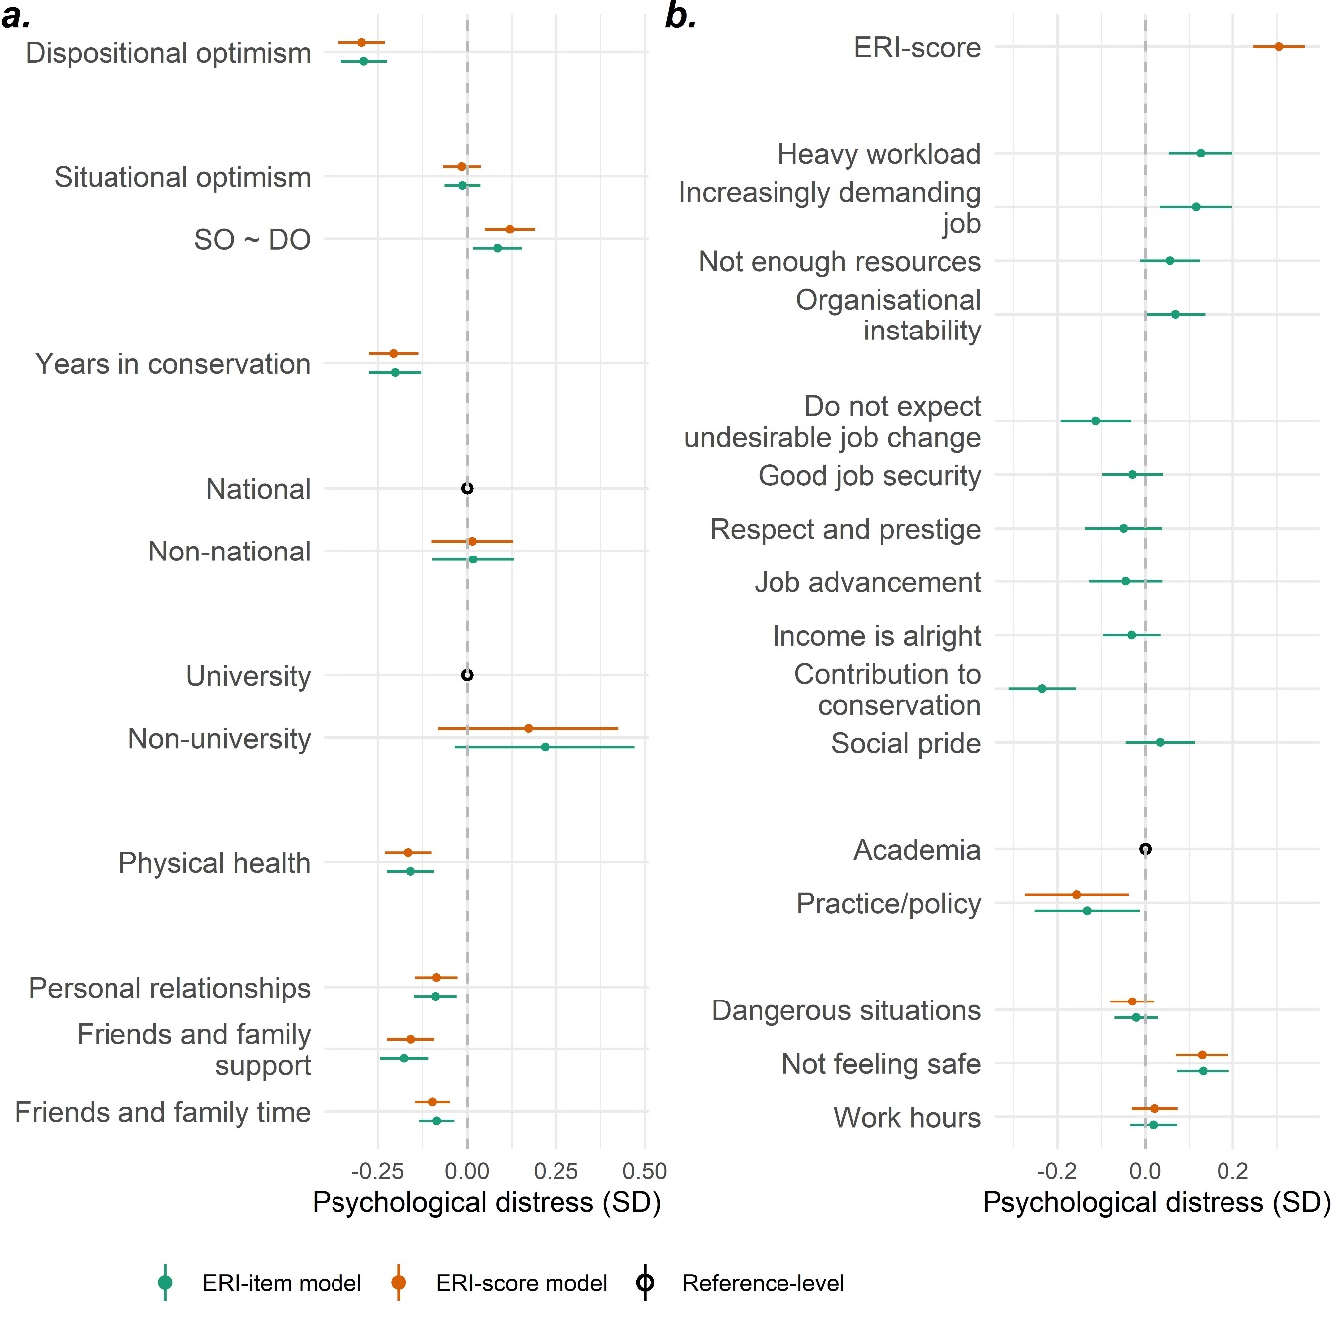
Figure S9. The estimated association in standard deviations (SD) between latent psychological distress and (a) personal characteristics and (b) occupational risk factors among 1208 women respondents. ‘ERI-score model’ included the effort-reward imbalance score but excluded the individual instrument items, while the ‘ERI-item model’ included these items but excluded the score. Continuous variables were scaled and centred. ‘Unknown’ response levels are not shown.

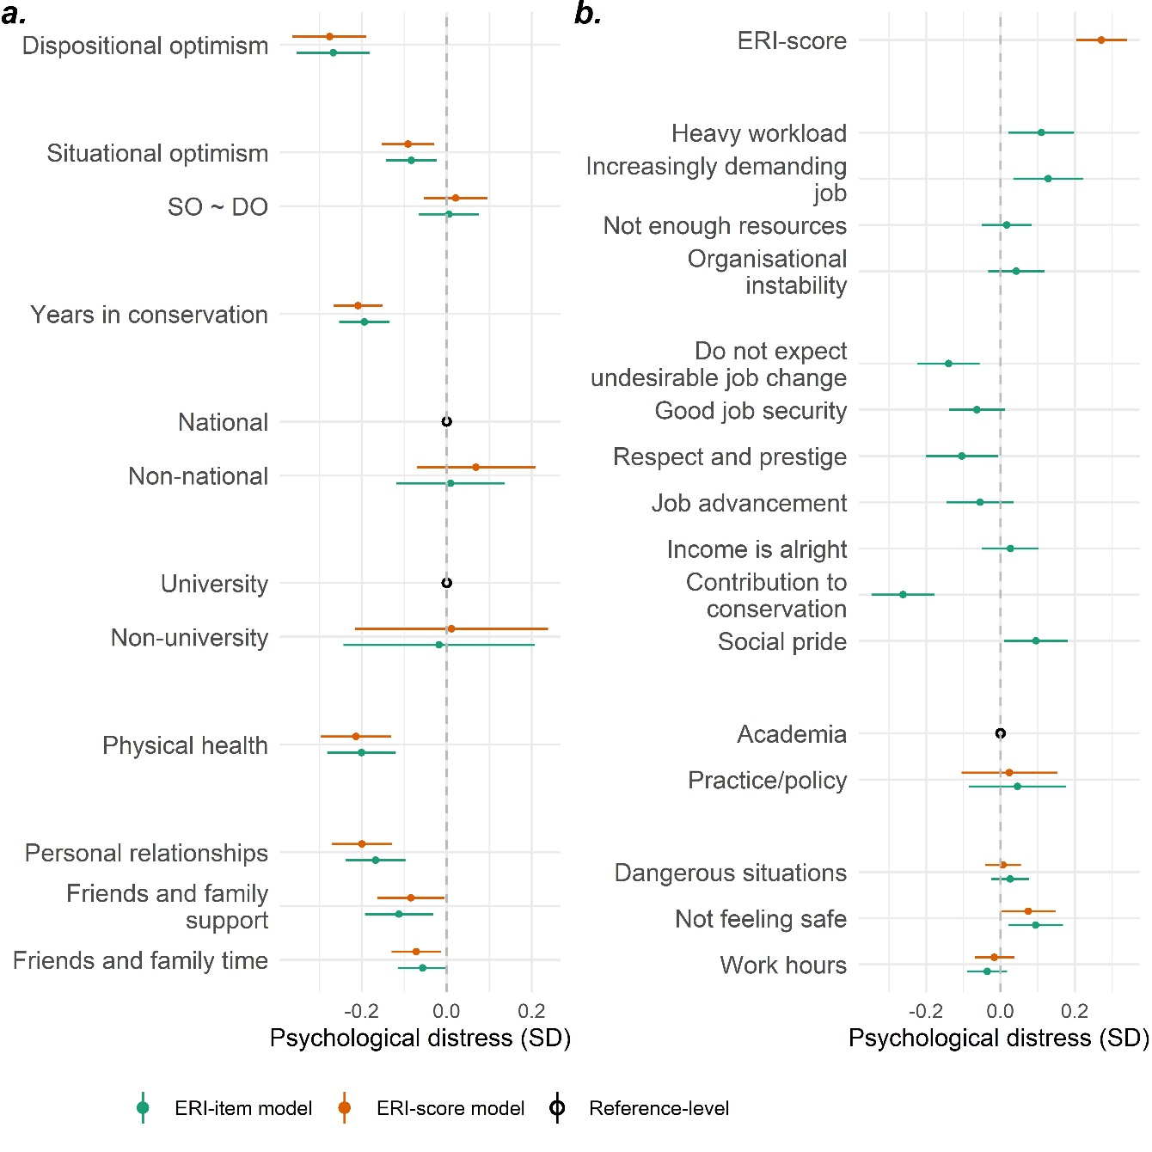
Figure S10. The estimated association in standard deviations (SD) between latent psychological distress and (a) personal characteristics and (b) occupational risk factors among 969 men respondents. ‘ERI-score model’ included the effort-reward imbalance score but excluded the individual instrument items, while the ‘ERI-item model’ included these items but excluded the score. Continuous variables were scaled and centred. ‘Unknown’ response levels are not shown.

SI 10: Using the original effort-reward imbalance instrument
The analysis was repeated with the scores and items from the original ERI instrument (Figure S11). The effect sizes were generally consistent between this supplementary analysis and the main results. However, the confidence intervals for “good job security” and “job advancement” were slightly smaller, so the association between these variables and psychological distress became statistically significant.
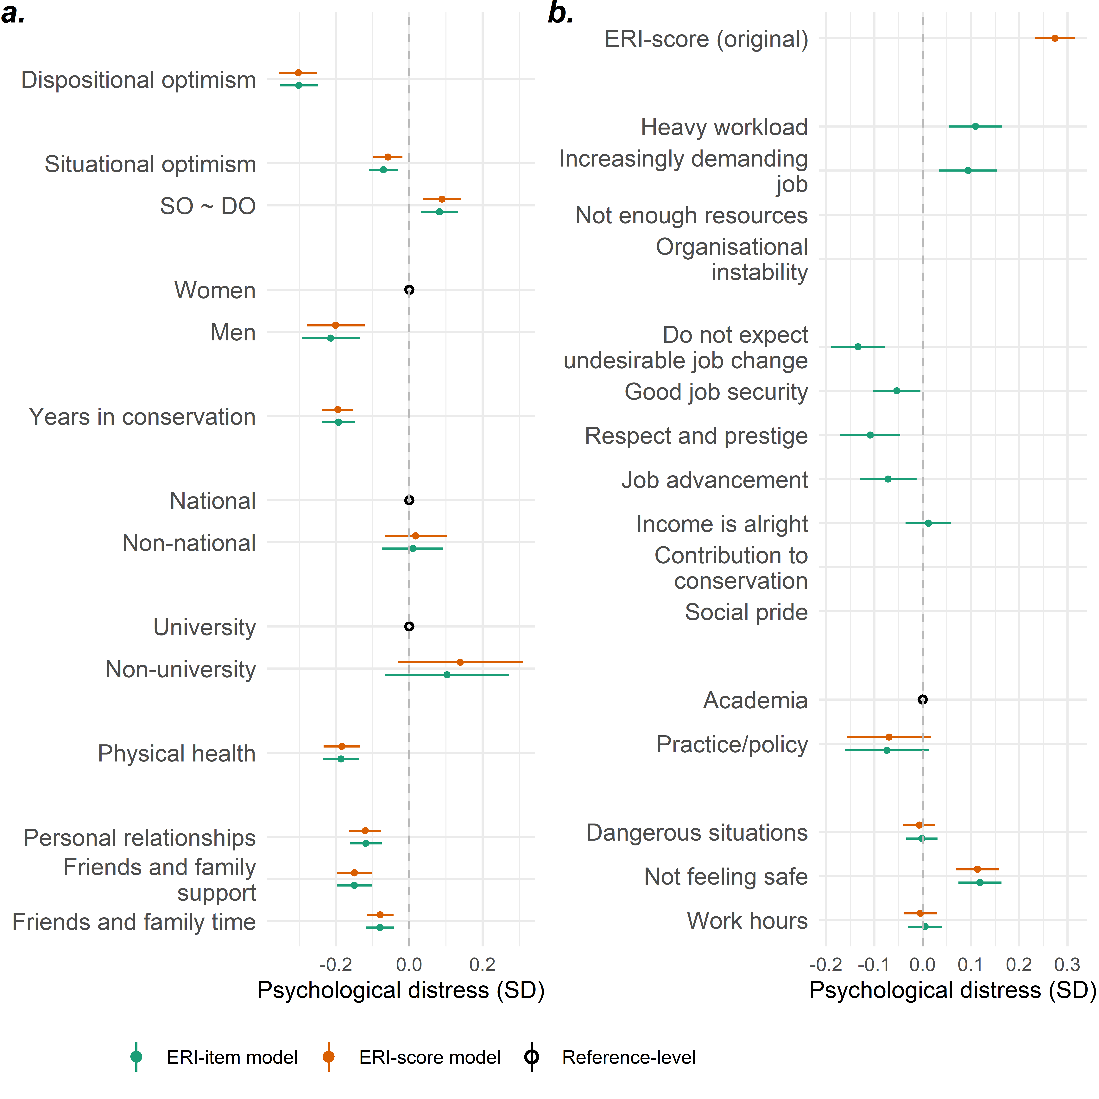
Figure S11. The estimated association in standard deviations (SD) between latent psychological distress and (a) personal characteristics and (b) risk factors among 2,306 respondents. Scores and items from the original effort-reward imbalance model were used. The ERI-score model included the effort-reward imbalance score but excluded the individual instrument items, while the ERI-item model included these items but excluded the score. Continuous variables were scaled and centred. ‘Unknown’ response levels are not shown.

SI 11: Impacts of the COVID-19 pandemic
The analysis was repeated with the inclusion of a dummy variable corresponding to the period of COVID-19 (coded as 0 for before 1st January 2020 and 1 for after, Figure S12). The analysis was also repeated to evaluate the potential confounding effects of the COVID-19 dummy variable on effort-reward scores and psychological distress (Figure S13). Perhaps surprisingly, we found no evidence of an association between the COVID-19 dummy variable and psychological distress or effort-reward scores. Any number of factors could explain this result, but doing so is outside the scope of our study.
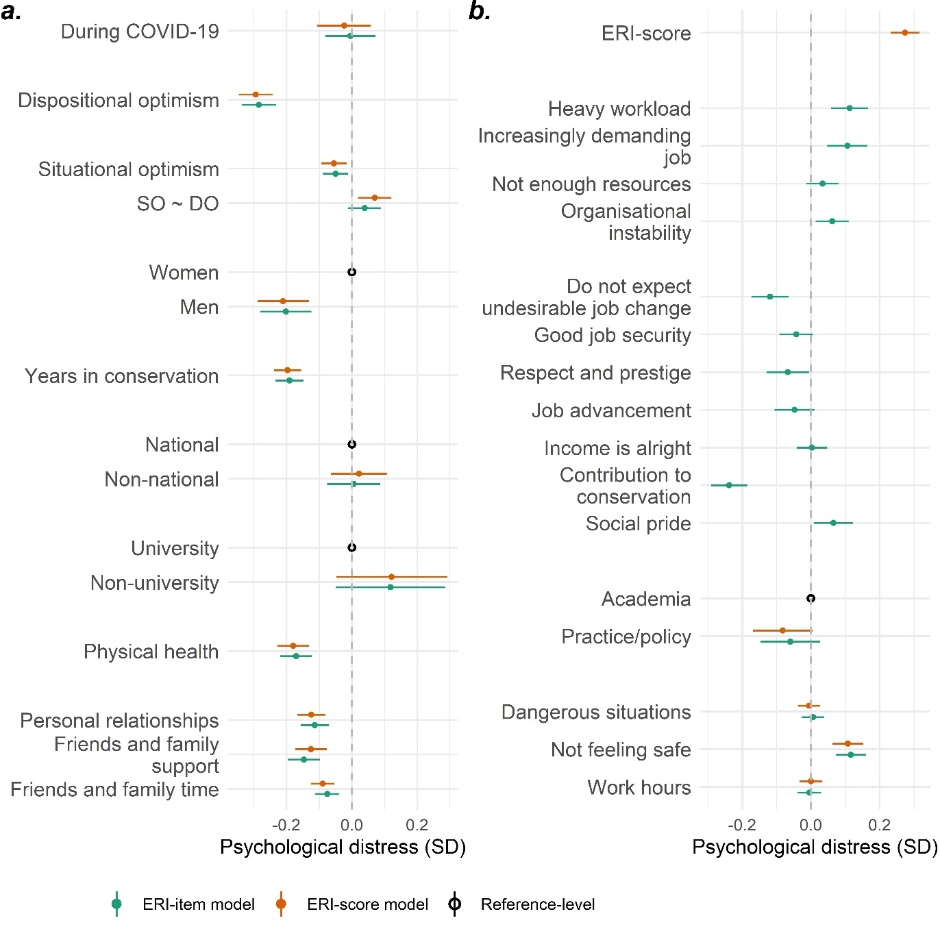
Figure S12. The estimated association in standard deviations (SD) between latent psychological distress and (a) personal characteristics and (b) occupational risk factors among 2,306 respondents, within the inclusion of a dummy variable indicating if the participant responded to the survey before (prior to 1st January 2020) or after the start of the COVID-19 pandemic. Continuous variables were scaled and centred. ‘Unknown’ response levels are not shown.
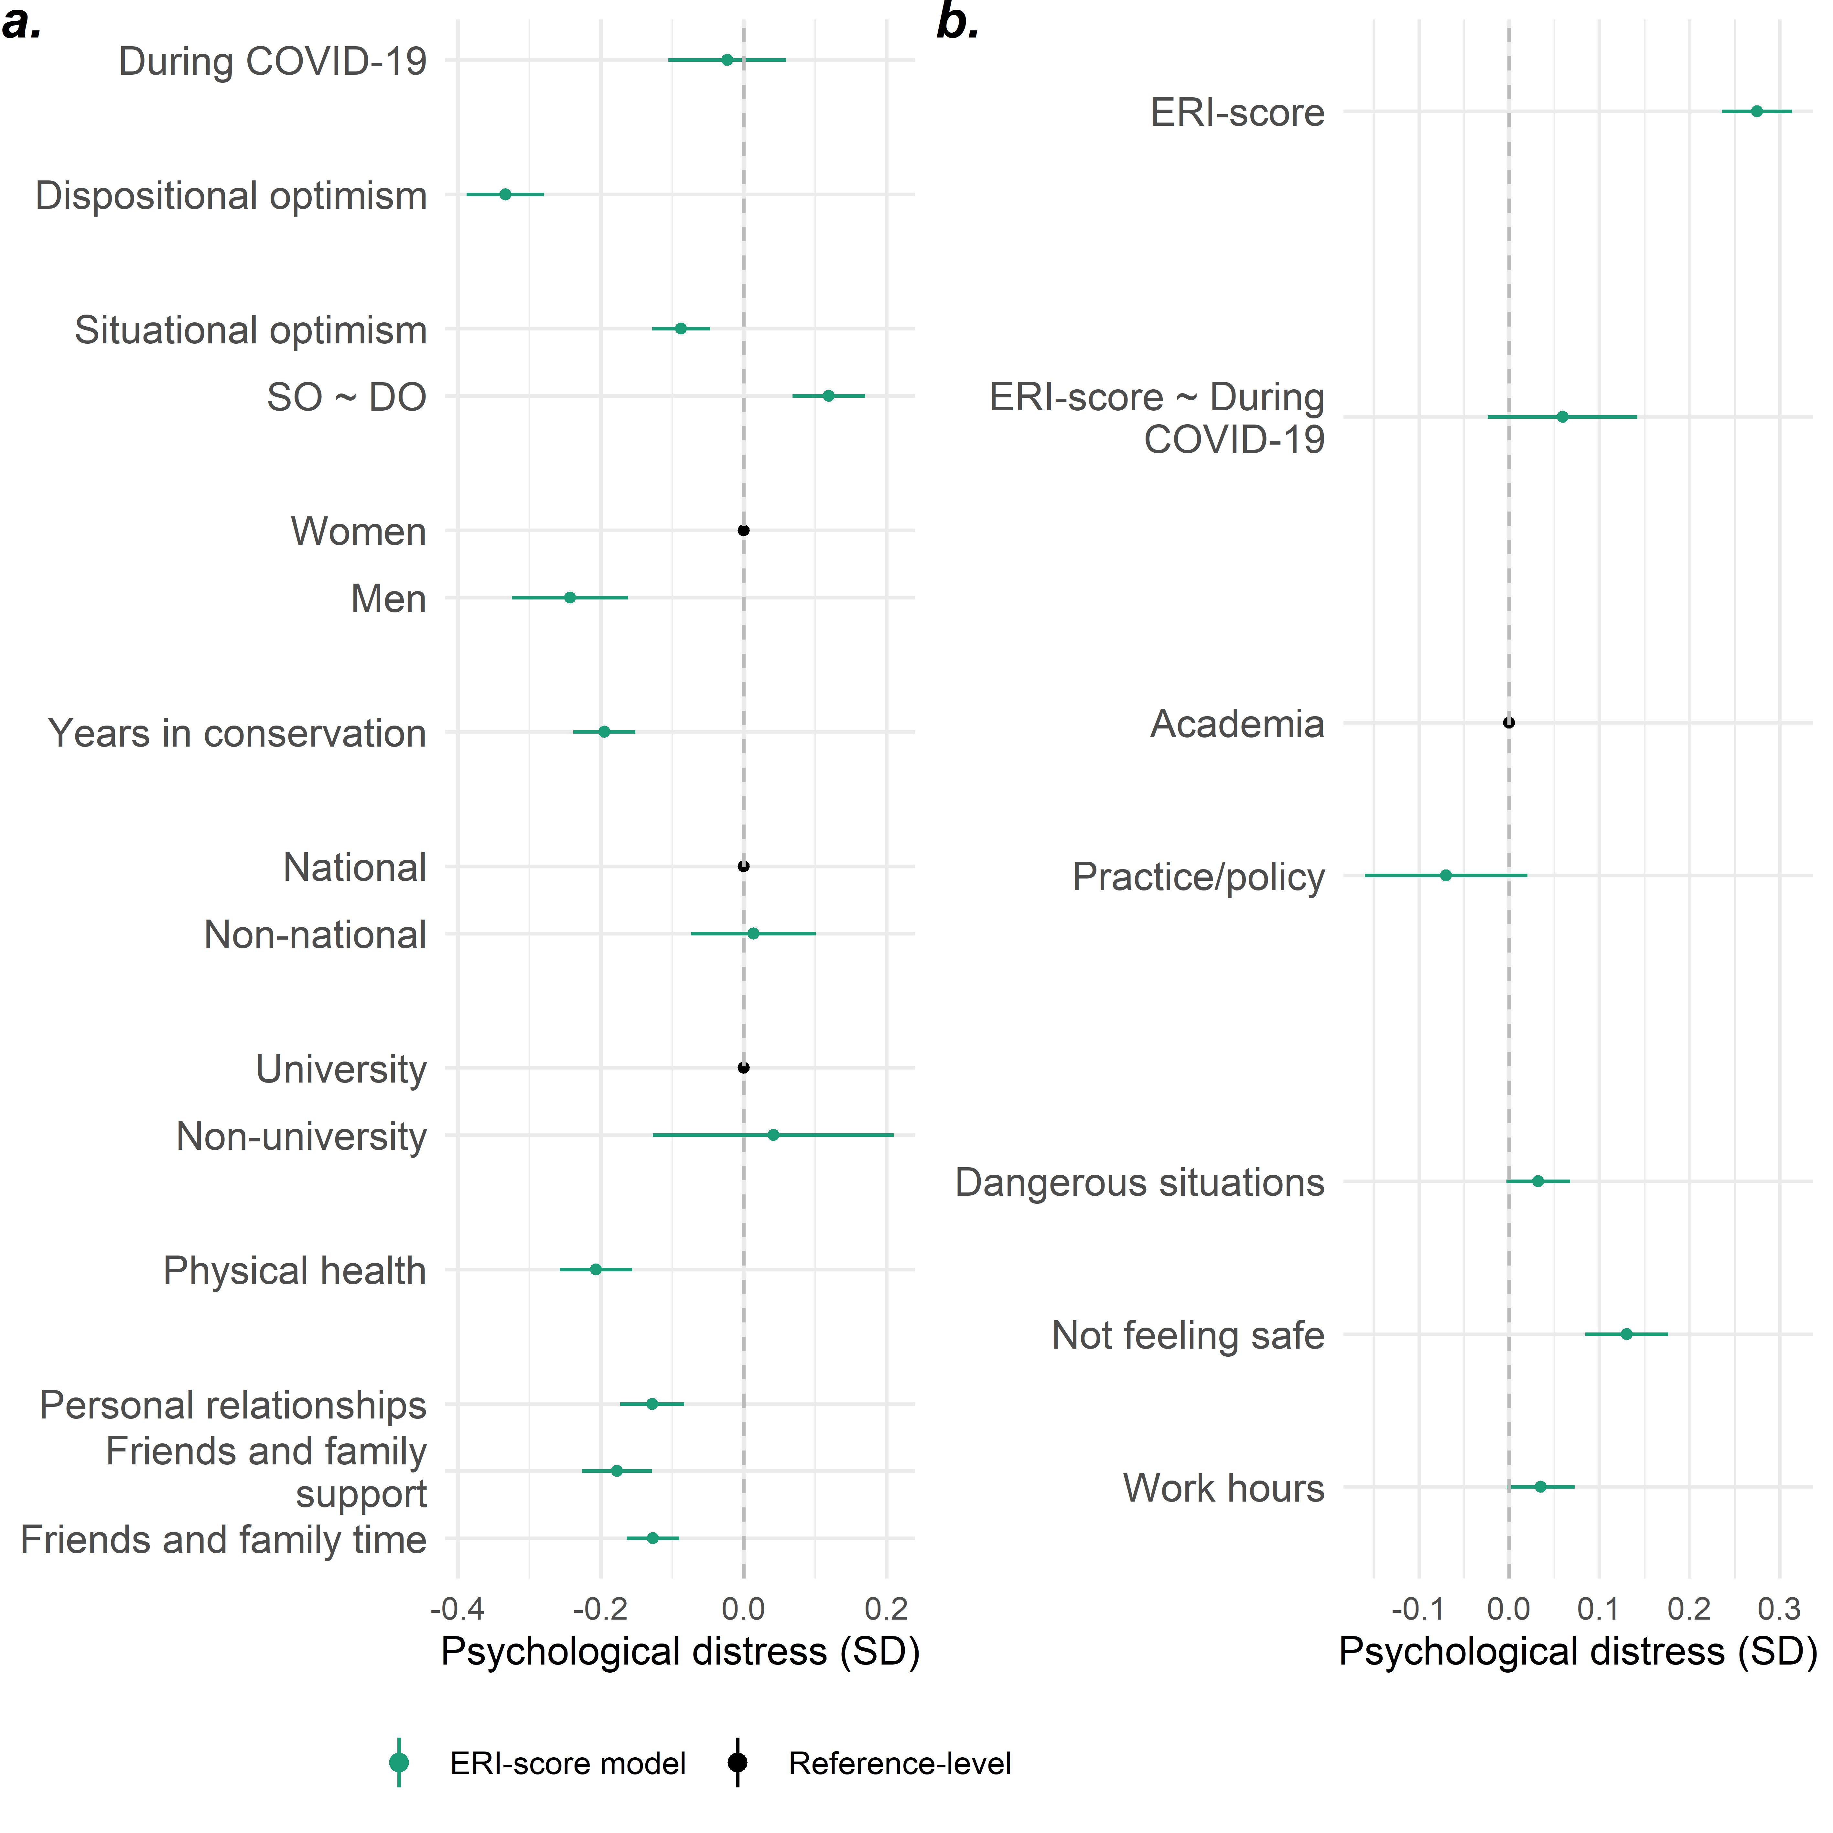
Figure S13. The estimated association in standard deviations (SD) between latent psychological distress and (a) personal characteristics and (b) occupational risk factors among 2,306 respondents, including associations between the COVID-19 dummy variable, effort-reward scores, and psychological distress. Continuous variables were scaled and centred. ‘Unknown’ response levels are not shown.

SI 12: Work country, nationalism, and psychological distress
Working conditions were expected to vary between countries, so we anticipated a priori that including the latter within the analysis might mask the effects of the former. To evaluate this, we repeated the analysis, including a variable describing the region in which respondents were currently working (Figure S14). Contrary to our expectations, the inclusion of work region did not strongly influence the effect sizes and confidence intervals of the covariates. Furthermore, respondents in Latin America and the Caribbean reported lower levels of distress than those in North America and Europe. We were also interested in broader patterns of psychological distress depending on where respondents were working. Therefore, we repeated the analysis with a variable describing work region but excluding workplace factors (Figure S15). This supplementary analysis suggested that those in Central and South Asia may have reported greater distress than those in North America and Europe, and other regions. Similar patterns were found when including nationality by region (Figure S16). However, the potential explanations for these results are beyond the scope of the current study.
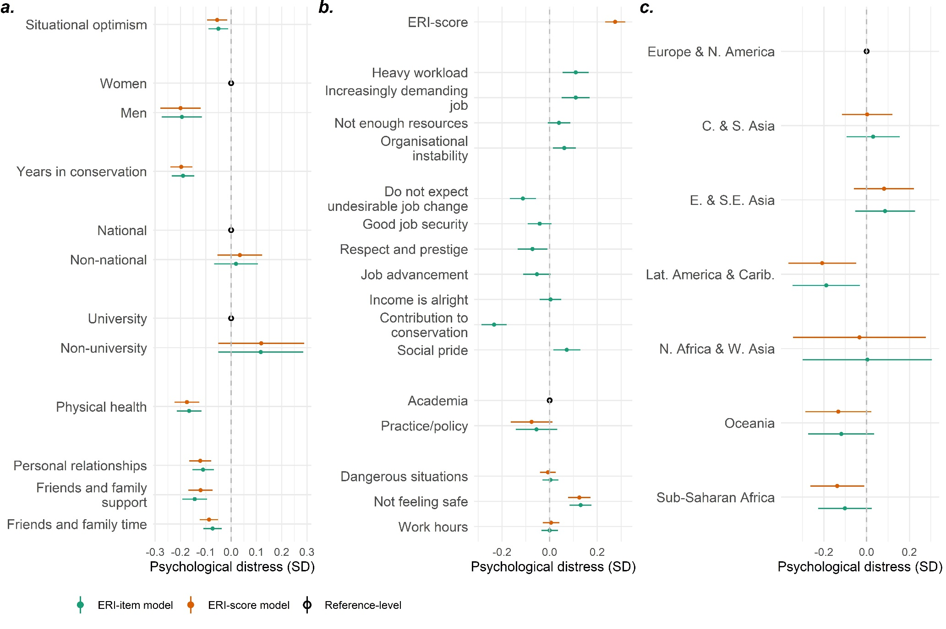
Figure S14. The estimated association in standard deviations (SD) between latent psychological distress and (a) personal characteristics, (b) occupational risk factors, and c) work country region among 2,306 respondents. Continuous variables were scaled and centred. ‘Unknown’ response levels are not shown.

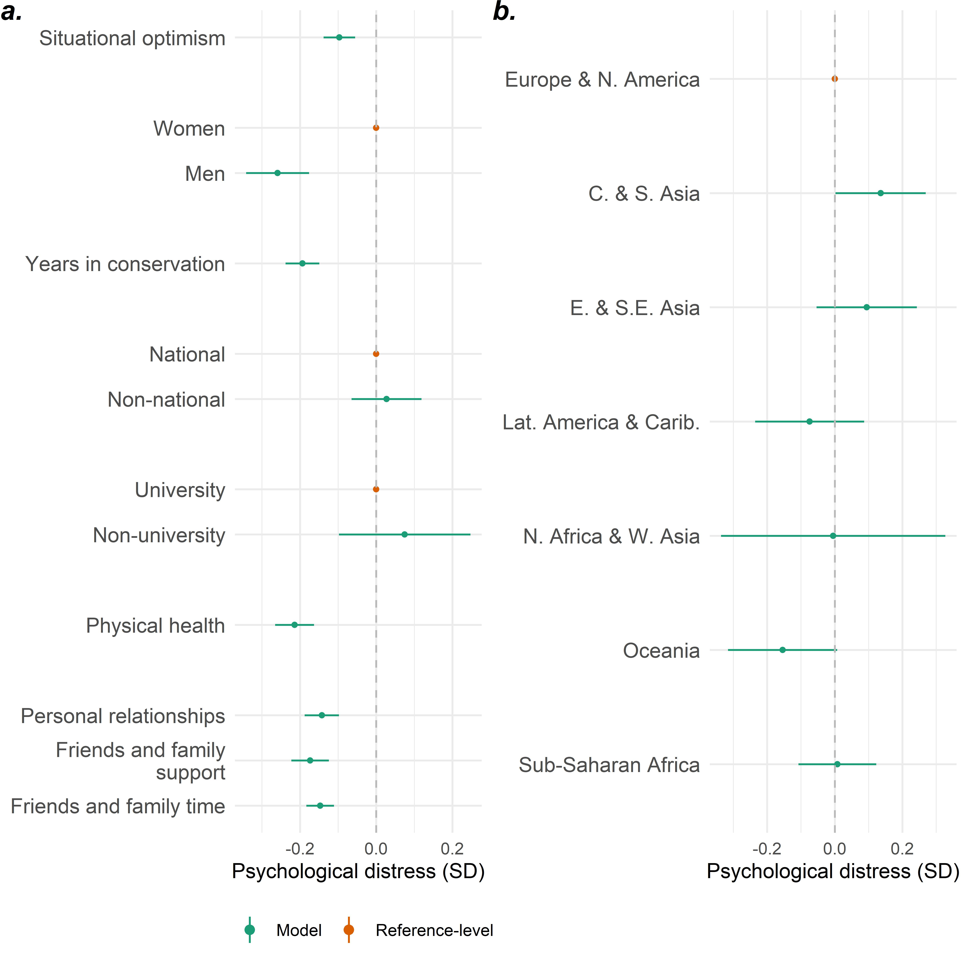
Figure S15. The estimated association in standard deviations (SD) between latent psychological distress and (a) personal characteristics and b) work country region among 2,306 respondents. Continuous variables were scaled and centred. ‘Unknown’ response levels are not shown.

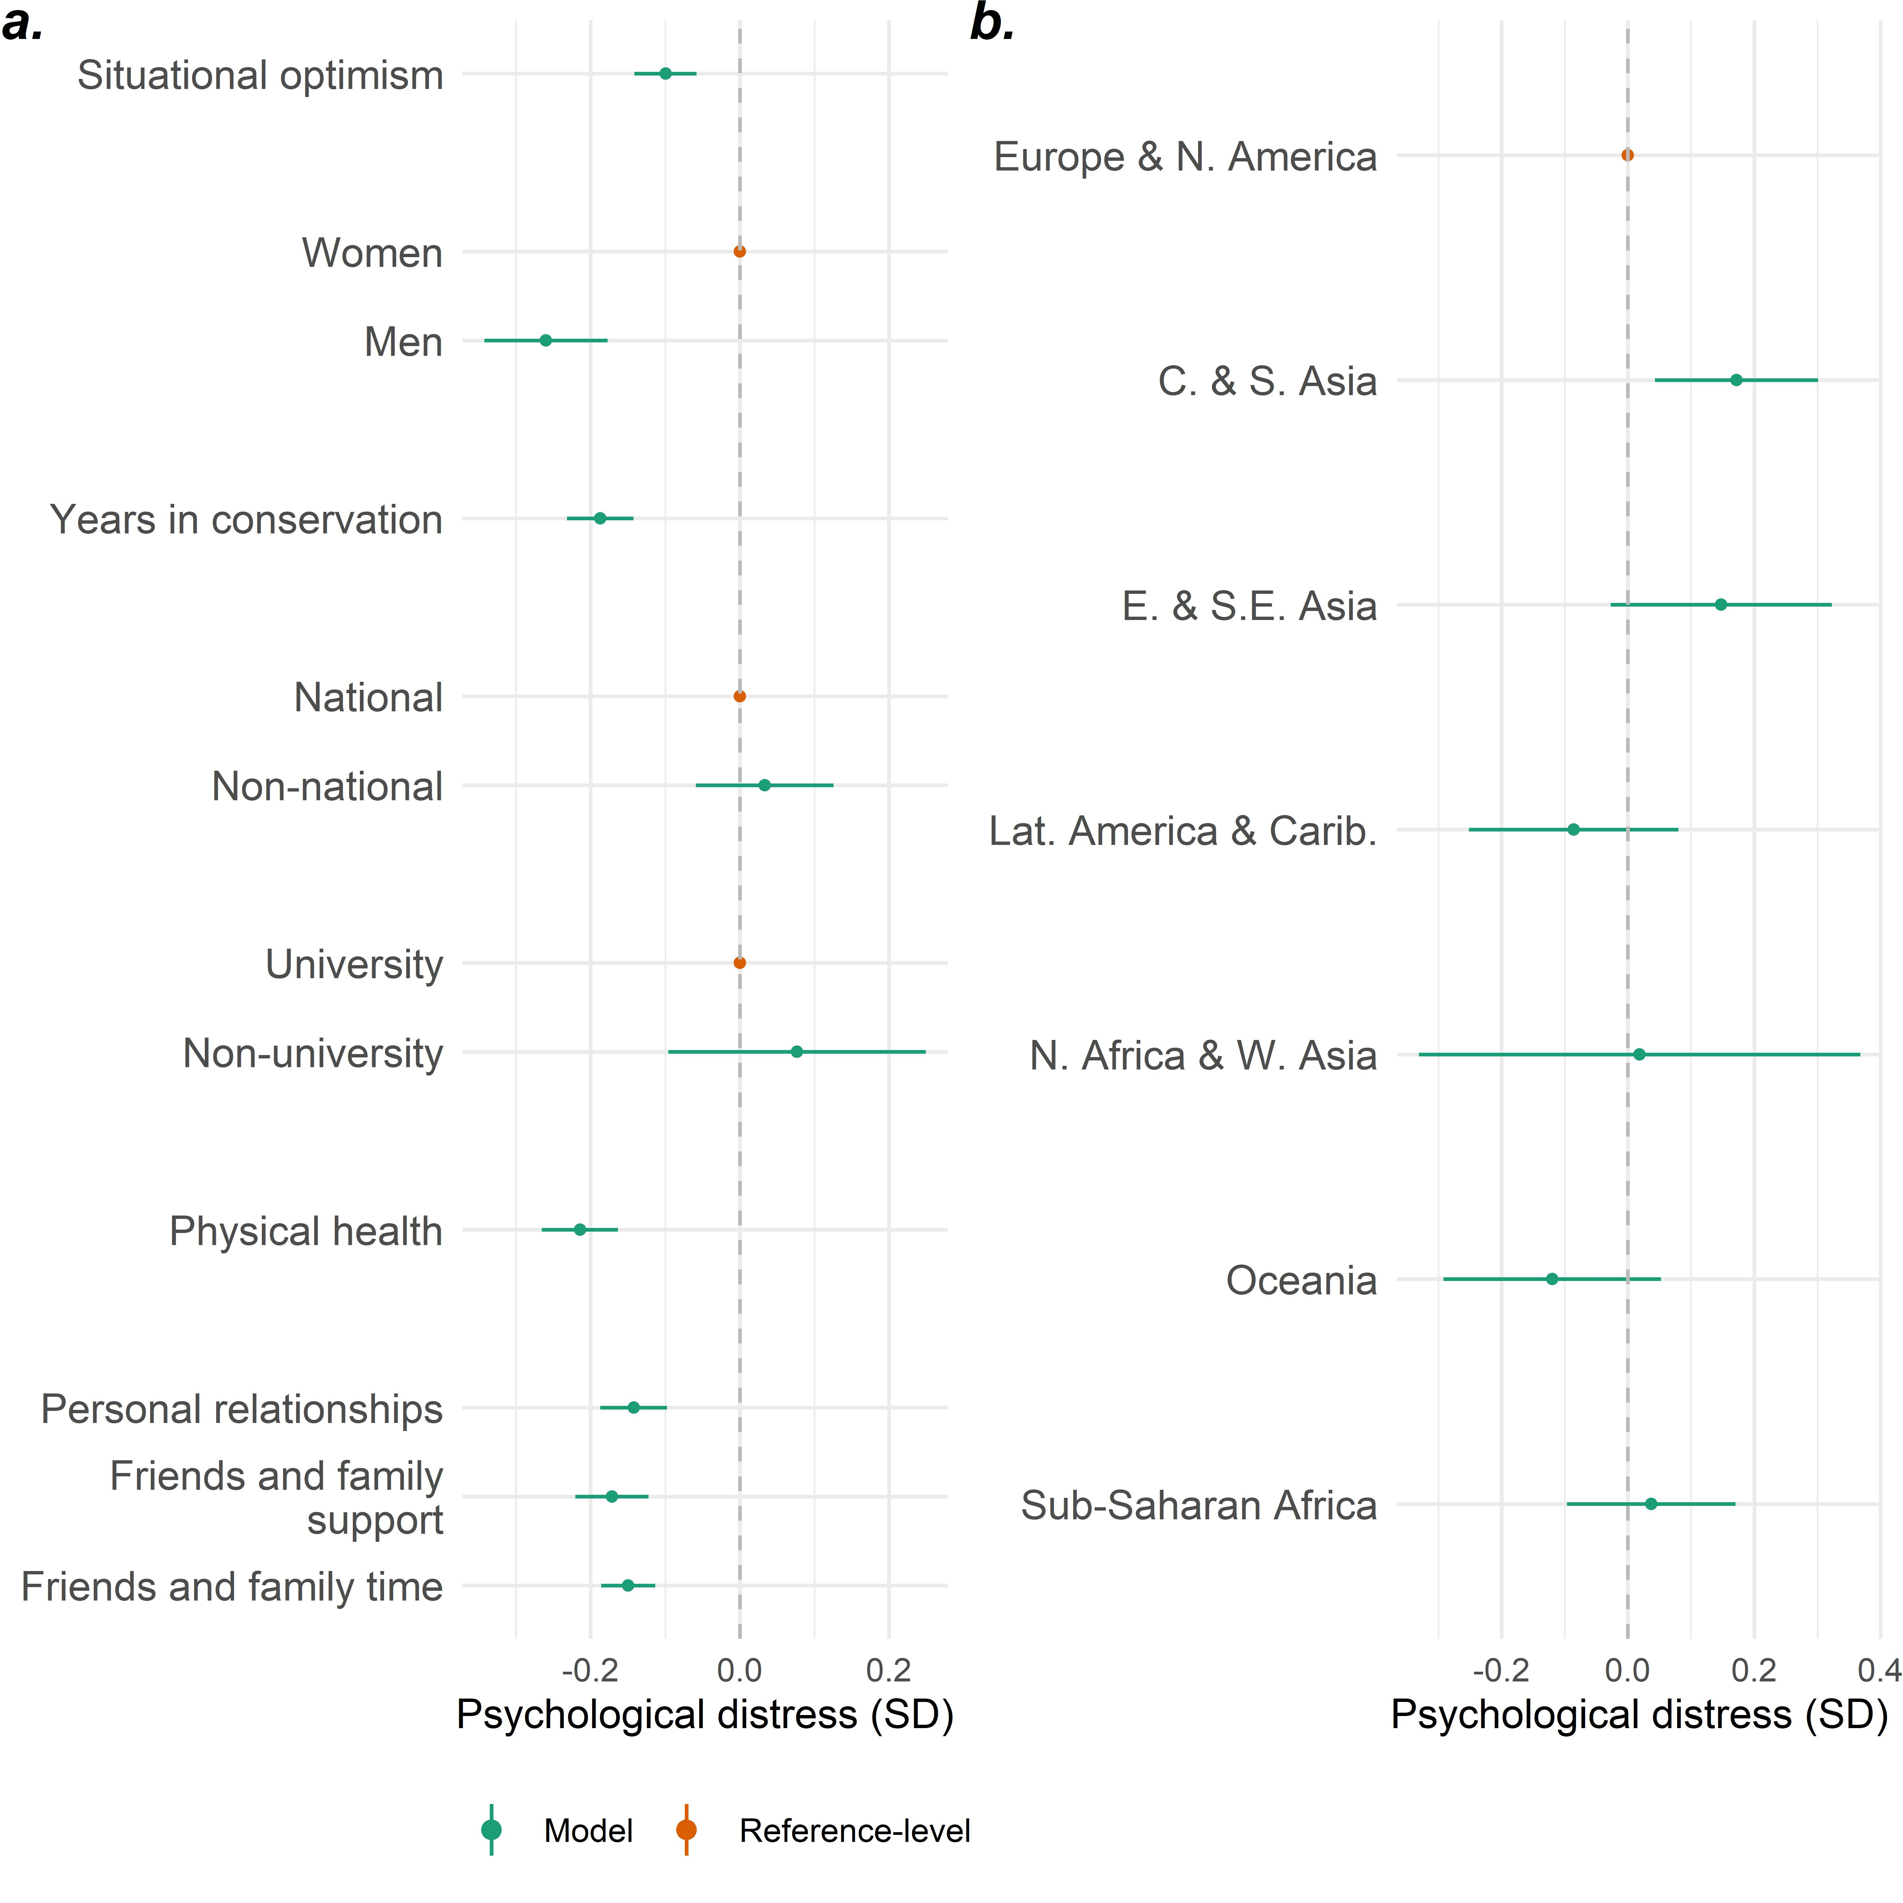
Figure S16. The estimated association in standard deviations (SD) between latent psychological distress and (a) personal characteristics and b) nationality region among 2,306 respondents. Continuous variables were scaled and centred. ‘Unknown’ response levels are not shown.

SI 13: Recruitment email
The following is a sample recruitment message, which we asked contacted conservation organisations to share among their staff and networks. This message was translated into the survey languages.
“Do you work, study, or do research in conservation? The Interdisciplinary Centre for Conservation Science (ICCS) would like to learn about your #lifeinconservation, and the challenges and rewards you face through this 8-minute online survey available in multiple languages: https://livedataoxford.shinyapps.io/lifeinconservation/
At the end, you’ll be able to see some of your results compared to others who have taken the survey. The ICCS would like to reach a diverse group of people working in conservation and would be grateful if you could share the survey with colleagues and friends. More details can be found by following the survey link or searching for #lifeinconservation on Twitter.”

SI 14: Ideas table
The following ideas are based on the UK Government’s Thriving at Work mental health core standards²⁹, which we tailored through interviews and written feedback from a purposeful sample of 20 team leaders and human-resource personnel in 14 conservation organisations. These individuals work internationally (7) or in Central and Southern Asia (5), Sub-Saharan Africa (4), and Eastern and South-Eastern Asia (4). The options presented in Table S3 focus on office-based workers but could be considered alongside advice for supporting other groups, such as rangers or field-based staff (e.g.,³⁰). Furthermore, some conservation organisations already take proactive measures to support staff mental health and wellbeing, particularly those that are larger and better resourced. Consequently, our suggestions are aimed at those taking the first steps to actively managing staff wellbeing, which may include many smaller or less well-resourced organisations.

Table S3. Ideas for employers to support staff mental health and wellbeing.
Ideas | Description | Considerations and risks
Understand experiences, attitudes, and knowledge among staff. | This option involves exploring the challenges, rewards, experiences, and attitudes around wellbeing and mental health within an organisation. Doing so may help tailor actions to specific needs in an organisation and between groups. Exploring attitudes around mental health and wellbeing might reveal the need for awareness-raising, including around stigma. Furthermore, this step may also involve identifying gaps in knowledge and expertise around mental health, which may be addressed through training and recruitment. | - Staff may be hesitant to disclose challenges because of concerns about reprisal. Similarly, some might not be open about their attitudes towards mental health. Furthermore, it may be challenging to create an environment where individuals speak openly.
Produce, implement, and update a wellbeing at work plan. | The plan should outline the steps taken to manage employee wellbeing at work. These steps should be based on an understanding of the experiences of staff in different roles in an organisation. The steps could include awareness-raising, training managers, enhancing positive job aspects, addressing workplace stressors. The plan could be developed after consulting the many free-to-use online resources in this area (e.g., Business in the Community: Mental health toolkit  for employers). It is important that the plan is not just produced but implemented and periodically updated, which may partly depend on the levels of engagement across an organisation’s hierarchy. Employers might consider co-designing the plan with staff – including allowing different groups and teams to develop measures appropriate for them. Furthermore, discussing the costs (such as sickness absence and staff turnover) and benefits (like engagement and productivity) linked to working conditions might generate senior management buy-in. Senior managers can play a critical role in organisational culture, so they should promote the plan and set an example through their behaviour. In some cases, some awareness-raising might be needed before the plan is developed. | - Staff may raise issues during the consultation that are challenging or take time to address. Failing to manage expectations about what the plan can achieve, especially in the short run, could be demotivating and create resentment.  - Similarly, designing but failing to implement the plan over the long term may waste resources and be demotivating. This point emphasises the importance of senior management buy-in and recognition that implementation is an ongoing process.  - Plans that are “handed down” from a head office or human resource personnel – rather than designed with staff input – may have limited uptake. Nevertheless, leaders and human resource personnel may play a key role in driving the process.  - Designing a comprehensive plan is likely to take time, effort, and resources. Small organisations without dedicated human resource personnel may struggle to find the right people to lead this process. In this case, an ad-hoc committee might be tasked with leading the plan. Alternatively, they might identify a ‘champion’ to lead this process. However, these responsibilities should be reflected in work plans (rather than being extra commitments) and be supported by senior management. These individuals may also require additional training (see Promote effective team leadership).
Develop awareness of wellbeing and resources among all staff. | Awareness among supervisors, team leaders, and other employees may help individuals care for themselves and others. Raising awareness of signs of poor mental health and burnout may help individuals and teams take proactive steps to manage these issues. Organisations could dedicate time to discussing mental health and wellbeing, such as during all-staff and team meetings. Employers could also share some of the many free-to-use online resources discussing workplace wellbeing and mental health:  - Mind: Taking care of yourself  - Mind: Taking care of your staff  Employers could make these resources available on staff intranets or subscribe to an Employee Assistance Program (which can include resources and counselling services). | - Many factors beyond work and related to individual circumstances can influence someone’s risk of poor mental health. So, the responsibility to manage mental health is balanced between employers and individuals. Discussions could include raising awareness of this balance of responsibilities and the need for staff engagement.
Encourage open conversations about wellbeing and mental health and the support available. | Staff should be encouraged to talk openly about wellbeing and mental health, where appropriate. These conversations can occur across settings, such as during meetings, when recruiting staff, or in conversation with line managers. A Wellness Action Plan may facilitate conversations between employees and line managers (e.g., Mind: Guide for line managers). Furthermore, ideas and beliefs about mental health can vary between places and groups. In some contexts, talking about wellbeing might be an entry point for discussing mental health and stigma. | - Developing and implementing a Wellness Action Plan can be a time-consuming and in-depth process. So, these might be prioritised for staff who are struggling.  - Poorly informed or stigmatising opinions expressed during conversations might be counter-productive. In some contexts, prior awareness-raising and a set of ground rules might be needed. Those leading efforts at an organisation might facilitate these conversations.
Provide good working conditions – ‘promoting the positives’. | Good working conditions can include ‘promoting the positives’. This promotion may include recognising and celebrating successes (particularly at a team level) and fostering social support between colleagues (such as through group tea breaks and activities). In addition, employers might examine employees’ motivations and positive work experiences in order to enhance them. For instance, many are motivated to work in conservation because they enjoy spending time in nature²⁸. Furthermore, exercise in nature can support good mental health³¹. So, staff might be provided with opportunities to do outdoor activities, like hiking.  Organisations might consider making public commitments to supporting mental health, such as signing the Mindful Employer Charter (giving access to resources and training). They may also consider providing private medical insurance or subscribing to an Employee Assistance Program. | - Providing benefits is not a substitute for meeting legal requirements around working conditions. Promoting the positives should go hand-in-hand with removing risks.  - Some actions might be relatively cheap, such as setting times for group coffee breaks or highlighting successes. Others might be more time-consuming and costly, such as providing private medical insurance or subscribing to an Employee Assistance Program. As such, some means of ‘promoting the positive’ might not be feasible for small or poorly resourced organisations.  - Focusing only on celebrating successes may create a culture that deters sharing failures, uncertainties, and criticisms. Doing so may limit opportunities to learn from failure and address problems³². Consequently, celebrating successes could occur within an action learning cycle that also recognises and learns from issues.
Provide good working conditions – removing the risks. | Good working conditions can also include removing workplace risks to wellbeing. Our results suggest that excessive workload, high job demand, job instability, organisational instability, and an overall imbalance of efforts and rewards can be distressing. Employers might also consider other risk factors around emotional demand, job control, health and safety, pay, issues of discrimination and bullying, and career progression^{33,34}. In addition, employers should meet minimum legal requirements, which vary between countries and roles). In the UK, these include:  - Fulfilling duty of care responsibilities (including health and safety in the workplace).  - Paying minimum wage (but aspiring to pay a living wage).  - Providing statutory holiday, sick, maternity and other pay (where eligible).  - Not mandating employees work more than 48 hours a week (unless they opt to do so).  - Protecting against discrimination.  - Protecting those who report wrongdoing in the workplace.  While the emphasis should be on removing workplace risk factors, some staff might also benefit from resources to help build resilience (e.g., Mind: How to manage stress). | - Some risk factors, such as those linked to work-life balance, might be reasonably feasible to address. For example, organisations might adopt rules around emailing outside office hours or move towards flexible working patterns. However, other challenges, such as job and organisational insecurity, might be outside an employer’s immediate control. These intractable challenges suggest the need to manage staff expectations – perhaps during the planning phase – for what challenges are likely to remain. It also highlights the need for other actors, such as funders, to create structural changes to support wellbeing in the sector.
Promote effective team leadership. | Good team leadership may support employee wellbeing at multiple levels. Good leadership can help ‘promote the positives’ (such as fostering collegial support) and removing risks (like managing team workloads). Team leaders can also be trained to identify signs of burnout and poor mental health and make adjustments or provide resources to those who are struggling. Employers might improve team leadership by recruiting those with appropriate management skills. Alternatively, employers might arrange formal training (e.g., Mindful Employer Charter) or encourage, create time, and expect leaders to review online resources (e.g., CIPD: Factsheets A – Z, Mind: Taking care of your staff, Mind: Guide for line managers). | - Reviewing online resources and training may have limited effectiveness unless leaders are rewarded for supporting team wellbeing. This reward could include recognizing good practices during performance reviews.  - Training may not be feasible for small, inadequately resourced organisations or where teams are isolated. In these cases, team leaders might be supported and expected to review free-to-use online resources.
Routinely monitor employee mental health and wellbeing. | Many employers monitor sickness absence, which can help identify those who may be struggling. This monitoring could be combined with informal monitoring by team leaders trained to spot signs of burnout and poor mental health. This monitoring may help identify individuals needing support. Moreover, it might reveal workplace stressors that should be addressed. | - These data are sensitive, so they should be handled by dedicated human resource personnel. Organisations without such personnel should consider the risks of collecting these data, who would access them, and why. In particular, there may be risks that data are used to discriminate against staff. In some cases, organisations may decide against adopting this option.  - Sickness absence data alone will not indicate presentism, a significant burden for individuals and organisations.

SI 15: Ethical protocol
Before starting the survey, potential participants were informed about the purpose of the study, who was conducting it, that participation was voluntary, and they were free to withdraw from the survey at any time. Respondents were also informed about the role of the third-party platform that hosted the survey, the risks of participating, and how the data would be used. Respondents were provided information about the complaints procedure, including the contact details for the Ethical Review Board that approved the study (Medical Sciences Interdivisional Research Ethics Committee, University of Oxford Central University Research Ethics Committee, reference number: R62487/RE001). Before participants could proceed, documented, free, prior, and informed consent was sought. Individuals were asked to either disclose their age or indicate that they were over 18 – those that reported that they were under the age of 18 were excluded. On completing the survey, respondents were directed to a debriefing page, which included the contact details of the research team and Ethical Review Board and guidance on where to seek support if distressed by the survey.

SI 16: Life Orientation Test - Revised
We estimated respondents’ latent dispositional optimism using data derived from the Life Orientation Test - Revised, which is a widely-used, standardised and validated tool³⁵. In summary, the Life Orientation Test - Revised instrument includes three positively worded (scored 0 to 4) and three negatively worded (scored 4 to 0) items with five response levels ranging from ‘strongly disagree’ to ‘strongly agree’³⁵. We did not include the four filler items found in the instrument. We used the factor structure described by Vecchione, et al. ³⁶ and validated in a companion study². This included estimating a factor representing the method effect associated with the positively worded items, which was assumed to be orthogonal to the dispositional optimism factor (so the covariance was set to 0).

SI 17: Situational optimism instrument
To estimate situational optimism about conservation outcomes, we designed an instrument attended by six co-authors, as discussed by Pienkowski, et al. ². In summary, we considered the five strategic goals of the Aichi Biodiversity Targets to represent broadly held conservation aspirations and so developed pairs of statements based on them³⁷. For each statement, respondents were asked about their expectations that each statement would be met over the next ten years. Response levels ranged from “definitely won't” (0) to “definitely will” (4).
We sought to develop an instrument that had good discriminatory power across a wide latent situational optimism range, so we included several very likely and unlikely outcomes. Correlated error terms were included to account for the dependencies between pairs of items when estimating the latent variable. The ten statements were:
- … public support for conservation will grow over the next ten years
- … government spending on conservation will grow over the next ten years
- … the harmful impact of people on nature will be less in ten years than it is now
- … human society will be more environmentally sustainable in ten years than it is now
- … there will be more wildlife in ten years than there is today
- … There will be more natural areas and habitats in ten years than there are today
- … people will spend more recreational time in nature in ten years than they do now
- … nature will be able to provide the same benefits to people in ten years as now
- … there will be more local participation in conservation in ten years than now
- … conservationists will have better tools and knowledge in ten years than now

SI 18: Effort-reward imbalance model
Within social-exchange theory, there are established principles that influence peoples’ interactions. One of these is the ‘reciprocity rule’. This rule states that when one individual supplies a benefit, then the receiver should respond in kind³⁸. Breaking this rule – where effort is not compensated – is a stressor that can cause distress.
The effort-reward imbalance (ERI) model is informed by this rule³⁹. It assumes that people work with the expectation that their efforts will be compensated through money, career opportunities, esteem and other occupational benefits. The experience of inadequate reward, in relation to effort, is a stressor³⁹. Ongoing stress, as the result of an effort-reward imbalance, can harm both mental and physical health⁴⁰. A number of studies explore associations between ERI and psychological distress in occupational environments. The ERI was positively associated with psychological distress in cross-sectional studies among 844 British academics, 78 Canadian police officers, 814 Canadian citizens, 1,803 Norwegians, 243 Japanese workers, and 2,596 US naval personnel ¹³⁻¹⁷. A large cross-sectional study of 10,308 civil servants in the UK found that ERI was correlated with psychological distress among men but not women¹⁸. These studies are observational and assume that ERI causes psychological distress. This assumption was tested in a multi-phase study of 211 Japanese workers that found a bi-directional relationship between ERI and psychological distress⁴¹. In other words, ERI appears to increase the risk of distress but suffering from distress simultaneously leads to greater ERI.
In addition to the ten statements within the original ERI model, we included five more that described unique challenges and rewards within the conservation sector (shown in bold below). Furthermore, to ease interpretability, we adjusted some of the phrases used in the instrument (underlined):
- [ERI1] I have constant time pressure due to a heavy work load
- [ERI2] I have many interruptions and disturbances while performing my job
- [ERI3] Over the past few years, my job has become more and more demanding
- [ADD1] I do not have the resources I need to archive my work goals
- [ADD2] The organisation I work for does not have enough funding to achieve its main aims
- [ADD3] The organisation I work for may not exist in five years’ time
- [ERI4] I receive the respect I deserve from my boss and work colleagues
- [ERI5] My job promotion or advancement prospects are poor (reverse coding)
- [ERI6] I have experienced or I expect to experience an undesirable change in my work situation (reverse coding)
- [ERI7] My job security is poor (reverse coding)
- [ERI8] Considering all my efforts and achievements, I receive the respect and prestige I deserve at work
- [ERI9] Considering all my efforts and achievements, my job promotion or advancement prospects are adequate (NA)
- [ERI10] Considering all my efforts and achievements, my salary or income is alright
- [ADD4] I am satisfied with the contribution I make to conservation
- [ADD5] My friends and family are proud that I work in conservation

SI 19: Patterns of missing data
Around 1.3% of values in the survey data were missing (Figures S17 and S18).
Figure S17. Illustrating which observations are missing.

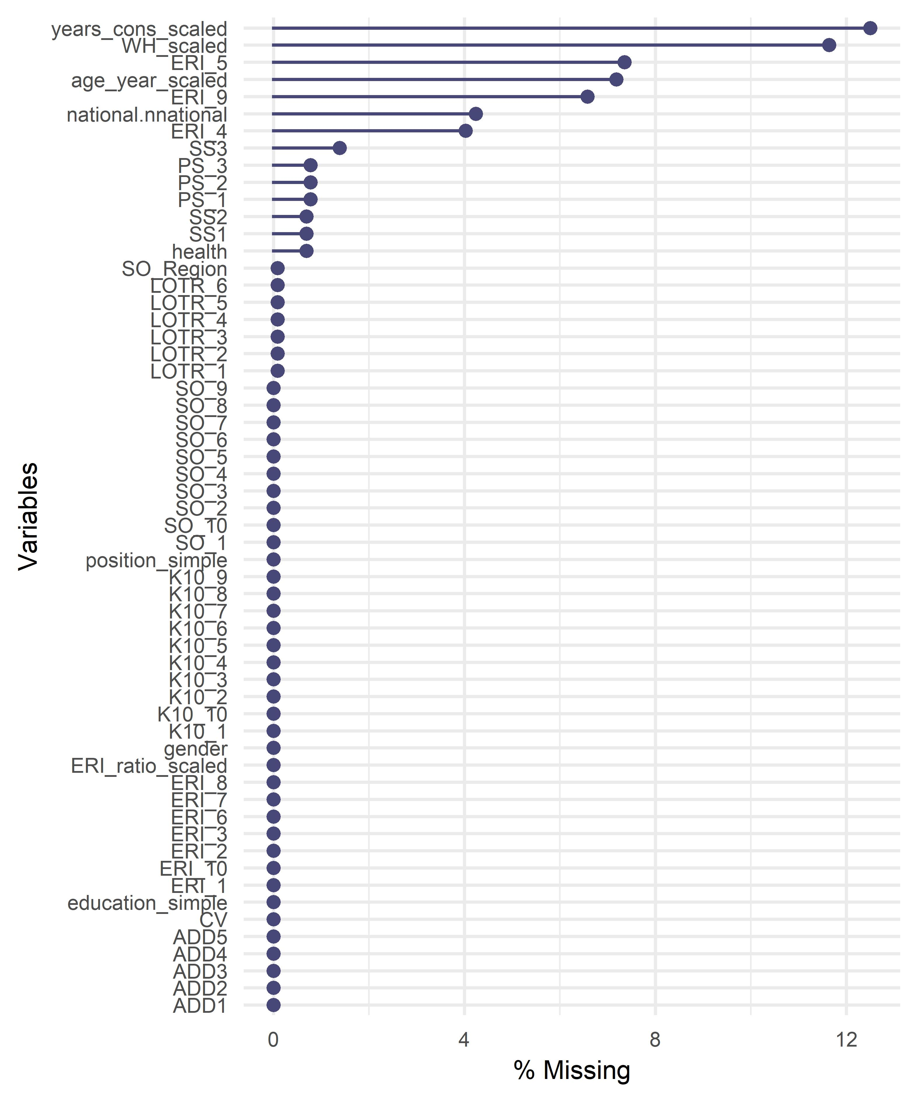
Figure S18. Illustrating the proportion of values missing for each variable.

SI 20: Multivariate imputation through chained equations
Implementing an analysis with only complete cases can be an inefficient use of data that contains some missingness. For instance, if one value of a given variable is missing from an otherwise complete observation, that entire observation would still be excluded when only analysing complete cases. In these instances, it can be useful to substitute the missing value with plausible synthetic values. There are multiple methods for doing this. However, multivariate imputation by chained equations is a popular approach.
Multivariate imputation by chained equations creates synthetic values based on data within a specific observation (which is missing the value) and the associations between variables across observations⁴². As a hypothetical example, Respondent A did not disclose the number of years they worked in conservation, but they did report their age. Modelling across other respondents with complete cases found a 0.75 correlation between age and years in conservation. Based on this, the missing value for Respondent A can be estimated based on their reported age. However, that single estimate does not capture the uncertainty associated with the imputation. Therefore, multiple imputed datasets containing different plausible values (reflecting the underlying uncertainty with a given imputation) are typically used with secondary analysis.
A key assumption when using this approach is that data is Missing at Random. Missing at Random means that the probability that a value (like years of experience) is missing is not conditional on the outcome variable of interest (once accounting for the effect of all other observed variables)⁴³. For example, the probability that values of years of experience are missing is the same for someone who is highly distressed as for someone with low levels of distress. We assumed that respondents did not want to disclose personal information for variables such as age because of concerns about anonymity. For other variables, including the missing ERI values, we assumed some did not respond because they felt the question did not apply to them. Based on this, we assumed that all missing values were Missing at Random.
Therefore, these missing data were substituted through multivariate imputation by chained equations creating ten datasets with imputed data using the package ‘mice’⁴⁴. Numeric variables with predictive mean matching, ordinal variables were imputed using proportional odds models, and unordered categorical variables with polytomous logistic regression. The pre- and post-imputation distributions of variables were inspected and were consistent.

References
1 Conversano, C. et al. Optimism and its impact on mental and physical well-being. Clinical Practice & Epidemiology in Mental Health 6, 25-29, doi:10.2174/1745017901006010025 (2010).
2 Pienkowski, T. et al. Personal traits predict conservationists’ optimism about outcomes for nature. Conservation Letters, e12873, doi:10.1111/conl.12873 (2022).
3 Jones, M. S. & Solomon, J. Challenges and supports for women conservation leaders. Conservation Science and Practice 1, e36, doi:10.1111/csp2.36 (2019).
4 Drapeau, A., Marchand, A. & Forest, C. Gender differences in the age-cohort distribution of psychological distress in Canadian adults: Findings from a national longitudinal survey. BMC Psychology 2, 25, doi:10.1186/s40359-014-0025-4 (2014).
5 Drapeau, A., Marchand, A. & Beaulieu-Prvost, D. in Mental Illnesses: Understanding, Prediction and Control (ed L. Labate) Ch. 5, 105-134 (INTECH, 2012).
6 Pienkowski, T. et al. Balancing making a difference with making a living in the conservation sector. Conservation Biology, 1-13, doi:https://doi.org/10.1111/cobi.13846 (2021).
7 Ager, A. et al. Stress, mental health, and burnout in national humanitarian aid workers in Gulu, northern Uganda. Journal of Traumatic Stress 25, 713-720, doi:10.1002/jts.21764 (2012).
8 Eriksson, C. B. et al. Social support, organisational support, and religious support in relation to burnout in expatriate humanitarian aid workers. Mental Health, Religion & Culture 12, 671-686, doi:10.1080/13674670903029146 (2009).
9 Wang, J. L., Schmitz, N. & Dewa, C. S. Socioeconomic status and the risk of major depression: The Canadian national population health survey. Journal of Epidemiology and Community Health 64, 447-452, doi:10.1136/jech.2009.090910 (2010).
10 Freeman, A. et al. The role of socio-economic status in depression: Results from the COURAGE (aging survey in Europe). BMC Public Health 16, 1-8, doi:10.1186/s12889-016-3638-0 (2016).
11 Ohrnberger, J., Fichera, E. & Sutton, M. The relationship between physical and mental health: A mediation analysis. Social Science and Medicine 195, 42-49, doi:10.1016/j.socscimed.2017.11.008 (2017).
12 Uchino, B. N. Social support and health: A review of physiological processes potentially underlying links to disease outcomes. Journal of Behavioral Medicine 29, 377-387, doi:10.1007/s10865-006-9056-5 (2006).
13 Janzen, B. L., Muhajarine, N., Zhu, T. & Kelly, I. W. Effort-reward imbalance, overcommitment, and psychological distress in Canadian police officers. Psychological Reports 100, 525-530, doi:10.2466/PR0.100.2.525-530 (2007).
14 Kinman, G. & Jones, F. Effort-reward imbalance and overcommitment: Predicting strain in academic employees in the United Kingdom. International Journal of Stress Management 15, 381-395, doi:10.1037/a0013213 (2008).
15 Lau, B. Effort-reward imbalance and overcommitment in employees in a Norwegian municipality: A cross sectional study. Journal of Occupational Medicine and Toxicology 3, 9, doi:10.1186/1745-6673-3-9 (2008).
16 Bridger, R. S., Dew, A., Brasher, K., Munnoch, K. & Kilminster, S. Chronic and acute psychological strain in naval personnel. Occupational medicine 59, 454-458, doi:10.1093/occmed/kqp104 (2009).
17 Aboa, B. Effort-reward imbalance at work and psychological distress: A validation study of post-myocardial infarction patients. Psychosomatic Medicine 73, 448-455, doi:10.1097/PSY.0b013e31829d1e0a (2011).
18 Stansfeld, S. A., Fuhrer, R., Shipley, M. & Marmot, M. Work characteristics predict psychiatric disorder: Prospective results from the Whitehall II study. Occupational and Environmental Medicine 56, 302-307, doi:10.1136/oem.56.5.302 (1999).
19 Davey, J. D., Obst, P. L. & Sheehan, M. C. Demographic and workplace characteristics which add to the prediction of stress and job satisfaction within the police workplace. Journal of Police and Criminal Psychology 16, 29-39, doi:10.1007/BF02802731 (2001).
20 Keinan, G. & Malach-Pines, A. Stress and burnout among prison personnel: Sources, outcomes, and intervention strategies. Criminal Justice and Behavior 34, 380-398, doi:10.1177/0093854806290007 (2007).
21 Harvey, S. B. et al. Can work make you mentally ill? A systematic meta-review of work-related risk factors for common mental health problems. Occupational and Environmental Medicine 74, 301-310, doi:10.1136/oemed-2016-104015 (2017).
22 Deci, E. L. & Ryan, R. M. The "what" and "why" of goal pursuits: Human needs and the self-determination of behavior. Psychological Inquiry 11, 227-268, doi:10.1207/S15327965PLI1104_01 (2000).
23 Ryan, R. M. & Deci, E. L. On happiness and human potentials: A review of research on hedonic and eudaimonic well-being. Annual Review of Psychology 52, 141-166, doi:10.1146/annurev.psych.52.1.141 (2001).
24 Strauman, T. J. Self-regulation and depression. Self and Identity 1, 151-157, doi:10.1080/152988602317319339 (2002).
25 Wrosch, C., Scheier, M. F. & Miller, G. E. Goal adjustment capacities, subjective well-being, and physical health. Social and Personality Psychology Compass 7, 847-860, doi:10.1111/spc3.12074 (2013).
26 Klug, H. J. P. & Maier, G. W. Linking goal progress and subjective well-being: A meta-analysis. Journal of Happiness Studies 16, 37-65, doi:10.1007/s10902-013-9493-0 (2014).
27 de Groot, J. I. & Steg, L. Value orientations to explain environmental attitudes and beliefs: How to measure egoistic, altruistic and biospheric value orientations. Environment and Behavior 40, 330-354, doi:10.1177/0013916506297831 (2007).
28 Papworth, S., Thomas, R. L. & Turvey, S. T. Increased dispositional optimism in conservation professionals. Biodiversity and Conservation 28, 401-414, doi:10.1007/s10531-018-1665-0 (2018).
29 Stevenson, D. & Farmer, P. Thriving at work: The Stevenson / Farmer review of mental health and employers. 1-84 (Department for Work and Pensions and Department of Health, London, United Kingdom, 2017).
30 Universal Ranger Support Alliance (URSA). Action plan for supporting implementation of the International Ranger Federation's Chitwan Declaration and furthering the professionalisation of rangers (2021 - 2025). 1-38 (International Ranger Federation, 2021).
31 Barton, J. & Pretty, J. What is the best dose of nature and green exercise for improving mental health? A multi-study analysis. Environmental Science & Technology 44, 3947-3955, doi:10.1021/es903183r (2010).
32 Catalano, A. S., Redford, K., Margoluis, R. & Knight, A. T. Black swans, cognition, and the power of learning from failure. Conservation Biology 32, 584-596, doi:https://doi.org/10.1111/cobi.13045 (2018).
33 Duchaine, C. S. et al. Psychosocial stressors at work and the risk of sickness absence due to a diagnosed mental disorder: A systematic review and meta-analysis. JAMA Psychiatry 77, 842-851, doi:10.1001/jamapsychiatry.2020.0322 (2020).
34 van der Molen, H. F., Nieuwenhuijsen, K., Frings-Dresen, M. H. W. & de Groene, G. Work-related psychosocial risk factors for stress-related mental disorders: An updated systematic review and meta-analysis. BMJ Open 10, e034849, doi:10.1136/bmjopen-2019-034849 (2020).
35 Scheier, M. F., Carver, C. S. & Bridges, M. W. Distinguishing optimism from neuroticism (and trait anxiety, self-mastery, and self-esteem): A re-evaluation of the Life Orientation Test. Journal of Personality and Social Psychology 67, 1063-1078, doi:10.1037//0022-3514.67.6.1063 (1994).
36 Vecchione, M., Alessandri, G., Caprara, G. V. & Tisak, J. Are method effects permanent or ephemeral in nature? The case of the Revised Life Orientation Test. Structural Equation Modeling: A Multidisciplinary Journal 21, 117-130, doi:10.1080/10705511.2014.859511 (2014).
37 Convention on Biological Diversity (CBD). The Strategic Plan for Biodiversity 2011-2020 and the Aichi Biodiversity Targets COP 10 decision X/2. 1-13 (Convention on Biological Diversity, Nagoya, Japan, 2010).
38 Cropanzano, R. & Mitchell, M. S. Social exchange theory: An interdisciplinary review. Journal of Management 31, 874-900, doi:10.1177/0149206305279602 (2005).
39 Siegrist, J. Adverse health effects of high-effort low-reward conditions. Journal of Occupational Health Psychology 1, 27-41, doi:10.1037/1076-8998.1.1.27 (1996).
40 van Vegchela, N., de Jongea, J., Bosmab, H. & Schaufelia, W. Reviewing the effort-reward imbalance model: Drawing up the balance of 45 empirical studies. Social Science and Medicine 60, 1117-1131, doi:10.1016/j.socscimed.2004.06.043 (2005).
41 Shimazu, A. & de Jonge, J. Reciprocal relations between effort-reward imbalance at work and adverse health: A three-wave panel survey. Social Science and Medicine 68, 60-68, doi:10.1016/j.socscimed.2008.09.055 (2009).
42 Schafer, J. L. & Graham, J. W. Missing data: Our view of the state of the art. Psychological Methods 7, 147-177, doi:10.1037//1082-989X.7.2.147 (2002).
43 Azur, M. J., Stuart, E. A., Frangakis, C. & Leaf, P. J. Multiple imputation by chained equations: What is it and how does it work? International Journal of Methods in Psychiatric Research 20, 40-49, doi:10.1002/mpr.329 (2011).
44 van Buuren S & K, G.-O. mice: Multivariate imputation by chained equations in R. Journal of Statistical Software 45, 1-67, doi:10.18637/jss.v045.i03 (2011).

