Supporting Information
Identification of new flavonoid compounds in dandelion Taraxacum mongolicum Hand.-Mazz. and evaluation of their antioxidant activities

Rong Wang^{a,b,c}, Weihua Li^{c}, Cao Fang^{a,b}, Xinxin Zheng^{a,b}, Chao Liu^{a,b}, Qing Huang^{a,b,⁎}

ª CAS Key Laboratory of High Magnetic Field and Ion Beam Physical Biology, Anhui Key Laboratory of Environmental Toxicology and Pollution Control Technology, Hefei Institute of Intelligent Agriculture，Institute of Intelligent Machines, Hefei Institutes of Physical Science, Chinese Academy of Sciences, Hefei 230031, China
^{b} Science Island Branch of Graduate School, University of Science & Technology of China, Hefei 230026, China
^{c} School of Environment and Energy Engineering, Anhui Jianzhu University, Heifei 230601, China

⁎ Corresponding author: Prof. Qing Huang, Email: huangq@ipp.ac.cn

- RESULTS

Part 1 Optimization of extraction conditions via response surface methodology
Table S1 Response Surface Optimization Experiential Results
No. | A Time | B Liquid to material ratio | C temperature | Y Total Flavonoid yield
No. | (min) | (mL/g) | (℃) | (%)
1 | 0 | 1 | 1 | 11.65
2 | 1 | -1 | 0 | 10.55
3 | 0 | 1 | -1 | 10.08
4 | 0 | 0 | 0 | 11.56
5 | 0 | -1 | 1 | 11.27
6 | -1 | 0 | -1 | 11.00
7 | 0 | 0 | 0 | 11.81
8 | 1 | 0 | 1 | 13.21
9 | -1 | 1 | 0 | 11.18
10 | 1 | 1 | 0 | 11.65
11 | -1 | -1 | 0 | 9.93
12 | 0 | 0 | 0 | 11.47
13 | 0 | -1 | -1 | 8.87
14 | 0 | 0 | 0 | 11.77
15 | 1 | 0 | -1 | 10.61
16 | -1 | 0 | 1 | 11.25
17 | 0 | 0 | 0 | 12.07

Multiple regression fitting is carried out to obtain quadratic polynomial equation, (fitting results given in Table S1):
Y=11. 74 +0.33 A+0. 49B+0. 85C-0. 037A×B+0. 59A×C-0. 21B×C+0. 071A²-0. 98B²-0. 29C²
A, B, C, A×C and B² have a significant effect on the yield of total flavonoids (P < 0.01) while A×B, B×C, A² and C² have no significant effect on the yield of total flavonoids (P > 0.05). It can be seen from R² =0. 9686, so the model fits well and can be used to predict the optimal extraction conditions of total flavonoids. The effect of three factors on the extraction of total flavonoids from Taraxacum are as follows: C(extraction temperature) > B(liquid-solid ratio) > A(extraction time).

Table S2 Analysis of variance of the second-order regression equation for response surface Design
Source of variation | Sum of square | Degrees of Freedom | Mean square | F value | P value | salience
Model | 14.73 | 9 | 1.64 | 23.97 | 0.0002 | **
A | 0.88 | 1 | 0.88 | 12.96 | 0.0087 | **
B | 1.94 | 1 | 1.94 | 28.43 | 0.0011 | **
C | 5.81 | 1 | 5.81 | 85.19 | < 0.0001 | **
A×B | 0.0056 | 1 | 0.0056 | 0.082 | 0.7824
A×C | 1.38 | 1 | 1.38 | 20.23 | 0.0028 | **
B×C | 0.17 | 1 | 0.17 | 2.52 | 0.1562
A² | 0.021 | 1 | 0.021 | 0.31 | 0.5957
B² | 4.04 | 1 | 4.04 | 59.16 | 0.0001 | **
C² | 0.35 | 1 | 0.35 | 5.16 | 0.0573
Residual | 0.48 | 7 | 0.068
Lack of fit | 0.26 | 3 | 0.086 | 1.56 | 0.3298
Pure error | 0.22 | 4 | 0.055
All items | 15.20 | 16
Note: ** indicates extremely signified (P < 0.01)
Effect of interaction of various factors on total flavonoids production: the denser the contour, the greater the influence of this factor on the response value. According to the response surface and isoline diagram of the interaction of various factors in Fig. 2 (a) ~ (c), the order of the three factors affecting the yield of total flavonoids of dandelion is: C(extraction temperature) > B(liquid-to-material ratio) > A(extraction time). The analysis results in Table S2 are verified again.
(A) Extraction result depending on time and liquid to material ratio

(B) Extraction result depending on time and temperature

(C) Extraction result depending on liquid to material ratio and temperature

Fig. S1 Extraction response surface with changes of variable factors

Part 2 Identification of flavonoid compounds via NMR and LC-MS spectroscopic methods
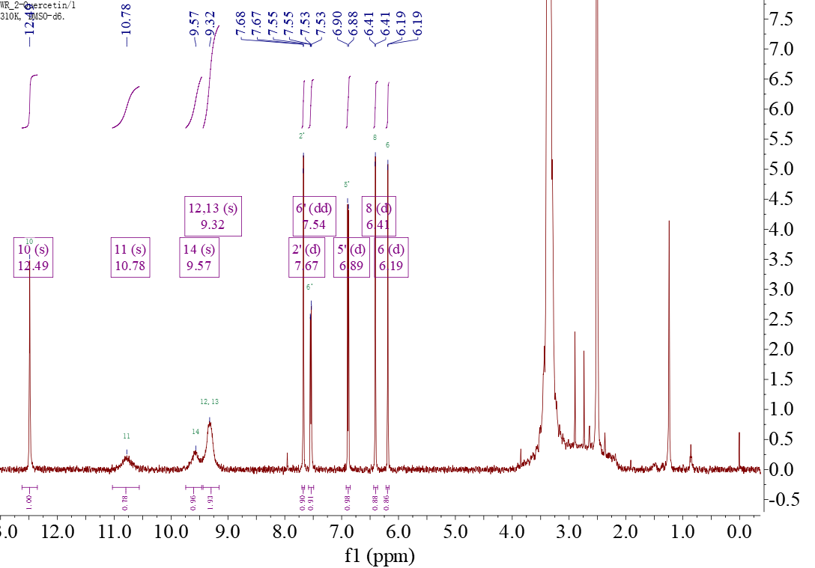
Fig. S2 The ¹H NMR spectrum (500 MHz, DMSO-d₆) of compound II
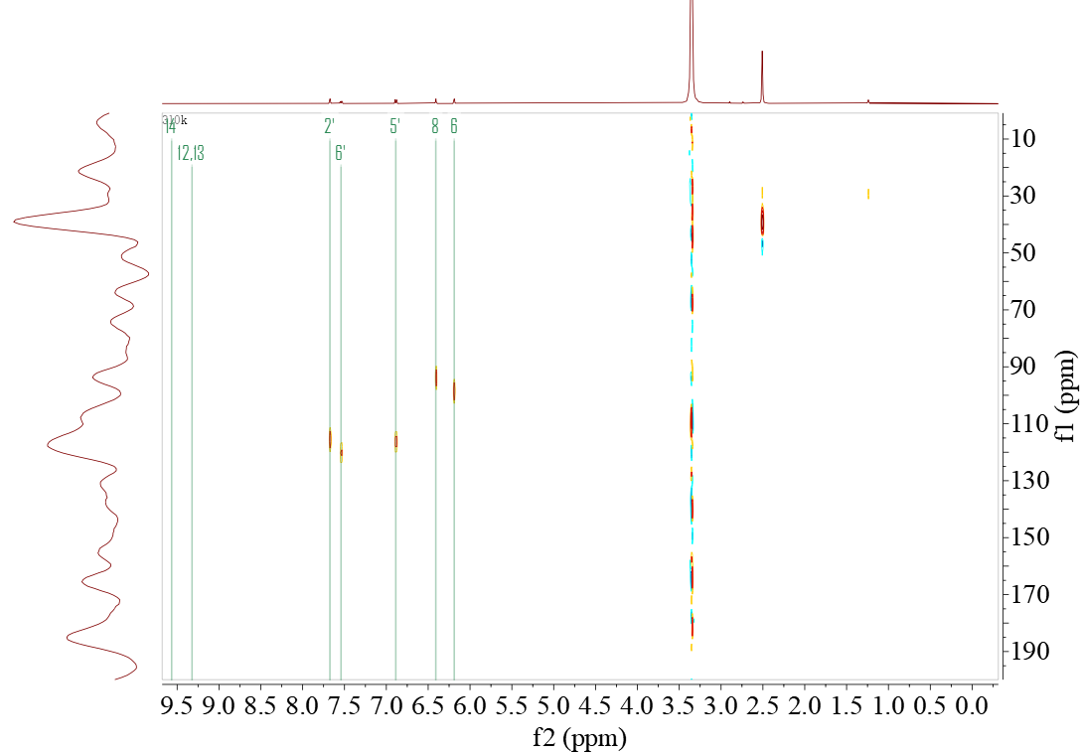
Fig. S3 The HSQC (¹³C,125 MHz, DMSO-d₆ ) spectrum of compound II

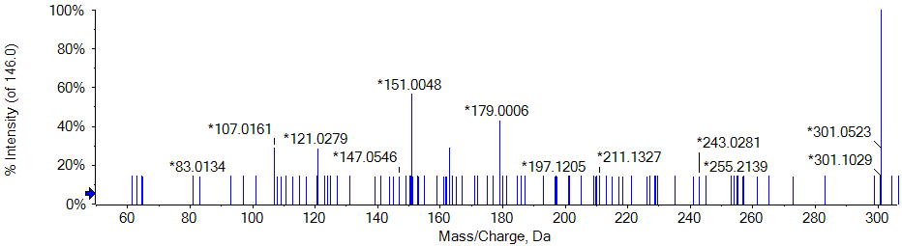
Fig. S4 The GC-MS spectrum of the compound II

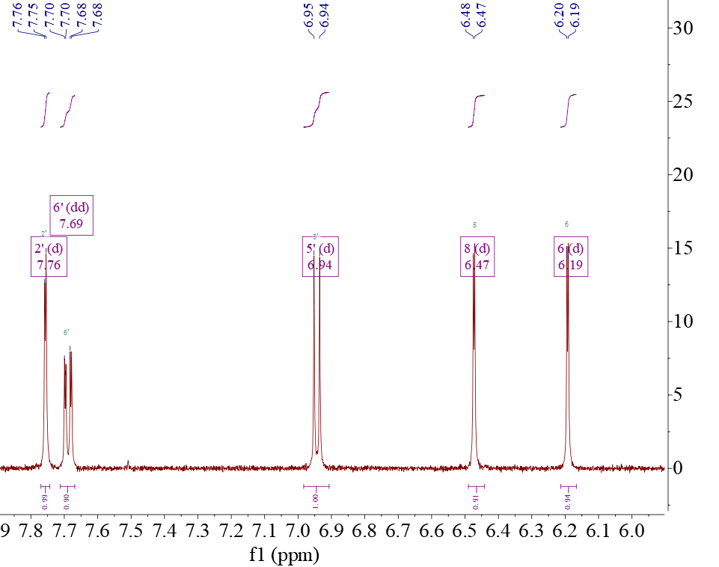
Fig. S5 The ¹H NMR spectrum (500 MHz, DMSO-d₆) of compound III

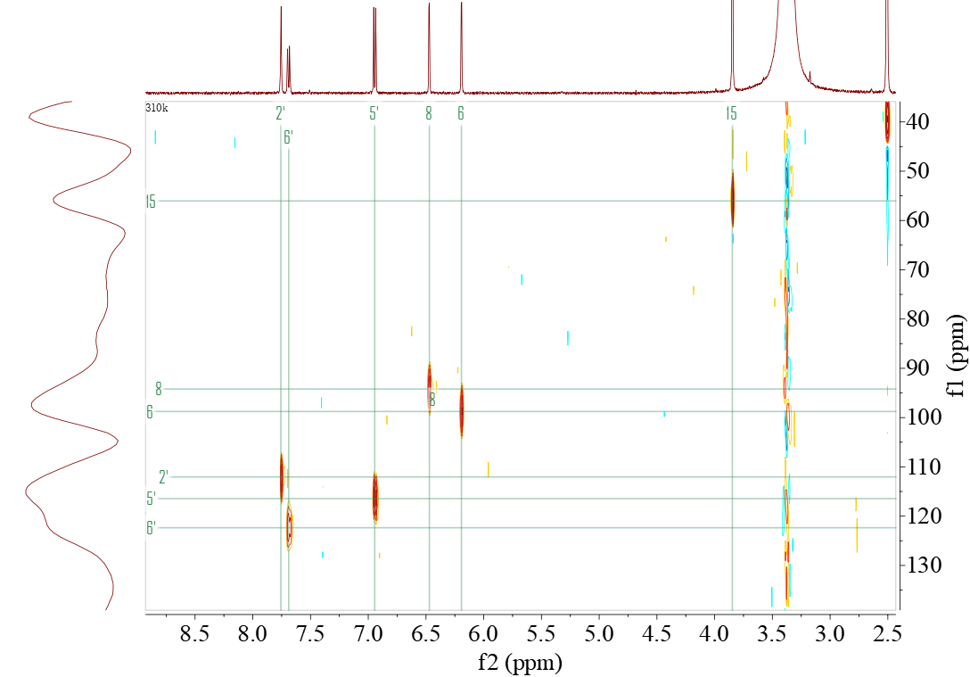
Fig. S6 The HSQC (¹³C,125 MHz, DMSO-d₆ ) spectrum of compound III

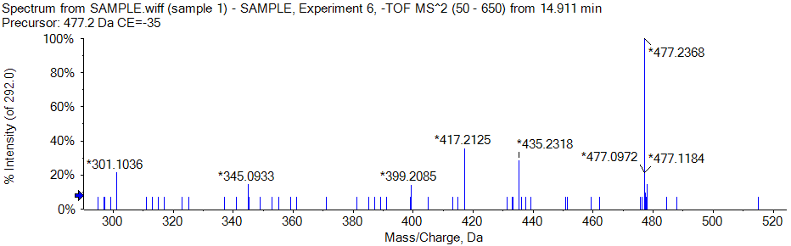
Fig. S7 The GC-MS spectrum of the compound III

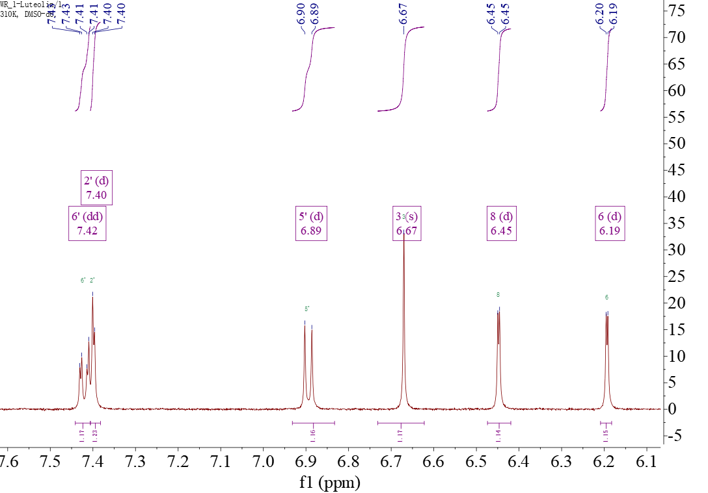
Fig. S8 The ¹H NMR spectrum (500 MHz, DMSO-d₆) of compound IV

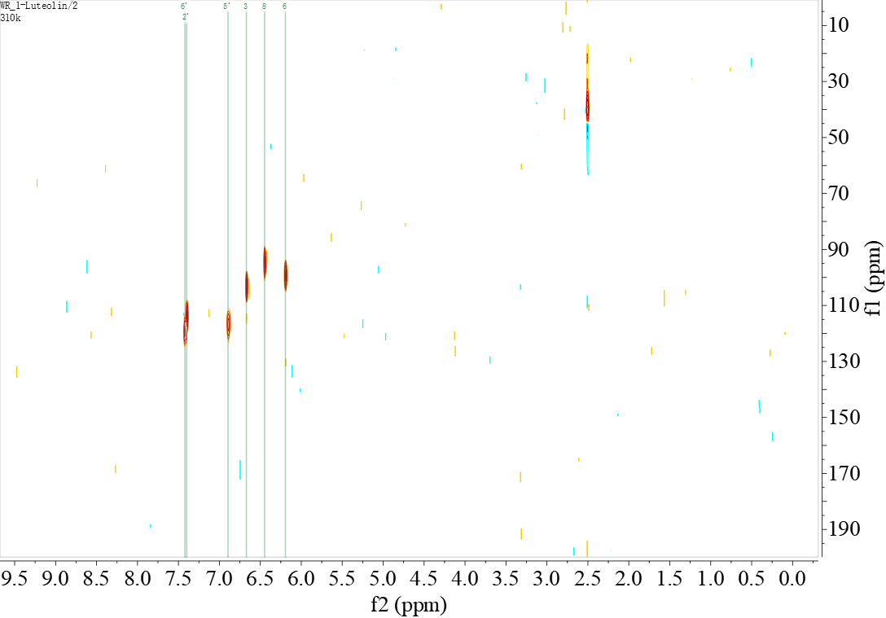
Fig. S9 The HSQC (¹³C,125 MHz, DMSO-d₆ ) spectrum of compound IV
Fig. S10 The GC-MS spectrum of the compound IV

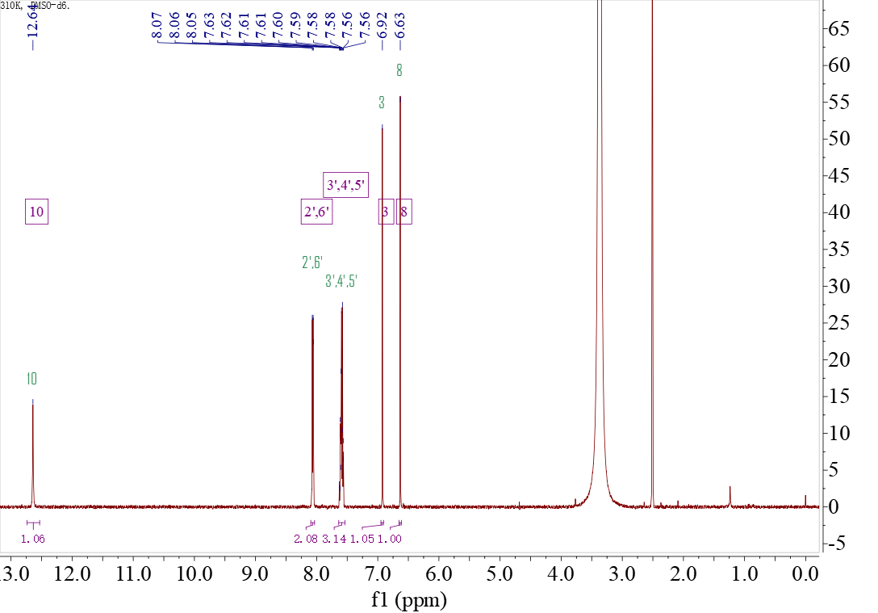
Fig. S11 The ¹H NMR spectrum (500 MHz, DMSO-d₆) of compound V
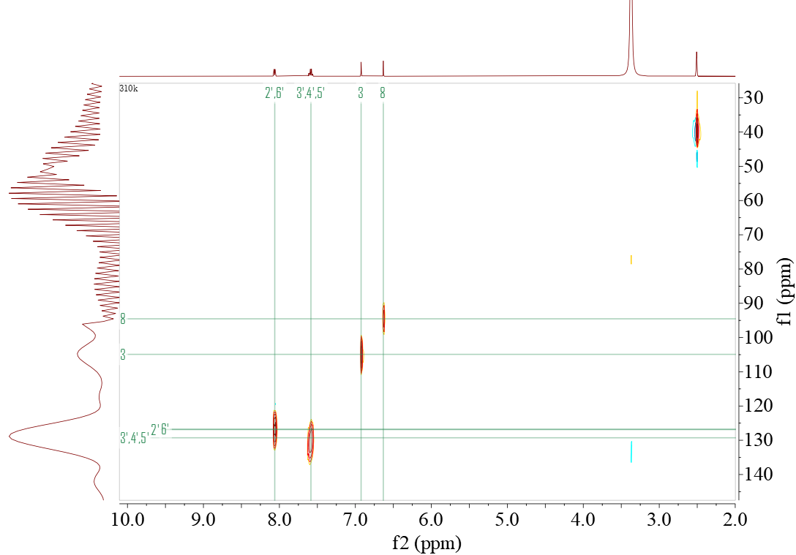
Fig. S12 The HSQC (¹³C,125 MHz, DMSO-d₆ ) spectrum of compound V

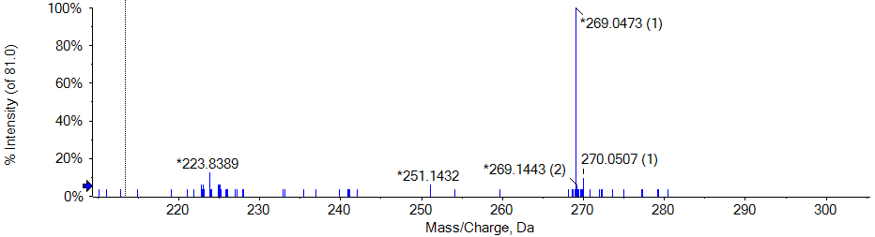
Fig. S13 The GC-MS spectrum of the compound V

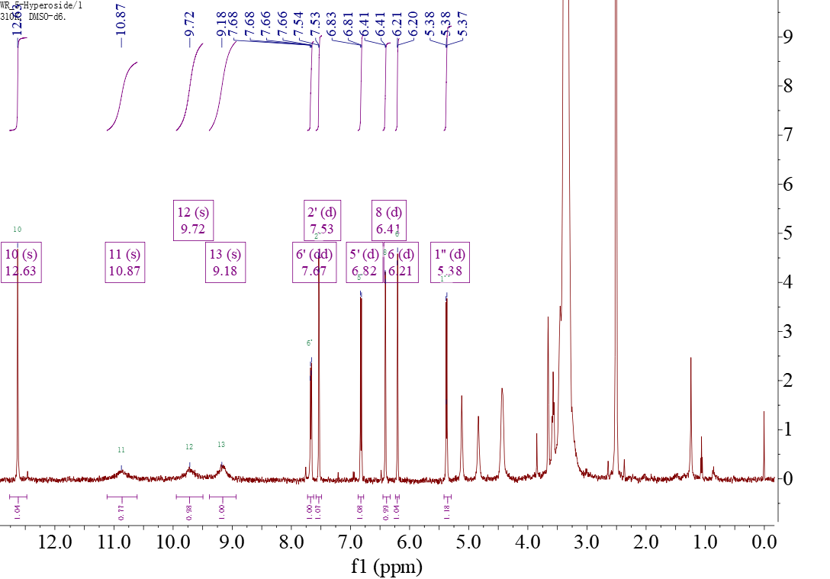
Fig. S14 The ¹H NMR spectrum (500 MHz, DMSO-d₆) of compound VI 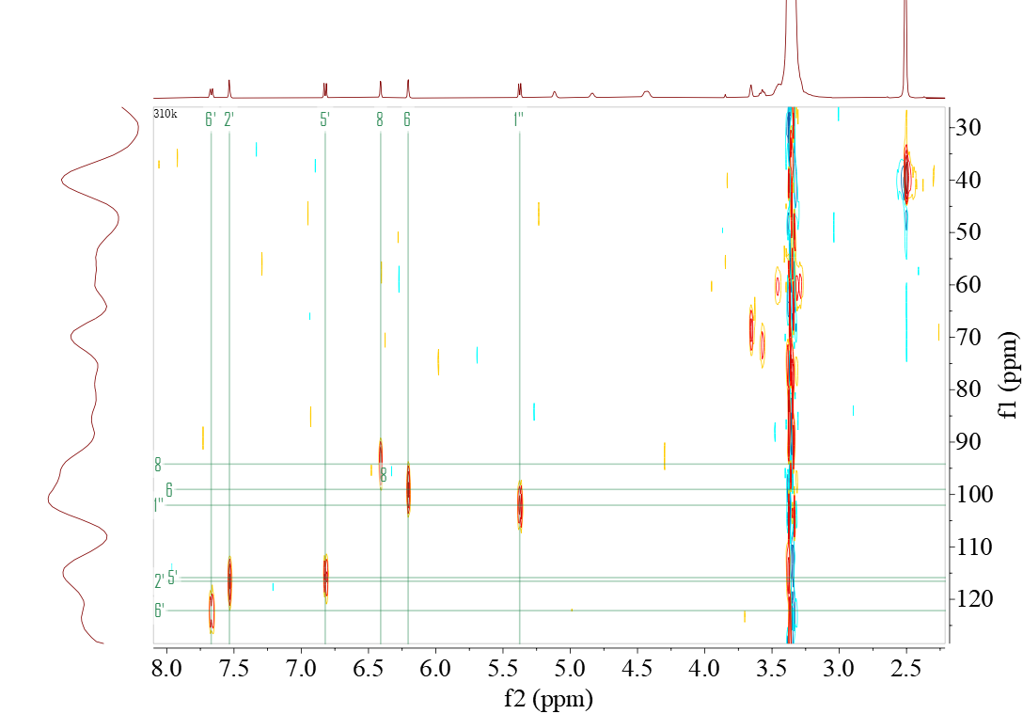
Fig. S15 The HSQC (¹³C,125 MHz, DMSO-d₆ ) spectrum of compound VI

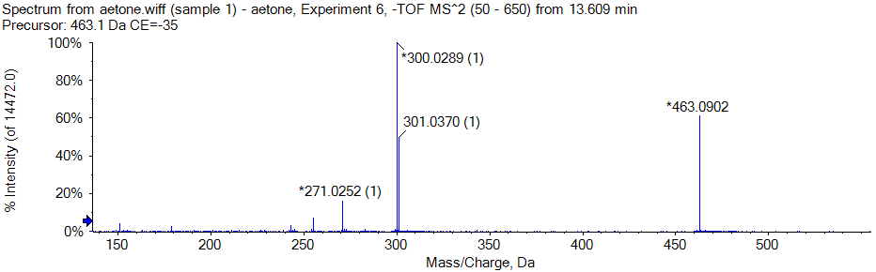
Fig. S16 The GC-MS spectrum of the compound VI

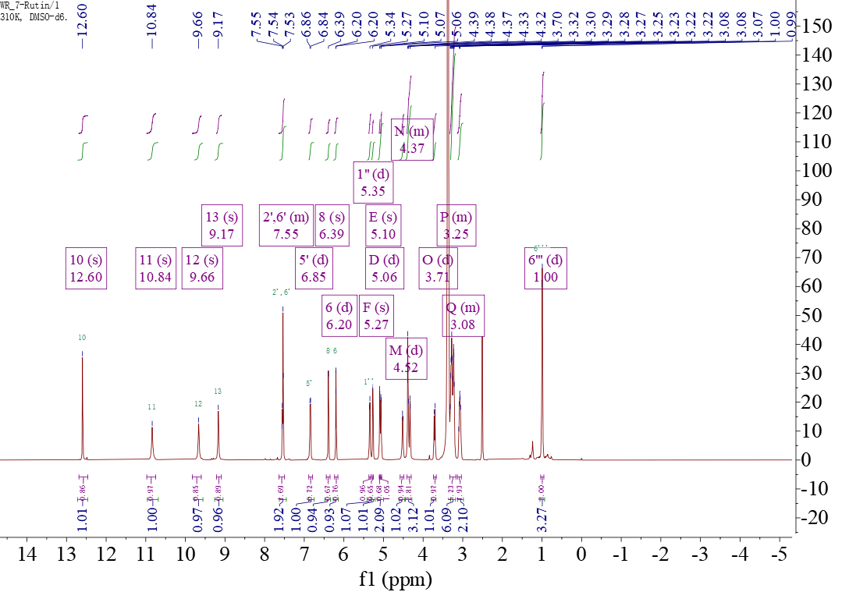
Fig. S17 The ¹H NMR spectrum (500 MHz, DMSO-d₆) of compound VII

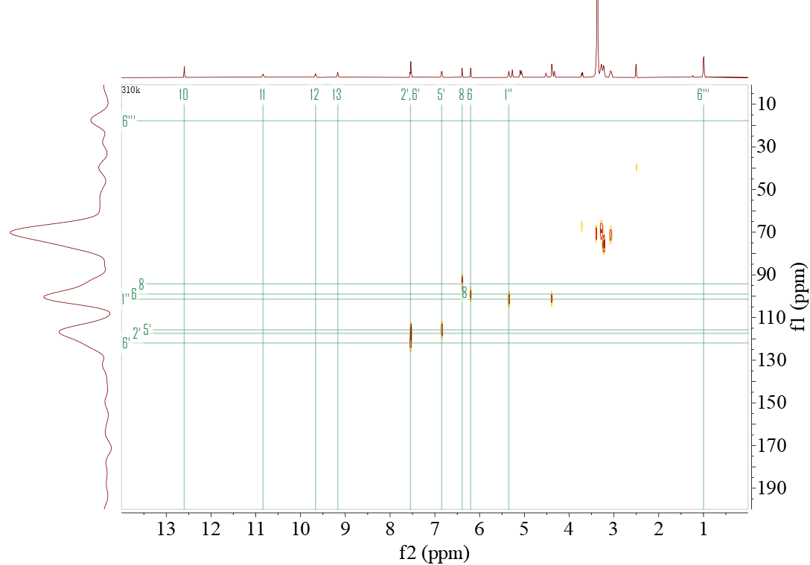
Fig. S18 The HSQC (¹³C,125 MHz, DMSO-d₆ ) spectrum of compound VII
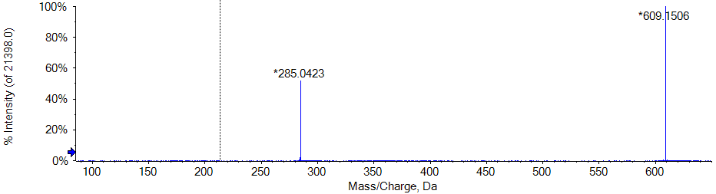
Fig. S19 The GC-MS spectrum of the compound VII

Part 3: Antioxidant activity assessment (measurement of scavenging DPPH via UV-Vis spectroscopy)
Fig. S 20 UV-vis absorption spectra for measuring the reaction between different flavonoid compounds and DPPH.

Table S3 Liner relationship between concentration of antioxidant and scavenging activity
Sample | Linear Equation | R² | IC₅₀
Quercetin | Y = 5.9696 x + 1.8239 | 0.9973 | 8.07
Hesperetin-5 '-O-β-rhamnoglucoside | Y = 5.7104 x + 0.1652 | 0.9945 | 8.72
Hesperetin 7-glucuronide | Y = 3.5306 x + 2.3531 | 0.9957 | 13.49
Baicalein | Y = 3.2095 x + 0.2277 | 0.9981 | 15.5
Kaempferol-3-glucoside | y = 2.3246 x-1.3727 | 0.9973 | 22.1
Hyperoside | y = 1.6876 x-2.9867 | 0.9894 | 31.39
Rutin | y = 1.5872 x-0.0651 | 0.9866 | 31.54

