Supplementary materials for “Climate change and nutrient fluctuations interact to affect ecological networks in lakes”

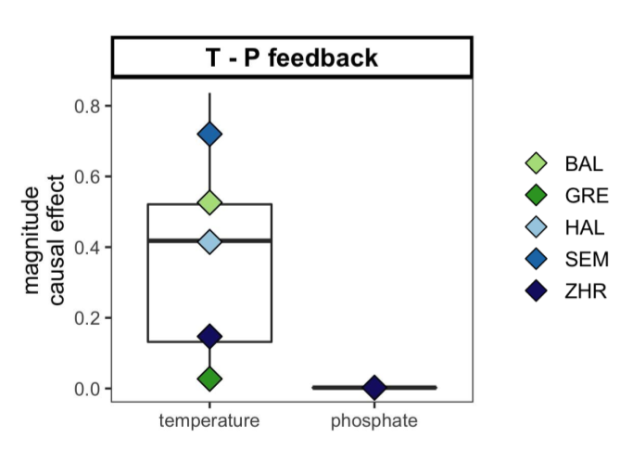

Fig. S1 Water temperature has an influence on phosphate levels but not vice versa: the magnitude of the effect was calculated by multiplying the predictive skill (rho) by the prevalence of the focal causal link over time and was corrected for seasonality (Methods). Points represent average effects per lake. Only lakes with significant effects are displayed. Phosphate levels had a significant effect on water temperature in lake Zurich on 1986-09-01 and from 1989-06-01 to 1989-09-01 (5 data points, probably outliers).
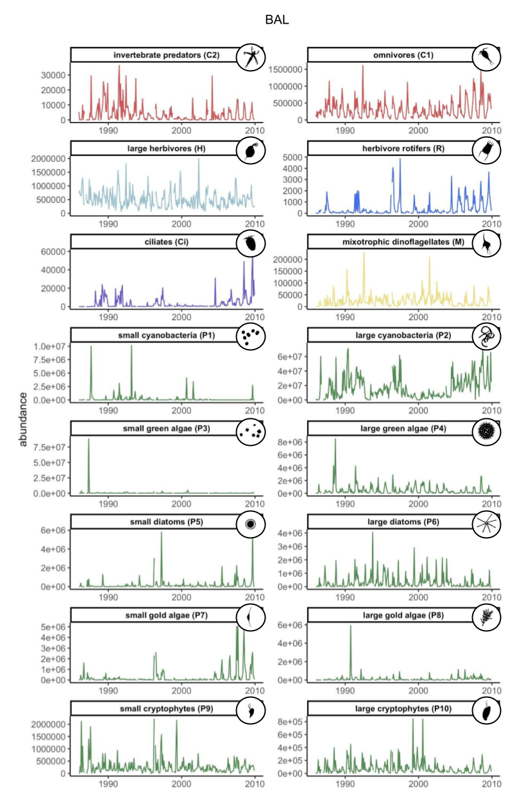

Fig. S2 Plankton network guild (node) time series. Abundances of C2-H are in indv./m2 and R-M as well as P1-P10 are in indv./L.

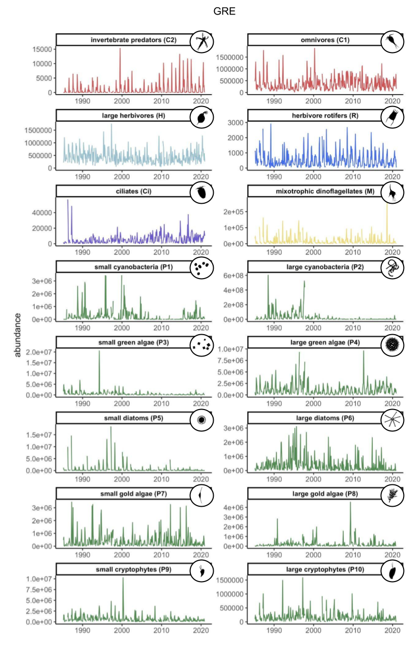
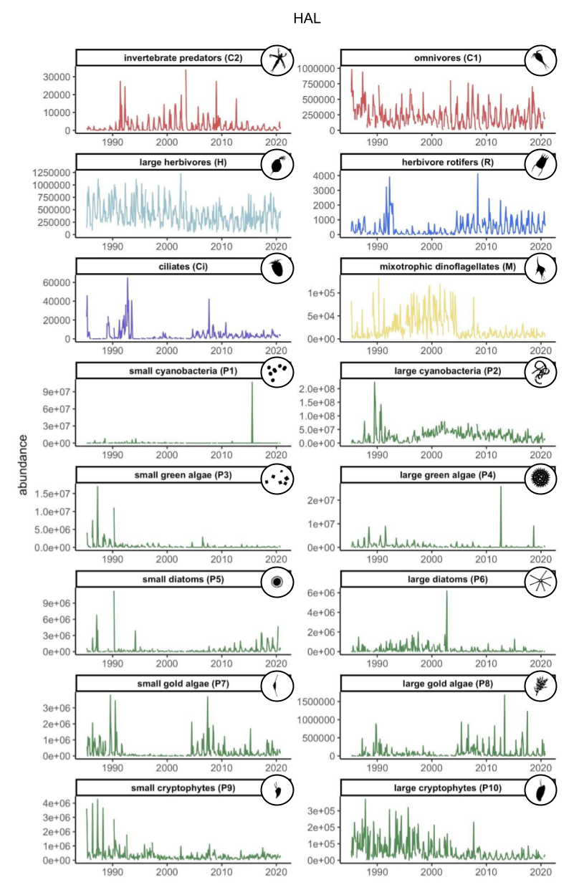
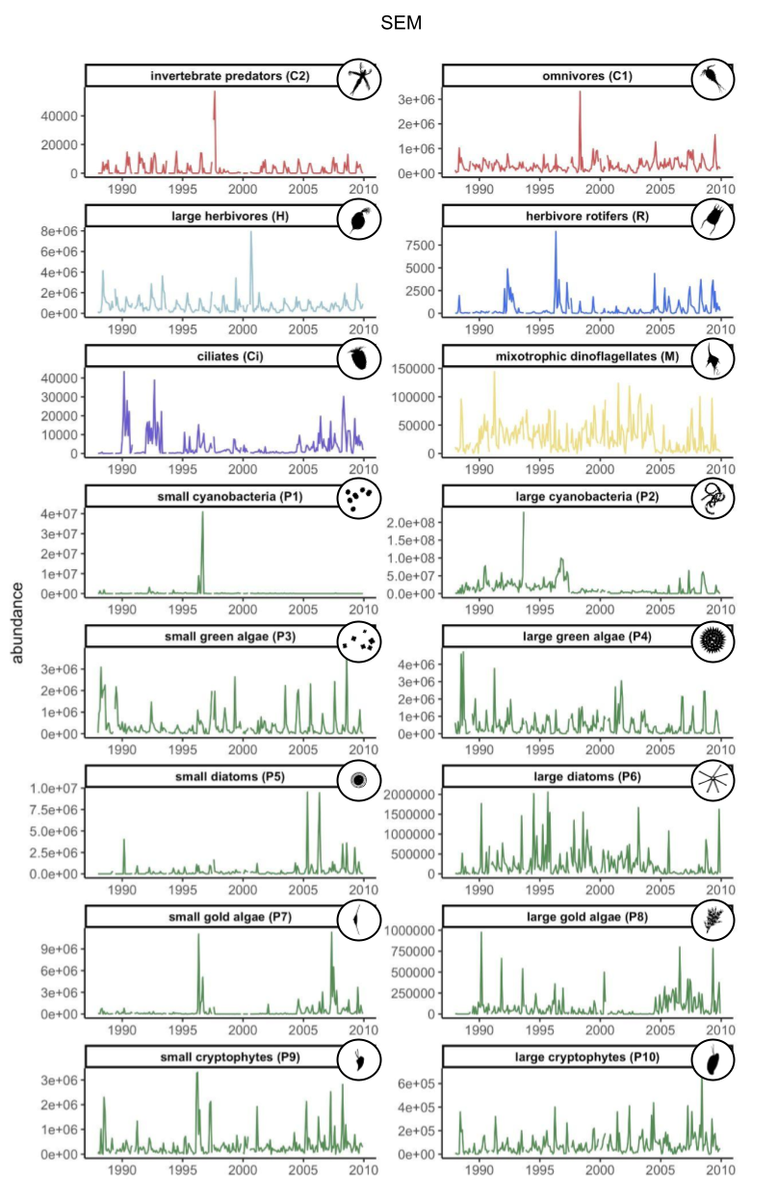
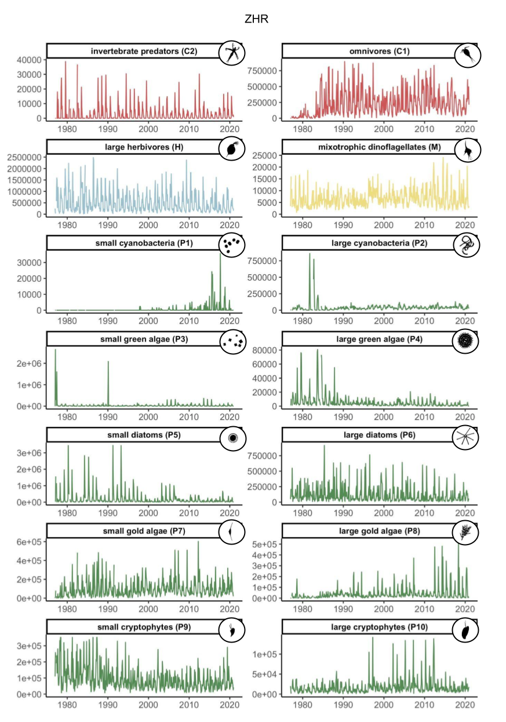
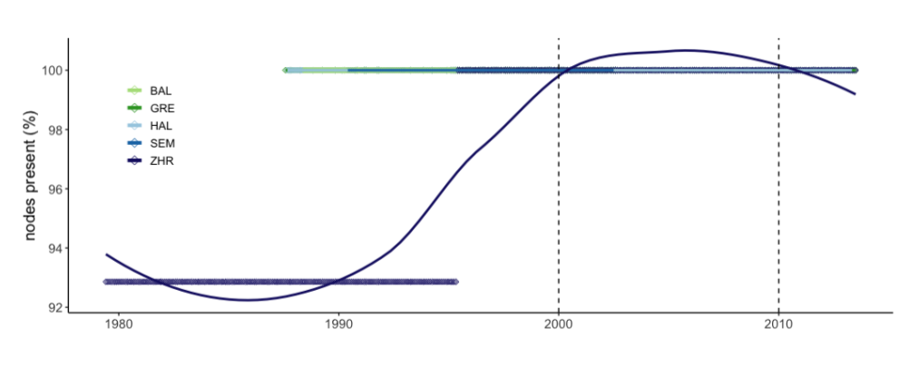

Fig. S3 Node richness is on average constant in all lakes. Node richness is calculated as the percentage of nodes that had an abundance >0 during the 60-month moving window used for the ccm analysis. Points show single measurements in time where lines are a smoothed average using loess and the formula y ~ x. Small cyanobacteria (P1) appeared (or were considered during sampling) in Lake Zurich (ZHR) for the first time on 1997-11-01.
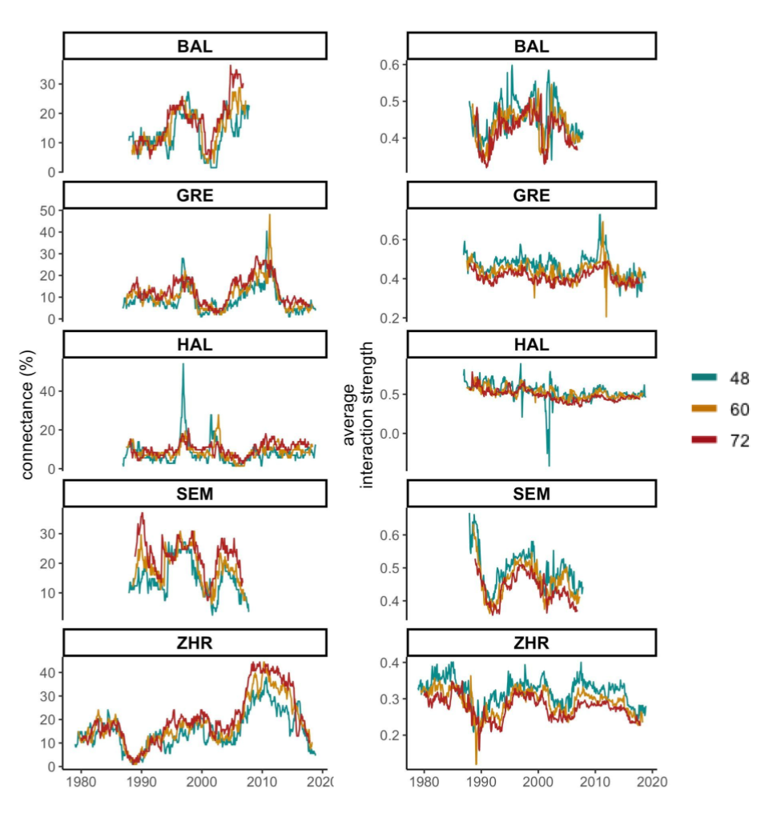

Fig. S4 Sensitivity analysis of cross-mapping window size (48, 60, and 72 months). [a] connectance (%) and [b] interaction strength (rho). The main trends are robust to the choice of size of the cross-mapping window.
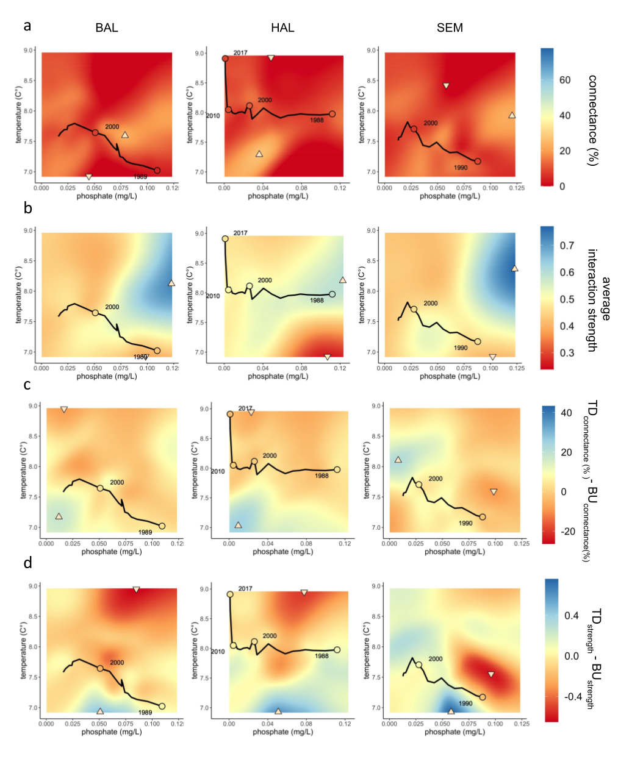

Fig. S5 S-map results for Lake Baldegg, Hallwil and Sempach network properties. Combined effects of average water-column phosphate levels and temperature on [a] realized connectance, [b] average interactions strengths, [c] Difference between the amount of realized TD and BU links, and [d] difference between the strength of TD and BU links: color-coded contour plots depict the s-map model inferred relationships, which emerge from predicting network properties (Z-axis) over varying levels of the chosen pair of explanatory variables (water temperature and phosphate), across the entire dataset while keeping lake depth and volume constant (Methods). To model the smallest and largest lake, we used lake depth and volume from Greifensee and lake Zurich, respectively (other lakes in Supplementary). Water temperature (y-axis), phosphate levels (x-axis), connectance (legend c), and average interaction strength (legend d) ranged between the minimum and maximum observed value across all lakes. Dots depict the start/end of the re-oligotrophication and net-warming phase. Trajectories show the direction of time. The displayed year is the middle point of a 5-year time window. Upwards triangles represent the maximum value of connectance or strength measured for paired values of water temperature and phosphate, whereas downwards triangles indicate the minimum.
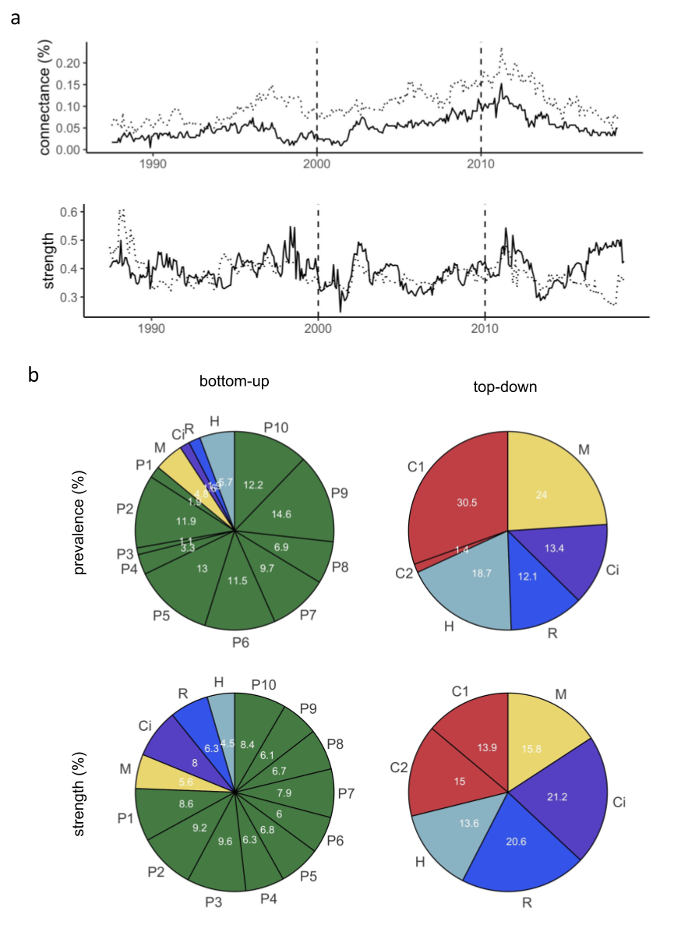

Fig. S6. Bottom-up and top-down network connectance (%) and strength in plankton networks. [a] Bottom-up and top-down connectance and strength were averaged over all 5 lake plankton networks and plotted across time. Averages were only calculated when data was available from at least three lakes. Solid line = bottom-up; Dashed line = top-down. Contribution (%) of each network guild to the [b] number of total bottom-up and top-down links and [c] averaged BU and TD interaction strength recorded across all lakes and time.

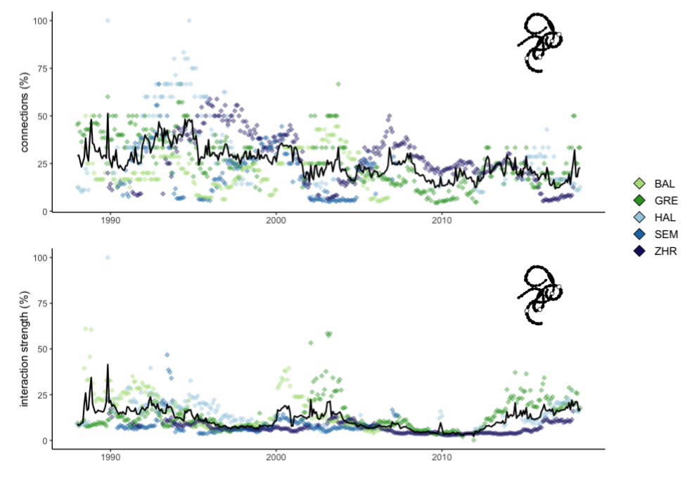

Fig. S7. Connectance (%) and interaction strength (%) of P2 (large or colonial cyanobacteria) relative to all the other plankton guilds. The black line shows the average across lakes (when data was available from three or more lakes).
Tab. S1: Lake metadata.

 |  |  |  | phytoplankton |  |  |  | small zooplankton |  |  |  | large zooplankton |  |  |  | chemistry
lake | abb. | volume (km3) | depth  sampling site (m) | time span | eff. dates | depth range | taxa (n) | time span | eff. dates | depth range | taxa (n) | time span | eff. dates | depth range | taxa (n) | time span | eff. dates | depth range | P-PO4 level (ug/L) 1985-2020 | ΔT(°C) 2005-2009 and 2016-2020 | matching data points (n)
Greifensee | GRE | 0.148 | 30 | 1985-2020 | 481 | 0-20 m | 340 | 1985-2020 | 479 | 0-20 m | 59 | 1985-2020 | 453 | 0-30 m | 50 | 1942-2020 | 822 | 0-30 m | 0.073 | 0.61 | 406
Zurichsee | ZHR | 3.3 | 135 | 1977-2020 | 552 | 0-135 m | 298 | NA | NA | NA | NA | 1977-2020 | 543 | 0-135 m | 99 | 1977-2020 | 527 | 0-135 m | 0.028 | 0.97 | 523
Hallwilersee | HAL | 0.285 | 45 | 1985-2020 | 453 | 0-13 m | 303 | 1985-2020 | 456 | 0-13 m | 60 | 1985-2020 | 453 | 0-43 m | 56 | 1969-2020 | 591 | 0-45 m | 0.051 | 0.93 | 408
Baldeggersee | BAL | 0.173 | 67 | 1986-2019 | 394 | 0-15 m | 278 | 1986-2019 | 390 | 0-15 m | 55 | 1986-2019 | 394 | 0-65 m | 63 | 1985-2020 | 449 | 0-65 m | 0.06 | 1.82 | 282
Sempachersee | SEM | 0.66 | 87 | 1986-2019 | 377 | 0-15 m | 267 | 1986-2019 | 378 | 0-15 m | 51 | 1986-2019 | 401 | 0-85 m | 59 | 1985-2020 | 441 | 0-85 m | 0.049 | 1.31 | 258

Tab. S2: S-map prediction accuracy.

 |  | all lakes included in library |  |  | only lake of interest included in library |  |  | lake of interest not included in library
network property | lake | rho (theta best) | rho (theta zero) | theta (rho highest) | rho (theta best) | rho (theta zero) | theta (rho highest) | rho (theta best) | rho (theta zero) | theta (rho highest)
connectance | ZHR | 0.79 | 0.01 | 8 | 0.85 | 0.43 | 6 | 0 | 0 | 0
connectance | GRE | 0.65 | 0 | 8 | 0.68 | 0.48 | 2 | 0 | 0 | 3
connectance | HAL | 0 | 0 | 0 | 0.09 | 0 | 8 | 0.07 | 0.07 | 0
connectance | SEM | 0.14 | 0 | 8 | 0.23 | 0 | 8 | 0.34 | 0 | 8
connectance | BAL | 0.66 | 0.2 | 8 | 0.66 | 0 | 4 | 0.52 | 0.37 | 0.5
int. strength | ZHR | 0.14 | 0 | 8 | 0.23 | 0 | 6 | 0.04 | 0 | 8
int. strength | GRE | 0.34 | 0 | 8 | 0.38 | 0.14 | 6 | 0.27 | 0 | 6
int. strength | HAL | 0.38 | 0 | 8 | 0.5 | 0.5 | 0 | 0.48 | 0.48 | 0
int. strength | SEM | 0.44 | 0 | 6 | 0.46 | 0 | 3 | 0.64 | 0 | 8
int. strength | BAL | 0.36 | 0 | 6 | 0.32 | 0 | 3 | 0.59 | 0 | 4
TD-BU con. | ZHR | 0.67 | 0 | 8 | 0.71 | 0.43 | 4 | 0.54 | 0 | 3
TD-BU con. | GRE | 0.31 | 0 | 2 | 0.27 | 0.25 | 1.5 | 0.4 | 0.02 | 3
TD-BU con. | HAL | 0 | 0 | 8 | 0.04 | 0 | 8 | 0.11 | 0.02 | 4
TD-BU con. | SEM | 0 | 0 | 0 | 0 | 0 | 8 | 0.36 | 0.35 | 0.1
TD-BU con. | BAL | 0.39 | 0 | 8 | 0.42 | 0.18 | 4 | 0.15 | 0.13 | 1
TD-BU strength | ZHR | 0.2 | 0 | 2 | 0.25 | 0.25 | 0 | 0.4 | 0 | 2
TD-BU strength | GRE | 0.32 | 0 | 6 | 0.28 | 0.16 | 2 | 0.25 | 0 | 1
TD-BU strength | HAL | 0.34 | 0 | 8 | 0.45 | 0 | 8 | 0.25 | 0.05 | 0.3
TD-BU strength | SEM | 0.62 | 0 | 8 | 0.7 | 0 | 8 | 0 | 0 | 4
TD-BU strength | BAL | 0.2 | 0 | 6 | 0.23 | 0.16 | 0.75 | 0.33 | 0.03 | 0.5

Tab. S3: Best embedding dimension and non-linear tuning parameter theta per network node and lake.

 | BAL |  | GRE |  | HAL |  | SEM |  | SEM
 | E | theta | E | theta | E | theta | E | theta | E | theta
P1 | 15 | 3 | 4 | 1 | 11 | 0 | 8 | 0.1 | 2 | 0
P2 | 4 | 1 | 9 | 1.5 | 9 | 0.75 | 13 | 0.1 | 14 | 1.5
P3 | 13 | 4 | 15 | 0.3 | 12 | 2 | 15 | 1.5 | 15 | 3
P4 | 8 | 6 | 11 | 4 | 5 | 4 | 11 | 2 | 12 | 0
P5 | 3 | 0.1 | 12 | 8 | 15 | 1 | 12 | 8 | 11 | 4
P6 | 12 | 2 | 6 | 2 | 11 | 1.5 | 13 | 0 | 15 | 2
P7 | 12 | 2 | 5 | 0.75 | 15 | 3 | 8 | 1.5 | 15 | 2
P8 | 5 | 3 | 3 | 0.3 | 15 | 2 | 13 | 1 | 15 | 1
P9 | 5 | 4 | 13 | 1 | 13 | 0 | 12 | 1.5 | 13 | 0.5
P10 | 8 | 6 | 12 | 0.75 | 12 | 1.5 | 15 | 1 | 14 | 0.75
Ci | 12 | 2 | 13 | 3 | 6 | 0.5 | 6 | 0.5
C1 | 14 | 1.5 | 8 | 3 | 15 | 2 | 13 | 0.1 | 15 | 2
C2 | 11 | 3 | 14 | 0.75 | 15 | 0 | 12 | 4 | 11 | 3
M | 15 | 0.75 | 8 | 1.5 | 11 | 2 | 13 | 2 | 14 | 0.5
R | 4 | 3 | 14 | 0.5 | 7 | 3 | 3 | 3
H | 11 | 1 | 14 | 0 | 12 | 1 | 15 | 4 | 15 | 1

