Supporting Information
Evaluation of the disinfection effect and mechanism of SO₄^{•-} and HO• in UV/ persulfate salts from the perspective of VBNC of bacteria

Zaihui Huang ª, Chunguang Liu ^{a, b,∗}

ª School of Environmental Science and Engineering, Shandong Key Laboratory of Environmental Processes and Health, China−America CRC for Environment & Health of Shandong Province, Shandong University, 72# Jimo Binhai Road, Qingdao, Shandong 266237, P.R. China
^{b} Guangdong Provincial Key Laboratory of Environmental Protection and Resources Utilization, Guangdong Province, P.R. China

Text S1. HPLC analyses
Text S2. Determination of anti-superoxide anion activity units
Fig.S1. HPC results of P. aeruginosa treated with UV, UV/PS, PS.
Fig.S2. The residual concentration of nitrobenzene (mg/L) in the system after UV, UV/PS, UV/H₂O₂ treatment for 60min, the concentration of nitrobenzene is inversely proportional to the concentration of hydroxyl radicals in the system. Conditions: [PS]₀= [H₂O₂]₀= 1 mM, the initial concentration of P. aeruginosa is ∼ 6 × 10⁵ cfu/mL.
Fig.S3. Cellular metabolic activity of single cell in different treatment groups based on 30% (v/v) D₂O-labeled Raman spectroscopy. (a) Distribution of C-D/ (C-D + C-H) % intensity ratio of single cell; (b) Distribution of C-D + C-H intensity ratio of single cell.
Fig.S4. P. aeruginosa was disinfected with UV, UV/PS, PS, UV/PS + MeOH and UV/PS + t-BuOH for 60 minutes and then measured with a fluorescence microplate reader.

Text S1. HPLC analyses.
The degradation of NB was determined by HPLC (high performance liquid chromatog-raphy, 2030, Shimazu, Japan) equipped with a C18 column (Poroshell, 4.6 × 150 mm, 5 μ m) and a UV detector set at 262 nm. The mobile phase consisted of methanol (A) and 3% acetic acid (B) with a gradient elution of A/B (v/v) kept at 70/30 in 10 min at a flow rate of 1 mL/min. The injection volume was20 μL.

Text S2. Determination of anti-superoxide anion activity units
Anti-superoxide anion activity unit is determined by the inhibition and production of superoxide anion free radical test kit (Nanjing Jiancheng Bioengineering Institute, China). After exposure, the bacteria were disrupted by an ultrasonic cell disruptor (300 w, ice water bath). Follow the instructions provided with the kit for testing. Use OD 600 to normalize the final experimental results.

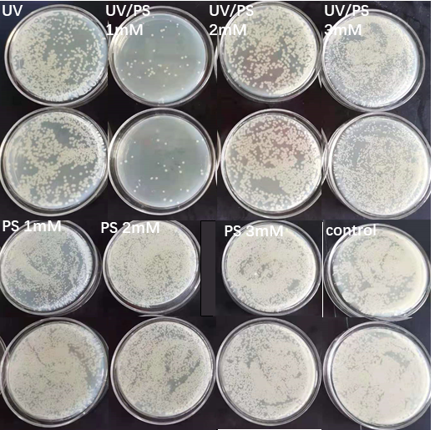
Fig.S1

Fig.S2.

Fig.S3.

Fig.S4.

∗Corresponding author: Tel: +86 150541873869 E-mail address:chunguangliu2013@sdu.edu.cn

