Supplementary Information for:
Simultaneously enhancing the strength and ductility of medium-entropy alloys via manipulating ordered oxygen complexes

Authors: Meiyuan Jiao¹, Zhifeng Lei^{2,*}, Yuan Wu^{1,*}, Jinlong Du³, Wenyue Li¹, Xiangyu Zhu⁴, Xiaoyuan Yuan¹, Shudao Wang¹, Huihui Zhu¹, Peipei Cao¹, Xiongjun Liu¹, Hui Wang¹, Suihe Jiang¹, Zhaoping Lu^{1,*}
Affiliations:
¹Beijing Advanced Innovation Center for Materials Genome Engineering, State Key Laboratory for Advanced Metals and Materials, University of Science and Technology Beijing, Beijing 100083, China
²College of Materials Science and Engineering, Hunan University, Changsha 410082, China
³Electron Microscopy Laboratory, School of Physics, Peking University, Beijing 100871, China
⁴Department of Materials Science and Engineering, the University of Texas at Dallas, Richardson, TX 75080, United States

*Corresponding to: zflei@hnu.edu.cn; wuyuan@ustb.edu.cn; luzp@ustb.edu.cn

Supporting computational details

Ab initio molecular dynamics (AIMD) simulations
Ab initio molecular dynamics (AIMD) simulations were implemented for the bcc Ti-30Zr-14Nb and Ti-30Zr-30Nb MEAs. All calculations were performed by the Vienna ab initio simulation package (VASP)¹. The 128 atoms supercells of each MEA were firstly generated with the special quasi-random structure (SQS) model as the initial configurations². The systems were firstly melted and equilibrated at 1.5 times the melting point (T_{m}) for 20 ps with a time step of 5 fs, and then quenched to 300 K with a constant-temperature, constant-volume (NVT) ensemble³. The values of T_{m} used for the Ti-30Zr-14Nb and Ti-30Zr-30Nb MEAs are the theoretical values of 2110 K and 2240 K, respectively. Brillouin zone integrations were performed by using a single Γ-center k-point. Projector-augmented-wave (PAW) potentials were employed with the Perdew-Burke-Ernzerhof (PBE) generalized-gradient approximation (GGA) for the exchange-correlation function⁴.

Supplementary Figures

Fig. 1 Tensile true stress-strain curves of the as-cast (a) Ti-30Zr-10Nb, (b) Ti-30Zr-18Nb, (c) Ti-30Zr-22Nb and (d) Ti-30Zr-30Nb MEAs added with a different amount of oxygen.
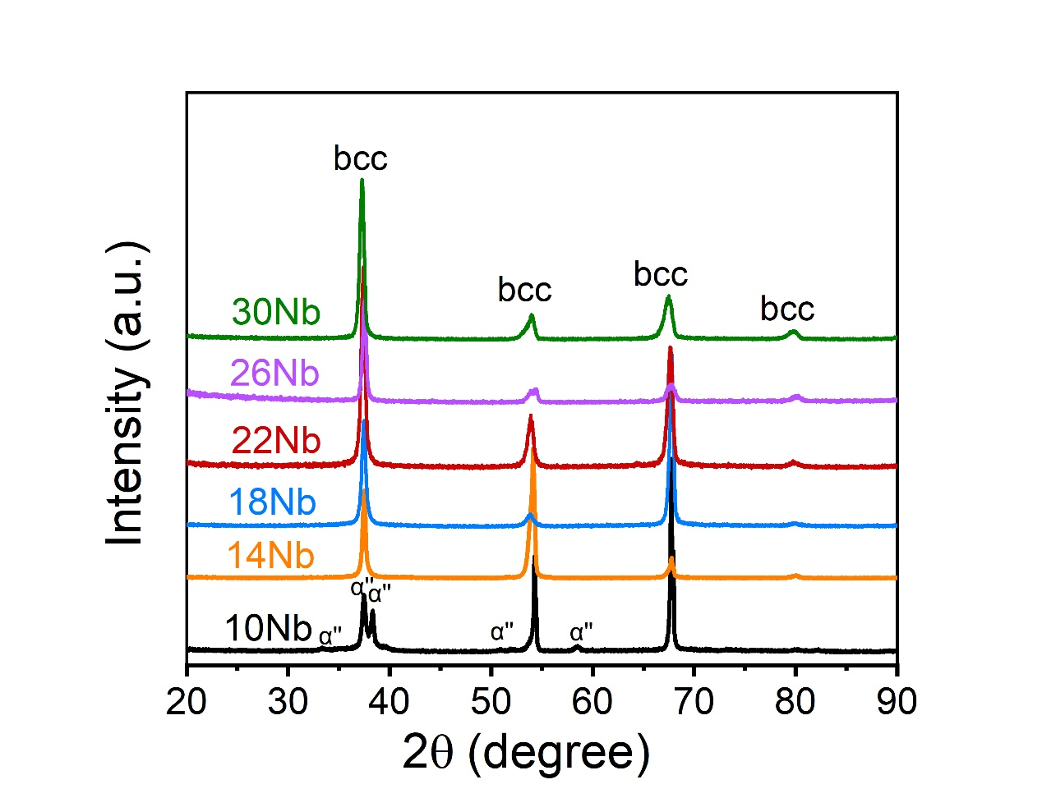
Fig. 2 XRD patterns of Ti-30Zr-xNb (x = 10, 14, 18, 22, 26, and 30 at.%) MEAs.

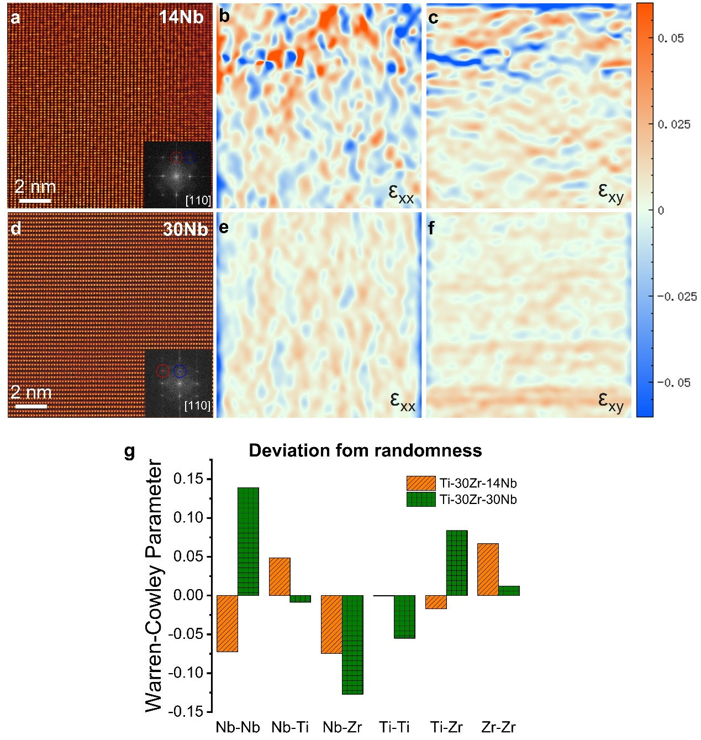
Fig. 3 Comparison of atomic strain distribution between the (a-c) Ti-30Zr-14Nb and (d-f) Ti-30Zr-30Nb MEAs. (a,d) STEM-HAADF images of the Ti-30Zr-14Nb and Ti-30Zr-30Nb MEAs, respectively. The fast Fourier transformed images are shown in the insets. (b,c) Strain maps of (a) showing nanometer-sized local fluctuations of strain (ε _{xx}, horizontal normal strain; ε _{xy}, shear strain). (e,f) Strain maps of (d) showing similar but much weaker contrast of local strains. The atomic strain field in the Ti-30Zr-30Nb MEA is more uniform, whereas substantial atomic strain fluctuations exist in the Ti-30Zr-14Nb MEA. (g) Warren-Cowley (WC) parameters for all atomic pairs in Ti-30Zr-14Nb and Ti-30Zr-30Nb. The value of the WC parameter of zero represents a purely random solid solution case, whereas negative values reflect the favored atomic pairs and positive values indicate repulsive pairs. The value of Ti-Zr and Nb-Nb pairs is negative in Ti-30Zr-14Nb but positive in Ti-30Zr-30Nb, confirming the formation of the Ti-Zr and Nb-Nb pairs is more favored in the former.
Fig. 4 (a) Three-dimensional reconstruction of atomic distribution of Ti, Zr, Nb, and O in Ti-30Zr-14Nb-3O MEA. (b) The iso-composition surface with a threshold oxygen concentration of 6.5 at.%, highlighting presence of the OOCs. (c) Proximity analysis from the interface between the matrix/and OCCs indicates the enrichment of O, Ti, Zr and depletion of Nb.
Fig. 5 Temperature-dependent variation of damping capacity (indexed by Tan Delta) of the as-cast (a) Ti-30Zr-14Nb-1O, (b) Ti-30Zr-14Nb-3O, (c) Ti-30Zr-18Nb-3O, (d) Ti-30Zr-22Nb-3O, (e) Ti-30Zr-26Nb-3O and (f) Ti-30Zr-30Nb-3O MEAs. The measurements were conducted on a multifunction internal friction apparatus by the forced vibration at 0.5, 1.0, 2.0 and 4.0 Hz. The red arrows in the figures indicate the additional low-temperature peak which reflects the existence of OOCs.

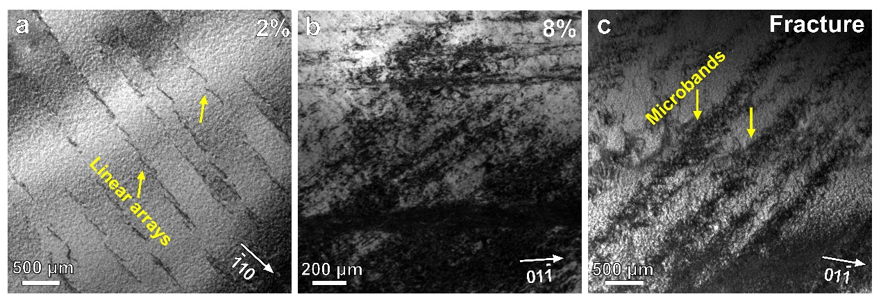
Fig. 6 Bright-field TEM images of the Ti-30Zr-14Nb MEA pre-strained to (a) 2%, (b) 8% and (c) fracture, respectively.

Fig. 7 Variation of yield stress with the oxygen content in the (a) Ti-30Zr-14Nb, (b) Ti-30Zr-26Nb and (c) Ti-30Zr-30Nb MEAs. The data were fitted by the Fleischer model and Labusch model, respectively. Δσ_{s} represents the increase in the yield strength, [O]^{n} represents the 1/2 and 2/3 power of the oxygen content, and R² is the fitting correlation index.
Fig. 8 (a) Room-temperature tensile true stress-strain curves of the as-cast Zr-15Nb-10Ti doped with different oxygen contents. With the increase of oxygen concentration from 0 to 4 at.%, the yield and fracture strength are greatly improved linearly. It should be noted that with addition of 2 at.% oxygen, the ductility is nearly doubled. (b) Temperature-dependent variation of damping capacity of the as-cast Zr-15Nb-10Ti-2O alloy by forced vibration at 0.5, 1.0, 2.0 and 4.0 Hz. The additional low-temperature peak in the Zr-15Nb-10Ti-2O alloy also verifies the formation of OCCs.
Table 1 Cluster analysis parameters, d_{max} and N_{min}, used for the three MEAs that showed signs of non-random distribution. Using the specified element(s) as the center, d_{max} represents the maximum radius up to which the cluster analysis tool searches for the same element(s). N_{min} is the minimum number of ions present in the cluster.
Parameter | Ti-30Zr-14Nb-1O | Ti-30Zr-14Nb-3O | Ti-30Zr-26Nb-3O
d_{max} (nm) | 0.89 | 0.89 | 0.89
N_{min} | 23 | 23 | 23

References
- Kresse, G. & Furthmuller, J. Efficient iterative schemes for ab initio total-energy calculations using a plane-wave basis set. Phys. Rev. B 54, 11169-11186 (1996).
- Zunger, A., Wei, S., Ferreira, L. G. & Bernard, J. E. Special quasirandom structures. Phys. Rev. Lett. 65, 353-356 (1990).
- Nosé, S. A unified formulation of the constant temperature molecular dynamics methods. Chem. Phys. 81, 511-519 (1984).
- Kresse, G. & Joubert, D. From ultrasoft pseudopotentials to the projector augmented-wave method. Phys. Rev. B 59, 1758-1775 (1999).

