Supplementary

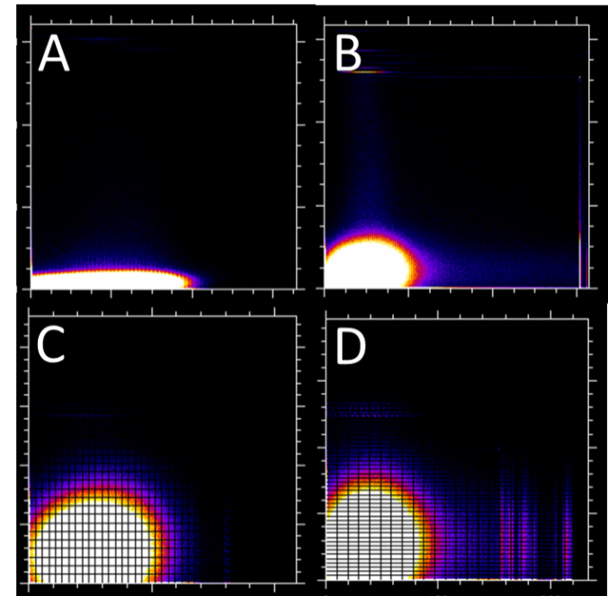
Supplementary 1: Cell-nuclei and 200 nm particles typical co-localization scatter plot, allowing calculating Pearson regression coefficient, R linear overlap coefficient, slope and intercept of co-appearance. (A) and (B) – internalized particles by LM and HM cells respectively; (C) and (D) internalizes and adhered particles by LM and HM cells respectively.
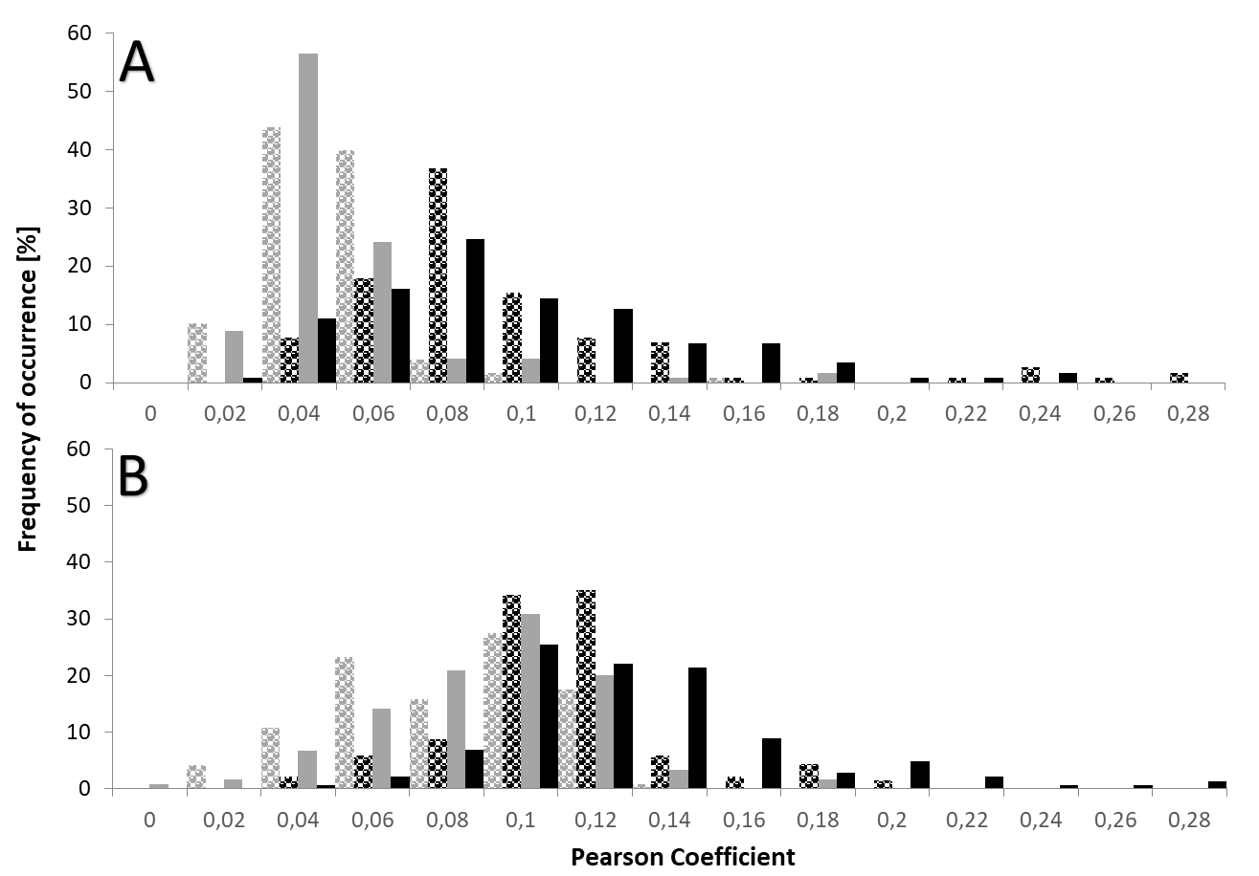
Supplementary 2: Distribution histogram of automatically calculated Pearson coefficients for breast cancer cells colocalization with (A) 100 nm and (B) 200 nm particles. Black bars – adhered and internalized particles by HM cells; black doted bars - internalized particles by HM cells; gray bars - adhered and internalized particles by LM cells; gray doted bars - internalized particles by LM cells.

