IRAK2 contributes to triple-negative breast cancer growth via NF-κB, ERK and stress-related signaling pathways
Francesca Ferraro¹, Anja Steinle¹, Harini Narasimhan¹, Andreas Bleilevens¹, Till Braunschweig², Elmar Stickeler¹ and Jochen Maurer ¹
¹ Department of Obstetrics and Gynecology, University Hospital Aachen (UKA), D-52074 Aachen, Germany
² Pathology Institute, University Hospital Aachen (UKA), D-52074 Aachen, Germany

Correspondence: PD Dr. Jochen Maurer, jmaurer@ukaachen.de;

Supplementary Information (SI)
This file contains the graphical abstract, supplementary figures and supplementary figures captures.

Graphical abstract
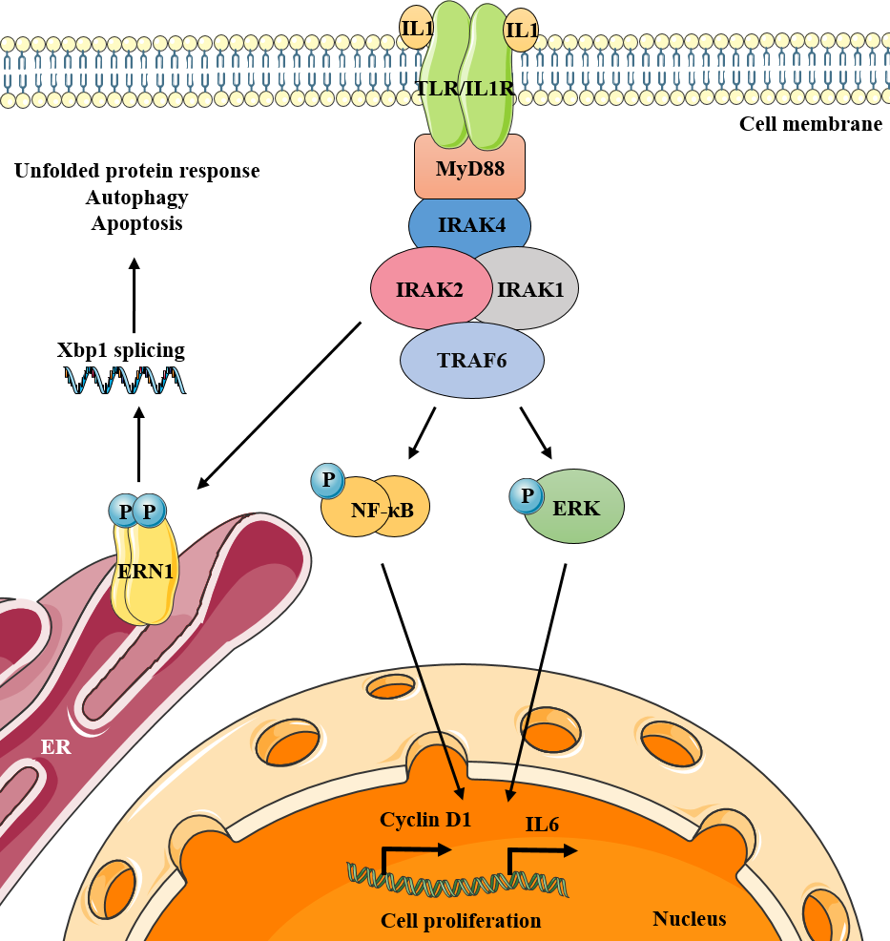

Supplementary Figures

Fig. S1

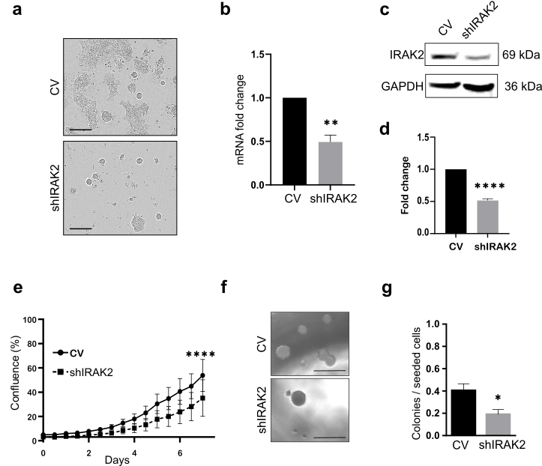
Fig. S1 IRAK2 stable knockdown affects BCSC1 proliferation and sphere-forming capacity. a Images representing BCSC1 phenotype in presence of IRAK2 knockdown compared to control cells. Scale bars represent 400 μm. b c IRAK2 stable knockdown in BCSC1 was confirmed at mRNA (b) and protein (c) level. d Quantification of IRAK2 knockdown at protein level. e f Reduced proliferation (e) and sphere-forming capacity (f) of cells in presence of IRAK2 knockdown compared to control cells. Proliferation data were analyzed with the Wilcoxon test. Scale bars represent 500 μm. g Sphere-forming capacity quantification. Unpaired t-test was applied to perform qRT-PCRs, western blot and sphere-forming capacity statistical analysis. Data (n=3) represent means ± SEM, *, P<0.05, **, P<0.01, ****, P<0.0001

Fig. S2
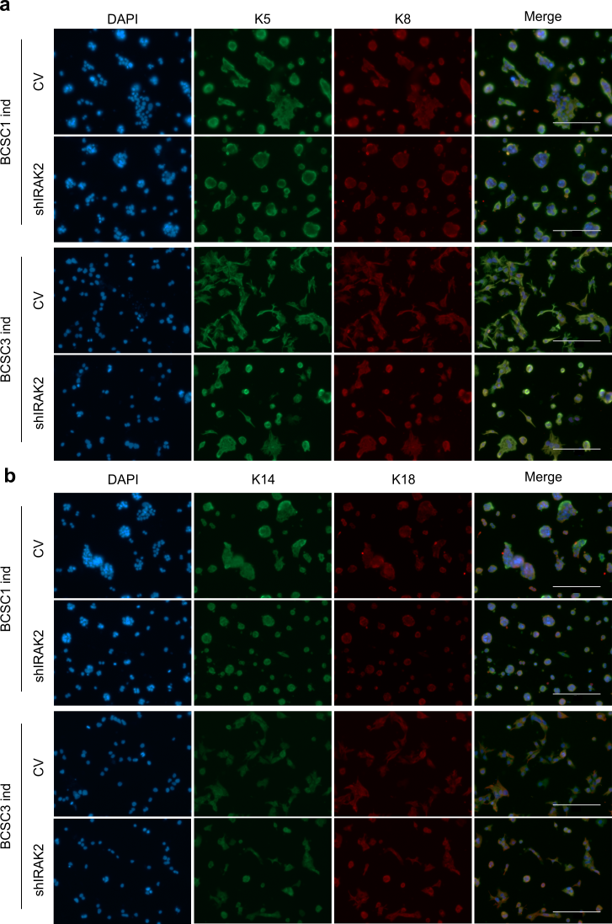

Fig. S2 IRAK2 knockdown does not affect keratins expression in BCSC1 and BCSC3. a b Pictures depicting immunofluorescence staining in BCSC1 and BCSC3, comparing control and IRAK2 induced knockdown cells, of keratins 5, 8 (a), 14 and 18 (b). Scale bars represent 200 µm
Fig. S3
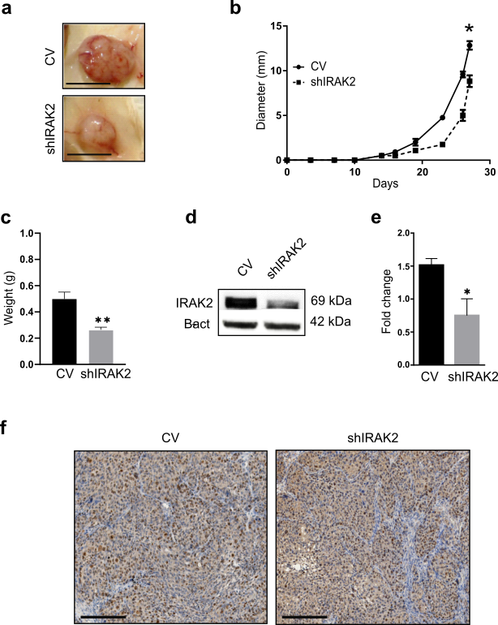

Fig. S3 BCSC1 tumorigenicity is delayed upon IRAK2 stable knockdown. a Examples of control and knockdown xenografts originated from BCSC1 transplants. Scale bars represent 1 cm. b Xenografts diameter during time. Mean values ± SEM, n=6, statistics made by paired t-test. c Average control and IRAK2 knockdown xenografts weight. Data represent mean values ± SEM, n=6, Mann-Whitney test. d e IRAK2 expression at protein level in control and knockdown xenografts (d) and relative quantification (e). Data represent mean ± SEM, n=3, unpaired t-test. f Ki67 staining comparing control and IRAK2 knockdown xenografts. Scale bars represent 400 µm. *, P<0.05, **, P<0.01

Fig. S4
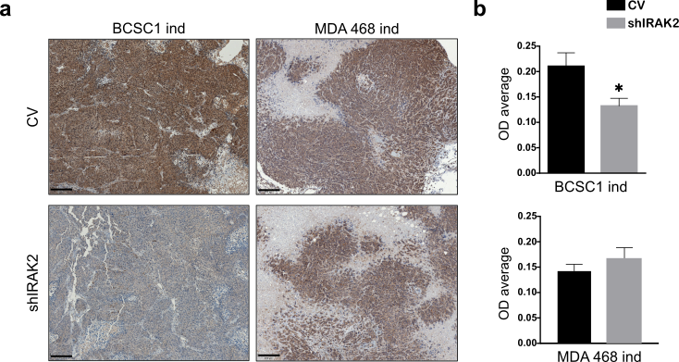
Fig. S4 BCSC1 xenografts present decreased cyclin D1 expression upon IRAK2 induced knockdown. a b Immunohistochemistry representing cyclin D1 expression in control and induced IRAK2 knockdown BCSC1 and MDA-MB-468 xenografts (a) and its relative quantification (b) expressed as optical density (OD) average. Scale bars represent 200 µm. *, P<0.05 by unpaired t-test

Fig. S5
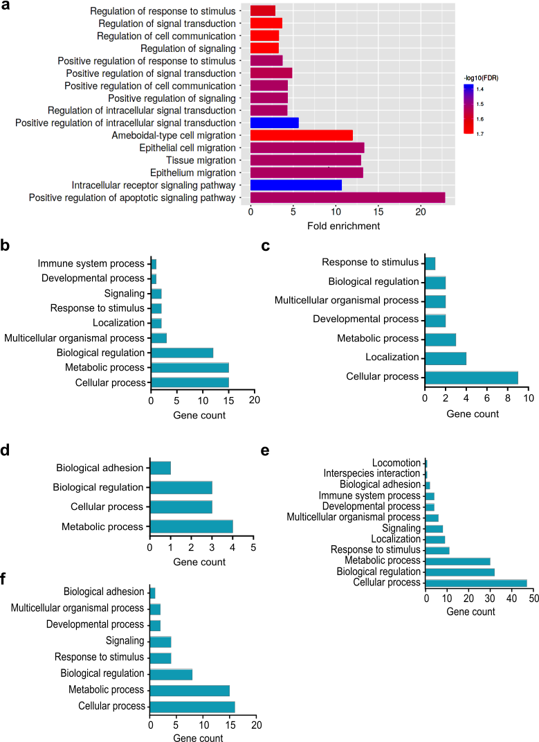
Fig. S5 Genes commonly downregulated or upregulated by BCSC1, BCSC3 and MDA-MB-468. a Gene ontology enrichment of genes commonly downregulated by BCSC1 and BCSC3 upon IRAK2 knockdown by ShinyGO. b Biological processes characterizing the genes commonly downregulated by BCSC3 and MDA-MB-468 upon IRAK2 knockdown identified through PANTHER classification system. c Genes commonly upregulated by BCSC1 and BCSC3 upon IRAK2 knockdown classified considering their biological processes using PANTHER classification system. d Genes commonly upregulated by BCSC3 and MDA-MB-468 upon IRAK2 induced knockdown classified considering their biological processes using PANTHER classification system. e f Gene ontology of MDA-MB-468 downregulated (e) or upregulated (f) genes in presence of IRAK2 induced knockdown

