Supporting Information
Highly water-dispersed composite of cellulose nanofibers and boron nitride nanosheets
Songfeng E,* Ruixia Zhao, Doudou Ning, Qin Ma, Bo Geng, Jiayi Liu, Zhaoqing Lu*
College of Bioresources Chemical and Materials Engineering, Shaanxi Provincial Key Laboratory of Papermaking Technology and Specialty Paper Development, National Demonstration Center for Experimental Light Chemistry Engineering Education, Shaanxi University of Science & Technology, Xi’an 710021, China
* Corresponding authors.
E-mails: esongfeng@sust.edu.cn; luzhaoqing302@163.com.

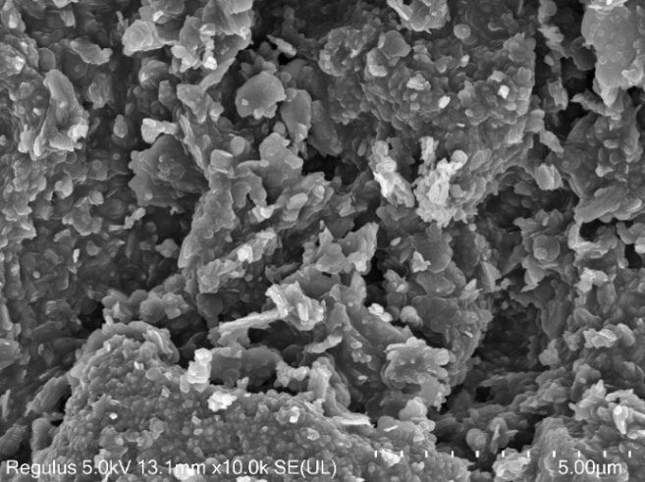
2 μm
BN
Fig. S1 SEM image of raw BN.

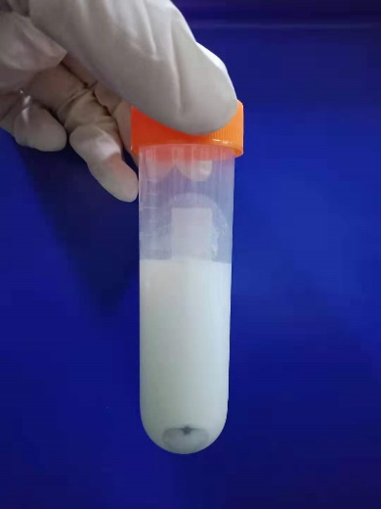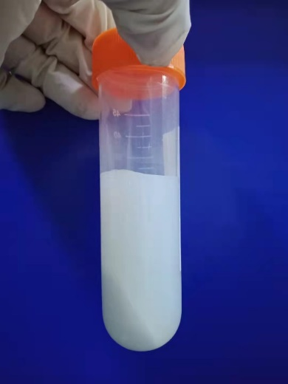
(b)
(a)
Fig. S2 Optical images of the ball-milled CNF-BNNS-III dispersions (a) with and (b) without high-pressure homogenization after centrifugation at 4000 rpm for 10 min.

Fig. S3 UV absorption spectra of the CNF/BNNS composites (a, c) with and (b, d) without homogenization after resting for (a, b) 0 and (c, d) 8 months.
Fig. S4 (a, b) XRD patterns and (c, d) Raman spectra of (a, c) CNF film and (b, d) raw BN powders.
Fig. S5 SEM images of the surface of (a) CNF and (b) CNF-BNNS-III films.

Table S1 Diameters and thicknesses of pure CNF and CNF/BNNS composite films.
Sample | BN content (wt.%) | Diameter (cm) | Thickness (μm)
Sample | BN content (wt.%) | Diameter (cm) | Test for mechanical property | Test for thermal conductivity
CNF | -- | 4 | 32 | 151±2
CNF-BNNS-I | 10 | 4 | 30 | 156±3
CNF-BNNS-II | 20 | 4 | 29 | 159±1
CNF-BNNS-III | 30 | 4 | 31 | 154±1
CNF-BNNS-IV | 40 | 4 | 29 | 156±2
CNF-BNNS-V | 50 | 4 | 30 | 155±2

Table S2 Peak positions of chemical bonds from B1s and N1s XPS spectra.
Sample | B1s (eV) |  | N1s (eV)
Sample | B−N | B−O | N−B | N−H
BN | 190.66 | 191.96 | 398.21 | 399.09
CNF-BNNS-III | 190.49 | 191.26 | 398.08 | 399.71

Table S3 Relative contents of chemical bonds from B1s and N1s XPS spectra.
Sample | B1s |  | N1s
Sample | B−N | B−O | N−B | N−H
BN | 93.99% | 6.01% | 89.46% | 10.84%
CNF-BNNS-III | 76.35% | 23.65% | 85.26% | 14.74%

Table S4 Peak positions of chemical bonds from C1s and O1s XPS spectra.
Sample | C1s (eV) |  |  | O1s (eV)
Sample | C−C/C−H | C−OH | O−C=O/  C−O−C | O−C=O | HO−C/  C−O−C | O−B
CNF | 284.61 | 286.47 | 287.98 | 532.0 | 532.8 | --
CNF-BNNS-III | 284.8 | 286.53 | 288.02 | 532.0 | 532.79 | 533.56

Table S5 Relative contents of chemical bonds from C1s and O1s XPS spectra.
Sample | C1s |  |  | O1s
Sample | C−C/C−H | C−OH | O−C=O/  C−O−C | O−C=O | HO−C/  C−O−C | O−B
CNF | 25.8% | 58.6% | 15.6% | 12.7% | 87.3% | --
CNF-BNNS-III | 17.9% | 59.9% | 22.2% | 14.9% | 57.0% | 28.1%

Table S6 Crystallinity indexes of pure CNF and CNF/BNNS composite films.
Sample | Crystallinity index (CI)
CNF | 69.60%
CNF-BNNS-I | 62.90%
CNF-BNNS-II | 66.97%
CNF-BNNS-III | 65.50%
CNF-BNNS-IV | 65.28%
CNF-BNNS-V | 56.16%

Table S7 Peak width at half height and the crystallite sizes of the (002) planes of the BNNSs in CNF/BNNS composite films.
Sample | Peak width at half height (º) | Crystallite size (nm)
CNF-BNNS-I | 0.259 | 31.21
CNF-BNNS-II | 0.275 | 29.39
CNF-BNNS-III | 0.229 | 35.29
CNF-BNNS-IV | 0.278 | 29.07
CNF-BNNS-V | 0.219 | 36.91
Table S8 Mechanical properties of pure CNF and CNF/BNNS composite films.
Sample |  |  | Stress  (MPa) | Strain  (%) | Toughness  (MJ·m^{‒3}) | Modulus  (MPa)
 | Homogenized | CNF | 77.8±3.3 | 9.45±2.24 | 4.42±1.15 | 1391±395
 | Homogenized | CNF-BNNS-I | 55.8±4.4 | 3.89±0.46 | 1.44±0.28 | 3046±285
 | Homogenized | CNF-BNNS-II | 62.8±6.6 | 5.26±0.84 | 2.21±0.56 | 3369±423
 | Homogenized | CNF-BNNS-III | 56.7±1.2 | 4.15±0.75 | 1.54±0.26 | 3120±358
 | Homogenized | CNF-BNNS-IV | 52.0±0.4 | 4.11±0.57 | 1.40±0.20 | 3251±127
 | Homogenized | CNF-BNNS-V | 36.5±1.1 | 2.03±0.06 | 0.48±0.04 | 3657±384
 | Unhomogenized | CNF | 54.9±2.8 | 3.06±0.31 | 1.03±0.16 | 1470±222
 | Unhomogenized | CNF-BNNS-I | 47.8±3.0 | 1.55±0.10 | 0.45±0.05 | 3381±127
 | Unhomogenized | CNF-BNNS-II | 44.4±3.1 | 1.71±0.22 | 0.43±0.10 | 3346±107
 | Unhomogenized | CNF-BNNS-III | 38.2±3.8 | 1.65±0.21 | 0.38±0.10 | 2962±654
 | Unhomogenized | CNF-BNNS-IV | 34.0±2.1 | 2.47±0.33 | 0.49±0.14 | 1799±856
 | Unhomogenized | CNF-BNNS-V | 26.4±1.6 | 1.20±0.26 | 0.19±0.06 | 3158±51

Table S9 Thermal conductivities of pure CNF and CNF/BNNS composite films.
Sample |  | Thermal conductivity (W·m^{‒1}·K^{‒1})
Homogenized | CNF | 0.062±0.004
Homogenized | CNF-BNNS-I | 0.103±0.002
Homogenized | CNF-BNNS-II | 0.131±0.001
Homogenized | CNF-BNNS-III | 0.143±0.003
Homogenized | CNF-BNNS-IV | 0.161±0.001
Homogenized | CNF-BNNS-V | 0.182±0.012
Unhomogenized | CNF | 0.056±0.001
Unhomogenized | CNF-BNNS-I | 0.141±0.012
Unhomogenized | CNF-BNNS-II | 0.157±0.006
Unhomogenized | CNF-BNNS-III | 0.194±0.004
Unhomogenized | CNF-BNNS-IV | 0.212±0.010
Unhomogenized | CNF-BNNS-V | 0.240±0.001

