Graphical abstract

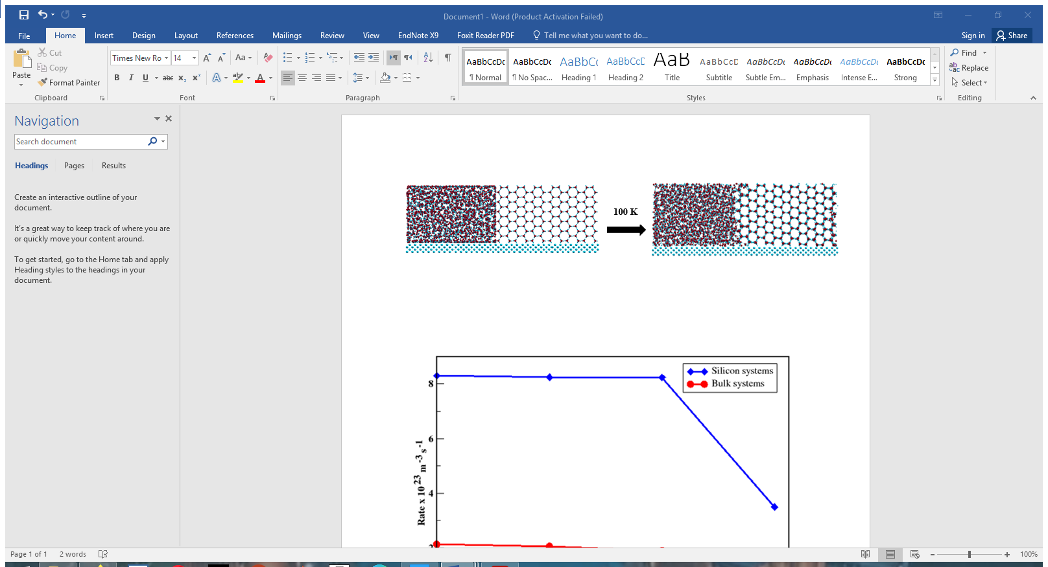
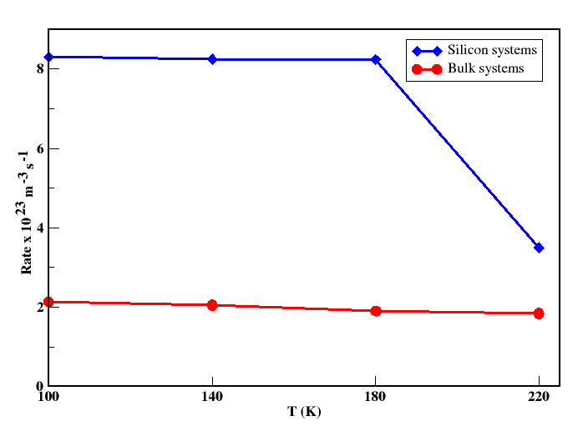
The figure above reveals the effect of silicon substrate on ice formation at low temperatures. As temperature decreased in the presence of silicon, the critical nucleus was formed faster. Two different behaviors were detected between 100K and 220K. The first behavior was found to exist from 100K to 180K were stable amorphous ice was formed. The second behavior started above 180K. The rate of ice formation was faster in the range of 100K and 180K than that at 220K. the rate of ice formation mainly depended on the number of water molecules transformed into ice. When this number increased, the ice formation progressed faster.

