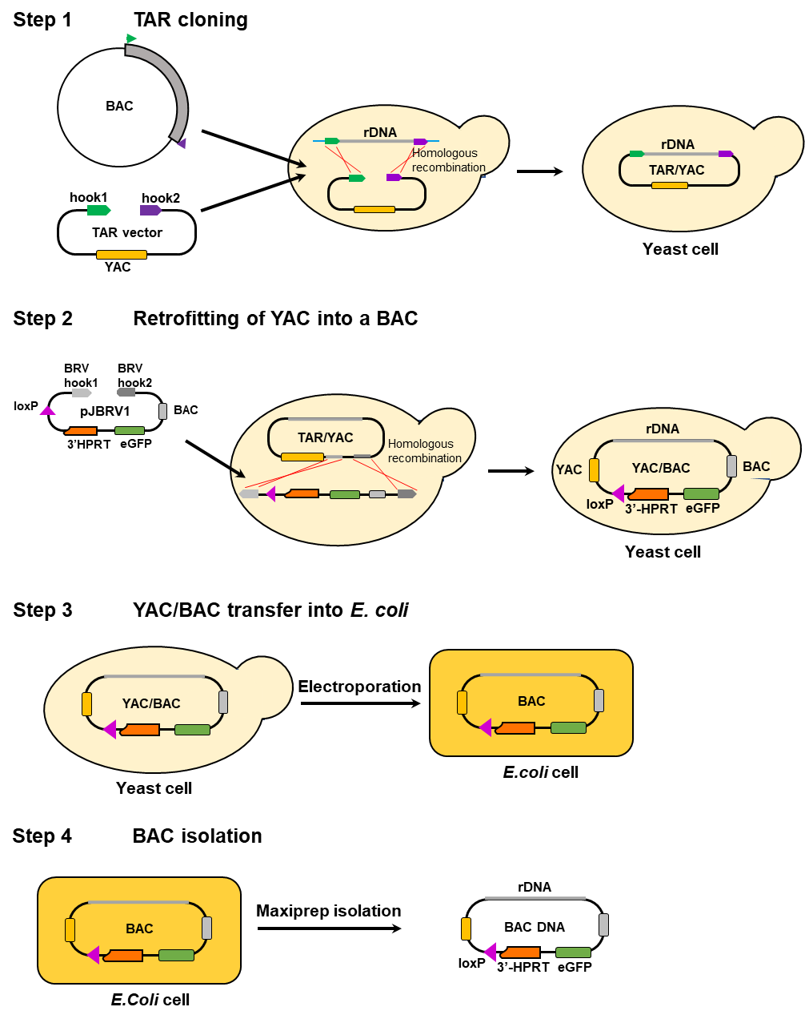
Figure S1 Scheme of consecutive experimental steps from selective TAR isolation of the rDNA-containing regions of interest and distal and proximal junction (DJ and PJ) sequences in yeast S. cerevisiae in a YAC form to isolation of TAR clones in a BAC form from E. coli cells. Step 1: TAR isolation of either the complete rDNA unit, its transcribed part (45S), non-transcribed part (IGS) or the DJ sequence from RP11-337M7 BAC DNA (Ac. No. AL592188) or the PJ sequence from JH42 BAC DNA (Ac. No. MT497460) with the TAR vectors. Each TAR vector contains two targeting sequences (hook1 in green and hook2 in purple), a YAC cassette [a yeast centromeric locus (CEN) and a yeast selectable marker HIS3]. Before TAR cloning, TAR vectors are linearized between the hooks to make them highly recombinogenic. Homologous recombination between the targeting hooks in a TAR vector and the targeted sequences in a BAC DNA leads to the rescue of a region of interest as a circular TAR/YAC molecule. Step 2: Retrofitting of the circular TAR/YAC molecules into BAC molecules using the pJBRV1 vector containing a 3′ HPRT-loxP-eGFP cassette. BamHI digestion of pJBRV1 expose BRV-hook 1 and BRV-hook2 sequences that have homology to the YAC cassette in the TAR/YAC molecules. Recombination of the hook sequences with a TAR/YAC molecule in yeast leads to replacement of the ColE1 origin of replication by the F′ factor origin of replication (a BAC cassette), allowing subsequent YAC/BAC propagation in a BAC form. Step 3: Transfer of YAC/BAC molecules from yeast to E. coli cells by electroporation. Step 4: BAC DNA isolation.

Figure S2 Construction of TAR4 vector (A) used to clone the PJ sequence and TAR5 vector (B) used to isolate the DJ sequence. The vectors were prepared by PCR amplification reaction (Gibson et al 2008) using the corresponding primer pairs as illustrated (42FseI-604F/42-604R and 337PacI-604R/337BsiWI-604F) (Supplementary Table S1). 42FseI-604F/42-604R primers contain hook4 and hook5 (in green and in purple). 337PacI-604R/337BsiWI-604F primers contain hook6 and hook7 (in green). Each primer has a 20 bp sequence homologous to the pVC604 vector (in brown). After PCR reaction, linear TAR4 and TAR5 vectors with the exposed targeting sequences (hooks) are developed. The linear TAR vectors, after gel purification, were used in TAR cloning experiments.

Figure S3 TAR constructs and their physical characterization. (A) TAR1 (rDNA) construct was isolated by TAR1 vector containing hook1 and hook3. TAR2 (45S) construct was isolated by TAR2 vector containing hook1 and hook2. TAR3 (IGS) construct was isolated by TAR3 vector containing hook2 and hook3. TAR4 (PJ) construct was isolated by TAR4 vector containing hook4 and hook5. TAR5 (DJ) construct was isolated by TAR 5 vector containing hook6 and hook7. The IGS-D construct was obtained by deletion of the 3’ end of the IGS sequence (this part includes pre-promoter sequences involved in regulation of rRNA transcription). (B) Schemes of TAR/BAC constructs. TAR1 construct contains the entire rDNA unit (rDNA). TAR2 construct contains the transcribed part of the rDNA unit (45S). TAR3 construct contains the IGS sequence. TAR4 construct contains the PJ sequence. TAR5 construct contains the DJ sequence. The IGS-Δ construct contains the 3’-end of the IGS sequence. Each construct has YAC and BAC cassettes. A YAC cassette includes a yeast centromeric locus CEN6 and a yeast selectable marker HIS3. A BAC cassette includes the F′ factor origin of replication. Each construct has a 3′ HPRT-loxP-GFP sequence consisting of the mammalian color marker GFP, a loxP loading site and a 3’-part of the HPRT gene, the kanamycin resistant gene Kan^{R} encoding a phosphotransferase and a yeast selectable marker URA3. (C) PCR analysis of BAC DNA of different constructs. PCR analysis of the TAR1 construct with a set of diagnostic primer pairs for 18S, 5.8S, 28S and IGS (lanes 1-16) (Table S1). PCR analysis of the TAR2 construct with a set of diagnostic primer pairs for 18S, 5.8S and 28S (lanes 1-11) (Table S1). PCR analysis of the TAR3 construct with a set of diagnostic primer pairs for the IGS sequence (lanes 12-16) (Table S1). PCR analysis of the IGS-D construct with a set of diagnostic primers for the IGS sequence (lanes 12, 13, 14) (Table S1). PCR analysis of the TAR4 construct with a set of diagnostic primers for the left and right junctions and the internal part of the PJ sequence (lanes 1, 2, 3). PCR analysis of the TAR5 construct with a set of diagnostic primers for the left and right junctions and the internal part of the DJ sequence (lanes 4, 5, 6). M - Quick-Load 1 kb Plus DNA Ladder (New England BioLabs). (D) CHEF analysis of BAC DNA of the TAR1, TAR2, TAR3, TAR4, TAR5 and IGS-D constructs. BAC DNA of the TAR1, TAR2 and TAR3 constructs was linearized by I-SceI. BAC DNA of TAR4 and TAR5 constructs was digested by NotI. BAC DNA of the IGS-D construct was digested by EcoRV. M – a marker [CHEF DNA Size Lambda Ladder (BIO-RAD)].

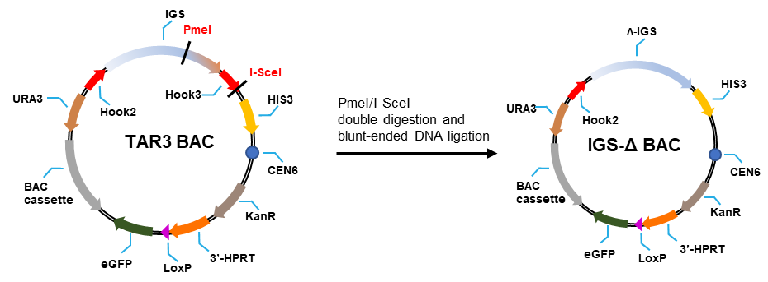

Figure S4 The construct IGS-Δ was obtained by ligation of the PmeI/I-SceI digested TAR3 BAC construct (IGS). The IGS-Δ construct contains a 18,971 bp fragment corresponding to the IGS sequence deleted by 9,630 bp at the 3’ end of IGS. The basic part of the TAR3 BAC and IGS-Δ BAC constructs contain BAC (F’ origin of replication) and YAC [the HIS3 marker and a centromere from the yeast chromosome 6 (CEN6)] cassettes. The constructs also contain the mammalian color eGFP marker, a loxP loading site and the 3’-part of the HPRT gene.

Figure S5 Scheme of consecutive experimental steps from TAR constructs insertion into the alphoid^{tetO}-HAC vector in hamster CHO cells to further HACs transfer to human HT1080 cells. (A) The BAC DNA constructs were loaded into a unique loxP site of the alphoid^{tetO}-HAC by Cre-loxP recombination system in hamster CHO cells. The alphoid^{tetO}-HACs carrying different constructs were MMCT transferred from CHO cells into human HT1080 cells. (B) Loading of the constructs into the loxP site of the HAC is accompanied by reconstruction of the HPRT gene allowing cell selection on the HAT medium. PCR analysis of the clones after insertion of TAR1 BAC (16 clones), TAR2 BAC (16 clones), TAR3 BAC, (8 clones), TAR4 BAC (8 clones), TAR5 BAC (8 clones) and IGS-BAC (12 clones) constructs into the loxP site. PCR products were sequenced to confirm reconstitution of the HPRT gene. Clones picked up for further analysis are marked in red. (C-E) PCR analysis of different constructs in hamster CHO cells. (C) PCR analysis of the TAR1 construct (clone 10) with a set of diagnostic primer pairs for 18S, 5.8S, 28S and IGS (lanes 1-16) (Table S1). PCR analysis of the TAR2 construct (clone 10) with a set of diagnostic primer pairs for 18S, 5.8S and 28S (lanes 1-11) (Table S1). PCR analysis of the TAR3 construct (clone 2) with a set of diagnostic primer pairs for the IGS sequence (lanes 12-16) (Table S1). PCR analysis of the IGS-Δ construct (clone 1) with a set of diagnostic primers for the IGS sequence (lanes 12, 13, 14) (Table S1). (D) PCR analysis of the TAR4 construct (clone 2) with a set of diagnostic primers for the left and right junctions and the internal part of the PJ sequence (lanes 1, 2, 3) (Table S1). (E) PCR analysis of the TAR5 construct (clone 1) with a set of diagnostic primers for the left and right junctions and the internal part of the DJ sequence (lanes 1, 2, 3) (Table S1). (F) PCR analysis of the HACs carrying different constructs with HPRT diagnostic primers (Table S1) after MMCT transfer of HACs from hamster CHO cells to human HT1080 cells. M - Quick-Load 1 kb Plus DNA Ladder (New England BioLabs).

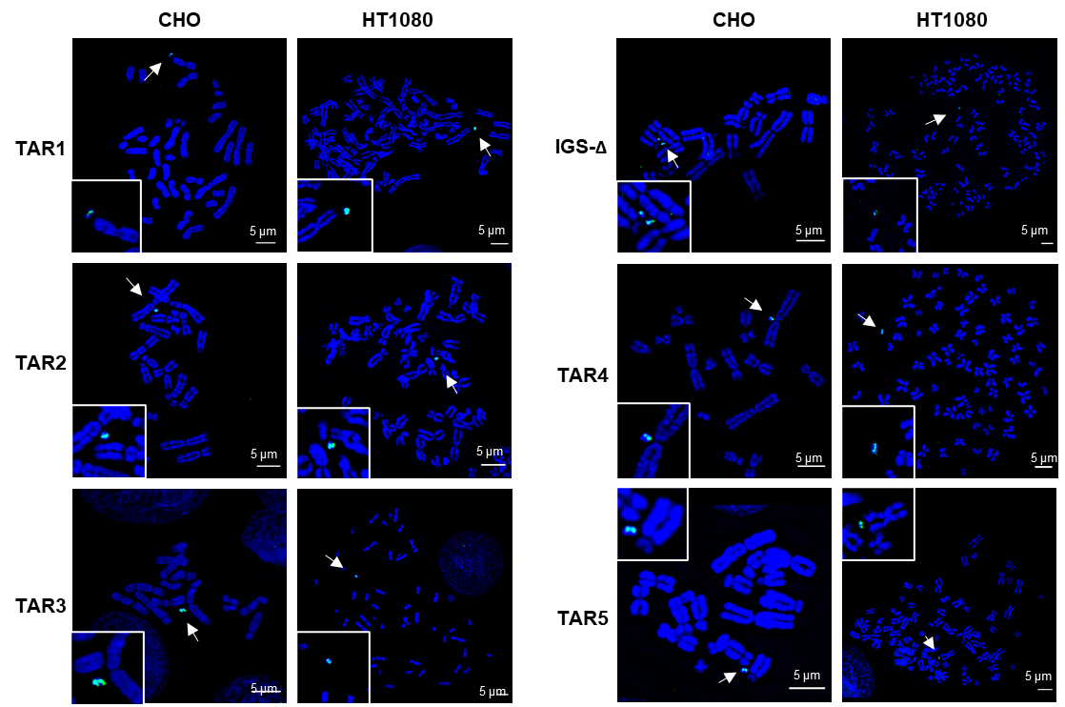

Figure S6 FISH analysis of the alphoid^{tetO}-HAC carrying different constructs in hamster CHO and human HT1080 cells using a specific probe for the HAC vector (in green, indicated with a white arrow) (see Materials and methods). TAR1 construct – the entire rDNA unit (rDNA). TAR2 construct – the transcribed part of the rDNA unit (45S). TAR3 construct – the IGS sequence. IGS-Δ construct – the 3’-end of the IGS sequence. TAR4 construct – the PJ sequence. TAR5 construct – the DJ sequence.

.

Figure S7 rDNA transcription in human/mouse hybrid cell lines A9(#13) 89-2 (chr13), A9 hygro14 10F (chr14), A9(Neo15)-3 (chr15), A9 #21-16 (chr21), A9#22(γ2) (chr22γ2) and A9HyTK-22 (chr22TK) containing human chromosomes 13, 14, 15, 21 and 22. Human ribosomal genes are transcriptionally silent in hybrid cell lines. Total RNA samples from human/mouse monochromosomal hybrid cells and human RPE cells were used in RP-qPCR with human-specific primers for 45S rRNA and GAPDH primers specific for both mouse and human. rRNA relative expression in A9(#13) 89-2 (chr13) cell line is equal to one.

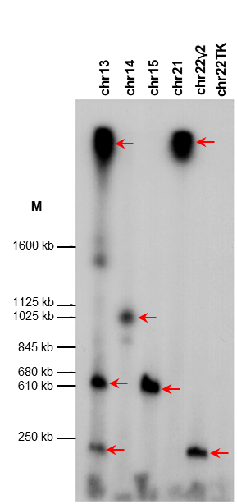

Figure S8 Southern blot analysis of six human/mouse hybrid cell lines A9(#13) 89-2 (chr13), A9 hygro14 10F (chr14), A9(Neo15)-3 (chr15), A9 #21-16 (chr21), A9#22(γ2) (chr22γ2) and A9HyTK-22 (chr22TK) containing human chromosomes 13, 14, 15, 21, and 22. Genomic DNA possessing one of the acrocentric chromosomes was isolated from each hybrid cell line, digested by EcoRV and separated by CHEF gel electrophoresis with range 250 kb-2.5 Mb. The rDNA repeats were detected with a radioactively labeled probe specific to the rDNA intergenic spacer (IGS) (see Materials and Methods). M - CHEF DNA Size Marker, 0.2–2.2 Mb, S. cerevisiae Ladder (Bio-Rad, cat. no. 1703605).

Figure S9 Expression of lentiviral vectors encoding TAF1A, TAF1B, TAF1C, and TAF1D. (A-D) Schemes of four pLVTHM vectors carrying TAF1A, TAF1B, TAF1C, and TAF1D transcription factors. (E) RT-PCR confirming expression of TAF1A, TAF1B, TAF1C, and TAF1D after infection of A9#13 89-2 cells by the lentiviral vectors.

Figure S10 Consensus folding for multiple alignment of the 5’end of predicted LncRNA NR_038958 in four primate species.

Figure S11 Expression of LncRNA NR_038958. (A) Schematic location of LncRNA NR_038958 and its exons. Black half-arrows indicate primers positions (see Table S1). Primers were designed to detect processed LncRNA NR_038958. Otherwise, RT-PCR product will be unidentifiable from DNA contamination. (B) The result of RT-PCR indicating expression of LncRNA NR_038958 in human cancer HT1080 cells and absence of expression in the human/mouse monochromosomal hybrid A9#13 89-2.

Figure S12 (A) TF sites identified near the 6-8 kb sequence. (B) Conserved sequences enriched with potential sites for protein binding between a 32 kb-50 kb region.

Table S1 List of primers used in this work

______________________________________________________________________________
Primers for hook amplification
______________________________________________________________________________
TAR vector 1 (rDNA unit plus 7.5 kb DJ)
______________________________________________________________________________
Hook 1
3 5' hook rDNA-BamHI-F1 5’-ATGCAGGATCCAAAATCATGAACCGCTCACC-3’
38 5' hook rDNA-SalI-R1 5’-TCGTAGTCGACCTGGAGGCACAATAGCTCAC-3’

Hook 3
39 3' hook rDNA-SalI-F1 5’-ATGCAGTCGACGGTCCCTCTGCCGCGATCCTT-3’
117 3' hook rDNA-I-SceI-XhoI-R1 5’-TCGTACTCGAGATTACCCTGTTATCCCTACCCCTCCTACGACCGGGACAC-3’
______________________________________________________________________________
TAR vector 2 (external transcribed spacer ETS plus 7.5 kb DJ)
______________________________________________________________________________
Hook 1
37 5' hook rDNA-BamHI-F1 5’-ATGCAGGATCCAAAATCATGAACCGCTCACC-3’
38 5' hook rDNA-SalI-R1 5’-TCGTAGTCGACCTGGAGGCACAATAGCTCAC-3’

Hook 2
41 3' hook rDNA TU-SalI-F1 5’-ATGCAGTCGACAAAACTATGTAAATGATATTTCC-3’
118 3' hook rDNA TU-I-SceI-XhoI-R1 5’-TCGTACTCGAGATTACCCTGTTATCCCTACACGTGTATGTAAATGAAATGGG-3’
______________________________________________________________________________
TAR vector 3 (intergenic spacer IGS)
______________________________________________________________________________
Hook 2
43 5' hook rDNA SP-BamHI-F1 5’-ATGCAGGATCCAAAACTATGTAAATGATATTTCC-3’
44 5' hook rDNA SP-SalI-R1 5’-TCGTAGTCGACCACGTGTATGTAAATGAAATGGG-3’

Hook 3
39 3' hook rDNA-SalI-F1 5’-ATGCAGTCGACGGTCCCTCTGCCGCGATCCTT-3’
117 3' hook rDNA-I-SceI-XhoI-R1 5’-TCGTACTCGAGATTACCCTGTTATCCCTACCCCTCCTACGACCGGGACAC-3’
______________________________________________________________________________
Detection primers
______________________________________________________________________________
TAR vector 1 (rDNA unit plus 7.5 kb DJ)
______________________________________________________________________________
5’ junction of vector with insert
M13-F 5’-TGTAAAACGACGGCCAGT-3’
48 5' hook rDNA seq-R1 5’-GCCTCTAAGCGAGACTCCA-3’

3’ junction of vector with insert
92 3' hook rDNA seq-F2 5’-CGATCCTTTCTGGCGAGTCC-3’
M13-R 5’-CAGGAAACAGCTATGACC-3’
TAR vector 2 (external transcribed spacer ETS plus 7.5 kb DJ)
______________________________________________________________________________
5’ junction of vector with insert
M13-F 5’-TGTAAAACGACGGCCAGT-3’
48 5' hook rDNA seq-R1 5’-GCCTCTAAGCGAGACTCCA-3’

3’junction of vector with insert
52 3' hook rDNA TU seq-F1 5’-ATCTTATTTTCTGAACGCTGCC-3’
M13-R 5’-CAGGAAACAGCTATGACC-3’
______________________________________________________________________________
TAR vector 3 (intergenic spacer IGS)
______________________________________________________________________________
5’junction of vector with insert
M13-F 5’-TGTAAAACGACGGCCAGT-3’
55 5' hook
3’ junction vector with insert
92 3' hook rDNA seq-F2 5’-CGATCCTTTCTGGCGAGTCC-3’
M13-R 5’-CAGGAAACAGCTATGACC-3’
______________________________________________________________________________
Primers for rDNA unit
______________________________________________________________________________
18S

rDNA 105734-1F 5’-TGTCAGGCGTTCTCGTCTC-3’
rDNA 105734-1R 5’-GACGTCACCACATCGATCAC-3’

rDNA 106285-2F 5’-GAACGGTGGTGTGTCGTTC-3’
rDNA 106285-2R 5’-GCGTCTCGTCTCGTCTCAC-3’

rDNA 109524-4F 5’-AAACGGCTACCACATCCAAG-3’
rDNA 109524-4R 5’-CCTCCAATGGATCCTCGTTA-3’
______________________________________________________________________________
5.8S

rDNA 112056-5F 5’-GTCGATGAAGAACGCAGCTA-3’
rDNA 112056-5R 5’-GACGCTCAGACAGGCGTAG-3’
______________________________________________________________________________
28S

rDNA 113431-6F 5’-AGTAACGGCGAGTGAACAGG-3’
rDNA 113431-6R 5’-GCCTCGATCAGAAGGACTTG-3’

rDNA 113678-7F 5’-GCTAAATACCGGCACGAGAC-3’
rDNA 113678 -7R 5’-TTCACGCCCTCTTGAACTCT-3’

rDNA 115727-8F 5’-GAACTTTGAAGGCCGAAGTG-3’
rDNA 115727-8R 5’-ATCTGAACCCGACTCCCTTT-3’

rDNA 117701-9F 5’-TGGGTTTTAAGCAGGAGGTG-3’
rDNA 117701-9R 5’-GACGGTCTAAACCCAGCTCA-3’

rDNA 118316-10F 5’-CCATTCGTAGACGACCTGCT-3’
rDNA 118316-10R 5’-CTTGTGTCGAGGGCTGACTT-3’
_____________________________________________________________________________
IGS (spacer)

rDNA 119957-11F 5’-CGGAACTCCCTCTCCTACATT-3’
rDNA 119957-11R 5’-AAGAAAACGCAAGGCAAAA-3’

rDNA 126263-11F 5’-GTGTTCCCGTGAGGAGTGAT-3’
rDNA 126263-11R 5’-ACAGAGAGAAGGCCCTAGCC-3’

rDNA 126263-12F 5’-GTGTTCCCGTGAGGAGTGAT-3’
rDNA 126263-12R 5’-ACAGAGAGAAGGCCCTAGCC-3’

rDNA 134304 -13F 5’-CACCTAGCGGCCACTGTTAT-3’
rDNA 134304-13R 5’-AGTAAAGCGCCGATCAAAGA-3’

rDNA 138700-14F 5’-GAATGCGACTCCTGCAAAAT-3’
rDNA 138700-14R 5’-TTCCCAAGTCTGGTTGATCC-3’

rDNA 142197-15F 5’-GGGAGTCCGAGACAGAATGA-3’
rDNA 142197-15R 5’-AGCTCCTGTGGTTTCAGGTG-3’

rDNA 144016-15F 5’-AGGAGTCCCCTGGTCTGTCT-3’
rDNA 144016-15R 5’-GTCAAGGTCCAAACCGAAAA-3’ ______________________________________________________________________________
Primers for construction of TAR4 and TAR5 vectors by PCR
______________________________________________________________________________
TAR vector 4 (PJ) (low case letters-Hook4 and Hook5; capital case letters – vector part)
______________________________________________________________________________
42FseI-604F 5’-gttggcgcagagcggcgcggcggagacagcggcgacgggaatccggccggGCAAGGCGATTAAGTTGGG-3’
42-604R 5’-ctcaccttcccctcatggaccttctgactttctgcacctgctccggcgctACATCCCCCCTTCGCCAGC-3’
______________________________________________________________________________
TAR vector 5 (DJ) (low case letters-Hook6 and Hook7 capital case letters – vector part)
______________________________________________________________________________
337PacI-604R 5’-atttggctcttgtaatttgcagtggaaagcttatatgagtatctaactctaaaccaattaACATCCCCCCTTCGCCAGC-3’
337BsiWI-604F 5’-actcagggtgtttggggtcttctggggaaatgttctgaaacaatggagtattttggtctgGCAAGGCGATTAAGTTGGG-3’
______________________________________________________________________________
Detection primers
______________________________________________________________________________
TAR vector 4 (PJ)
5’ junction of vector with insert
RCO-504F 5’-GATTTAGAGCTTGACGGGGA-3’
42-detR 5’-TCACCTCTCCTCCCACAAACT-3’

3’ junction of vector with insert
RCO-502R 5’-TGGAGCTCCAATTCGCCCT-3’
42-detF 5’-CCACCTAACTGGCTCCCAAAC-3’

Internal
42-det IN F 5’-TCCTGAGGAAGCCTCTTTATTG-3’
42-det IN R 5’-CCAACCTCACATGGTCTGAA-3’
______________________________________________________________________________
TAR vector 5 (DJ)
______________________________________________________________________________
5’ junction of vector with insert
337 det-PacI-R 5’-GCACCACAAGCAGCAGTCATA-3’
RCO-504F 5’-GATTTAGAGCTTGACGGGGA-3’

3’ junction of vector with insert
337-det-BsiWI-F 5’-CTTTCATCACCACCACCGAAGA-3’
RCO-502R 5’-TGGAGCTCCAATTCGCCCT-3’

Internal
337-det IN F 5’-CCAGTGCAGAACCCATCTATT-3’
337-det IN R 5’-CCTGAGAAGTCTGTGTGTGTATG-3’
______________________________________________________________________________
Primers for human rDNA copy numbers
______________________________________________________________________________
Human IGS
rDNA 134304 -13F 5’-CACCTAGCGGCCACTGTTAT-3’
rDNA 134304-13R 5’-AGTAAAGCGCCGATCAAAGA-3’

rDNA 142197-15F 5’-GGGAGTCCGAGACAGAATGA-3’
rDNA 142197-15R 5’-AGCTCCTGTGGTTTCAGGTG-3’

Mouse single copy
Mouse Chr5 F 5’-GATCTGGCTTTCCGGCTATT-3’
Mouse Chr5 R 5’-CCCTATTTGTGTGGCCTCTT-3’
Primers for human rRNA transcription
______________________________________________________________________________
Human 45S rRNA
h45S-F 5’-CCGCGCTCTACCTTACCTACCT-3’
h45S-R 5’-GCATGGCTTAATCTTTGAGACAAG -3’

Human/Mouse GAPDH
GAPDH-F 5’-CCATCTTCCAGGAGGGAGA-3’
GAPDH-R 5’-GGCAGTGATGGCATGGACTGT -3’
______________________________________________________________________________
Primers for Southern analysis
______________________________________________________________________________
FOR-F 5’-GGGAGTCCGAGACAGAATGA-3’
REV-R 5’-AGCTCCTGTGGTTTCAGGTG-3’
______________________________________________________________________________
Primers for HPRT gene reconstruction
_____________________________________________________________________________
Lox137-R 5’-AGCCTTCTGTACACATTTCTTCTC-3’
Rev #6 5’-GCTCTACTAAGCAGATGGCCACAGAACTAG-3’
SV40 PA term rev 5’-AATGGTTACAAATAAAGCAATAGCATCAC-3’
______________________________________________________________________________
Primers for lentiviral vectors construction
______________________________________________________________________________
AscI_TAF1A 5’-TATGCAGGCGCGCCAATGAGTGATTTCAGTGAAGAATTAAAAGGGC-3’
SpeI_TAF1A 5’-TATGCAGGACTAGTTCAGAGTCTTGGATTTACAATACTGTATTTT-3’
AscI_TAF1B 5’-TATGCAGGCGCGCCAATGGACCTCGAGGAGGCGGAA-3’
SpeI_TAF1B 5’-TATGCAGGACTAGTTCAATGTCGTCTCACTTTCTTGGATCTTG-3’
AscI_TAF1C 5’-TATGCAGGCGCGCCAATGGACTTCCCCAGCTCCCTCCG-3’
SpeI_TAF1C 5’-TATGCAGGACTAGTTCAGAAGCCCATTCGAGGCTTCTTCC-3’
AscI_TAF1D 5’-TATGCAGGCGCGCCAATGGATAAATCAGGAATAGATTCTCTTGACC-3’
SpeI_TAF1D 5’-TATGCAGGACTAGTTCACATTTTCAGGCCTCTCTGTCCAGTA-3’
______________________________________________________________________________
Primers for RT-PCR
______________________________________________________________________________
rt-WRRE-R1 5’-GCCATACGGGAAGCAATAGCA-3’
TAF1A-F1 5’-AAACTGGTGGCCAGGCTTTC-3’
TAF1B-F1 5’-ACACATGTGACAACCTATGAAGAA-3’
TAF1C-F1 5’-TGCTCCGTGACTACATGGC-3’
TAF1D-F1 5’-GCAGAGGATGAGGATGCAACA-3’
NR_038958_F1 5’-TTGGGGCACACAGATGAGAC-3’
NR_038958_R1 5’-AATGGAGAGAAGCCCAAGGC-3’
______________________________________________________________________________

Table S2 Number of human rDNA copies in human/mouse monochromosomal hybrid cells determined by qPCR

Cell line | rDNA copy number | 95% CI
A9(#13) 89-2 (chr13) | 78 | 48-108
A9hygro14 (chr14) | 39 | 26-53
A9(Neo15)-3 (chr15) | 17 | 14-19
A9 #21-16 (chr21) | 43 | 29-57
A9#22 (γ2) (chr22γ2) | 9 | 7-11
A9HyTK-22 (chr22TK) | 2 | 2

Table S3 % of human NORs associated with nucleoli in human/mouse monochromosomal hybrid cells

Cell line | Number of nucleoli with a chromosome colocalized | Number of nucleoli without a chromosome colocalization | Total number of analyzed nucleoli | % of nucleoli with colocalized chromosomes
A9(#13) 89-2 (chr13) | 134 | 183 | 317 | 42%
A9hygro14 (chr14) | 152 | 27 | 179 | 85%
A9(Neo15)-3 (chr15) | 98 | 30 | 128 | 77%
A9 #21-16 (chr21) | 130 | 154 | 284 | 46%
A9#22(γ2) (chr22γ2) | 58 | 85 | 143 | 41%
A9HyTK-22 (chr22TK) | 42 | 99 | 141 | 30%

Table S4 % of human NORs associated with nucleoli in human/mouse monochromosomal hybrid cells A9(#13) 89-2 (chr13) after reactivation of rDNA transcription

Cell line |  | Number of nucleoli with a chromosome colocalized | Number of nucleoli without a chromosome colocalization | Total number of analyzed nucleoli | % of nucleoli with colocalized chromosomes
A9(#13) 89-2 (chr13) | Exp. 1 | 36 | 50 | 86 | 40
 | Exp. 2 | 66 | 82 | 148 | 44
 | Exp. 3 | 42 | 55 | 97 | 43
 | Total | 144 | 187 | 331 | 42
A9(#13) 89-2 (chr13) + pLVTHM TAFs | Exp. 1 | 93 | 54 | 147 | 63
 | Exp. 2 | 76 | 60 | 136 | 55
 | Exp. 3 | 73 | 49 | 122 | 59
 | Total | 242 | 163 | 405 | 59

Table S5 % of HACs associated with nucleoli in human HT1080 cells

Construct  name | Number of nucleoli with colocalized HAC | Number of nucleoli without HAC colocalization | Total number of analyzed nucleoli | % of nucleoli with colocalized HAC | P value
TAR1 (rDNA) | 201 | 90 | 291 | 69% | < 0.0001
TAR2 (45S) | 174 | 105 | 279 | 62% | < 0.0001
TAR3 (IGS) | 224 | 141 | 365 | 61% | < 0.0001
IGS-Δ | 68 | 98 | 166 | 41% | 0.9268
TAR4 (PJ) | 139 | 178 | 317 | 44% | 0.554
TAR5 (DJ) | 253 | 103 | 356 | 71% | < 0.0001
GFP | 189 | 266 | 455 | 42%

Table S6 % of HACs associated with nucleoli in dox+ and dox-media

Conditions | Number of nucleoli with a  colocalized HAC | Number of nucleoli without a HAC colocalization | Total number of analyzed nucleoli | % of nucleoli with a colocalized HAC
HAC/GFP (dox+) | 173 | 200 | 373 | 46
HAC/GFP (dox-) | 162 | 197 | 359 | 45
HAC/GFP+ tetR-tTA^{VP64} (dox+) | 154 | 177 | 331 | 47
HAC/GFP+ tetR-tTA^{VP64} (dox-) | 107 | 206 | 313 | 34
HAC/rDNA (dox+) | 185 | 88 | 273 | 68
HAC/rDNA (dox-) | 208 | 92 | 300 | 69
HAC/rDNA+ tetR-tTA^{VP64} (dox+) | 229 | 99 | 328 | 70
HAC/rDNA+ tetR-tTA^{VP64} (dox-) | 155 | 169 | 324 | 48

Table S7 % of HAC localized on the nucleoli periphery versus nucleoli stroma in dox+ and dox-media

Conditions | Number of HACs localized on nucleoli periphery | Number of HACs localized on nucleoli stroma | Total number of analyzed nucleoli | % of nucleoli with HACs localized on nucleoli periphery
HAC/GFP+ tetR-tTA^{VP64} (dox+) | 180 | 40 | 220 | 82
HAC/GFP+ tetR-tTA^{VP64} (dox-) | 162 | 31 | 193 | 84
HAC/rDNA+ tetR-tTA^{VP64} (dox+) | 147 | 28 | 175 | 84
HAC/rDNA+ tetR-tTA^{VP64} (dox-) | 177 | 44 | 221 | 80

Table S8
(fttp://ncbi.nlm.nih.gov/pub/shabalin/DJ_Region/Supplementary Table S8).

Table S9 A list of conserved between human and chimpanzee and experimentally validated TF sites in the 92.5-94.5 kb region

Stable ID: ENSM00000419675
Location: GL000220.1:93039-93055
Binding matrix: ENSPFM0042
Transcription factors CTCF
Experimentally verified in Hu. Fe., A549, GM12878, K562, SK-N., MCF-7, keratinocyte, bipolar neuron, cardiac muscle, HepG2, MM.1S, IMR-90, H1-hESC_3, hepatocyte, A673, transverse colon, astrocyte spinal cord, foreskin fibroblast_1

Stable ID: ENSM00197656300
Location: GL000220.1:93502-93515
Binding matrix: ENSPFM0085
Transcription factors EBF1
Experimentally verified in GM12878

Stable ID: ENSM00000159588
Location: GL000220.1:93691-93707
Binding matrix: ENSPFM0042
Transcription factors CTCF
Experimentally verified in Hu. Fe., HeLa-S3, A549, pancreas_2, GM12878, K562, SK-N., MCF-7, NHLF, keratinocyte, bipolar neuron, cardiac muscle, B, HepG2, MM.1S, IMR-90, PC-9, CD14+ monocyte_1, HUVEC, H1-hESC_3, osteoblast, HSMM, PC-3, HCT116, hepatocyte, A673, mammary epithelial_1, myotube, astrocyte, dermal fibroblast, transverse colon, astrocyte cerebellum, DND-41, astrocyte spinal cord, foreskin fibroblast_1

Stable ID: ENSM01052209394
Location: GL000220.1:93723-93736
Binding matrix: ENSPFM0487
Transcription factors: RXRG, RXRA, RORB
Experimentally verified in HepG

Stable ID: ENSM00524452267
Location: GL000220.1:93747-93758
Binding matrix: ENSPFM0427
Transcription factors NRF1
Experimentally verified in K562, HepG2

Stable ID: ENSM01051890022
Location: GL000220.1:93747-93760
Binding matrix: ENSPFM0086
Transcription factors EGR1, EGR2, EGR4, EGR3
Experimentally verified in K562

Stable ID: ENSM00100257483
Location: GL000220.1:93817-93827
Binding matrix: ENSPFM0357
Transcription factors KLF14, SP4, KLF16, SP8, SP3, SP1
Experimentally verified in H1-hESC_3

Stable ID: ENSM00040818633
Location: GL000220.1:93879-93889
Binding matrix: ENSPFM0186
Transcription factors FOXB1, FOXC1, FOXA1, FOXC2
Experimentally verified in HepG2

Stable ID: ENSM00523520434
Location: GL000220.1:93882-93893
Binding matrix: ENSPFM0366
Transcription factors MEF2A, MEF2D, MEF2B
Experimentally verified in GM12878

Stable ID: ENSM00096422097
Location: GL000220.1:93900-93911
Binding matrix: ENSPFM0350
Transcription factors IRF2
Experimentally verified in K562

Stable ID: ENSM00145521040
Location: GL000220.1:93919-93932
Binding matrix: ENSPFM0290
Transcription factors HNF4A, RXRG, NR2F6, NR2F1, NR2C2, RXRA, RXRB
Experimentally verified in HepG2

Stable ID: ENSM00524154916
Location: GL000220.1:93931-93941
Binding matrix: ENSPFM0614
Transcription factors YY2, YY1
Experimentally verified in K56

Stable ID: ENSM00206651778
Location: GL000220.1:93984-93998
Binding matrix: ENSPFM0363
Transcription factors MAFF, MAFG, MAFK
Experimentally verified in HeLa-S3, A549, GM12878, K562, HepG2, IMR-90, H1-hESC_3

Stable ID: ENSM00184630099
Location: GL000220.1:94070-94080
Binding matrix: ENSPFM0614
Transcription factors YY2, YY1
Experimentally verified in GM12892, SK-N-SH_RA, GM12878, H1-hESC_3

Stable ID: ENSM00101682473
Location: GL000220.1:94136-94147
Binding matrix: ENSPFM0364
Transcription factors MAFK, NRL
Experimentally verified in HeLa-S3, A549, GM12878, K562, HepG2, IMR-90, H1-hESC_3

Stable ID: ENSM00522999631
Location: GL000220.1:94332-94345
Binding matrix: ENSPFM0392
Transcription factors MYBL1::ELF1
Experimentally verified in K562

Stable ID: ENSM00526279279
Location: GL000220.1:94382-94396
Binding matrix: ENSPFM0191
Transcription factors FOXO1::ELF1, FOXJ2::ELF1, FOXJ3::ELF1
Experimentally verified in K562

Stable ID: ENSM00524689175
Location: GL000220.1:94395-94416
Binding matrix: ENSPFM0305
Transcription factors HOXB2::ELF1
Experimentally verified in K562

Table S10 The most common motifs that were found at the proximal end of the DJ region by the DME-X program

ID DME20
SEQ GGGAGG
FGCOUNT=140
INFO=2.21389
SCORE=13.2833
ID DME28
SEQ AGGCTG
FGCOUNT=129
INFO=2.11006
SCORE=12.6604
ID DME29
SEQ CTGGGA
FGCOUNT=127
INFO=2.11006
SCORE=12.6604
ID DME23
SEQ CAGAGA
FGCOUNT=137
INFO=2.05693
SCORE=12.3416
ID DME3
SEQ AGAAAG
FGCOUNT=291
INFO=1.99122
SCORE=11.9473
ID DME5
SEQ GAAAGA
FGCOUNT=257
INFO=1.99122
SCORE=11.9473
ID DME13
SEQ GAAGAA
FGCOUNT=167
INFO=1.99122
SCORE=11.9473
ID DME15
SEQ AGAGAA
FGCOUNT=164
INFO=1.99122
SCORE=11.9473
ID DME18
SEQ AGAAGA
FGCOUNT=158
INFO=1.99122
SCORE=11.9473
ID DME19
SEQ GAGAAA
FGCOUNT=157
INFO=1.99122
SCORE=11.9473
ID DME22
SEQ AGGAAA
FGCOUNT=143
INFO=1.99122
SCORE=11.9473
ID DME24
SEQ AAGAAG
FGCOUNT=139
INFO=1.99122
SCORE=11.9473
ID DME26
SEQ AAGAGA
FGCOUNT=138
INFO=1.99122
SCORE=11.9473
ID DME14
SEQ CAGAAA
FGCOUNT=167
INFO=1.98271
SCORE=11.8963
ID DME21
SEQ ACAGAA
FGCOUNT=146
INFO=1.98271
SCORE=11.8963
ID DME25
SEQ AAACAG
FGCOUNT=139
INFO=1.98271
SCORE=11.8963
ID DME27
SEQ AAGCAA
FGCOUNT=138
INFO=1.98271
SCORE=11.8963
ID DME30
SEQ TGGAAA
FGCOUNT=135
INFO=1.97012
SCORE=11.8207
ID DME1
SEQ AAGAAA
FGCOUNT=427
INFO=1.91699
SCORE=11.502
ID DME2
SEQ AAAGAA
FGCOUNT=390
INFO=1.91699
SCORE=11.502

