Supplemental Table S1: P-values from pairwise PERMANOVA of leaf samples at T1 testing the effects of destination site at particular destination sites. All values are fdr-correct and bold values are significant at 0.05 after a correction.
 | from CC | from DB | from MM | from WP
CC and DB | 0.0018 | 0.0018 | NA | NA
CC and MM | 0.0018 | 0.0018 | NA | NA
CC and WP | 0.0018 | 0.0018 | NA | NA
DB and MM | 0.0018 | 0.0018 | 0.0018 | 0.0245
DB and WP | 0.0018 | 0.0018 | 0.0018 | 0.0018
MM and WP | 0.0018 | 0.0018 | 0.026 | 0.0267

Supplemental Table S2: R² from pairwise PERMANOVA of leaf samples at T1 testing the effects of destination site at particular origin sites. Bold values were significant after fdr-correction (see Supplemental Table S1A for p-values)
 | from CC | from DB | from MM | from WP
CC and DB | 0.607 | 0.452 | NA | NA
CC and MM | 0.521 | 0.406 | NA | NA
CC and WP | 0.339 | 0.215 | NA | NA
DB and MM | 0.214 | 0.231 | 0.278 | 0.123
DB and WP | 0.484 | 0.334 | 0.201 | 0.348
MM and WP | 0.416 | 0.31 | 0.174 | 0.139

Supplemental Table S3: P-values from pairwise PERMANOVA of leaf samples at T1 testing the effects of origin site at particular destination sites. All values are fdr-correct and bold values are significant at 0.05 after a correction.
 | to CC | to DB | to MM | to WP
CC and DB | 0.0944 | 0.1356 | 0.4216 | 0.3628
CC and MM | NA | 0.0035 | 0.026 | 0.0519
CC and WP | NA | 0.2027 | 0.0829 | 0.2493
DB and MM | NA | 0.0068 | 0.0546 | 0.0931
DB and WP | NA | 0.856 | 0.0735 | 0.1003
MM and WP | NA | 0.22 | 0.0787 | 0.0768

Supplemental Table S4: R² from pairwise PERMANOVA of leaf samples at T1 testing the effects of origin site at particular destination sites. Bold values were significant after fdr-correction (see Supplemental Table S1A for p-values)
 | to CC | to DB | to MM | to WP
CC and DB | 0.083 | 0.067 | 0.051 | 0.06
CC and MM | NA | 0.131 | 0.097 | 0.163
CC and WP | NA | 0.07 | 0.102 | 0.066
DB and MM | NA | 0.098 | 0.137 | 0.122
DB and WP | NA | 0.038 | 0.129 | 0.078
MM and WP | NA | 0.067 | 0.107 | 0.139

Supplemental Table S5: P-values from pairwise PERMANOVA of root samples at T1 testing the effects of destination site at particular origin sites. All values are fdr-correct and bold values are significant at 0.05 after a correction.
 | from CC | from DB | from MM | from WP
CC and DB | 0.0027 | 0.0027 | 0.0094 | 0.006
CC and MM | 0.0027 | 0.0027 | 0.0027 | 0.0027
CC and WP | 0.006 | 0.006 | 0.0048 | 0.0162
DB and MM | 0.0027 | 0.0027 | 0.0048 | 0.0103
DB and WP | 0.0048 | 0.0027 | 0.0103 | 0.0027
MM and WP | 0.0027 | 0.0103 | 0.0027 | 0.0027

Supplemental Table S6: R² from pairwise PERMANOVA of root samples at T1 testing the effects of destination site at particular origin sites. Bold values were significant after fdr-correction (see Supplemental Table S3A for p-values)
 | from CC | from DB | from MM | from WP
CC and DB | 0.287 | 0.208 | 0.175 | 0.254
CC and MM | 0.42 | 0.295 | 0.43 | 0.376
CC and WP | 0.187 | 0.172 | 0.135 | 0.137
DB and MM | 0.352 | 0.26 | 0.291 | 0.218
DB and WP | 0.213 | 0.195 | 0.188 | 0.282
MM and WP | 0.213 | 0.173 | 0.418 | 0.375

Supplemental Table S7: P-values from pairwise PERMANOVA of root samples at T1 testing the effects of origin site at particular destination sites. All values are fdr-correct and bold values are significant at 0.05 after a correction.
 | to CC | to DB | to MM | to WP
CC and DB | 0.4189 | 0.3727 | 0.5369 | 0.456
CC and MM | 0.0747 | 0.2437 | 0.0385 | 0.1404
CC and WP | 0.0189 | 0.3826 | 0.2808 | 0.042
DB and MM | 0.046 | 0.759 | 0.046 | 0.2175
DB and WP | 0.0518 | 0.6071 | 0.3353 | 0.015
MM and WP | 0.4757 | 0.5126 | 0.0077 | 0.046

* Note: Many of the p-values varied slightly between different permutations of data. We’ve highlighted sets here that were close to significance after correction as their variance allows us to best understand the community patterns.

Supplemental Table S8: R² from pairwise PERMANOVA of root samples at T1 testing the effects of origin site at particular destination sites. Bold values were significant after fdr-correction (see Supplemental Table 4A for p-values)
 | to CC | to DB | to MM | to WP
CC and DB | 0.287 | 0.208 | 0.175 | 0.254
CC and MM | 0.42 | 0.295 | 0.43 | 0.376
CC and WP | 0.187 | 0.172 | 0.135 | 0.137
DB and MM | 0.352 | 0.26 | 0.291 | 0.218
DB and WP | 0.213 | 0.195 | 0.188 | 0.282
MM and WP | 0.213 | 0.173 | 0.418 | 0.375

Supplemental Table S9: Do the calculated Net Relatedness Index (NRI) values differ from zero by time point and site? Here a significant p-value indicates that a site has an NRI are significantly different from zero. In our case, all of these indicate clustered communities at a site (see Figures 4 and 5).
Sample Type | Time | Site | p-value NRI
Leaf | 1 | CC | 0.762
Leaf | 1 | DB | <0.001
Leaf | 1 | MM | 0.001
Leaf | 1 | WP | 0.028
Leaf | 2 | CC | 0.135
Leaf | 2 | DB | <0.001
Leaf | 2 | MM | <0.001
Leaf | 2 | WP | 0.003
Leaf | 3 | CC | 0.544
Leaf | 3 | DB | 0.174
Leaf | 3 | MM | 0.142
Leaf | 3 | WP | 0.006
Root | 1 | CC | <0.001
Root | 1 | DB | <0.001
Root | 1 | MM | 0.001
Root | 1 | WP | <0.001
Root | 2 | CC | <0.001
Root | 2 | DB | 0.001
Root | 2 | MM | 0.024
Root | 2 | WP | <0.001
Root | 3 | CC | 0.038**
Root | 3 | DB | 0.984
Root | 3 | MM | 0.186
Root | 3 | WP | <0.001
** ns after fdr correction

Supplemental Table S10: Are nodes that are significantly different among sites more or less phylogenetically shallow than expected by chance? Red is the observed distribution of tip placement as shown in Figures S2-S7, black is the null distribution based on all nodes present in samples at those time points. Only roots at T2 and T3 show slightly less than expected. All distances are log-normalized.
Sample Type | Time |  | t-test
Leaf | 1 | 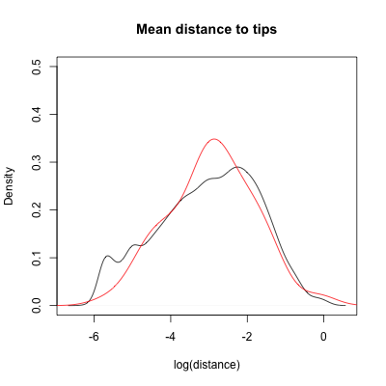 | t = - 0.81862,  df = 88.148,  p-value = 0.415
Leaf | 2 | 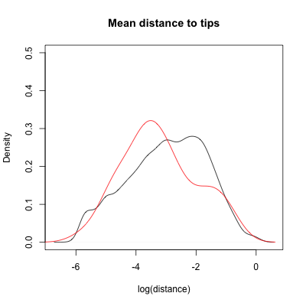 | t = 1.2126,  df = 39.488,  p-value = 0.2325
Leaf | 3 | 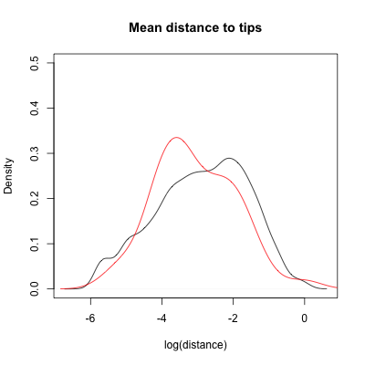 | t = 1.1535,  df = 46.008,  p-value = 0.2547
Root | 1 | 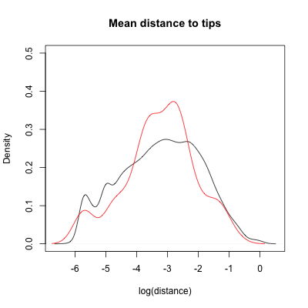 | t = 0.18297,  df = 68.81,  p-value = 0.8554
Root | 2 | 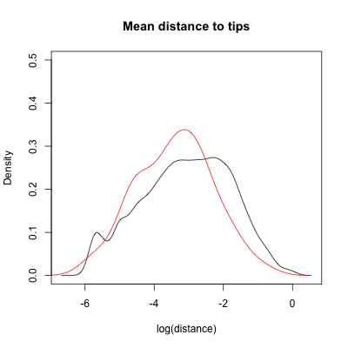 | t = 2.2451,  df = 54.835,  p-value = 0.02881
Root | 3 | 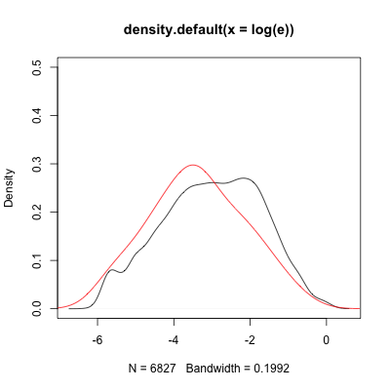 | t = 2.3334,  df = 45.165,  p-value = 0.02414

Supplemental Table S11: Temperature and other notes about site characteristics.
 | Campbell Cove  (CC) | Westside  Park  (WP) | Mason’s Marina  (MM) | Doran  Beach  (DB)
Temperature summer 2015 (7/8 -9/23) ˚C  mean +/- SD  range  Measured in this study | 15.86 +/- 1.21  12.5 - 19.66 | 16.27 +/- 1.24  12.4 - 20.62 | N/A  (HOBO data collector lost) | 18.07 +/- 1.38  14.42 - 21.76
Temperature summer 2019 (7/17 - 8/30) ˚C  mean +/- SD  range  Stachowicz unpublished data | 14.86 +/- 1.57  10.59 - 18.83 | 15.34 +/- 1.56  10.34 - 21.11 | 15.81 +/- 1.48  12.44 - 18.83 | N/A  (not measured in this study)
Other site notes | Closest to mouth of the harbor, high flow, sandy sediment | Site of many eelgrass experiments at Bodega Bay | Restored site, finer sediment grain size | Furthest from clamming activity

Supplemental information on balances
Leaf microbial balances contained between 2 and 9241 ASVs; Root balances contained between 2 and 478 ASVs.

Supplemental Figure S1 Each balance identified here is a single node in the tree of microbial communities where one site was differentially weighted compared to all other sites. Here for this node within the bacterial family Cyclobacteriaceae, CC has two ASVs in this family upweighted compared to the seven ASVs on the other side of the node. All other sites had higher relative abundance of the ASVs on the other side of the node.
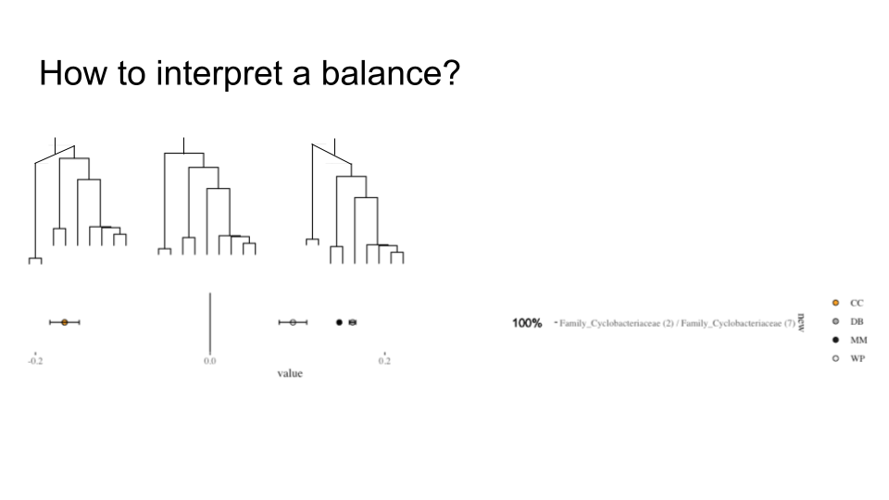

Supplemental Figure S2: After one month, we identified 14 balances distinguishing leaf bacterial communities at CC, 15 balances at DB, 35 at MM and 27 at WP.
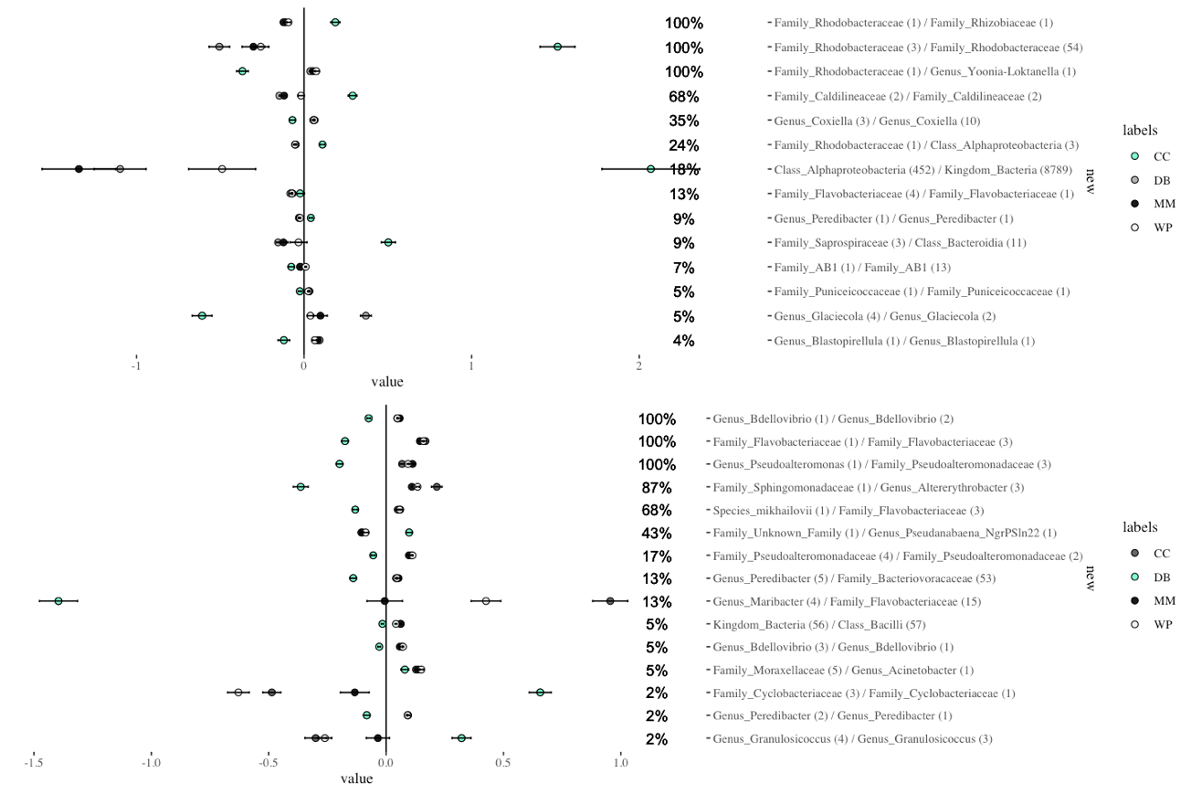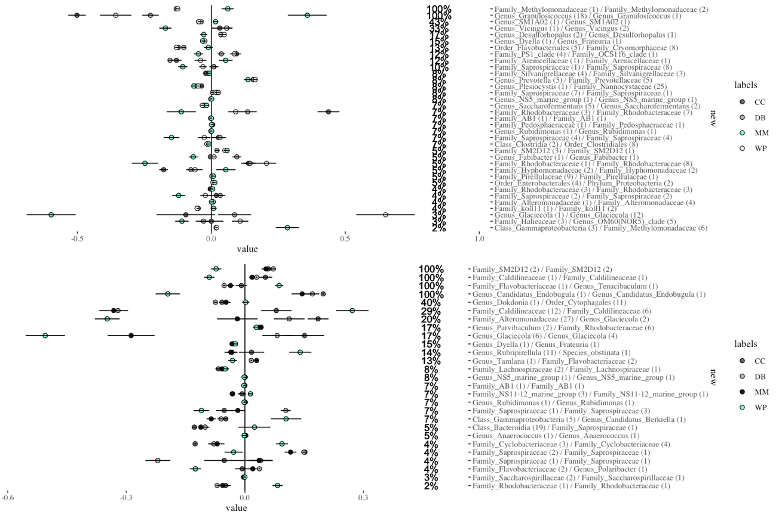
Supplemental Figure S3: After two months, we identified 9 balances distinguishing leaf bacterial communities at CC, 11 balances at DB, 11 at MM and 9 at WP.
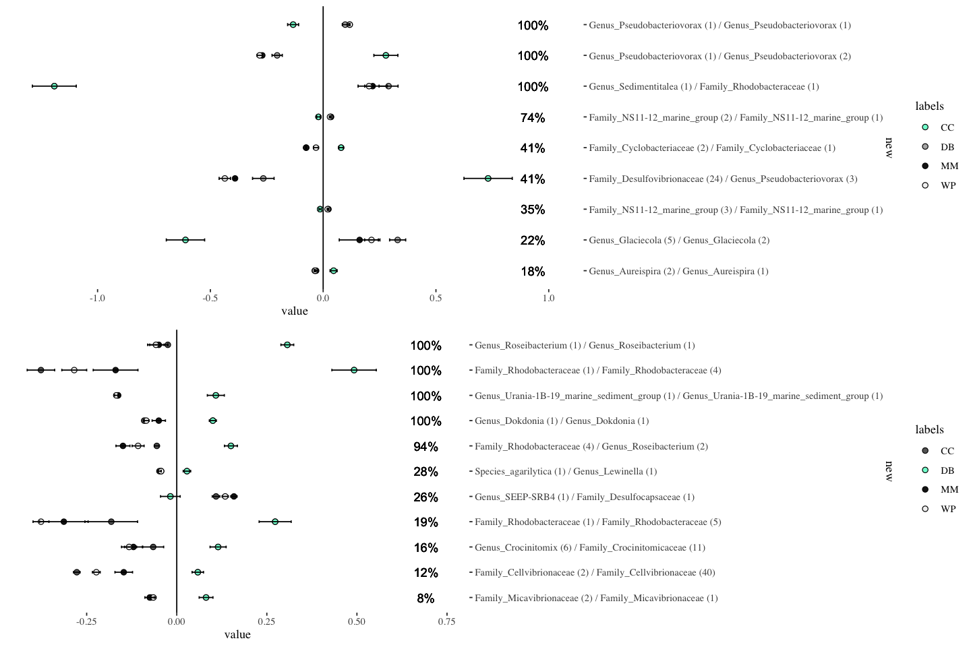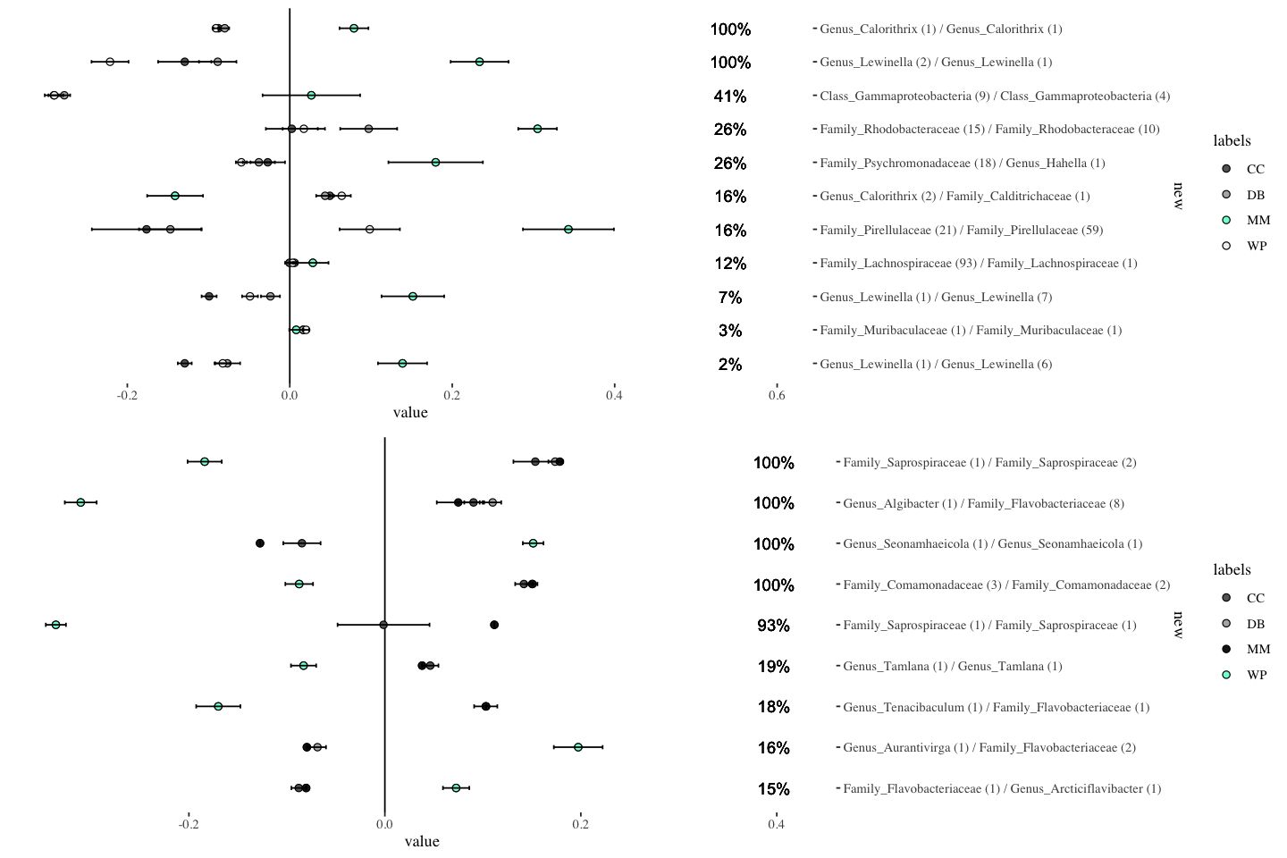Supplemental Figure S4: After three months, we identified 8 balances distinguishing leaf bacterial communities at CC, 11 balances at DB, 16 at MM and 11 at WP.
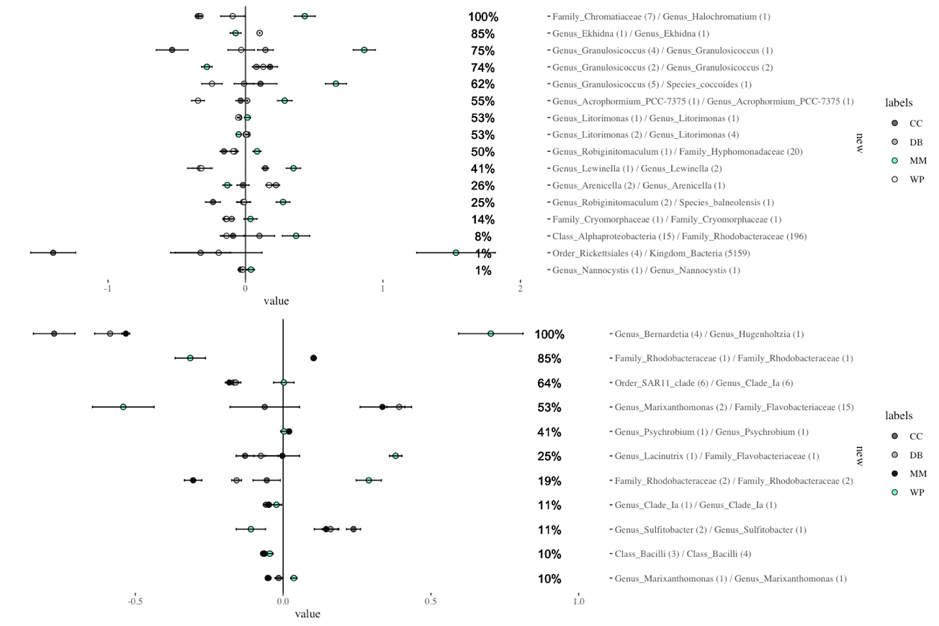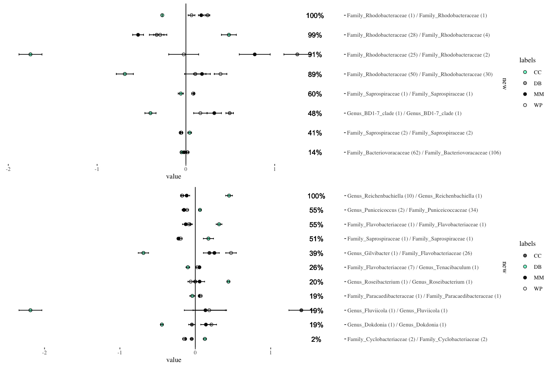
Supplemental Figure S5: In roots, after one month, we identified 17 balances distinguishing root bacterial communities at CC, 10 balances at DB, 23 at MM and 20 at WP.
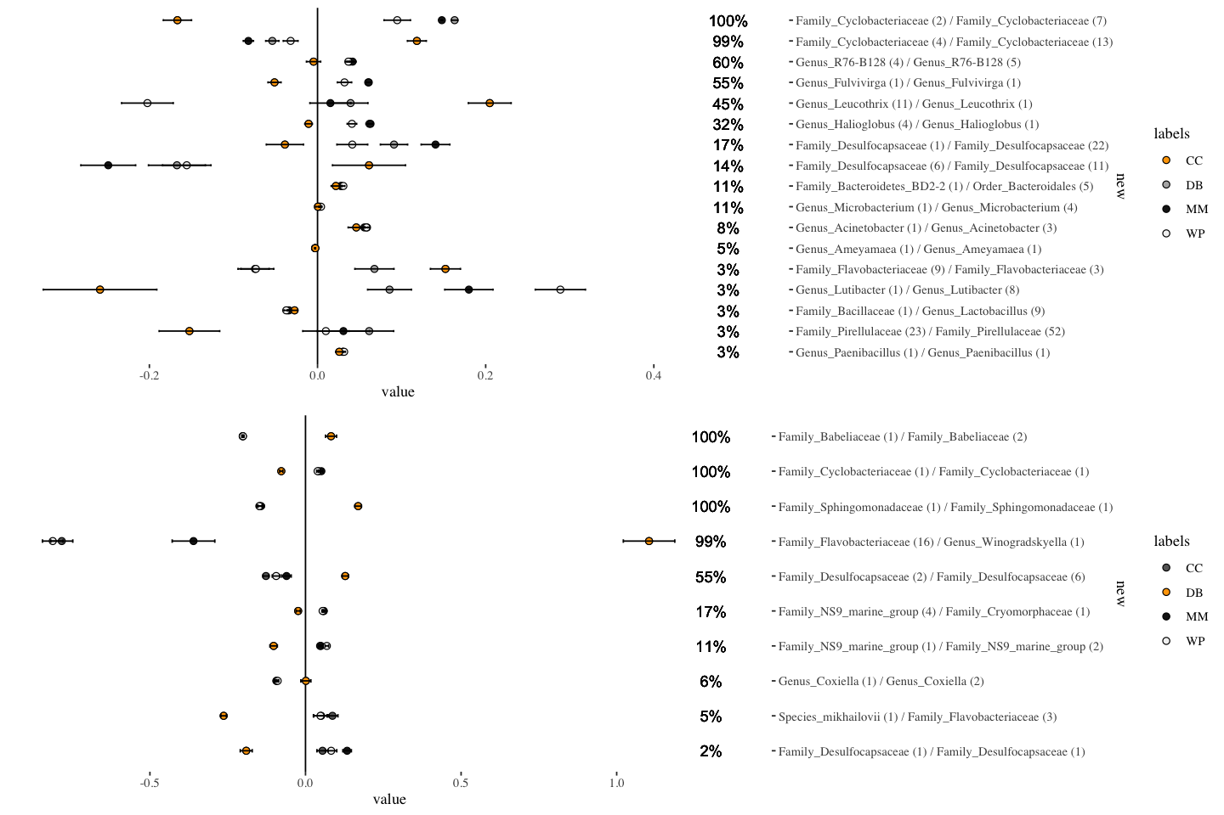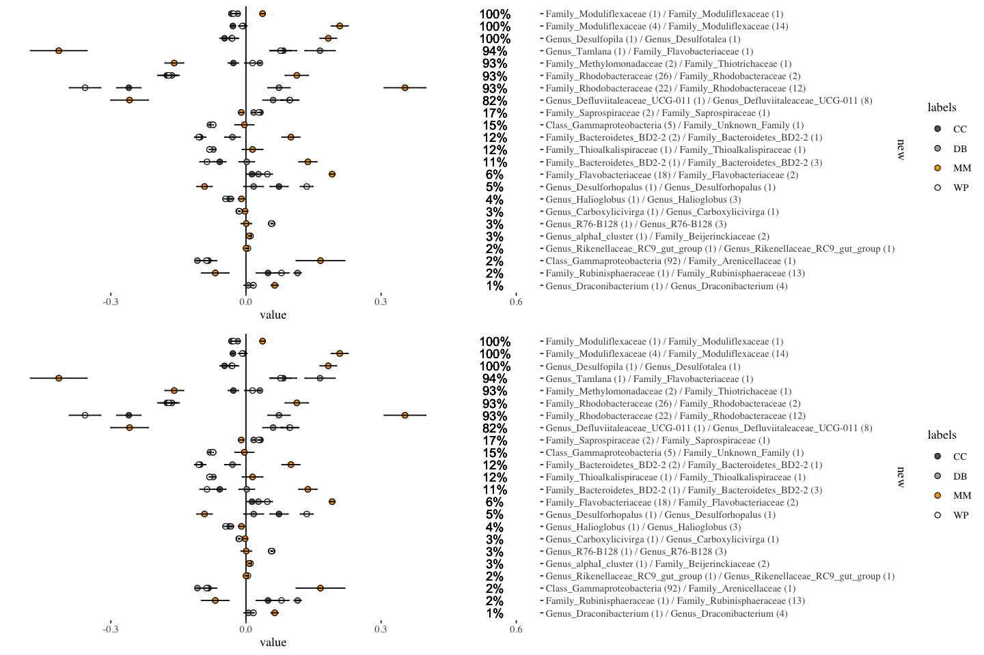
Supplemental Figure S6: After two months, we identified 21 balances distinguishing leaf bacterial communities at CC, 10 balances at DB, 18 at MM and 6 at WP.
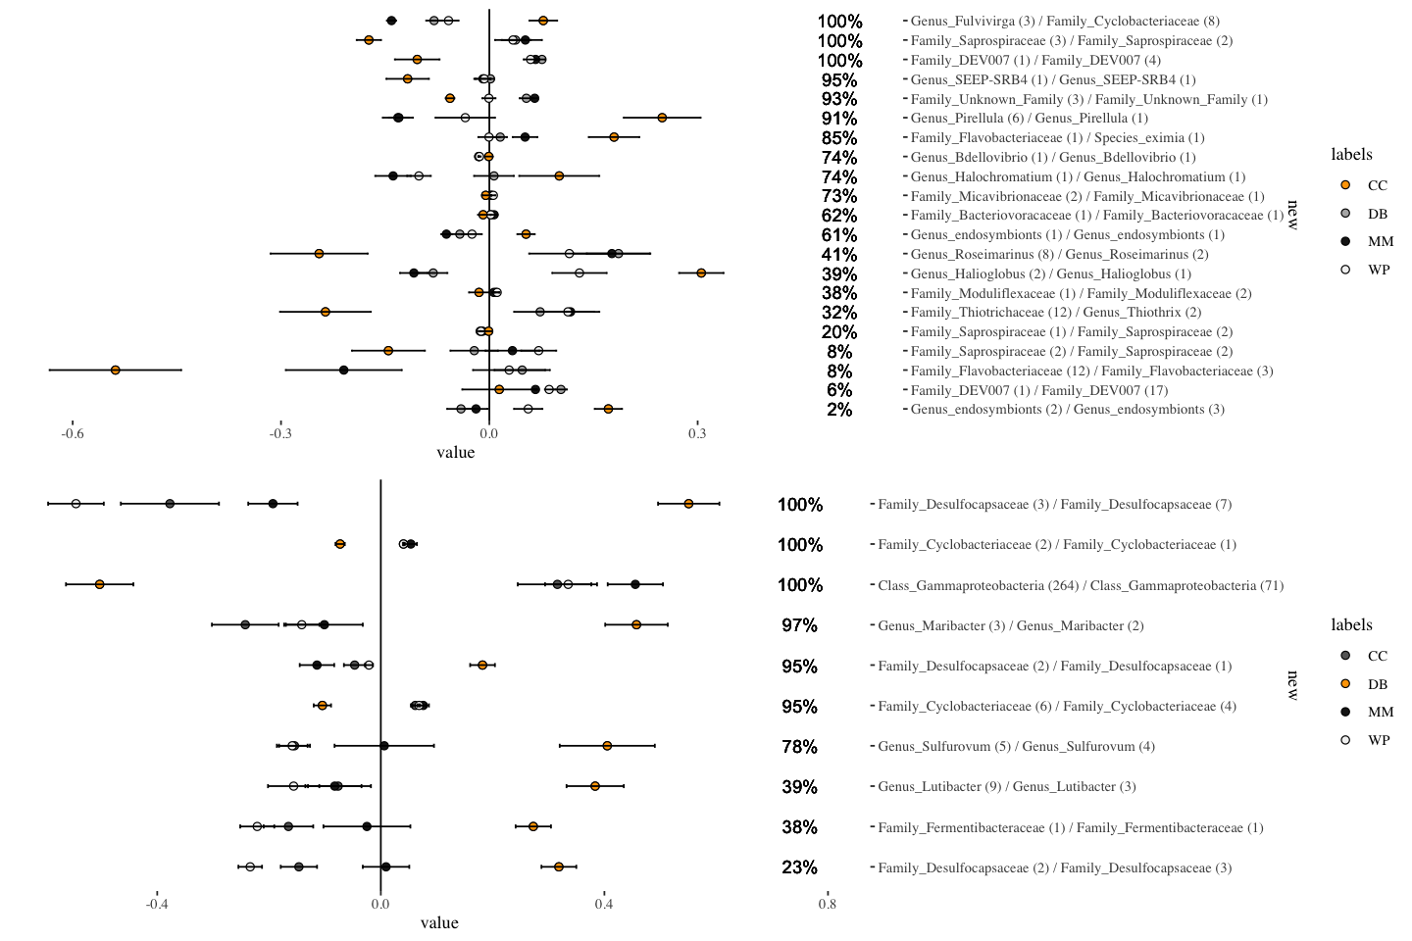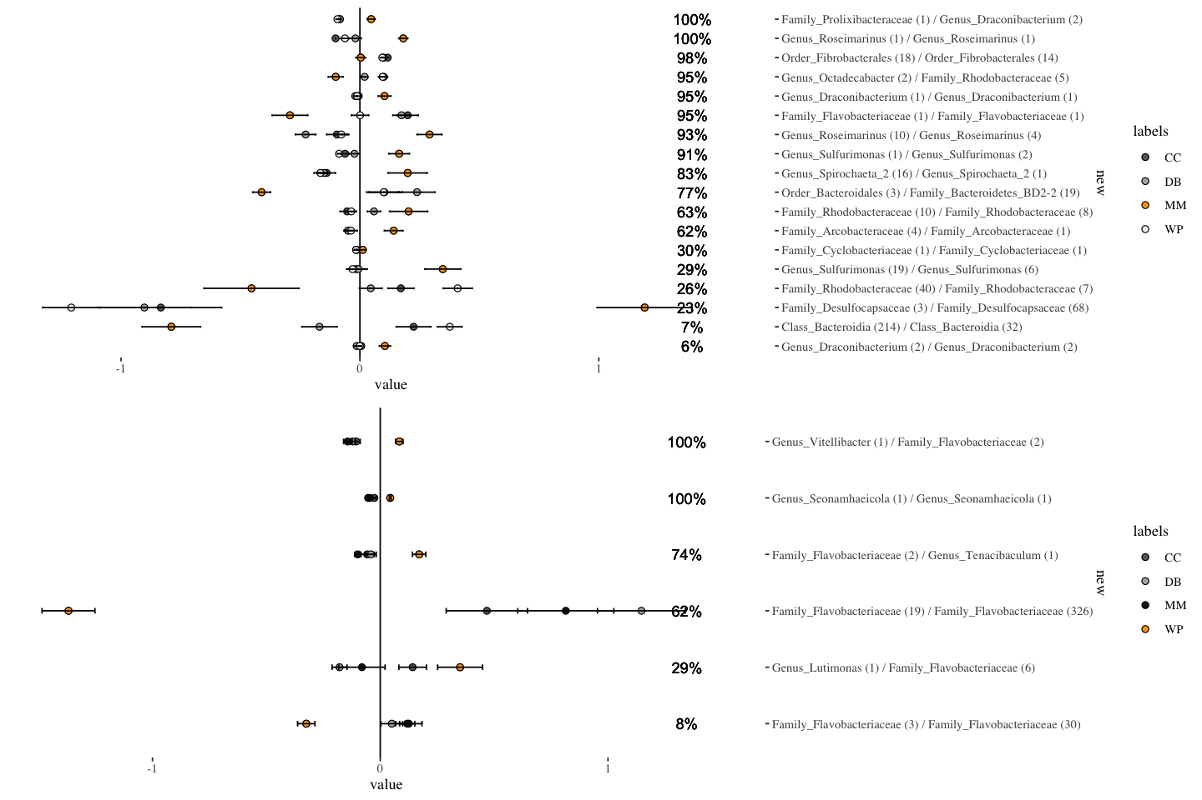
Supplemental Figure S7: After three months, we identified 12 balances distinguishing leaf bacterial communities at CC, 5 balances at DB, 15 at MM and 13 at WP.
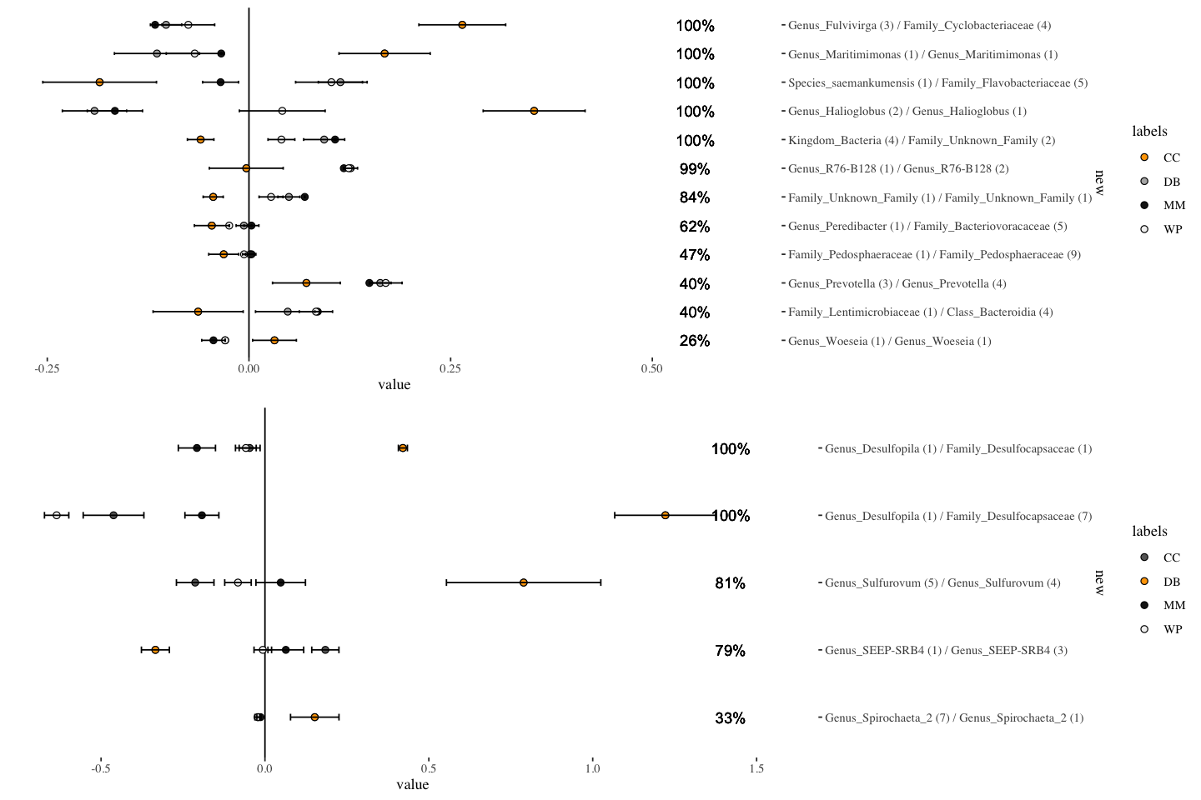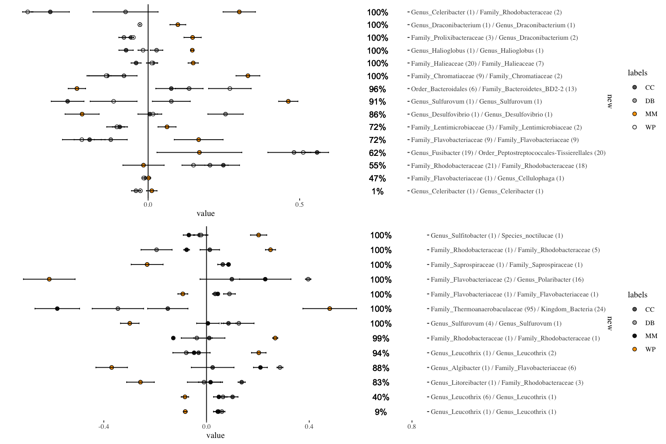
Supplemental Figure S8: Mean amplicon sequence variant (ASV) richness on leaves (left column) and roots (right column by transplant status. Here, we plot means and standard errors by time point; the first row is after one month, the second after two, and the third after three months. Only leaves at T3 showed a significant difference in microbial community richness.
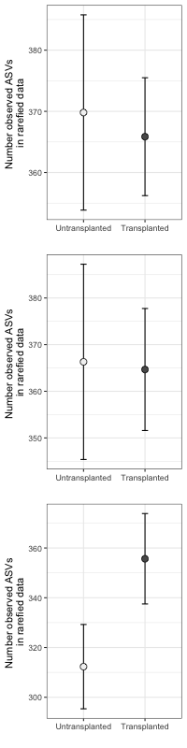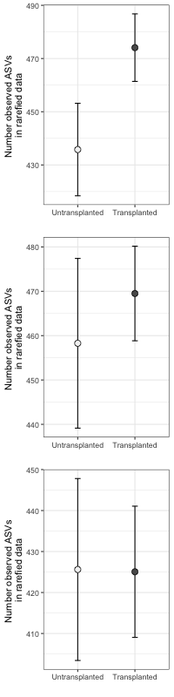

Supplemental Figure S9: Ordination of leaf bacterial community structure based on principal coordinate analysis of phylogenetic-isometric log-ratio transformed distances. Though there is a transplantation effect in root microbiome, this was not due to them changing to resemble leaves. Here brown/yellow points are root communities and green points are leaf communities. Brighter triangles indicate undisturbed controls and darker circles are transplanted plants. While transplanted microbial communities were distinct from undisturbed microbial communities in roots, they still strongly resemble control root microbial communities rather than leaf microbial communities.
