Supplementary Figures
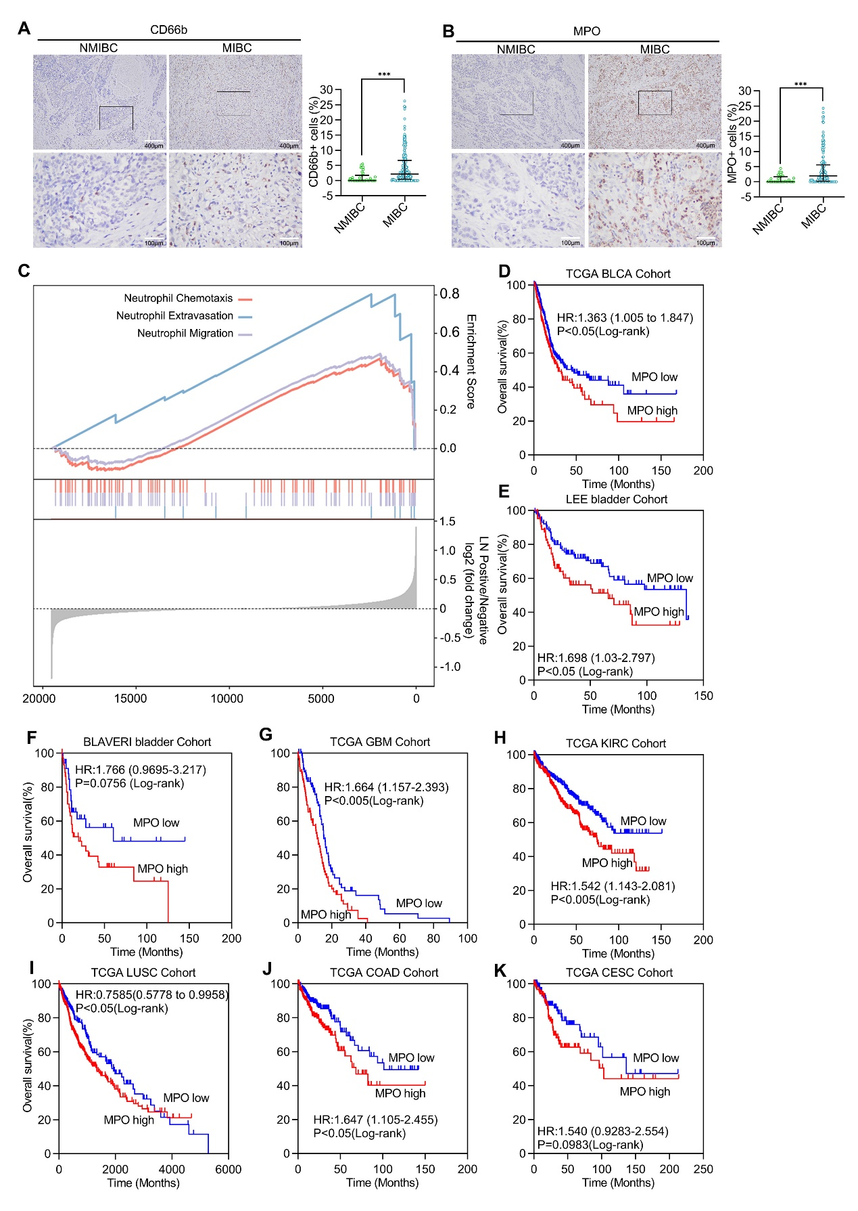
Supplementary Figure 1. TANs predict poor prognosis in multiple cancers.
(A, B) Representative IHC images straining for CD66b (A) and MPO (B) (left) and quantification of CD66b⁺ (A) and MPO ⁺ (B) cells infiltrated in NMIBC and MIBC (right). (C) Gene‐set enrichment analysis (GSEA) of neutrophil chemotaxis, extravasation and migration pathways in LN (-) and LN (+) BCa tissues from TCGA database. (D-F) Kaplan-Meier survival analysis of OS of BCa patients with high level versus low level MPO expression in TCGA cohort (242 vs 160) (D), LEE bladder Cohort (64 vs 101) (E) or BLAVERI bladder Cohort (65 vs 34) (F) from Oncomine database. (G-K) Kaplan-Meier survival analysis of OS of patients with high level versus low level MPO expression in Glioblastoma (GBM, 76 vs 76) (G), Kidney Clear Cell Carcinoma (KIRC, 277 vs 245) (H), (I) Lung Squamous Cell Carcinoma (LUSC, 211 vs 277), Colon Cancer (COAD, 230 vs 210) (J), and Esophageal Cancer (CESC, 137 vs 127) (K) from TCGA database. Statistical significance was assessed using two-tailed t tests or one-way ANOVA. *** p < 0.001.

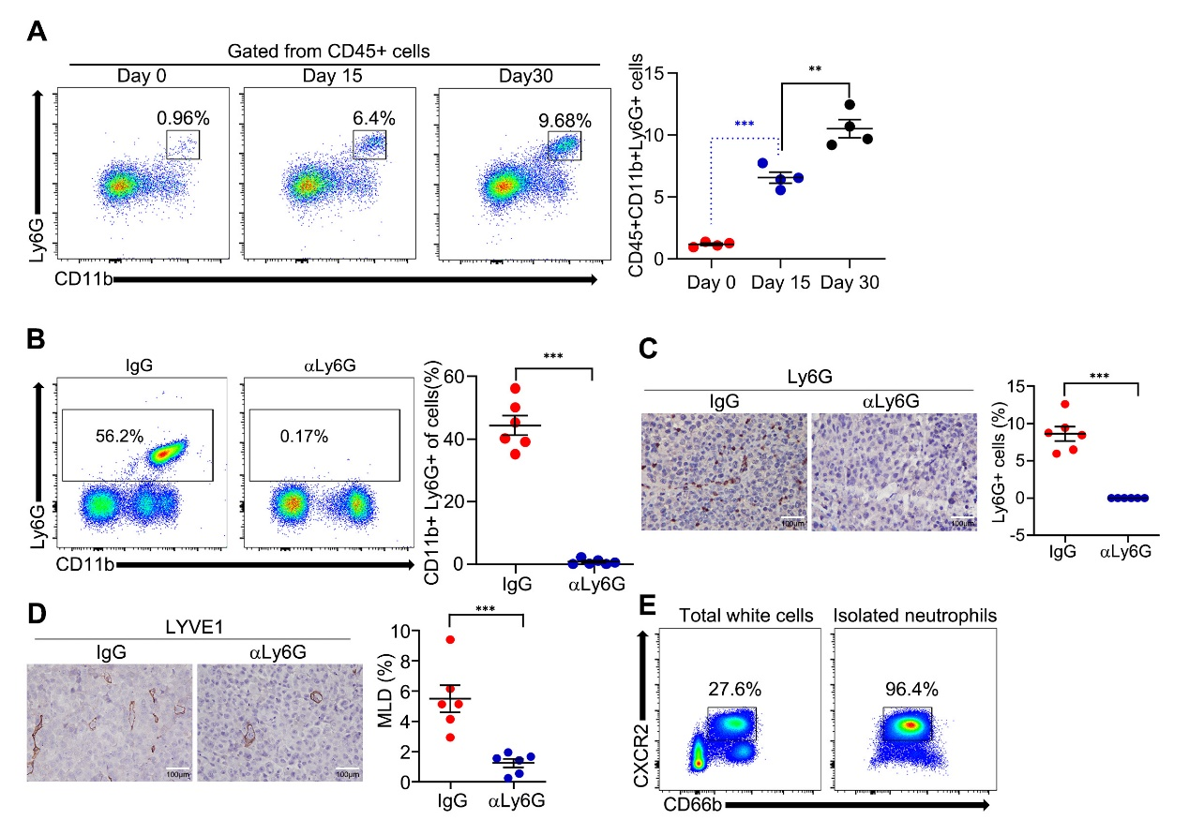
Supplementary Figure 2. TANs promote LN metastasis of BCa in mice.
(A) Flow cytometry analysis of CD45⁺CD11b⁺Ly6G⁺ neutrophils from fresh surgically excised footpad tumor tissues. (B) Flow cytometry analysis of CD11b⁺Ly6G⁺ neutrophils in peripheral blood. (C) Representative IHC images straining for Ly6G (left) and quantification of Ly6G⁺cells infiltrated in indicated footpad tumor (right). (D) Representative IHC images straining for LYVE1 (left) and quantification of LYVE1⁺cells in indicated footpad tumor (right). (E) Flow cytometry analysis of CD66b⁺CXCR2⁺ cells in total white cells and isolated neutrophils. Statistical significance was assessed using two-tailed t tests or one-way ANOVA. ** p < 0.01, ***p < 0.001.

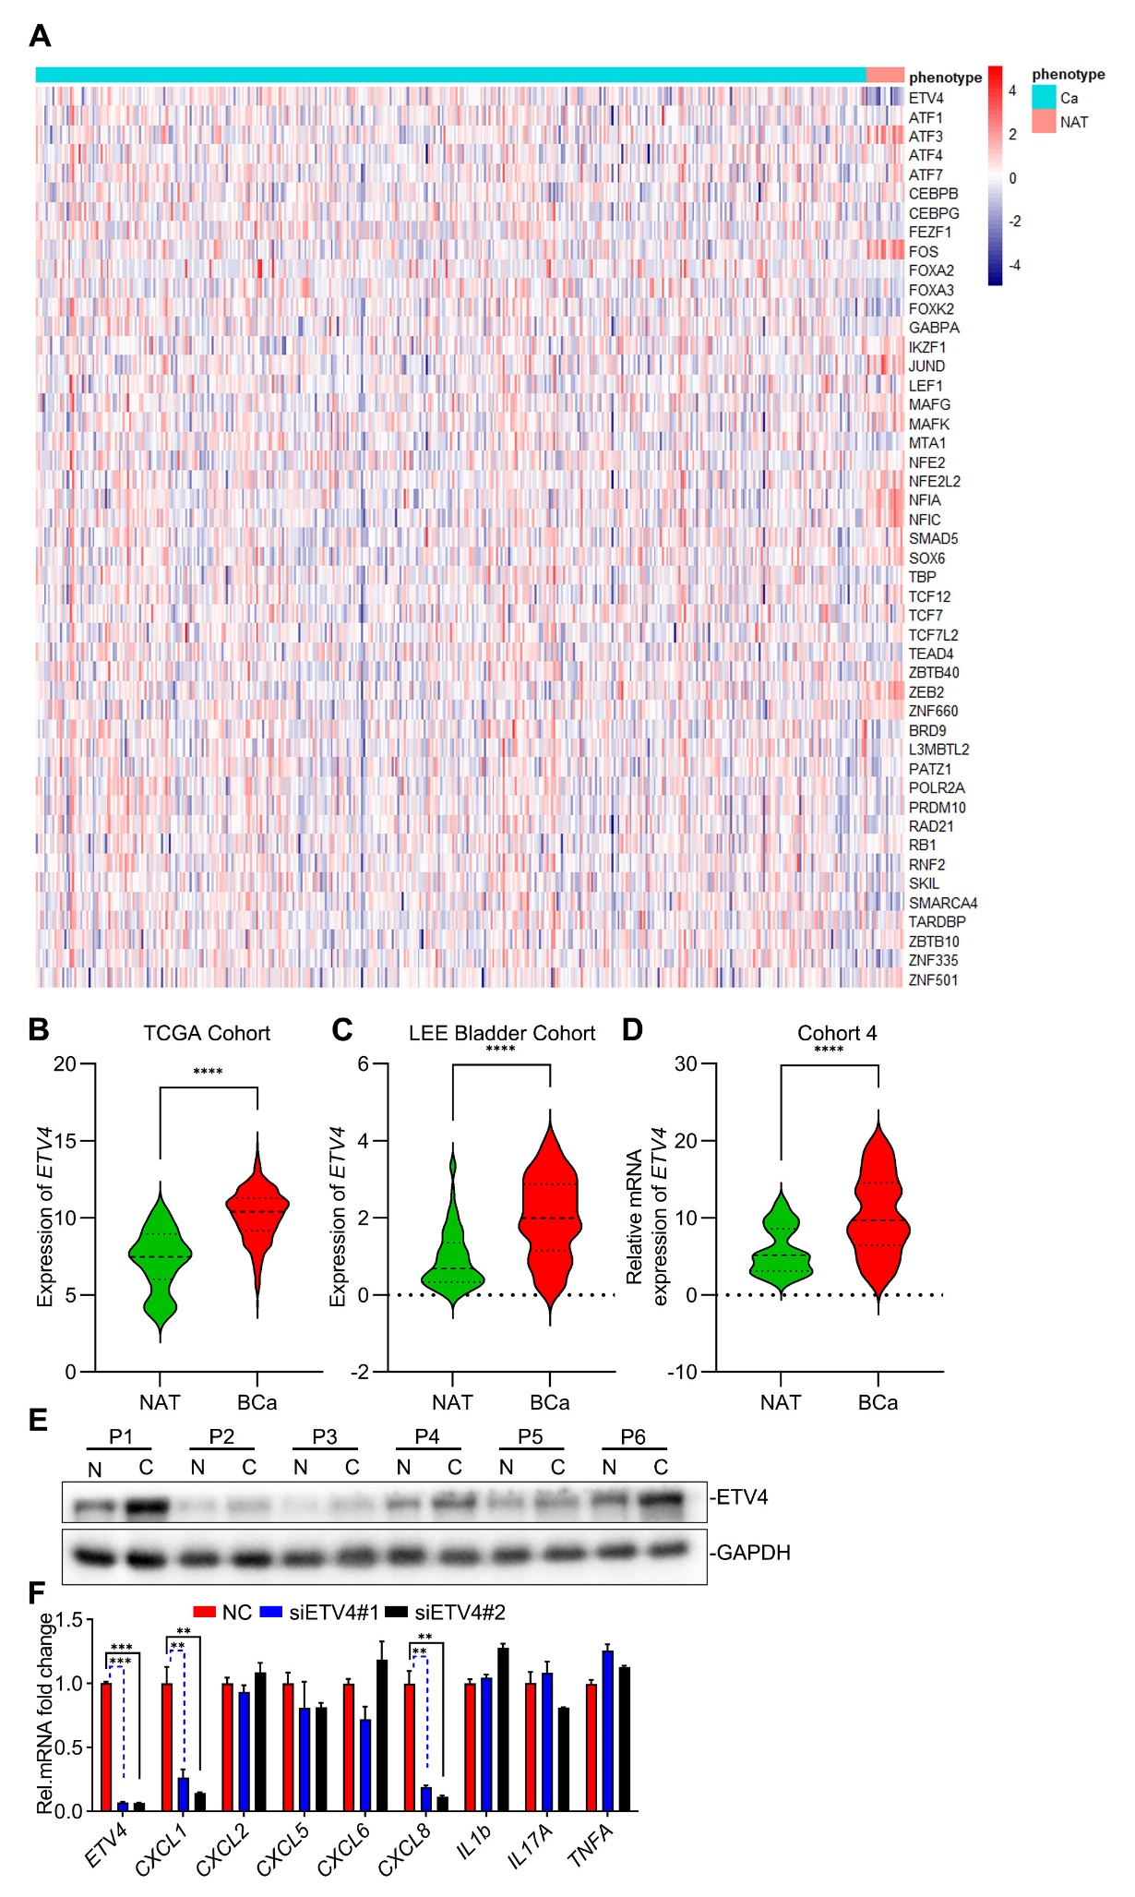 Supplementary Figure 3. ETV4 is overexpressed in BCa.
(A) Heatmap of expression of the indicated genes from TCGA database of BCa. (B-C) Analysis of the expression of ETV4 in TCGA database of BCa (B) and LEE bladder Cohort (C). (D) qRT-PCR analysis of ETV4 mRNA in Cohort 4. (E) Immunoblot analysis of ETV4 and GAPDH in NAT (N) or BCa (C) tissues. (F) qRT-PCR analysis of ETV4, CXLC1, CXCL5, CXCL8, IL1b, IL17A and TNFA mRNA in UM-UC-3 cells treated with NC, siETV4#1 or siETV4#2 for 48 h. Statistical significance was assessed using two-tailed t tests or one-way ANOVA. **p < 0.01, ***p < 0.001, ****p < 0.0001. Data are representative of two (E) or three independent experiments (mean ± S.D. in F).

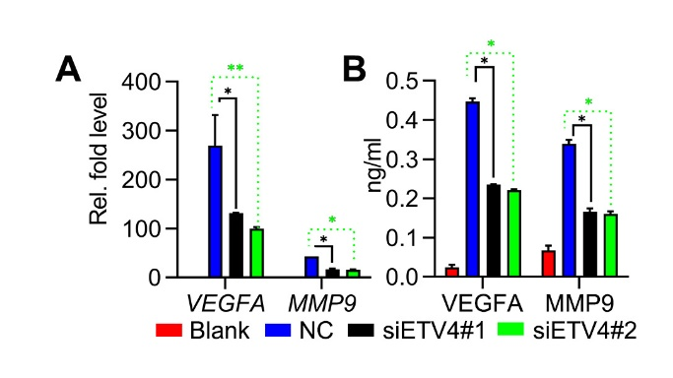
Supplementary Figure 4. Tumour ETV4 promotes VEGFA and MMP9 expression in TANs.
(A) qRT-PCR analysis of VEGFA and MMP9 mRNA in neutrophils incubated with UM-UC-3 CM. (B) ELISA analysis of VEGFA and MMP9 in the supernatants of neutrophils treated with the indicated supernatant for 12 h. Statistical significance was assessed using two-tailed t tests or one-way ANOVA. *p < 0.05, **p < 0.01. Data are representative of two (B) or three independent experiments (mean ± S.D. in A).

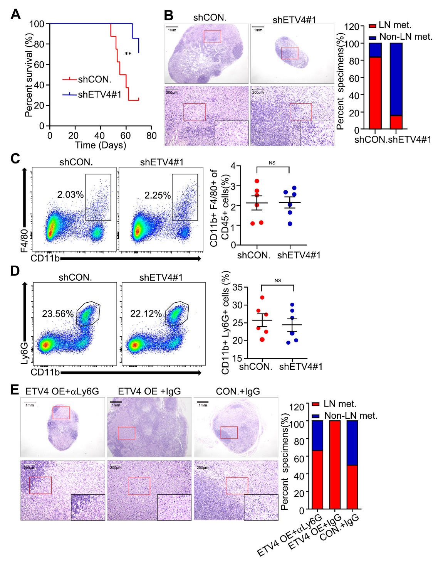
Supplementary Figure 5. ETV4 promotes LN metastasis of BCa in mice.
(A) Kaplan-Meier survival analysis of mice inoculated with shCON. and shETV4#1 UM-UC-3 cells. (B) Representative H&E images (left) and quantification (right) of LN metastasis status in indicated LNs. (C) Flow cytometry analysis of CD11b⁺F4/80⁺ cells in indicated footpad tumors. (D) Flow cytometry analysis of CD11b⁺Ly6G⁺ neutrophils in spleen. (E) Representative H&E images (left) and quantification (right) of LN metastasis status in LNs from the empty vector (CON.) or ETV4 overexpression vector stably transfected UM-UC-3 cells and IgG or neutralizing antibody of Ly6G. Statistical significance was assessed using two-tailed t tests or one-way ANOVA. **p < 0.01.
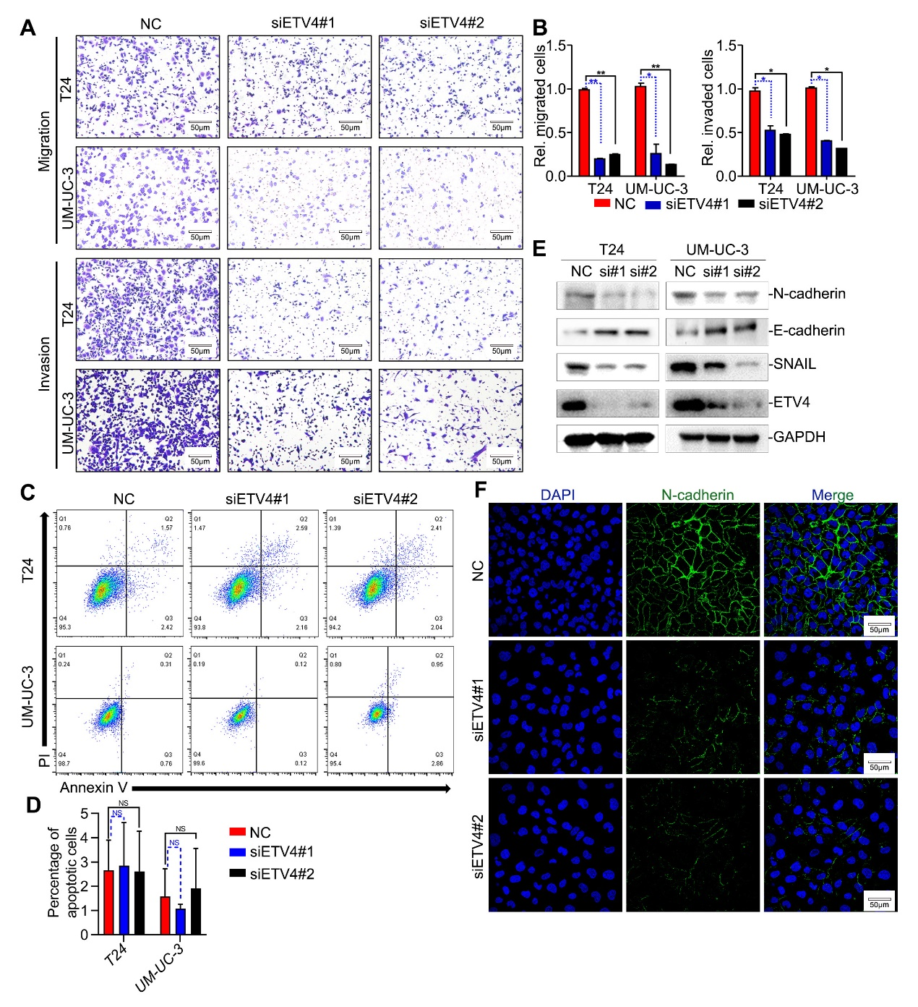 Supplementary Figure 6. ETV4 promotes migration and invasion of BCa cells in vitro.
(A, B) Representative images (A) and analysis (B) of transwell migration and invasion in T24 and UM-UC-3 cells treated with NC, siETV4#1 or siETV4#2. (C, D) Flow cytometry analysis of Annexin V and PI staining T24 and UM-UC-3 cells treated as indicated. (E) Immunoblot analysis of N-cadherin, E-cadherin, SNAIL, ETV4 and GAPDH in T24 and UM-UC-3 cells treated as indicated. (F) Representative immunofluorescence images staining for N-cadherin in T24 cells treated as indicated. Statistical significance was assessed using two-tailed t tests or one-way ANOVA. *p <0.05, **p < 0.01. Data are representative of two (E, F) or three independent experiments (mean ± S.D. in A-D).
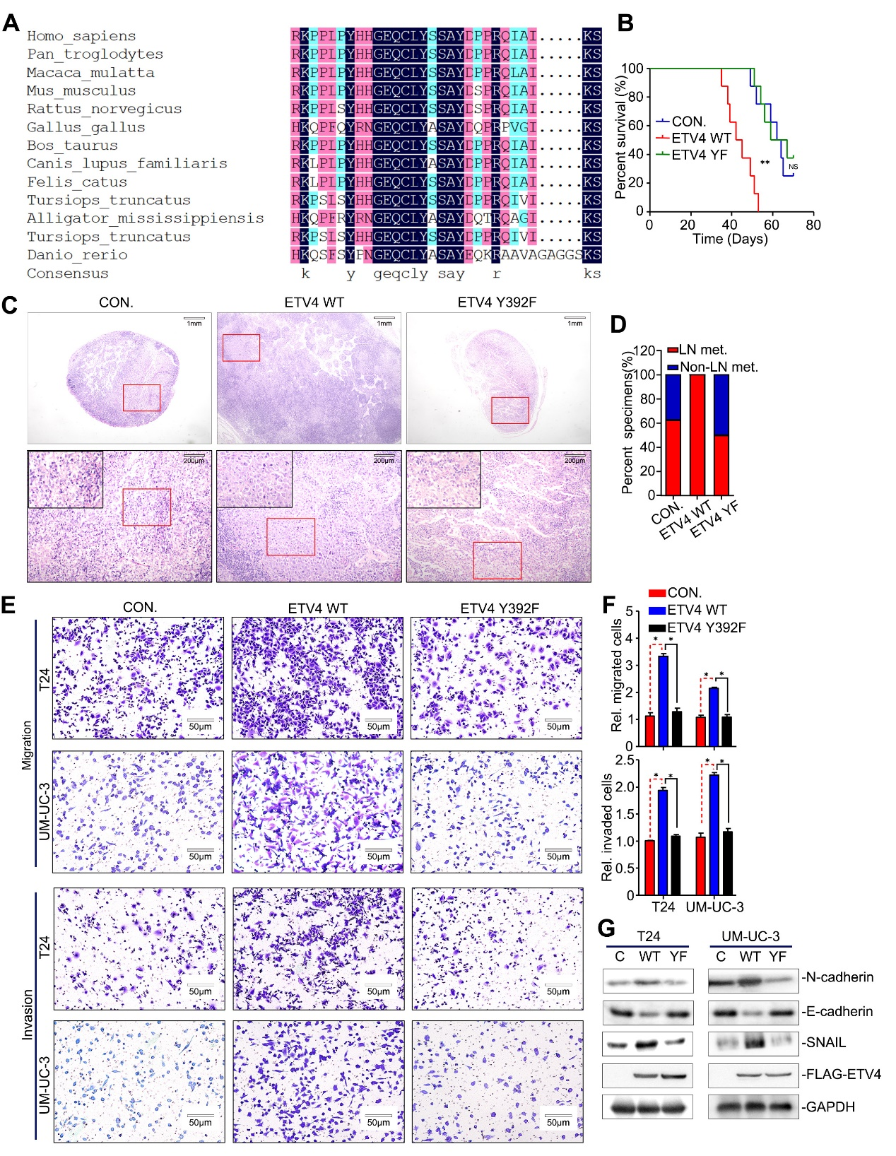 Supplementary Figure 7. Y392 of ETV4 is required for the pro-LN-metastatic effect.
(A) Alignment of primary sequences of Homo. sapiens ETV4 and its homologues in 11 species: Pan troglodytes, Macaca mulatta, Mus musculus, Rattus norvegicus, Gorilla gorilla, Bos taurus, Canis familiaris, Felis catus, Tursiops truncates, Alligator mississippiensis and Danio rerio. Consensus sequences are listed at the left of the column; conserved amino acids are highlighted in black. (B) Kaplan-Meier survival analysis of mice inoculated with CON and ETV4 WT or Y392F overexpression vector stably transfected UM-UC-3 cells. (C, D) Representative H&E images (C) and quantification (D) of LN metastasis status in indicated LNs. (E, F) Representative images (E) and analysis (F) of transwell migration and invasion in the empty vector (CON.) or ETV4 WT or Y392F overexpression vector stably transfected T24 and UM-UC-3 cells. Statistical significance was assessed using two-tailed t tests or one-way ANOVA. **p < 0.01.

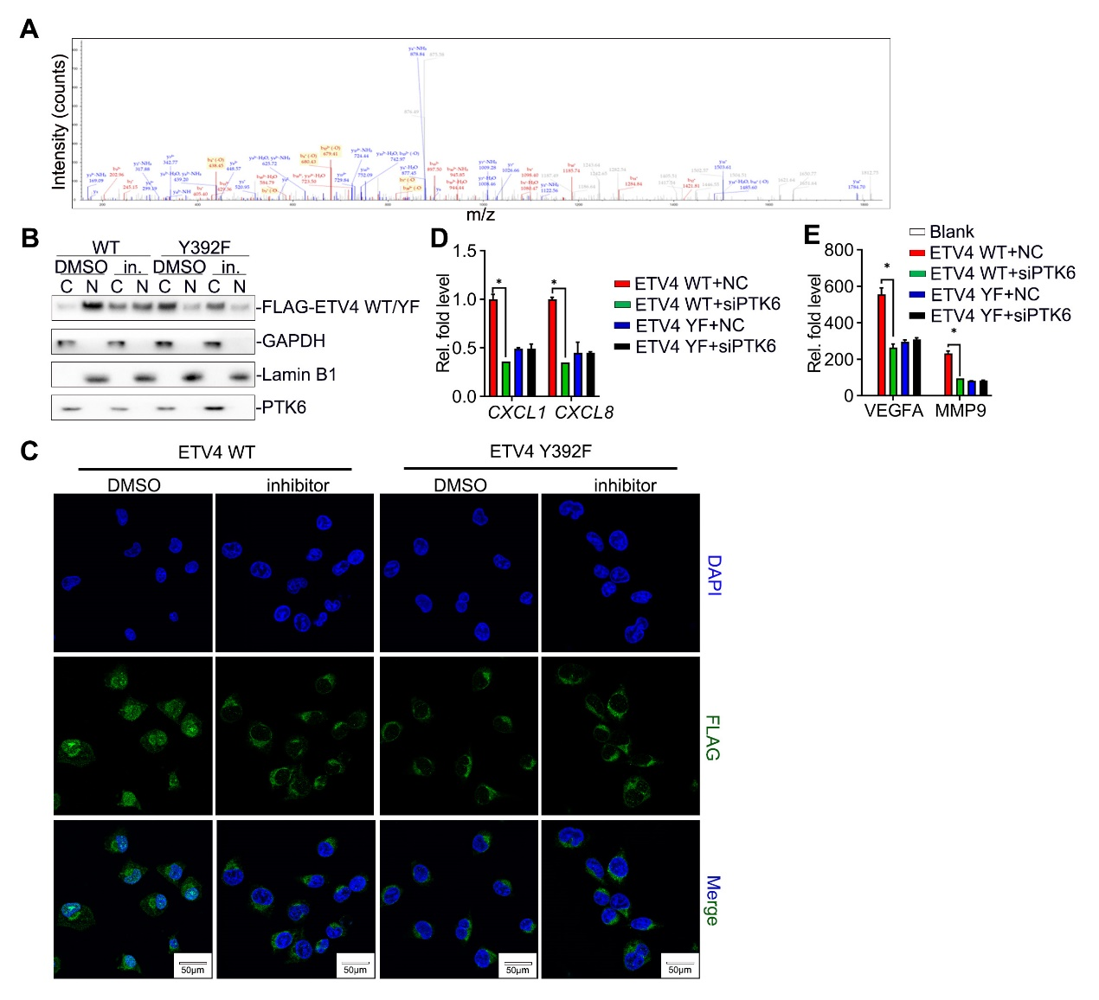
Supplementary Figure 8. Inhibition of PTK6 suppressed the nuclear translocation of ETV4.
(A) Mass spectrometry (MS) identification of cytoplasmic ETV4-interacting proteins. (B) Immunoblot analysis of cytoplasmic and nuclear FLAG-ETV4, PTK6, GAPDH and Lamin B1 in UM-UC-3 cells that stably express FLAG-ETV4 WT or Y392F, treated with DMSO or inhibitor of PTK6 (Tilfrinib, 20 µM) for 36 h. (C) Representative immunofluorescence images staining for FLAG-ETV4 in UM-UC-3 cells treated as indicated. (D) qRT-PCR analysis of CXCL1 and CXCL8 mRNA in UM-UC-3 cells treated as indicated. (E) qRT-PCR analysis of VEGFA and MMP9 mRNA in neutrophils incubated with indicated UM-UC-3 CM. Statistical significance was assessed using two-tailed t tests. *p <0.05. Data are representative of two (A-C) or three independent experiments (mean ± S.D. in D, E).

