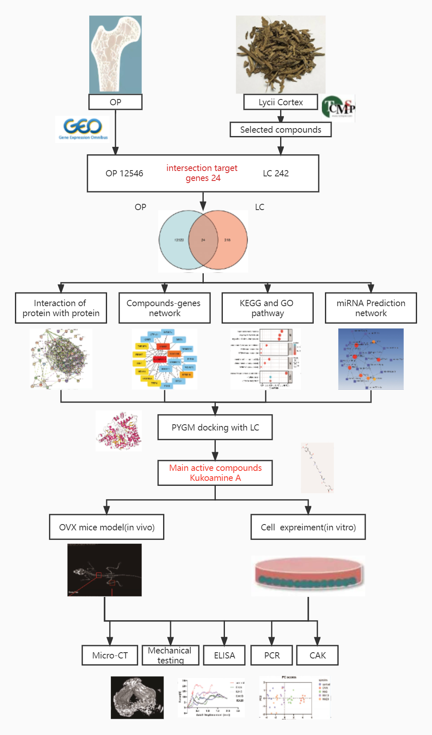
Supplement Figure 1. The workflow of KuA in treatment of OP.
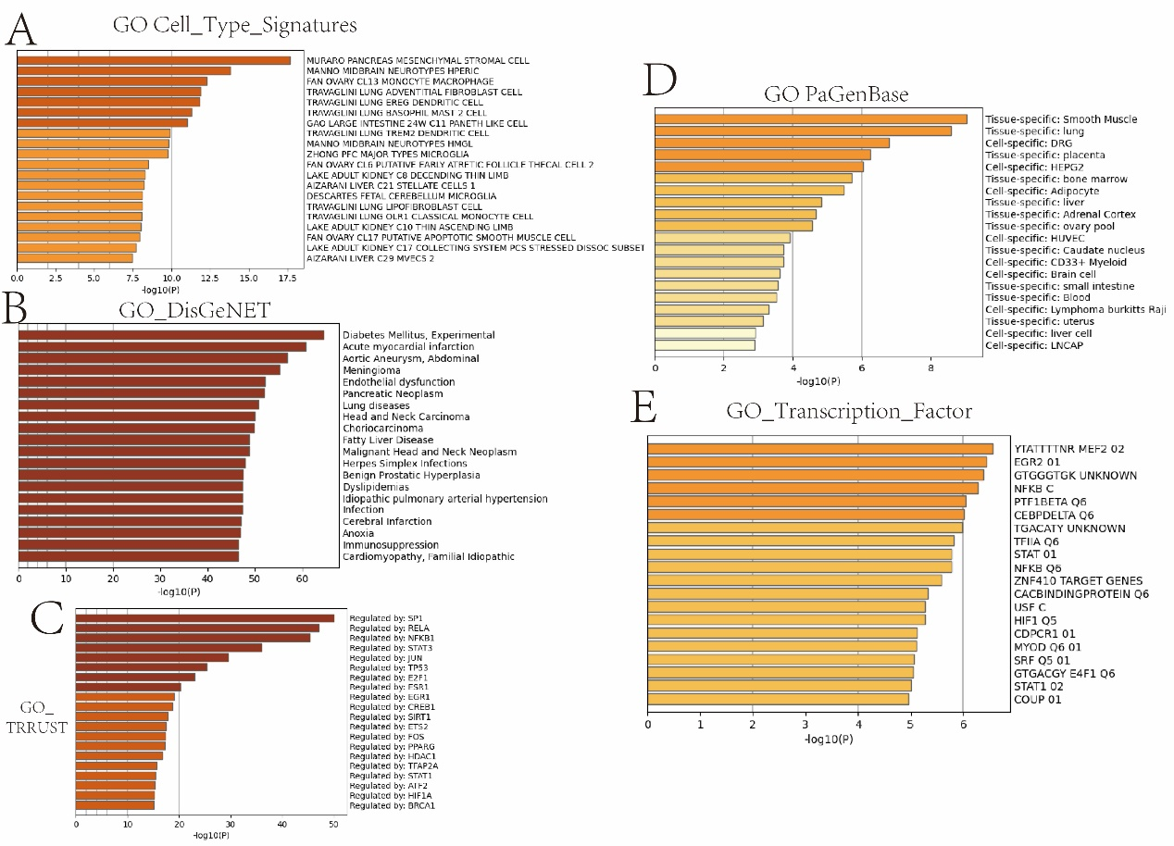
Supplement Figure 2. GO enrichment analysis among target genes. (A) Cell type signature. (B) Disgenet analysis. (C) Trrust analysis. (D) Pagenbase analysis. (E) Transcription factor.
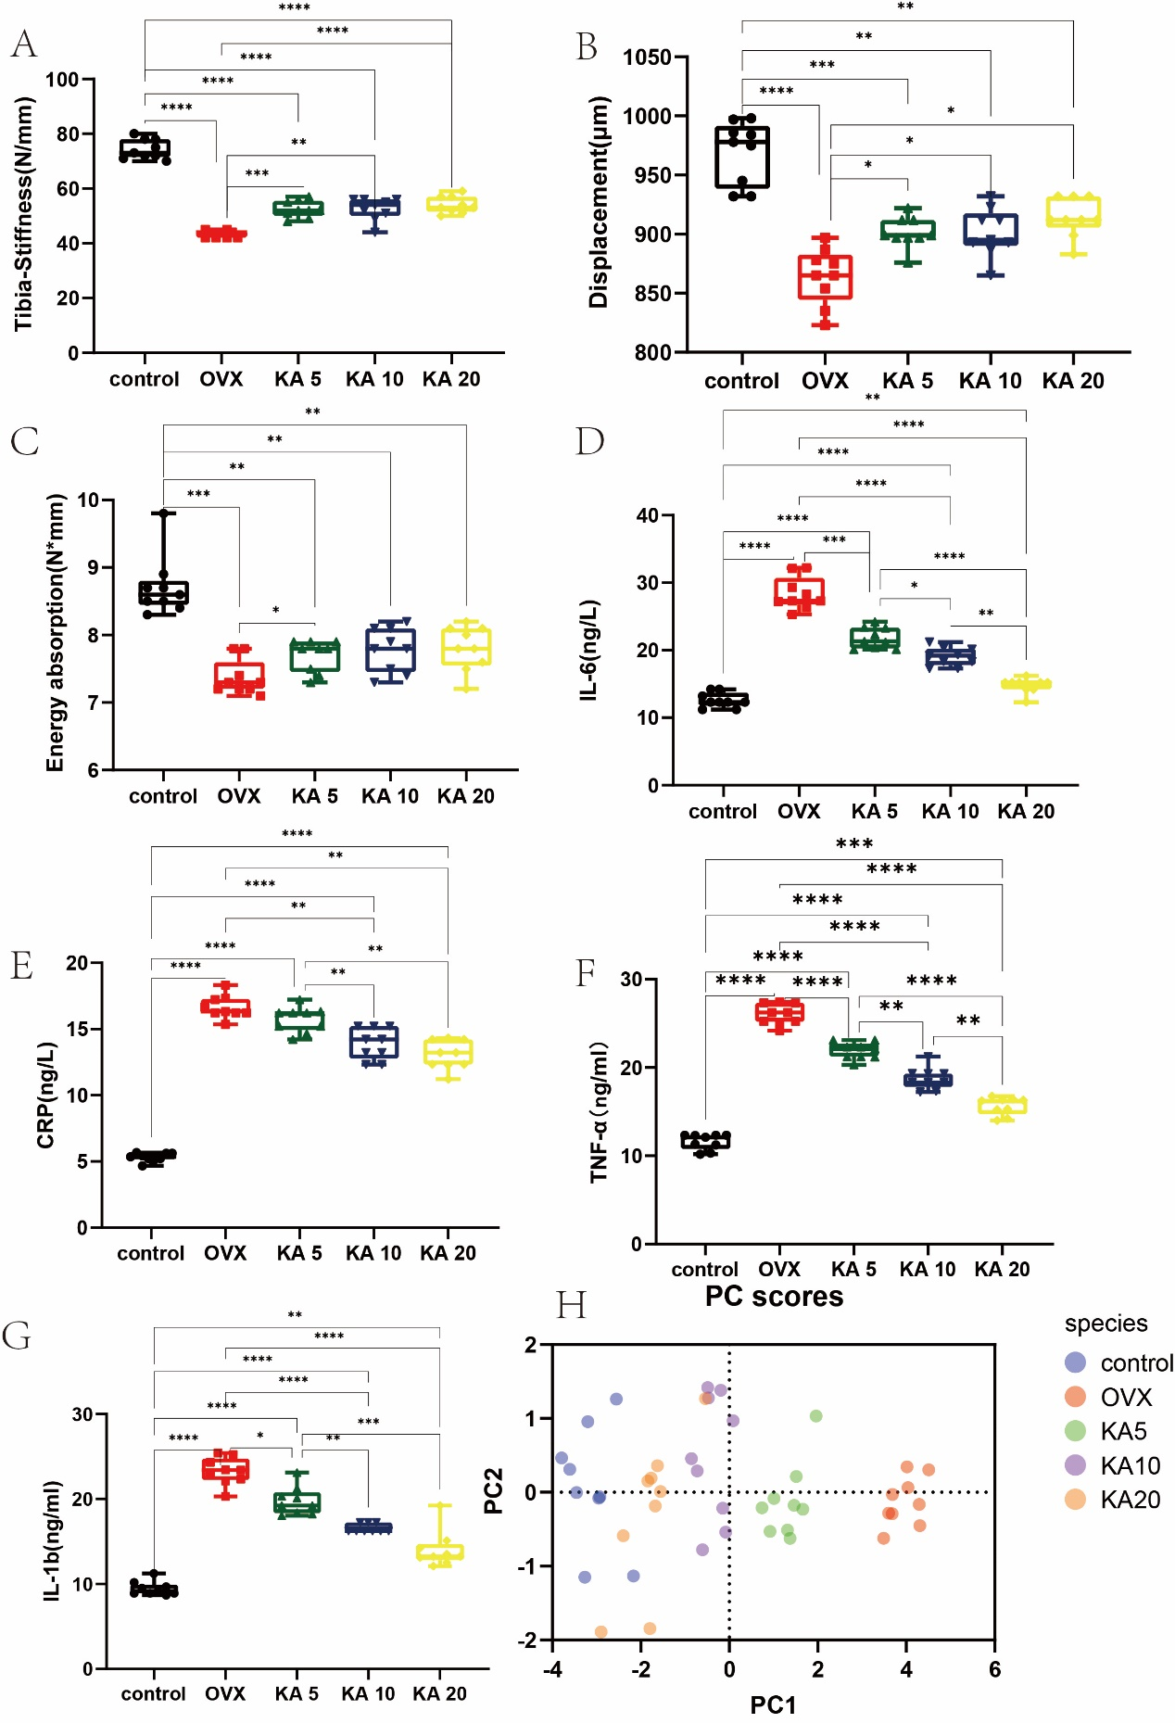
Supplement Figure 3. KuA improve the mechanical properties and inflammation level in OVX mice. (A) Stiffness of tibia. (B) Displacement of tibia. (C) Energy absorption. (D) serum IL-6.(E)serum CRP. (F) serum TNF-α. (G) serum IL-1b.(H) Principal genetic analysis among all variable.

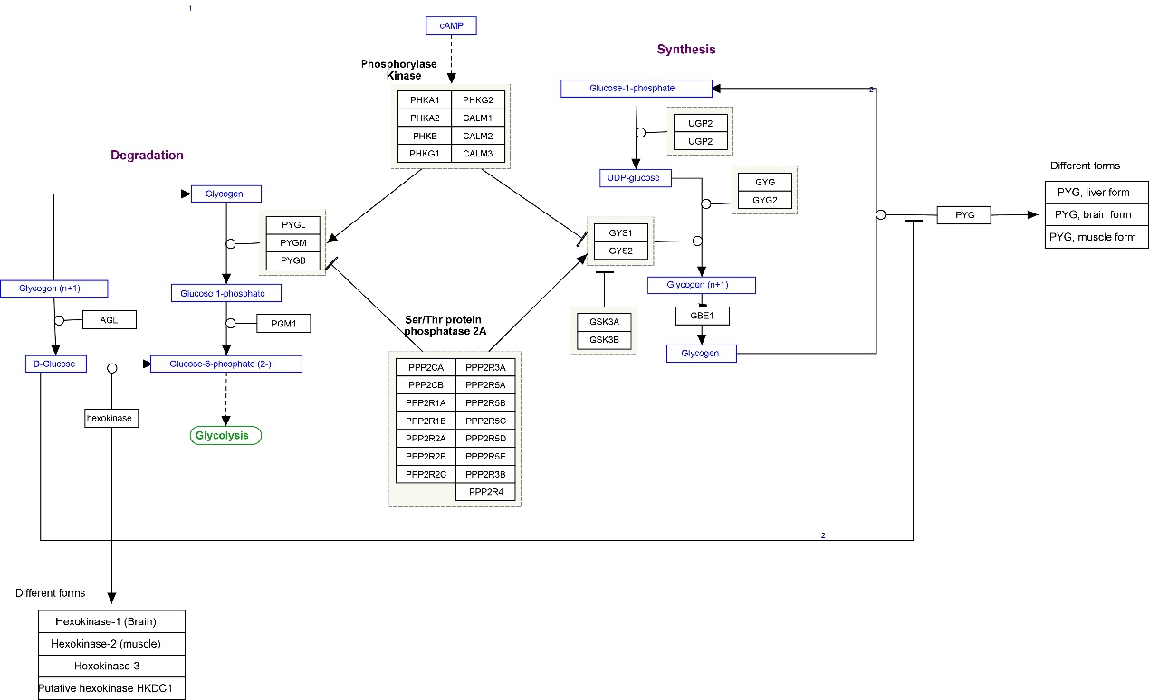
Supplement Figure 4. The PYGM related signaling pathway of potential target genes of LC in OP.
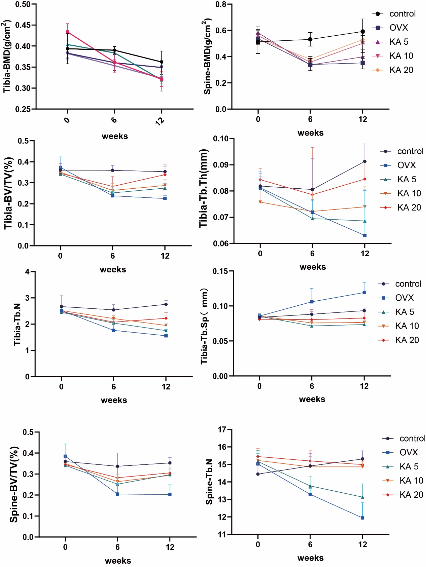
Supplement Figure 5. KuA increased significantly the tibia and spine bone microstructure and mechanical properties in OVX mice.
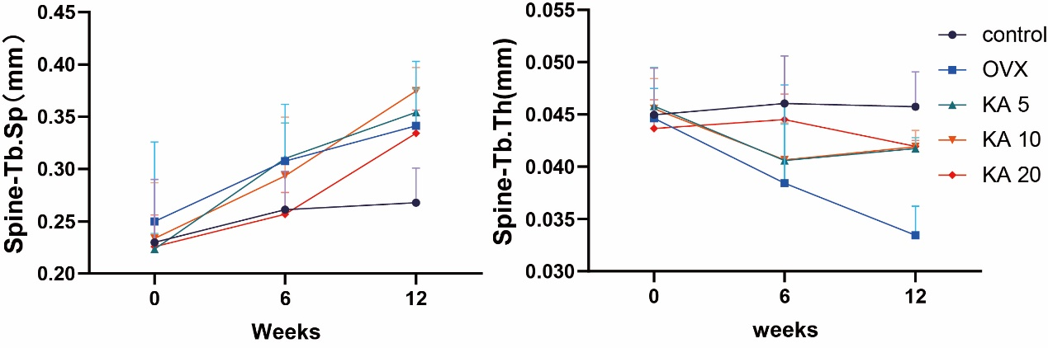
Supplement Figure 6. KuA increased significantly the spine bone microstructure and mechanical properties in OVX mice.

