Supplementary materials
Video
Supplementary video.

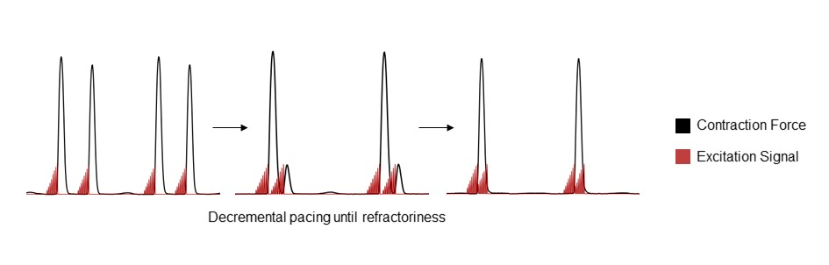
Supplementary Figure 1. Refractory period is determined with decremental pacing, defined as the time-delay of the second stimulus which does not lead to capture of contraction.
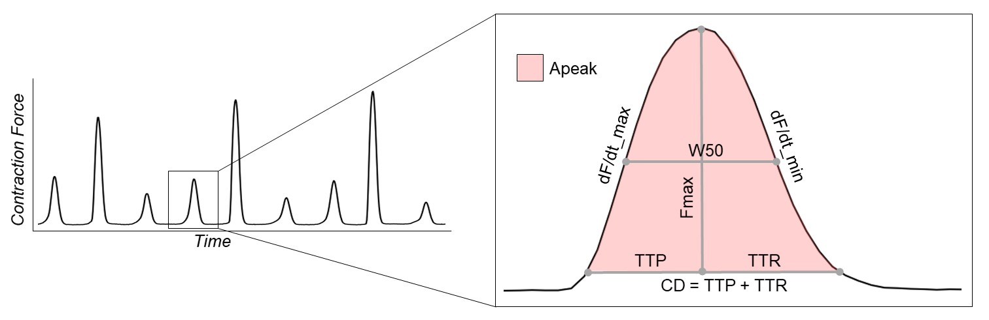
Supplementary Figure 2. Definitions of different contractility parameters. Apeak = peak area. CL = cycle length. CD = contraction duration. dF/dt_max = steepest positive slope. dF/dt_min = steepest negative slope. Fmax = maximum contraction force. TTP = time to peak. TTR = time to relaxation. W50 = width at 50% of peak height.

