Supporting Information on
Efficient separation and recovery of Re (VII) from Re/U bearing acidic solutions using aminotriazole modified cellulose microsphere adsorbents
Di Wen^{1,2#}, Rong Hua^{1#}, Zhen Dong¹, Kangjun Xie^{1,2}, Wei Qi^{1,2},Long Zhao^{1*}
¹State Key Laboratory of Advanced Electromagnetic Engineering and Technology, School of Electrical and Electronic Engineering, Huazhong University of Science and Technology, Wuhan 430074, China
² School of Chemistry and Chemical Engineering, Huazhong University of Science and Technology, Wuhan 430074, China
³School of Nuclear Science and Engineering, East China Institute of Technology, 330013, Nanchang, China

- Kinetic Model Fitting
The pseudo-first-order, pseudo-second-order kinetic models are given as following Eqs. (S1, 2) (Ho and McKay 1998):
$In\left(q_{e}-q_{t}\right)=Inq_{e}+K_{1}t$ (S1)
$\frac{t}{q_{t}}=\frac{1}{K_{2}q_{e}^{2}}+\frac{t}{q_{e}}$ (S2)
The intraparticle diffusion model is shown in Eq. (3) (W.J. Weber 1963):
$$q_{e}=k_{int}t^{0.5}+c (S3)$$
The Boyd liquid film diffusion model is shown in Eqs. (S4, 5) (Boyd et al. 1947; Reichenberg and McCauley 1955)
$-0.4977-\ln\left(1-F\right)=k_{b}t\left(F<0.85\right)$ (S4)
${(\sqrt{π}-\sqrt{π-\frac{π^{2}F}{3}})}^{2}=k_{b}t\left(F>0.85\right)$ $(S5)$
Where k₁ (h⁻¹) and k₂ (g∙mg⁻¹∙h⁻¹) refer to the rate constants of pseudo-first-order and pseudo-second-order kinetic models, respectively. k_{int} (mg⋅g⁻¹ h^{-1/2}) and k_{b} (h⁻¹) are the intra-particle diffusion and Boyd film diffusion rate constants, respectively. C (mg⋅g⁻¹) shows the thickness of adsorption layer. F (F=q_{t}/q_{e}) is the fractional attainment of equilibrium at different time t. q_{e} and q_{t} are the amounts of Re(VII) adsorbed (mg∙g⁻¹) at equilibrium and at time t(h), respectively.

- Isotherm Model Fitting
The equilibrium data were fitted using the following models: Langmuir model, Freundlich model and Temkin model.
Generally, the Langmuir model, Freundlich model can be expressed as Eq. (S6, S7) (Freundlich 1906; Langmuir 1917)
$\frac{Ce}{q_{e}}=\frac{Ce}{q_{m}}+\frac{1}{K_{F}q_{m}}$ (S6)
$q_{e}=K_{F}{C_{e}}^{1/n}$ (S7)
Where q_{e} is the adsorption amount at equilibrium (mg∙g⁻¹) and C_{e} is the equilibrium concentration (mg∙L⁻¹), q_{m} is the theoretical maximum adsorption amount (mg∙g⁻¹), K_{L} (L∙mg⁻¹) and K_{F} [(mg⋅g⁻¹) (L mg⁻¹) ^{(1/n)}] are the Langmuir and empirical constants, respectively; n represents the adsorption intensity or surface heterogeneity of the sample. K_{DR} is a constant related to sorption energy (mol²⋅kJ⁻²).

S3 FTIR analysis and SEM analysis
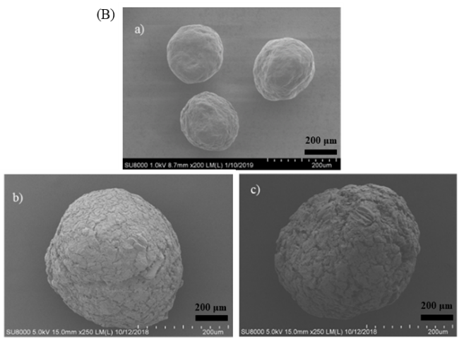
Fig S1. FTIR image of MCC, MCC-g-GMA, 3-ATAR (A);SEM image of (a) MCC; (b) MCC-g-GMA; (c) 3-ATAR(B)
The FTIR spectra of MCC, MCC-g-GMA and 3-ATAR are shown in Fig. 2. The characteristic absorption band of epoxide group at 906 cm⁻¹ and 843 cm⁻¹ and carbonyl group (C=O) at 1720 cm⁻¹ indicated that the GMA was successful grafted onto the MCC. The absorption bands of N-H at 1567 cm⁻¹ and the band of the –C–N– in the triazole rings at 1110 cm⁻¹ in 3-ATAR (Vashchenko et al. 2016). Meanwhile, C-O-C stretching vibration in epoxide ring decreased. Furthermore, the increase in intensity of the band around 3405 cm^{–1} in the spectrum of 3-ATAR can attribute to the combination and overlap of -OH and NH (in the triazole ring) (Wrzosek and Bukowska 2007; Moghaddam et al. 2019). The microstructure of sample was observed by SEM and shown in Fig. 5, it can be clearly seen that all exhibits sphere-like shape but various surface morphology, and some larger gaps and the bigger microsphere after opening reaction were appeared on the fracture surface (Fig 2B, b, c). 3-ATAR exhibited a spherical shape with a diameter about 300 μm.

Table S1. Kinetic parameter of Re(VII) adsorption onto 3-ATAR
Parameter | 3-ATAR
q_{e,exp} / (mg·g⁻¹) | 16.83
t_{e} / (min) | 45
Langmuir Model
q_{e,est} / (mg·g⁻¹) | 16.45
k₁ / (g·mg⁻¹·h⁻¹) | 0.1671
R² | 0.9405
Freundlich Model
q_{e,est} / (mg·g⁻¹) | 17.22
k₂ / (g·mg⁻¹·min⁻¹) | 0.01949
R² | 0.9999
Intraparticle diffusion Model
Stage 1
kint (mg·g⁻¹·min^{−0.5}) | 1.778
C (mg·g⁻¹) | 6.3826
R² | 0.9536
Stage 2
kint (mg·g⁻¹ min^{−0.5}) | 0.1024
C (mg·g⁻¹) | 15.72
R² | 0.9996
Stage 3
k_{int} (mg·g⁻¹ min^{−0.5}) | 0.02853
C (mg·g⁻¹) | 16.24
R² | 0.9996
 | Boyd film Model
K_{b} (min⁻¹) | 0.04306
Intercept | 1.207
R² | 0.9662
q_{e,est}: equilibrium adsorption capacities obtained from kinetic models
q_{e,exp}: experimental adsorption capacities at equilibrium
k₁ and k₂: Adsorption kinetic rate constants of Pseudo-first order and Pseudo-second order models, respectively;
R²: Correlation coefficient;
k_{int}: Intraparticle diffusion rate constant;
K_{b}: Boyd film diffusion rate constant;
C: Constant related to the boundary layer thickness;

Table S2 Isotherm parameters for the adsorption Re (VII) on 3-ATAR in U/Re binary system
 | Langmuir model |  |  | Freundlich model
 | q_{e}(mg g⁻¹) | k1(L mg⁻¹) | R² | k₂ / (mg/g)/(mg/l)1/n) | n | R²
3-ATAR | 146.4 | 0.025 | 0.9870 | 12.71 | 2.425 | 0.9942

Reference
Boyd GE, Adamson AW, Myers LS (1947) The Exchange Adsorption of Ions from Aqueous Solutions by Organic Zeolites. II. Kinetics. J Am Chem Soc 69:2836–2848. https://doi.org/10.1021/ja01203a066
Freundlich HMF (1906) Over the adsorption in solution. J Phys Chem 57:1100–1107
Ho YS, McKay G (1998) A Comparison of chemisorption kinetic models applied to pollutant removal on various sorbents. Process Saf Environ Prot 76:332–340. https://doi.org/10.1205/095758298529696
Langmuir I (1917) The Adsorption of Gases on Plane Surfaces of Glass, Mica and Platinum. J Am Chem Soc 40:. https://doi.org/10.1021/ja02242a004
Moghaddam RH, Dadfarnia S, Shabani AMH, Tavakol M (2019) Synthesis of composite hydrogel of glutamic acid, gum tragacanth, and anionic polyacrylamide by electron beam irradiation for uranium (VI) removal from aqueous samples: Equilibrium, kinetics, and thermodynamic studies. Carbohydr Polym 206:352–361. https://doi.org/10.1016/j.carbpol.2018.10.030
Reichenberg D, McCauley D (1955) Properties of ion-exchange resins in relation to their structure. Part VII. Cation-exchange equilibria on sulphonated polystyrene resins of varying degrees of cross-linking. J Chem Soc 3:. https://doi.org/10.1039/jr9550002741
Vashchenko O V., Khomenko DM, Doroshchuk RO, et al (2016) Structure and Fluorescence Properties of Uranyl Ion Complexes with 3-(2-Hydroxyphenyl)-5-(2-Pyridyl)-1,2,4-Triazole Derivatives. Theor Exp Chem 52:38–43. https://doi.org/10.1007/s11237-016-9448-8
W.J. Weber JCM (1963) Kinetics of Adsorption on Carbon from Solution. J Sanit Eng Div 89:31–40
Wrzosek B, Bukowska J (2007) Molecular structure of 3-amino-5-mercapto-1,2,4-triazole self-assembled monolayers on Ag and Au surfaces. J Phys Chem C 111:17397–17403. https://doi.org/10.1021/jp075442c

