Supplemental Files
This supplement details the study materials used in the energy estimation task described in the paper “Erring on the side of caution: People misperceive energy consumption metrics more when energy goals are not achieved”.
Experiment 1a
In each condition, manipulated within-subjects, participants were given the following vignette:
Your team at work set a target for recommended electricity use of up to [quantity and unit]/month. The speedometer represents your team’s usage for the month.

Unit: kWh, target value = 5200 kWh/month
 | 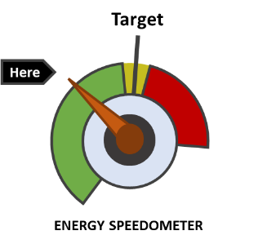 | 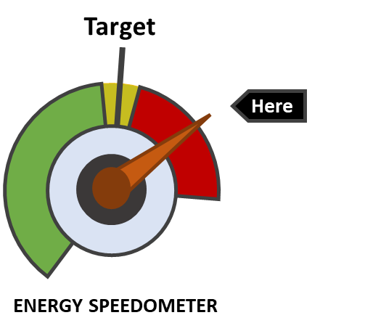
Looking at the two images, how many kWh do you think your team has used? (Please give a number)

Unit: £, target value = £750
Looking at the two images, how much do you think your team has spent? (Please give a number)

Experiment 1b
In each condition (units manipulated within-subjects, reference point manipulated between-subjects), participants were given the following vignette:
Your team at work set a target for recommended electricity use of up to [quantity and unit]/month. The speedometer represents your team’s usage for the month.
Looking at the image below, how much do you think your team has spent? (Please give a number).
The values and stimuli for the 3 units and 2 reference points were (each figure always presented on a separate page):
 | Reference point: below target | Reference point: above target
Target unit: kWh | 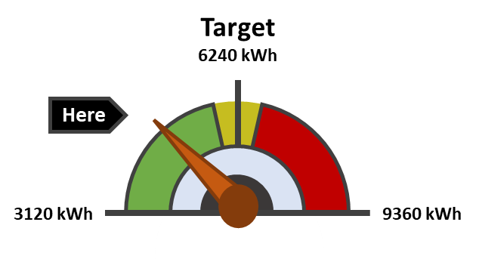 | 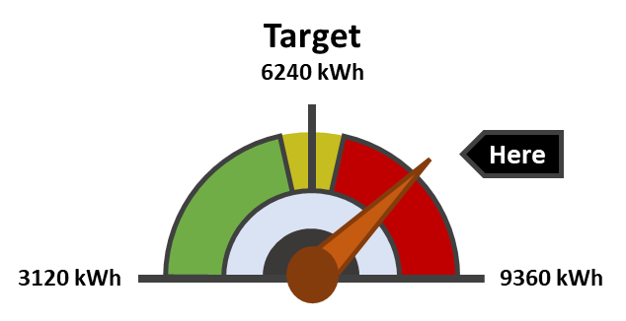
Target unit: £ | 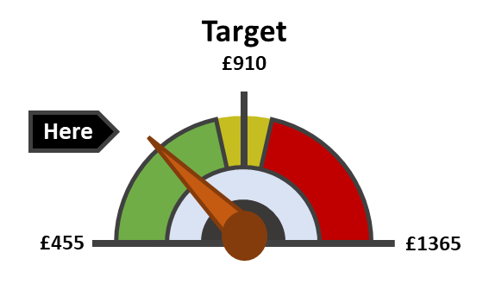 | 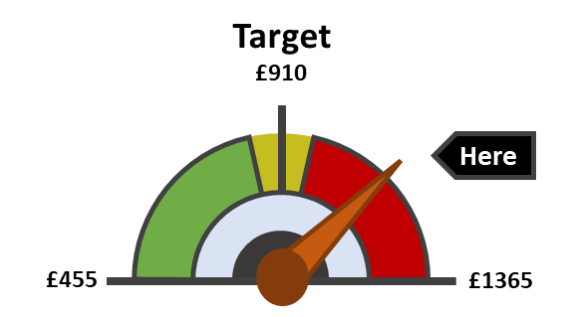
Target unit: kg CO₂ | 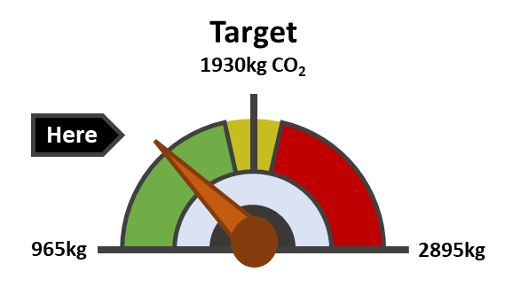 | 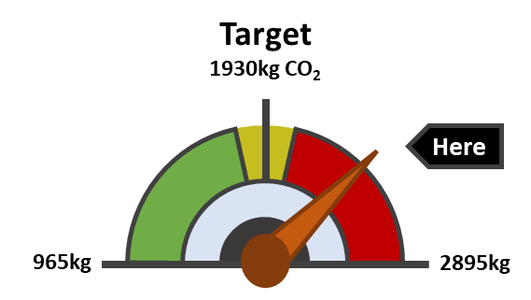

Experiment 2a
In each condition (units manipulated within-subjects, reference point manipulated between-subjects), participants were given the following vignette:
Your team at work set a target for recommended electricity [use/savings] of up to [quantity and unit]. The speedometer represents your team’s [consumption/savings] for the month relative to the [budget/target].
Looking at the image below, how much do you think your team has [spent/saved]? (Please give a number).
The values and stimuli for the 3 units and 2 goal types were (each figure always presented on a separate page):
 | Goal type: Minimisation (budget) | Goal type: Maximisation (savings)
Target unit: kWh | 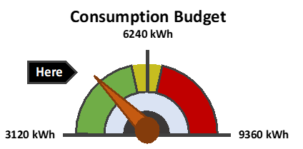 | 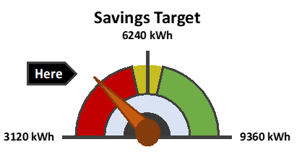
Target unit: £ | 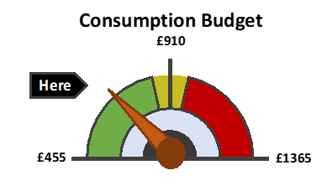 | 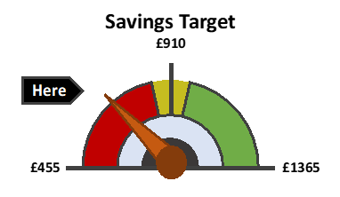
Target unit: kg CO₂ | 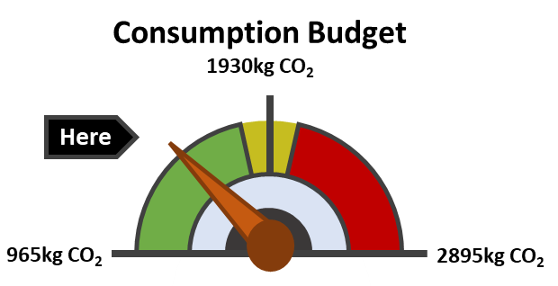 | 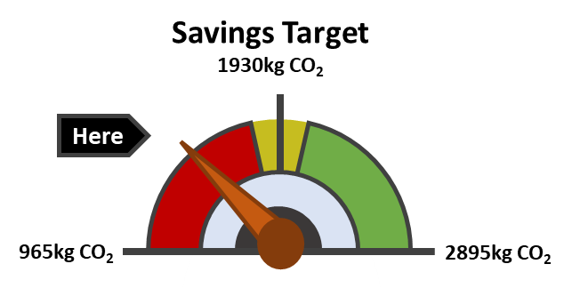

Experiment 2b
In each condition (units manipulated within-subjects, reference point manipulated between-subjects), participants were given the following vignette:
Your team at work set a target for recommended electricity [use/savings] of up to [quantity and unit]. The speedometer represents your team’s [consumption/savings] for the month relative to the [budget/target].
Looking at the image below, how much do you think your team has [spent/saved]? (Please give a number).
The values and stimuli for the 3 units and 2 goal types were (each figure always presented on a separate page):
 | Goal type: Minimisation (budget) | Goal type: Maximisation (savings)
Target unit: kWh | 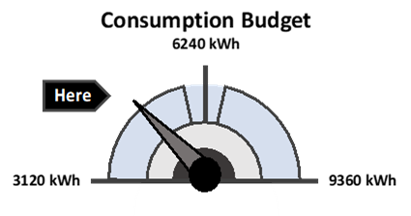 | 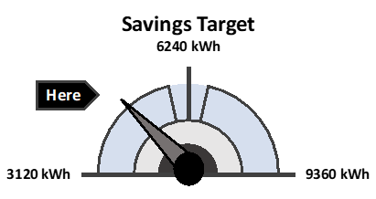
Target unit: £ | 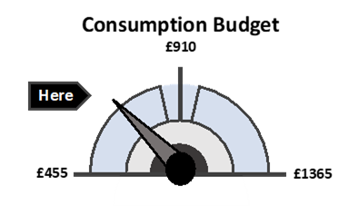 | 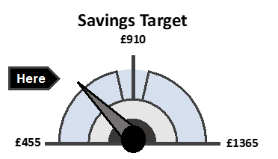
Target unit: kg CO₂ | 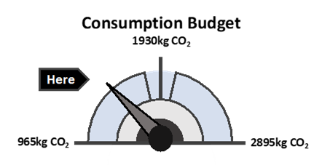 | 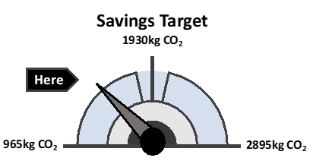

Training questions (presented before energy estimation task)
The following training questions were used in Experiments 1b, 2a and 2b. Participants had to correctly answer the training questions before proceeding to the energy estimation task.
Experiment 1b
Your team at work set a target for recommended electricity use. The speedometer represents your team’s usage for the month. Looking at the two images, which image shows that…
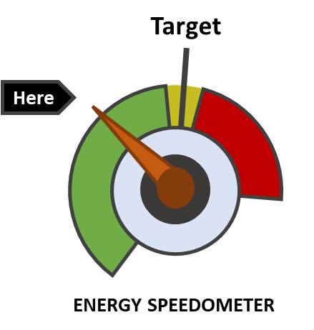
The team achieved target (did not exceed the recommended energy use)
The team did not achieve target (exceeded the recommended energy use)
To confirm you understand, please select the image that represents the better performance against target.

Experiment 2a
Minimisation goal condition:
The speedometer represents electricity consumption for the month against a budget. To show that you understand the information, please look at the two images, and select which image shows that …
 | 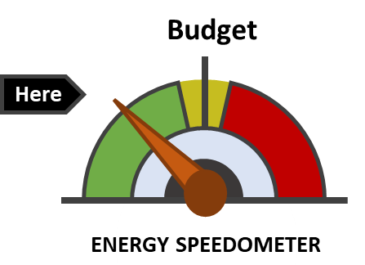 | 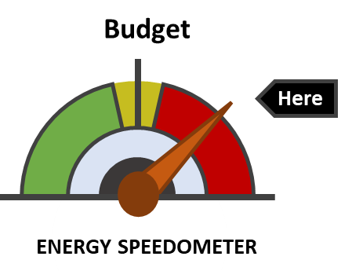
The budget goal was achieved
The budget goal was not achieved
To confirm you understand, please select the image that represents the better performance against budget

Maximisation goal condition:
The speedometer represents electricity consumption for the month against a target. To show that you understand the information, please look at the two images, and select which image shows that …
 | 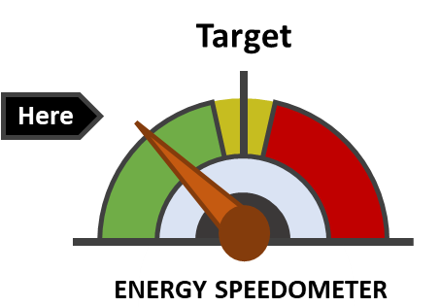 | 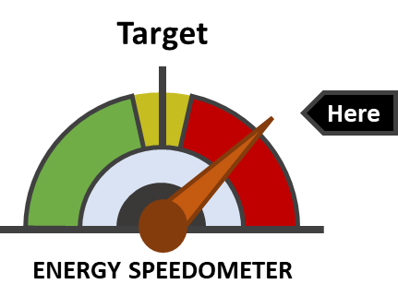
The target was achieved
The target was not achieved
To confirm you understand, please select the image that represents the better performance against target
Experiment 2b
Minimisation goal condition:
The below speedometers represent electricity consumption for two different companies for the month against a budget.
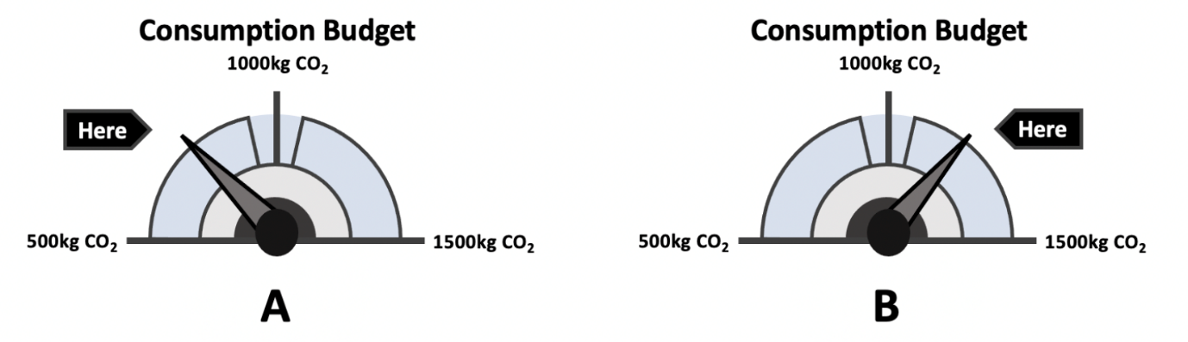
To show that you understand the information, please look at the two images, and select the company that…
 | Company A | Company B
Was within the budget
Exceeded the budget
Was the better performing company against budget

Maximisation goal condition:
The below speedometers represent electricity savings for two different companies for the month against a target.
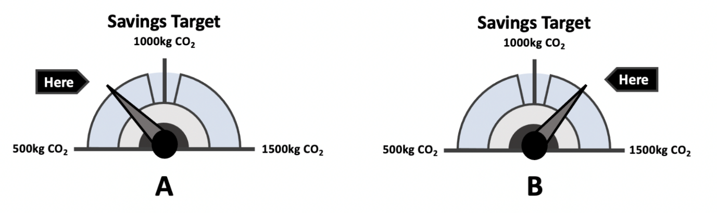
To show that you understand the information, please look at the two images, and select the company that…
 | Company A | Company B
Achieved the target
Did not achieve the target
Was the better performing company against target

Understanding check question (presented after energy estimation task)
The following two understanding check questions were used in Experiment 2b.
Minimisation goal condition:
- Looking at the figure, has the energy consumption stayed within the budget?
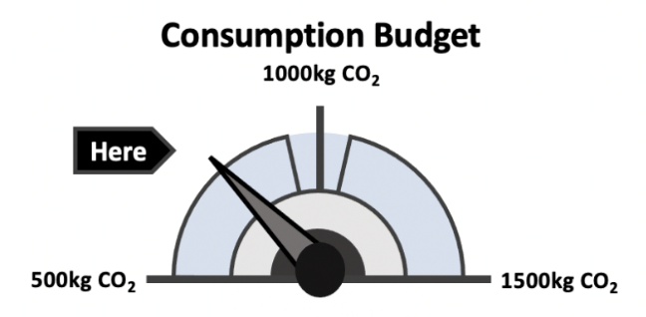
- Yes [correct answer]
- No
- Unsure

- Looking at the figure, how much energy has been consumed?
- 250 kg CO2
- 750 kg CO2 [correct answer]
- 1000 kg CO2
- 1250 kg CO2

Maximisation goal condition:
- Looking at the figure, has the savings target been met?
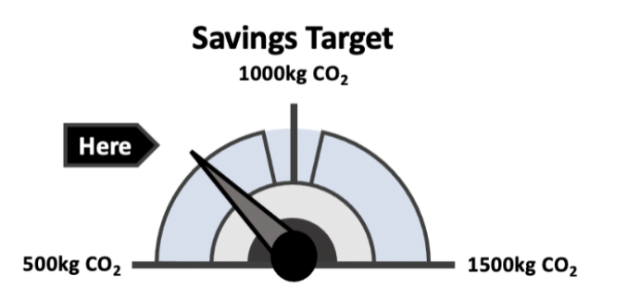
- Yes
- No [correct answer]
- Unsure

- Looking at the figure, how much energy has been saved?
- 250 kg CO2
- 750 kg CO2 [correct answer]
- 1000 kg CO2
- 1250 kg CO2

