Supplementary Data 1

P-glycoprotein exacerbates brain injury following experimental cerebral ischemia by promoting pro-inflammatory microglia activation

Yan Chen¹, Xuan Fei¹, Ge Liu¹, Xiang Li¹, Liangliang Huang¹, Lele Zixin Yang², Yunman Li^{1*}, Baohui Xu³, Weirong Fang^{1*}.

¹ State Key Laboratory of Natural Medicines, School of Basic Medical Sciences and Clinical Pharmacy, China Pharmaceutical University, Nanjing, Jiangsu 210009, P. R. China
² Penn State University, University Park 16802
³ Department of Surgery, Stanford University School of Medicine, Stanford, CA 94305, USA

*All correspondence to:
Yunman Li, Ph.D and Weirong Fang, Ph.D
Mailbox 207, Tongjiaxiang 24, Nanjing, Jiangsu 210009, P. R. China
Tel/Fax: 86-25-83271173.
E-mail: yunmanlicpu@hotmail.com (Yunman Li), weirongfang@163.com (Weirong Fang)
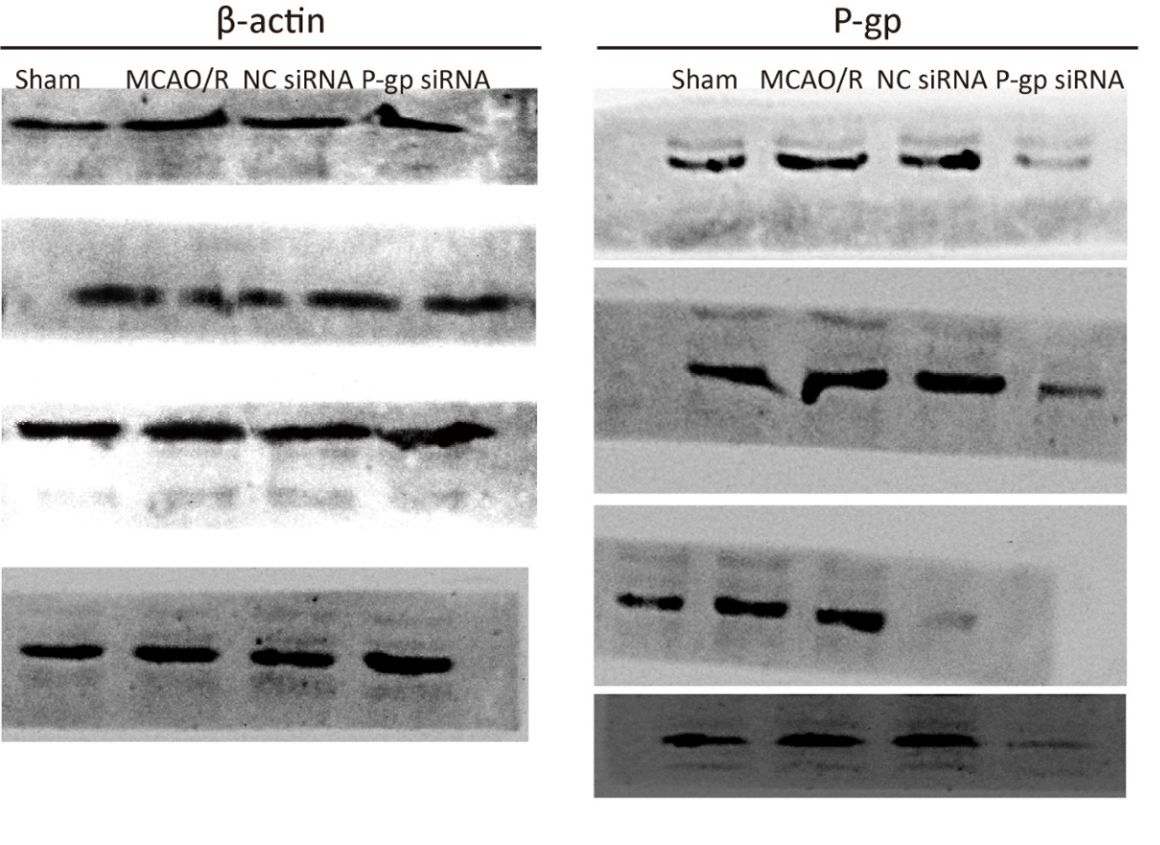
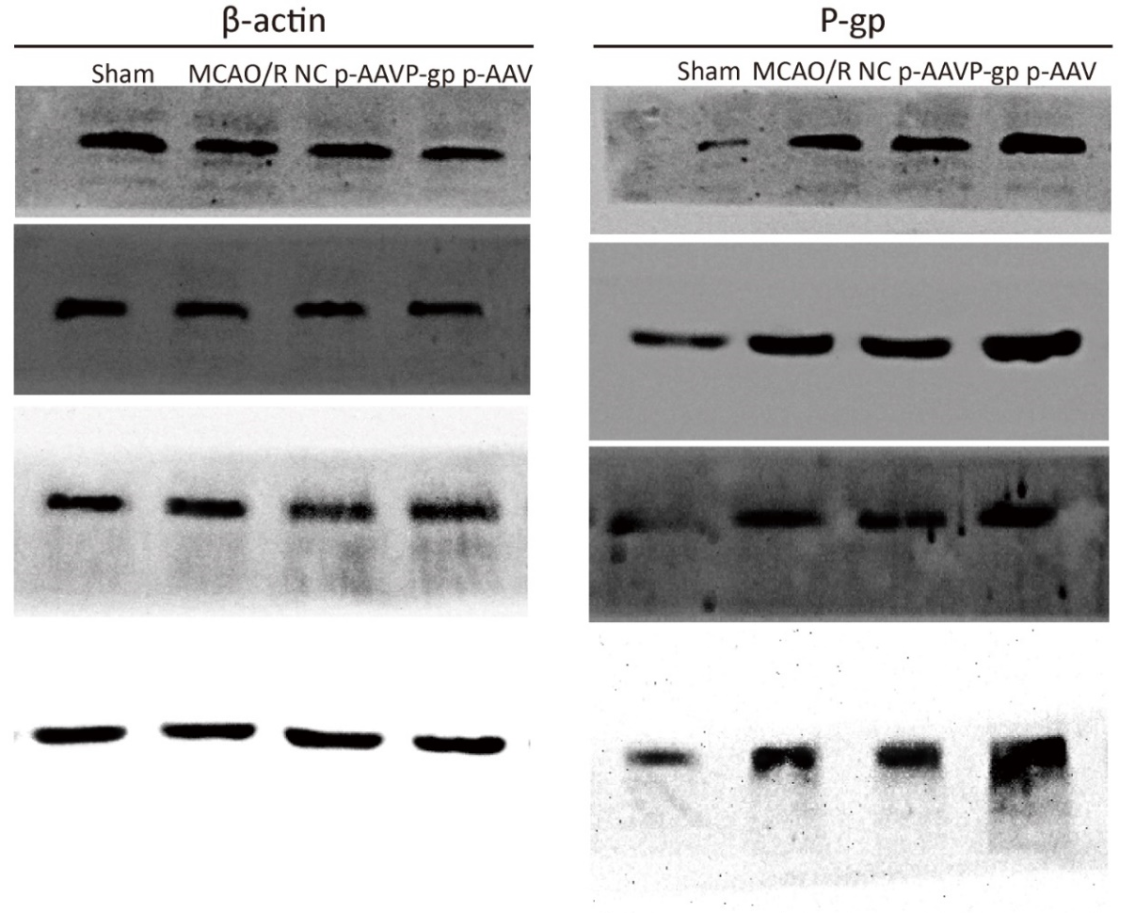
Supplementary Figure 1. Original images for western blot analysis of P-gp and β-actin in ischemic cortex in Figure 1A and 1B.
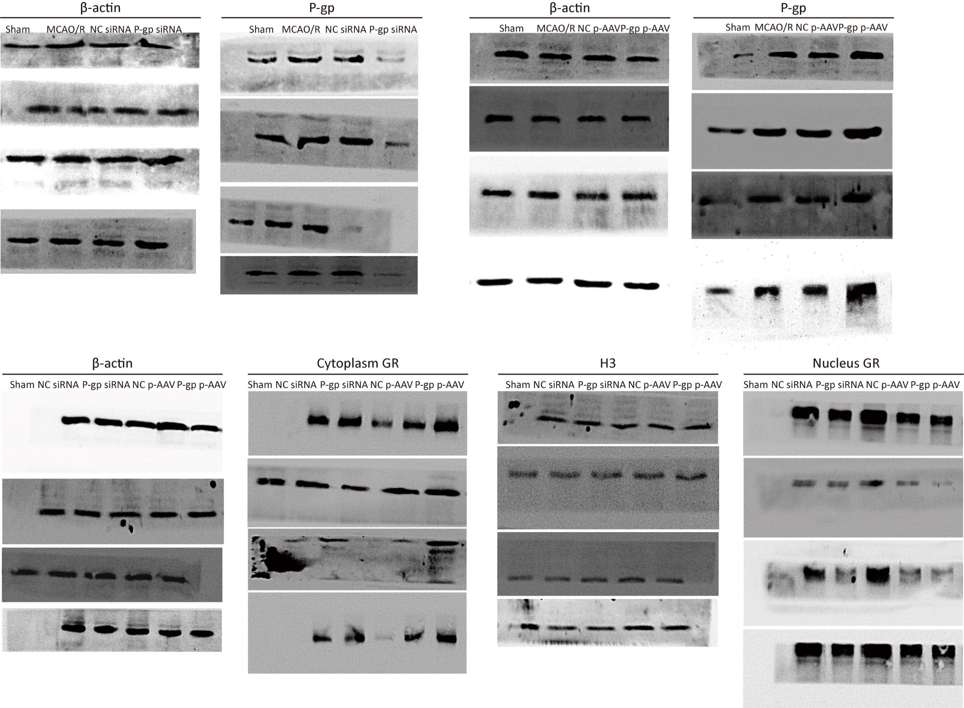
Supplementary Figure 2. Original images for western blot analysis of GR, H3, and β-actin in ischemic cortex in Figure 4C.
Supplementary Figure 3. Original images for western blot analysis of P-gp and β-actin in bEnd.3 cells in Figure 5B and 5C.
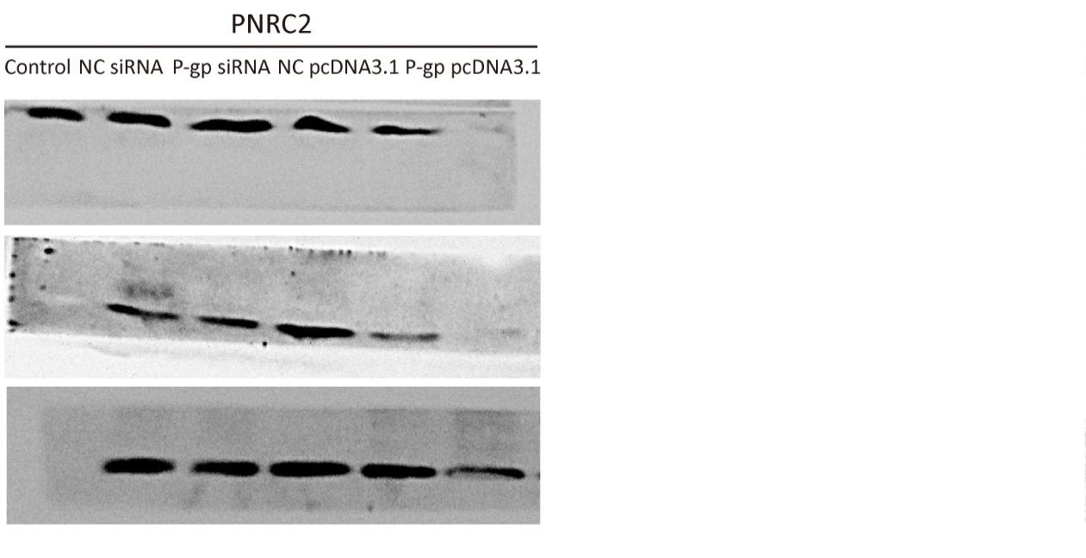
Supplementary Figure 4. Original images for western blot analysis of GR, H3, DCP1A, UPF1, PNRC2, and β-actin in bEnd.3 cells in Figure 8C and 8F.

