One-dimensional nanostructured vanadium oxides with single-crystalline structure synthesized by cellulose nanocrystal-template-assisted hydrothermal method for Li-ion battery cathodes

Chulmin Youn^{a,c}, Wonsuk Ko^{b}, Ayoung Jo^{c}, Joonbong Lee^{c}, Sang Young Yeoª, Yongho Seo^{c}, Jonghun lee^{e,f}, Byoung-Sun Lee^{d*}, Jongsoon Kim^{b*}, Taekjib Choi^{c*}
ªAdvanced Textile R&D Department, Korea Institute of Industrial Technology, 143 Hanggaul-ro, Sangnok-gu, Ansan-si, Gyeonggi-do, 15588, Republic of Korea
^{b}Department of Energy Science, Sungkyunkwan University, 2066 Seobu-ro, Jangan-gu, Suwon-si, Gyeonggi-do, 16419, Republic of Korea
^{c}Hybrid Materials Research Center, Department of Nanotechnology and Advanced Materials Engineering, Sejong University, 209 Neungdong-ro, Gwangjin-gu, Seoul, 05006, Republic of Korea
^{d}School of Polymer System/Department of Fiber Convergence Material Engineering, College of Engineering, Dankook University, 152 Jukjeon-ro, Suji-gu, Yongin-si, Gyeonggi-do, 16890, Republic of Korea
^{e}Division of Automotive Technology, Daegu Gyeongbuk Institute of Science and Technology, 333 Techno Jungang-daero, Hyeonpung-eup, Dalseong-gun, Daegu, 42988, Republic of Korea
^{f}Department of interdisciplinary Engineering, Graduate School, Daegu Gyeongbuk Institute of Science and Technology, 333 Techno Jungang-daero, Hyeonpung-eup, Dalseong-gun, Daegu, 42988, Republic of Korea

*Corresponding authors:
E-mail: tjchoi@sejong.ac.kr (T. choi)
jongsoonkim@skku.edu (J. Kim)
sp6002@snu.ac.kr (B.-S. Lee)

This supporting information contains the following sections:
Fig. S1. TEM image of TEMPO-oxidized cellulose nanocrystal.
Fig. S2. Hydrothermal synthesis process for polycrystalline VO₂(B) NPs without TCNC and various vanadium oxide with TCNC.
Fig. S3. Schematic diagram explaining step-by-step processes of nuclei formation, one-dimensional nanostructure formation, and one-dimensional nanostructure VO₂(B) formation during the hydrothermal synthesis process.
Fig. S4. FESEM image showing the diameters of V₂O₅nH₂O and VO₂(B) NBs.
Fig. S5. XPS spectra of a) V₂O₅nH₂O and b) VO₂(B) NBs (C1s in the range of 281–291 eV).

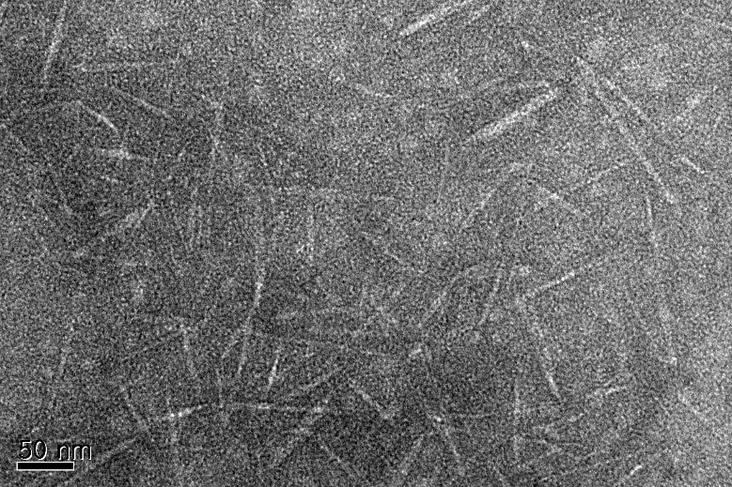
Fig. S1 TEM image of TEMPO-oxidized cellulose nanocrystal.

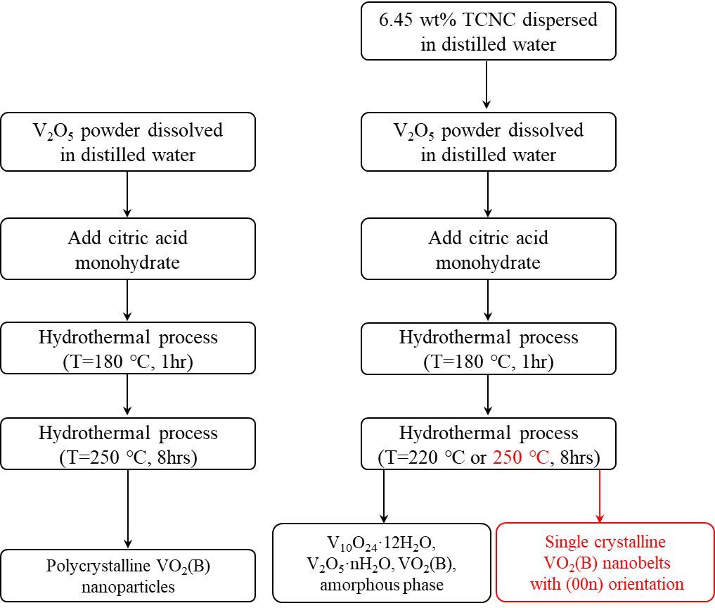
Fig. S2 Hydrothermal synthesis process for polycrystalline VO₂(B) NPs without TCNC and various vanadium oxide with TCNC.

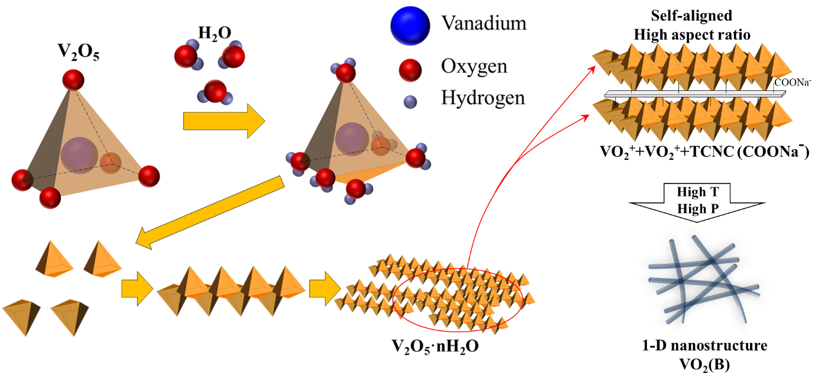
Fig S3 Schematic diagram explaining step-by-step processes of nuclei formation, one-dimensional nanostructure formation, and one-dimensional nanostructure VO₂(B) formation during the hydrothermal synthesis process.

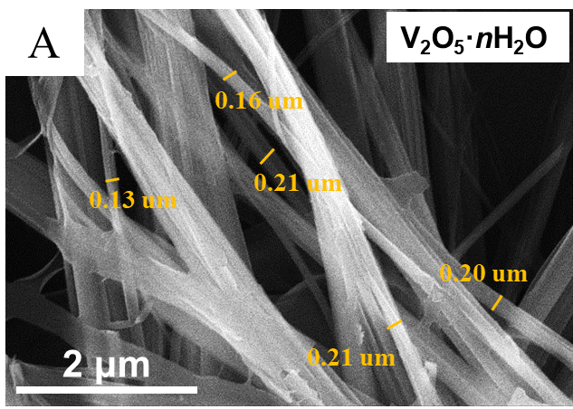 | 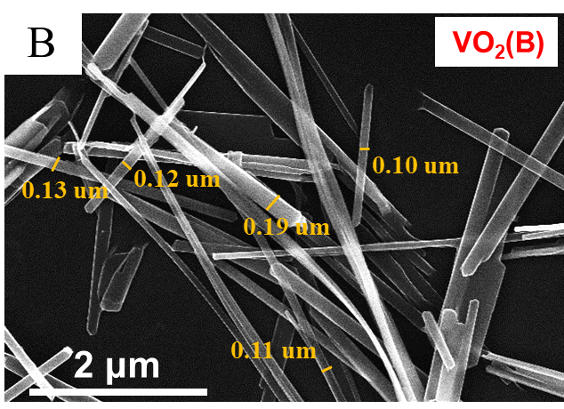
Fig. S4 FESEM image showing the diameters of V₂O₅nH₂O and single crystalline VO₂(B) NBs.

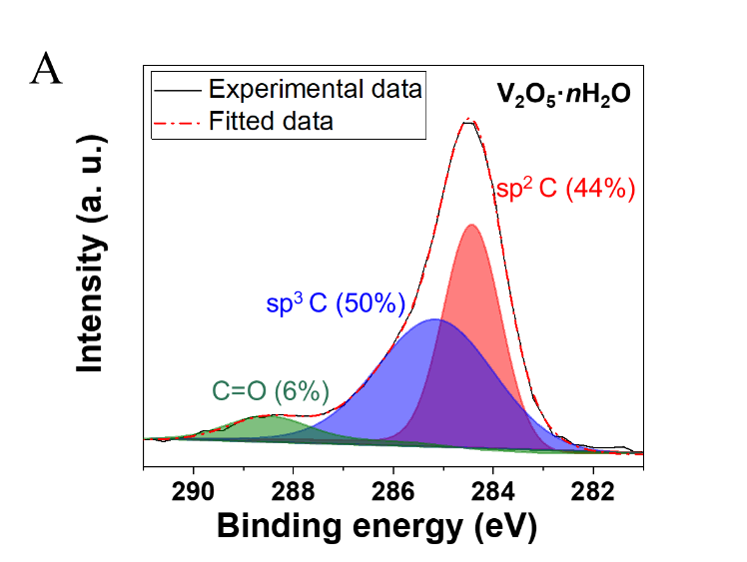 | 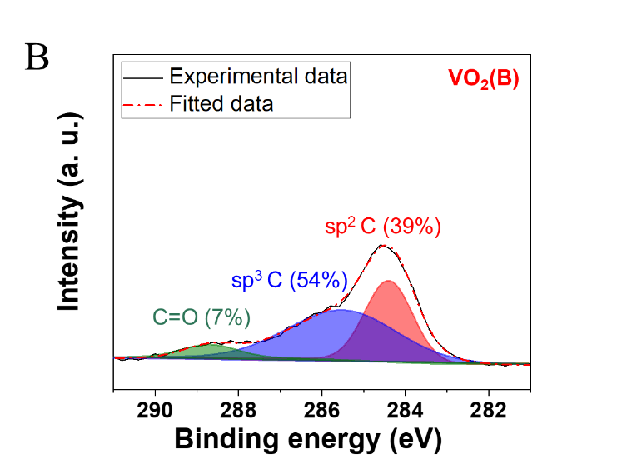
Fig. S5 XPS spectra of a) V₂O₅nH₂O and b) single crystalline VO₂(B) NBs (C1s in the range of 281–291 eV).

