To bait or not to bait? Optimizing the use of adult mosquito traps for monitoring arbovirus vector populations in La Réunion Island
Supplementary information
Iris Claudel^{1,a}, Ronan Brouazin^{1,a}, Renaud Lancelot^{2,3}, Louis-Clément Gouagna⁴, Marlène Dupraz^{2,3}, Thierry Baldet^{2,3}, Jérémy Bouyer^{2,5}*
¹ UMR Mivegec (Maladies Infectieuses et Vecteurs: Écologie, Génétique, Évolution et Contrôle), IRD-CNRS-Univ. Montpellier, 97410 Saint-Pierre, La Réunion
² UMR Astre (Animals, Health, Territories, Risks, Ecosystems), Cirad, Inrae, Univ. Montpellier, 34398 Montpellier, France
³ Cirad, UMR Astre, 97491 Sainte Clotilde, La Réunion
⁴ UMR Mivegec, 34394 Montpellier, France
⁵ Insect Pest Control Laboratory, Joint FAO/IAEA Programme of Nuclear Techniques in Food and Agriculture, IAEA Vienna, Wagramer Strasse 5, 1400 Vienna, Austria
ª These authors contributed equally to the work
(*) Corresponding author: Jérémy Bouyer jeremy.bouyer@cirad.fr

1 Figure
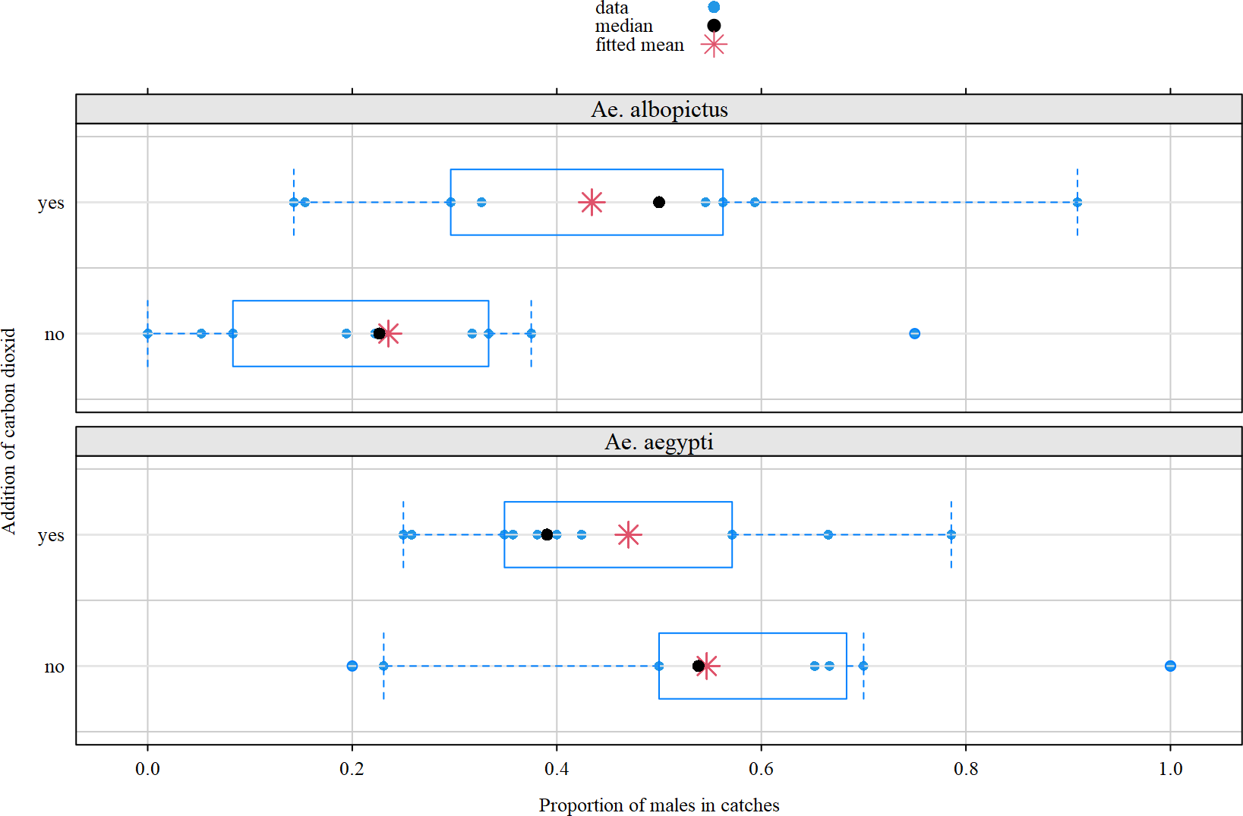
Fig. S1. Proportion of males mosquitoes in catches, according to mosquito species and CO₂-baiting status of BG-Sentinel traps during a field experiment implemented in 2020, La Réunion Island (mosquito data were aggregated by date to avoid infinite data; data from BG-Lure-baited traps were excluded; fitted means were estimated with a beta-binomial logistic regession model)

2 Tables
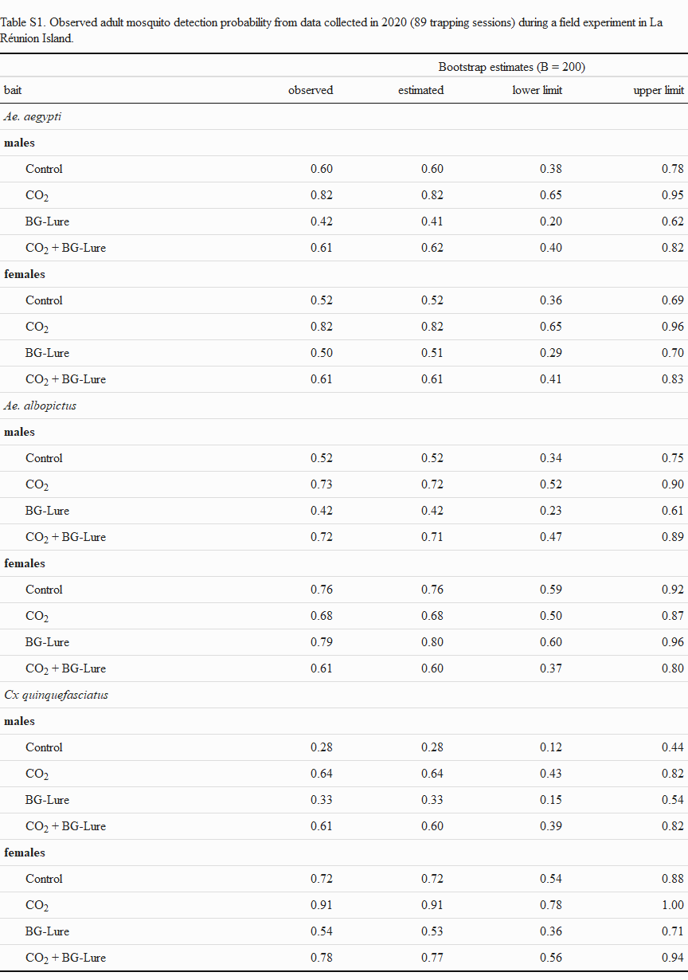
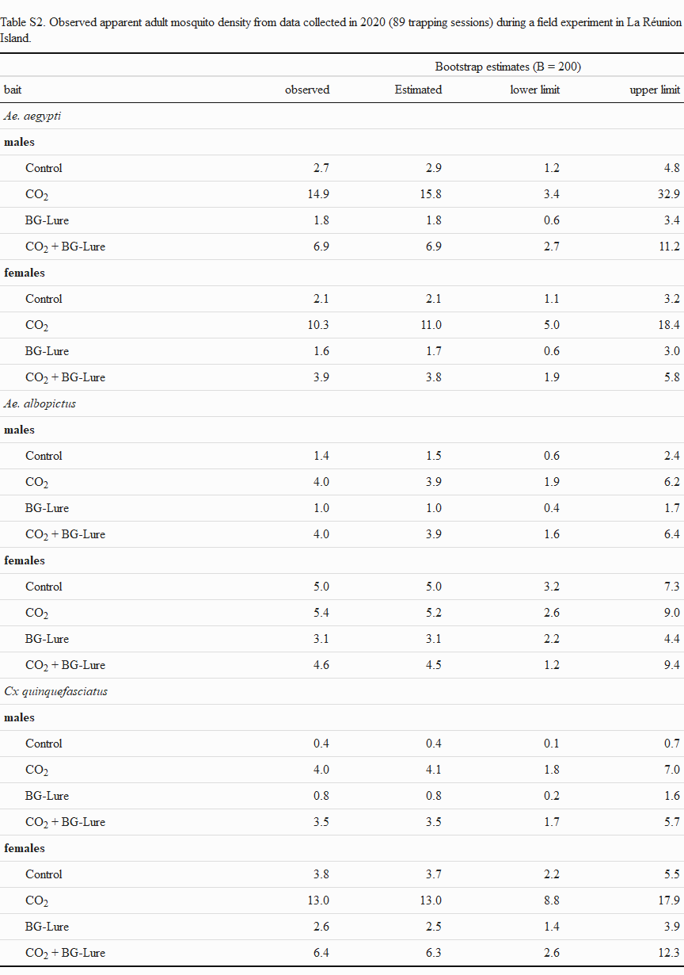
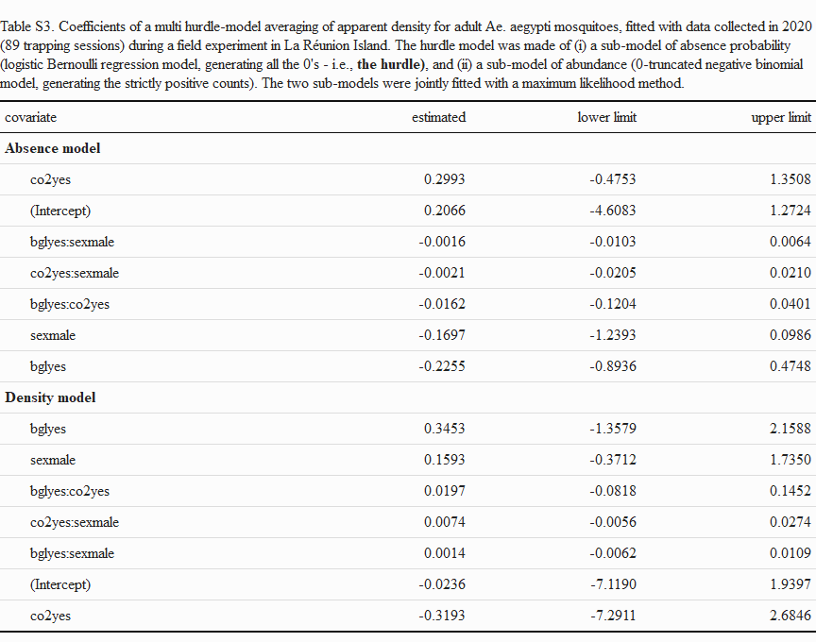

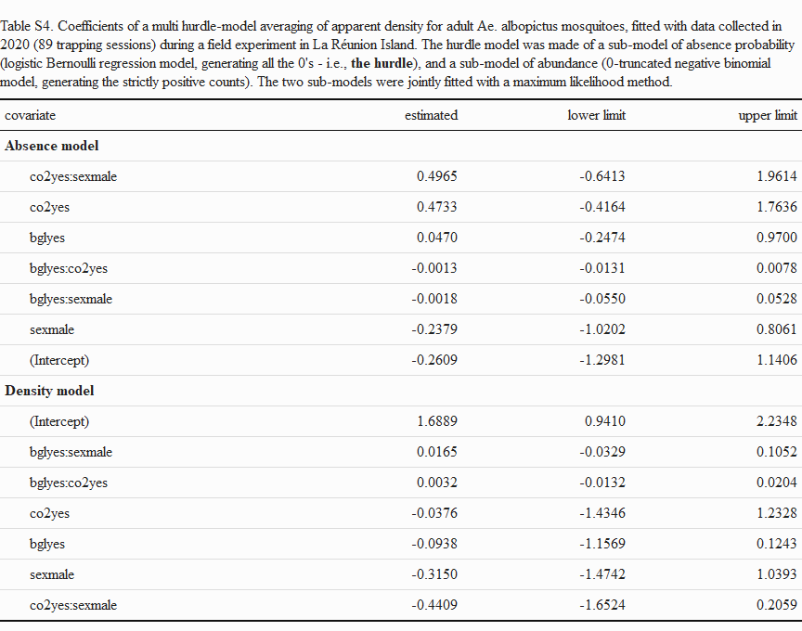
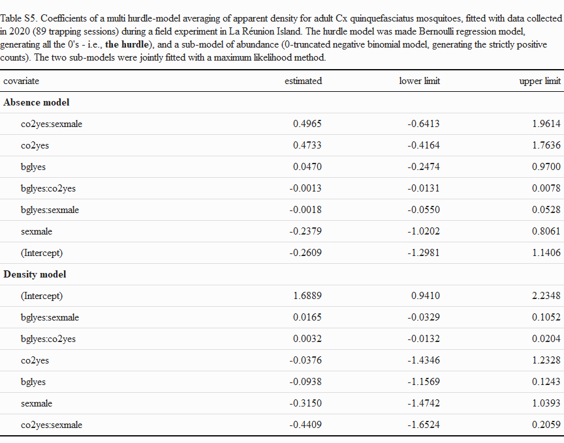

3 Instructions to reproduce the analysis
The dataset, as well as the R code to reproduce the results presented in this paper, are available in a zipped file called bgtrap.zip. To reproduce the analysis (with a computer running MS Windows OS: not tested with other OS’s), use a computer with valid and updated installations of
- the R software, and at least the knitr and rmarkdown add-on packages, available at https://cran.r-project.org/
- Imagick and ImageMagick software: https://github.com/Imagick/imagick
- pandoc software: https://pandoc.org/
- unzip bgtrap.zip in an empty folder, making sure the sub-folder structure present in the zipped file is respected. You should get the following sub-folders and files:
  - in the root folder, (i) an rmarkdown file called bgtrap.Rmd containing the dataset as well as the master R code to produce the output, i.e. an HTML ioslides presentation called bgtrap.HTML, as well as graphic files, and HTML tables, (ii) an R file called make_bgtrap.R, and (iii) a configuration file _bookdown.yml.
  - a sub-folder called src, containing two R files: (i) a file packages.R: code to install, update, and load necessary add-on R packages, and (ii) a file functions.R: the R functions written for this analysis;
  - a sub-folder called data, containing a semi-colon separated text representation of the analysed dataset;
  - two empty sub-folders called tab and figs, to store the output.
- Either use R-Studio https://www.rstudio.com/ to launch bgtrap.Rmd, or run make_bgtrap.R from within the folder where it lies. The analysis takes ca. 15 min. to complete with a DELL Laptop with co-processor Intel(R) Core(TM) i5-8350U CPU @ 1.70GHz 1.90 GHz, and 16 Go RAM.
- In case of difficulties to run th code, please contact the corresponding author, or the code author R. Lancelot (renaud.lancelot@cirad.fr)

