Supplementary information

Efficient optical plasmonic trapping-coupled Single-molecule SERS vibrational characterization of pH-dependent amylin species in aqueous milieu
Wenhao Fu†, Huanyu Chi†, Xin Dai, Hongni Zhu, Vince St. Dollente Mesias, Wei Liu*, and Jinqing Huang*

†These authors contributed equally to this work.
*Corresponding author. Email: wliu276@hku.hk (W. L.); jqhuang@ust.hk (J. H.)

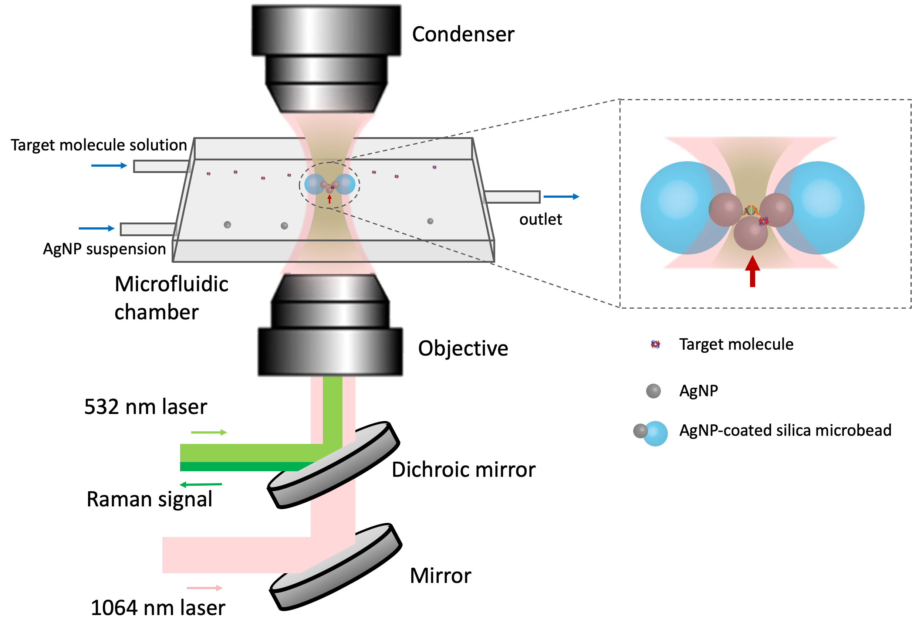
Supplementary Fig. 1. Instrumental setup of the optical plasmonic tweezers-coupled SERS platform.

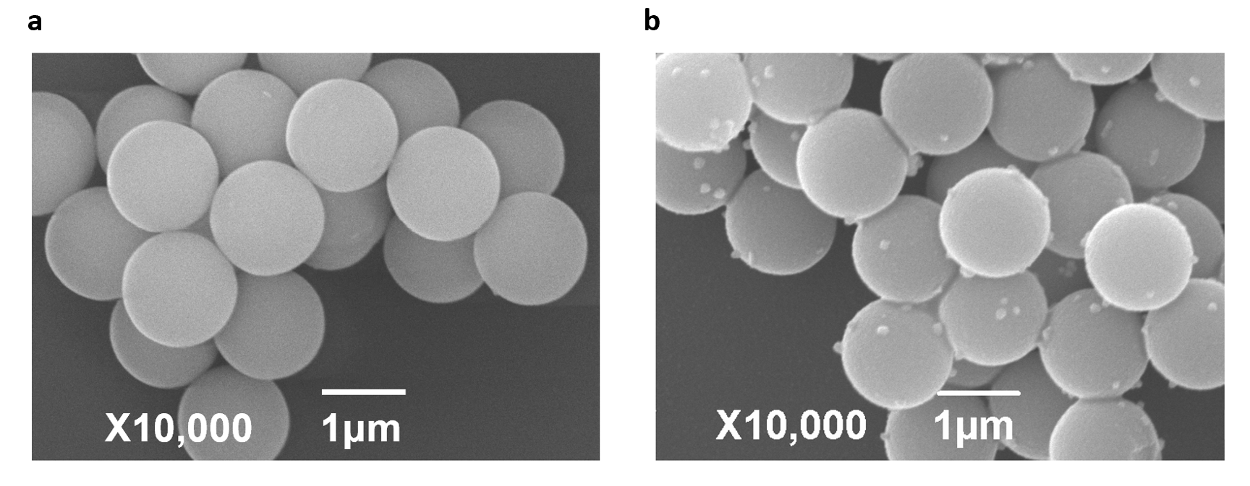
Supplementary Fig. 2. Scanning electron microscope (SEM) characterization of silica microbeads (a) and AgNP-coated silica microbeads (b).

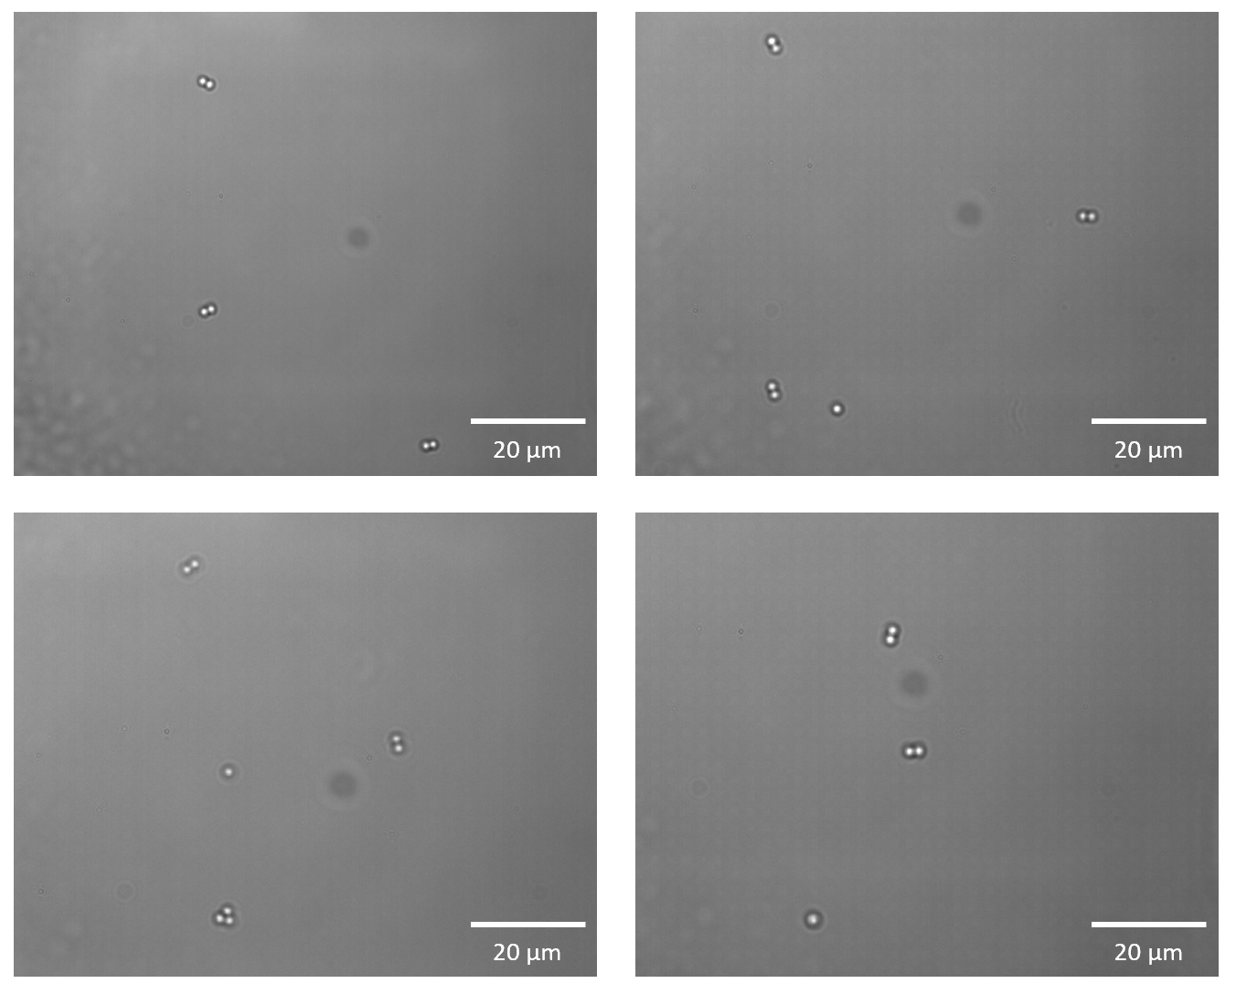
Supplementary Fig. 3. Brightfield images of the oligonucleotides-linked AgNP-coated bead assemblies deposited on the bottom surface of microfluidic chambers using the conventional microscope.

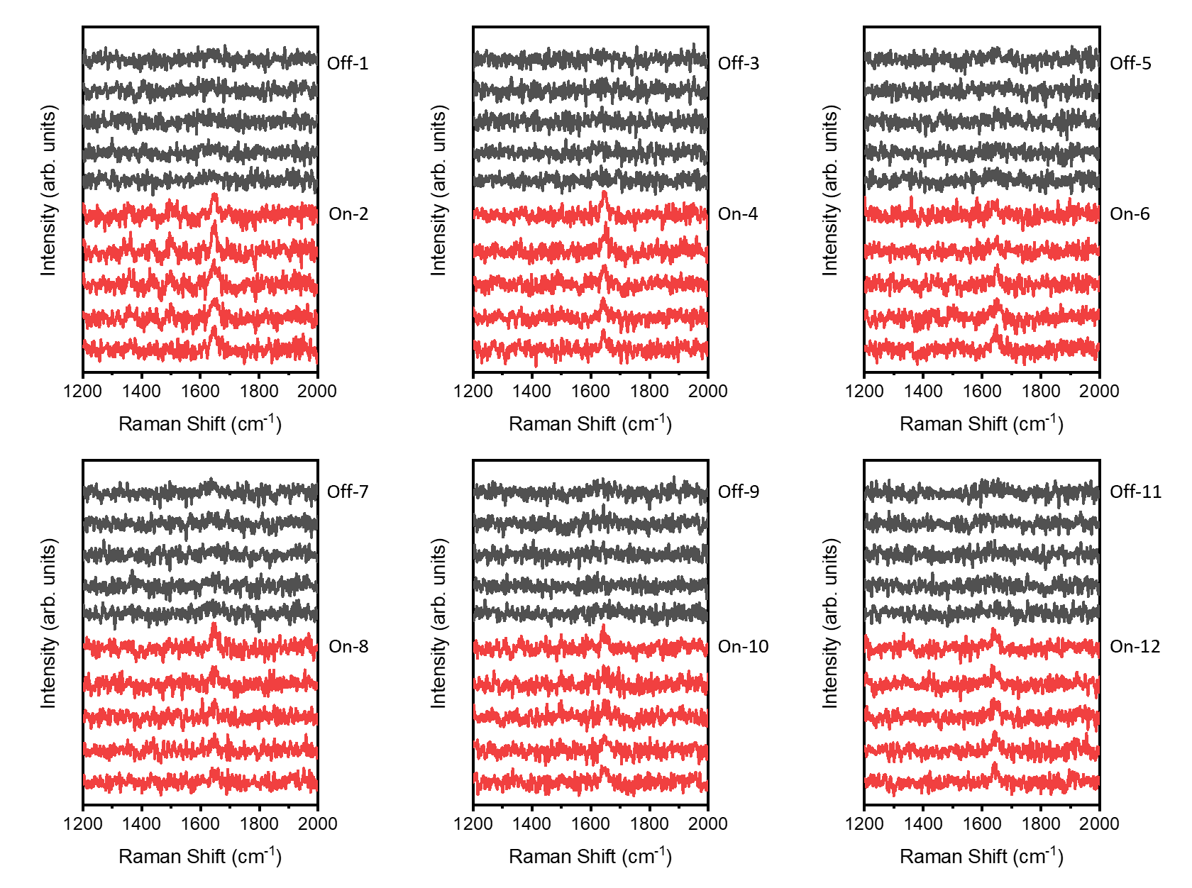
Supplementary Fig. 4. Real-time SERS spectra of 500 nM NBA acquired from the dynamic nanocavity during 12 times switching of the trapping laser. Black spectra were acquired at the off state and red spectra were acquired at the on state. Integration time: 1 s per spectrum.

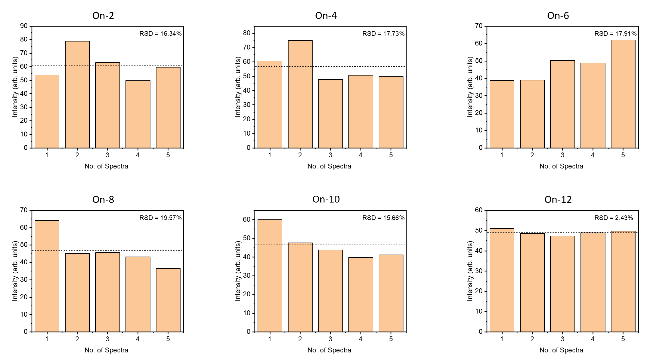
Supplementary Fig. 5. Histograms of peak intensities (1645 cm⁻¹) at each on state. Dot lines represent the average peak intensity at each on state. All the relative standard deviations (RSD) are within 20%, verifying the reproducibility of creating the dynamic nanocavity on our platform.

Supplementary Note 1. 3D-FDTD Simulation
Three-dimensional finite-difference time-domain (3D-FDTD) simulation was performed using Lumerical FDTD SOLUTIONS to simulate the intensity and distribution of electromagnetic field and caluculate the trapping force and trapping potential. A simplified model was constructed consisting of a pair of dimeric AgNP (70 nm) coated on the junction between two silica beads (1.26 μm). The interparticle gap was set as 10 nm. The dielectric properties of Ag and SiO₂ were taken from Johnson & Christy database and Palik database, respectively. The refractive index of background fluid was set as 1.33. A 532 nm Gaussian wave and a 1064 nm Gaussian wave with polarization parallel to the AgNP-coated beads dimer was injected along the z-axis. Perfectly matched layer (PML) boundary condition was used, and the mesh size in the interparticle gap was set as 0.2 nm to increase the accuracy of the simulation. An overall mesh setting with an accuracy of 5 was applied for the rest region.

Trapping force simulation
The force exerted on a AgNP in a harmonic electromagnetic field can be derived using the Maxwell Stress Tensor (MST)^{1–3}. By integrating the MST over a closed cubic surface surrounding the particle, the time-averaged force can be calculated by:
$$F= \int_{V}^{ }{fdτ= -\oint_{S}^{ }{\overset{⃡}{T}·n dS}}$$
Where $F$ is the time averaged optical force, $V$ is the volume of AgNP, $f$ is the force density, $τ$ is the unit volume. $S$ is the surface surrounding the particle, $n$ is the unit normal vector to the surface, and $\overset{⃡}{T}$ is the Maxwell Stress Tensor which can be expressed as:
$$\overset{⃡}{T}=ε_{0}εEE+μ_{0}μHH-\frac{1}{2}(ε_{0}εE^{2}+μ_{0}μH^{2})\overset{⃡}{I}$$

where $EE$ and $HH$ represent the outer products of electric field and magnetic field, $\overset{⃡}{I}$ denotes the unit tensor, and $ε$ and $μ$ are the dielectric permittivity and magnetic permeability of the surrounding medium, respectively.

Since the diameter of AgNP is much smaller than the wavelength of light, the AgNP itself can be treated as a point dipole with polarizability $α = α’ + iα’’=3V\frac{ε_{p}-ε_{m}}{ε_{p}+{2ε}_{m}}$. In this case, the trapping potential can be calculated by:
$$U= -\int{Fdr=-\frac{α’}{2}{|E|}^{2}}$$

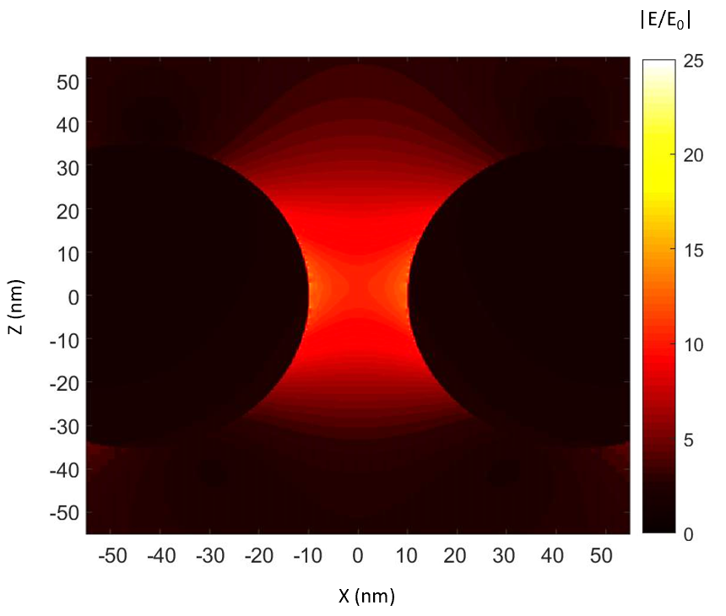
Supplementary Fig. 6. FDTD simulation of the electric field distribution in the vicinity of the AgNP-coated bead dimer upon excitation of plasmonic resonance. The region with most intense field intensity locates in the junction between two beads.

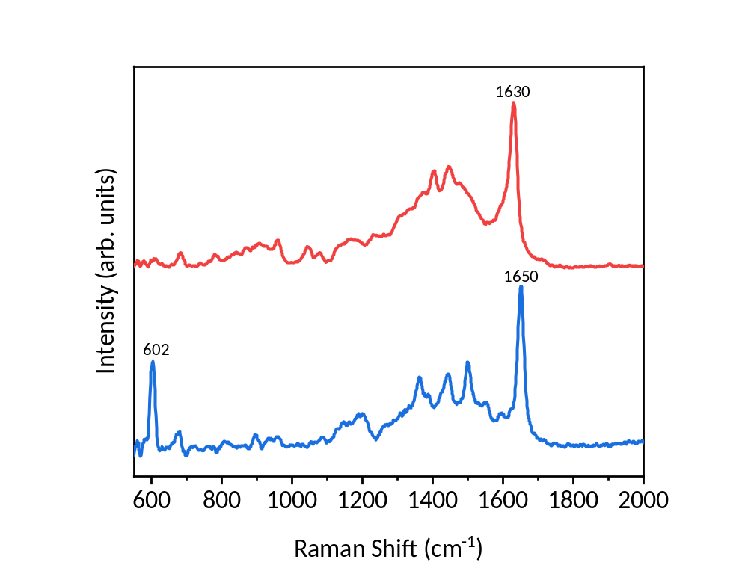
Supplementary Fig. 7. SERS spectra of MB (red) and NBA (blue) at 10⁻⁵ M as the reference. The Raman characteristics for the identification of ‘MB’ and ‘NBA’ events were marked.

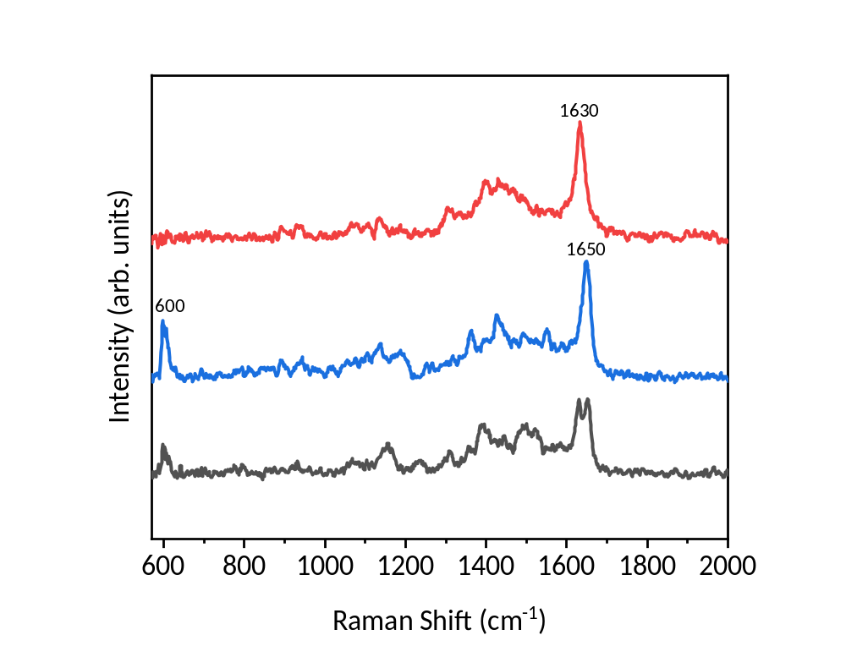
Supplementary Fig. 8. Representative full-ranged spectra of ‘single-MB’ event (red), ‘single-NBA’ event (blue) and ‘dual-MB and NBA’ event (black), corresponding to the spectra shown in Fig. 2B.

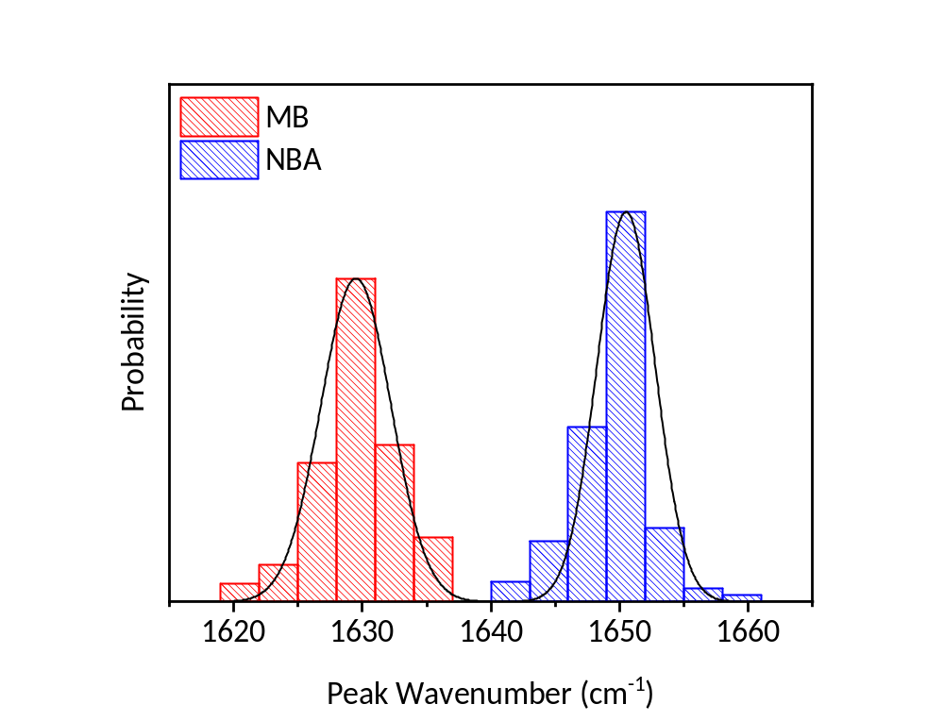
Supplementary Fig. 9. Distribution of the characteristic peak positions of ‘single-MB’ events (red), and ‘single-NBA’ events (blue) in the BiASERS experiment.

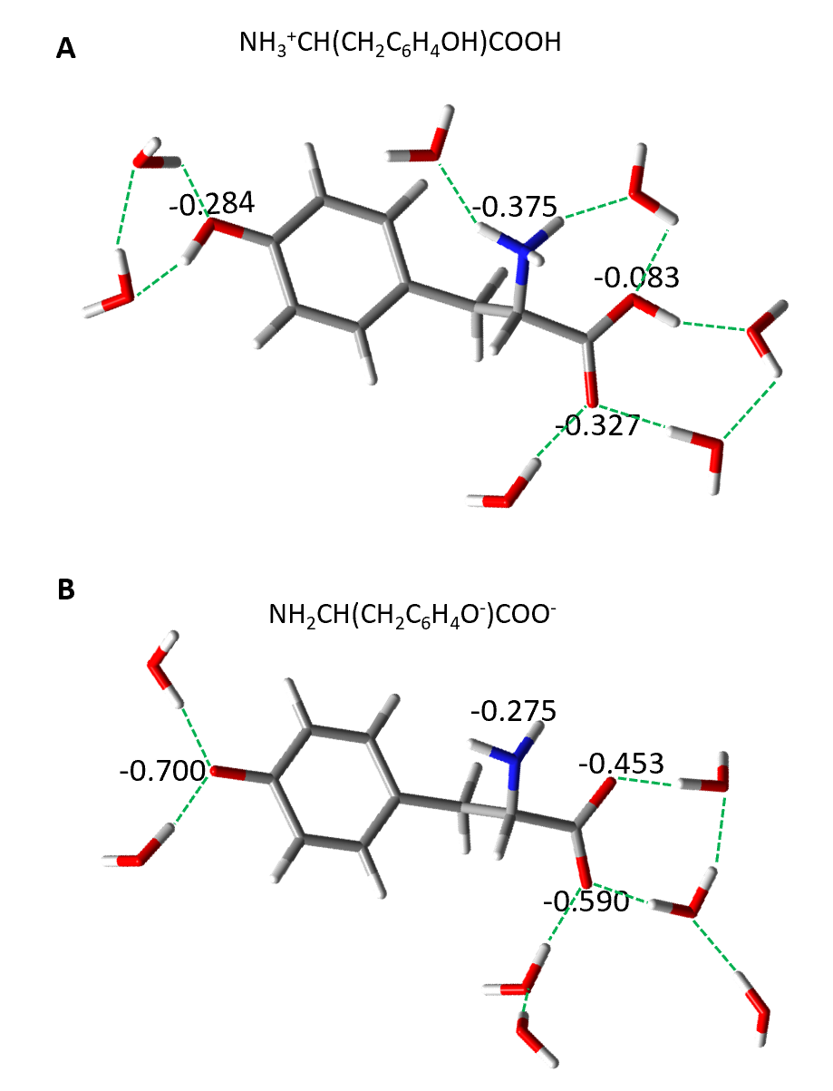
Supplementary Fig. 10. Sketch map of Tyrosine (+1) + 7 H₂O cluster (A) and Tyrosinate (-2) + 7 H₂O cluster (B). Dotted green lines represent hydrogen-bonds. The numbers denote the calculated charge of nitrogen/oxygen.

Supplementary Note 2. Density functional theory (DFT) calculation
DFT calculations were performed using the Gaussian 09 software package. The geometry optimizations and vibrational frequencies of the Tyr-H₂O clusters were computed using the hybrid B3LYP density functional level along with 6-311++ G(d,p) basis set. The construction of Tyr-H₂O clusters was initially based on B. Hernández’s work⁴ by involving seven water molecules in the vicinity to simulate the hydration states of the amino group, carboxyl group, and phenol hydroxyl group of Tyr. Electrostatic potential (ESP) analysis of Tyr (+1) and Tyr (-2) molecules was carried out by Multiwfn 3.7 code⁵ and depicted by the VDM visualization program⁶, respectively.

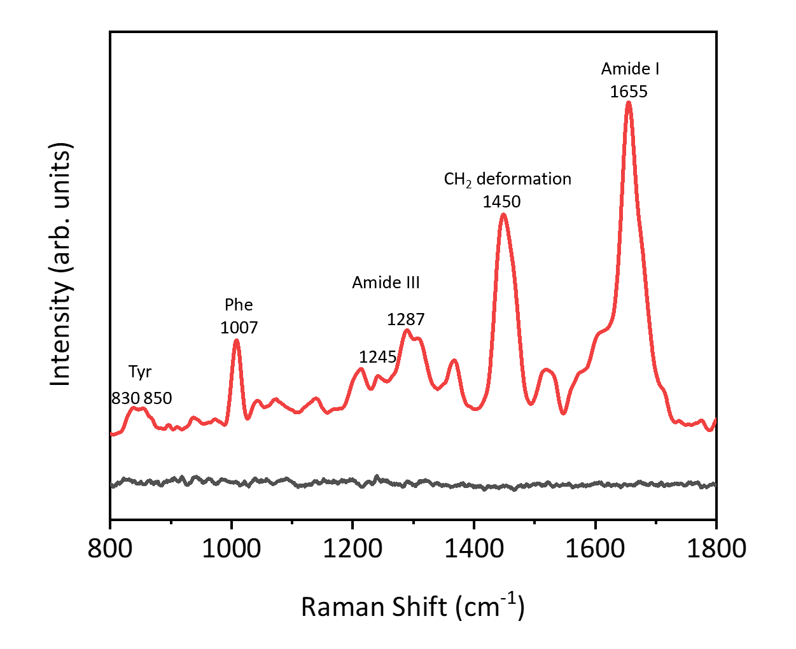
Supplementary Fig. 11. Spontaneous Raman spectrum (black) and SERS spectrum (red) of 10 μM hIAPP, showing the SERS enhancement to overcome the detection threshold of spontaneous Raman spectroscopy. The SERS spectrum (red) of 10 μM hIAPP is the same as the data shown in Fig. 4D.

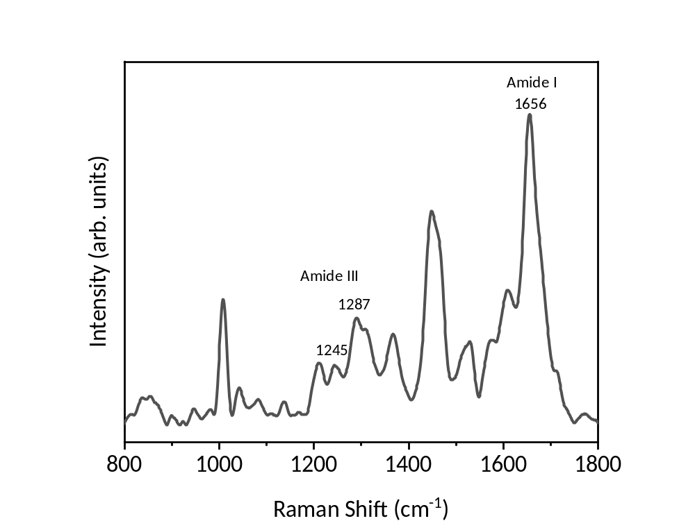
Supplementary Fig. 12. SERS spectrum of hIAPP incubated at pH 5.5 for 24 h.

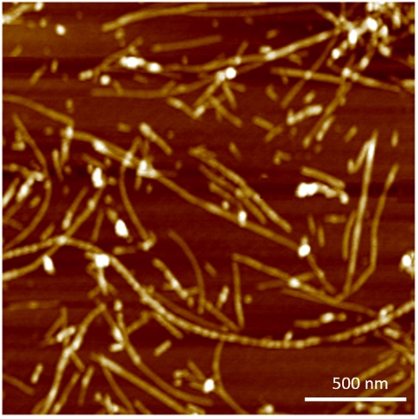
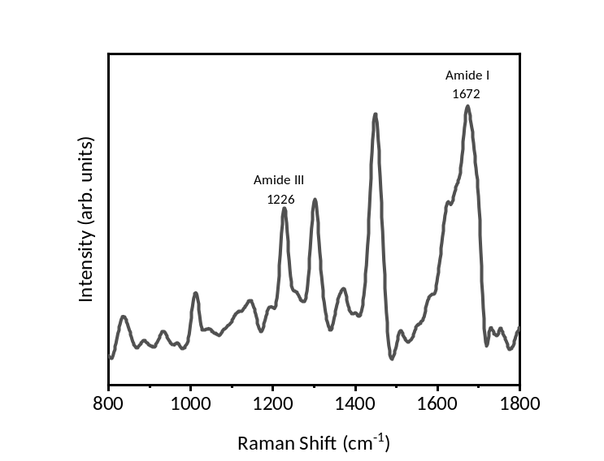
Supplementary Fig. 13. SERS spectrum and AFM image of hIAPP incubated at pH 7.4 for 24 h.

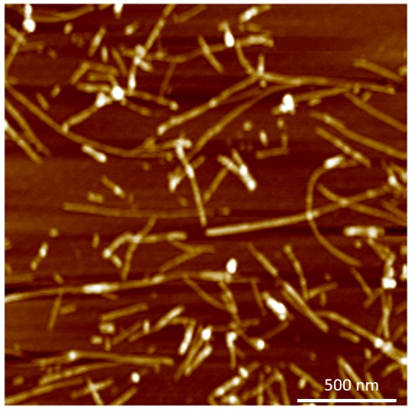
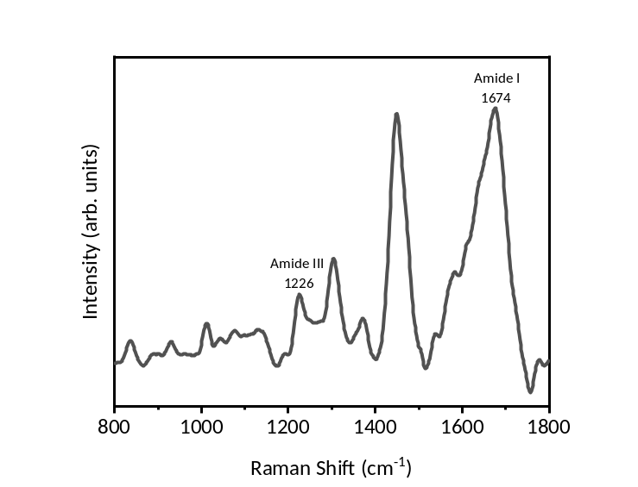
Supplementary Fig. 14. SERS spectrum and AFM image of hIAPP incubated at pH 7.4 for the first 2 h then at pH 5.5 for the remaining 22 h.

Supplementary Table. 1. The vibrational bands assignment of hIAPP.
Raman Shift (cm⁻¹) | Assignment*
836, 854 | Tyr doublet
899 | v(C-C)
946 | v(C-C)
1010 | Phe
1090 | v(C-C), v(C-N), v(C-O)
1135 | v(C-C)
1211 | Tyr
1220-1240, β-sheet | Amide III
1240-1250, Random coil | Amide III
1270-1300, α-helix | Amide III
1310 | CH₂ deformation
1366 | CH₂ deformation
1450 | CH₂, CH₃ deformation
1604 | Phe
1612 | Tyr
1650-1660, helix-coil | Amide I
1670-1680, β-sheet | Amide I
*Assignments are based on References^{7,8}.

References
1. Kotsifaki, D. G., Truong, V. G. & Nic Chormaic, S. Plasmon-Enhanced Optical Forces and Tweezers. in 177–206 (2022). doi:10.1007/978-3-030-87544-2_8.
2. Min, C. et al. Focused plasmonic trapping of metallic particles. Nat. Commun. 4, 1–7 (2013).
3. Hong, S., Shim, O., Kwon, H. & Choi, Y. Autoenhanced Raman Spectroscopy via Plasmonic Trapping for Molecular Sensing. Anal. Chem. 88, 7633–7638 (2016).
4. Hernández, B., Coïc, Y. M., Pflüger, F., Kruglik, S. G. & Ghomi, M. All characteristic Raman markers of tyrosine and tyrosinate originate from phenol ring fundamental vibrations. J. Raman Spectrosc. 47, 210–220 (2016).
5. Lu, T. & Chen, F. Multiwfn: A multifunctional wavefunction analyzer. J. Comput. Chem. 33, 580–592 (2012).
6. Humphrey, W., Dalke, A. & Schulten, K. VMD: Visual Molecular Dynamics. J. Mol. Graph. 14, 33–38 (1996).
7. Rygula, A. et al. Raman spectroscopy of proteins: A review. J. Raman Spectrosc. 44, 1061–1076 (2013).
8. Louros, N. N. et al. Tracking the amyloidogenic core of IAPP amyloid fibrils: Insights from micro-Raman spectroscopy. J. Struct. Biol. 199, 140–152 (2017).

