Potential Antibacterial Co-culture first-reported Streptomyces flavalbus from Indonesian mangroves induces the production of pyocyanin by Pseudomonas aeruginosa

Nuril Azhar². Ervia Yudiati^{1,2}*.

¹Department of Marine Science, Faculty of Fisheries and Marine Science, Diponegoro, Jl Prof. Sudharto, Tembalang, Semarang 50275, INDONESIA.
²Tropical Marine Biotechnology, Faculty of Fisheries and Marine Sience, Diponegoro University, J Building, Tembalang, Semarang 50275 INDONESIA
*Corresponding Author email: eyudiati@gmail.com; erviayudiati@lecturer.undip.ac.id

Supporting Information

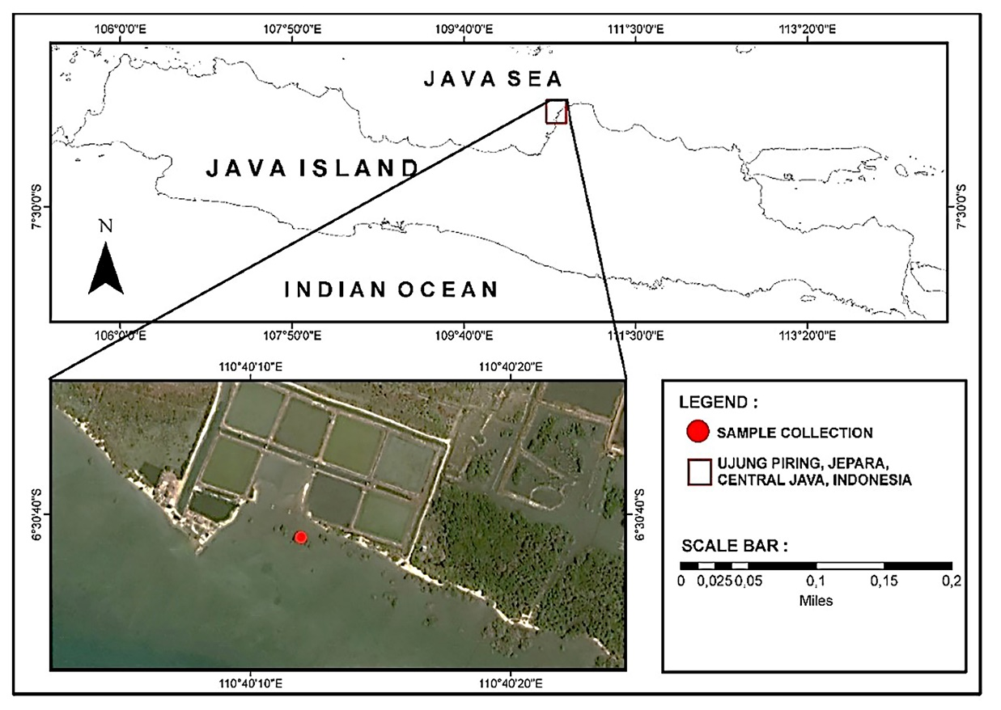
Fig S1. Sampling map

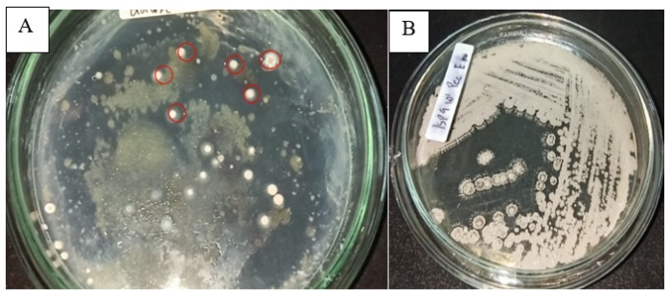
Fig S2. Isolation (A) and Purification (B) of Actinobacteria

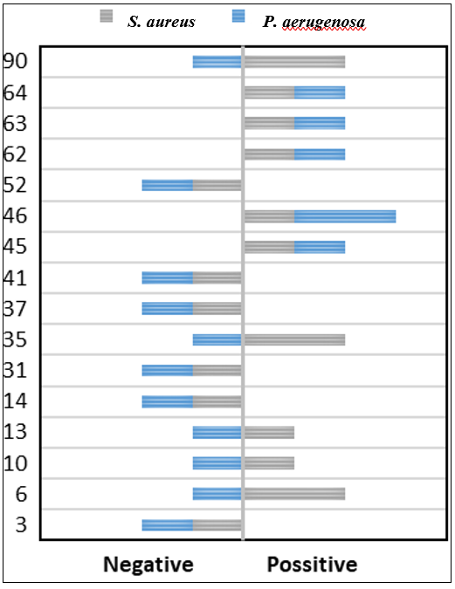
Fig S3 Antagonist test against S. aureus and P. aerugenosa

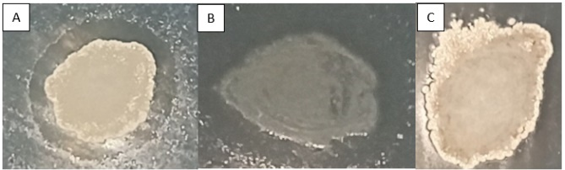
Fig S4 Antagonist test. A). Strong; B). Light; and negative

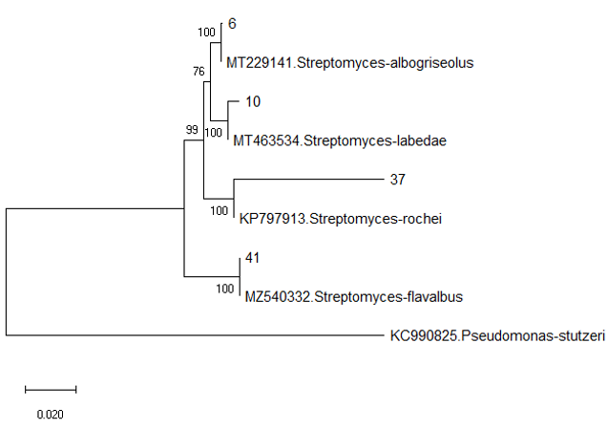
Fig S5 Philogenetic tree of Streptomyces spp. using Neighbor-Joining method with Kimura 2-parameter models and 1.000 bootstrap

Table S1 Macroscopic of Actinobacteria from Sediment dan root Mangrove
Sample | Strain | Aerial mycelium | Substrate mycelium
Sediment | 3 | Creamy white | Black
 | 6 | White | White
 | 10 | Dark gray | Dark gray
 | 14 | White | Chocolate
 | 17 | Dark gray | Dark brown
 | 31 | bluish ash | Black
 | 32 | Gray brown | dark brown
 | 34 | bluish gray | black
 | 35 | White | black cream
 | 37 | White gray | Reddish brown
 | 39 | Yellowish ash | Brownish yellow
 | 41 | White | yellow
 | 45 | gray white | yellow
 | 46 | White | cream
 | 51 | White | Dark orange
 | 52 | White | yellow
 | 71 | Gray | Gray
 | 87 | White | cream
Roots | 13 | Dark gray | black
 | 16 | gray white | Gray
 | 22 | Dark gray | Gray brown
 | 26 | Dark brown | Dark brown
 | 42 | White gray | Cream
 | 62 | White middle brown | White
 | 63 | Dark brown | Dark brown
 | 64 | White gray | brown cream
 | 72 | gray white | Red Black
 | 90 | White middle gray | White

Table S2 Microscopic Appearance of Actinobacteria from Sediment and Mangrove Roots
Sampel | Strains
 | 3 | 6 | 10 | 14
Sediment | 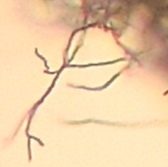 | 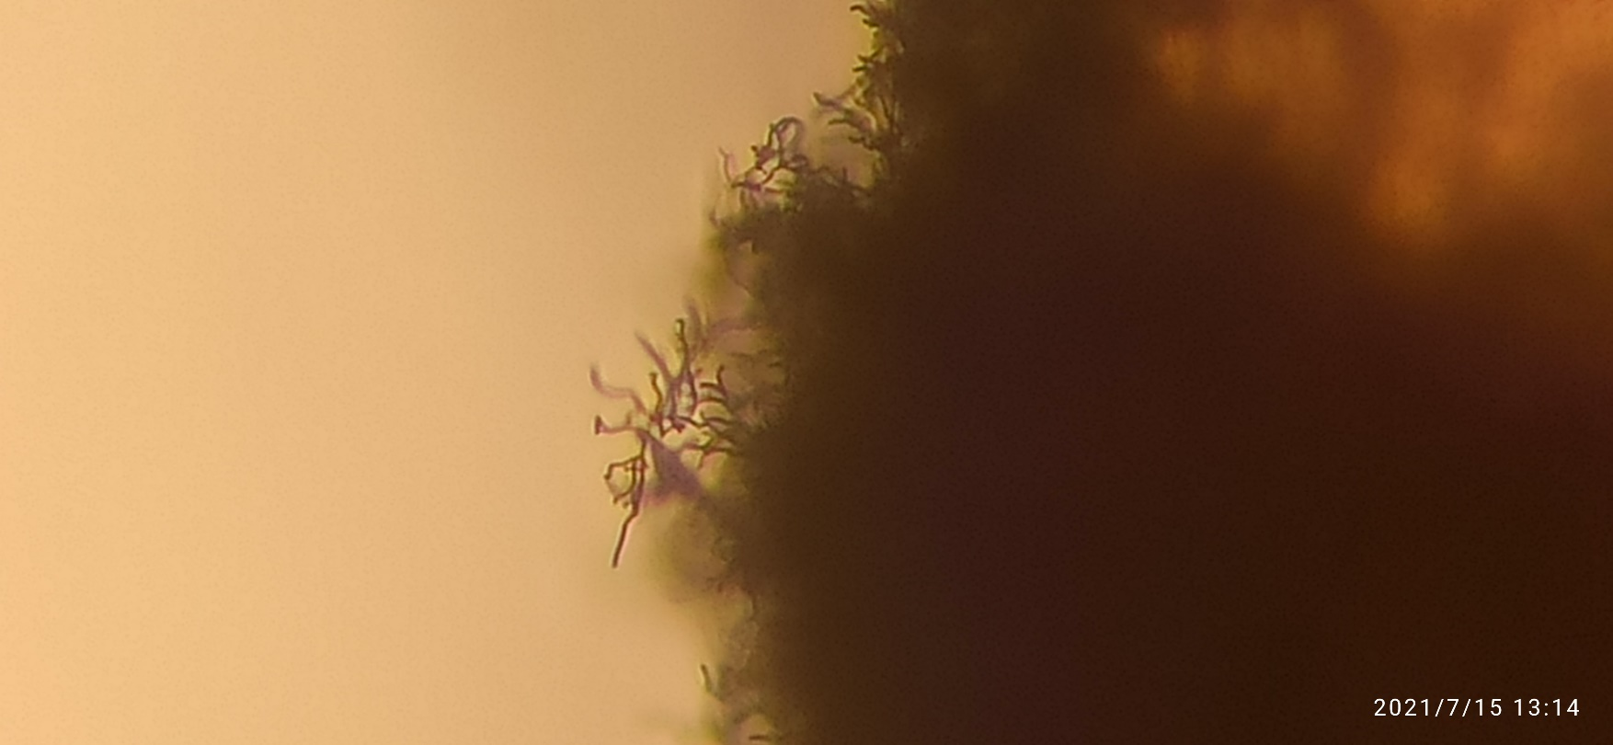 | 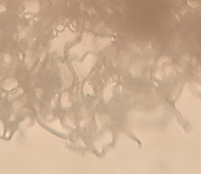 | 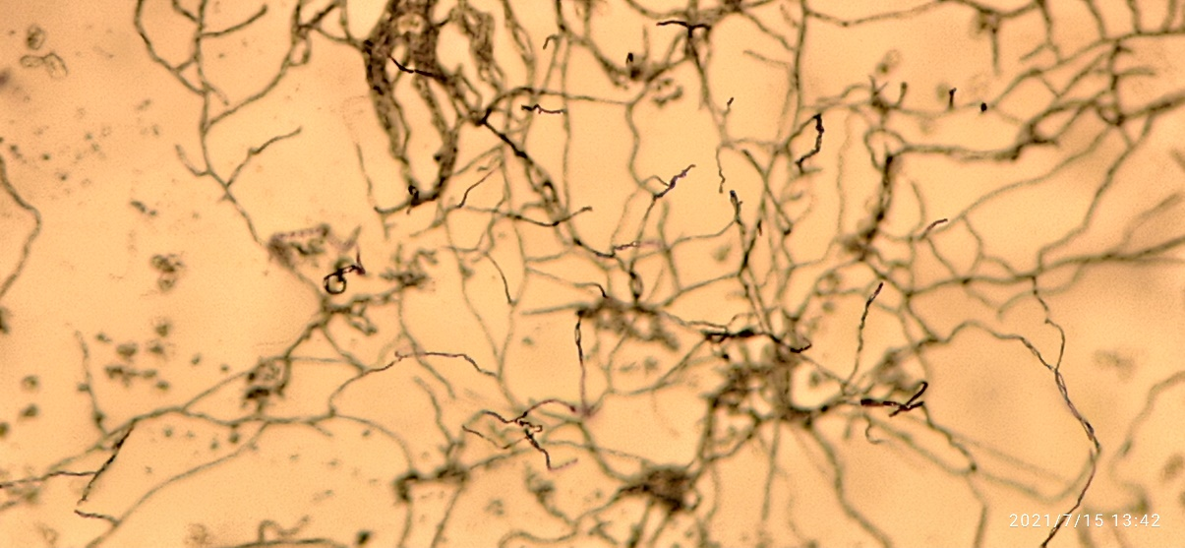
 | 17 | 31 | 32 | 34
 | 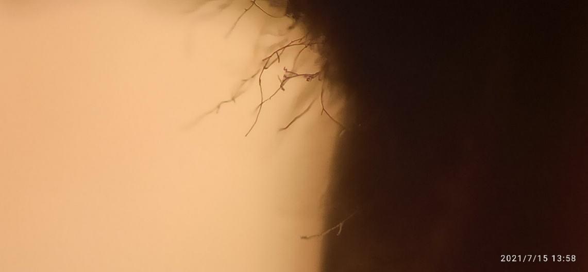 | 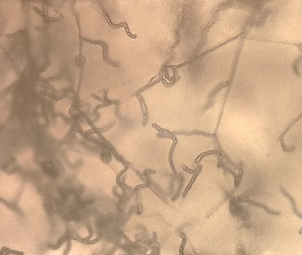 | 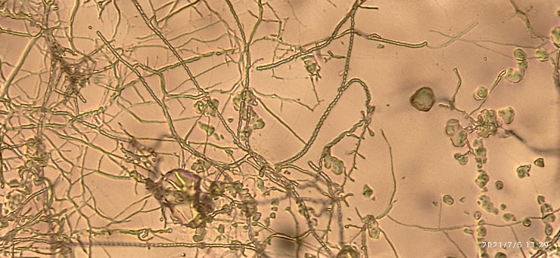 | 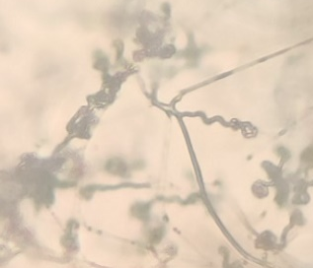
 | 35 | 37 | 39 | 41
 | 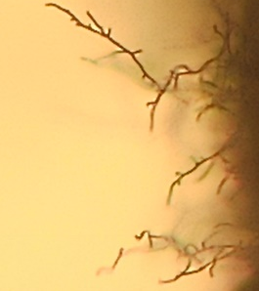 | 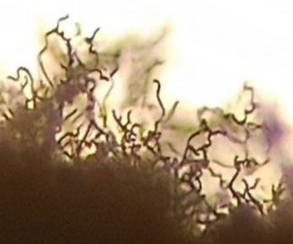 | 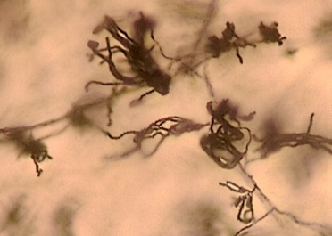 | 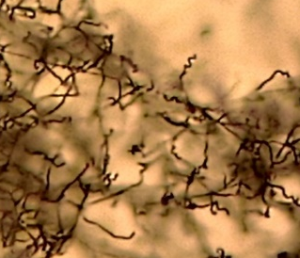
 | 45 | 46 | 51 | 52
 | 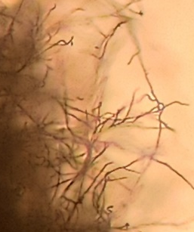 | 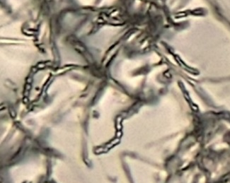 | 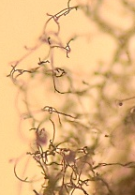 | 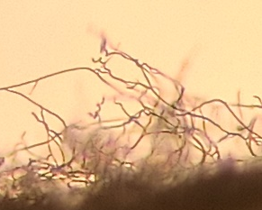
 | 71 | 87
 | 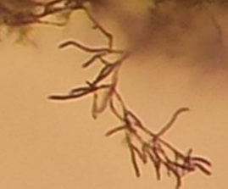 | 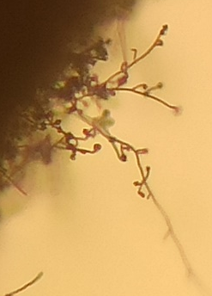
Roots | 13 | 16 | 22 | 26
 | 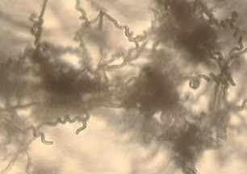 | 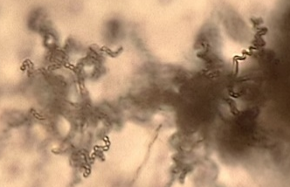 | 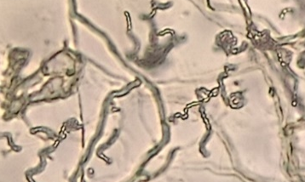 | 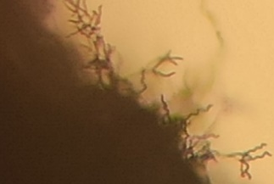
 | 42 | 62 | 63 | 64
 | 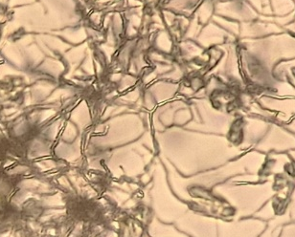 | 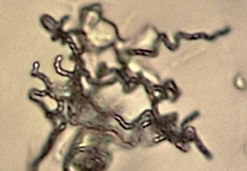 | 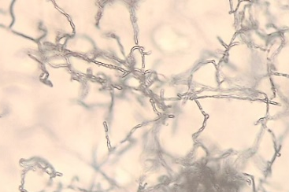 | 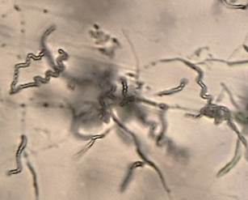
 | 72 | 90
 | 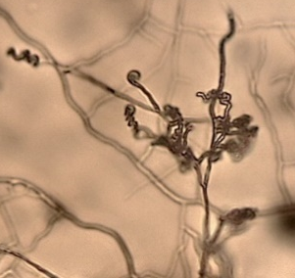 | 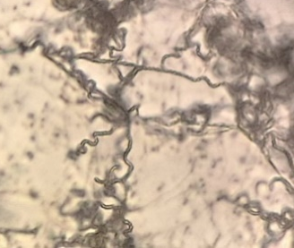

Table S3 Susceptibility of S. aureus and P. aerugenosa
S. aureus
Antibiotic | inhibition zone (mm) |  | Interpretation
Tetracyline | 23.15±1.02 |  | S
Doxycline | 25.2±1.46 |  | S
Rifamycin | 9.6±0.20 |  | R
Erythromycin | 6.00±0.00** |  | R
Azhytromycin | 6.00±0.00** |  | R
Gentamycin | >30 |  | S
Penicilin | 14.53±2.13 |  | R
Ofloxacin | 20.62±0.4 |  | S
Minocycline | 16.03±1 |  | I
Chloramfenicol | 17.07±1.06 |  | I
Ciprofloxacin | 27.13±0.20 |  | S
Levofloxacin | 19.37±0.67 |  | S
Clindamycin | 6.00±0.00* |  | R
P. aerugenosa
Antibiotic | inhibition zone (mm) | Interpretation
Ceftadazime | 26.33±0.38 | S
Gatifloxacin | >30 | S
Gentamycin | >30 | S
Levofloxacin | >30 | S
Ciprofloxacin | >30 | S
Tobramycin | 21.75±0.15 | S
Doripenem | >30 | S
Meropenem | >30 | S
* R = Resistance, I = Intermediate and S = Sensitive
** Paper disc

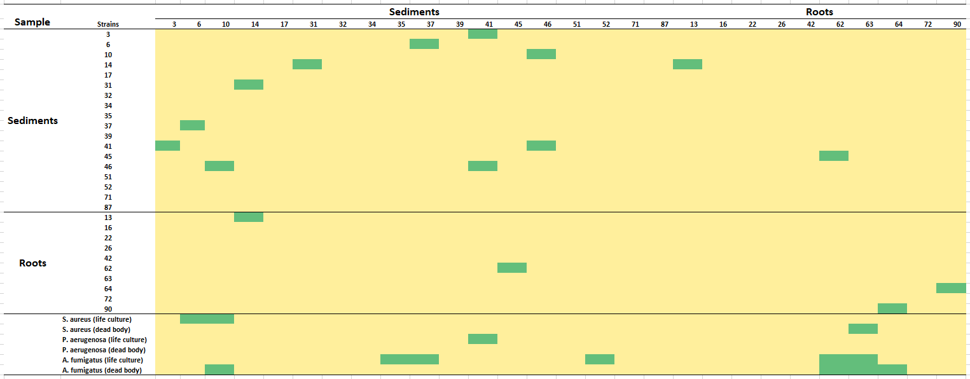
Table S4 Antibacterial screening heatmap from co-culture

Table S5. Result Identification of Actinobacteria
Strains | Name of blast result | Accession number | Squence (Bp) | Identication (%)
6 | Streptomyces albogriseolus | MZ701854 | 1408 | 99.79
10 | Streptomyces labedae | MZ701855 | 1396 | 99
37 | Streptomyces rochei | MZ558503 | 1427 | 93.52
41 | Streptomyces flavalbus | MZ540332 | 1399 | 98.07

