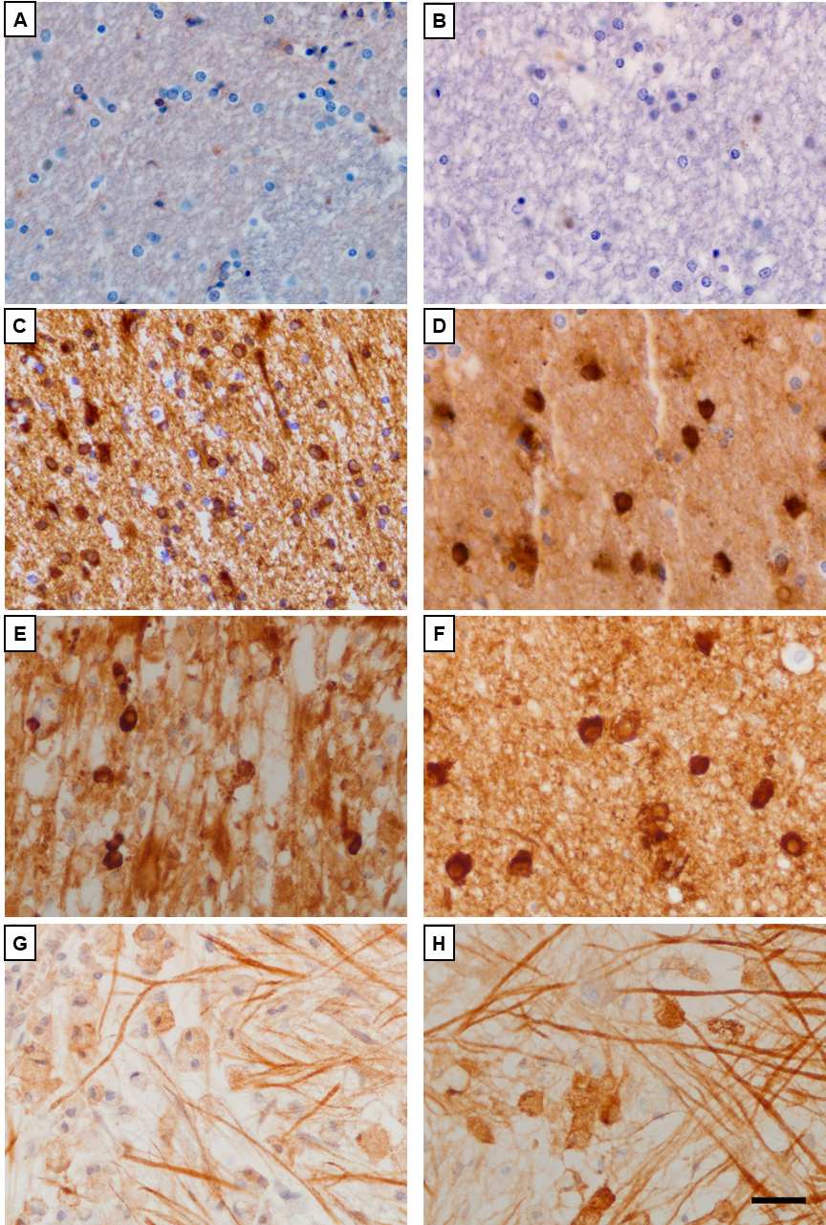

Supplementary Data 1. Analysis by immunohistochemistry of IgG and IgM deposits in MS patients. Serial sections of a sample from control group (A-B) and NAWM (C, D) and chronic active lesion (E-H) from a MS patient. Labeling for IgG (A, C, E, G) and IgM (B, D, F, H). Representative examples of IgG (C, E) and IgM (D, F) deposits on oligodendrocyte like cells. Pictures showed IgG (G) and IgM (H) deposits on axon like structures. Scale bar=25 µm

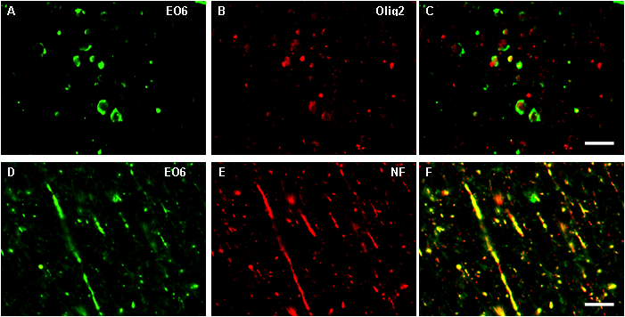
Supplementary Data 2. Characterization of the structures showing oxidative stress in MS patients. Fluorescent microscopy high magnification images from the edge of a chronic active lesion from MS patient (A-E). Staining for EO6 (A, D, green), oligodendrocyte nuclei (Olig-2) (B, red), and neurofilament (NF) (E, red). Overlays showed that oligodendrocytes (C) and axons (F) located in lesions were stained for EO6. Scale bar=25µm.

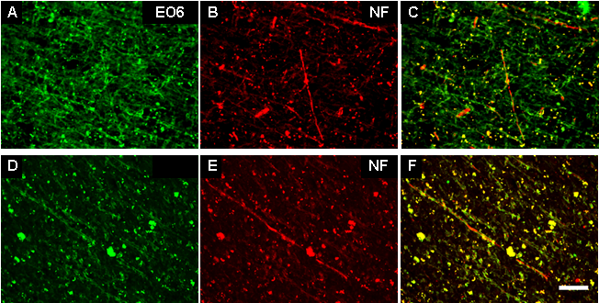
Supplementary Data 3. Characterization of the structures showing oxidative stress in ALS (A-C) and FTD (D-F) patients. Fluorescent microscopy high magnification images from injured areas. Staining for EO6 (A, D, green), and neurofilament (NF) (B, E), red). Overlays showed that axons located in impaired areas were stained for EO6 in ALS patients (C) and FTD (F) patients. Scale bar=25µm

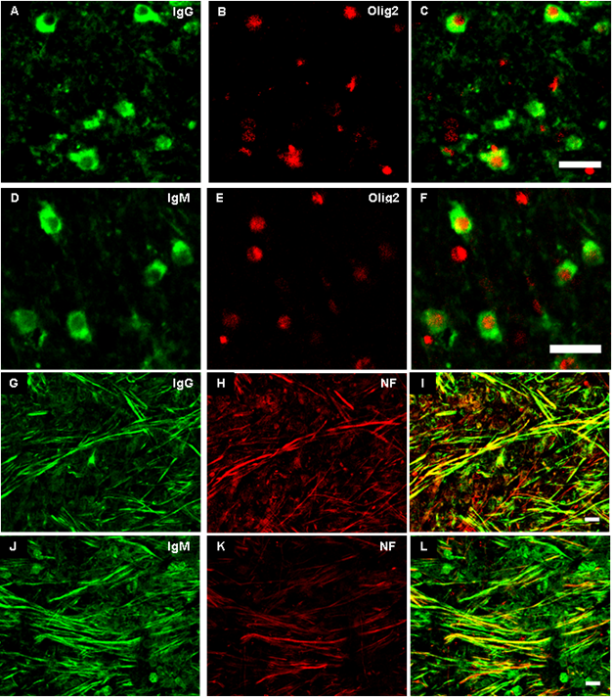
Supplementary Data 4. Identification of the structures showing deposits of antibodies in MS patients. Fluorescent microscopy high magnification images from the center of a chronic active lesion (A-I) from MS patients. Staining for IgG (A, G green) IgM (D, J, green), Olig2 (B, E) and neurofilament (NF) (H, K) red). Overlays showed that Olig2 positive cells were positive stained for IgG (C) and IgM (F). Double immunofluorescence demonstrated that axons (Neu positive) were IgG positive (I, yellow) and IgM positive (L, yellow). Scale bar=25µm.

