Supplementary material
Title: Breeding priorities for rice adaptation to climate change in Northeast China

Xin Dong1*,2, Tianyi Zhang1, Xiaoguang Yang3, Tao Li4

1 State Key Laboratory of Atmospheric Boundary Layer Physics and Atmospheric Chemistry, Institute of Atmospheric Physics, Chinese Academy of Sciences, Beijing, China
2 University of Chinese Academy of Sciences, Beijing, China
3 College of Resources and Environmental Sciences, China Agricultural University, Beijing, China
4 DNDC Applications, Research and Training, 87 Packers Falls Road, Durham, NH 03824, USA

Supplementary Text S1
Experimental data on the responses of different rice varieties to chilling stress during the reproductive stage were obtained from Wang et al. (2009) and Zhang et al. (2021) (Supplementary Table S2). They both used climate chambers to conduct low-temperature control experiments in the booting and flowering stages. The Wang et al. (2009) trial included 25 japonica rice varieties bred between 1980 and 2000 in Northeast China. Zhang et al. (2021) included 3 rice varieties bred between 2015 and 2019 in Harbin, Gongzhuling, and Yanji. The results of the trial were recorded separately for each variety in terms of sterility and yield data. Moreover, weather data were recorded hourly using an automatic weather monitoring device.
We followed the ORYZA simulation model to determine the relationship between the fraction of fertile spikelets caused by low temperatures. The concept of cooling degree-days (CDDs) is used to quantify relationship between chilling injury and rice sterility (Eq. 1).
Sc = 1 - (4.6 + 0.054 × CDD^{COLSTER})/100 | (1)
where S_{C} is the fraction of fertile spikelets caused by low temperature (%), CDD is the cooling degree-days (ºCd), and COLSTER is empirical parameter of chilling sensitivity (-), which is determined for each variety (Supplementary Fig. S1a).

Supplementary Text S2
We collected information from controlled experiments using 29 rice varieties from multiple data sources (Supplementary Table S3) and determined rice fertility under different high temperatures and durations of treatment. Similar to the chilling temperature treatment, researchers used a climate cha mber to identify differences in tolerance to high temperatures with various rice varieties. They used day/night temperature combinations for continuous heat treatment during the rice booting and flowering stages. For each treatment, there were multiple replications, and fertility and yields were measured after harvest. The results can effectively distinguish three types of varieties with low, medium and high sensitivity to heat. The difference in the heat response between the low- and high-sensitivity varieties was approximately 2-8°C.
We followed the ORYZA simulation model to determine the relationship between the fraction of fertile spikelets caused by high temperatures (Eq. 2).
S_{h} = 1/(1 + exp(0.853 (T_{m,a} - CTSTER))) | (2)
where S_{h} is the fraction of fertile spikelets caused by high temperatures (%), T_{m,a} is the daily maximum temperature over the flowering period (ºC), and CTSTER is the empirical temperature threshold at 50% fertility rate (ºC), which is determined for each variety (Supplementary Fig. S1b).

Supplementary Text S3
We collected rice phenological data from the China Agricultural Meteorological Station (CAMS), including the emergence, transplanting, panicle initial, flowering, and maturity dates between 1981 and 2013 at 24 sites in Northeast China. Rice varieties were switched over 3-5 years, and 95 varieties were derived from these sites over time.
In the ORYZA model, the dimensionless scale was used for development. The developmental stage (DVS) indicates the rice physiological age. The developmental rate for the juvenile phase (DVRJ), corresponding to the period from sowing (DVS = 0) to the start of the photoperiod-sensitive phase (DVS = 0.4). The developmental rate for the photoperiod-sensitive phase (DVRI) corresponds to the time from the end of the basic vegetative phase to panicle initiation (DVS = 0.65). The developmental rate for the panicle development phase (DVRP) ranges from panicle initiation to first flowering (DVS = 1). The developmental rate for the reproductive phase (DVRR) corresponds to the time from first flowering to physiological maturity (DVS = 2).
In the ORYZA model, the three development rate constants (DVRV, DVRP and DVRR) were defined by the inverse of the accumulated daily thermal units (DTUs) required to complete a specific phase. Based on the collected experimental data, we calculated the DVRJ, DVRP, and DVRR for each variety (Eq. 3-5).
$$DVRJ={(0.4-0.0)/(DTU}_{S_JP})$$ | (3)
$$DVRP={(1.0-0.65)/(DTU}_{PI_FL})$$ | (4)
$$DVRR={(2.0-1.0)/(DTU}_{FL_MT})$$ | (5)
where DTU_{S_JP} is the sum of the DTU from sowing to the photoperiod-sensitive phase, DTU_{PI_FL} is the sum of the DTU from panicle initiation to flowering, and DTU_{FL_MT} is the sum of the DTU from first flowering to physiological maturity.

Supplementary Table S1. Detailed information on the five global climate models used in this study.
Climate models | Model sources | Release year | Approximate atmospheric resolution
CNRM_ESM | CNRM-CERFACS | 2018 | 1.0° × 1.0°
EC_Earth3 | IS-ENES | 2019 | 1.0° × 1.0°
FGOALS_g3 | LASG, IAP | 2019 | 1.0° × 1.0°
GFDL_ESM4 | NOAA-GFDL | 2018 | 1.0° × 1.0°
MIROC6 | CCSR | 2021 | 1.0° × 1.0°

Supplementary Table S2. Data sources and the values of parameters estimated for the low-temperature treatment experiment.
Data source | Cultivar names | Chilling temperature (°C) | Duration (days) | COLSTER
Zhang et al. (2021) | Songgeng6 | 15,18,21,24  12,15,18,21 | 2,4,6,8  2,4,6,8 | 1.356
 | Tong35 | 12,15,18 | 2,4,6,8 | 1.436
 | Jigeng511 | 6 altitudes | 2,4,6 | 1.744
Wang et al. (2009) | Dongnong424 | 15 | 1,7 | 1.124
 | Hejiang21 | 15 | 1,7 | 1.728
 | Kendao12 | 15 | 1,7 | 1.762
 | Longdao3 | 15 | 1,7 | 1.251
 | Longgeng13 | 15 | 1,7 | 1.835
 | Shangyu397 | 15 | 1,7 | 1.447
 | Songgeng7 | 15 | 1,7 | 1.727
 | Dongnong419 | 15 | 1,7 | 1.784
 | Fushiguang | 15 | 1,7 | 1.421
 | Hejiang19 | 15 | 1,7 | 1.742
 | Longgeng15 | 15 | 1,7 | 1.723
 | Longgeng16 | 15 | 1,7 | 1.797
 | Suigeng7 | 15 | 1,7 | 1.253

Supplementary Table S3. Data sources and the values of parameters estimated for the high-temperature treatment experiment.
Data source | Cultivar names | Heat temperature (°C) | Duration (days) | CTSTER
Nguyen et al. (2014) | Odae |  |  | 32.6
Nguyen et al. (2014) | Unkwang |  |  | 32.6
Nguyen et al. (2014) | Chucheong |  |  | 38.5
Nguyen et al. (2014) | Dongan |  |  | 38.5
Nguyen et al. (2014) | Dasan |  |  | 40.8
Nguyen et al. (2014) | Anda |  |  | 40.8
Satake and Yoshida (1978) | BKN6624 |  |  | 33.5
Satake and Yoshida (1978) | IR747 |  |  | 36.5
Satake and Yoshida (1978) | N22, |  |  | 39
Shi et al. (2010) | huajing1 | 31,33,35,37,41 | 1,3,5 | 35.8
Zhang et al. (2012) | Remin4628 | 32,34,36,38 | 5 | 35.8
Zhang et al. (2012) | Naire996 | 32,34,36,38 | 5 | 37.1
Zheng et al. (2007) | Teyou559 | 35,37,39,41 | 3 | 36.1
Zheng et al. (2007) | Teyou559 | 35,37,39,41 | 5 | 36.2
Horie (1993) | Akihikari |  |  | 36.6
Matsui et al. (2001) | Naire996 | 35,37.5,40 | 6 | 37.1
Matsui et al. (2001) | Hinohikari | 35,37.5,40 | 6 | 37.3
Matsui et al. (2001) | Minamihikari | 35,37.5,40 | 6 | 37.4
Matsui et al. (2001) | Aoinokaze | 35,37.5,40 | 6 | 37.9
Matsui et al. (2001) | Kinmaze | 35,37.5,40 | 6 | 38.1
Matsui et al. (2001) | Akihikari | 35,37.5,40 | 6 | 38.2
Matsui et al. (2001) | Yumehikari | 35,37.5,40 | 6 | 38.6
Matsui et al. (2001) | Aichinokaori | 35,37.5,40 | 6 | 38.6
Matsui et al. (2001) | Nipponbare | 35,37.5,40 | 6 | 39.3
Matsui et al. (2001) | Akitakomachi | 35,37.5,40 | 6 | 39.8
Zhou (2017) | Nanjing43 | 35,39 | 1,3,5,7 | 38.5
Zhou (2017) | WYJ24 | 32,36,40,44 | 2,4,6 | 39
Zhou (2017) | NJ41 | 32,36,40,40 | 2,4,6 | 39.7
Xie et al. (2010) | Yangdao6 | 35,39 | 1,3,5,7 | 38.9

Supplementary Table S4. Percentage changes in rice yield (%) of variety-sensitive scenarios for cold and heat stresses relative to the median sensitive variety at the baseline period (1980-2010) for SSP1-2.6 (a), SSP2-4.5 (b), SSP3-7.0 (c), and SSP5-8.5 (d).
Variety scenario/  Climate scenario | Time | LC_LH | LC_HH | HC_LH | HC_HH
SSP1-2.6 | 2040 | -7.09 | -10.40 | -11.16 | -14.46
SSP1-2.6 | 2060 | -7.03 | -10.86 | -10.33 | -14.14
SSP1-2.6 | 2080 | -7.61 | -11.81 | -10.83 | -15.01
SSP1-2.6 | 2100 | -7.03 | -10.89 | -10.38 | -14.21
SSP2-4.5 | 2040 | -7.96 | -11.05 | -10.96 | -14.04
SSP2-4.5 | 2060 | -11.90 | -16.20 | -14.19 | -18.47
SSP2-4.5 | 2080 | -15.07 | -20.12 | -16.75 | -21.78
SSP2-4.5 | 2100 | -18.25 | -25.20 | -19.32 | -26.26
SSP3-7.0 | 2040 | -8.74 | -11.31 | -12.13 | -14.70
SSP3-7.0 | 2060 | -17.73 | -22.03 | -19.44 | -23.72
SSP3-7.0 | 2080 | -24.99 | -31.00 | -25.83 | -31.83
SSP3-7.0 | 2100 | -32.49 | -42.22 | -33.31 | -43.02
SSP5-8.5 | 2040 | -6.53 | -9.72 | -9.94 | -13.11
SSP5-8.5 | 2060 | -16.94 | -22.17 | -18.48 | -23.70
SSP5-8.5 | 2080 | -24.57 | -32.53 | -25.29 | -33.23
SSP5-8.5 | 2100 | -33.22 | -47.52 | -33.51 | -47.78

Supplementary Table S5. Percentage change in rice yield (%) of the variety development rate scenarios for growth phases relative to the median development rate variety at the baseline period (1980-2010) for SSP1-2.6 (a), SSP2-4.5 (b), SSP3-7.0 (c), and SSP5-8.5 (d).
Variety scenario/  Climate scenario | Time | F_DVRJ | F_DVRP | F_DVRR | S_DVRJ | S_DVRP | S_DVRR
SSP1-2.6 | 2040 | -46.17 | -37.60 | -23.32 | 9.62 | 7.91 | 0.43
SSP1-2.6 | 2060 | -45.86 | -37.21 | -23.16 | 10.60 | 9.02 | 1.59
SSP1-2.6 | 2080 | -45.95 | -37.09 | -23.99 | 9.93 | 8.12 | 1.85
SSP1-2.6 | 2100 | -45.41 | -36.40 | -23.63 | 10.27 | 9.23 | 2.77
SSP2-4.5 | 2040 | -46.33 | -37.51 | -23.83 | 8.74 | 7.51 | 0.94
SSP2-4.5 | 2060 | -48.21 | -39.40 | -27.30 | 6.03 | 4.31 | -1.90
SSP2-4.5 | 2080 | -49.84 | -40.72 | -30.14 | 4.10 | 0.95 | -3.79
SSP2-4.5 | 2100 | -50.78 | -40.77 | -32.83 | 0.14 | 4.03 | -4.32
SSP3-7.0 | 2040 | -46.64 | -38.21 | -24.34 | 6.77 | 6.09 | -0.95
SSP3-7.0 | 2060 | -51.38 | -42.28 | -32.22 | 0.44 | -1.90 | -6.86
SSP3-7.0 | 2080 | -54.75 | -45.69 | -38.37 | -6.84 | -11.36 | -12.43
SSP3-7.0 | 2100 | -58.33 | -49.01 | -44.24 | -16.02 | -23.25 | -18.87
SSP5-8.5 | 2040 | -45.58 | -36.36 | -22.78 | 9.59 | 8.27 | 2.31
SSP5-8.5 | 2060 | -50.60 | -40.97 | -31.70 | 1.93 | -1.69 | -4.48
SSP5-8.5 | 2080 | -54.08 | -44.36 | -37.86 | -6.66 | -12.54 | -10.49
SSP5-8.5 | 2100 | -58.50 | -48.91 | -44.48 | -17.98 | -25.95 | -18.75

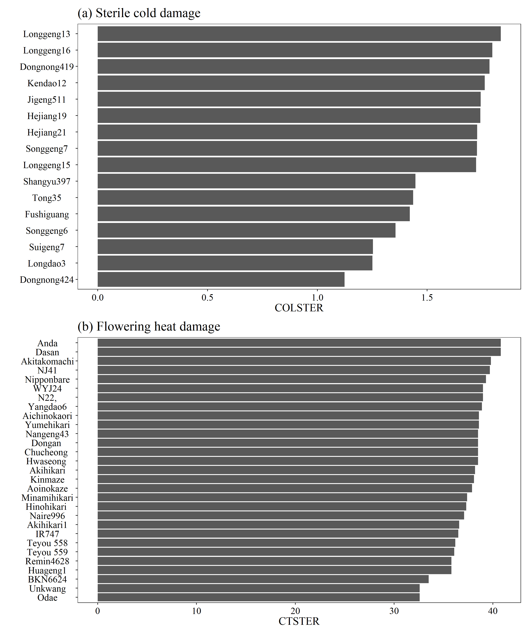
Supplementary Fig. S1. Variety-specific COLSTER parameters (a) and variety-specific CTSTER parameters (b).

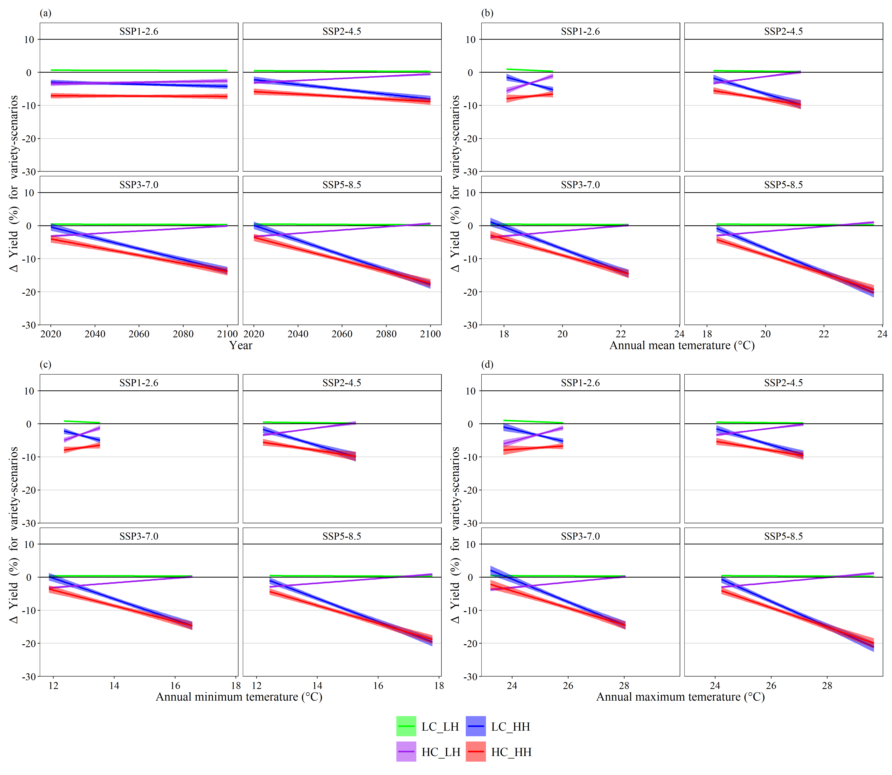
Supplementary Fig. S2. Percentage yield difference for the combination of varieties sensitive to cold and heat stresses relative to the median-sensitive variety for different SSPs in each year (a), annual mean temperature (b), annual minimum temperature (c), and annual maximum temperature (d). Shaded bands indicate the 95% confidence interval based on the regressions of projected data form five climate models.

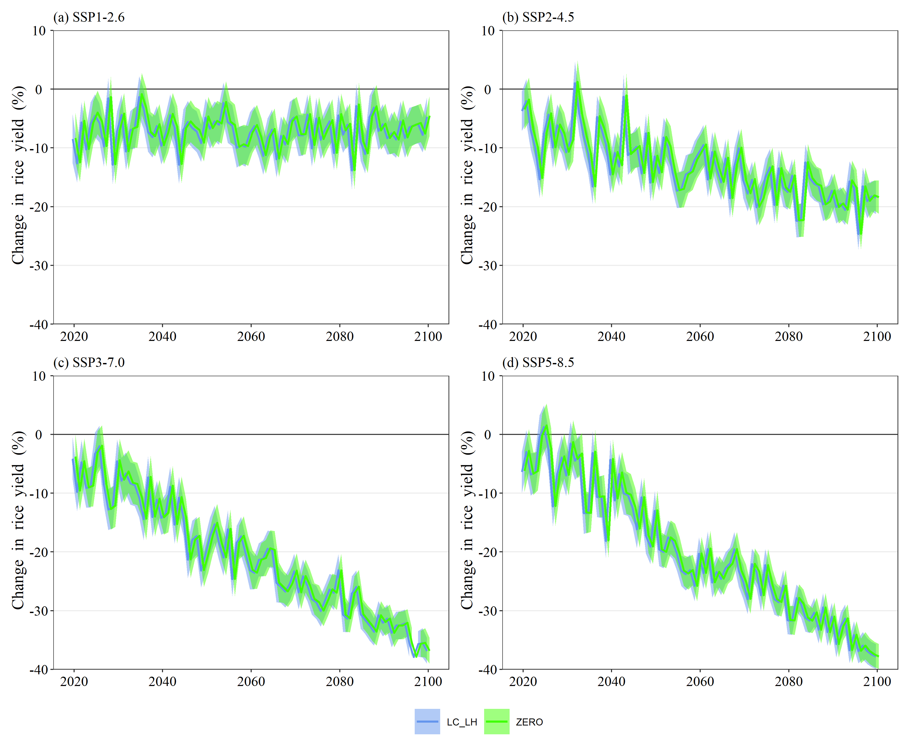
Supplementary Fig. S3. Percentage change in rice yield (%) of the variety low (blue) and zero (green) sensitivity scenarios for cold and heat stresses relative to the median sensitive variety at the baseline period (1980-2010) for SSP1-2.6 (a), SSP2-4.5 (b), SSP3-7.0 (c) and SSP5-8.5 (d). Shaded bands indicate the 95% confidence interval based on the five climate models.

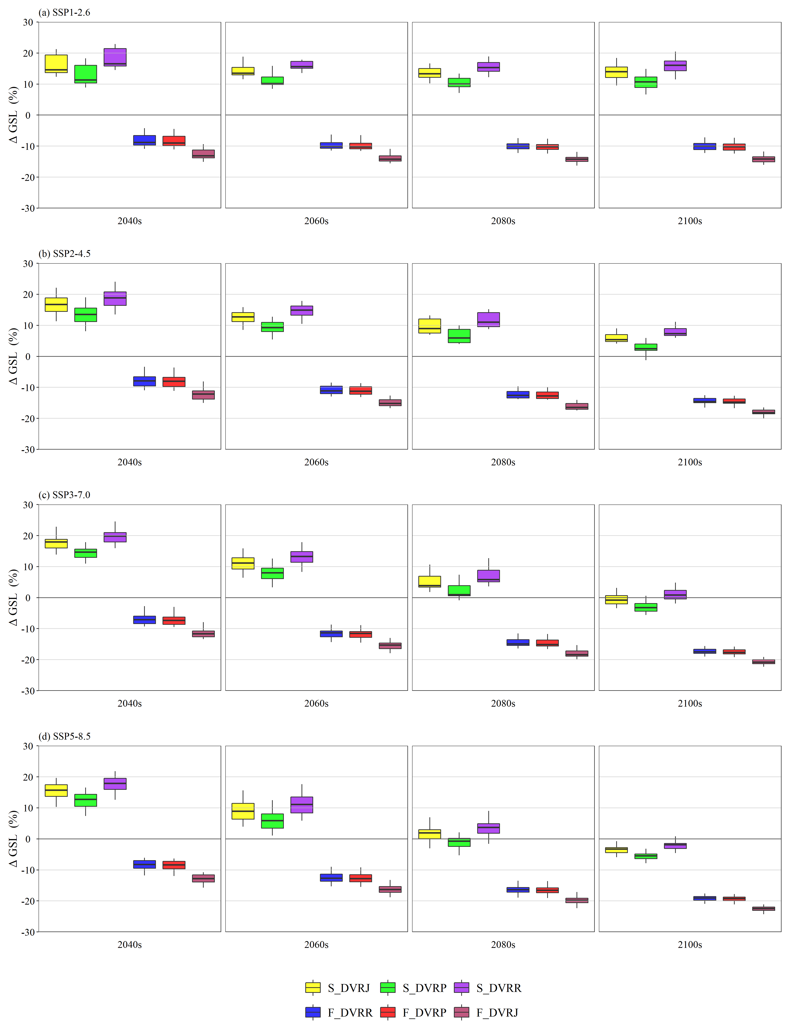
Supplementary Fig. S4. Percentage change in rice GSL under the variety development rate scenarios for growth phases relative to the median development rate at baseline climate for SSP1-2.6 (a), SSP2-4.5 (b), SSP3-7.0 (c), and SSP5-8.5 (d). For each boxplot, the black lines inside the boxes indicate the median values for each 20-year analysis period, the edges of the box are the 25th and 75th percentiles, and the whiskers extend to the extreme data points not considered outliers.

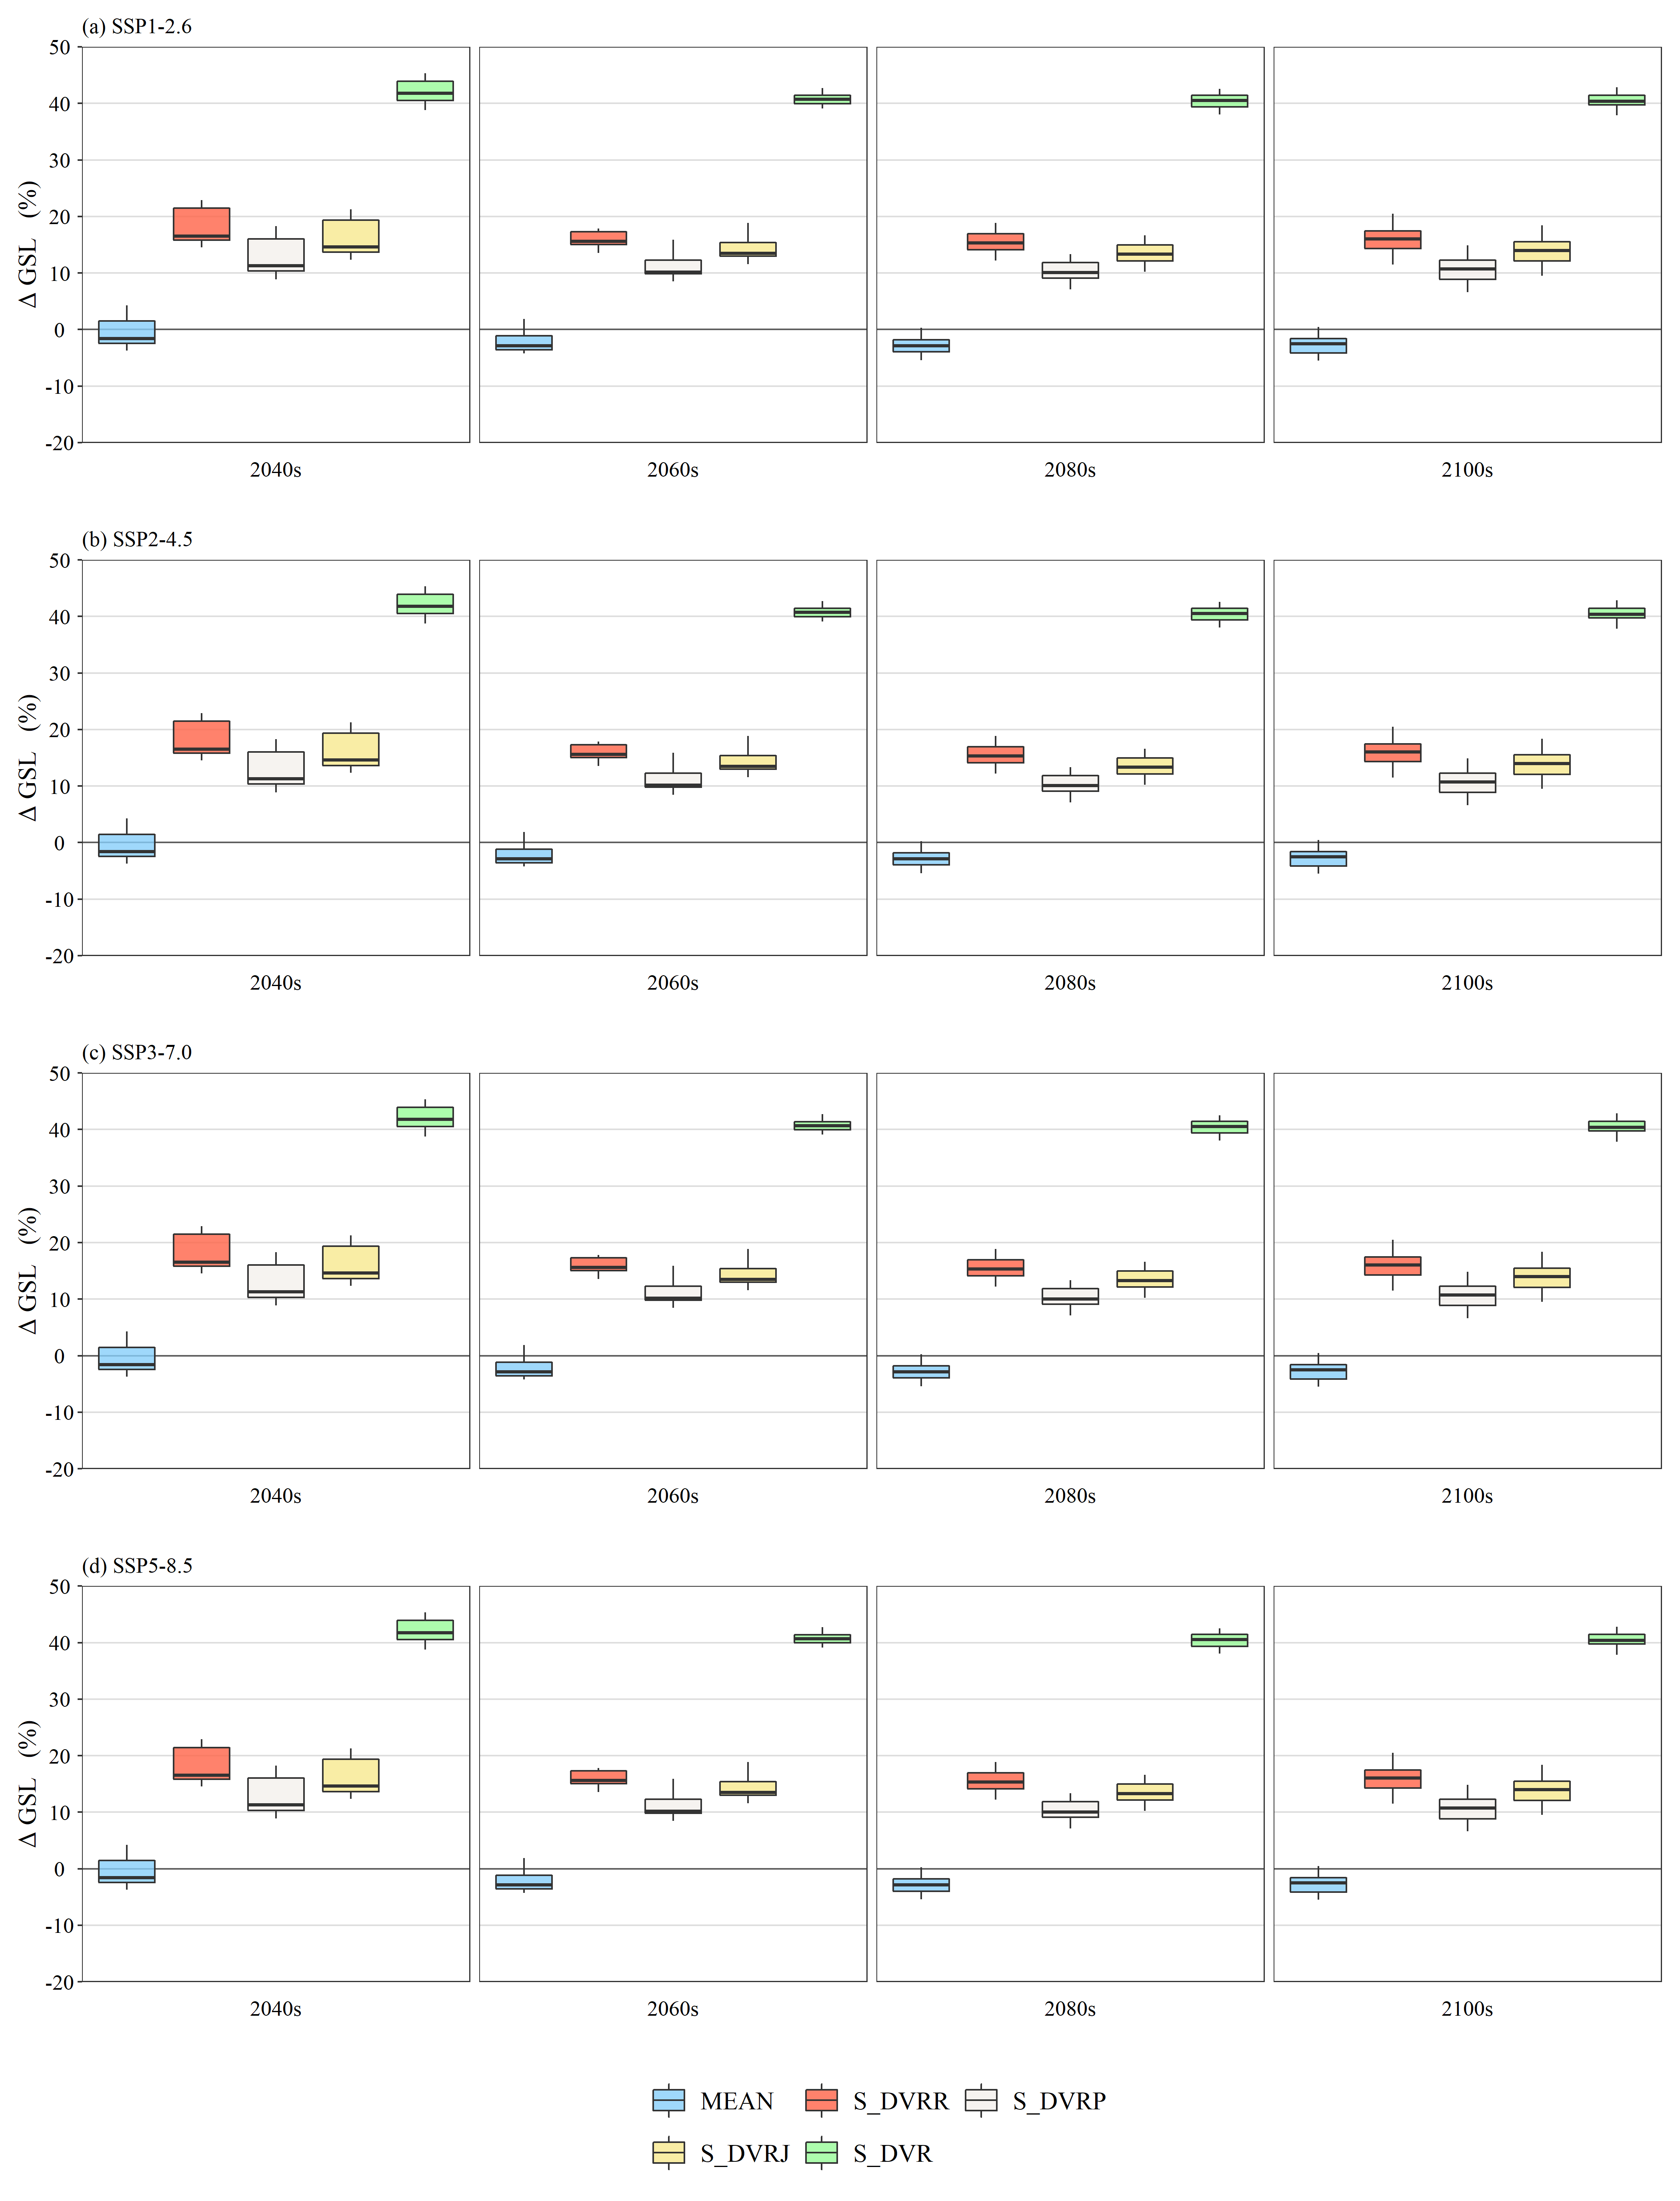
Supplementary Fig. S5. Box plot of percentage change in rice GSL (%) of variety development rate scenarios for growth phases relative to the baseline period (1980-2010) for SSP1-2.6 (a), SSP2-4.5 (b), SSP3-7.0 (c), and SSP5-8.5 (d). The upper and lower hinges of the box indicate the 75th percentile and 25th percentile of the dataset, respectively. The black lines inside the boxes indicate the median values for each 20-year analysis period, and the whiskers extend to the extreme data points not considered outliers.

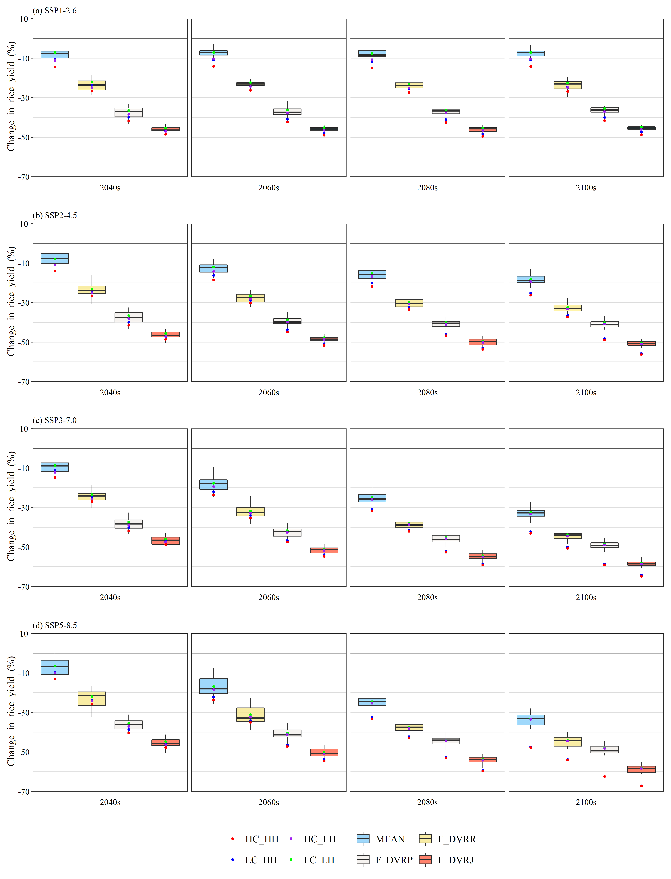
Supplementary Fig. S6. Box plot of percentage change in rice yield (%) of variety development rate scenarios for growth phases relative to the baseline period (1980-2010) for SSP1-2.6 (a), SSP2-4.5 (b), SSP3-7.0 (c), and SSP5-8.5 (d). The dots represent different scenarios of varieties with different cold and heat stresses under LC_LH (green), LC_HH (blue), HC_LH (purple), and HC_HH (red). The upper and lower hinges of the box indicate the 75th percentile and 25th percentile of the dataset, respectively. The black lines inside the boxes indicate the median values for each 20-year analysis period, and the whiskers extend to the extreme data points not considered outliers.

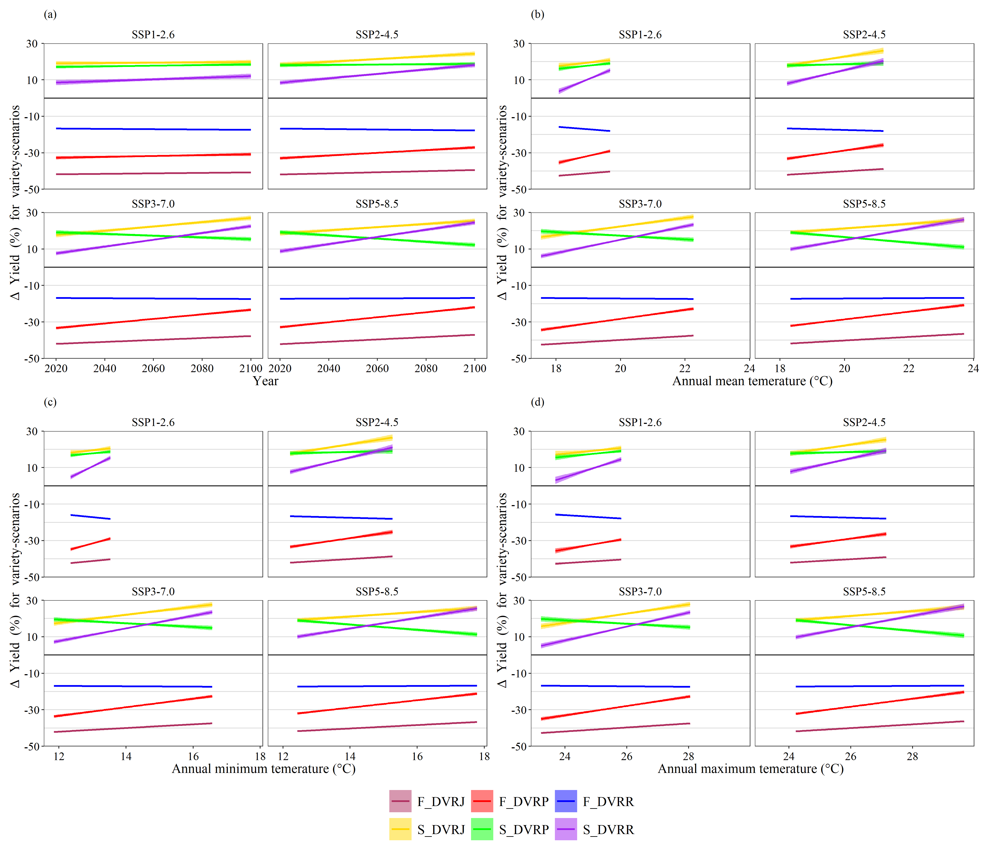
Supplementary Fig. S7. Percentage yield difference among variety development rate scenarios for growth phases relative to the median development rate variety at baseline climate in the year (a), annual mean temperature (b), annual minimum temperature (c), and annual maximum temperature (d) for different SSPs. Shaded bands indicate the 95% confidence interval based on the regressions of projected data from five climate models.

References
Bouman, B.A.M., Kropff, M.J., Wopereis, M.C.S., Ten Berge, H.F.M., Van Laar, H.H., 2001. ORYZA2000: Modeling Lowland Riceed. International Rice Research Institute (IRRI), Los Baños, PH.
Horie, T., 1993. Predicting the effects of climatic variation and elevated CO₂ on rice yield in Japan. J. Agric. Meteorol. 48, 567–574. https://doi.org/10.2480/agrmet.48.567.
Matsui, T., Omasa, K., Horie, T., 2001. The difference in sterility due to high temperatures during the flowering period among Japonica-rice varieties. Plant Prod. Sci. 4, 90–93. https://doi.org/10.1626/pps.4.90.
Nguyen, D.N., Lee, K.J., Kim, D.I., Anh, N.T., Lee, B.W., 2014. Modeling and validation of high-temperature induced spikelet sterility in rice. Field Crops Res. 156, 293–302. https://doi.org/10.1016/j.fcr.2013.11.009.
Satake, T., Yoshida, S., 1978. High temperature-induced sterility in Indica rices at flowering. Jpn. J. Crop Sci. 47, 6–17. https://doi.org/10.1626/jcs.47.6.
Shi, C.L., Jin, Z.Q., Tang, R.S., Zheng, J.C., 2010. Response difference of seed setting rate of rice florets at the meiosis and anthesis stages to high temperature. Jiangsu J. Agric. Sci. 26, 1139–1142.
Wang, C.Y., Zeng, X.G., Wang, L.M., Wang, L.Z., Jiang, L.X., Li, Z.J., Li, R., 2009. Rice cooling injury in Heilongjiang province Ⅱ difference of cooling injury tolerance among varities. Heilongjiang Agricultural Sciences (In Chinese with English Abstract), 220(22).
Xie, X.J., Li, B.B., Li, Y.X., Li, H.Y., Zhao, X.Y., Yang, S.B., Wang, Z.M., 2010. Effects of high temperature stress on yield components and grain quality during heading stage. Chin. J. Agrometeorol. 31, 411.
Yoshino, M., 1988. The effects of climatic variations on agriculture in Japan, in Parry, M.L., Carter, T.R., Konijn, N.T. (Eds.), The Impact of Climatic Variations on Agriculture: Assessment in Cool Temperate and Cold Regions. Springer, Dordrecht, Netherlands, pp. 728–868.
Zhang, G., Liu, S., Zhang, S., Xiao, Y., Tang, W., Chen, L., 2012. Effects of different high temperature treatment on flowering characteristics and seed setting of rice during heading and flowering period. Chin. Agric. Sci. Bull. 28, 116–120.
Zhang, T., Guo, E., Shi, Y., Xue, C., Zhu, X., Dong, X., Li, T., Wang, L., Jiang, S., Xiang, H., Wang, L., Feng, Y., Lai, Y., Cao, T., Li, S., Ma, S., Ma, H., Zhou, L., Wang, X., Yang, X., 2021. Modelling the advancement of chilling tolerance breeding in Northeast China. J. Agron. Crop Sci. 207, 984–994. https://doi.org/10.1111/jac.12547.
Zheng, J., Sheng, J., Tang, R., Shi, C., Chen, L., 2007. Regularity of high temperature and its effects on pollen vigor and seed setting rate of rice in Nanjing and Anqing. Jiangsu J. Agric. Sci. 23, 1–4.

