Figure S1. Fluorescence intensity of Met-AuNCs synthesized from different microwave heating procedures.
Figure S2. Linear plots for Rhodamine 6G and Met-AuNCs synthesized under microwave irradiation.
Figure S3. A. The stability of Met-AuNCs synthesized under microwave irradiation in different concentrations of NaCl. B. Different pH on the stability of Met-AuNCs synthesized under microwave irradiation.
Figure S4. A. The effect of NaOH concentration on Al³⁺ detection. B. SA concentration optimization. C. Corresponding photographic image with different concentrations of SA under UV lamp. D. The fluorescence intensity of SA-Met-AuNCs versus reaction time.
Table S1. Comparison of the method reported for Al³⁺ determination.

Figure S1

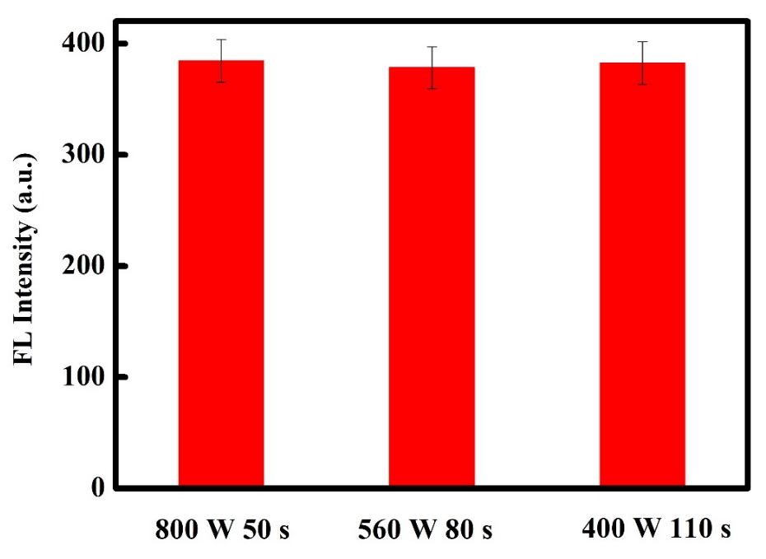

Figure S2

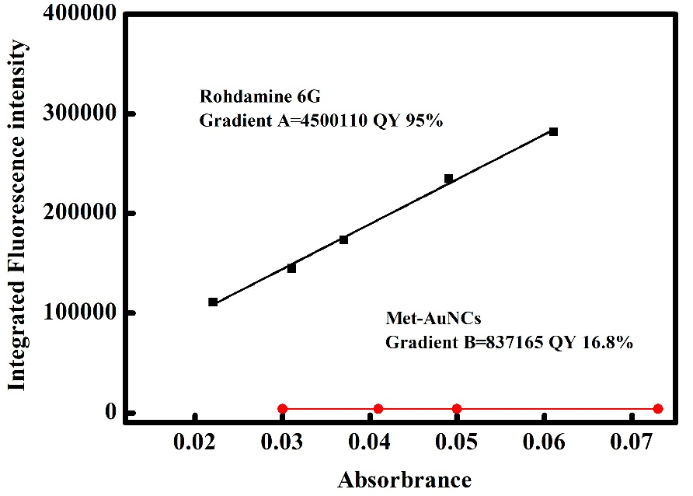

Figure S3

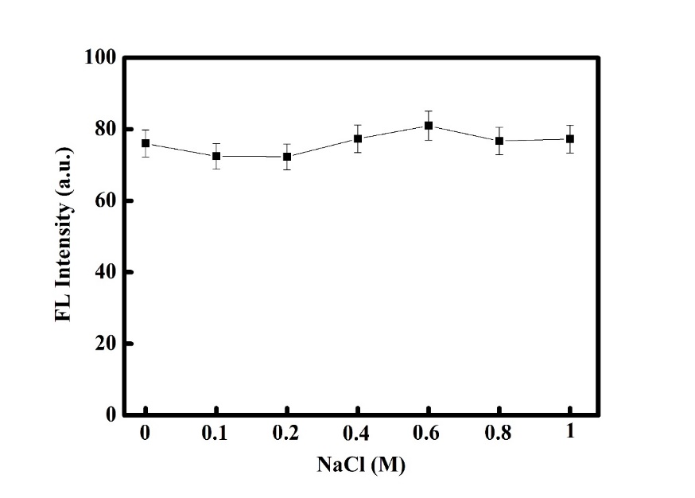
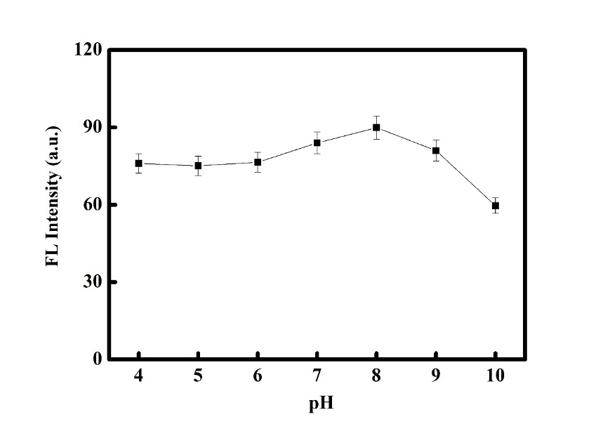
A B

Figure S4

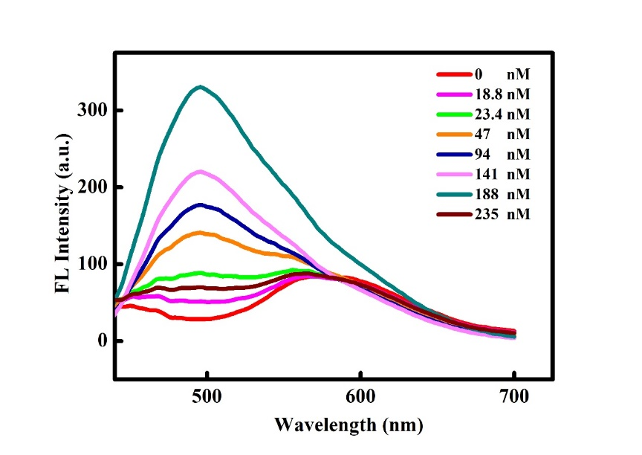
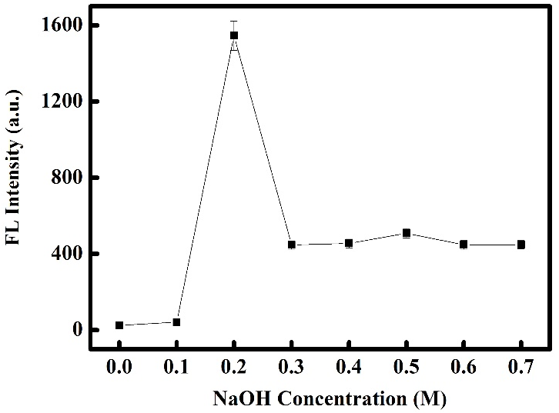
A B

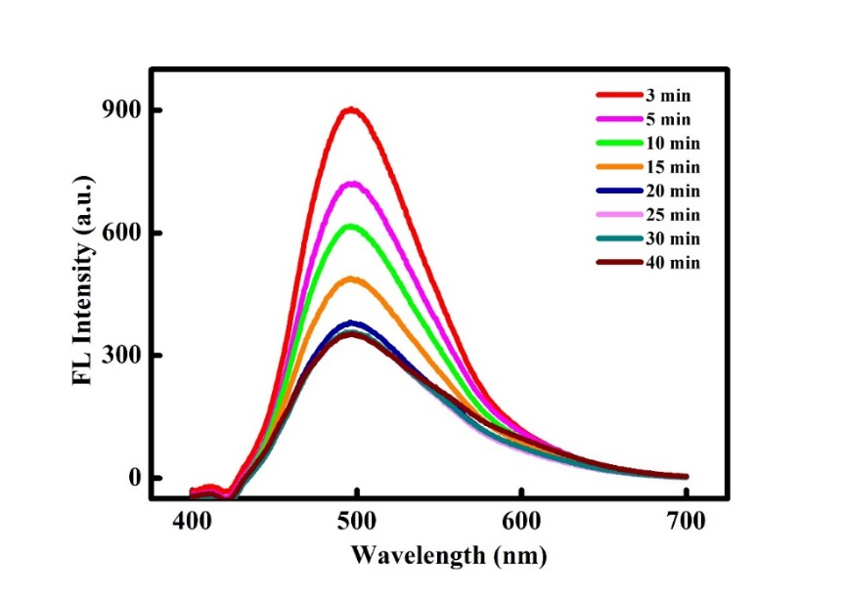

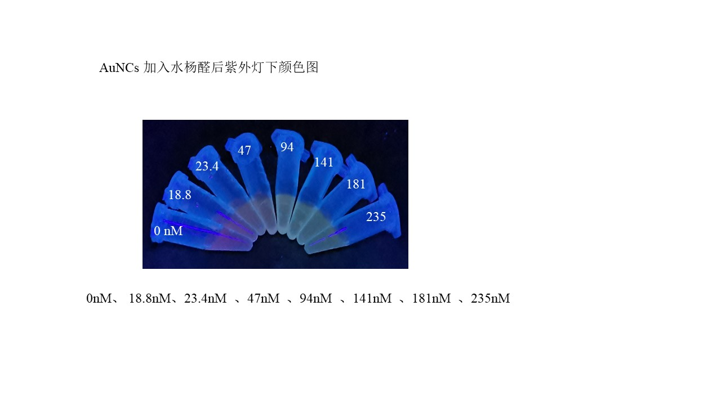
C D

Table S1

Detection methods | Detection Ions | Detection limit (nM) | Reference
Fluorescence | Al³⁺ | 83 | 1
Fluorescence | Al³⁺ | 1.27 | 2
Fluorescence | Al³⁺ | 53.7 | 3
Fluorescence | Al³⁺ | 52.2 | 4
Fluorescence | Al³⁺ | 800 | 5
Fluorescence | Al³⁺ | 0.002 | This work
[1] H. Liu, T. Liu, J. Li, Y. Zhang, J. Li, J. Song, J. Qu, W. Wong, A simple schiff base as dual-responsive fluorescent sensor for bioimaging recognition of Zn²⁺ and Al³⁺ in living cells, J Mater Chem B. 34, (2018), 5435-5442.
[2] D. Aydin, A novel turn on fluorescent probe for the determination of Al³⁺ and Zn²⁺ ions and its cells applications, Talanta 210 (2020), 120615.
[3] G. Zhao, G. Wei, Z. Yan, B. Guo, S. Guang, R. Wu, H. Xu, A multiple fluorescein-based turn-on fluorophore (FHCS) identified for simultaneous determination and living imaging of toxic Al³⁺ and Zn²⁺ by improved stokes shift, Anal. Chim. Acta. 1095 (2020), 185-196.
[4] S. Erdemir, O. Kocyigit, Dual recognition of Zn²⁺ and Al³⁺ ions by a novel probe containing two fluorophore through different signaling mechanisms, Sens Actuators B Chem. 273 (2018), 56-61.
[5] B.K. Kundu, P. Mandal, B.G. Mukhopadhyay, R. Tiwari, S. Mukhopadhyay, Substituent dependent sensing behavior of schiff base chemosensors in detecting Zn²⁺ and Al³⁺ ions: Drug sample analysis and living cell imaging, Sens Actuators B Chem. 282 (2019), 347-358.

