Supplementary Figures

Fig. S1
The construction of pan-tumor cell atlas and cell atlas across normal tissues. A, tSNE depicting tumor origins of cell populations. B, Marker gene expression for each cell type in pan-tumor, where dot size and color represent the percentage of marker gene expression (Pct. exp) and the averaged scaled expression (Avg. exp. scale) value, respectively. C, Bar plots showing the proportion of cell populations in each tumor type. D, tSNE depicting tissue origins of cell populations. E, Marker gene expression for each cell type across normal tissues, where dot size and color represent the percentage of marker gene expression (Pct. exp) and the averaged scaled expression (Avg. exp. scale) value, respectively. F, Bar plots showing the proportion of cell populations in each tissue.

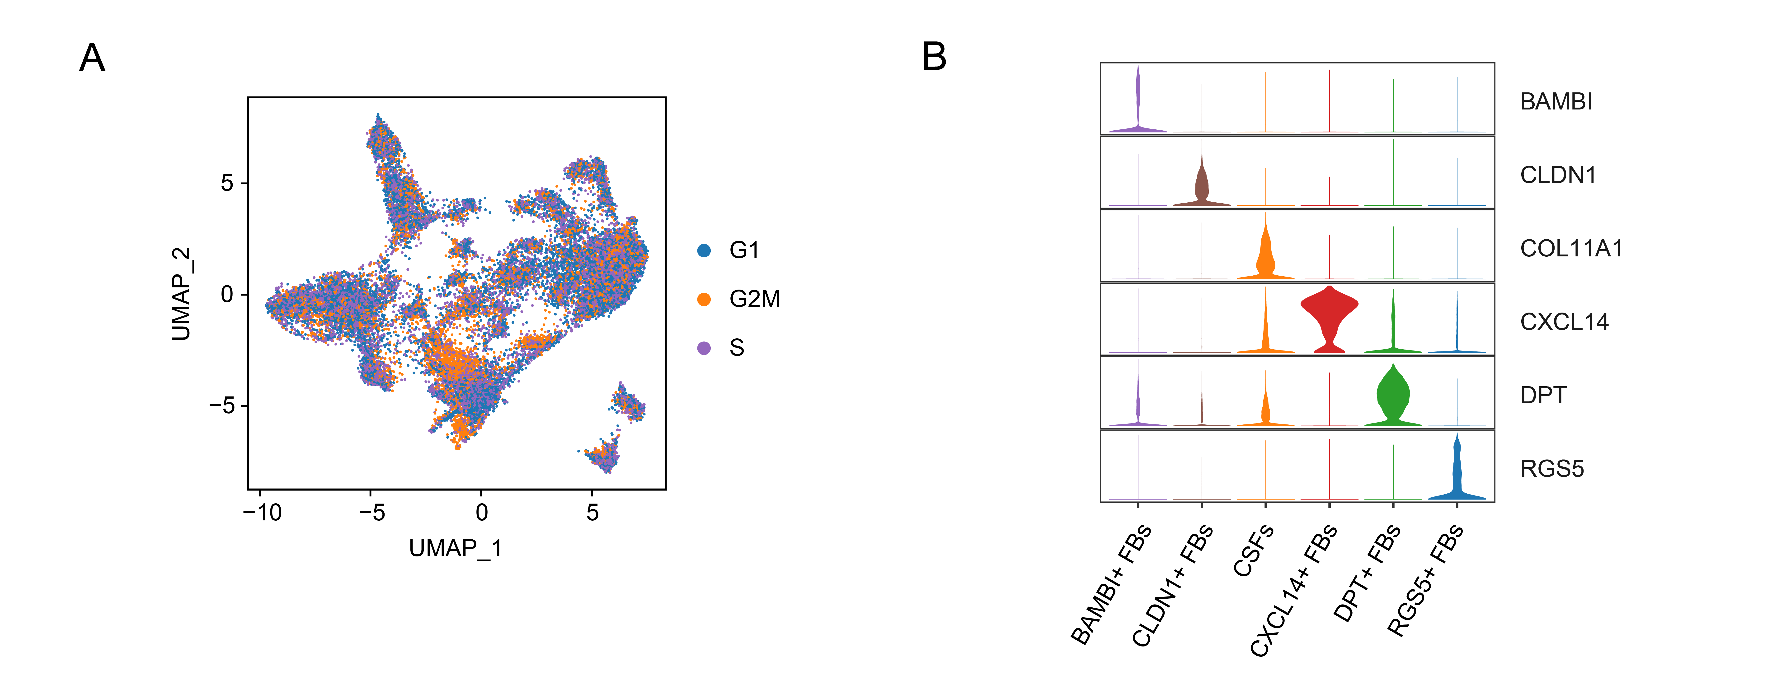
Fig. S2
The construction of human fibroblast atlas across normal tissues and tumors. A, UMAP depicting cell-cycle states of fibroblast subtypes. B, Violin plots showing marker genes for six fibroblast subtypes.

Fig. S3
Cell-cell communication analysis of CSFs and other cell types for cancers. Interaction analysis showing enriched receptor-ligand pairs in CSFs and other cell types for PDAC (A) and LC (B).

Fig. S4
Cell-cell communication analysis of fibroblasts and other cell types in tumor and normal tissues. Interaction analysis showing enriched receptor-ligand pairs in fibroblasts and other cell types for PDAC (A), normal pancreas tissues (B), LC (C), and normal lung tissues (D). E, Violin plots showing the expression of SPP1 for cell populations.

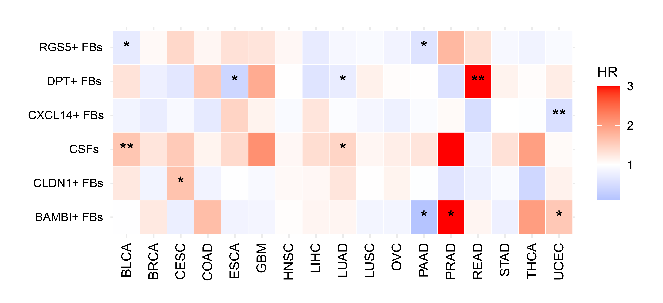
Fig. S5
The clinical relevance of fibroblast subtypes for pan-cancer. Heatmap showing the HRs and statistical significance for 6 fibroblast subtypes, where color represent HR value [red, HR above 1 (poor prognosis); and blue, HR below 1 (favorable prognosis)]. *p < 0.05, **p < 0.01. HR, hazard ratio.

