Supplementary Information
Nearly or nanoscale natural amorphous particles in the critical zone and biosphere
Meiqu Lu^{a,b,c,d}, Jianjin Cao^{a,b,c,d,*}, Guai Hu ^{a,b,c,d}, Zeyu Wang^{a,b,c,d}, Shaoting Ma^{a,b,c,d}

a School of Earth Sciences and Engineering, Sun Yat-sen University, Guangzhou 510275, China
b Guangdong Provincial Key Laboratory of Mineral Resources and Geological Processes, Guangzhou 510275, China
c Guangdong Provincial Key Laboratory of Geodynamics and Geohazards, Guangzhou 510275, China
d Southern Laboratory of Ocean Science and Engineering (Guangdong, Zhuhai, 519000)
*Corresponding author: J.J. Cao, School of Earth Sciences and Engineering, Sun Yat-sen University, Guangzhou 510275, China.
E-mail: eescjj@mail.sysu.edu.cn

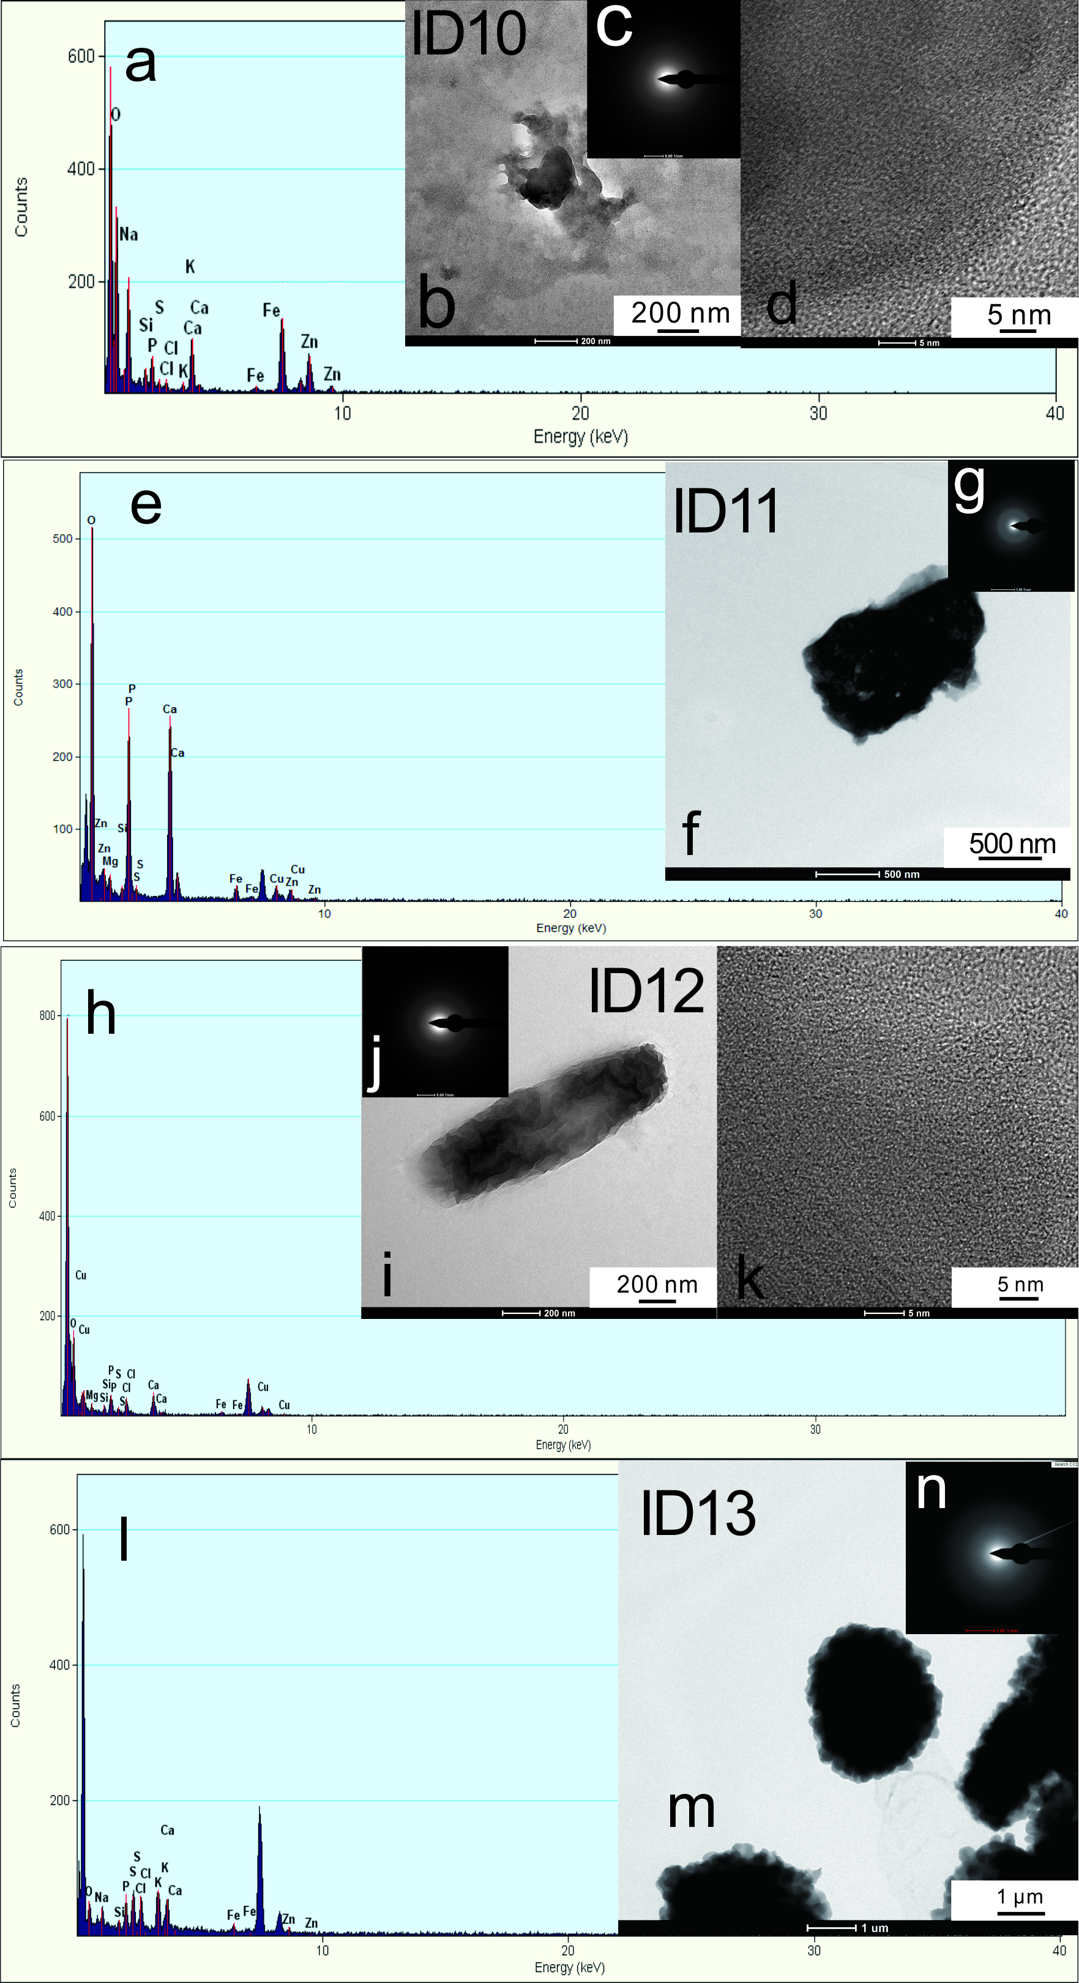
Figure S1 Spectra (a, e, h, and l), TEM images (b, f, i, and m), SAED patterns (c, g, j, and n), and HRTEM images (ID10, d; ID12, k) of P–O-bearing nearly or NNAPs in the Dabaoshan (ID10), Chaihulanzi (ID11), and Qujia (ID12) deposits and Cl–(O)-bearing nearly or NNAPs in the Dongshengmiao deposit (ID13).

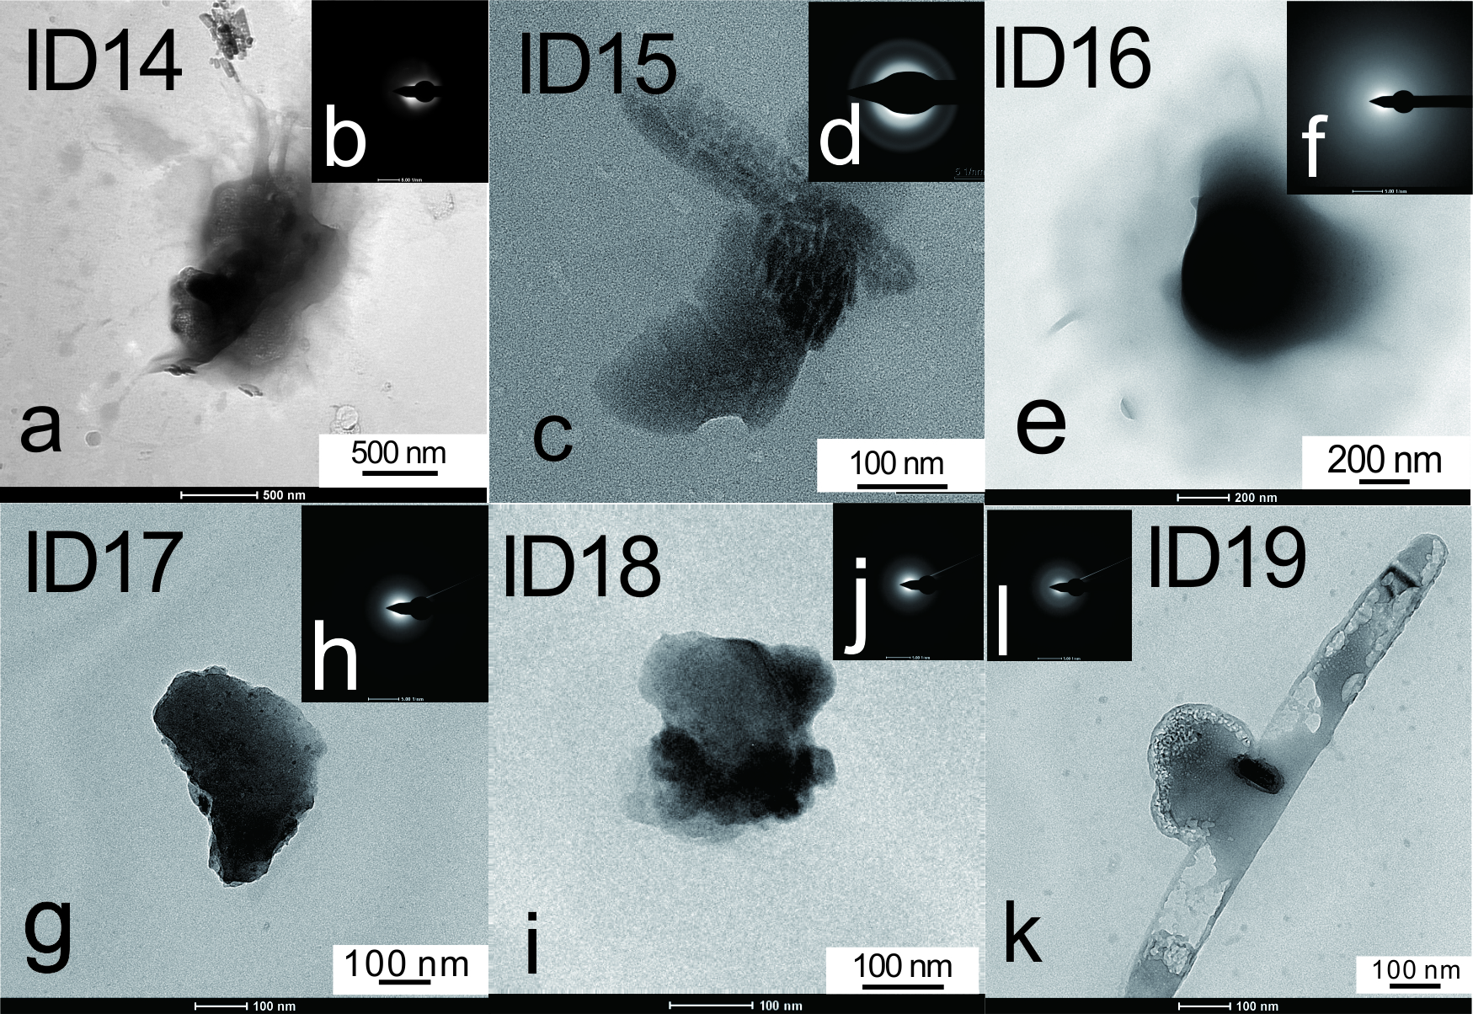
Figure S2 TEM images (a and c) and SAED patterns (b and d) of Cl–(O)-bearing nearly or NNAPs in the Dabaoshan (ID14) and Panlong deposits (ID15).
TEM images (e, g, i, and k) and SAED patterns (f, h, j, and l) of oxide nearly or NNAPs in the Dongshengmiao deposit (ID16–19).

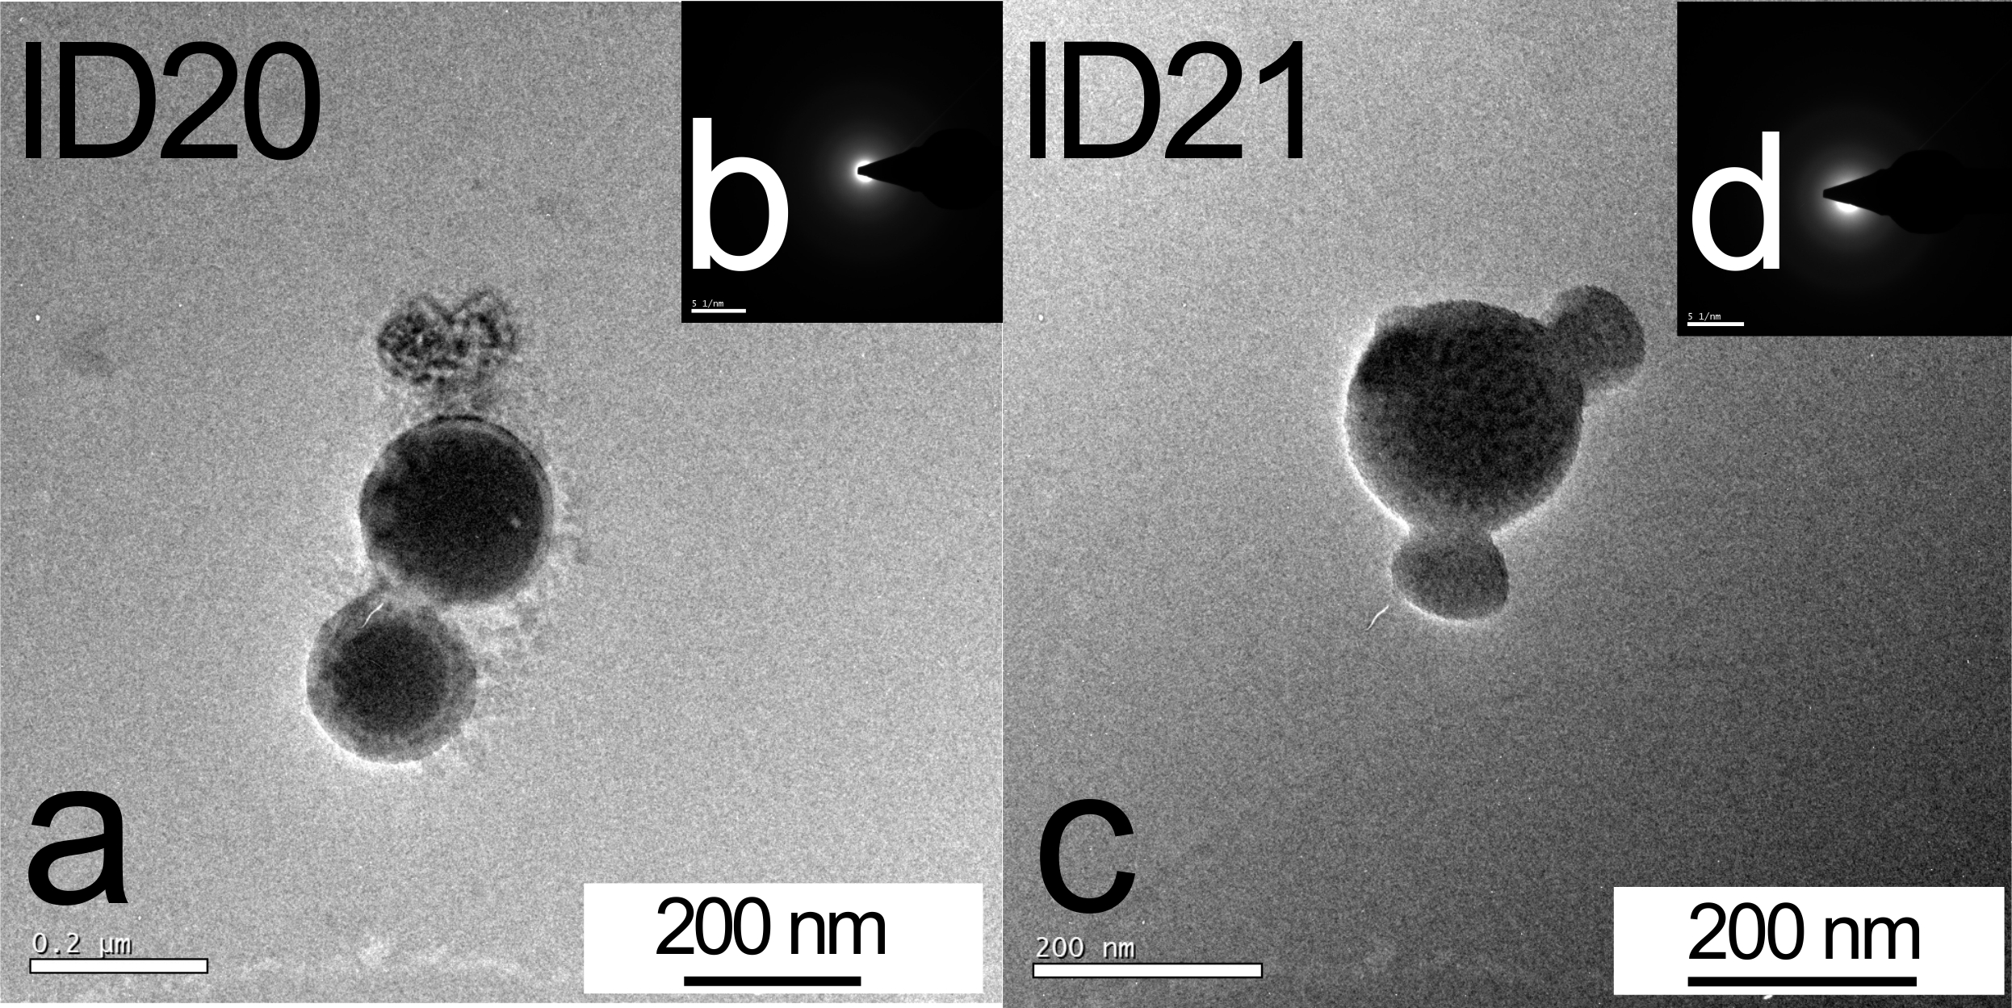
Figure S3 TEM images (a and c) and SAED patterns (b and d) of Cu–Zn–(Pb)-carrying oxide nearly or NNAPs in Kangjiawan deposit (ID20 and ID21).

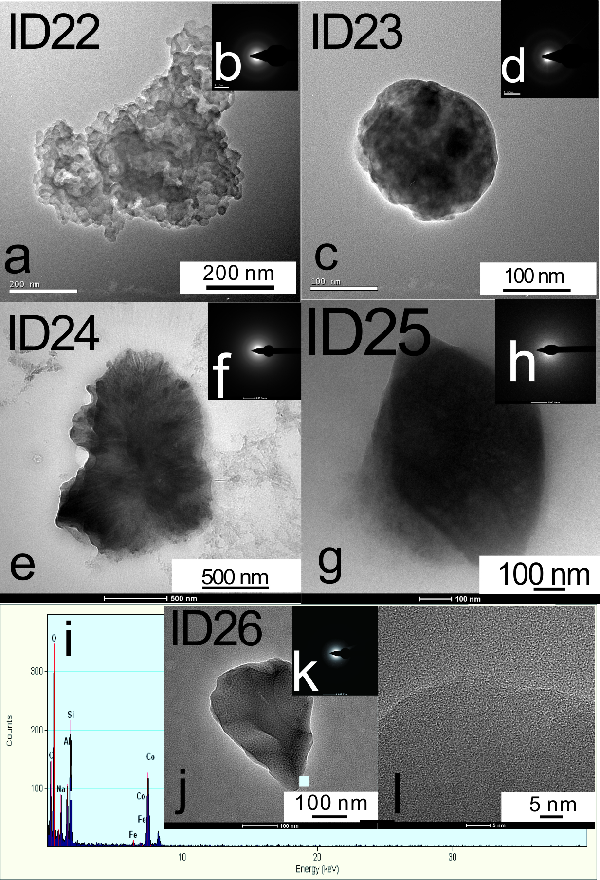
Figure S4 TEM images (a, c, e, i, and l), SAED patterns (b, d, f, j, and m), HRTEM images (ID24, g; ID26, l) and EDS spectra (ID25, h; ID26, k) of oxide nearly or NNAPs in Kangjiawan (ID22, ID23), and Dabaoshan (ID24~ID26) deposit.

Figure S5 EDS spectrum (a), TEM image, SAED pattern, and HRTEM image of W-carrying oxide nearly or NNAPs in Qujia deposit (ID27). Similar particles: TEM images (e, g, and i) and SAED patterns (f, h, and j) of W-carrying oxide nearly or NNAPs in Qujia deposit (ID28–30).

Figure S6 TEM images (a, c, e, and g) and SAED patterns (b, d, f, and h) of oxide nearly or NNAPs in the Qujia (ID31), Chaihulanzi deposits (ID32 and 33), and Weilasituo deposit (ID34).

Figure S7 TEM images (a, c, and e) and SAED patterns (b, d, and f) of oxide nearly or NNAPs in Shijiangshan deposit (ID35, ID36, ID37). TEM images (g, i, and l), SAED patterns (h, j, and m), and HRTEM images (ID39, k; ID40, n) of nearly or NNAPs in background areas in Huizhou (ID38), Qingyuan (ID39) and Heyuan (ID40).

Figure S8 Schematic diagram: nearly or NNAPs carrying a high content of ore-related elements were found in the surface media of deposits but not in the background areas.

Tables with captions

Table S1 Detailed information of Cl–(O)-bearing nearly or NNAPs (ID13–15) and oxide nearly or NNAPs (ID16–25)
Particle ID | 13 | 14 | 15 | 16 | 17 | 18 | 19 | 20 | 21 | 22 | 23 | 24 | 25
Sources | Dabaoshan |  | Panlong | Dongshengmiao |  |  |  | Kangjiawan |  |  |  | Dabaoshan
Media | Soil |  | Plant tissue | Ascending gas
w（O） | 9.19 | 30.97 | 0 | 28.91 | 60.95 | 51.53 | 17.5 | 35.91 | 50.99 | 48.86 | 29.05 | 46.93 | 33.43
a（O） | 18.81 | 43.81 | 0 | 51.77 | 74.66 | 73.79 | 55.18 | 58.47 | 69.44 | 65.74 | 66.39 | 70.57 | 55.43
w（Fe） | 5.89 | 1.11 | 0 | 0 | 4.45 | 9.19 | 0 | 0 | 3.62 | 0 | 0 | 0 | 0
a（Fe） | 3.45 | 0.45 | 0 | 0 | 1.56 | 3.77 | 0 | 0 | 1.41 | 0 | 0 | 0 | 0
w（Cu） | 0 | 0 | 0 | 0 | 0 | 0 | 0 | 6.58 | 10.67 | 6.9 | 6.72 | 0 | 0
a（Cu） | 0 | 0 | 0 | 0 | 0 | 0 | 0 | 2.69 | 3.66 | 2.34 | 3.86 | 0 | 0
w（P） | 10.15 | 0 | 0 | 0 | 0 | 0.47 | 0 | 0 | 0 | 0.65 | 0 | 0 | 0.57
a（P） | 10.73 | 0 | 0 | 0 | 0 | 0.35 | 0 | 0 | 0 | 0.45 | 0 | 0 | 0.49
w（S） | 15.56 | 0 | 0 | 0.75 | 0 | 5.14 | 0 | 3.62 | 1.52 | 4.01 | 3.28 | 0.78 | 0
a（S） | 15.89 | 0 | 0 | 0.67 | 0 | 3.67 | 0 | 2.94 | 1.03 | 2.69 | 3.75 | 0.59 | 0
w（Ca） | 15.51 | 2.56 | 89.94 | 0 | 0 | 1.89 | 0 | 0 | 0 | 0 | 0 | 2.2 | 0.36
a（Ca） | 12.66 | 1.45 | 88.78 | 0 | 0 | 1.08 | 0 | 0 | 0 | 0 | 0 | 1.32 | 0.24
w（Zn） | 3.31 | 1.33 | 0 | 48.99 | 0 | 0 | 0 | 6.39 | 2.26 | 0 | 0 | 13.36 | 61.27
a（Zn） | 1.66 | 0.46 | 0 | 21.46 | 0 | 0 | 0 | 2.54 | 0.75 | 0 | 0 | 4.92 | 40.62
w（Al） | 0 | 3.31 | 0 | 0 | 0.03 | 0.25 | 0 | 0.68 | 0 | 0 | 0 | 0 | 0
a（Al） | 0 | 2.77 | 0 | 0 | 0.02 | 0.21 | 0 | 0.65 | 0 | 0 | 0 | 0 | 0
w（K） | 22.86 | 0 | 0 | 0 | 0 | 0.55 | 15.73 | 6.65 | 3.16 | 11.12 | 0 | 0 | 2.93
a（K） | 19.13 | 0 | 0 | 0 | 0 | 0.32 | 20.3 | 4.43 | 1.76 | 6.12 | 0 | 0 | 1.98
w (Mg） | 0 | 2.24 | 0 | 0 | 0 | 0.83 | 0 | 0.76 | 0.1 | 0 | 0 | 1.13 | 0
a（Mg） | 0 | 2.09 | 0 | 0 | 0 | 0.78 | 0 | 0.81 | 0.09 | 0 | 0 | 1.12 | 0
w（Si） | 0.09 | 2.79 | 0 | 2.2 | 33.39 | 13.68 | 0.94 | 16.24 | 25.4 | 22.69 | 6.39 | 0 | 0.83
a（Si） | 0.11 | 2.25 | 0 | 2.24 | 23.3 | 11.16 | 1.69 | 15.06 | 19.7 | 17.39 | 8.32 | 0 | 0.79
w（Cl） | 14.45 | 23.37 | 10.05 | 0 | 0 | 0 | 0 | 0.32 | 0 | 0.39 | 0 | 2 | 0.56
a（Cl） | 13.34 | 14.91 | 11.21 | 0 | 0 | 0 | 0 | 0.24 | 0 | 0.24 | 0 | 1.35 | 0.42
w（Na） | 2.93 | 32.27 | 0 | 19.13 | 0 | 0.99 | 3.48 | 6.46 | 2.24 | 5.34 | 4.55 | 7.82 | 0
a（Na） | 4.18 | 31.77 | 0 | 23.84 | 0 | 0.98 | 7.56 | 7.32 | 2.12 | 5 | 7.24 | 8.19 | 0
w（Mn） | 0 | 0 | 0 | 0 | 0 | 0.87 | 0 | 7.85 | 0 | 0 | 0 | 0 | 0
a（Mn） | 0 | 0 | 0 | 0 | 0 | 0.36 | 0 | 3.72 | 0 | 0 | 0 | 0 | 0
w（Cr） | 0 | 0 | 0 | 0 | 1.16 | 0 | 0 | 0 | 0 | 0 | 0 | 25.74 | 0
a（Cr） | 0 | 0 | 0 | 0 | 0.43 | 0 | 0 | 0 | 0 | 0 | 0 | 11.91 | 0
w（Mo） | 0 | 0 | 0 | 0 | 0 | 14.55 | 0 | 0 | 0 | 0 | 0 | 0 | 0
a（Mo） | 0 | 0 | 0 | 0 | 0 | 3.47 | 0 | 0 | 0 | 0 | 0 | 0 | 0
w（Pb） | 0 | 0 | 0 | 0 | 0 | 0 | 62.33 | 8.49 | 0 | 0 | 44.86 | 0 | 0
a（Pb） | 0 | 0 | 0 | 0 | 0 | 0 | 15.17 | 1.06 | 0 | 0 | 7.91 | 0 | 0
w（As） | 0 | 0 | 0 | 0 | 0 | 0 | 0 | 0 | 0 | 0 | 5.1 | 0 | 0
a（As） | 0 | 0 | 0 | 0 | 0 | 0 | 0 | 0 | 0 | 0 | 2.49 | 0 | 0

Table S2 Detailed information of oxide nearly or NNAPs (ID26–40)
Particle ID | 26 | 27 | 28 | 29 | 30 | 31 | 32 | 33 | 34 | 35 | 36 | 37 | 38 | 39 | 40
Sources | Dabaoshan | Qujia |  |  |  |  | Chaihulanzi |  | Weilasituo | Shijiangshan |  |  | Huizhou | Qingyuan | Heyuan
Media | Soil | Groundwater
w（O） | 59.52 | 23.32 | 22.63 | 25.75 | 20.83 | 13.58 | 60.42 | 53.09 | 82.64 | 38.57 | 22.82 | 40.74 | 85.49 | 91.5 | 78.64
a（O） | 71.27 | 73.7 | 71.36 | 73.1 | 65.2 | 34.45 | 80.94 | 71.56 | 93.44 | 69.13 | 53.88 | 71.68 | 91.59 | 94.97 | 87.83
w（Fe） | 0.68 | 5.79 | 6.21 | 7.88 | 15.04 | 33.03 | 1.81 | 7.08 | 1.09 | 40.73 | 0 | 40.69 | 0 | 0 | 3.55
a（Fe） | 0.23 | 5.24 | 5.61 | 6.41 | 13.49 | 24 | 0.69 | 2.73 | 0.35 | 20.91 | 0 | 20.51 | 0 | 0 | 1.13
w（Cu） | 0 | 0 | 0 | 0 | 0 | 9.97 | 3.75 | 0 | 0 | 5.69 | 76.75 | 0 | 0 | 0 | 0
a（Cu） | 0 | 0 | 0 | 0 | 0 | 6.36 | 1.26 | 0 | 0 | 2.57 | 45.62 | 0 | 0 | 0 | 0
w（P） | 0 | 0 | 0 | 0 | 0 | 0 | 3.53 | 0 | 0 | 0 | 0 | 0.5 | 0 | 0 | 0
a（P） | 0 | 0 | 0 | 0 | 0 | 0 | 2.44 | 0 | 0 | 0 | 0 | 0.45 | 0 | 0 | 0
w（S） | 0 | 0 | 0 | 0 | 0 | 0 | 1.55 | 0 | 1.07 | 0 | 0.42 | 0 | 0 | 0 | 0
a（S） | 0 | 0 | 0 | 0 | 0 | 0 | 1.04 | 0 | 0.6 | 0 | 0.49 | 0 | 0 | 0 | 0
w（Ca） | 0 | 1.56 | 3.55 | 2.01 | 2.21 | 14.11 | 1.85 | 1.02 | 0.44 | 0.94 | 0 | 1.32 | 2.42 | 0 | 2.86
a（Ca） | 0 | 1.97 | 4.47 | 2.28 | 2.76 | 14.29 | 0.98 | 0.55 | 0.19 | 0.67 | 0 | 0.93 | 1.03 | 0 | 1.27
w（Zn） | 0 | 0 | 0 | 0 | 0 | 9.02 | 2.59 | 0 | 8.2 | 1.89 | 0 | 0 | 0 | 0 | 0
a（Zn） | 0 | 0 | 0 | 0 | 0 | 5.6 | 0.85 | 0 | 2.27 | 0.83 | 0 | 0 | 0 | 0 | 0
w（Al） | 9.2 | 0 | 0 | 0 | 0 | 0 | 0 | 7.75 | 0 | 0 | 0 | 0 | 0 | 0 | 9.73
a（Al） | 6.53 | 0 | 0 | 0 | 0 | 0 | 0 | 6.19 | 0 | 0 | 0 | 0 | 0 | 0 | 6.44
w（K） | 0 | 0 | 0 | 0 | 0 | 0 | 0 | 8.82 | 1.37 | 0 | 0 | 0 | 0 | 0 | 0
a（K） | 0 | 0 | 0 | 0 | 0 | 0 | 0 | 4.87 | 0.63 | 0 | 0 | 0 | 0 | 0 | 0
w (Mg） | 0 | 0 | 0 | 0 | 0 | 0 | 1.47 | 0.87 | 0 | 0 | 0 | 0 | 0 | 0 | 0
a（Mg） | 0 | 0 | 0 | 0 | 0 | 0 | 1.3 | 0.77 | 0 | 0 | 0 | 0 | 0 | 0 | 0
w（Si） | 20.93 | 0 | 0 | 0 | 0 | 0 | 0 | 12.16 | 0.18 | 1.91 | 0 | 3.12 | 12.07 | 8.49 | 5.19
a（Si） | 14.28 | 0 | 0 | 0 | 0 | 0 | 0 | 9.34 | 0.12 | 1.95 | 0 | 3.13 | 7.37 | 5.02 | 3.3
w（Cl） | 0 | 0 | 0 | 0 | 0.93 | 2.58 | 0.57 | 0 | 1.77 | 0 | 0 | 0.87 | 0 | 0 | 0
a（Cl） | 0 | 0 | 0 | 0 | 1.32 | 2.95 | 0.34 | 0 | 0.9 | 0 | 0 | 0.69 | 0 | 0 | 0
w（Na） | 8.91 | 0 | 0 | 1.32 | 0.32 | 0 | 1.68 | 1.03 | 1.43 | 0 | 0 | 0.78 | 0 | 0 | 0
a（Na） | 7.43 | 0 | 0 | 2.62 | 0.7 | 0 | 1.57 | 0.96 | 1.12 | 0 | 0 | 0.95 | 0 | 0 | 0
w（W） | 0 | 69.31 | 67.59 | 63.01 | 60.65 | 0 | 0 | 0 | 0 | 0 | 0 | 0 | 0 | 0 | 0
a（W） | 0 | 19.06 | 18.54 | 15.56 | 16.52 | 0 | 0 | 0 | 0 | 0 | 0 | 0 | 0 | 0 | 0
w（Cr） | 0 | 0 | 0 | 0 | 0 | 1.62 | 20.73 | 0 | 0 | 0 | 0 | 0 | 0 | 0 | 0
a（Cr） | 0 | 0 | 0 | 0 | 0 | 1.27 | 8.54 | 0 | 0 | 0 | 0 | 0 | 0 | 0 | 0
w（Co） | 0.73 | 0 | 0 | 0 | 0 | 16.09 | 0 | 8.11 | 0 | 0 | 0 | 0 | 0 | 0 | 0
a（Co） | 0.23 | 0 | 0 | 0 | 0 | 11.08 | 0 | 2.97 | 0 | 0 | 0 | 0 | 0 | 0 | 0
W (Mo） | 0 | 0 | 0 | 0 | 0 | 0 | 0 | 0 | 1.75 | 0 | 0 | 0 | 0 | 0 | 0
a（Mo） | 0 | 0 | 0 | 0 | 0 | 0 | 0 | 0 | 0.33 | 0 | 0 | 0 | 0 | 0 | 0
w（Pb） | 0 | 0 | 0 | 0 | 0 | 0 | 0 | 0 | 0 | 0 | 0 | 11.94 | 0 | 0 | 0
a（Pb） | 0 | 0 | 0 | 0 | 0 | 0 | 0 | 0 | 0 | 0 | 0 | 1.62 | 0 | 0 | 0
w（As） | 0 | 0 | 0 | 0 | 0 | 0 | 0 | 0 | 0 | 10.24 | 0 | 0 | 0 | 0 | 0
a（As） | 0 | 0 | 0 | 0 | 0 | 0 | 0 | 0 | 0 | 3.92 | 0 | 0 | 0 | 0 | 0

