Additional file 2
Table 1 The details of nested PCR testing for differentiating between various Plasmodium species
Nested PCR | Specificity of primers | Primer name△ | Primer sequence△ | Expected PCR product (bp) | Reaction conditions | Reaction systems
First round | Genus | rPLU5 | 5’-CCTGTTGTTGCCTTAAACTTC-3； | 1200 | 94 ° C for 3min;94° C for 30s, 58° C for 30s, 72° C for 60s, 34 cycles; 72° C for 5min. | 25 ul reaction volume including 2.6 μl template, 14.0 μl 2 × PCR Mix hybrid system (Containing Taq enzyme), 0.7 μl upstream primer (20umol / L) and 0.7 μl downstream primers (20umol / L)
First round | Genus | rPLU6 | 5’-TTAAAATTGTTGCAGTTAAAACG-3’ | 1200
Second round | P. falciparum | rFAL1 | 5’-TTAAACTGGTTTGGGAAAACCAAATATATT-3’ | 205 | 94 ° C for 3min;94° C for 30s, 60° C for 30s, 72° C for 60s, 34 cycles; 72° C for 5min
Second round | P. falciparum | rFAL2 | 5’-ACACAATGAACTCAATCATGACTACCCGTC-3’ | 205
Second round | P. vivax | rVIV1 | 5’-CGCTTCTAGCTTAATCCACATAACTGATAC-3’ | 120
Second round | P. vivax | rVIV2 | 5’-ACTTCCAAGCCGAAGCAAAGAAAGTCCTTA-3’ | 120
Second round | P. malariae | rMAL1 | 5’-ATAACATAGTTGTACGTTAAGAATAACCGC-3’ | 141
Second round | P. malariae | rMAL2 | 5’-AAAATTCCCATGCATAAAAAATTATACAAA-3’ | 141
Second round | P. ovale | rOVA1 | 5’-ATCTCTTTTGCTATTTTTTAGTATTGGAGA-3’ | 800
Second round | P. ovale | rOVA2 | 5’-GGAAAGGACACATTAATTGTATCCTAGTG-3’ | 800
_{[Snounou]}: The primers’ name and sequence were cited from References Snounou G, Viriyakosol S, Zhu XP, Jarra W, Pinheiro L, do Rosario VE, et al. High sensitivity of detection of human malaria parasites by the use of nested polymerase chain reaction. Mol Biochem Parasitol. 1993;61(2):315-20.

Genetic confirmation by Yunnan Province Malaria Diagnosis Referent Laboratory
All of five imported-malaria cases were confirmed as mono-infection by using Snounou’s method in Yunnan Province Malaria Diagnosis Referent Laboratory. The results were as follows.

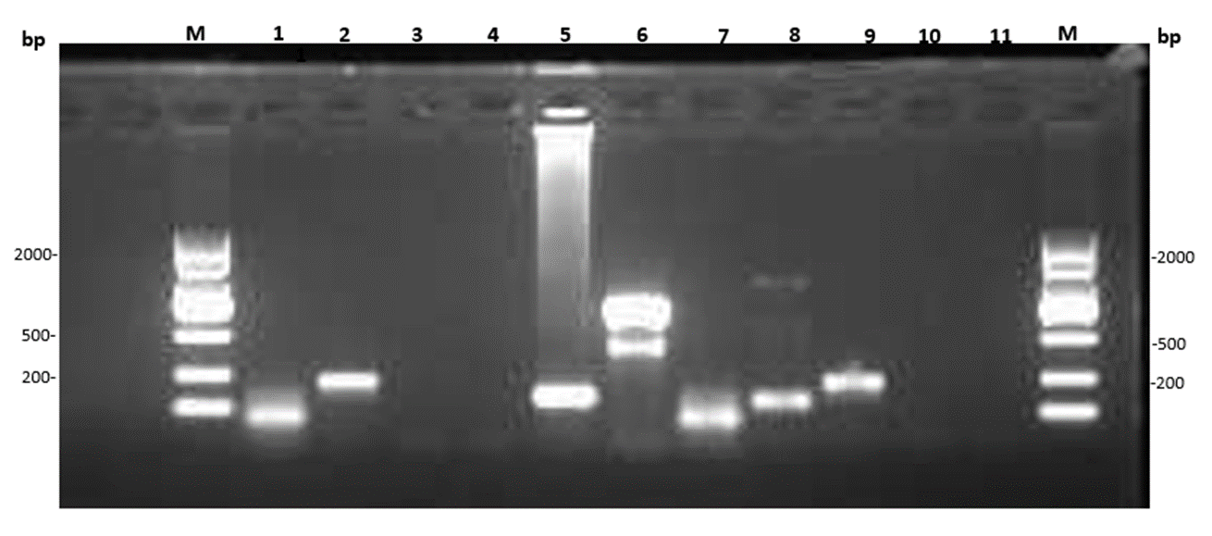
Figure 1 Electrophoretic image of the amplified products by nested polymerase chain reaction for five bone marrow fruit samples （1）M: DNA Marker; (2) 1 and 7: Case1 and Case5, Plasmodium malariae; (3) 2: Case4, Plasmodium falciparum; (4) 5 and 8: Case2 and Case3, Plasmodium vivax; (5) 6: positive sample, Plasmodium ovale; (6) 9: positive sample, Plasmodium falciparum; (7) 3, 4: Negative sample; (8) 10 and 11: The blank controls of first-round PCR and second-round PCR, respectively.

Table 2 The information records of confirmation diagnosis for 5 malaria cases
Patients | Infection source | Peripheral blood |  |  | Bone marrow fruit
Patients | Infection source | Species | Method |  | Species | Method
Case 1 | Congo | P. malariae | Microscopy examination |  | P. malariae | Genetic detection
Case 2 | Guinea | Negative | Microscopy examination |  | P. vivax | Genetic detection
Case 3 | Cameroon | Negative | Microscopy examination |  | P. vivax | Genetic detection
Case 4 | Guinea | Negative | Microscopy examination |  | P. falciparum | Genetic detection
Case 5 | Congo | Negative | Microscopy examination |  | P. malariae | Genetic detection

