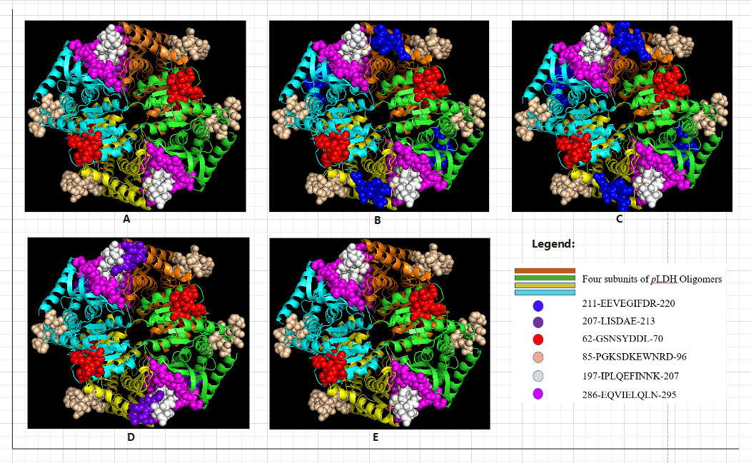
Figure 1. Spatial structures of Plasmodium pLDH peptide chain and distribution of B-cell antigenic determinants of five strains

