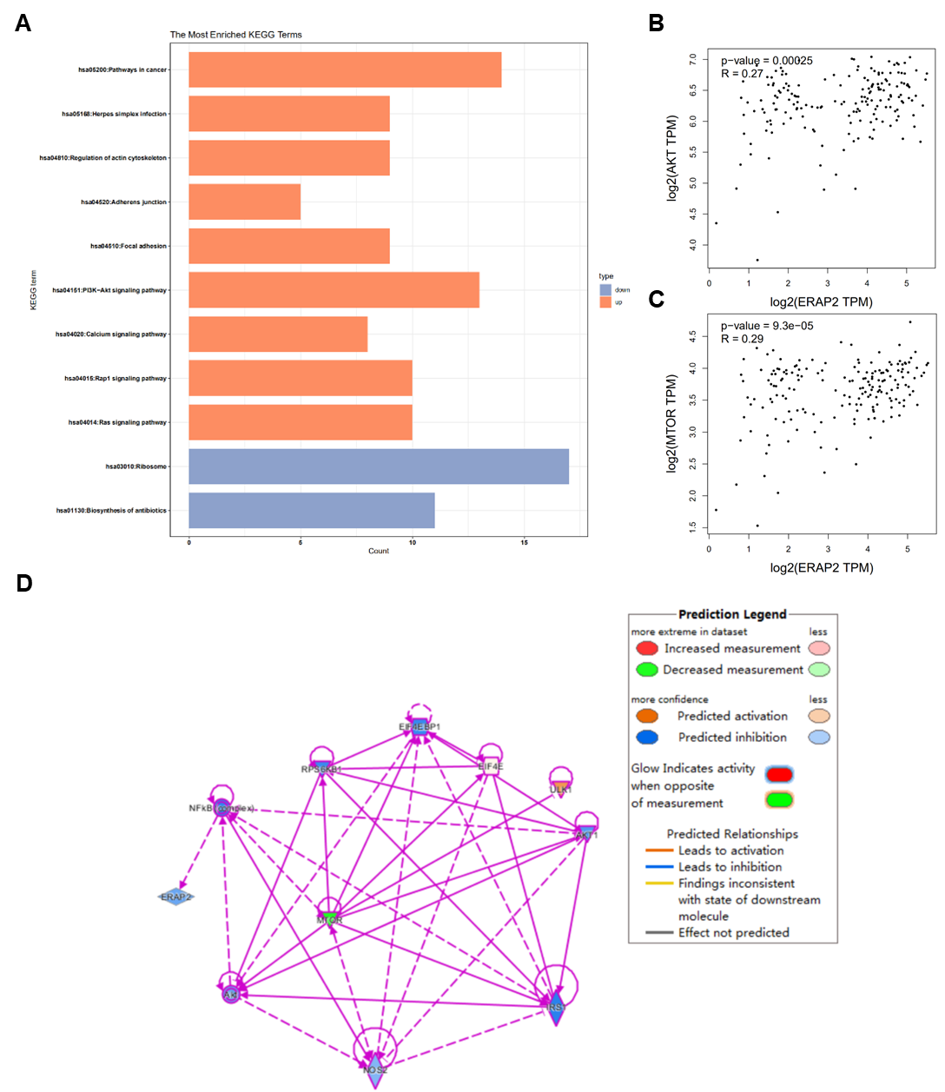
Additional file 2: SFig. 2 ERAP2 involved in the classic AKT/mTOR pathway. (A) KEGG pathway analysis to validate the effects of ERAP2. (B) The correlation between ERAP2 and AKT was analyzed by GEPIA analysis tool. (C) The correlation between ERAP2 and mTOR was analyzed by GEPIA analysis tool. (D) The regulatory network of ERAP2 is constructed using IPA software.

