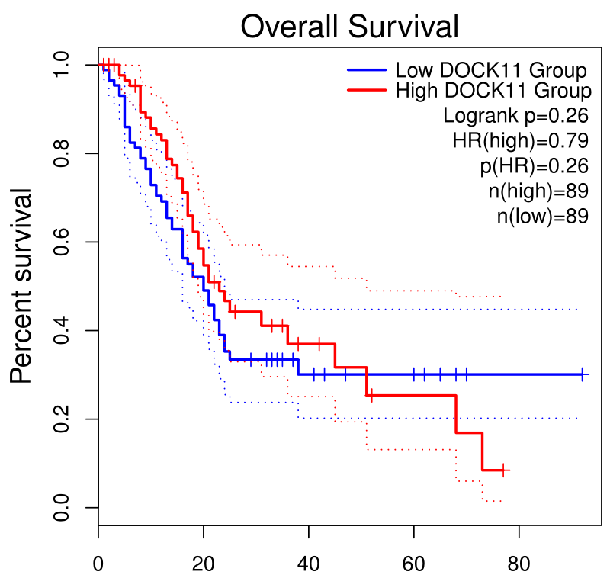 Additional file 1: SFig. 1 Prognosis of DOCK11 in pancreatic cancer. Kaplan-Meier survival curve of DOCK11 in pancreatic cancer data set from GEPIA database.

