Supplementary material
Supplement figure 1
Supplement figure 1. The synchronization result of TUBB4B-KO mouse spermatogonia compare with the control group during the cell cycle progression.
A is the synchronization comparison of G0-G1 phase of mouse spermatogonia between control and TUBB4B-KO, B is the synchronization of S phase of control and TUBB4B-KO spermatogonia, C is the synchronization of G2-M phase of control and TUBB4B-KO spermatogonia.

Supplement figure 2
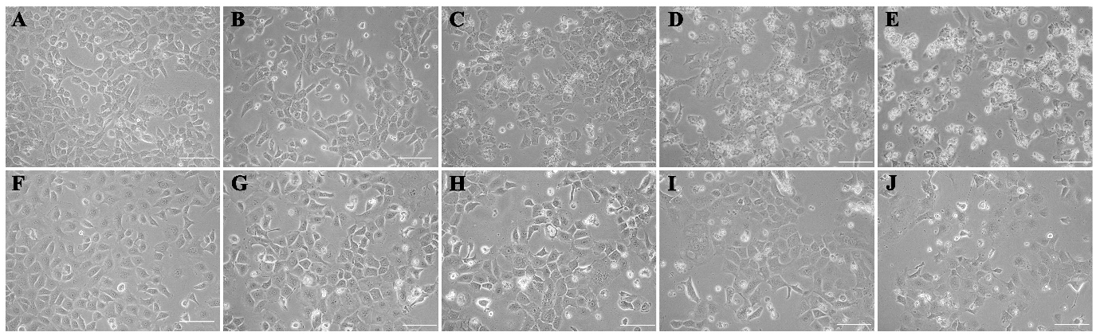
Supplement figure 2. The culture of mouse spermatogonia in G0-G1 phase synchronization
A is the growth of mouse spermatogonia under 10% serum culture; B-E is the growth of mouse spermatogonia under the condition of serum starvation culture day1, day2, day3 and day4, respectively; F is the growth of TUBB4B-KO mouse spermatogonia under 10% serum culture; G-J is the growth of TUBB4B-KO mouse spermatogonia under the condition of serum starvation culture day1, day2, day3 and day4, respectively. The scale is 100 μm.

Supplement figure 3
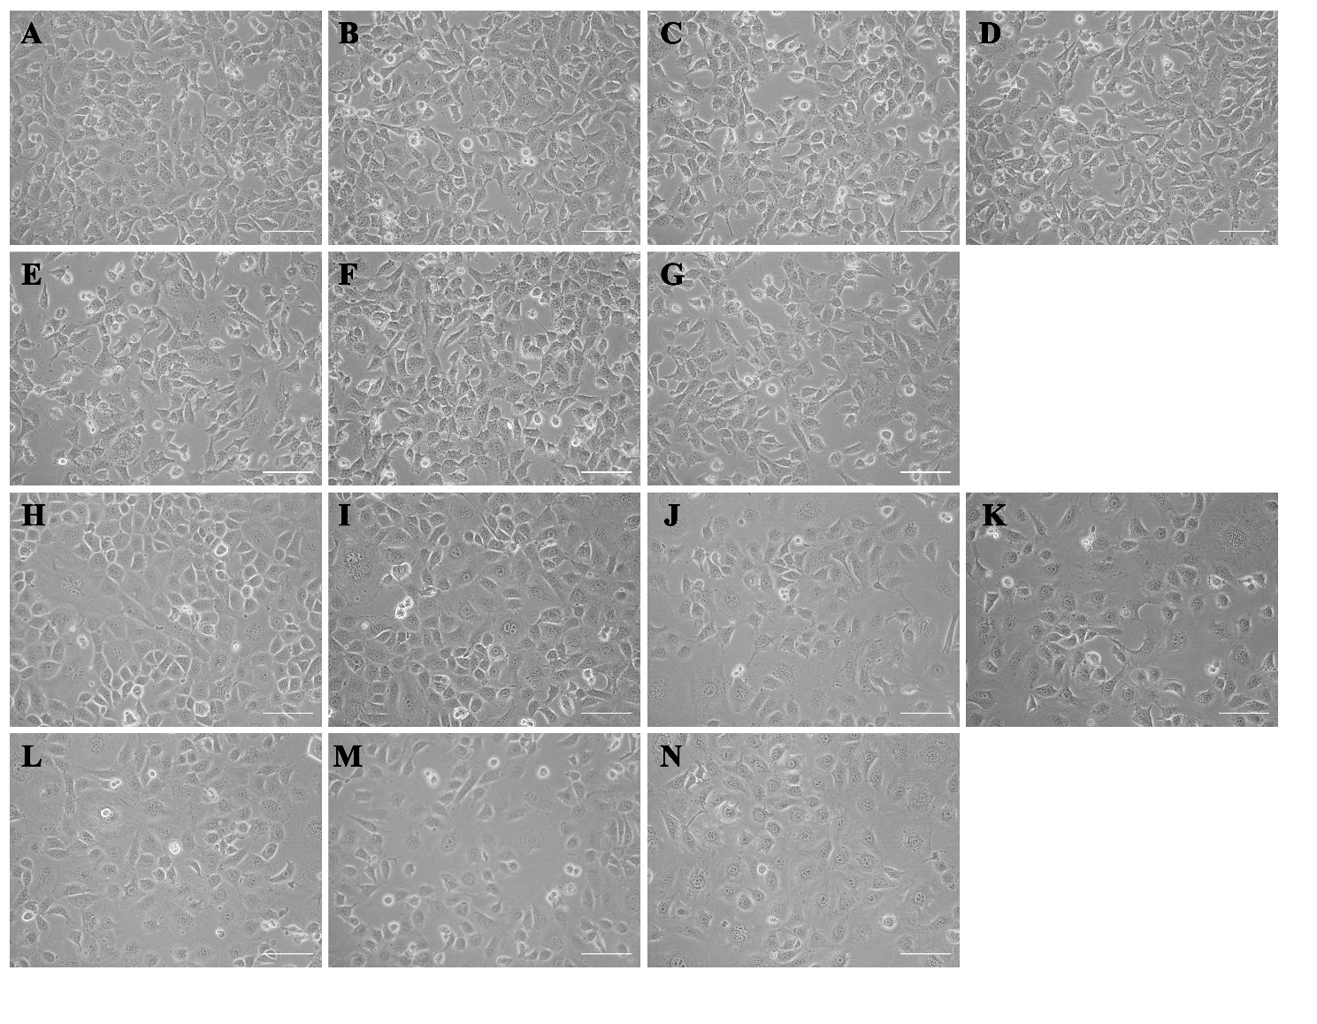
Supplement figure 3. The culture of mouse spermatogonia in S-phase synchronization
A-G are the growth of mouse spermatogonia in 10% serum medium supplemented with 0, 1 nM, 10 nM, 100 nM, 1 uM, 10 uM and 100 uM thymidine, respectively; H-N are the growth of TUBB4B-KO group mouse spermatogonia in 10% serum medium supplemented with 0, 1 nM, 10 nM, 100 nM, 1 uM, 10 uM and 100 uM thymidine, respectively. The scale is 100 μm.

Supplement figure 4
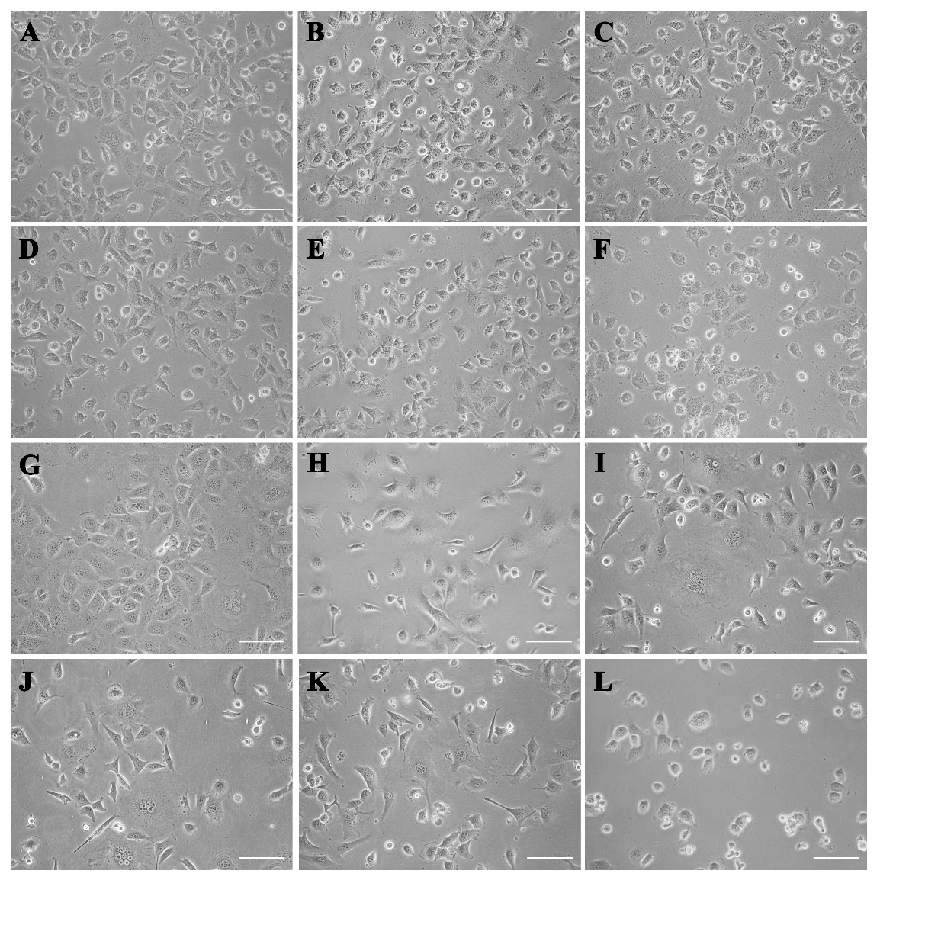
Supplement figure 4. The culture of mouse spermatogonia in G2-M phase synchronization
A-F are the growth of mouse spermatogonia in 10% serum medium supplemented with 0、0.005ng、0.05 ng、0.5 ng、5 ng and 50 ng of nocodazole, respectively; G-L are the growth of TUBB4B-KO group mouse spermatogonia in 10% serum medium supplemented with 0, 0.005 ng, 0.05 ng, 0.5 ng, 5 ng and 50 ng of nocodazole, respectively. The scale is 100 μm.

WB raw figure
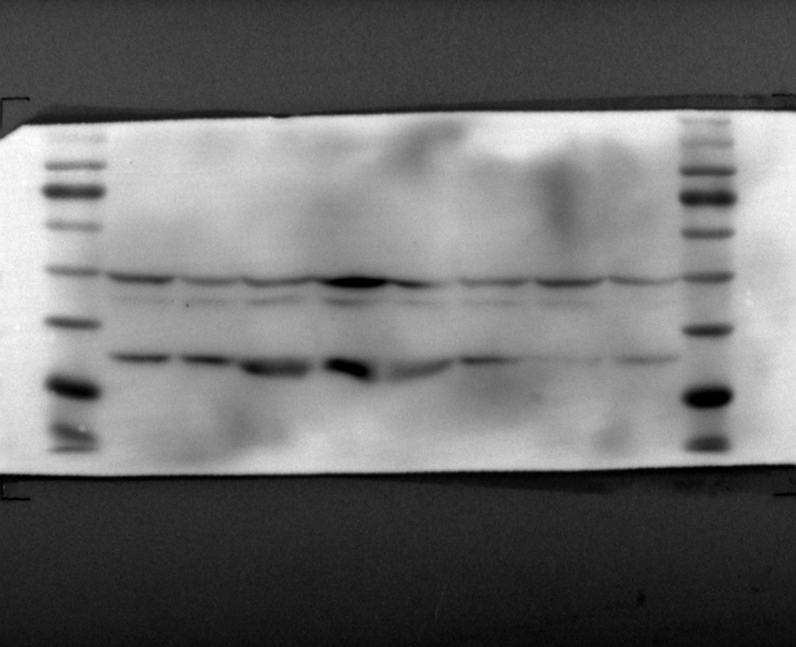

Supplementary figure 5. The WB raw figure of Figure 4K

